**Unique Code :- l21 (Himanshu Vishwakarma)**

**Project 1 :- Inventory Management System::--**

I run a small retail store and to keep track of my inventory. can you create a software solution that helps me manage my products ,sales and inventory more efficientely?

**FEATURES REQUESTED::--**

**PRODUCT MANAGEMENT :** "I need a system where I can easily addd new products, update their detials , and remove outdated ones. "

**STOCK TRACKING ::** " Can the software track hoe many of eeach items I have instock and notify me when I need to restock?"

**SALES RECORDING ::** " I want to record eack sale and havee It automatically updted my invetory levels. "

**REPORT GENERATOR ::** " It would be great to generate reports showing what's selling well and what's low in stock. "

**Output:-- 1.** Firstly Adding Product…

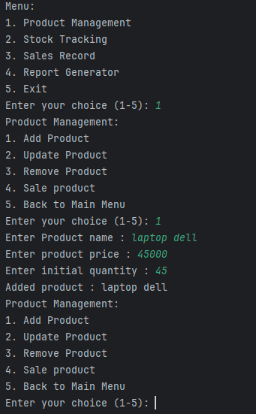 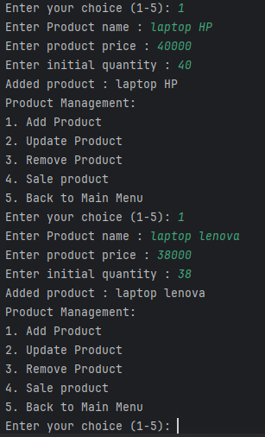

2.After adding product we back and then

to check stock Track…

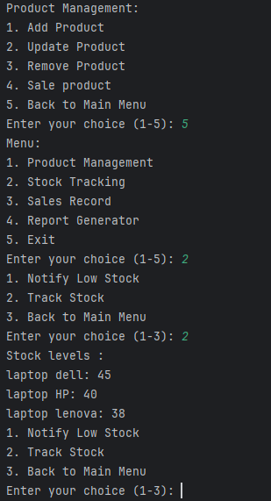

3. check whole broser product in store

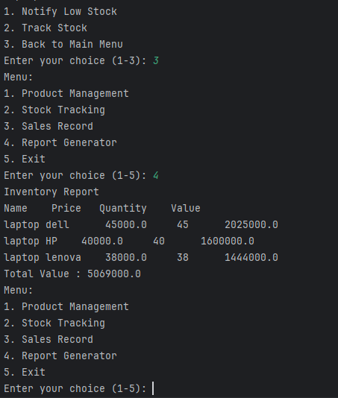

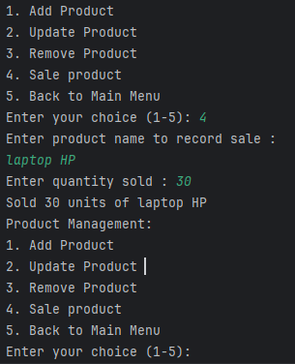

4.let sell 30 laptop HP from store..

Now we try to check items so go back to main meno..

Then we check sales Record..So press 3 to go inside ‘sale Product’ menu..

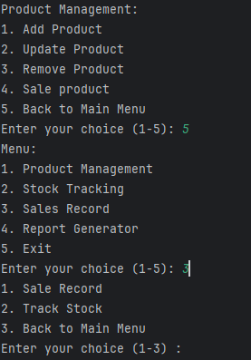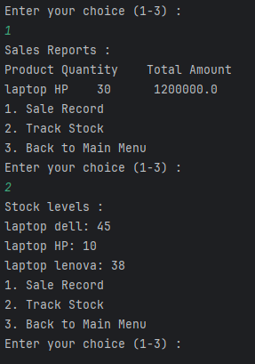

We sold some product and we have less than 10 (< 10 ) pieces then show notify …{Note:- for sell we have to go Product management menuinside..}

Let we sell again ‘laptop HP’ 2 pieces then we have 8 piece only..

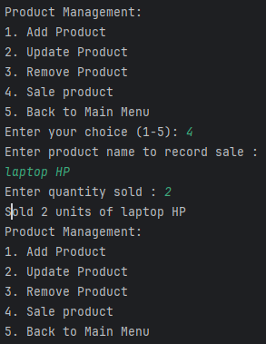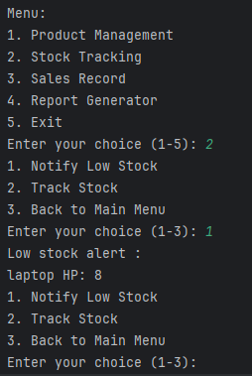

And also we see “Track Stock” that are also here show notified me low stock product…

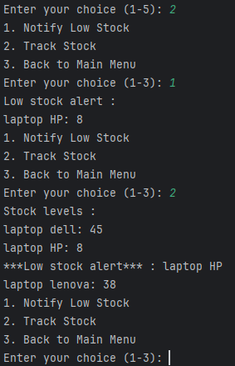

And also if we want to see “report Generator” here seen are…

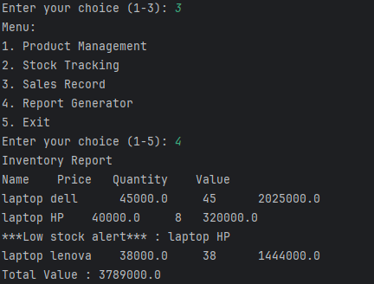

And for below menus option, we need to from main “Menu” > Product Management >

1. Add product :-
2. Update product:-
3. Remove Product:-
4. Sale Product:-

And For Stock Tracking , we need to go from main “Menu” > Stock Tracking >

1. Notify Low Stock

2. Track Stock

3. Back to Main Menu

And For Knowing Sale record , we need to go from main “Menu” > Stock Tracking >

1. Sale Record

2. Track Stock

3. Back to Main Menu

Enter your choice (1-3) :

And for report generator , we need to go form main “Menu” > Report Generator>

Here we see our all stock report ..

And at last If want to shutdown System , we need to press 5 option –

Then Exiting From “Inventory Management System..”

“--:: ***THANK YOU*** ::--“