**DRIVER DRWOSINESS DETECTION SYSTEM**

**PROJECT SYNOPSIS**

**BACHELOR OF TECHNOLOGY**

**COMPUTER SCIENCE AND ENGINEERING**

SUBMITTED BY-

JAY MISHRA-1901920100134 HARSH BHAGWANI-1901920100112

HIMANSHU JAIN-1901920100123

2020-2021



**Dr. SATENDRA KUMAR**

**Department of Computer Science & Engineering**

G L Bajaj Institute of Technology and Management

Greater Noida - 201306

**ABSTRACT**

This document is a review report on the research conducted and the project made in the field of computer engineering to develop a system for driver drowsiness detection to prevent accidents from happening because of driver fatigue and sleepiness. The report proposed the results and solutions on the limited implementation of the various techniques that are introduced in the project. Whereas the implementation of the project give the real world idea of how the system works and what changes can be done in order to improve the utility of the overall system.

Furthermore, the paper states the overview of the observations made by the authors in order to help further optimization in the mentioned field to achieve the utility at a better efficiency for a safer road

**Keywords**—Driver drowsiness; eye detection; yawn detection; blink pattern; fatigue

**MOTIVATION**

* A study (In the INDIA) showed that **21% of drivers** surveyed admitted to falling asleep at the wheel.
* An estimated **1.48 million** drivers have been involved in a drowsy driving related crash in the past five years.
* **Fall-asleep crashes are likely to be serious.** The morbidity and mortality associated with drowsy-driving crashes are high, perhaps because of the higher speeds involved combined with delayed reaction time.
* Time of occurrence of crashes in drivers at ages 26 to 45 in which the crashes were attributed by the police to the driver being asleep (but in which alcohol was not judged to be involved).

**INTRODUCTION**

Humans have always invented machines and devised techniques to ease and protect their lives, for mundane activities like traveling to work, or for more interesting purposes like aircraft travel. With the advancement in technology, modes of transportation kept on advancing and our dependency on it started increasing exponentially. In modern times, almost everyone in this world uses some sort of transportation every day. However, there are some rules and codes of conduct for those who drive irrespective of their social status.

Neglecting our duties towards safer travel has enabled hundreds of thousands of tragedies to get the associated with this wonderful invention. It may seem like a trivial thing to most folks but following rules and regulations on the road is of utmost importance, it can be destructive and sometimes, that carelessness can harm lives even of the people on the road. One kind of carelessness is not admitting when we are too tired to drive. In order to monitor and prevent a destructive outcome from such negligence, many researchers have written research papers on driver drowsiness detection systems. But at times, some of the points and observations made by the system are not accurate enough. Hence, to provide data and another perspective on the problem at hand, in order to improve their implementations and to further optimize the solution, this project has been done.

There are many products out there that provide the measure of fatigue level in the drivers which are implemented in many vehicles. The driver drowsiness detection system provides the similar functionality but with better results and additional benefits. Also, it alerts the user on reaching a certain saturation point of the drowsiness measure.

Fatigue is a safety problem that has not yet been deeply tackled by any country in the world mainly because of its nature. Fatigue, in general, is very difficult to measure or observe unlike alcohol and drugs, which have clear key indicators and tests that are available easily. Probably, the best solutions to this problem are awareness about fatigue-related accidents and promoting drivers to admit fatigue when needed. The former is hard and much more expensive to achieve, and the latter is not possible without the former as driving for long hours is very lucrative.

**SCOPE**

The scope of the Drowsy Driver Detection in modern period is to diminish the vehicle street mishap and furthermore this project utilized for security reason for a driver as it reduces car accident. The fatigue detection system in this project is capable of detecting drowsiness on drivers and then based on the current situation will alert the driver using an alarm.

**METHODOLOGY**

In this Python project, we will be using OpenCV for gathering the images from webcam and feed them into a Deep Learning model which will classify whether the person’s eyes are ‘Open’ or ‘Closed’. The approach we will be using for this Python project is as follows:

Step 1 – Take image as input from a camera.

Step 2 – Detect the face in the image and create a Region of Interest (ROI). Step 3 – Detect the eyes from ROI and feed it to the classifier.

Step 4 – Classifier will categorize whether eyes are open or closed. Step 5 – Calculate score to check whether the person is drowsy.

**Software Requirements**

1. Python 3
2. Windows

**Hardware Requirements**

1. Laptop (Processor 1.0 GHz or greater)
2. Web cam
3. Ram (512 MB or greater)

**SYSTEM DESIGN**

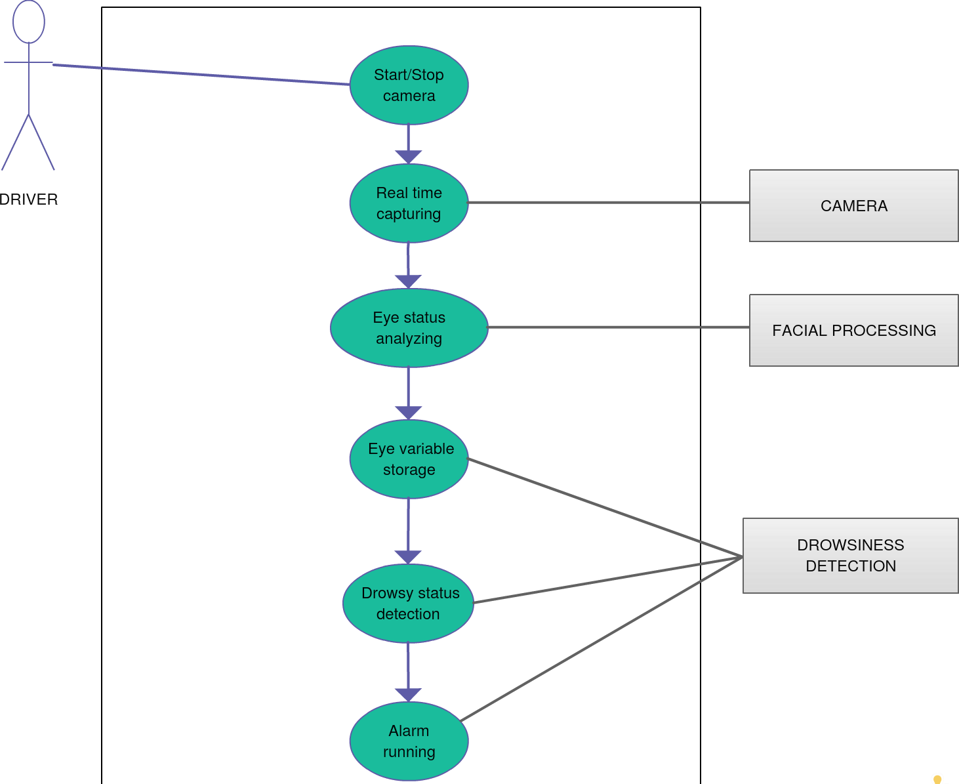

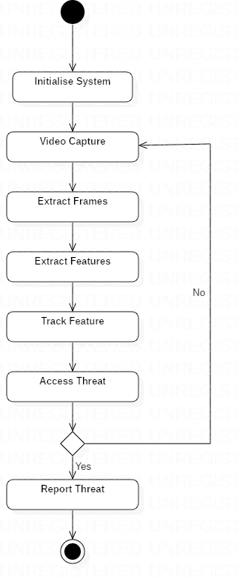

**SYSTEM TESTING**

|  |  |  |  |  |
| --- | --- | --- | --- | --- |
| TEST ID | TEST CASE TITLE | TEST CONDITION | SYSTEM BEHAVIOUR | EXPECTED RESULT |
| T01 | NSGY | Straight face, Good light | Open | Open |
| T02 | YTGN | Straight face, Good light | Open | Open |

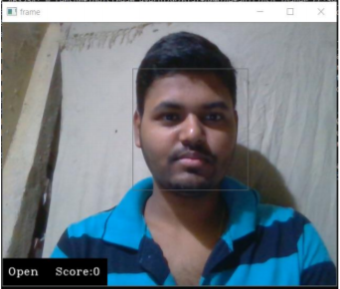

Fig: T01

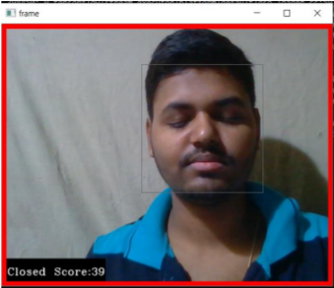

Fig: T02

**CONCLUSION**

It completely meets the objectives and requirements of the system. The framework has achieved an unfaltering state where all the bugs have been disposed of. The framework cognizant clients who are familiar with the framework and comprehend it's focal points and the fact that it takes care of the issue of stressing out for individuals having fatigue-related issues to inform them about the drowsiness level while driving.

## REFRENCES

* + 1. COMPUTATIONALLY EFFICIENT FACE DETECTION; B. SCHLKOPF-A. BLAKE, S. ROMDHANI, AND P. TORR.
    2. USE OF THE HOUGH TRANSFORMATION TO DETECT LINES AND CURVES IN PICTURE; R. DUDA AND P. E. HART.
    3. JAIN, “FACE DETECTION IN COLOR IMAGES; R. L. HSU, M. ABDEL- MOTTALEB, AND A. K. JAIN.
    4. OPEN/CLOSED EYE ANALYSIS FOR DROWSINESS DETECTION;P.R. TABRIZI AND R. A. ZOROOFI.
    5. <http://ncrb.gov.in/StatPublications/ADSI/ADSI2015/chapter1A%20traffic>%20accidents.pdf

[6] http://www.jotr.in/text.asp?2013/6/1/1/118718

[7] <http://dlib.net/face_landmark_detection_ex.cpp.html>