MULYANKAN
Professional Technical and Institutional Assessment Report
AI-Assisted Preliminary Evaluation and Governance Platform
for Science & Technology Proposals

Current focus: Ministry of Coal Science & Technology proposals
Prepared by
Himanshu Shukla
B.Tech - Mathematics and Computing, MITS Gwalior
Report version 1.0 | 7 July 2026

Classification: Production-engineered pilot decision-support platform
Mulyankan is designed to support preliminary scrutiny and human decision-making. It does not autonomously approve or reject proposals, and the current scoring engine is not yet a scientifically validated machine-learning model.

Document Control
Field | Description
Document title | Mulyankan Professional Technical and Institutional Assessment Report
Purpose | Professional description of the system, methodology, scope, features, applicability, maturity and recommended validation path
Current system version | Mulyankan 0.4.0 rebuilt pilot source
Primary domain | Preliminary scrutiny and governance of Ministry of Coal Science & Technology proposals
Intended audience | CMPDI / Ministry stakeholders, technical reviewers, institutional decision-makers, research administrators and implementation partners
Decision authority | Authorized human reviewers, adjudicators and committees
Report status | For evaluation, demonstration and structured institutional discussion

Purpose of this report
This report presents Mulyankan as an institutional decision-support system rather than as a simple document-scoring application. It explains the problem being addressed, the operating methodology, system architecture, evidence and governance controls, evaluation framework, expected benefits, limits, risks, validation status and the pathway required for responsible adoption.
Core positioning
Mulyankan should be presented as a secure, evidence-grounded preliminary scrutiny and workflow-governance platform with mandatory human oversight. Its present value lies in standardisation, traceability, early risk detection and reviewer support - not in autonomous sanctioning.

Contents
1. Executive Summary | 4 | 12. Potential Applicability | 13
2. Strategic Context and Problem Definition | 4 | 13. Expected Benefits and Value Proposition | 14
3. System Vision and Objectives | 5 | 14. Current Maturity and Validation Status | 15
4. Mulyankan at a Glance | 6 | 15. Risks, Limitations and Safeguards | 15
5. Key Features and Institutional Value | 7 | 16. Recommended Institutional Pilot | 16
6. Methodology | 8 | 17. Roadmap to a Validated AI-Assisted System | 17
7. Technical Architecture | 10 | 18. Conclusion | 17
8. Evaluation Framework for MOC-ST | 10 | Appendix A. MOC-ST Rubric Structure | 18
9. Governance, Review and Decision Workflow | 11 | Appendix B. Glossary | 18
10. Security, Privacy, Auditability and Reproducibility | 12 | Reference Basis | 19
11. Scope and Boundaries | 13
Reading guide
Sections 1-6 explain the problem, objectives, features and methodology. Sections 7-10 describe the technical and governance architecture. Sections 11-18 address scope, applicability, maturity, risks, pilot design and the validation roadmap.

1. Executive Summary
Mulyankan is a secure, evidence-grounded platform designed to assist the preliminary evaluation and institutional governance of Science & Technology proposals. Its current implementation is configured for Ministry of Coal S&T proposals, where it converts unstructured proposal documents into structured evidence, applies versioned eligibility and financial-compliance rules, produces criterion-level advisory scores, checks prior-project similarity, and supports technical review, financial review, conflict management, adjudication and committee decision-making.
The system follows a hybrid methodology. Objective conditions are evaluated through explicit rules, while qualitative aspects are analysed by a transparent contextual baseline that requires supporting evidence and information sufficiency. Low-confidence, contradictory or incomplete cases are routed for clarification or human review. Official approval and rejection remain outside the automated engine and are reserved for authorised institutional users.
Mulyankan therefore addresses a broader problem than scoring. It creates a controlled digital record of what was submitted, which policy and rubric versions were applied, what evidence supported each finding, which reviewers participated, how conflicts were handled and why the final decision was made. This design can improve consistency, accountability and auditability while reducing repetitive preliminary scrutiny.
12  Versioned MOC-ST eligibility and compliance rules | 41  Rubric criteria across eight assessment categories | 100  Total configurable technical assessment marks | 134  Backend tests passed in source-level validation | 72.19%  Backend test coverage in the final validation run

Institutional value proposition
Mulyankan can reduce administrative inconsistency, make scrutiny evidence easier to verify, identify missing or contradictory information earlier, provide a common evaluation structure to reviewers, and create high-quality expert-labelled data for future validated AI development.

Principal conclusions
- The system is technically suitable for a controlled institutional pilot and expert-labelled dataset collection.
- Its strongest capabilities are proposal versioning, document intelligence, configurable rules, evidence-linked advisory analysis, reviewer governance and auditability.
- The current contextual scoring engine is deterministic and transparent; it is not yet a trained or independently validated machine-learning model.
- The platform is potentially adaptable to other ministries, PSUs, research councils, universities and grant programmes by replacing the scheme configuration, required documents, rules, rubric and roles.
- Responsible deployment requires real historical proposals, expert double-scoring, held-out evaluation, calibration, bias and failure-mode analysis, shadow-mode testing, security assessment and formal institutional approval.

2. Strategic Context and Problem Definition
Science and Technology proposals are complex institutional documents. A single submission may contain scientific objectives, prior work, methodology, work packages, schedules, budgets, equipment requirements, expected benefits, safety approvals, deployment plans and supporting annexures. Preliminary scrutiny must determine both whether the submission is administratively and financially compliant and whether it contains enough credible evidence for expert evaluation.
Traditional scrutiny is usually distributed across documents, spreadsheets, email threads and reviewer notes. This creates several recurring challenges: inconsistent interpretation of guidelines, repetitive checking of the same conditions, difficulty locating evidence inside long proposals, limited visibility into missing information, weak version control, variable review quality and incomplete audit trails.

Problems addressed by Mulyankan
Institutional challenge | Operational consequence | Mulyankan response
Unstructured proposals | Important facts are distributed across narrative text, tables, schedules and annexures. | Page-aware extraction, OCR and canonical field resolution.
Inconsistent preliminary scrutiny | Different reviewers may interpret the same eligibility condition differently. | Versioned, source-referenced rules with explicit uncertainty states.
Weak evidence traceability | Scores and comments may not show exactly where supporting evidence was found. | Criterion-level evidence linked to the submitted proposal version.
Version ambiguity | Revised proposals can overwrite or blur the record of what was originally submitted. | Immutable numbered proposal versions and document checksums.
Reviewer coordination | Technical, financial and committee processes may be difficult to track. | Role-separated assignments, conflict handling, adjudication and controlled decisions.
Audit and accountability | It may be difficult to reconstruct why a decision was reached. | Tamper-evident audit events, decision reasons and reproducible run metadata.
Premature automation risk | A numeric score may be treated as authoritative despite weak evidence. | Advisory positioning, abstention/manual review and mandatory human authority.
Design principle
Mulyankan treats evaluation as a governed evidence workflow. The objective is not merely to generate a score, but to make the path from submission to decision structured, reviewable, reproducible and accountable.

3. System Vision and Objectives
The long-term vision is to establish a reusable digital evaluation infrastructure for public-sector and institutional R&D programmes. The platform should help decision-makers process more proposals without weakening expert control, while progressively building the reliable evidence and labels required for scientifically valid machine-learning models.

Primary objectives
Objective | Practical meaning
Standardise preliminary scrutiny | Apply the same approved rules and rubric structure to every proposal version.
Improve evidence accessibility | Identify the passages, pages and structured fields that support or contradict each finding.
Strengthen reviewer productivity | Reduce repetitive administrative checks so experts can focus on scientific merit, feasibility and sectoral value.
Preserve institutional accountability | Record versions, assignments, conflicts, overrides, adjudication and committee decisions.
Support responsible AI development | Generate expert-reviewed, versioned and evidence-linked data suitable for later model validation.
Enable configurable reuse | Allow the same platform architecture to support other schemes through configuration rather than full redevelopment.

Operating principles
- Evidence before score: automated findings should identify supporting or missing evidence.
- Human authority: official decisions remain with designated institutional roles.
- Version integrity: every evaluation is bound to an immutable proposal version and document checksum.
- Transparency: rules, rubric versions, model versions and decision reasons are retained.
- Fail safely: uncertainty should produce clarification, exception review or abstention rather than a fabricated conclusion.
- Security by design: proposal access, storage and download must follow least-privilege controls.
- Configurable governance: rules and rubrics are scheme-specific and should be approved institutionally.

4. Mulyankan at a Glance
Dimension | Current position
System type | Secure preliminary scrutiny and human decision-support platform
Current scheme | Ministry of Coal Science & Technology (MOC-ST)
Primary inputs | PDF, DOCX and text proposal documents; scanned PDFs through OCR fallback
Primary outputs | Eligibility findings, clarification flags, evidence-linked advisory scores, similarity findings, reviewer records and decision history
Primary users | Applicants, scrutiny officers, technical reviewers, financial reviewers, adjudicators, committee secretariat and administrators
Decision model | Human-in-the-loop; no autonomous official approval or rejection
Current engine | contextual-rule-heuristic-v2 deterministic advisory baseline
Deployment model | React frontend, FastAPI backend, PostgreSQL, Redis/ARQ and private MinIO/S3 storage
Current maturity | Production-engineered pilot suitable for controlled institutional evaluation

Major functional modules
Module | Purpose
Proposal workspace | Create, revise, submit and track immutable proposal versions.
Secure document ingestion | Private upload sessions with ownership, file-type, signature, size and checksum validation.
Document intelligence | Page-aware extraction, Hindi-English OCR fallback and structured field resolution.
Rules engine | Versioned eligibility, financial and compliance rules with pass/fail/clarification/exception states.
Advisory evaluation | Criterion-level contextual evidence, information sufficiency and anti-keyword-stuffing checks.
Similarity assessment | Prior-project comparison to identify potential duplication or overlap.
Reviewer governance | Separate technical and financial review, conflict declaration, adjudication and committee decision.
Audit and operations | Readiness checks, metrics, rate limiting, worker heartbeat and tamper-evident audit chaining.

5. Key Features and Institutional Value
Feature | How it works | Institutional value
Immutable proposal versions | Each revision becomes a numbered version with its own documents and evaluation history. | Protects the evidentiary record and prevents later edits from changing past decisions.
Private document storage | Documents are stored in a private S3-compatible bucket and exposed through short-lived authorised links. | Reduces uncontrolled distribution of sensitive proposals.
Hindi-English OCR fallback | Scanned pages can be processed when native PDF text is unavailable. | Extends usability to scanned and bilingual institutional records.
Canonical field extraction | Important values are normalised with source positions, confidence and warnings. | Makes rule checks reproducible and easier to verify.
Versioned rule screening | Eligibility and financial rules are configured separately from application code. | Supports policy updates without redesigning the complete platform.
Evidence-grounded advisory scoring | Qualitative criteria require contextual evidence and information sufficiency. | Makes automated findings more transparent and less vulnerable to simple keyword repetition.
Similarity records | New proposal versions can be compared with prior submissions. | Supports duplication checks and prior-work awareness.
Role-separated human review | Technical and financial assessments are independently recorded. | Improves accountability and reduces role ambiguity.
Conflict and adjudication workflow | Conflicts are declared, resolved and escalated where necessary. | Creates a defensible governance process.
Committee decision controls | Final status transitions are linked to completed review evidence or adjudication. | Keeps official authority with designated institutional bodies.
Tamper-evident audit trail | Material actions are chained and verifiable. | Supports later review, investigation and compliance assurance.
Operational readiness and metrics | Database, migration, reference data, Redis, storage and worker state can be checked. | Improves reliability of institutional operation.

6. Methodology: Evidence-First, Rule-Governed and Human-in-the-Loop
Mulyankan uses a layered methodology because proposal evaluation contains different types of judgement. Objective conditions such as duration limits, prohibited budget items or required approvals should be tested through explicit rules. Qualitative dimensions such as novelty, validation design or industry benefit require contextual interpretation and expert judgement. The system therefore separates hard screening, advisory analysis and official decision-making.
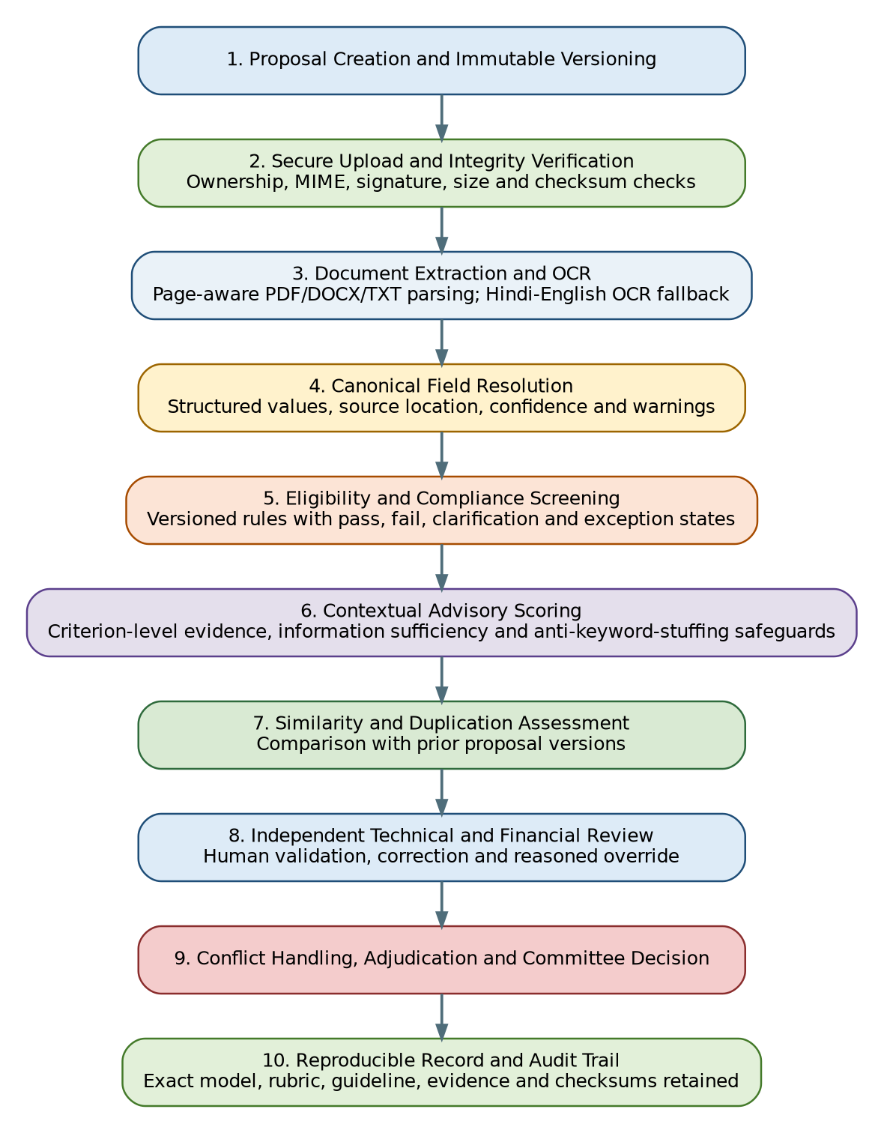
Figure 1. End-to-end Mulyankan evaluation methodology
Stage | Inputs | System output | Human control
1. Proposal and version creation | Applicant data, title, summary and scheme selection | Immutable proposal version | Applicant confirms submission intent
2. Secure upload | PDF/DOCX/TXT file and upload session | Verified private document with checksum | Rejected if ownership, type, signature, size or checksum fails
3. Extraction and OCR | Native document text and scanned pages | Page-aware text, OCR flags and extracted sections | Manual review when extraction quality is insufficient
4. Canonical fields | Extracted text, tables and source locations | Normalised values with confidence and warnings | Ambiguities become clarification states
5. Rule screening | Fields plus versioned scheme rules | Pass, fail, clarification or exception-review findings | Scrutiny officer reviews uncertain or exceptional cases
6. Advisory scoring | Contextual evidence and rubric criteria | Criterion scores, evidence and information sufficiency | Reviewer validates, corrects or overrides with reasons
7. Similarity | Current version and prior proposal corpus | Potential overlap or duplication record | Human interpretation of legitimate continuation versus duplication
8. Independent review | Automated report and original documents | Technical and financial assessments | Role-separated reviewers submit reasoned scores
9. Adjudication and committee | Independent reviews, conflicts and evidence | Resolved assessment and final institutional decision | Authorised committee retains final authority
10. Audit and reproducibility | All material events and run metadata | Verifiable decision history | Audit chain and governance review

6.1 Explicit rule screening
The active MOC-ST rule set contains twelve eligibility, financial and compliance rules. These rules address recognised institution type, principal-investigator qualification, project duration, justification for longer projects, thrust-area alignment, contingency and overhead limits, foreign travel conditions, prohibited vehicle and permanent-salary costs, duplicate equipment and mine-safety approval requirements.
Rules do not operate as a simplistic binary filter. Where evidence is missing, contradictory or dependent on an exception, the rule engine can return clarification or exception-review states. This is important because a missing statement is not always equivalent to non-compliance.

6.2 Contextual advisory scoring
The active engine, contextual-rule-heuristic-v2, is a deterministic baseline. It is designed for transparent pilot use and does not claim the predictive validity of a trained model. Compared with raw keyword counting, it requires contextual evidence, evaluates information sufficiency and penalises patterns associated with keyword stuffing. The result is an advisory score and evidence set, not an official decision.

6.3 Uncertainty, abstention and clarification
The platform should abstain when evidence is insufficient. Uncertain duration, unclear budget percentages, missing approval evidence, contradictory sections or low-quality OCR should create a clarification or manual-review requirement. This safeguard prevents a clean numeric output from concealing weak source information.

6.4 Human review and reasoned override
Technical and financial reviewers independently examine the original proposal, extracted evidence and automated findings. They may confirm, correct or override the advisory result, but the reason and criterion-level evidence should remain part of the institutional record. Material disagreement can be escalated to adjudication before committee consideration.

7. Technical Architecture
The architecture separates the public interface, authoritative API, background evaluation worker, database, private storage and operational controls. This separation supports scale, security and maintainability while allowing the evaluation logic and scheme configurations to evolve independently of the user interface.
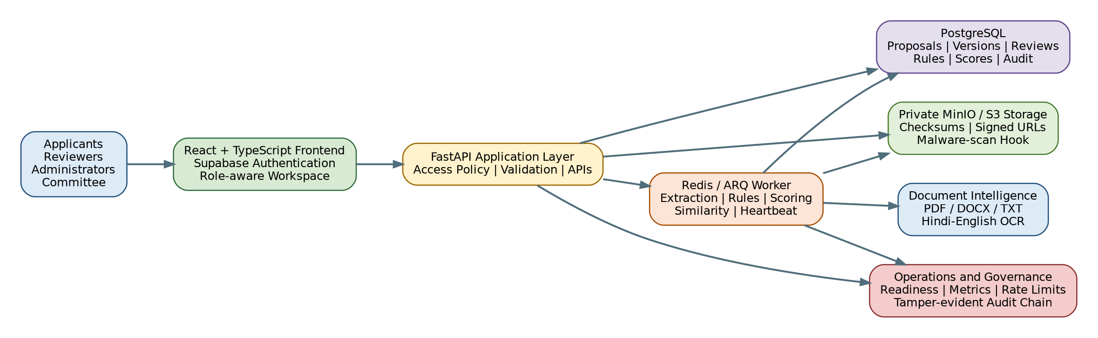
Figure 2. High-level technical architecture
Layer | Responsibility
Frontend | React, TypeScript and Vite; Supabase-based authentication; role-aware proposal and governance workspace.
API | FastAPI with async SQLAlchemy and Alembic; access control, validation, workflow APIs and signed-download authorisation.
Database | PostgreSQL storing users, proposals, immutable versions, extraction evidence, evaluation runs, rules, reviews, decisions and audit records.
Worker | Redis and ARQ background processing for extraction, rule evaluation, advisory scoring, similarity and heartbeat monitoring.
Document storage | Private MinIO/S3-compatible object storage with checksums and short-lived signed links.
Document intelligence | PDF, DOCX and text extraction plus Hindi-English OCR fallback.
Operations | Rate limiting, malware-scan integration, readiness checks, Prometheus metrics, request IDs and security headers.
Audit | Append-only/tamper-evident event chain and exact run metadata for reproducibility.

Deployment model
For local and controlled institutional deployment, the services can run through Docker Compose. In a production environment, the frontend may be deployed separately while the API, worker, PostgreSQL, Redis and object storage remain inside a secured infrastructure boundary. Production operation requires managed secrets, TLS, explicit CORS and allowed-host configuration, backup and restore procedures, monitoring and security review.

8. Evaluation Framework for MOC-ST Proposals
The current configurable rubric contains 41 criteria grouped into eight categories and totals 100 marks. The rubric is stored as versioned configuration rather than hardcoded frontend logic. This allows future policy-approved revisions to be introduced while preserving the exact rubric used for historical evaluations.
Assessment category | Marks | Illustrative focus
Problem Definition, Need and Thrust Alignment | 12 | Coal-specific problem, thrust justification, genuine R&D content and evidence of significance
Novelty and Progressive R&D Contribution | 14 | Prior work, research gap, scientific contribution, indigenisation, IPR potential and duplication risk
Objectives, Methodology and Validation Design | 16 | Clear objectives, output mapping, scientific validity, experimental design, data plan and validation protocol
Team Capability, Infrastructure and Past Performance | 12 | PI expertise, track record, facilities, collaborators and conflict checks
Work Plan, Milestones and Implementation Feasibility | 12 | Work packages, milestones, schedule realism, procurement/recruitment and backup paths
Coal-Industry Benefit, Adoption and Replication | 16 | Quantified benefit, end user, commitment evidence, scale-up and post-project ownership
Budget Realism and Fund-Use Quality | 10 | Arithmetic consistency, quotations, equipment justification, milestone phasing and value for money
Safety, Regulation, Dependency and Risk Readiness | 8 | Statutory needs, environmental permissions, risk register, operational risks and exit strategy
Important interpretation
The rubric provides a disciplined assessment structure, but the resulting marks remain advisory until validated against real historical proposals and expert decisions. A high automated score cannot substitute for evidence quality, rule compliance, reviewer judgement or committee authority.

Rule findings and rubric scores are complementary
Eligibility rules answer whether mandatory conditions appear to be satisfied. The rubric assesses the relative quality and completeness of the proposal. A proposal may be strong on scientific merit but require clarification on a financial condition, or may be formally eligible but weak in methodology and industry benefit. Mulyankan retains these two dimensions separately to avoid hiding a hard-screening problem inside an aggregate score.

9. Governance, Review and Decision Workflow
Mulyankan is designed around institutional roles rather than a single evaluator. This is essential because proposal scrutiny combines administrative, technical, financial and policy responsibilities. The platform separates these responsibilities while retaining a unified history.
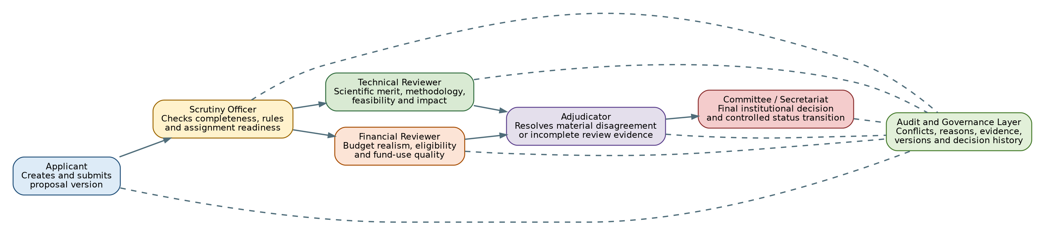
Figure 3. Human governance and decision workflow
Role | Primary responsibility
Applicant | Creates and submits proposal versions; responds to clarification; cannot alter a historical submitted version.
Scrutiny officer / secretariat | Checks completeness, reviews rule exceptions and assigns qualified reviewers.
Technical reviewer | Assesses scientific merit, methodology, feasibility, novelty, risk and expected industry benefit.
Financial reviewer | Assesses budget realism, cost eligibility, quotations, equipment need and value for money.
Adjudicator | Resolves material disagreement or incomplete evidence after independent reviews.
Committee / authorised decision body | Records the final institutional decision and controlled status transition.
Administrator | Manages users, approved roles and system reference data without replacing review authority.
Auditor / governance reviewer | Verifies the event chain, access history, review evidence and decision rationale.

Conflict-of-interest safeguards
Review assignments can carry conflict declarations and authorised resolution. A reviewer should not proceed when a material institutional, financial, collaborative or personal conflict exists. The platform preserves the declaration and subsequent action as part of the audit record.

Reasoned override
Human reviewers may disagree with an automated rule interpretation or criterion score. A responsible system must allow reasoned correction rather than forcing conformity to the machine output. Mulyankan treats the automated analysis as evidence support and a consistency aid; reviewer judgement remains explicit and reviewable.

10. Security, Privacy, Auditability and Reproducibility
Proposal documents may contain unpublished research, commercial information, institutional plans and personally identifiable data. The security model therefore treats documents and evaluation records as controlled institutional assets.
Control | Purpose
Least-privilege access | Proposal and evaluation access is restricted to the owner, assigned reviewers and authorised institutional roles.
Private object storage | Documents are not stored as public web assets; access uses short-lived authorised links.
Upload integrity | Ownership, expected size, extension, MIME type, file signature and SHA-256 checksum are checked.
Malware-scan integration | Uploads can fail closed when the configured scanner is enabled and operational.
Immutable versions | Historical proposal versions and their evaluation context are preserved.
Exact run metadata | Model, rubric, guideline, extraction version and input/output checksums are retained.
Tamper-evident auditing | Material events are hash-chained and can be verified.
Operational protection | Rate limits, security headers, request IDs, readiness checks and protected metrics are included.
Release hygiene | Source packaging excludes secrets, caches, local databases, dependency directories and generated output.
Data-governance requirement
Production use requires an approved lawful basis, data-retention schedule, access-review process, backup and restoration plan, incident-response procedure and clear ownership of operational and model-governance responsibilities.

11. Scope and Boundaries

In scope
- Secure proposal intake, document integrity checks and immutable version management.
- Page-aware extraction and Hindi-English OCR fallback for supported formats.
- Preliminary eligibility, financial and compliance screening using approved configurable rules.
- Criterion-wise advisory analysis with supporting evidence and information-sufficiency indicators.
- Prior-proposal similarity records for duplication review.
- Technical and financial reviewer workflows, conflicts, adjudication and committee decisions.
- Audit history, reproducibility metadata, monitoring and controlled document access.
- Expert-labelled dataset creation for future model development.

Out of scope without additional validation or authority
- Autonomous official approval, rejection, sanction or funding commitment.
- Replacement of domain experts, finance scrutiny, statutory authorities or committees.
- Prediction of project success, commercial return or long-term impact without validated outcome data.
- Final legal, contractual, procurement, safety or financial certification.
- Scientifically validated machine-learning claims based only on synthetic or unlabelled data.
- Cross-scheme deployment without approved scheme-specific rules, rubrics, documents and operating procedures.

Current product classification
The appropriate classification is a production-engineered pilot decision-support platform. It is suitable for controlled workflow pilots, reviewer assistance, structured evidence collection and expert-labelled dataset development. It should not yet be represented as an autonomous or scientifically validated proposal-selection model.

12. Potential Applicability
The platform architecture is reusable because scheme-specific content is separated from core workflow components. To support a new programme, the institution would configure its scheme metadata, required documents, canonical fields, eligibility and compliance rules, assessment rubric, user roles, decision states and reporting requirements.
Potential setting | Likely value | Required adaptation
Ministry / PSU R&D grant programmes | Preliminary screening, technical-financial coordination, committee governance and auditability | Approved programme rules, sector vocabulary, reviewer roles and data-residency controls
Research councils and mission-mode programmes | Standardised evidence review across large proposal volumes | Domain-specific rubrics, expert panels and outcome definitions
University seed grants and innovation funds | Transparent internal calls, reviewer assignment and version-controlled decisions | Simplified rules, institutional identity integration and local approval workflow
Corporate and industrial R&D portfolios | Concept-note comparison, duplication detection, risk and budget review | Commercial confidentiality controls and portfolio-specific benefit metrics
CSR innovation and social-impact grants | Completeness checks, rubric consistency and evidence-based review | Impact indicators, beneficiary safeguards and programme-specific compliance
Incubation and technology challenge programmes | Stage-gate assessment, technical readiness and expert feedback | TRL criteria, prototype evidence, IP and market-validation modules

Conditions for successful transfer to another domain
- The receiving institution formally approves the rules, rubric and decision states.
- Domain experts define canonical fields and evidence expectations.
- Historical data and reviewer labels are governed lawfully and representatively.
- Language, OCR, security, retention and data-residency needs are validated.
- Automated outputs remain advisory until domain-specific scientific validation is complete.

13. Expected Benefits and Value Proposition
Stakeholder | Expected value
Applicants | Clearer completeness requirements, earlier clarification and a traceable submission history.
Scrutiny teams | Reduced repetitive checking, consistent application of approved rules and better exception visibility.
Technical reviewers | Faster navigation to relevant evidence and a common criterion structure.
Financial reviewers | Structured budget/compliance findings and clear source references.
Committees | Consolidated evidence, reviewer disagreement visibility and recorded decision rationale.
Institutional leadership | Portfolio-level transparency, auditability and measurable workflow performance.
Future model development | High-quality versioned, evidence-linked and expert-adjudicated training data.

Potential measurable outcomes
- Reduced time spent on repetitive completeness and eligibility checks.
- Higher consistency in the interpretation of approved rules and rubric criteria.
- Greater proportion of scores and findings supported by traceable evidence.
- Earlier identification of missing documents, contradictory values and unsupported claims.
- More complete review records and stronger accountability for overrides and decisions.
- Better quality institutional data for policy review, programme monitoring and future AI validation.

14. Current Maturity and Validation Status
The rebuilt source has passed a substantial set of source-level quality gates. These results demonstrate engineering discipline and regression coverage, but they do not establish real-world evaluation accuracy or institutional fitness by themselves.
Validation area | Status
Backend tests | 134 passed; 3 live-service tests skipped in the source-only validation environment
Backend coverage | 72.19%, above the enforced 70% threshold
Python quality | Bytecode compilation, Ruff and Mypy passed
Database migrations | Complete Alembic PostgreSQL chain rendered successfully in offline SQL validation
Frontend quality | TypeScript compilation, ESLint and production Vite build passed
Dependency audit | Zero known npm vulnerabilities reported in the validated production dependency set
Release hygiene | Secret-pattern scan, manifest generation, checksum verification and exclusion of runtime artefacts passed
Live operational validation | Still required for final PostgreSQL, Redis, MinIO/S3, Supabase, OCR, malware scanning, backup and production-domain configuration
Meaning of the validation
These gates show that the codebase is suitable for a controlled pilot and further institutional evaluation. They do not prove that automated scores match expert judgement, predict successful projects or are free from domain bias.

15. Risks, Limitations and Safeguards
Risk | Potential consequence | Primary safeguard
Poor OCR or extraction | Incorrect fields and misleading rule results | Page-level confidence, source display, clarification states and reviewer correction
Over-reliance on automated score | Automation bias and unjustified decisions | Advisory labelling, human review, no autonomous approval and recorded overrides
Rule or rubric drift | System no longer matches current policy | Versioned configurations, effective dates and formal approval before activation
Biased or unrepresentative training data | Unequal or inaccurate future ML performance | Institution/time-held-out evaluation, subgroup analysis and independent review
Sensitive-data exposure | Confidentiality and legal harm | Least-privilege access, private storage, signed URLs, secrets management and audit logs
Reviewer conflict or inconsistency | Compromised or unstable outcomes | Conflict declarations, independent reviews, adjudication and committee oversight
Operational outage or queue failure | Delayed evaluations or incomplete processing | Readiness checks, heartbeat, retry controls, monitoring, backups and incident procedures
False duplication signal | Legitimate continuation misclassified as overlap | Similarity treated as evidence for human interpretation, not automatic rejection

Scientific limitations of the current engine
The contextual-rule baseline is deterministic and transparent, but it is not trained on a representative historical corpus and has not been calibrated against adjudicated expert outcomes. It cannot presently support claims of predictive accuracy, fairness or generalisation. Its appropriate use is preliminary assistance, evidence organisation and controlled pilot learning.

16. Recommended Institutional Pilot
A controlled pilot should test workflow value and evidence quality before testing autonomous prediction. The objective is to determine whether Mulyankan improves consistency, traceability and reviewer productivity without introducing unacceptable errors or operational burden.
- Approve the pilot scheme configuration, eligibility rules, rubric, user roles and decision states.
- Select a governed set of historical and/or current proposals with appropriate confidentiality controls.
- Run document extraction and rule screening while keeping official evaluation fully independent.
- Have qualified technical and financial reviewers score the same proposals using an approved annotation rulebook.
- Compare automated evidence and advisory scores with reviewer findings; record disagreements and correction reasons.
- Evaluate OCR quality, field accuracy, rule precision/recall, evidence retrieval, reviewer agreement, workflow time and user experience.
- Conduct security, access-control, backup, recovery and operational readiness tests.
- Review pilot results institutionally and decide whether to continue in shadow mode, revise the system or proceed to a wider controlled rollout.

Suggested pilot success indicators
Pilot dimension | What should be demonstrated
Document intelligence | Correct extraction of critical fields and high reviewer traceability to source pages
Rule screening | Low false-fail and false-pass rates on approved eligibility conditions
Evidence quality | Reviewer-supported evidence for criterion-level findings
Workflow efficiency | Reduced preliminary scrutiny time without reduced review quality
Reviewer acceptance | Usable reports, understandable reasoning and manageable correction workflow
Governance | Complete assignment, conflict, adjudication and decision records
Security and operations | Successful access tests, backup restoration, monitoring and incident procedures

17. Roadmap to a Validated AI-Assisted Evaluation System
Stage | Primary work | Required outcome
Stage 1 - Controlled workflow pilot | Validate document handling, rules, reviewer workflow, security, usability and auditability. | Approved pilot configuration and operational evidence
Stage 2 - Expert-labelled corpus | Create a governed dataset binding immutable proposal versions, evidence spans, rule outcomes, two expert scores and adjudicated labels. | Versioned institutional dataset and annotation rulebook
Stage 3 - Retrieval and criterion models | Develop evidence retrieval, semantic similarity and criterion-level prediction with abstention. | Reproducible model candidates and registry metadata
Stage 4 - Scientific validation | Use institution-held-out and time-held-out tests, calibration, subgroup analysis, false-decision costs and failure-mode review. | Independent validation report and approved thresholds
Stage 5 - Shadow operation | Run alongside the official human process without affecting decisions. | Measured workflow impact, disagreement analysis and safety evidence
Stage 6 - Governed production support | Deploy as advisory support under approved operating procedures, monitoring, review and rollback controls. | Institutionally authorised decision-support service

Required ML validation gates
- Domain-expert annotation rulebook approved.
- Double-label agreement reaches the institutionally approved threshold.
- All versions of the same proposal remain in one dataset split.
- Time-based and institution-held-out testing prevents leakage.
- Criterion error, rank agreement, calibration, evidence retrieval and abstention are measured.
- False-approval and false-rejection consequences are explicitly analysed.
- Performance is examined by proposal type, institution size, language and OCR status.
- Independent technical and institutional sign-off is obtained.

18. Conclusion
Mulyankan represents a practical and responsible approach to modernising proposal scrutiny. Its contribution is not merely computational scoring; it is the creation of a secure, structured and auditable evaluation environment in which proposal evidence, rules, expert judgement and institutional decisions can be connected.
For the Ministry of Coal S&T context, the platform can support preliminary eligibility and compliance screening, evidence organisation, advisory criterion analysis, prior-project similarity review, independent technical and financial assessment, conflict management, adjudication and committee decision records. This can reduce repetitive work while improving consistency and accountability.
The correct next step is a controlled institutional pilot followed by rigorous data and model validation. Until those gates are completed, Mulyankan should remain a human-controlled decision-support platform. With expert-labelled data, approved policy configurations and independent validation, the same architecture has the potential to evolve into a robust, reusable evaluation infrastructure for multiple public-sector and research-funding programmes.
Recommended positioning statement
Mulyankan is a secure, evidence-grounded AI-assisted platform for preliminary proposal scrutiny and institutional decision support. It standardises rules, structures evidence, assists expert review and preserves an auditable decision trail, while final authority remains with authorised human reviewers and committees.

Appendix A. Detailed MOC-ST Rubric Structure
Category | Criteria count | Scope
Problem Definition, Need and Thrust Alignment (12) | 4 | Coal-specific problem; thrust-area justification; genuine R&D content; evidence of significance
Novelty and Progressive R&D Contribution (14) | 6 | Prior work; research gap; scientific contribution; indigenisation; IPR; duplication risk
Objectives, Methodology and Validation Design (16) | 6 | Objectives; output mapping; validity; experimental design; data plan; validation protocol
Team Capability, Infrastructure and Past Performance (12) | 5 | PI expertise; track record; facilities; collaborators; conflict check
Work Plan, Milestones and Implementation Feasibility (12) | 5 | Work packages; milestones; schedule; procurement/recruitment; backup paths
Coal-Industry Benefit, Adoption and Replication (16) | 5 | Quantified benefit; end user; commitment evidence; scale-up; post-project ownership
Budget Realism and Fund-Use Quality (10) | 5 | Arithmetic; quotations; equipment justification; milestone phasing; value for money
Safety, Regulation, Dependency and Risk Readiness (8) | 5 | Statutory needs; environmental permissions; risk register; operational risks; exit strategy

Appendix B. Glossary
Term | Meaning
Adjudication | A structured process for resolving material disagreement or incomplete review evidence.
Advisory score | A non-binding automated assessment intended to support, not replace, expert judgement.
Canonical field | A normalised structured value extracted from a proposal, with source and confidence metadata.
Clarification state | A result used when required evidence is missing or ambiguous and additional information is needed.
Committee decision | The formal institutional outcome recorded by an authorised decision body.
Evidence span | A source passage, page or location supporting a rule or criterion finding.
Immutable version | A preserved proposal snapshot that cannot be silently changed after submission.
OCR | Optical character recognition used to extract text from scanned document images.
Shadow mode | Operation alongside the official process without influencing real decisions.
Tamper-evident audit chain | Linked event records that make unauthorised modification detectable.

Reference Basis. Project materials used to prepare this report
- [R1] Mulyankan 0.4.0 README - system purpose, architecture, security rules and operating model.
- [R2] Mulyankan Evaluation System - authoritative execution path, decision safeguards and limitations.
- [R3] MOC-ST Eligibility Rules v1 - twelve configured eligibility, financial and compliance rules.
- [R4] MOC-ST 100-Mark Technical Assessment Rubric v1 - forty-one criteria across eight categories.
- [R5] Mulyankan ML Validation Plan - dataset, metrics, validation gates and model-registry requirements.
- [R6] Mulyankan 0.4.0 Phased Development Report - completed security, extraction, workflow and operations work.
- [R7] Mulyankan 0.4.0 Final Release Validation - source-level tests, coverage, build, dependency and packaging gates.
- [R8] Mulyankan Deep Codebase Audit - original limitations, risk findings and completion roadmap.
End of report

