Database Assignment

Problem Statement: There can be multiple customers, who can place multiple orders on the site. Now these orders will distribute into multiple sales persons (One order will be assign to one salesperson only). So a sales person can have multiple orders of multile customers

1) Create Database



2) Design Schema

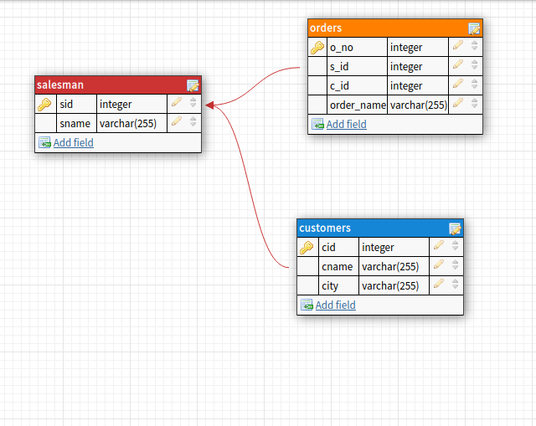

3) Create tables

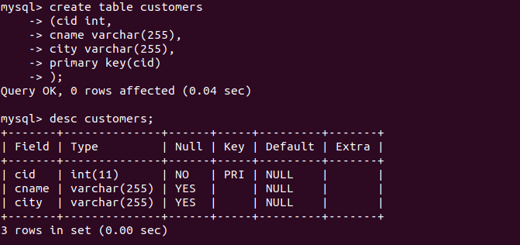

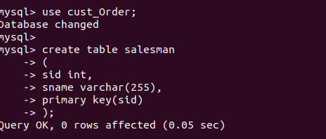

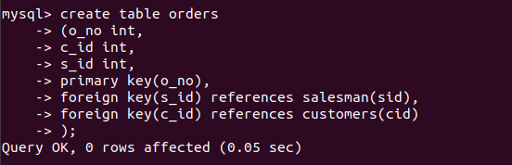

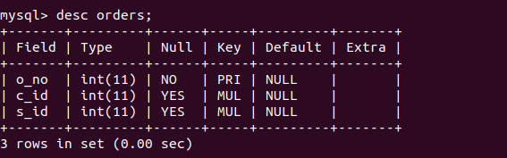
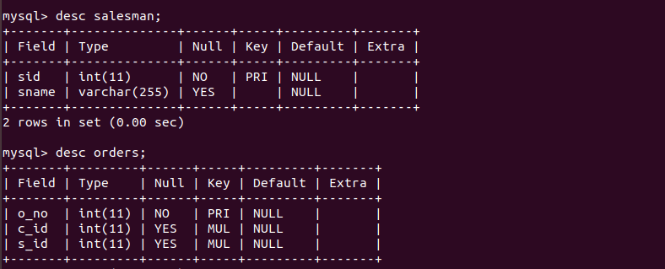

4) Insert sample data

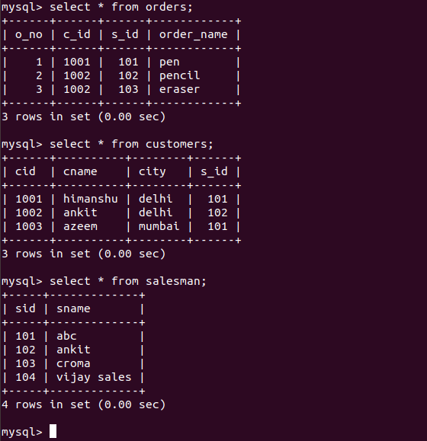
5) Find the sales person have multiple orders.

select sid,sname
from salesman a where (select count(*) from orders where s_id=a.sid) >1;



6) Find the all sales person details along with order details

select orders.o_no,orders.order_name,salesman.sname from orders inner join salesman on
orders.s_id=salesman.sid;
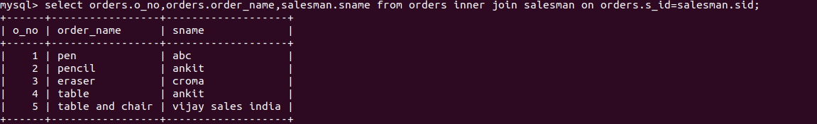

7) Create index

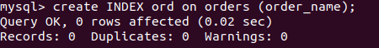

8) How to show index on a table

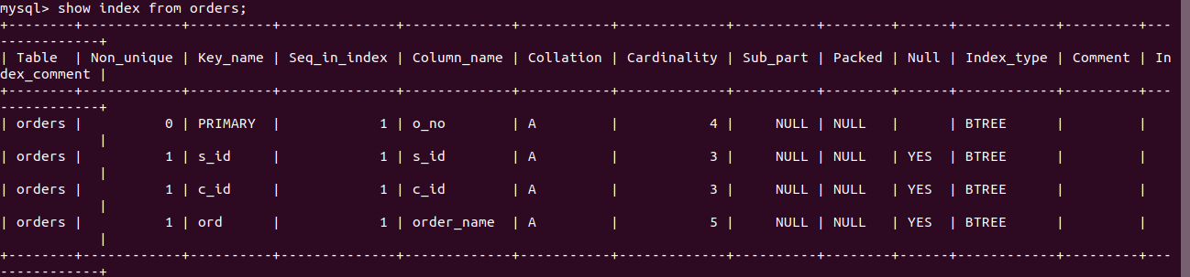
9) Find the order number, sale person name, along with the customer to whom that order belongs to

