

**School of Computer Science**

**UNIVERSITY OF PETROLEUM AND ENERGY STUDIES**

**DEHRADUN, UTTARAKHAND**

**OOPS**

**Lab File**

**(2022-2023)**

**for**

**3nd Semester**

**Submitted By:**

Himanshu Hemant

B. Tech. CSE [3nd Semester]

500091727

B1 (Devops )

**Submitted To:**

Mr. Suvra Jyoti Choudhary

Assistant Professor

School of Computer Science

INDEX

|  |  |  |  |
| --- | --- | --- | --- |
| **S. No.** | **Exp. No.** | **Description** | **Page No.** |
| 1. | 2 & 3 | Basic java programming |  |
| 2. | 4 | Inheritance |  |
|  |  |  |  |
|  |  |  |  |
|  |  |  |  |

EXPERIMENT – 2 & 3

1. Write a program to find the largest of 3 numbers.

Code :-

import java.util.*;

public class Main

{

public static void main(String[] args) {

System.out.println("enter three numbers");

Scanner s = new Scanner(System.in);

int a,b,c;

a=s.nextInt();

b=s.nextInt();

c=s.nextInt();

if(a>b && a>c){

System.out.println("a is greater");

}

else if(b>a && b>c){

System.out.println("b is greater");

}

else{

System.out.println("c is greater");

}

}

}

Output –

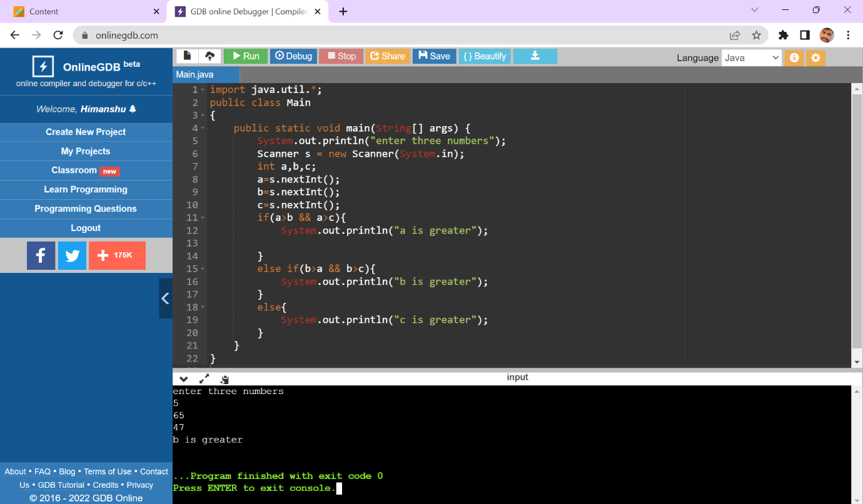

2) Write a program to add two number using command line arguments.

Code :-

public class Main {

public static void main(String args[]) {

int x = Integer.parseInt(args[0]); //first arguments

int y = Integer.parseInt(args[1]); //second arguments

int sum = x + y;

System.out.println("The sum of x and y is: " +sum);

}

}

3) Write a program to print Fibonacci series using loop.

Code:-

import java.util.*;

public class Main

{

public static void main(String[] args) {

System.out.println("enter the term");

Scanner ob=new Scanner(System.in);

int n,a,b,c;

n=ob.nextInt();

a=0;

b=1;

System.out.println(a);

System.out.println(b);

for(int i=2;i<=n;i++){

c=a+b;

System.out.println(c);

a=b;

b=c;

}

}

}

Output:-

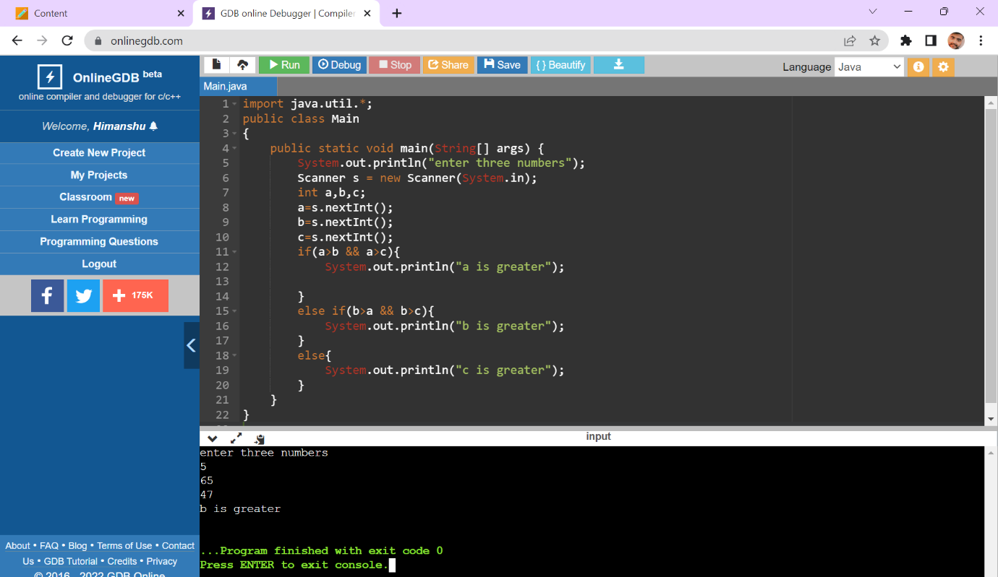

4) WAP to implement a command line calculator.

Code:-

public class Main{

public static void main(String[] args){

int numOne = args[0];

int numTwo = args[1];

add(numOne, numTwo) {

result = numOne + numTwo;

System.out.println(result);

}

subtract(numOne, numTwo) {

result = numOne - numTwo;

System.out.println(result);

}

multiply(numOne, numTwo) {

result = numOne * numTwo;

System.out.println(result);

}

divide(numOne, numTwo) {

result = numOne / numTwo;

System.out.println(result);

}

}

}

5) Write a program using classes and object in java.

Code:-

class student{

void info(){ // method declaration

System.out.println("myself Ant .");

System.out.println("Sap id-500091315");

}

}

public class Main{

public static void main(String[] args){

student ob = new student();//object declaration

ob.info();

}

}

Output :-

1. Write a program to accept 10 student’s marks in an array, arrange it into ascending order, convert into the following grades and print marks and grades in the tabular form.

Between 40 and 50 : PASS

Between 51 and 75 : MERIT

and above : DISTINCTION

Code:-

import java.util.*;

public class Main

{

public static void main(String[] args) {

System.out.println("enter the marks");

int marks[]=new int[12];

Scanner ob =new Scanner(System.in);

for(int i=0;i<10;i++){

marks[i]=ob.nextInt();

}

System.out.println("displaying the array element");

for(int i=0;i<10;i++){

System.out.println(marks[i]);

}

for(int i = 0; i < 10; i++) {

for (int j = i + 1; j <10; j++) {

if (marks[i] > marks[j]) {

int temp = marks[i];

marks[i] = marks[j];

marks[j] = temp;

}

}

}

System.out.print("Array Elements in Ascending Order:");

for(int i=0; i<10; i++) {

System.out.print(marks[i] + ", ");

}

for (int i = 0; i <10; i++) {

if (marks[i] >= 0 && marks[i] <= 39) {

System.out.println(marks[i] + "" + " FAIL");

} else if (marks[i] >= 40 && marks[i] <= 50) {

System.out.println(marks[i] + "" + " PASS");

} else if (marks[i] >= 51 && marks[i] <= 75) {

System.out.println(marks[i] + " " + " MERIT");

} else {

System.out.println(marks[i] + "" + " DISTINCTION ");

}

}

}

}

Output :-

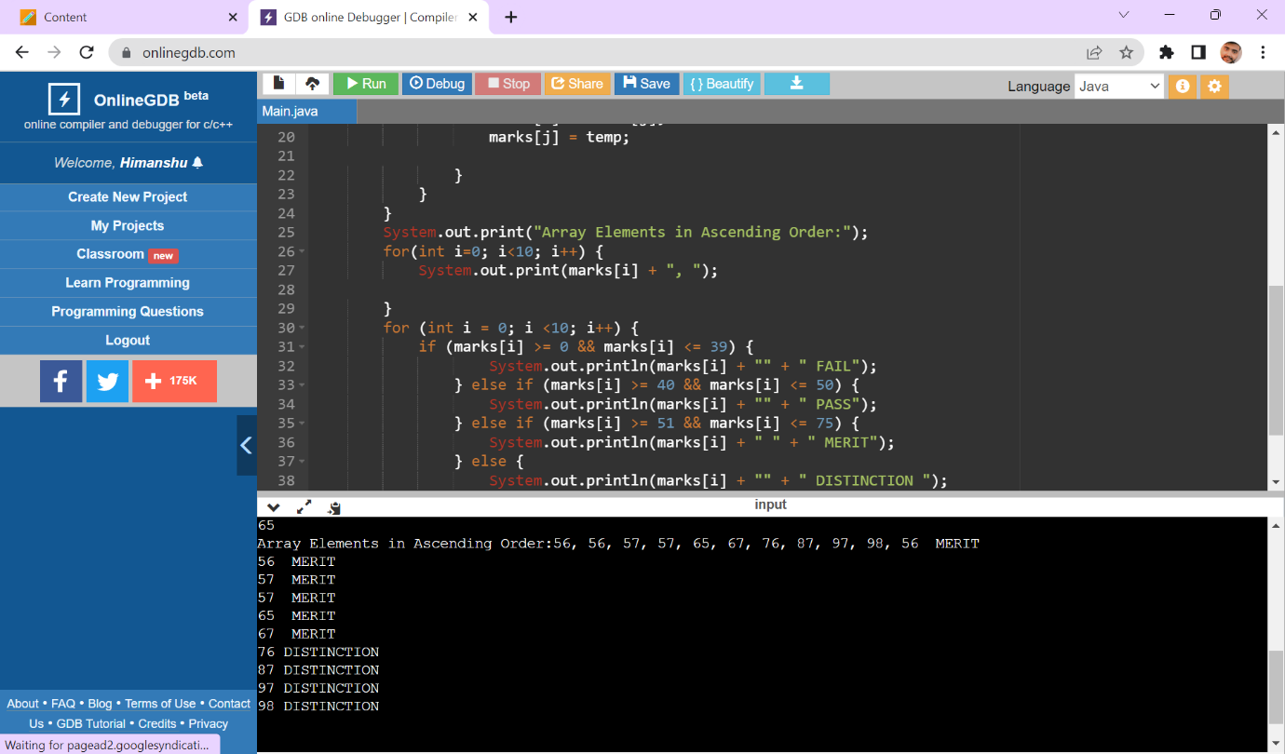

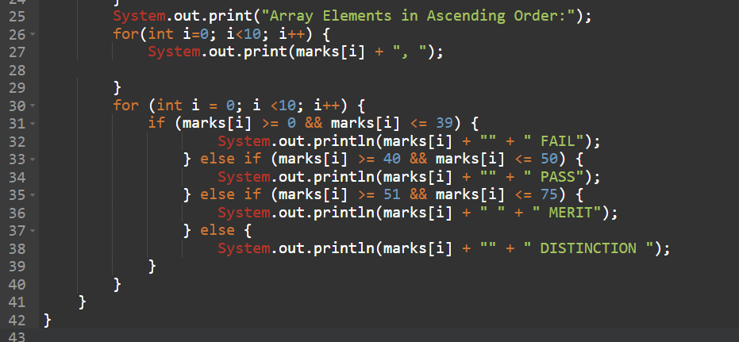

1. Write a program to accept three digits (i.e. 0 - 9) and print all its possible combinations.

Code:-

import java.util.*;

public class Main {

public static void main(String[] args) {

int i, j, k;

System.out.println("Enter 3 numbers: ");

Scanner sn = new Scanner(System.in);

int a = sn.nextInt();

int b = sn.nextInt();

int c = sn.nextInt();

int d[] = { a, b, c };

for (i = 0; i < 3; i++) {

for (j = 0; j < 3; j++) {

for (k = 0; k < 3; k++) {

if (i != j && j != k && k != i)

System.out.println(d[i] + " " + d[j] + " " + d[k]);

}

}

}

}

}

Output:-

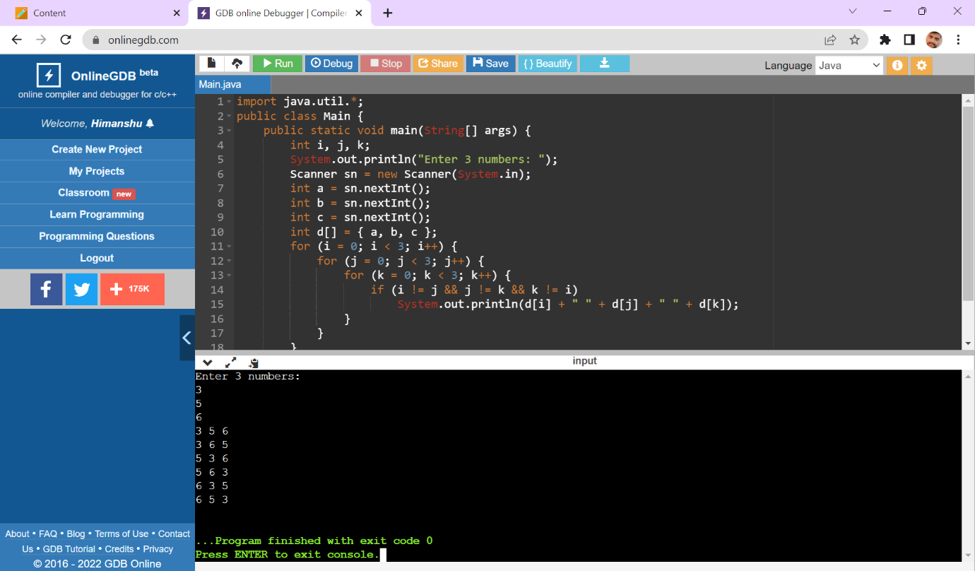

1. Write a Java Program to accept 10 numbers in an array and compute the square of each number. Print the sum of these numbers.

Code:-

import java.util.*;

public class Main

{

public static void main(String[] args) {

int sum=0;

System.out.println("enter number in an array");

int arr[]=new int[10];

Scanner ob=new Scanner(System.in);

for(int i=0;i<10;i++){

arr[i]=ob.nextInt();

}

for(int i=0;i<10;i++){

arr[i]=arr[i]*arr[i];

}

System.out.println("displaying the array");

for(int i=0;i<10;i++){

System.out.println(arr[i]);

}

System.out.println("sum of the numbers:");

for(int i=0;i<10;i++){

sum=arr[i]+sum;

}

System.out.println(sum);

}

}

Output:-

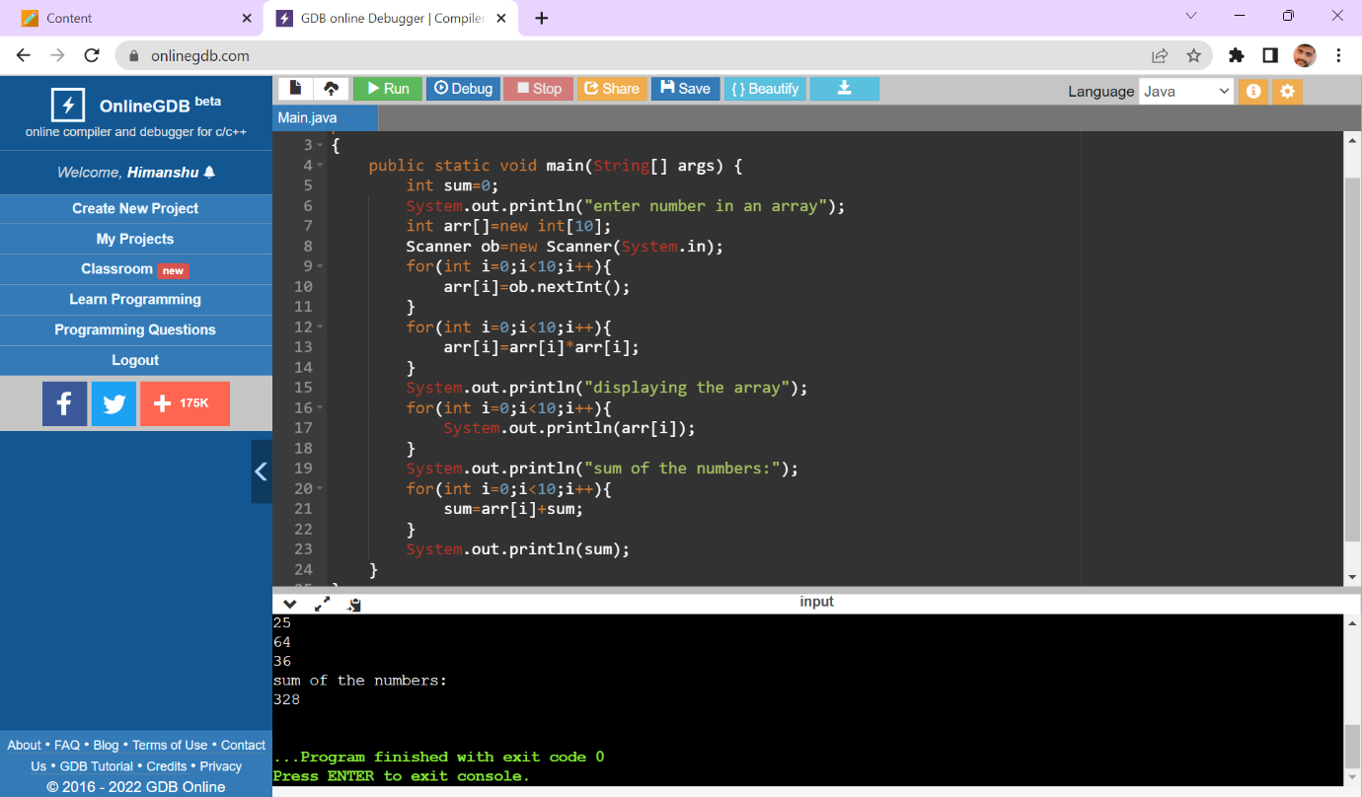

1. Write a program to input a number of a month (1 - 12) and print its equivalent name of

the month.( e.g 1 to Jan, 2 to Feb. 12 to Dec.)

Code:-

import java.util.*;

public class Main

{

public static void main(String[] args) {

System.out.println("Enter the number between 1-12");

Scanner ob= new Scanner(System.in);

int n;

n=ob.nextInt();

switch(n){

case 1:

System.out.println("Jan");

break;

case 2:

System.out.println("Feb");

break;

case 3:

System.out.println("March");

break;

case 4:

System.out.println("april");

break;

case 5:

System.out.println("may");

break;

case 6:

System.out.println("June");

break;

case 7:

System.out.println("July");

break;

case 8:

System.out.println("august");

break;

case 9:

System.out.println("sep");

break;

case 10:

System.out.println("oct");

break;

case 11:

System.out.println("Nov");

break;

case 12:

System.out.println("Dec");

break;

default:

System.out.println("invalid number");

}

}

}

Output:-

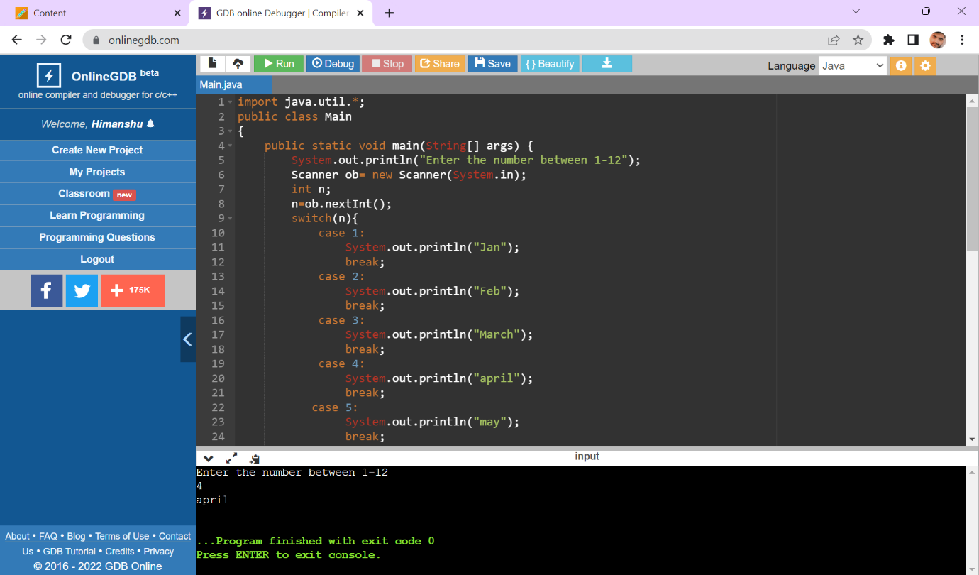

1. Write a program to find the sum of all integers greater than 40 and less than 250 that are divisible by 5.

Code:-

public class Main

{

public static void main(String[] args) {

int sum=0,i;

System.out.println("numbers divisible by 5");

for(i=41;i<250;i++){

if(i%5==0){

sum=sum+i;

System.out.println(i);

}

else{

continue;

}

}

System.out.println("sum =" + sum);

}

}

Output:-

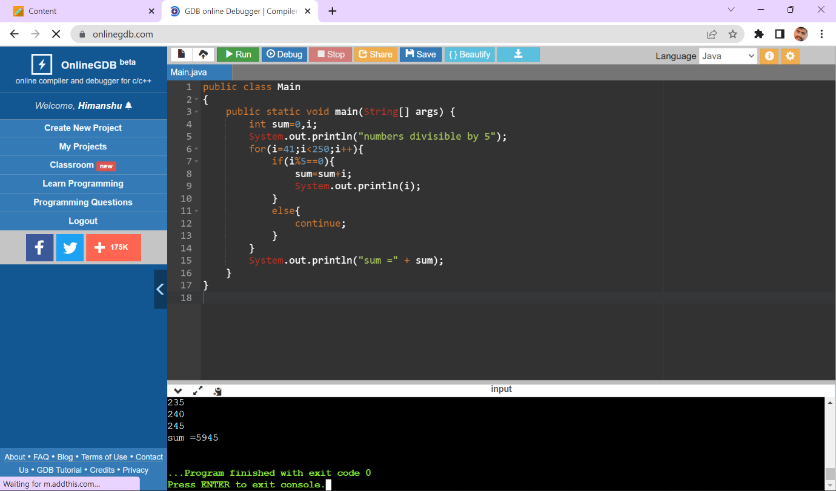

Experiment -4

1. Write a Java program to show that private member of a super class cannot be accessed from derived classes.

Code:-

class A{

private int a=9,b=12; // declare as a private variable

void sum(){

System.out.println(a+b);

}

}

class B extends A{

void sub(){

System.out.println(a-b);

}

}

public class Main

{

public static void main(String[] args) {

System.out.println("Hello World");

B ob=new B();

ob.sum();

ob.sub();

}

}

Output:-

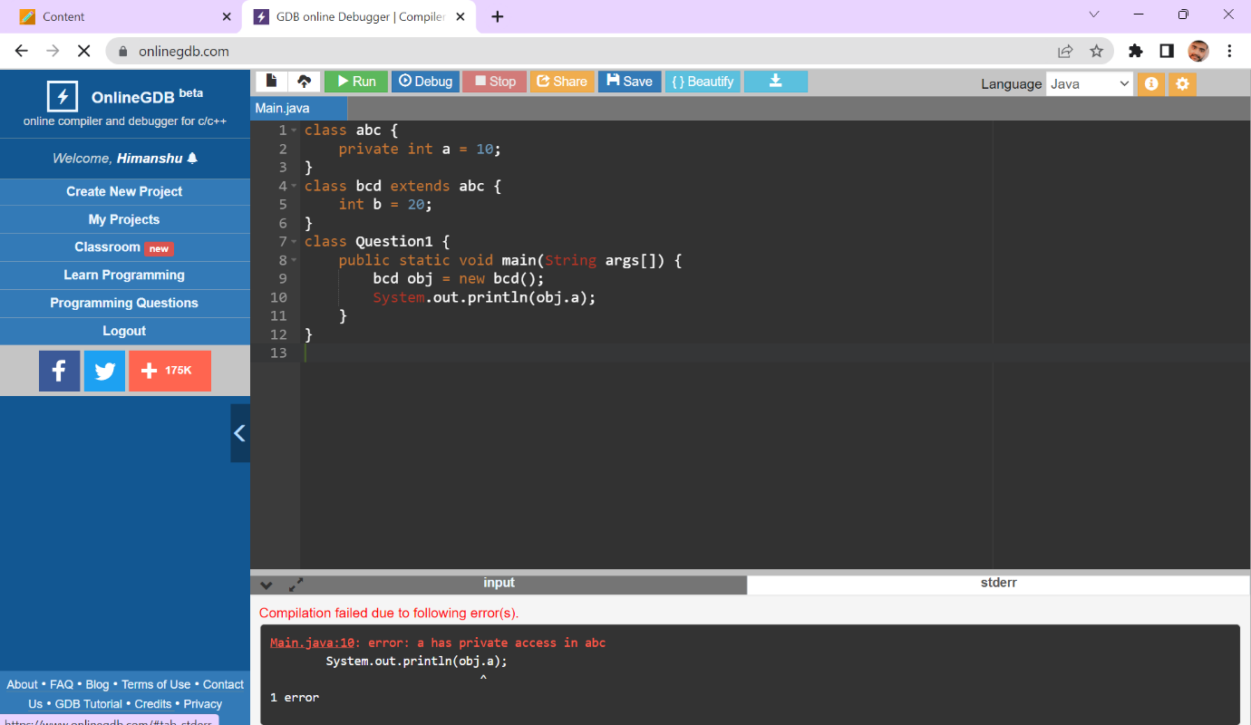

1. Write a program in Java to create a Player class. Inherit the classes Cricket _Player, Football _Player and Hockey_ Player from Player class.

Code:-

class player_class{

void details(){

System.out.println("player_class");

}

}

class cricket_player extends player_class{

void fun1(){

System.out.println("Cricket game has 11 players in each team");

}

}

class football_player extends player_class{

void fun2(){

System.out.println("Football game has 11 players in each team");

}

}

class hockey_player extends player_class{

void fun3(){

System.out.println("hockey game has 11 players in each team");

}

}

public class Main

{

public static void main(String[] args) {

cricket_player n1=new cricket_player();

football_player n2=new football_player();

n1.details();

n1.fun1();

}

}

Output:-

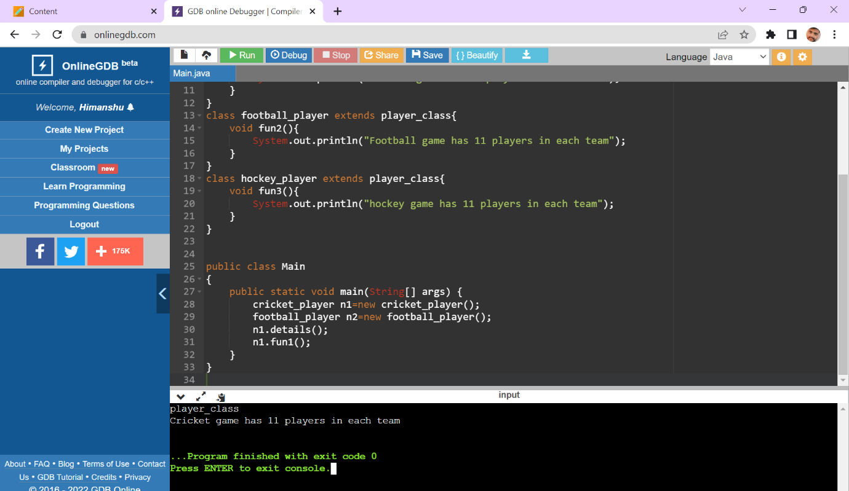

3)Write a class Worker and derive classes DailyWorker and SalariedWorker from it. Every worker has a name and a salary rate. Write method ComPay (int hours) to compute the week pay of every worker. A Daily Worker is paid on the basis of the number of days he/she works. The Salaried Worker gets paid the wage for 40 hours a week no matter what the actual hours are. Test this program to calculate the pay of workers. You are expected to use the concept of polymorphism to write this program.

Code :-

class Worker{

String name;

Worker(String n){

name=n;

}

void info(){

System.out.println("Employee name"+name);

}

}

class Daily_worker extends Worker{

int rate;

Daily_worker(String n,int r){

super(n);

rate=r;

}

void Compay(int hr){

info();

System.out.println("salary"+" "+rate*hr);

}

}

class Salaried_worker extends Worker{

int rate;

Salaried_worker(String n,int r){

super(n);

rate=r;

}

int h=40;

void Compay(){

info();

System.out.println("salary"+" "+rate*h);

}

}

public class Main

{

public static void main(String[] args) {

Daily_worker d =new Daily_worker("Ant",75);

Salaried_worker s= new Salaried_worker("Ant",100);

d.Compay(4);

s.Compay();

}

}

Output :-

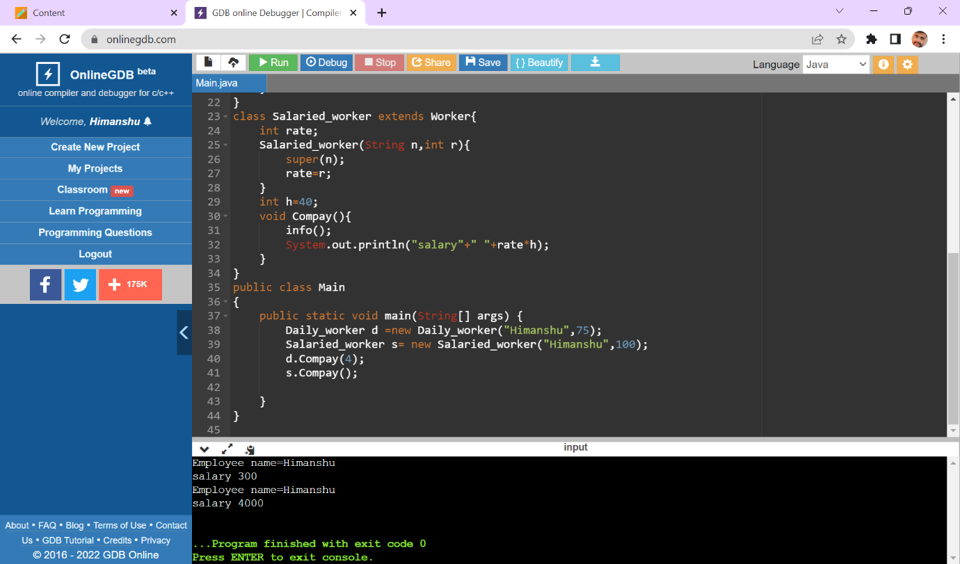

5) Design a class employee of an organization. An employee has a name, empid, and salary. Write the default constructor, a constructor with parameters (name, empid, and salary) and methods to return name and salary. Also write a method *increaseSalary* that raises the employee’s salary by a certain user specified percentage. Derive a subclass Manager from employee. Add an instance variable named department to the manager class. Supply a test program that uses theses classes and methods.

Code:-

import java.util.Scanner;

class employee{

int eid;

String name;

float salary;

employee(){ // Default constructor

}

employee(int id,String n,float s){ // parameterised constructor

eid=id;

name=n;

salary=s;

}

String names(){

return name;

}

float salaries(){

return salary;

}

float increaseSalary(float per_rate){

float in=(salary*(per_rate/100));

float s=salary+in;

return s;

}

}

class manager extends employee{

public String department="d";

}

public class Main{

public static void main(String[] args) {

Scanner sc= new Scanner(System.in);

System.out.println("enter the name");

String n=sc.next();

System.out.println("enter the employee id");

int id=sc.nextInt();

System.out.println("enter the salary");

float s=sc.nextInt();

System.out.println("enter the percentage_rate increaced in salary");

float p=sc.nextFloat();

employee e1=new employee(id,n,s);

System.out.println(e1.names());

System.out.println(e1.salaries());

System.out.println(e1.increaseSalary(p));

}

}

Output:-

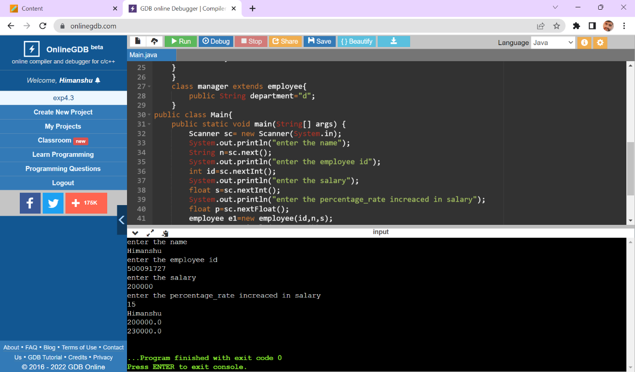

Experiment -5

1. Write a program to create interface named test. In this interface the member function is square. Implement this interface in arithmetic class. Create one new class called ToTestInt. In this class use the object of arithmetic class.

Code:-

interface test{

void square();

}

class arithmetic implements test{

public void square(){

System.out.println("square");

}

}

public class Main

{

public static void main(String[] args) {

test ob=new arithmetic();

ob.square();

}

}

Output:-

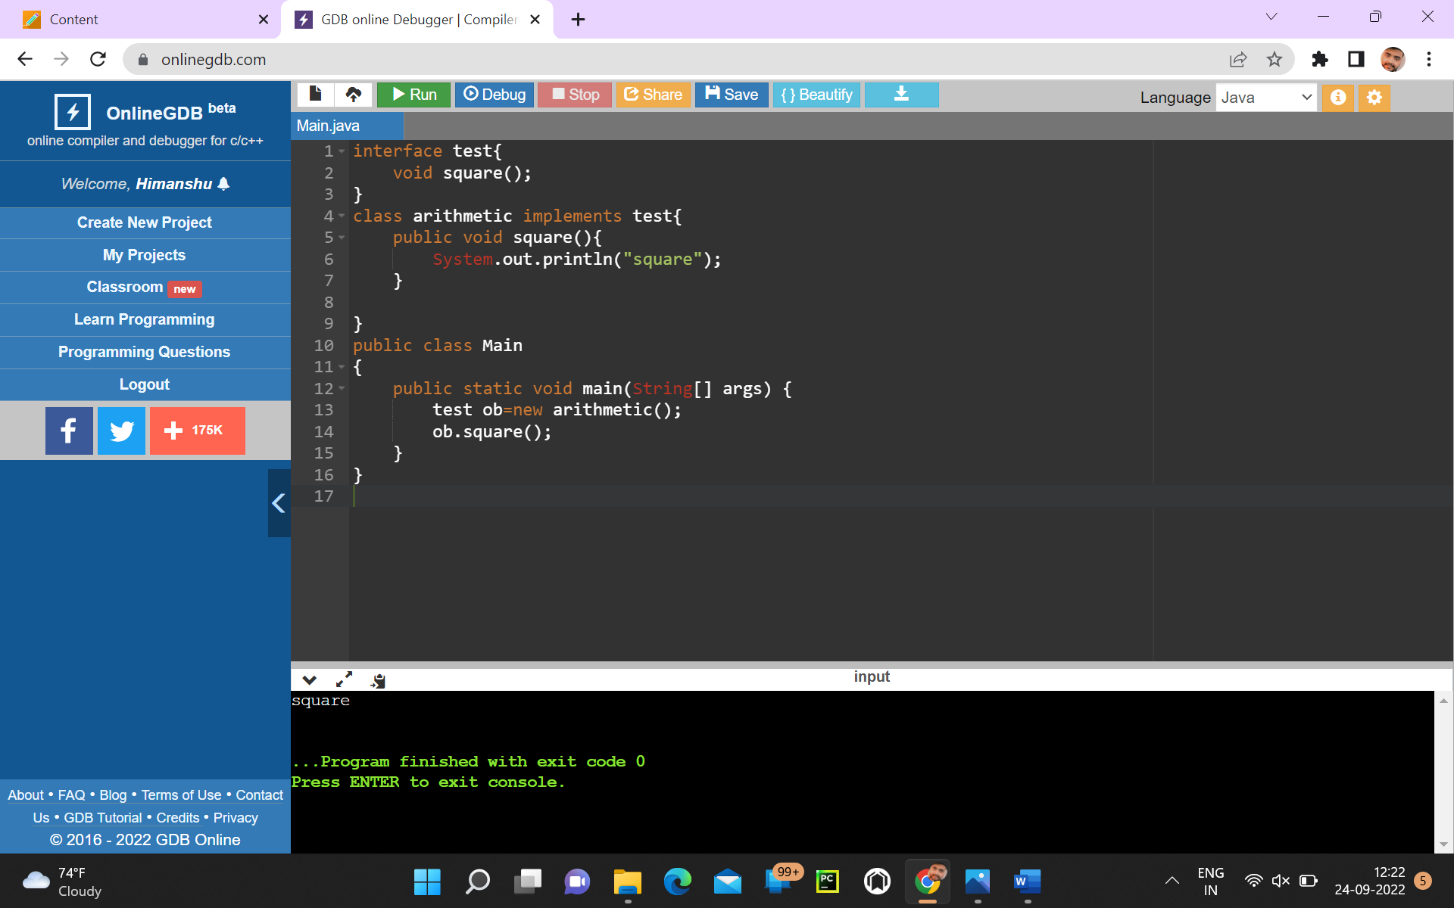

1. Write a program to create interface A, in this interface we have two method meth1 and meth2. Implements this interface in another class named MyClass.

Code:-

interface A{

void meth1();

void meth2();

}

class MyClass implements A{

public void meth1(){

System.out.println("hello everyone");

}

public void meth2(){

System.out.println("what's up?");

}

}

public class Main

{

public static void main(String[] args) {

MyClass ob=new MyClass();

ob.meth1();

ob.meth2();

}

}

Output:-

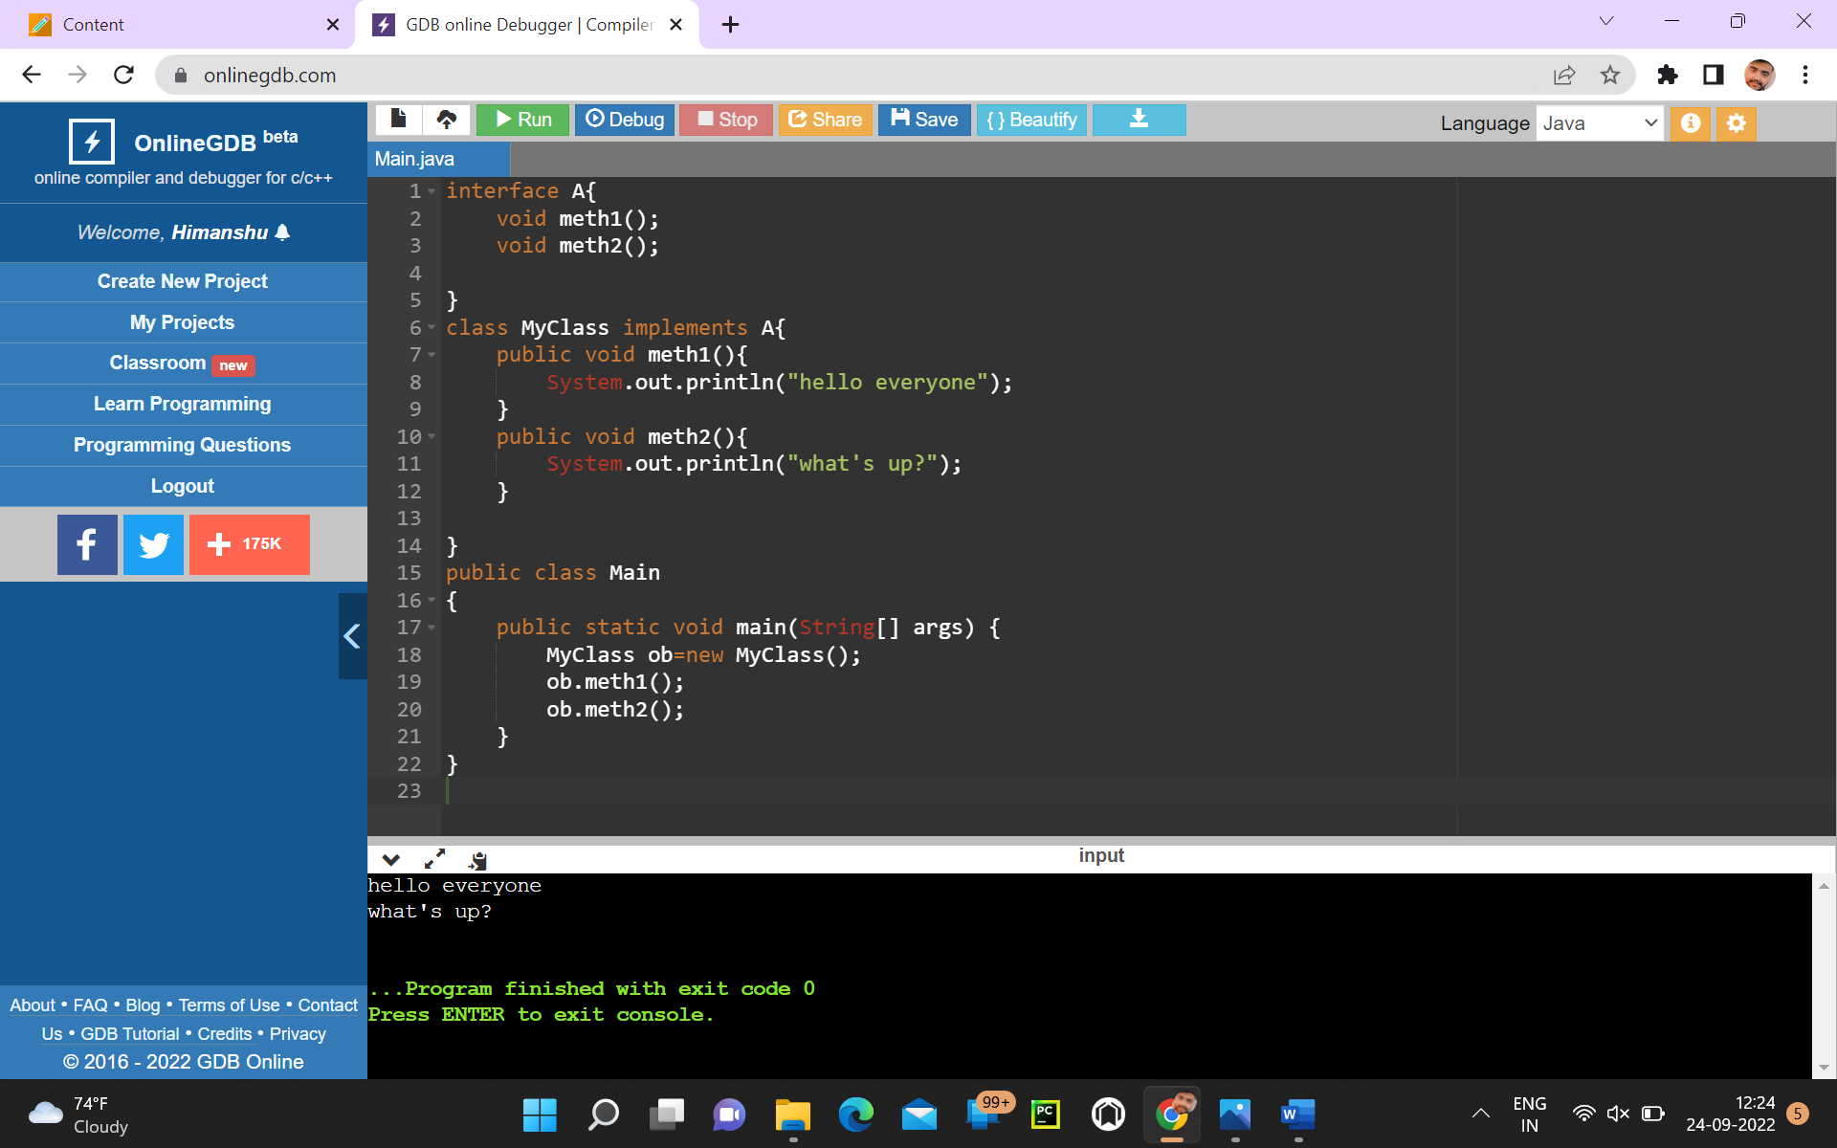

4)Write a program to create an Interface having two methods division and modules. Create a class, which overrides these methods.

Code:-

interface A{

void divison(int a);

void module(int b);

}

class B implements A{

int div,mod;

public void divison(int a){

div=a;

System.out.println("divison "+ div);

}

public void module(int b){

mod=b;

System.out.println("module "+mod);

}

}

public class Main{

public static void main(String[] args){

B ob= new B();

ob.divison(4);

ob.module(6);

}

}

Output:-

