

A

PROJECT REPORT ON

# CINEMA SEAT ARRANGEMENT

SUBMITTED BY

AKASH HATAGALE

TEJAS POOJARI

OMKAR BABAR

HIMANSHU DOYE

VIBHAV TAYADE

Batch: 2022 - 8330

Center: Pune - Chinchwad

# Under the Guidance Of

**Jayanth Vellingiri.**

**(EON Master Trainer)**

EduBridge

(School of coding)

**Introduction:**

Our project Cinema Seat Arrangement. This project mainly explains related to arranging seats in cinema hall. You can arrange seats management.

**Modules: -**

* Admin Module.

We have developed this Project in **Java.** It’s a java-based project so we have used only java.

The main feature of the project is to check available cinema hall site You can see available seat in cinema hall.

In Admin module, admin can add the customer and give them seats

**Software Requirements:**

**Front end:** Java console.

**IDE:** Eclipse IDE Neo 3.

**Operating System:** Windows 11.

1TB HDD, 256 SSD Internal Storage.

8GB RAM.

# Screenshots:

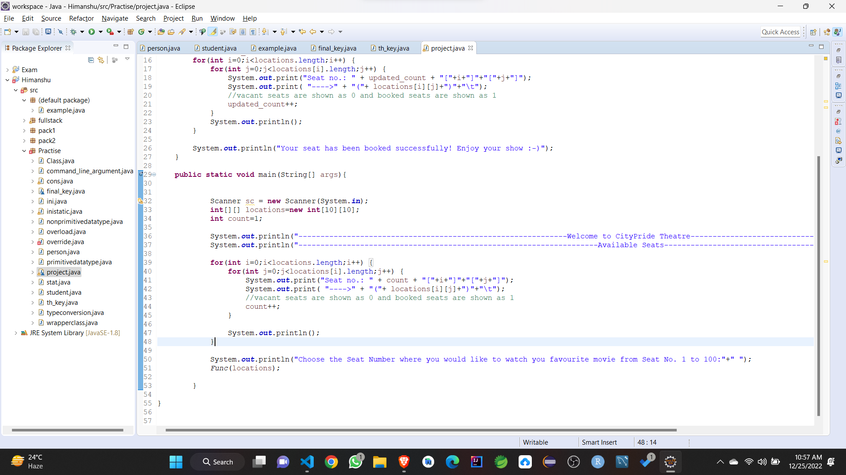

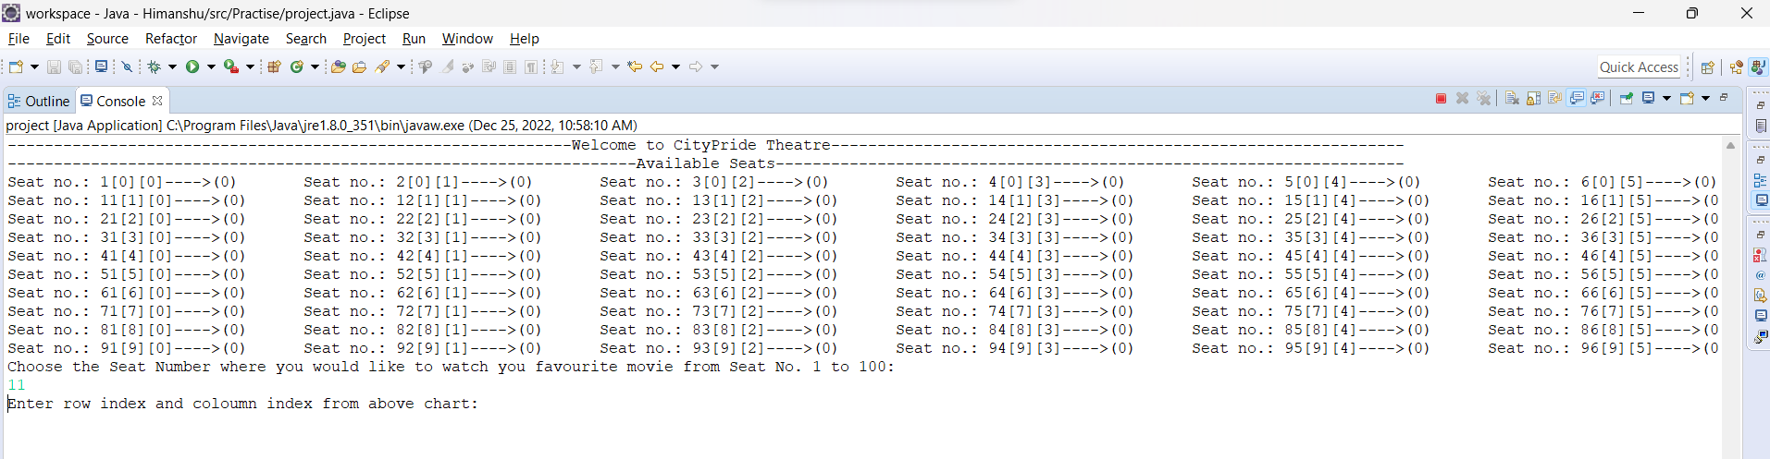

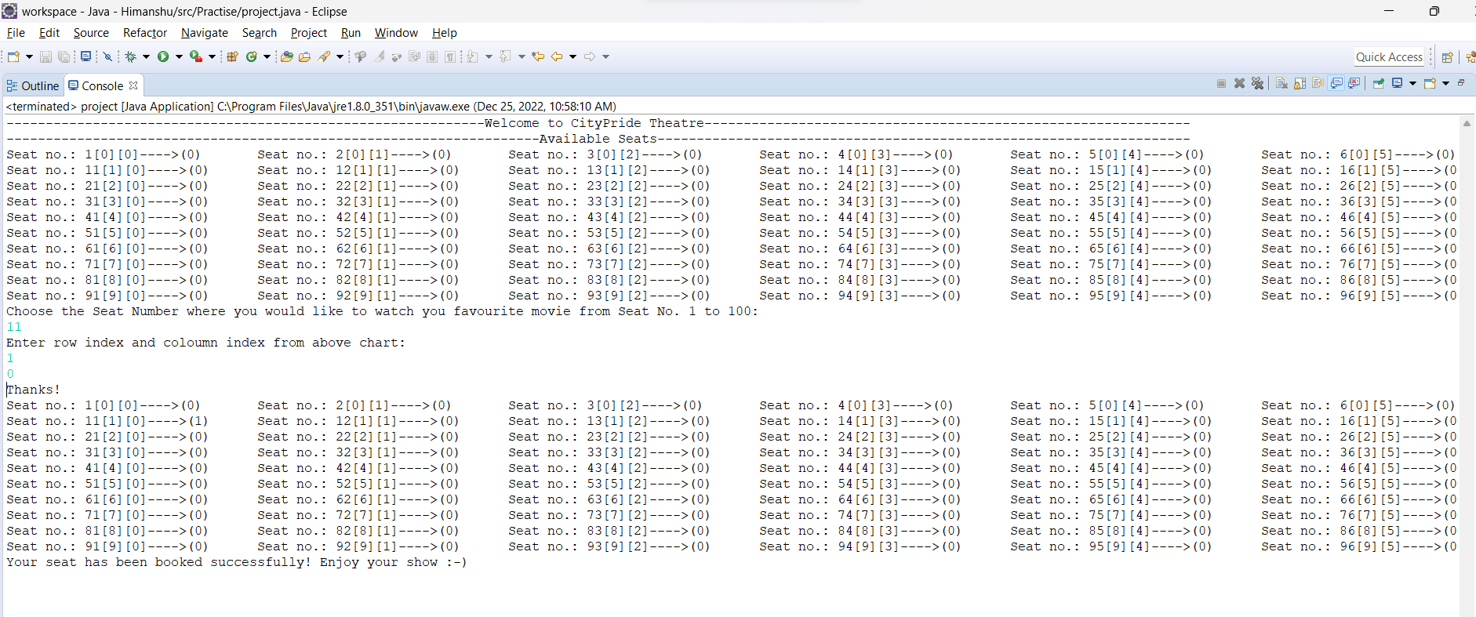

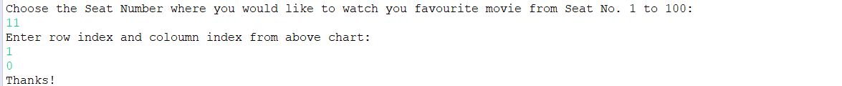

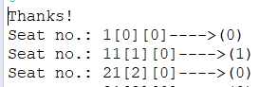

Note: As we can see the above picture (1) is mentioned in front of seat no 11. That means seat no 11 is booked.