QR-Dedicated Counter Terminal
Screen Control Software — Comprehensive Technical Document
(NsScreen / Flutter, Windows)
Ver 2 September 2026

This document is a comprehensive technical reference covering the project's system architecture, communication specification, screen behaviour, implementation detail, class structure, and key design decisions.

Table of Contents
1. System Overview
2. Screen Overview (Application Flow)
3. Screen (UI) Structure
4. System Configuration
5. Communication Protocol Basics
6. Communication Sequences (NsScreen <-> Main Control)
7. Data Changes by Business Tab
8. Error Message Display
9. Camera Functionality
10. Implementation Classes / Function List
11. Configuration File Specification

1. System Overview
NsScreen.exe is a screen-control application that reads a displayed QR code and executes counter operations such as Entry, Exit, Fare Settlement, Void, and Origin-Station Cancellation. These operations run over TCP/IP communication with Main Control (the main process group running under Tobu.MainTask.exe). This chapter separates "what the software runs on" (program environment) from "what device it runs on" (tablet environment).

1.1 Program Environment
Information about the NsScreen software's own runtime and implementation.
Item | Detail
Application name | NsScreen.exe
Framework | Flutter (Windows Desktop)
Language | Dart
Communication partner | Main Control (sequence control / screen DLLs under Tobu.MainTask.exe; see 4.1)
Communication method | TCP/IP socket communication (custom binary + JSON protocol; see chapter 5)

1.2 Tablet Operating Environment
Information about the physical device and installation environment NsScreen actually runs on.
Item | Detail
Device | 10.1-inch Windows tablet (touch-panel kiosk)
OS | Windows
Input device | Touch panel, built-in camera (for QR reading; see chapter 9)
Output device | Journal / receipt printer
Installation site | Ticket counters at Tobu Railway stations

1.3 Key Functions and Screen Overview
The screens and states provided by this software are listed below. The "Coverage" column indicates how far this document describes each screen (o = detailed, including a process-flow diagram and/or screen capture; △ = example screen or overview only; – = out of scope for this document). See chapter 2 for a visual walkthrough using real screen captures.
*Business processing, printing, and error display are not separate screens in their own right, but processing that occurs within the info display screen or the business-execution screens; this table therefore folds them into the row for the relevant screen rather than listing them separately.
Category | Screen / State | Coverage | Main Reference
Startup / Shutdown | Starting up (waiting for 0x0A81) | o | 6.1
Startup / Shutdown | Shutdown processing (sending 0x0F01) | △ | Ch.10 Command List
Login | Login screen | o | 6.1, Ch.3
Login | Maintenance menu (AUTHORITY=99) | △ (example only) | 6.1
QR Read | QR-read waiting screen | o | 6.2, Ch.3
QR Read | Camera-reading screen (incl. viewfinder / zoom) | o | Ch.9
QR Read | Info display screen (incl. ticket info, business  processing [Entry/Exit/Void/Origin Cancel],  printing, error display) | o | 6.2, 6.3, 6.5, Ch.7, Ch.8, Ch.3
QR Read | Detail info dialog | o | Ch.7, Ch.3
Business Exec. | Fare settlement screen (incl. route  selection, receipt printing) | o | 6.4
Business Exec. | Completion / failure screen (incl. printing,  error display) | o | 6.3, Ch.8
Related Business | Closing screen | o | 3.7
Related Business | Closing bulletin / re-export screens | △ (example only) | 3.7
Related Business | Customer service history screen | △ (example only; gap between spec  and implementation being organized separately) | 3.7
Related Business | Logoff screen | o | 6.7

2. Screen Overview (Application Flow)
This chapter uses real screen captures to show the basic flow from startup through to the info display screen. Confirmation dialogs during business execution, error displays, and other details are covered in chapter 3 onward and in each process-flow diagram in chapter 6. The intent here is to give a general sense of the overall flow, so dialogs are deliberately left out of the screens shown.
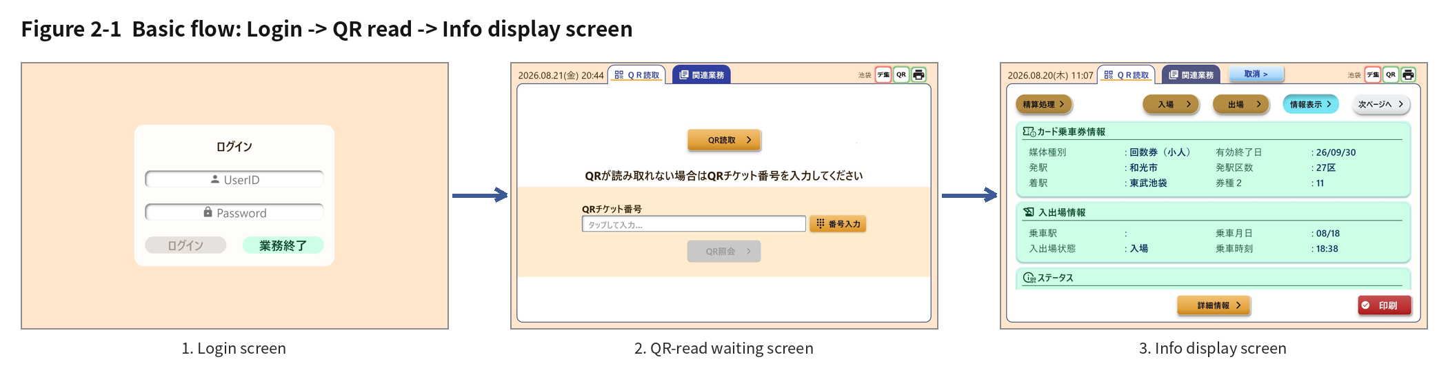
Figure 2-1 Basic flow: Login -> QR read -> Info display screen
Entering an ID and password on the login screen moves to the QR-read waiting screen. Reading a QR code (or entering a QR ticket number manually and querying it) brings up the info display screen. From there, the details of business execution (Entry, Exit, Fare Settlement, Void, Origin-Station Cancellation), route selection, printing, error display, and related business are each covered in chapter 3 (screen structure) and chapter 6 (communication sequences).

3. Screen (UI) Structure

3.1 Screen Transition Overview
Screen | Transition From | Transition To
Login screen | At startup (after receiving 0x0A81) | AUTHORITY=1: QR-read screen  AUTHORITY=99: wait for maintenance app to launch
QR-read screen | Login success, or confirming from a  completion screen | Business-selection screen (on successful QR inquiry)
Business-selection screen  (5 buttons - Entry/Exit/Settlement/  Void/Origin, 2-page layout) | Successful QR inquiry and display-  data retrieval | Each business-execution screen
Completion screen | Business execution succeeded | Back to QR-read screen on confirm
Failure screen | Business execution failed | Back to QR-read screen on confirm  (same as success case)
Settlement-complete screen | Fare settlement succeeded | Issue receipt, or back to QR-read screen

Figure 3.1-1 Overall screen transition map: from startup through login, QR read, business execution, related business, and logoff, along with the key commands that trigger each transition.

3.2 QR-Read Waiting Screen — 2-Page Button Layout
Page | Button Layout
View 1 | Settlement / (blank) / Entry / Exit / Info Display / Next Page
View 2 | Previous Page / (blank) / Void / Origin-Station Cancel

Item | Detail
State management | Page-switch state held by QrButtonView (provider.dart)
Implementation | qr_process/secondary_tab_content_unselected.dart
Button component | TransitionButton (component/secondary_tab_content_core.dart)
Layout | Fixed width (170px) plus blank slots to align button positions across both pages

Figure 3.2-1 Button page 1: Settlement / Entry / Exit / Info Display / Next Page. A blank slot is placed between the leftmost "Settlement" button and the middle three buttons, to align button positions with page 2.
Figure 3.2-2 Button page 2: Previous Page / Void / Origin-Station Cancel. "Next Page" carries a right-arrow icon; "Previous Page" carries a left-arrow icon.

3.3 Tab Transition Method List
Method | Destination
goto() | Transitions to the tab at the given index (shared logic)
gotoDefaultTab() | QR-read waiting screen
gotoStateQrTab() | QR-read-complete (business-selection) screen
gotoCompleteTab() | Completion screen (plays the completion sound)
gotoCompletePrintTab() | Settlement-complete screen (plays the completion sound)
gotoFailedTab() | Failure screen (does not play the completion sound)

3.4 Detail Info Dialog Layout by Ticket Type
The fields shown in the detail info dialog, organized by ticket type, are as follows.
Item (Key) | Regular Ticket | Multi-Ride Ticket | Special Ticket
Origin-station zone count | o | x | x
Transfer station | o | x | x
Transfer-station zone count | o | x | x
Destination station | x | o | o
Route 1-4 | o | o | o
Route 5-8 | x | x | o
Ticket type 2-series | o | o | x
Ticket type 3 | x | x | o
Adult/Child | x | x | o
Round trip on one ticket | x | x | o
Free-travel zone | x | x | o
Free code | x | x | o

Screen Captures
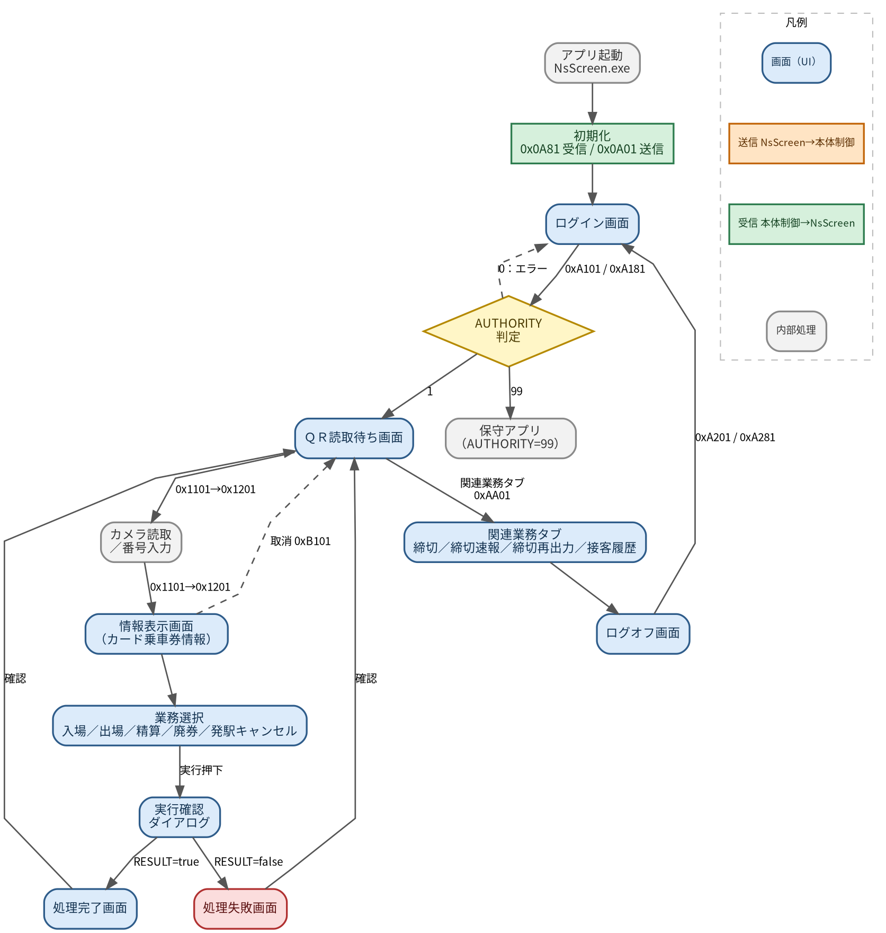
Figure 3.4-1 Detail info dialog (Regular / Multi-ride / Special ticket). Displayed fields branch by ticket type. Special tickets show Route 1-8, Ticket Type 3, round-trip status, free-travel zone, etc.
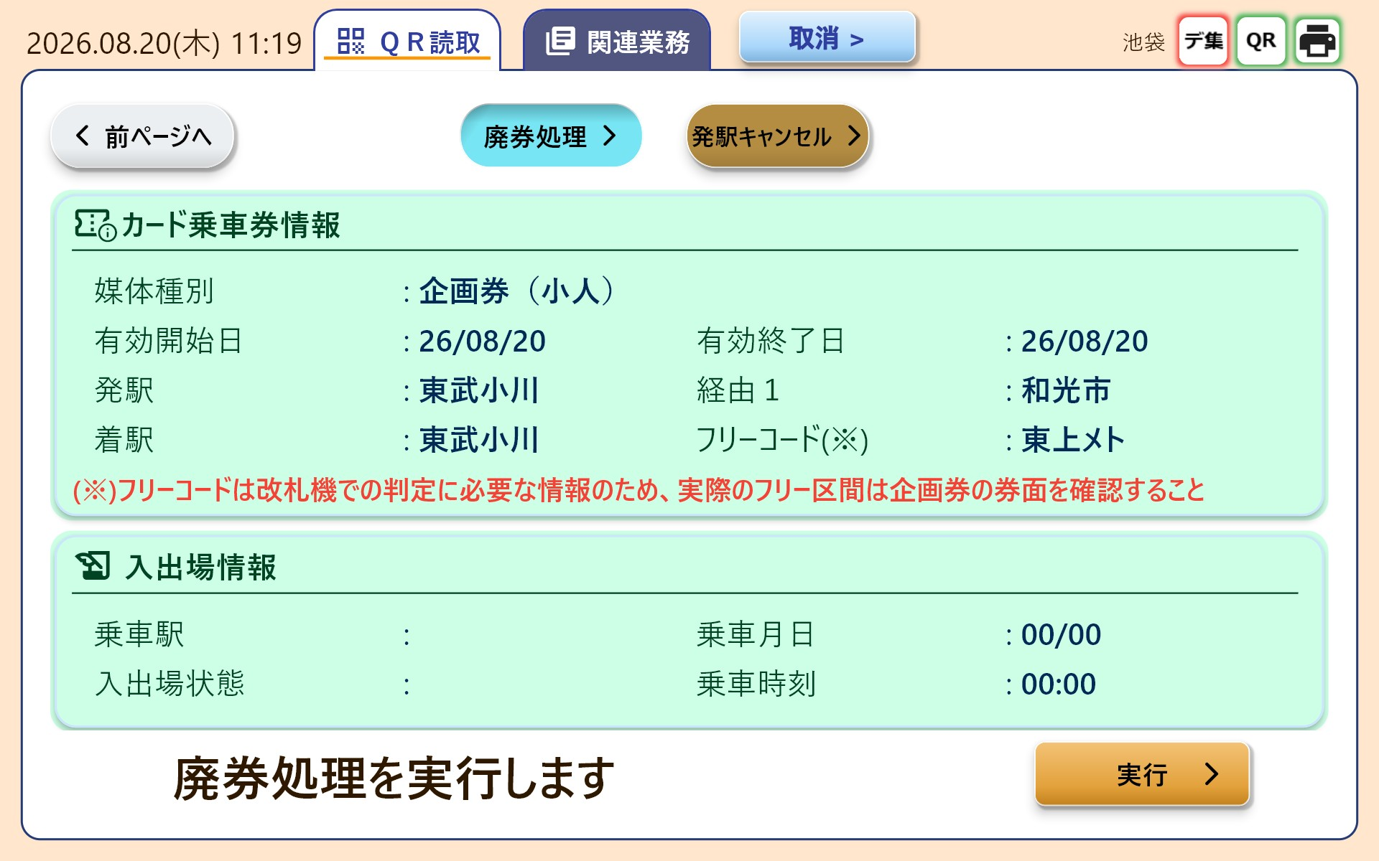
Figure 3.4-2 Special-ticket card info (reference): the slot to the right of "Media Type" is left blank, and Valid-From / Valid-To / Origin / Route 1 / Destination / Free Code are shown. Routes 2-8 are shown only in the detail info dialog.

3.5 Display Format

3.6 Other UI Specifications

3.7 Related-Business Tab Screens
The related-business tab consists of 4 sub-tabs: "Closing," "Closing Bulletin," "Closing Re-export," and "Customer Service History." Selecting a tab sends a business-selection notification (0xAA01) (BUSINESS values: Closing=50 / Closing Re-export=51 / Closing Bulletin=52, etc.).
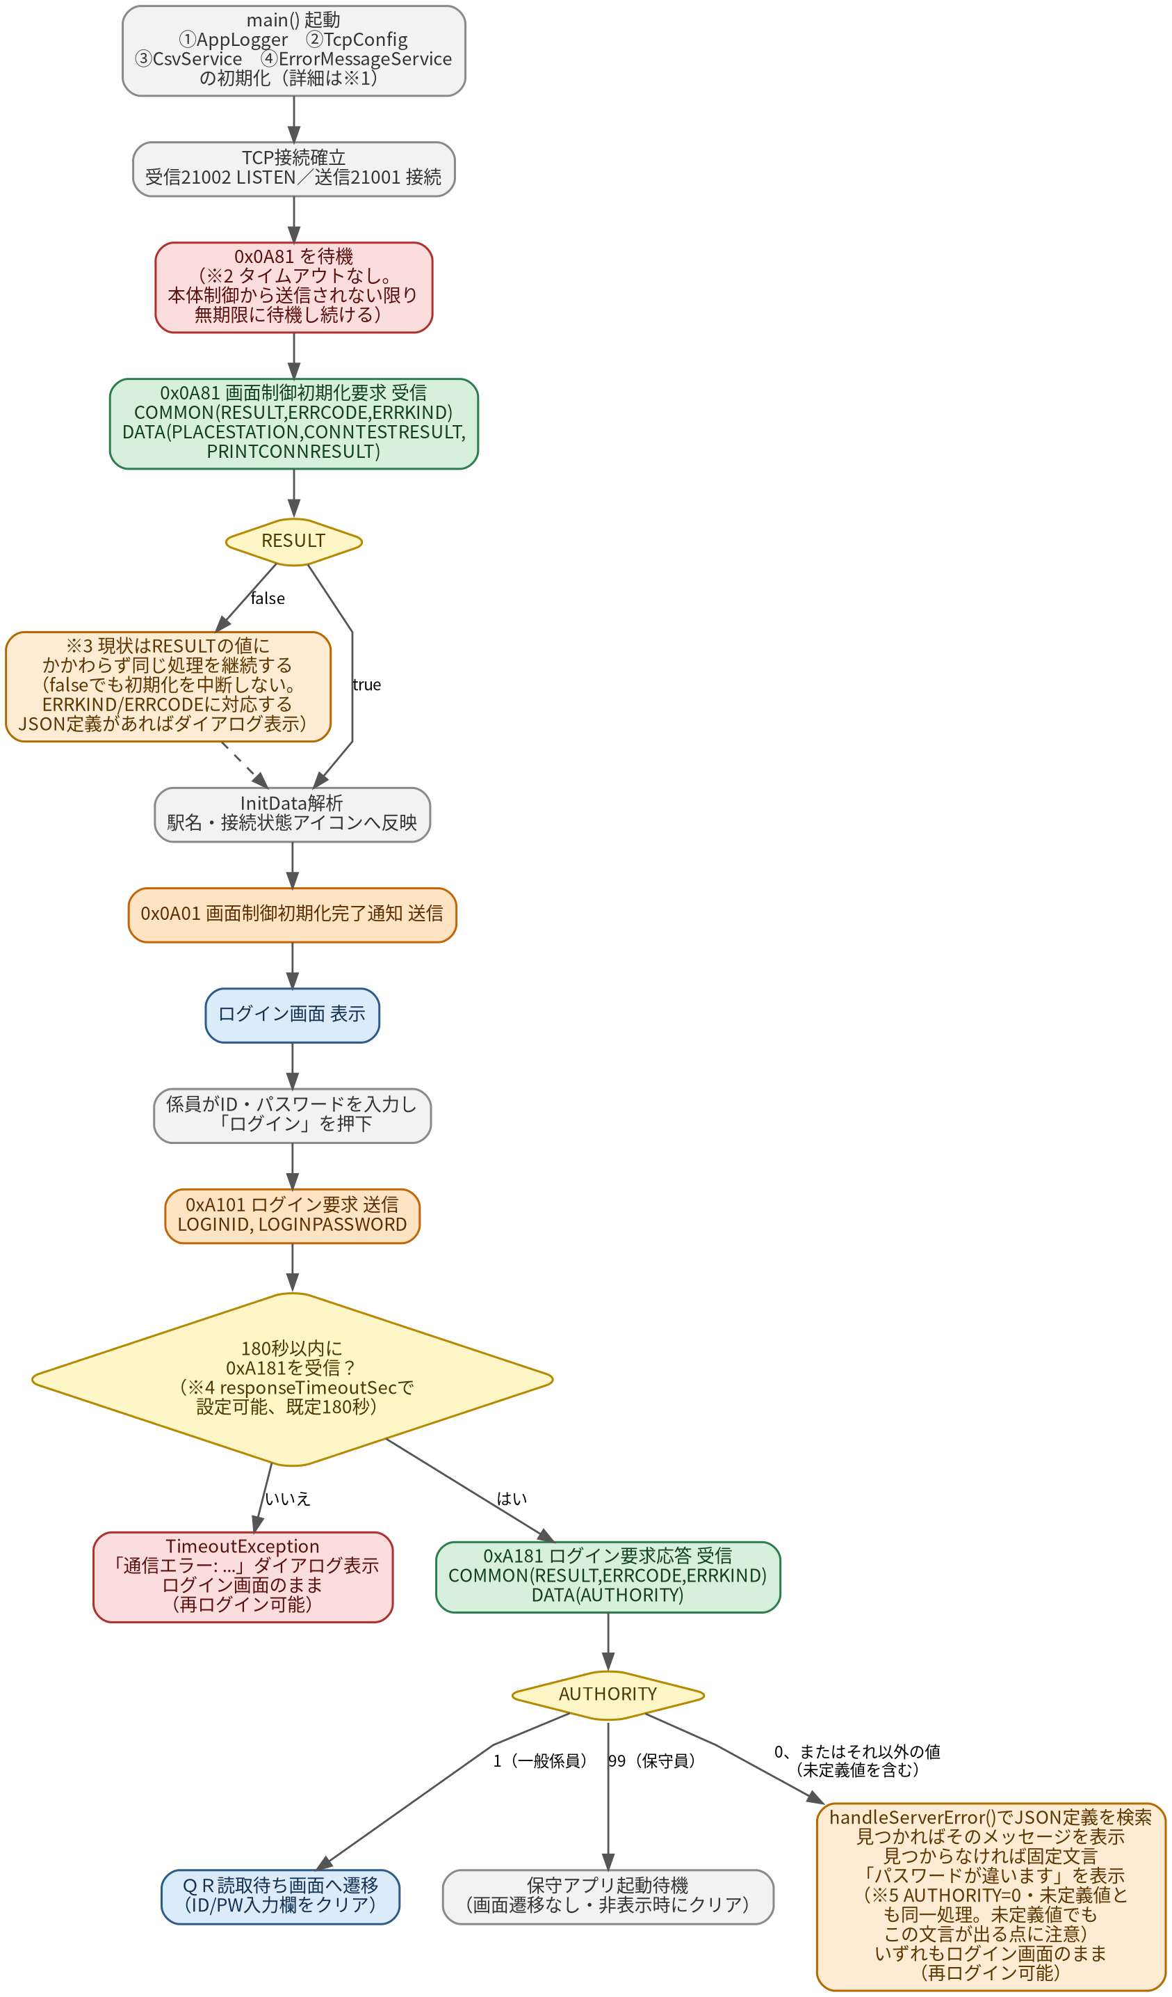
Figure 3.7-1 Closing screen: transaction data is split into 4 categories ("Total Handled," "Magnetic Ticket Handling," "Count," "Per-Company Settlement Breakdown") and shown as expandable cards via an arrow icon at the right of each heading. The display content (CloseTallyMainContent) is shared across the Closing, Closing Bulletin, and Closing Re-export screens.

4. System Configuration
Main Control is made up of multiple processes and DLLs, but from NsScreen's (this application's) perspective, the only communication partner is the single TCP/IP interface that Main Control exposes. From here on, "Main Control" in this document refers to that interface.

4.1 Process Structure (Overview)
Process / Module | Role
NsScreen.exe (this application) | Screen control, user-input handling, TCP/IP communication
Tobu.MainTask.exe (Main Control) | Business logic, print control, QR-module control, upstream system integration
NsQRControl.exe | Communication with the QR authentication system (via Main Control)
NsAxJudge.exe | Fare-settlement judgment processing (via Main Control)

*NsQRControl.exe, NsAxJudge.exe, and similar are processes under Main Control; NsScreen never communicates with them directly. All exchanges go through Main Control.

4.2 TCP/IP Communication Structure
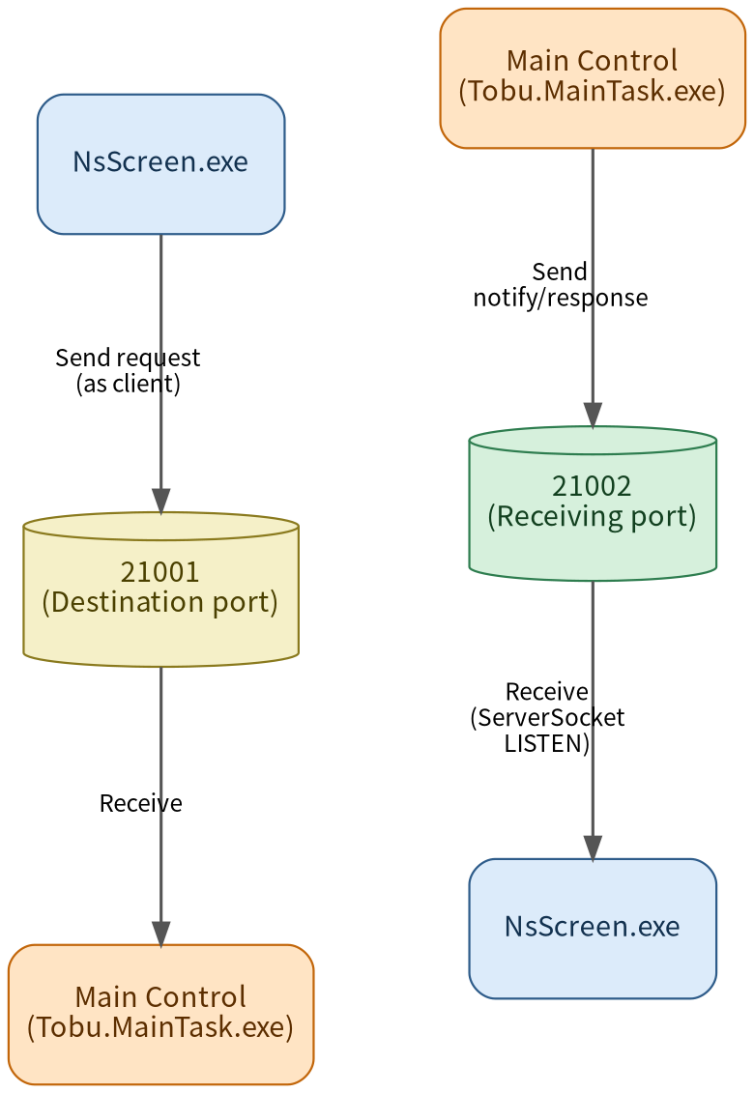
Figure 4.2-1 TCP/IP port structure (send and receive use separate ports)
NsScreen holds both the "sending client" and "receiving server" roles within a single process. Note that sending and receiving use different port numbers.

4.3 Source Code Structure (Folder Layout)
This software's implementation (under the lib/ folder) is split by function into the folders below. This matches the folder layout in VS Code, so it can be used as a guide when looking for particular code. Rather than an abstract classification like "layers," this is explained in terms of the folders that actually exist.
Folder | Key Files (examples) | Role
(root) | main.dart, app_config.dart,  my_home_page.dart, rout_config.dart,  camera_scanner.dart | App startup, screen-transition route  definitions, tab structure, camera control
config/ | tcp_config.dart | Loads app_config.json and holds config values
model/ | display_data.dart, init_data.dart,  login_response.dart, process_response.dart,  error_message.dart, route_label.dart | Data models that convert received JSON  into Dart objects
service/ | tcp_service.dart, packet_codec.dart,  error_message_service.dart, csv_service.dart,  sound_service.dart, app_logger.dart | Shared processing: communication,  external file loading, logging
provider/ | provider.dart,  display_data_provider.dart,  cancel_btn_visible.dart | Holds screen state and received data via  Riverpod
login/ | login_page.dart, station_splash.dart | Login screen
qr_process/ | qr_process_menu.dart,  secondary_tab_menu.dart,  secondary_tab_content_unselected.dart,  secondary_tab_process_information.dart | Screens for QR reading through business  execution
related_process/ | related_process_menu.dart,  close_tally.dart,  customer_service_history.dart,  log_off.dart | Screens for the related-business  (closing series) tab
component/ | secondary_tab_content_core.dart,  process_completed.dart, scanner.dart,  pop_out_button.dart, etc. | UI parts shared across multiple screens
utility/ | confirm_dialog.dart, error_dialog.dart,  error_handler.dart,  date_time_converter.dart | Helpers: shared dialogs, error evaluation,  date conversion, etc.
gen/ | assets.gen.dart, fonts.gen.dart | Auto-generated asset-reference code

*Chapter 10, "Implementation Classes / Function List," is organized to correspond with this folder structure.

4.4 Character Encoding
The data this software handles uses different character encodings depending on the communication path or reference file involved. Since this is easy to mix up, each target is listed explicitly below.
Target | Encoding | Notes
TCP/IP communication (JSON body of each message) | UTF-8 | Encoded/decoded in packet_codec.dart
KbaErrorMessage.json (error definition file) | Shift-JIS | JSON format, but Shift-JIS encoded.  Path given by app_config.json's ERROR_MSG_PATH
Dispinfo.csv (code-conversion CSV) | Shift-JIS | Loaded in csv_service.dart
app_config.json (configuration file) | UTF-8 (assumed) | No explicit encoding conversion found in  code; relies on Dart's default (UTF-8) read
Log files (AppLogger output) | UTF-8 (assumed) | Same as above

*app_config.json and the log files are marked "assumed" because no explicit encoding specification was found in the code. If garbled text is suspected on the real device, check the actual output file in binary.

5. Communication Protocol Basics

5.1 Message Format
Offset | Size | Content
0 | 2 bytes | Command ID (big-endian)
2 | 4 bytes | JSON data length (big-endian)
6 | variable | JSON data body (UTF-8)

*Implementation: lib/service/packet_codec.dart (encode/decode). Character encoding is UTF-8.

5.2 Common JSON Structure
Most request/response messages share the following COMMON / DATA structure.
{ "COMMON": { "RESULT": true, "ERRCODE": 0, "ERRKIND": 0 },
"DATA": { ... message-specific data ... } }
Field | Content
COMMON.RESULT | Processing result (true = success, false = failure)
COMMON.ERRCODE | Detailed error code (valid when RESULT=false)
COMMON.ERRKIND | Location where the error occurred (e.g. always present for 0xFA81; omitted in some messages)
DATA | Message-specific data (e.g. ticket info for 0x1281, AUTHORITY for 0xA181)

5.3 Command ID List
Before the list of processing names, here is how a received message is handled inside NsScreen.
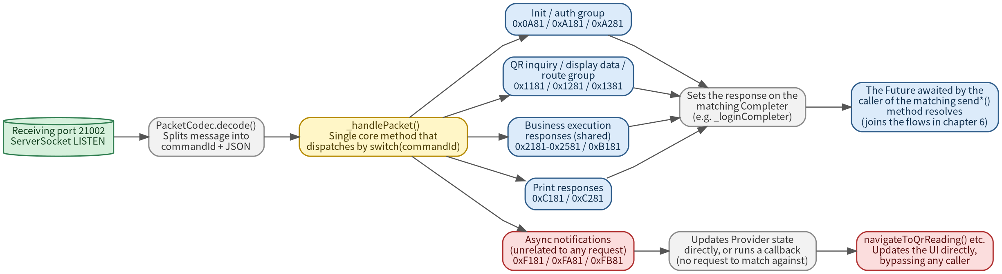
Figure 5.3-1 Dispatch structure for received messages (_handlePacket)
The meaning of the columns below is as follows.
"Implementation (Send)" = the NsScreen-side method that sends this command (lib/service/tcp_service.dart)
"Handling (Receive)" = which Completer/state is updated in the switch statement inside _handlePacket() when this command is received (the "Processing Name" column shows what that case does)
Command ID | Direction | Name | Implementation (Send) / Handling (Receive)
0x0A81 | Recv | Screen-control init request | _handlePacket() case initRequest
0x0A01 | Send | Screen-control init complete notice | sendInitComplete()
0xA101 | Send | Login request | sendLoginRequest()
0xA181 | Recv | Login request response | case loginResponse
0xA201 | Send | Logoff request | sendLogoff()
0xA281 | Recv | Logoff request response | case logoffResponse
0x1101 | Send | QR server inquiry request | sendQrServerRequest()
0x1181 | Recv | QR server inquiry response | case qrServerRefResponse
0x1201 | Send | Display data request | sendDisplayDataRequest()
0x1281 | Recv | Display data response | case displayDataResponse
0x1301 | Send | Fare re-judgment request | sendFareJudge()
0x1381 | Recv | Fare re-judgment response | case fareJudgeResponse
0xAA01 | Send | Business-selection notice | sendBusinessSelect()
0x2101  0x2201  0x2301  0x2401  0x2501 | Send | Entry/Exit/Settlement/Void/  Origin-Cancel execution request | sendProcessRequest()
0x2181  0x2281  0x2381  0x2481  0x2581 | Recv | Each business-execution response | case enter/exit/adjust/  cancelTicket/enterCancelResponse
0xB101 | Send | Business cancel request | sendCancel()
0xB181 | Recv | Business cancel response | case cancelResponse
0xC101 | Send | QR ticket-info journal print request | sendPrintQrInfo()
0xC181 | Recv | QR ticket-info journal print response | case printQrInfoResponse
0xC201 | Send | Receipt print request | sendPrintReceipt()
0xC281 | Recv | Receipt print response | case printReceiptResponse
0xF181 | Recv | Connection-state change notice | case connectionStatusNotify
0xFA81 | Recv | Main-Control abnormality notice | case systemErrorNotify
0xFB81 | Recv | Forced business-cancel notice | case forceCancelNotify
0x0F01 | Send | Application exit request | sendAppExit()

6. Communication Sequences (NsScreen <-> Main Control)

6.1 Startup -> Initialization -> Login
This covers everything from app startup, through authentication on the login screen, to reaching the QR-read waiting screen (or the maintenance app). This stretch includes several branches around "what happens if there's no response for a while" and "what happens if an unexpected value comes back," so figure 6.1-1 covers those branches alongside the normal path.

Four Classes Initialized at Startup
Immediately after main() starts, the following four classes (all singletons) are initialized. Since later chapters often refer to them by name alone, their roles are summarized here.
Class | Implementation | Role
AppLogger | service/app_logger.dart | Writes to the daily log file; auto-deletes old log files.  Log examples in this document (e.g. "0xC101 timeout") are this class's output
TcpConfig | config/tcp_config.dart | Reads app_config.json and holds config values such as  the TCP destination, timeout seconds, and file paths.  Falls back to in-code defaults if the read fails
CsvService | service/csv_service.dart | Reads Dispinfo.csv (Shift-JIS) and converts code values  into display names (station names, ticket-type names, etc.)
ErrorMessageService | service/error_message_service.dart | Reads KbaErrorMessage.json (Shift-JIS) and looks up error  messages and button layouts by ERRKIND/ERRCODE; see ch.8

Process Flow (All Branches)
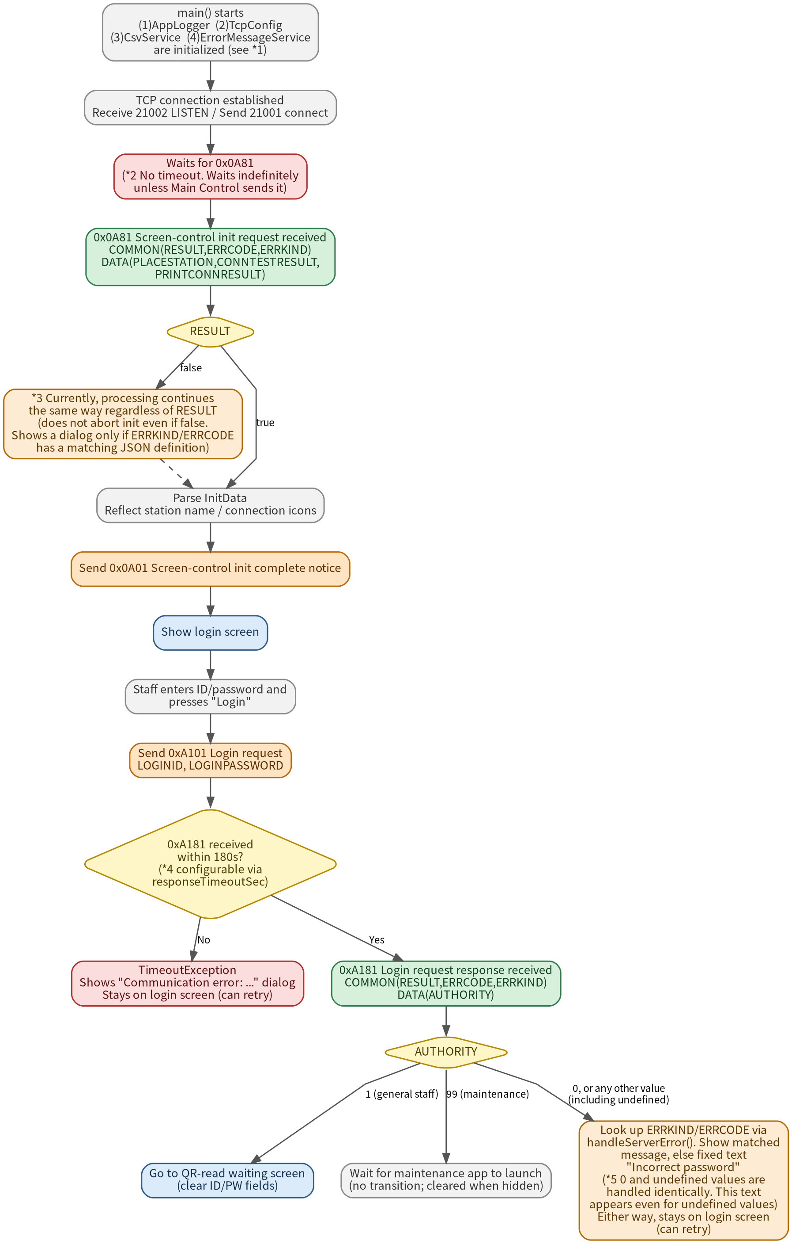
Figure 6.1-1 Startup -> Initialization -> Login process flow (normal path, error path, and unexpected values)

Notes on the Diagram
*1 See the table above for the four classes initialized at startup.
*2 No timeout is implemented in code for receiving 0x0A81. Unless Main Control sends it, the app waits indefinitely and does not even show the login screen. The design assumes Main Control starts up normally.
*3 Even if RESULT is false in the 0x0A81 response, the current code does not abort and continues the same steps as when RESULT is true (parse InitData -> send 0x0A01 -> show login screen). The only difference is that if ERRKIND/ERRCODE has a matching definition in KbaErrorMessage.json, an extra error dialog is shown after the login screen appears. If there's no matching definition, the fact that RESULT was false is not shown anywhere on screen.
*4 0xA181, the response to 0xA101 (login request), carries a timeout set via TcpConfig's responseTimeoutSec (app_config.json's RESPONSE_TIMEOUT_SEC, default 180 seconds). If there's no response within that time, a TimeoutException occurs, a "Communication error: ..." dialog is shown, and the app stays on the login screen. The ID/password fields are not cleared, so pressing "Login" again retries.
*5 AUTHORITY is evaluated in code as one of three cases: "1 (general staff)," "99 (maintenance)," or "anything else." "Anything else" covers both 0 (the value defined as authentication failure) and any value that is none of 0, 1, or 99. These two are not distinguished; both run exactly the same logic (a JSON-definition lookup via handleServerError()). If a matching definition is found, that message is shown; if not, the fixed text "Incorrect password" is shown regardless of the actual ERRCODE value. This means that if Main Control returns an undefined AUTHORITY value for some reason other than an incorrect password, the screen still tells the operator it was a password error. In every case, there is no screen transition, so the operator can simply try logging in again.

6.2 QR Read -> Inquiry -> Retrieve Display Data
When the camera detects a QR code, an inquiry request (0x1101) is sent; on success, a display data request (0x1201) is sent to retrieve the ticket information.
Process Flow
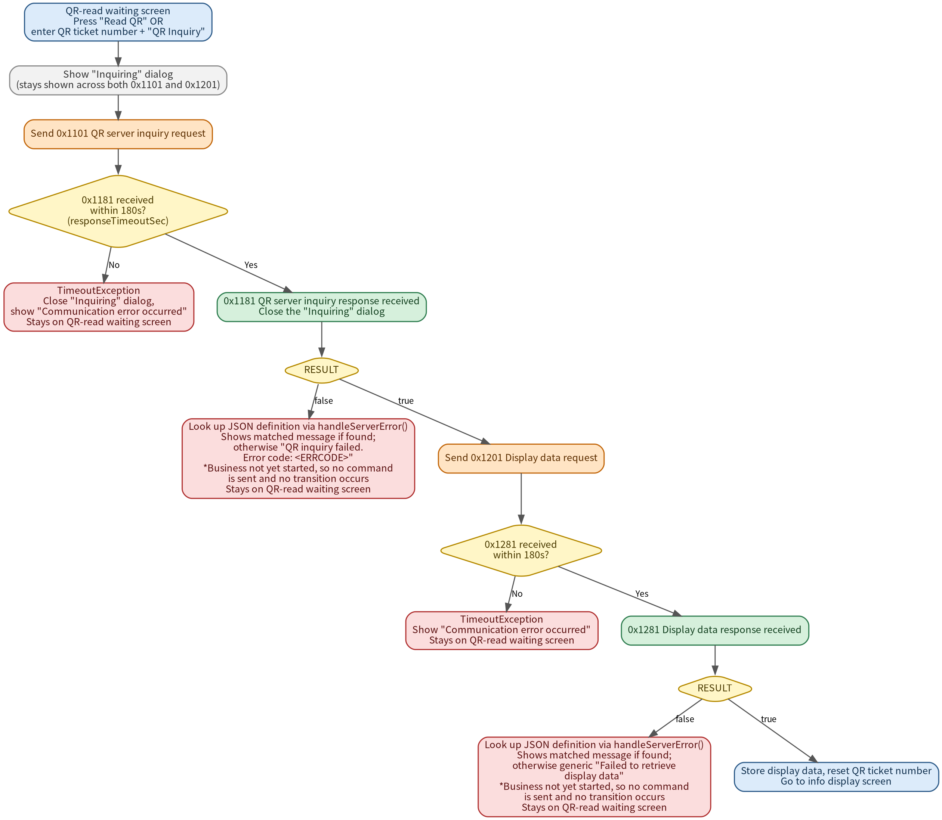
Figure 6.2-1 QR Read -> Inquiry -> Retrieve Display Data process flow (normal path, timeouts, and error path)
*The "Inquiring" dialog stays shown across both the 0x1101 and 0x1201 round trips, and is reliably closed via rootNavigator.
*0x1101 and 0x1201 each carry their own responseTimeoutSec timeout (default 180s). Whichever step fails or times out, 0xB101 (business cancel request) is not sent, since the business hasn't started yet; the app stays on the QR-read waiting screen. The QR-inquiry failure's generic message is the only one that actually shows the real ERRCODE value on screen, unlike the other generic messages.
Screen Captures
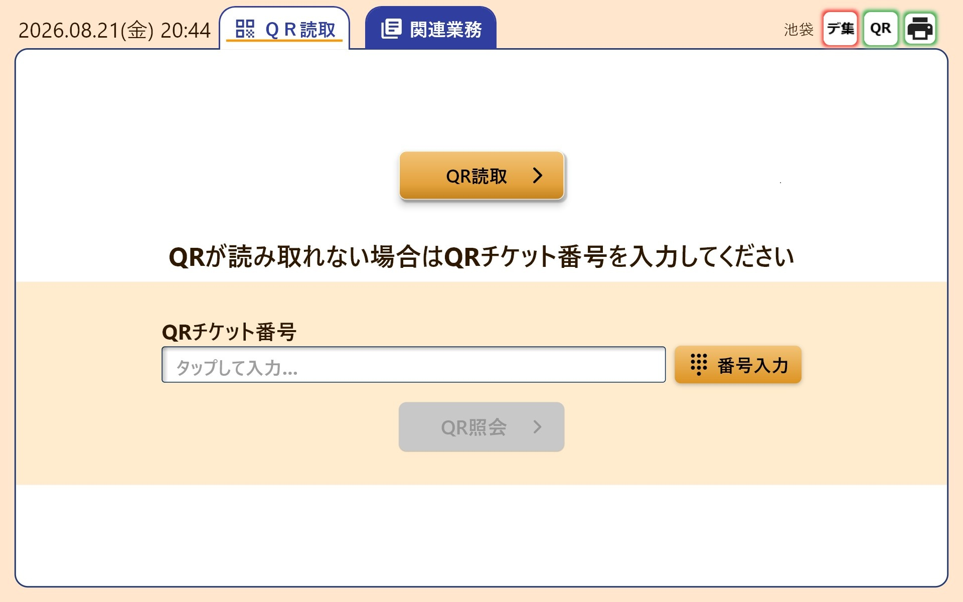
Figure 6.2-2 QR-read waiting screen: pressing "Read QR" starts the camera. If the QR can't be read, enter the QR ticket number manually via "Enter Number" and press "QR Inquiry."
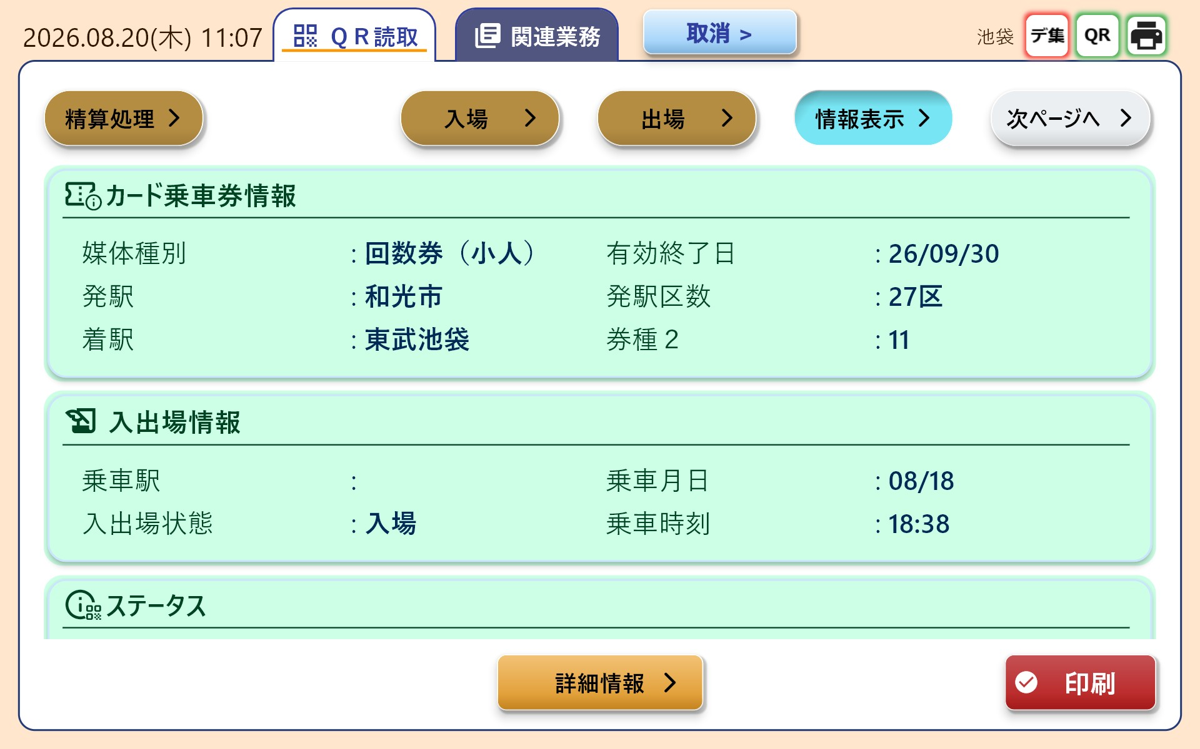
Figure 6.2-3 Info display screen shown after receiving 0x1281 (multi-ride ticket example). Three cards are shown -- ticket info, entry/exit info, and status -- along with the business buttons at the top. Button enabled/disabled state is determined by the control flags in the 0x1281 response.

6.3 Business Execution (Entry, Exit, Fare Settlement, Void, Origin-Station Cancel -- Shared)
Process Flow
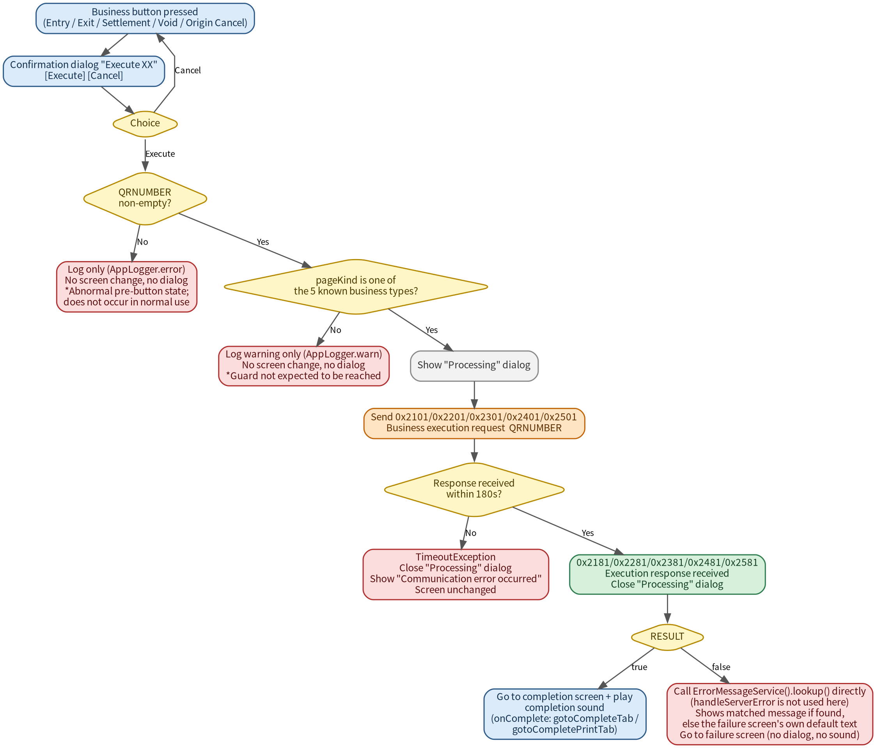
Figure 6.3-1 Business execution (shared across all 5 business types) process flow, including the internal guards for an empty QRNUMBER and an unknown pageKind
Screen Captures (Entry example)
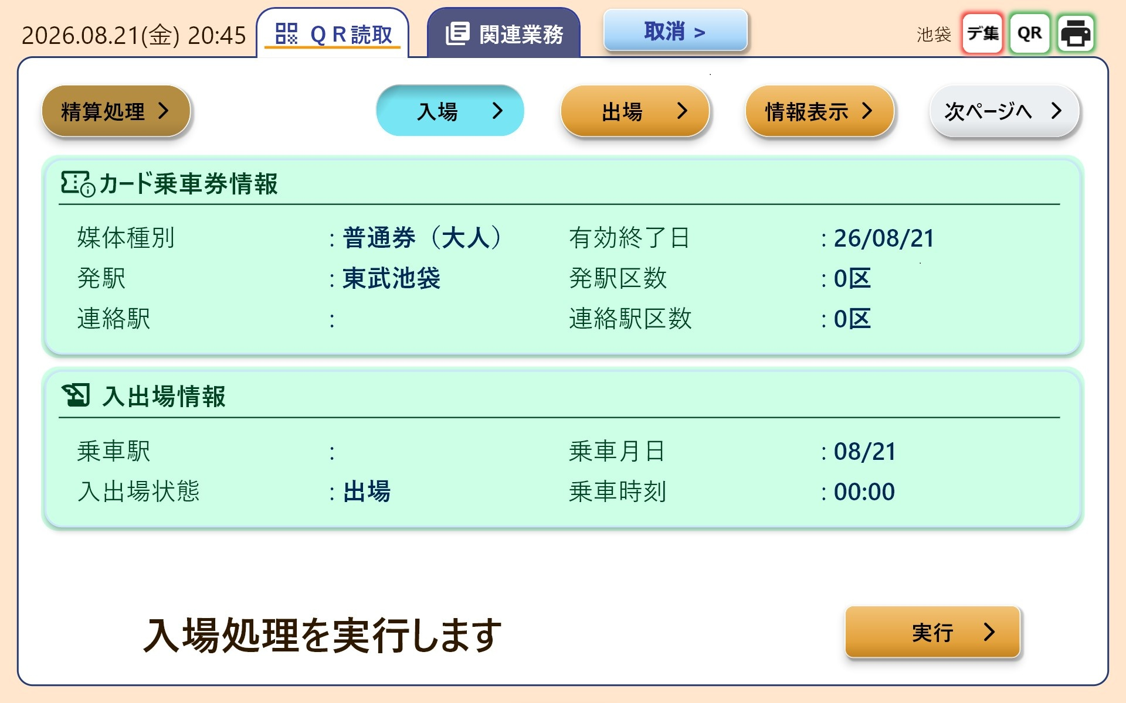
Figure 6.3-2 Entry screen: pressing "Execute" at bottom-right shows a confirmation dialog.
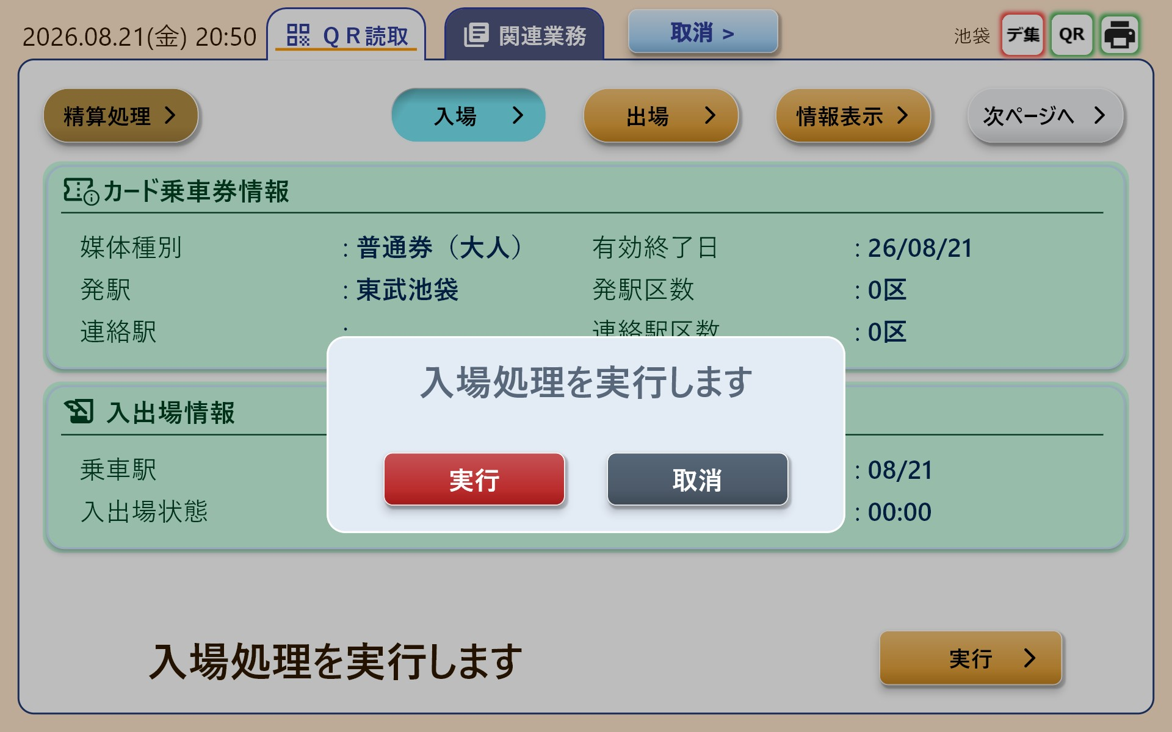
Figure 6.3-3 Confirmation dialog: pressing "Execute" sends 0x2101 (Entry). All 5 business types share the same dialog format ("Execute XX").
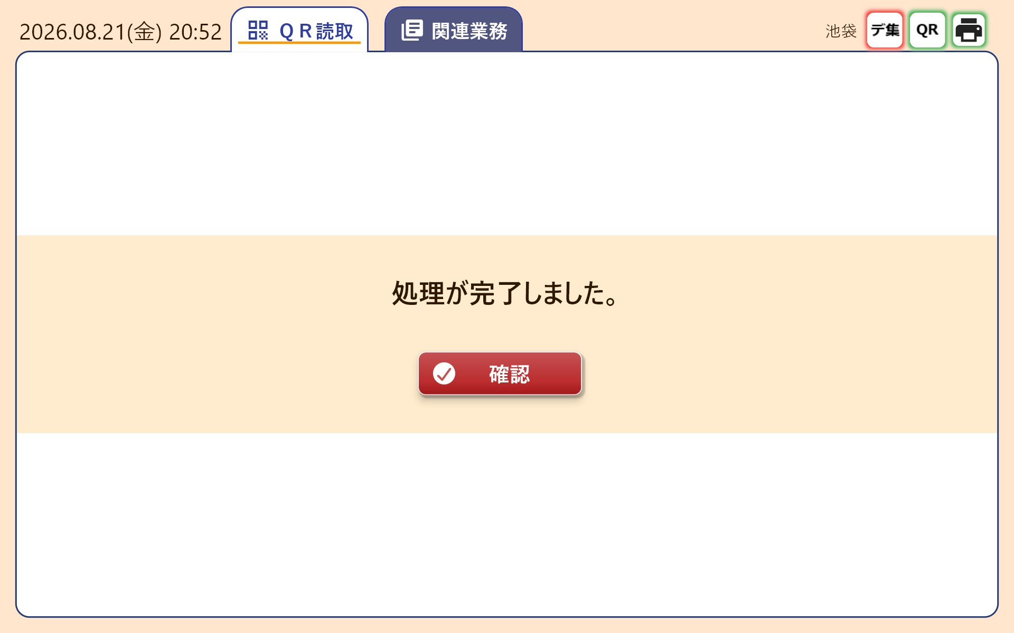
Figure 6.3-4 RESULT=true case: transitions to the completion screen and plays the completion sound. Pressing "Confirm" clears the display data and returns to the QR-read waiting screen.
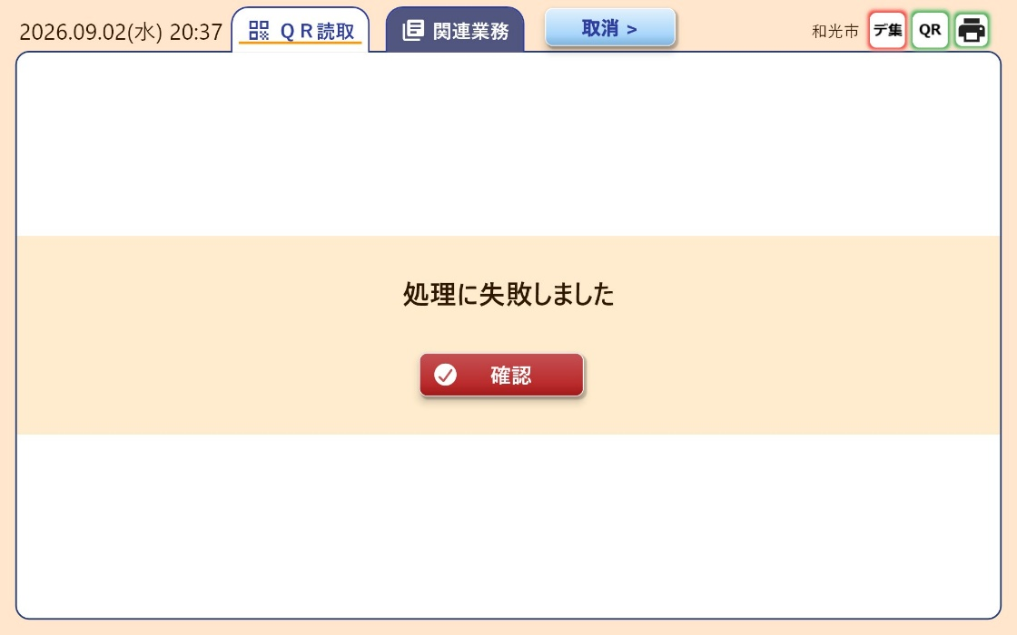
Figure 6.3-5 Failure screen (RESULT=false): shows the message from KbaErrorMessage.json. The completion sound is not played.
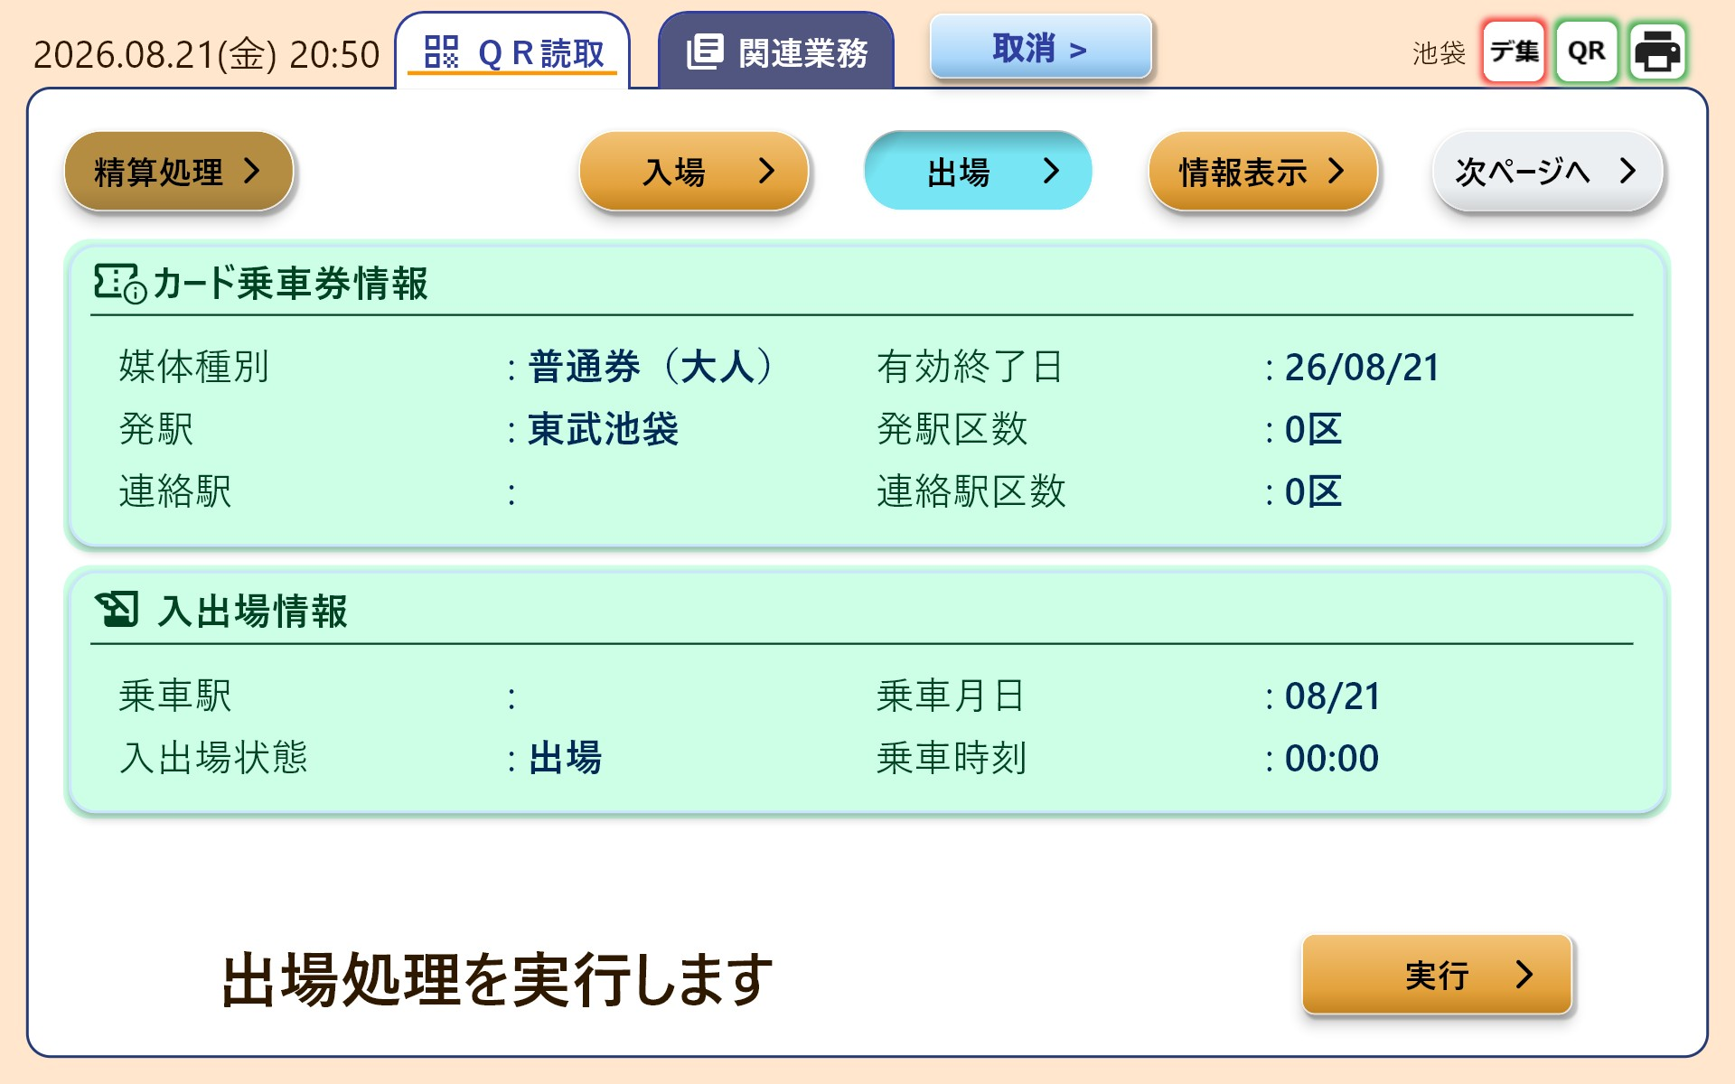
Figure 6.3-6 Exit screen (0x2201)
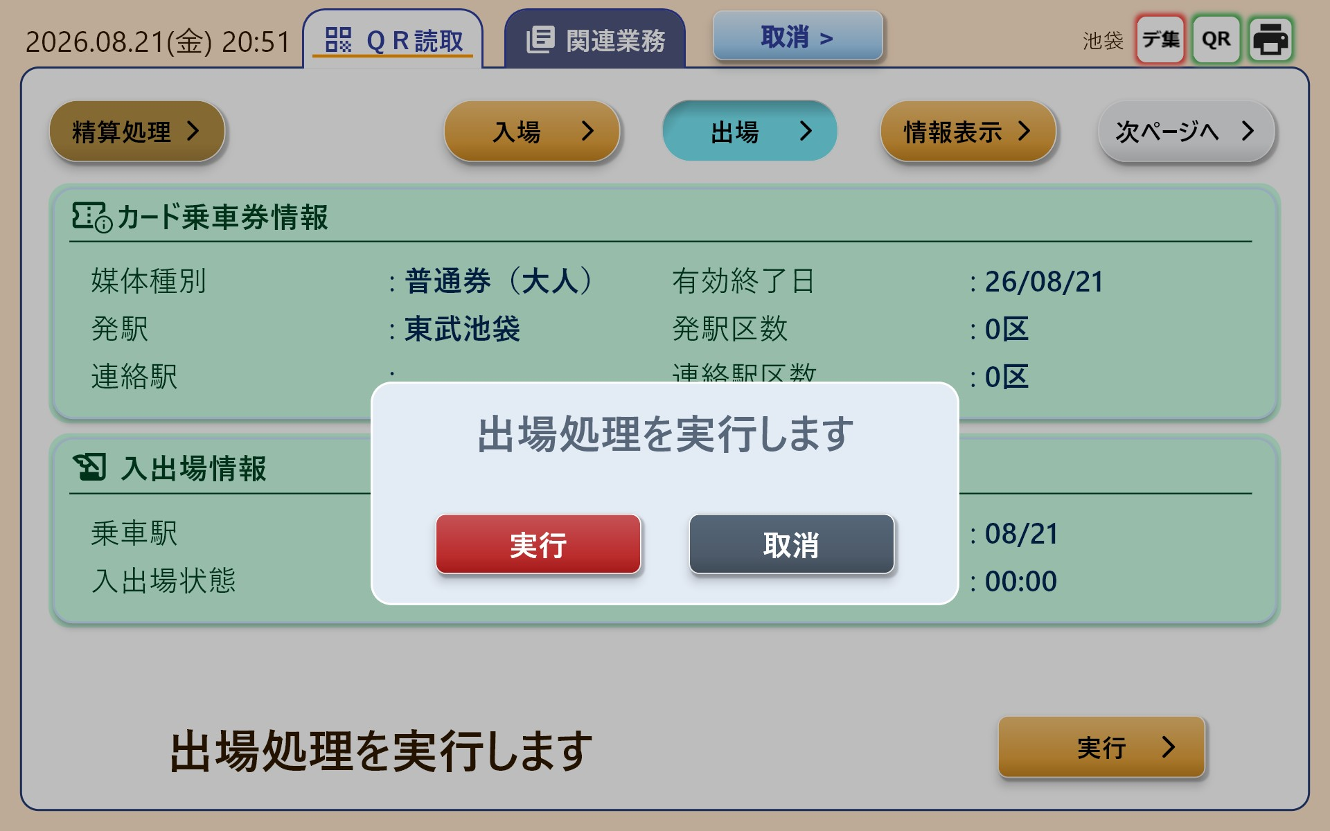
Figure 6.3-7 Exit-execution confirmation dialog
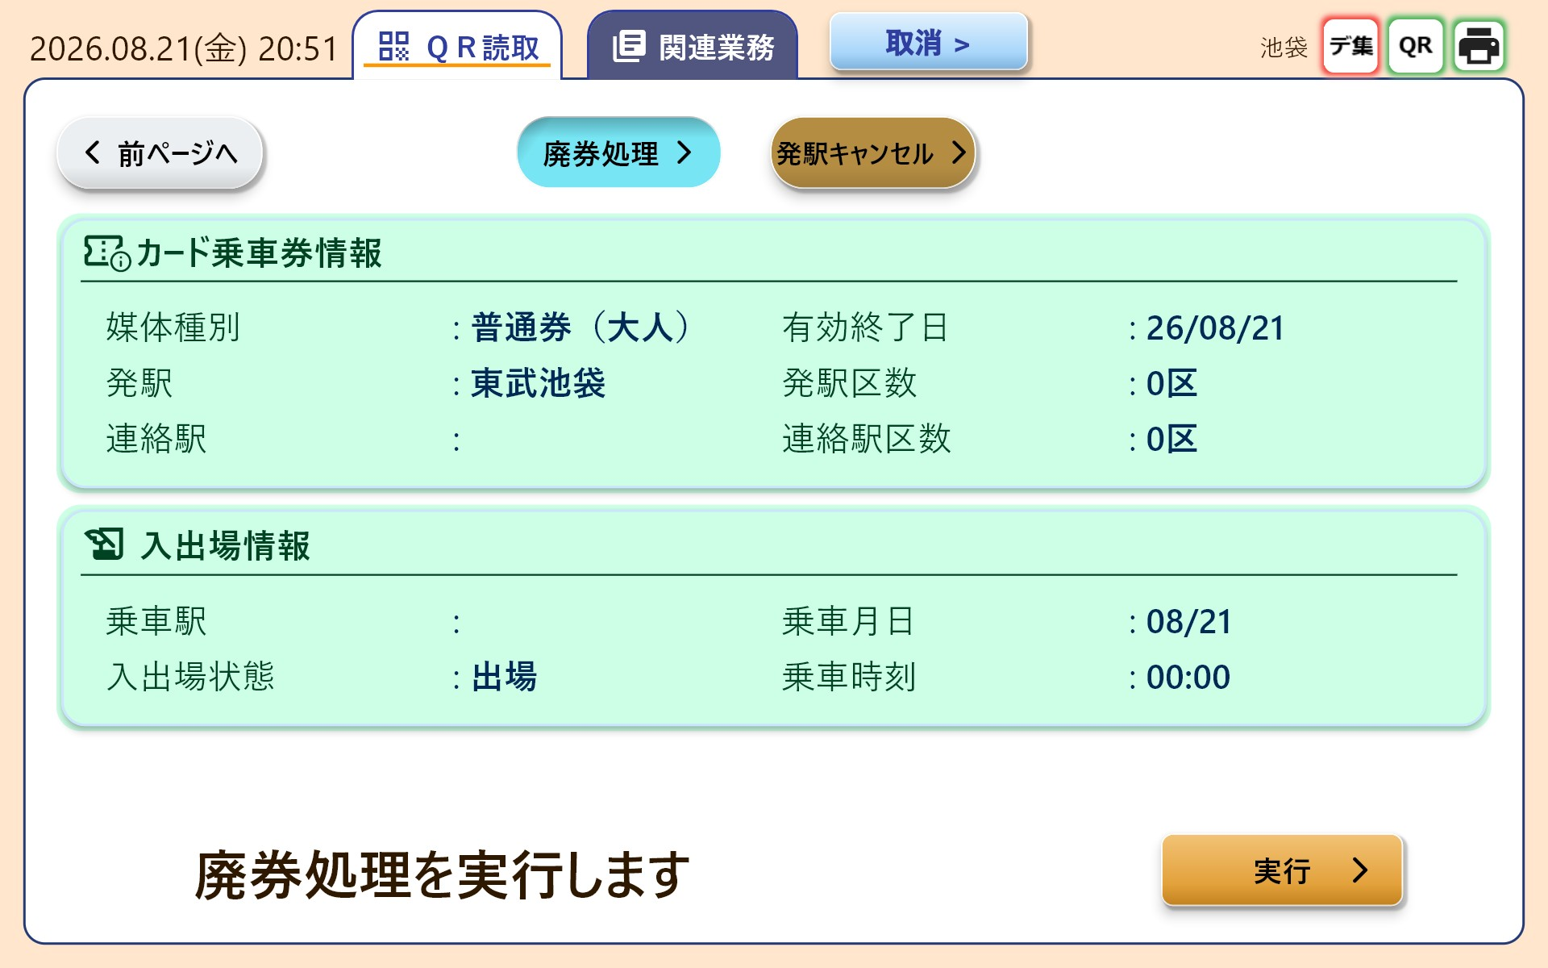
Figure 6.3-8 Void screen (0x2401). Void and Origin-Station Cancel are on page 2 of the business buttons (switch via "Next Page"; see 3.2).
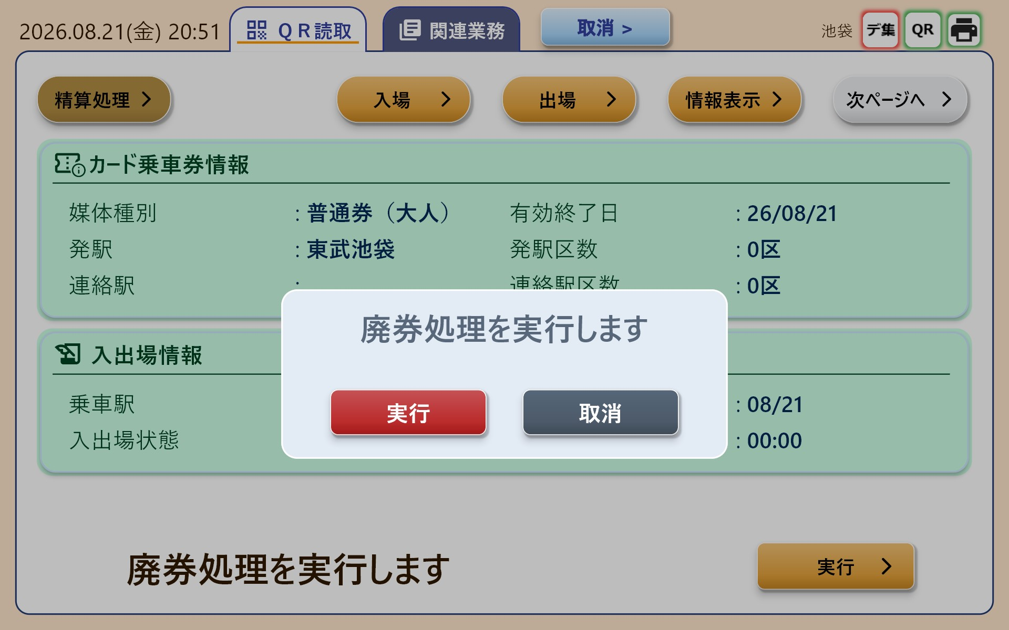
Figure 6.3-9 Void-execution confirmation dialog
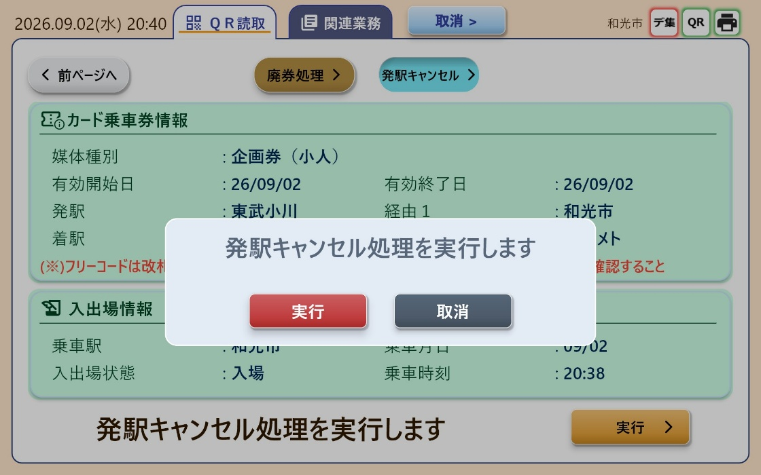
Figure 6.3-10 Origin-Station Cancel screen (0x2501) and confirmation dialog. Screen layout and dialog format are shared with the other 4 business types.

6.4 Fare Settlement (with Route Selection)
Process Flow
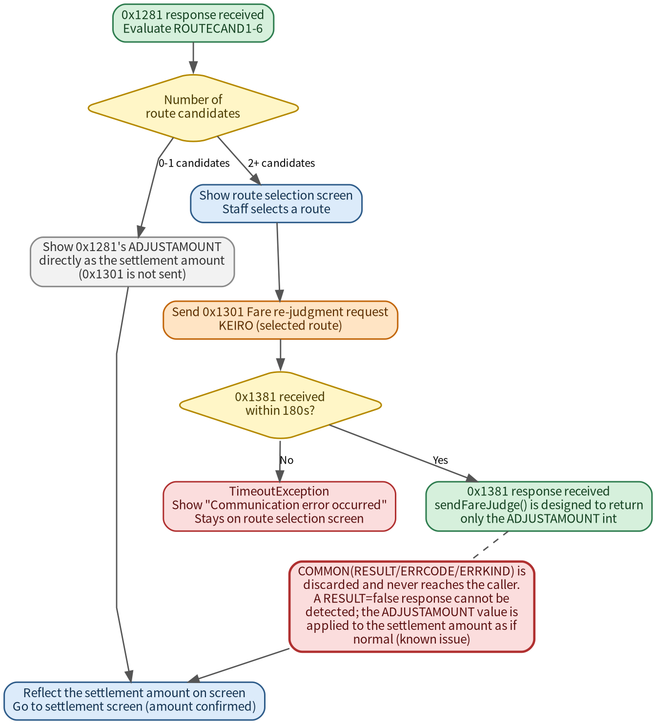
Figure 6.4-1 Fare settlement (route-selection judgment) process flow, including the known issue where 0x1381's RESULT is discarded
Screen Captures
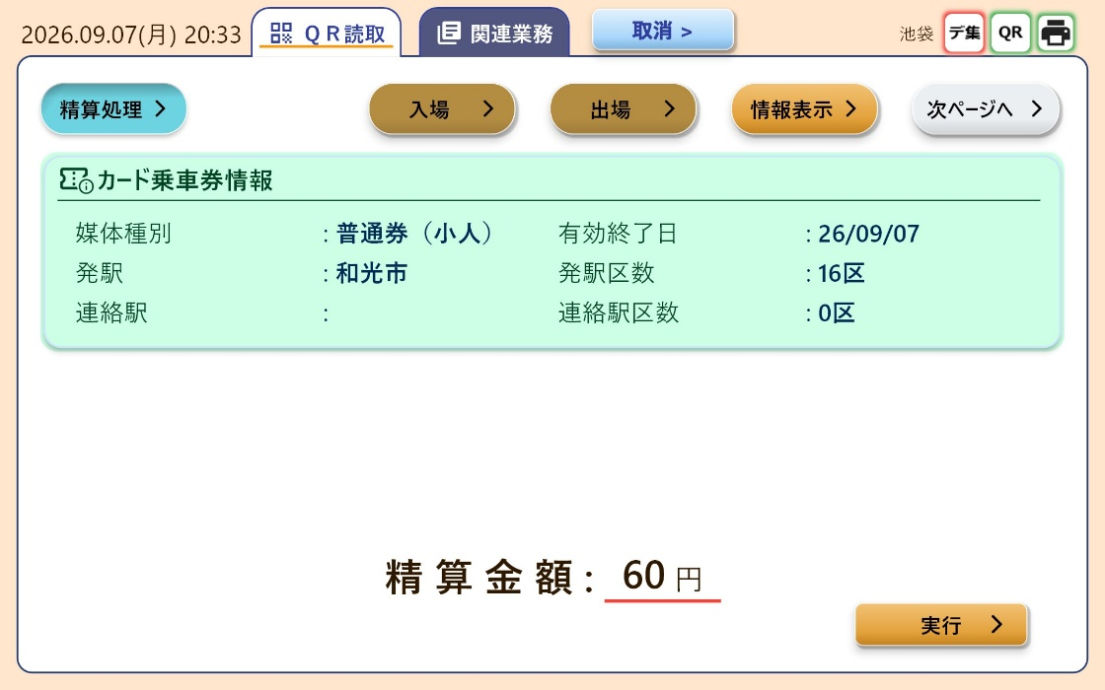
Figure 6.4-2 Settlement screen (no route selection: ROUTECAND has 0-1 entries)
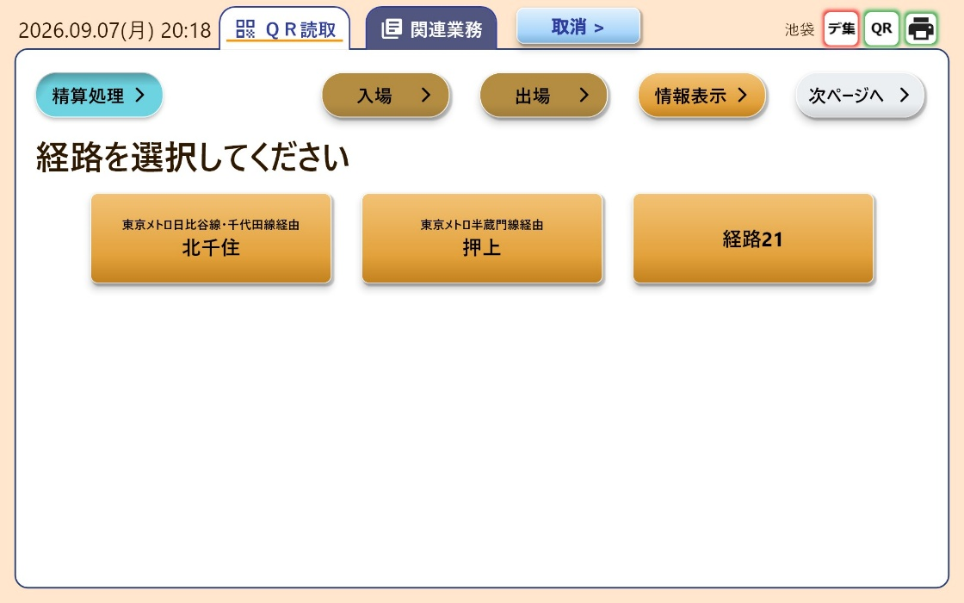
Figure 6.4-3 Route selection screen (ROUTECAND has 2+ entries)

6.5 Printing (QR Ticket-Info Journal / Receipt)
Process Flow
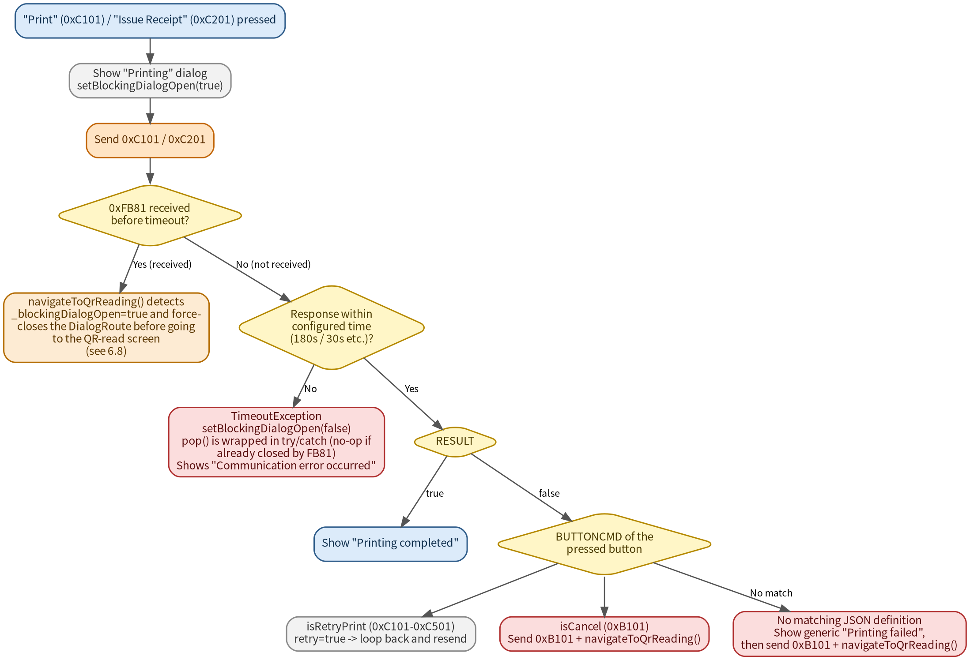
Figure 6.5-1 Printing (journal / receipt) process flow, including the 0xFB81 race-condition fix, retry, cancel, and the no-JSON-match branch
Screen Captures
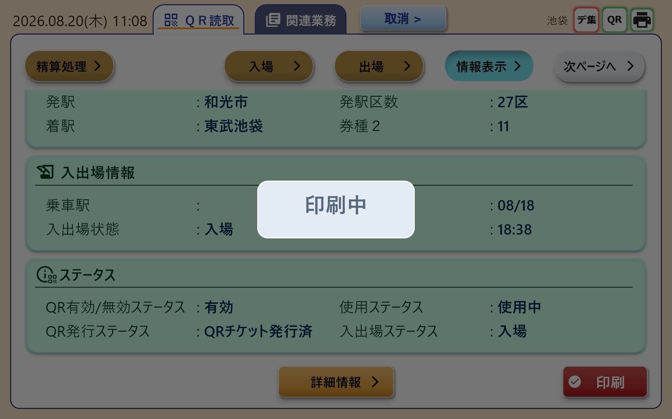
Figure 6.5-2 Pressing "Print" on the info display screen (sends 0xC101): shows the "Printing" dialog.
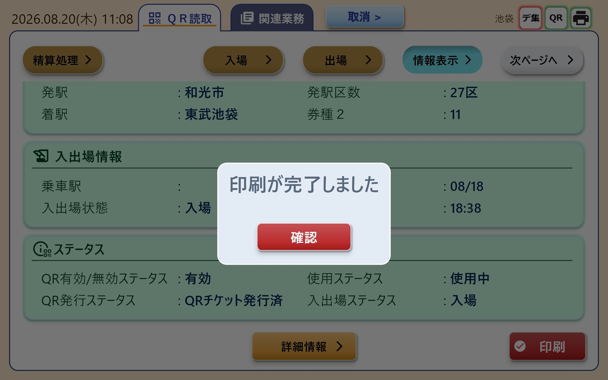
Figure 6.5-3 When 0xC181 is received with RESULT=true: shows "Printing completed."
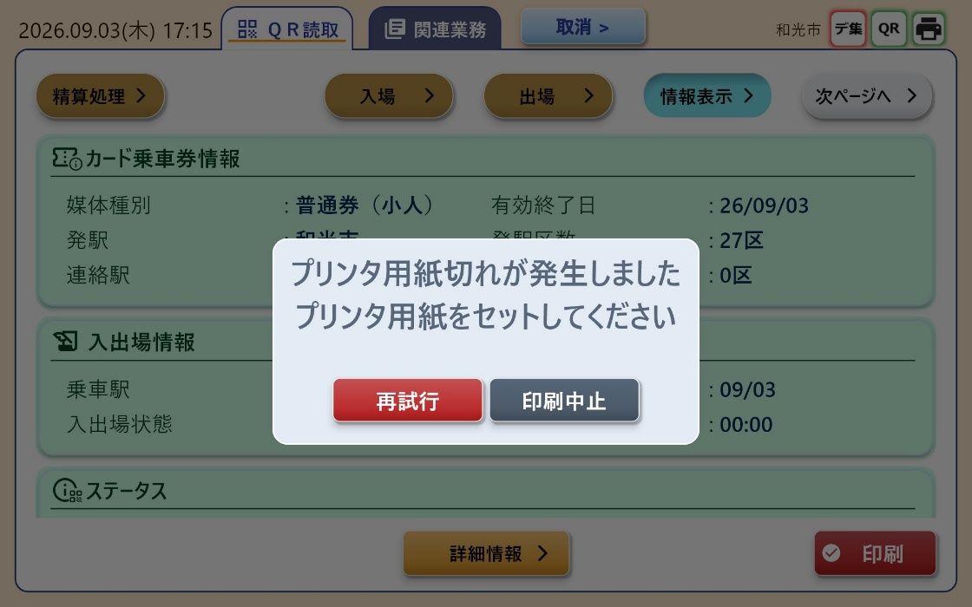
Figure 6.5-4 Out-of-paper error dialog ([Retry] / [Cancel Printing]): the two buttons come from KbaErrorMessage.json's BUTTONLIST. [Retry] re-sends the same command.

6.6 Business Cancellation (Pressing the Cancel Button)
Process Flow
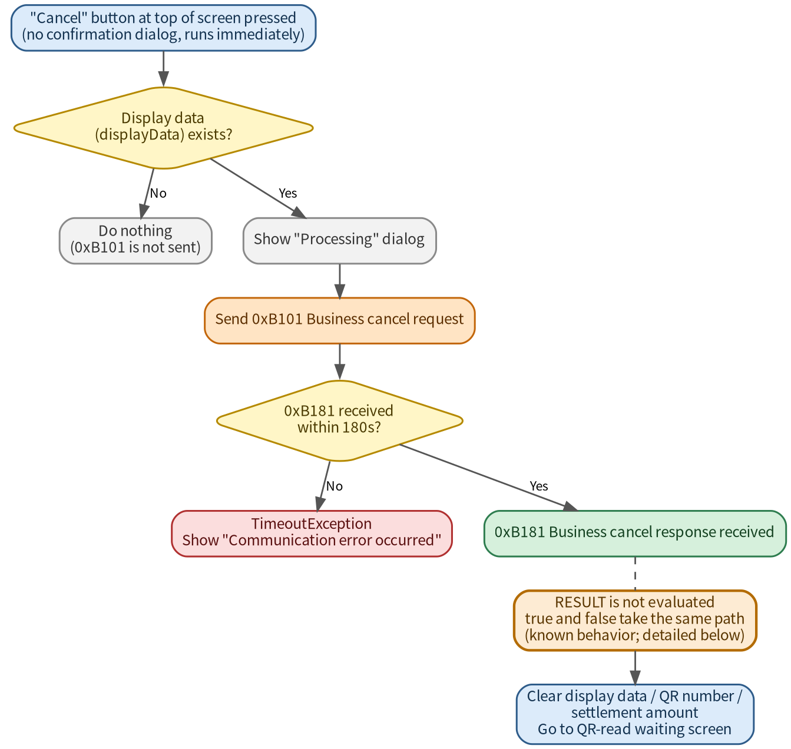
Figure 6.6-1 Business cancellation process flow, including the displayData-presence check and the known behavior that 0xB181's RESULT is not evaluated

6.7 Logoff
Process Flow
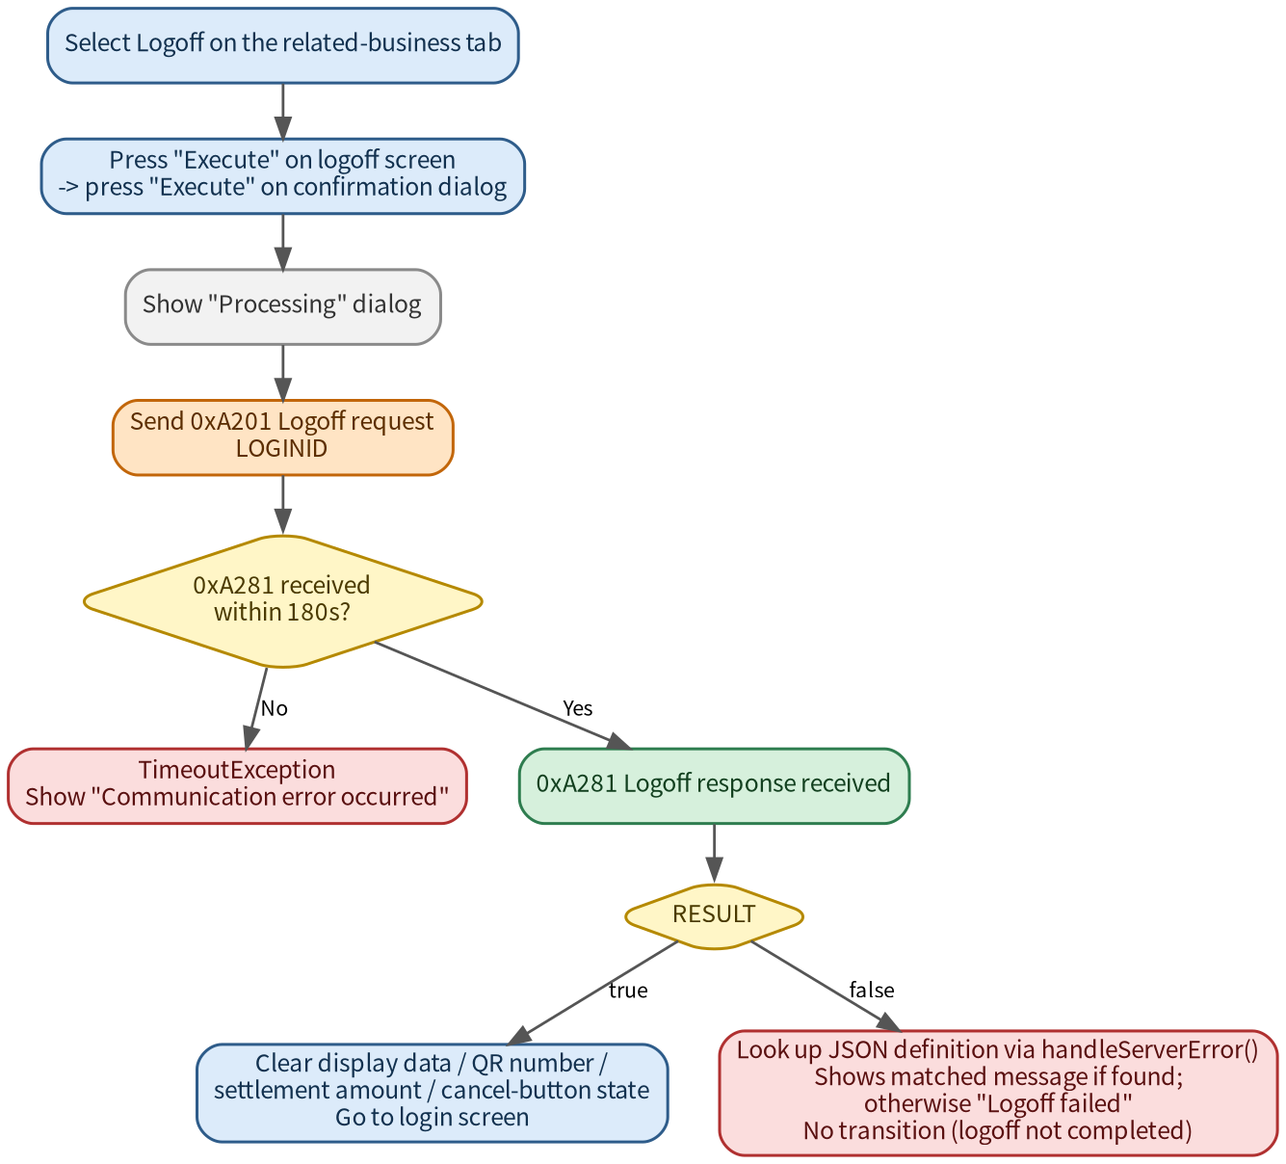
Figure 6.7-1 Logoff process flow, including the timeout and JSON-definition-error branches
Screen Captures
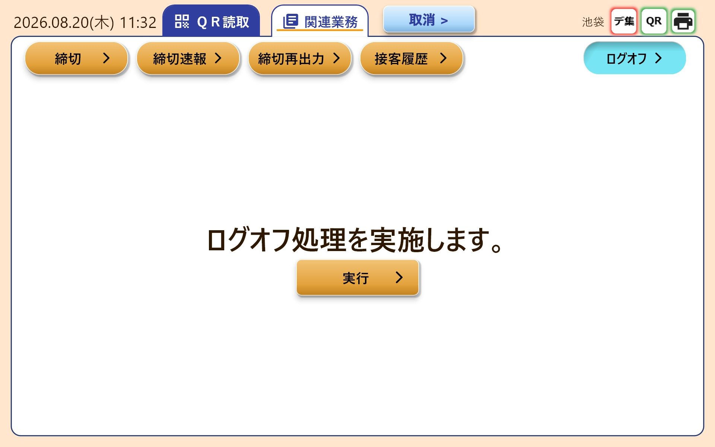
Figure 6.7-2 Logoff screen (within the related-business tab): pressing "Execute" shows a confirmation dialog.
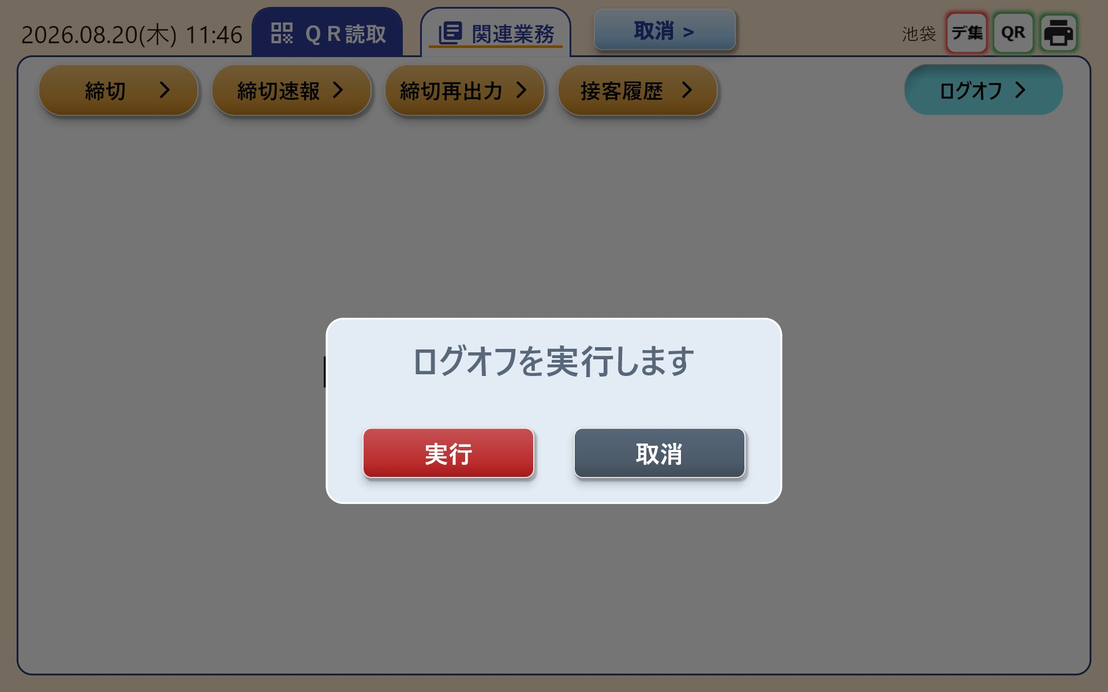
Figure 6.7-3 Logoff confirmation dialog: pressing "Execute" sends 0xA201 (with LOGINID attached). After receiving 0xA281 with RESULT=true, all state is cleared and the app returns to the login screen.

6.8 Asynchronous Notifications (Connection-State Change / Main-Control Abnormality / Forced Business Cancellation)
Process Flow
Figure 6.8-1 Asynchronous notification (0xF181 / 0xFA81 / 0xFB81) process flow
Screen Captures
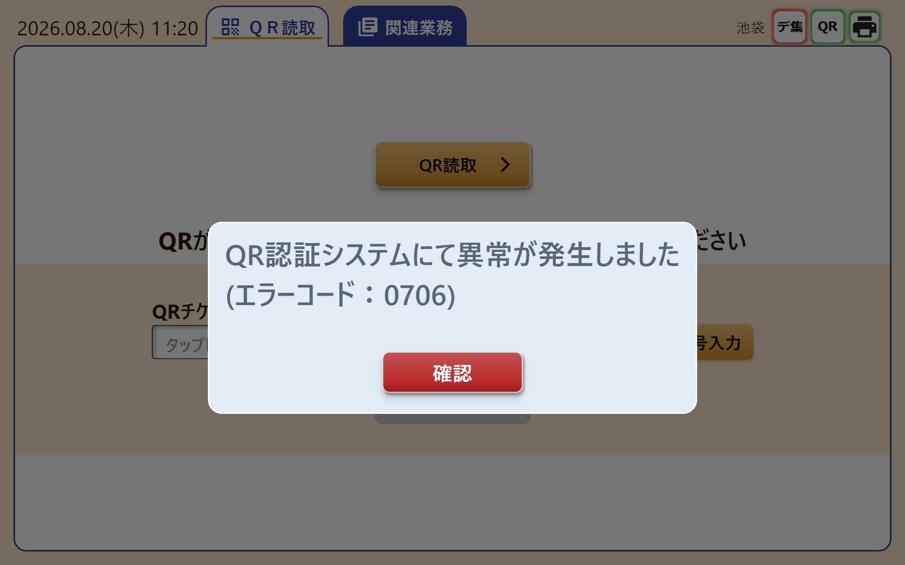
Figure 6.8-2 Example error dialog: KbaErrorMessage.json is searched by ERRKIND/ERRCODE, and the defined MESSAGE and BUTTONLIST are shown (this example: QR authentication system abnormality, error code 0706). This dialog format is shared across error displays for every response message, not just 0xFA81.

7. Data Changes by Business Tab
This chapter shows how screen data changes, by timing, across each business tab (Entry, Exit, Fare Settlement, Void, Origin-Station Cancel) after a QR read. The related-business (closing series) tab is out of scope here.

7.1 Shared Prerequisite: Up to Retrieving Display Data
Among the flags in the 0x1281 response, the ones that determine whether each business button is enabled are as follows.
Button | JSON Flag | If true | If false or flag missing
Entry | ENTERBTNENABLED | Button turns orange (enabled) | Shown grey (disabled). Tapping does not start processing
Exit | EXITBTNENABLED | Button turns orange (enabled) | Shown grey (disabled). Tapping does not start processing
Fare Settlement | ADJUSTBTNENABLED | Button turns orange (enabled) | Shown grey (disabled). Tapping does not start processing
Void | HAISATUBTNENABLED | Button turns orange (enabled) | Shown grey (disabled). Tapping does not start processing
Origin-Station Cancel | ENTERCANCELBTNENABLED | Button turns orange (enabled) | Shown grey (disabled). Tapping does not start processing

7.2 Ticket-Type-Specific Data Changes in the Card Ticket Info
Which fields are shown on the card switches based on the value of MEDIATYPE.
Item (Key) | Regular  (11/12) | Multi-Ride  (21/22) | Special  (31/32)
Media type | o | o | o
Valid-from date | x | x | o
Valid-to date | o | o | o
Origin station | o | o | o
Origin-station zone count | o | o | x
Transfer station | o | x | x
Transfer-station zone count | o | x | x
Destination station | x | o | o
Ticket type 2 | x | o | x
Route 1 | x | x | o
Route 2-8 | x | x | △ (detail info dialog only)
Free code | x | x | o

7.3 Shared Specification for the Completion / Failure Screens
Result | Destination | Completion Sound | After Pressing Confirm
Success | Completion screen  (fare settlement has its own dedicated completion screen) | Played | To QR-read screen
Failure | Failure screen (new) | Not played | To QR-read screen (same as success)

*The completion sound is played when gotoCompleteTab() / gotoCompletePrintTab() is called (on every transition to those tabs). It is not played on gotoFailedTab() (the failure screen).

8. Error Message Display
A mechanism that, based on the ERRKIND/ERRCODE carried in Main Control's responses and notifications, looks up the message and button layout from an external definition file (KbaErrorMessage.json) and displays it.

8.1 Definition File Specification
Item | Detail
File name | KbaErrorMessage.json (path given by app_config.json's ERROR_MSG_PATH)
Character encoding | Shift-JIS
Load timing | Loaded in full and cached at app startup (main.dart)
Lookup key | Composite key of ERRKIND (error location) + ERRCODE (detail code)

Example JSON structure:
{ "ERRORLIST": [ { "ERRORKIND": 0, "ERRORCODE": 4098,
"MESSAGE": "Printer out of paper...",
"BUTTONLIST": [ {"BUTTONTXT":"Retry","BUTTONCMD":49409},
{"BUTTONTXT":"Cancel Printing","BUTTONCMD":45313} ] } ] }
The flow from a JSON definition to the actual dialog on screen, and the constraints on button count and character count, are shown below.
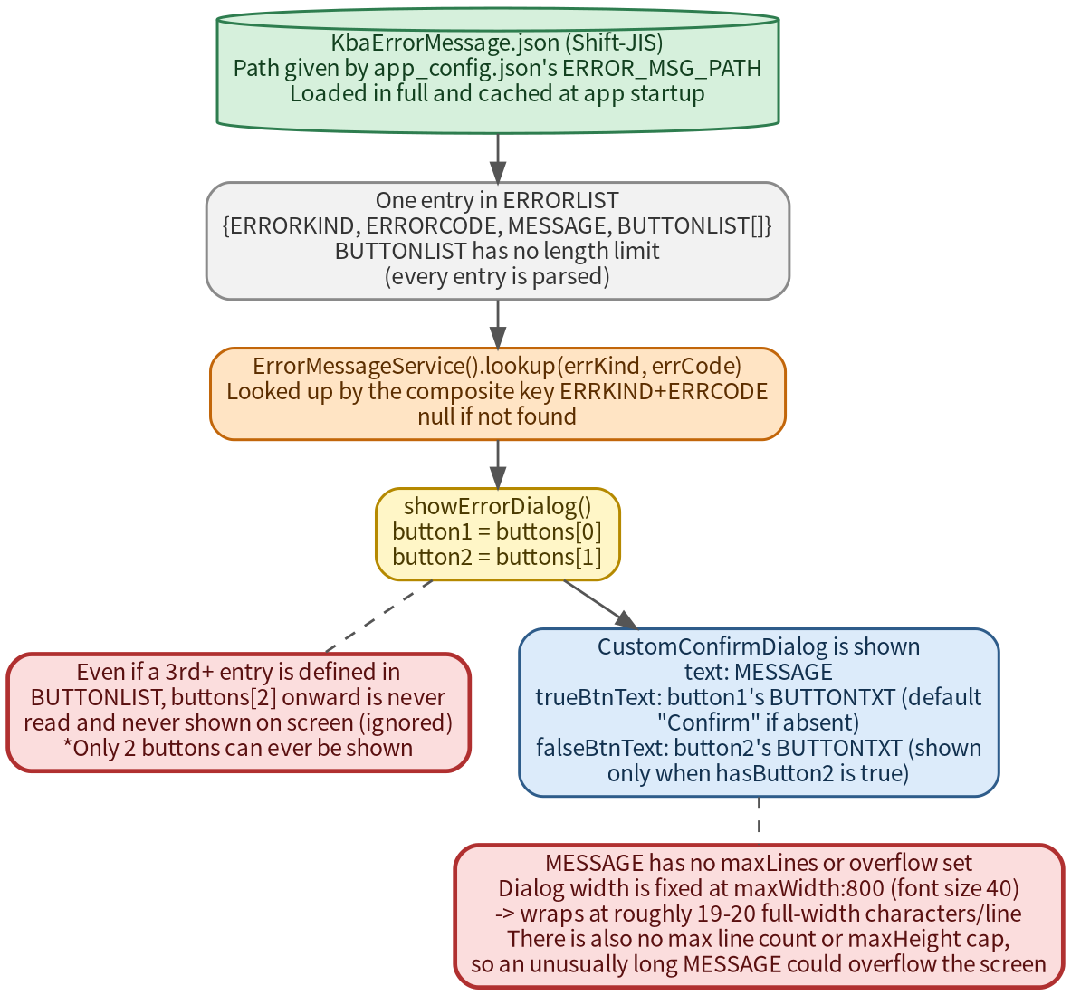
Figure 8.1-1 Flow from JSON definition to dialog display, and the constraints on button count and character count

8.2 Implementation Classes
Class / Function | Location | Summary
ErrorMessage / ErrorButton | model/error_message.dart | Model for one JSON definition entry. BUTTONCMD is held as an int;  commandHex exposes it formatted as "0xNNNN"
ErrorMessageService | service/error_message_service.dart | load() reads and caches the JSON; lookup(errKind, errCode) searches it
showErrorDialog() | utility/error_dialog.dart | Shared dialog that shows the message and buttons
handleServerError() | utility/error_handler.dart | Shared function: lookup -> display -> returns an ErrorResult  (the command of the pressed button)
ErrorResult | utility/error_handler.dart | Carries isRetryPrint / isCancel / isAppExit evaluation properties

8.3 Button Commands and What the Caller Does
Command | ErrorResult Evaluation | Action Taken by the Caller
0xB101 | isCancel | Sends sendCancel() and transitions to the QR-read screen
0x0F01 | isAppExit | Sends sendAppExit() and exits the app
0xC101-0xC501 | isRetryPrint | Re-sends the matching print request (retry loop)
No command (null) | handled=true, command="" | Only closes the dialog. No transition, no command sent
No matching definition | handled=false | Falls back to the default message each caller provides

8.4 Differences in Behaviour by Location
Location | Behaviour on isCancel (0xB101)
Login (0xA181) | Not applied. Only shows the JSON-defined message
QR Inquiry (0x1181) | Not applied by design, since the business hasn't started yet:  no command is sent, no transition occurs
Display Data (0x1281) | Not applied (as of August 2026). A change to send sendCancel()  is planned
Business Execution (0x2181-2581) | On failure, transitions to the failure screen (see ch.6, ch.7).  isCancel itself is unused on this path
Printing (0xC101/0xC201) | Retries via isRetryPrint; sends 0xB101 via isCancel
0xFA81 | Only isAppExit is evaluated; isCancel is unused
Fare Re-judgment (0x1301/1381) | Not implemented. ERRCODE is not evaluated even when RESULT=false

9. Camera Functionality
Camera control used for QR reading. The implementation follows the constraints of the camera_windows plugin.

9.1 Class Structure
Class | Location | Summary
CameraScanner | camera_scanner.dart | Stateful widget showing the camera preview and running QR analysis
_CameraScannerState | camera_scanner.dart | Holds the actual logic for camera init, the analysis loop, and camera switching
CameraScannerController | camera_scanner.dart | Controller letting a parent widget operate the camera
ScannerWidget | component/scanner.dart | QR-read screen; wraps CameraScanner and returns detection results to its caller

9.2 QR Analysis
Item | Detail
Capture method | Still image via CameraController.takePicture()
Decode library | zxing2 (QRCodeReader)
Data extraction | Taken from resultMetadata's byteSegments, converted with b & 0xFF for unsigned bytes
Byte-length limit | None. All read QR data is sent to Main Control

The processing from a camera image to QR-code detection runs as a loop on a fixed interval (Timer.periodic). The overall flow is shown below.
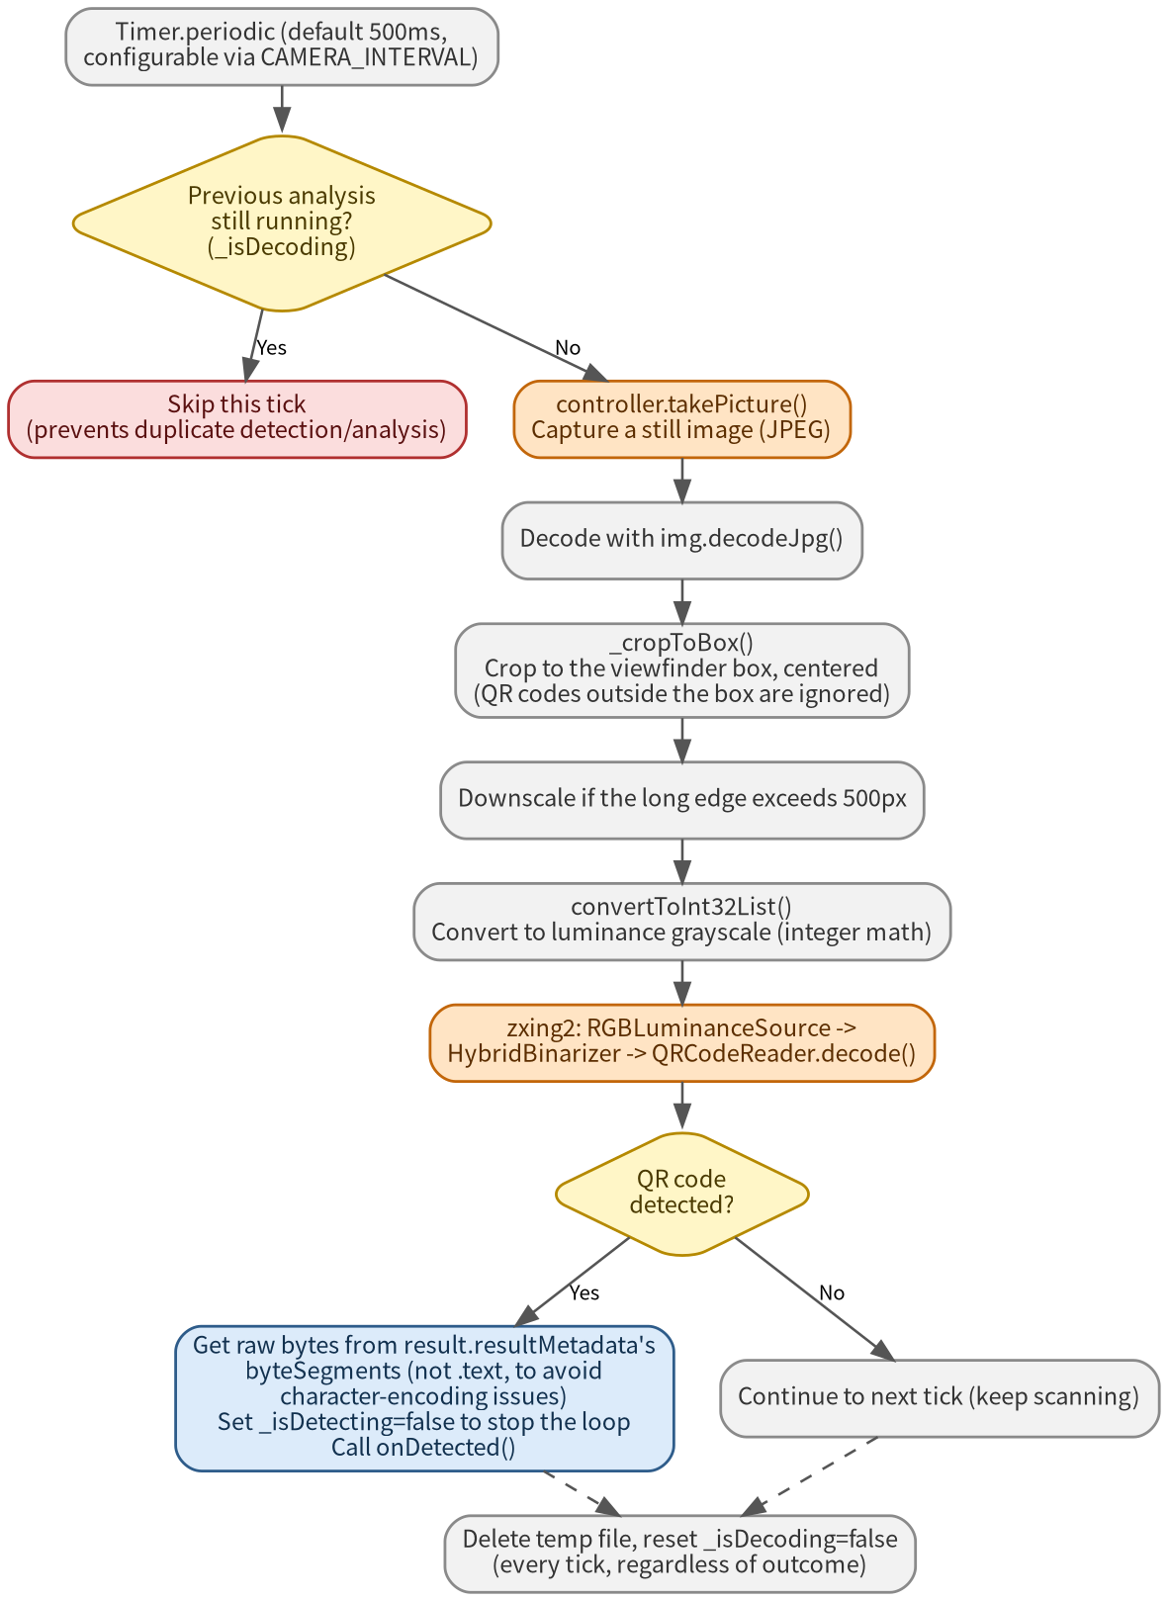
Figure 9.2-1 QR analysis process flow (the full detection loop)
Behaviour When an Unexpected QR Code or Size Is Read
The responsibility for handling "a QR code that isn't actually a real ticket" or "a QR code whose size differs from what's expected" is split between the client side (camera_scanner.dart) and the server side (Main Control).
Case | Client-Side (Dart) Behaviour
Cannot detect a QR code at all  (too small, blurry, etc.) | zxing2's decode() throws an exception, caught in a catch block. Simply continues to the next tick (effectively, nothing happens)
Detected as a QR code but has no  byteSegments  (e.g. non-binary-encoded QR) | onDetected is never called; simply continues to the next tick
Detected as a QR code and  byteSegments is retrieved, but the  data is invalid as a ticket  (unexpected size/content, etc.) | No content validation is performed client-side at all; onDetected() is called as-is and  the data is sent to 0x1101. Validity is judged entirely on the Main Control side  (0x1181's RESULT); see 6.2

*In every case above, an internal status string (e.g. "No QR code," "Decode failed") is set on _qrText, but this string is shown on screen only when the displayResult parameter is true. In the actual production screen (invoked via scanner.dart), displayResult is left at its default of false, so none of these states are ever shown to staff. In other words, there is currently no way for staff to know what's happening on the camera screen when a read fails.

9.3 Individual Implementation Considerations
The following 4 points are individual accommodations made for constraints of the camera_windows plugin and issues found on the real device. Each pairs with a corresponding entry in chapter 11's known design decisions.

9.3.1 Performance Optimization
Measure | Detail
Resolution | ResolutionPreset.low, enableAudio: false
Downscale before decode | After JPEG decode, downscale to a 500px long edge before analysis
Analysis interval | Externally configurable via app_config.json's CAMERA_INTERVAL (default 500ms)

9.3.2 Preventing Duplicate Detection
A countermeasure for a screen going black due to dialogs stacking up from repeated detection of the same QR code.
*This only occurred on faster devices (a race between dialog creation and disposal).

9.3.3 Digital Zoom
*camera_windows does not support setZoomLevel (getMaxZoomLevel always returns 1.0), so a crop-based approach was used instead.

9.3.4 Remembering the Selected Camera
*Both cameras on this device report lensDirection as "front," so lens direction can't be used to tell them apart; the camera name (CameraDescription.name) is used instead.
Screen Captures
Figure 9-1 Camera-reading screen (preview, pinch-zoom, camera-switch button) -- shows the behaviour covered in 9.3.2-9.3.4 (duplicate-detection prevention, digital zoom, remembering the selected camera)

10. Implementation Classes / Function List

10.1 TcpService (service/tcp_service.dart)
Method | Matching Command | Summary
start() / stop() | - | Start/stop the service (connect the send socket, start the receive listener)
sendPacket() | - | Generic packet send (shared internal logic)
sendInitComplete() | 0x0A01 | Screen-control init complete notice
sendLoginRequest() | 0xA101 | Login request
sendLogoff() | 0xA201 | Logoff request
sendQrServerRequest() | 0x1101 | QR server inquiry request
sendDisplayDataRequest() | 0x1201 | Display data request
sendFareJudge() | 0x1301 | Fare re-judgment request
sendBusinessSelect() | 0xAA01 | Business-selection notice
sendProcessRequest() | 0x2101-0x2581 | Business execution request (shared method, command ID passed as an argument)
sendCancel() | 0xB101 | Business cancel request
sendPrintQrInfo() | 0xC101 | QR ticket-info journal print request
sendPrintReceipt() | 0xC201 | Receipt print request
sendAppExit() | 0x0F01 | Application exit request
navigateToQrReading() | - | Forces a transition to the QR-read screen, either on receiving 0xFB81 or when called explicitly from one of the flows. When called, closes any blocking dialog first if _blockingDialogOpen is set (see 6.8)
_handlePacket() | - | Core method that dispatches a received packet by command ID
setBlockingDialogOpen() | - | Sets/clears the flag indicating a long-wait blocking dialog ("Printing," "Processing," etc.) is showing

10.2 Data Models (model/*.dart)
*Every model shares a common fromJson structure that parses COMMON (RESULT/ERRCODE/ERRKIND) and DATA.
Model | Matching Command | Summary
InitData | 0x0A81 | Init data (station name, connection-check result)
LoginResponse | 0xA181 | Login result (includes AUTHORITY)
QrServerResponse | 0x1181 | QR server inquiry result
DisplayData | 0x1281 | Ticket info, button control flags, etc.
ProcessResponse | 0x2181-2581/B181/C181/C281 | Shared response model for each business execution, cancel,  and print result
ErrorMessage / ErrorButton | - (KbaErrorMessage.json) | Model for one error definition entry

10.3 State Management (provider/*.dart, Riverpod)
*JudgeRouteList / JudgeRouteId have keepAlive:false, so they must be subscribed to via ref.watch to stay alive (ref.read alone does not prevent auto-disposal).
Provider | keepAlive | Summary
DisplayDataNotifier | true | Holds the content of 0x1281 and reflects it on screen
LastQrData | true | The raw data of the most recently read QR code
QrTicketNo | true | QR ticket number
ConnectionStatus | true | For the connection-status icons at the top of the screen (TOTALSERVER/QRMODULE/PRINTER)
CurrentCameraLens | true | The lens direction of the camera currently in use
CancelBtnVisible | true | Controls display of the cancel button
FareAmount | true | Settlement amount display
FailedMessage | false (default) | Message shown on the failure screen
QrButtonView | false (default) | Which of the 2 business-button pages is showing
JudgeRouteList / JudgeRouteId | false | Fare-settlement route candidates and the selected state
QrReadPageSelectedBtn | false | The currently selected business tab
PrintingProgress / PrinterCreated / ToPrint | false | State related to print processing

10.4 Shared Processing
Class / Method | Location | Summary
CsvService.lookup() | service/csv_service.dart | Looks up Dispinfo.csv (Shift-JIS, 4 columns) to convert code values into display names
SoundService.playComplete() | service/sound_service.dart | Plays the completion sound when business execution finishes
AppLogger | service/app_logger.dart | Writes to the daily log file; auto-deletes old logs
DisplayDataMapper | model/display_data_mapper.dart | Converts each DisplayData field for display (e.g. hex conversion of ticket type)

10.5 Screen (UI) Key Classes
Class | Location | Summary
LoginPage / _LogInBox | login/login_page.dart | Login screen. ID/password entry, AUTHORITY branching
QrProcessMenu / QrProcessMenuState | qr_process/qr_process_menu.dart | Tab control from QR read through business selection. _doQrInquiry(), etc.
SecondaryTabMenuForQrProcess | qr_process/secondary_tab_menu.dart | Switches between the business-flow tabs (QR read / business select / complete / fail)
SecondaryTabContentUnselected | qr_process/secondary_tab_content_unselected.dart | The business-selection buttons and _sendProcessRequest()
CardInfoContents | qr_process/secondary_tab_process_information.dart | Ticket-type-specific display of the card ticket info
ProcessCompleted / ProcessCompletedPrint / ProcessFailed | component/process_completed.dart | The completion and failure screen widgets
CameraScanner / ScannerWidget | camera_scanner.dart  component/scanner.dart | Camera control and the QR-read screen
MyHomePage | my_home_page.dart | Overall app tab structure and cancel-button control

11. Configuration File Specification
app_config.json externalizes settings such as the TCP destination and various file paths. Implementation: config/tcp_config.dart.
*Default values are given by the _default* constants in config/tcp_config.dart. If the configuration file fails to load, every setting falls back to its default value.
Config Key | Detail | Default
TCP_HOST | Destination host | 127.0.0.1
TCP_RECEIVE_PORT | Receiving port | 21002
TCP_SEND_PORT | Sending port | 21001
LOG_DIR | Log output directory | (see the in-code default)
BEEP_SOUND_PATH | Completion-sound file path | (see the in-code default)
CSV_PATH | Display-dictionary CSV path | (see the in-code default)
ERROR_MSG_PATH | Error-message definition JSON path | (see the in-code default)
CAMERA_INTERVAL | Camera QR-analysis interval (ms) | 500

