

**TITLE**

**DEPARTMENT OF COMPUTER SCIENCE & ENGINEERING**

**SHARDA SCHOOL OF ENGINEERING AND TECHNOLOGY SHARDA UNIVERSITY, GREATER NOIDA**

Secure Online Auction System

***A project submitted***

***in partial fulfillment of the requirements for the degree of Bachelor of Technology in Computer Science and Engineering***

**by**

**HIMANSHU GOYAL (2019001426)**

**MUSKAN KUNDNANI (2019657007)**

**Supervised by:**

**PROF. MURARI KUMAR**

MAY, 2023

# CERTIFICATE

This is to certify that the report entitled **“Online Auction System”** submitted by **“**(Himanshu Goyal (2019001426) and Muskan Kundnani (2019657007))**”** to Sharda University, towards the fulfillment of requirements of the degree of **“Bachelor of Technology”** is record of bonafide final year Project work carried out by them in the **“**Department of Computer Science & Engineering, Sharda School of Engineering and Technology, Sharda University**”**.

The results/findings contained in this Project have not been submitted in part or full to any other University/Institute forward of any other Degree/Diploma.

### Signature of the Guide

**Name:** Prof. Murari Kumar Singh

**Designation: Assistant Professor**

**Signature of Head of Department**

**Name:** Prof. (Dr.) Nitin Rakesh

**Place:** Sharda University

### Date:

### Signature of External Examiner

### Date:

# ACKNOWLEDGEMENT

A major project is a golden opportunity for learning and self-development. We consider ourselves very lucky and honored to have so many wonderful people lead us through in completion of this project.

First and foremost, we would like to thank Dr. Nitin Rakesh, HOD, CSE who gave us an opportunity to undertake this project.

Our grateful thanks to Mr. Murari Kumar for her guidance in our project work. Mr. Murari Kumar, who in spite of being extraordinarily busy with academics, took timeout to hear, guide and keep us on the correct path. We do not know where we would have been without her help.

CSE department monitored our progress and arranged all facilities to make life easier. We choose this moment to acknowledge their contribution gratefully.

Name and signature of Students:

Himanshu Goyal (2019001426)

Muskan Kundnani (2019657007

# ABSTRACT

Online Auctions for the items are profitable and are rising in demand in the current industries. Online Auctions have many advantages over face-to-face or offline auction systems, the most important advantage is flexible timing and locations for the buyers and sellers. We are willing to construct an online auction system where people may register as buyers, sellers, or as both. Our online Auction System also has admins whose work will be to determine whether a product is genuine or not, there might not be any fraud users (seller or buyer), to provide solutions to the complaint filed by the users. It will act as a platform for the sellers to sells the items and buyers to buy the items.

Keywords: - Online Auction, Seller, Buyer, Admin, fraud

**CONTENTS**

TITLE 1

CERTIFICATE 2

ACKNOWLEDGEMENT 3

ABSTRACT 4

LISTOF FIGURES 6

CHAPTER1: INTRODUCTION 7

* 1. Problem Statement 8
  2. Project Overview 8
  3. Hardware & Software Specifications 9
  4. Report Outline 9

CHAPTER2: LITERATURESURVEY 10

* 1. Existing Work 11
  2. Limitation 12

CHAPTER3: SYSTEM DESIGN & ANALYSIS 13

* 1. Modules 14
  2. Block Diagram 15
  3. Data Flow Diagram 16
  4. Methodology 17
  5. UML Diagram 18
  6. Use Case Diagram 19-20

CHAPTER4: SYSTEM IMPLEMENTATION AND RESULT 21

* 1. Algorithm 1 22
  2. Algorithm 2 . 23
  3. Algorithm 3 . 24
  4. Algorithm 4 25
  5. Results 26

CHAPTER5: CONCLUSION AND FUTURE WORK 27

* 1. Conclusion. 27
  2. Future Scope 27

CHAPTER6: REFERENCES 28

# LIST OF FIGURES

# Fig 1: Block Diagram

# Fig 2: Data Flow Diagram

# Fig 3: Login System

# Fig 4: UML Diagram

# Fig 5: Auction System’s Use Case Diagram

# Fig 6: Buyer’s Use Case Diagram

# Fig 7: Algorithm 1 (Seller Submits Auction Specifics)

# Fig 8: Algorithm 2 (Seller’s Assessment Process)

# Fig 9: Algorithm 3 (During the Auction, Buyers Placed Bids)

# Fig 10: Algorithm 4 (Announcing the winning Bride)

**1. INTRODUCTION**

A key element of the electronic market are auction systems, which enable consumers to purchase and sell goods from any location. Anything that they have may be put up for auction by the sellers, and whoever places the highest bid is the winner. Online auction is a different type of business, here price bidding is done for any item to be sold. Every Bidding has one starting price and limited time.

An item's price is determined through participant competition in an auction, a type of market. Typically, the sellers can sell one item at a particular time, and while the auction is still going on, buyers can place their bids at any moment. The popularity of auction has increased recently thanks to online auction. There no particular time and location to attend an online auction as compared to offline auctions. Online auction sites like eBay.com, Amazon.com, and Yahoo.com are among the most popular ones.

Online auctions may be divided into three categories based on when they take place: pre-auction, in-auction, and post-auction. Additionally, the outcomes of auctions may change dependent on achieving specific corporate goals including boosting sales, guaranteeing the best price, and ensuring little collusion. It includes a wide range of things, including trip packages, consumer electronics, books, clothes, and even electronic content itself. Handheld computing devices like palm computers are getting more affordable and well-liked at the same time as mobile computing technology is developing. This opens up possibilities for creating more sophisticated auction services. For instance, a user may use his portable device to send a bidding agent to the network from any location and manage the agent operations.

**1.1. PROBLEM STATEMENT**

This project is made in regards to the completion of our final year curriculum. We are proposing an online auction system where people may register as buyers, sellers, or as both. Our online Auction System also has admins whose work will be to determine whether a product is genuine or not, there might not be any fraud users (seller or buyer), to provide solutions to the complaint filed by the users. It will act as a platform for the sellers to sells the items and buyers to buy the items.

**1.2. PROJECT OVERVIEW**

Online bidding is an extended market and hence not restricted to the general population of a specific zone. For e.g. If you are searching for a service provider for your site, you require not to sit tight for a more extended time. You should simply post a promotion on the web and welcome the viewers to offer. You can likewise settle a bidding time and once the course of events is shut, you can check for the bidder who falls under your criteria. You can additionally talk about the necessities and close the Online bidding at the most punctual. The whole work talked about so far does not cost anything. In this way, a course of events can be settled to finish the venture and close the work at the most punctual.

**1.3. HARDWARE AND SOFTWARE REQUIREMENTS**

*Hardware Specifications:*

* 8 GB RAM
* GB GeForce GTX Graphics
* I5 Processor
* 1 TB SDD

*Software Specifications:*

* HTML 5
* CSS 3
* Visual Studio IDE
* Mongo DB
* Express JS
* React JS
* Node JS

**1.4. REPORT OUTLINE**

Rest of the paper has structured as follows. Section II review the existing literature. Section III explains the working of system analysis UML, Use case, and proposed algorithms. Section IV consists of system implementation algorithms, and result. Section V consists conclusion and future work.

**2. LITERATURE SURVEY**

Ebay.com is the most famous auction website till date and we have considered it as the existing system in this research paper. eBay is considered as the largest online market in the world which enables both local and international. Users on eBay can buy and sell products using online auction forms, often known as auction-style posts, or by direct purchases through "purchase it now" buttons [14]. Pierre Omidyar designed eBay in 1995. eBay allows users to register, connect to the website, and have a home page with a broad explanation of the portal. It also provides a personal page where users may check the status of their auctions or offers [14]. But there is no rating functionality available on the portal of eBay [10]. Bidding of Products can only be done in this existing System.

Huuto.net is a Finnish online auction platform comparable to the worldwide eBay. In 1999, Lari Lohikoski designed it in Helsinki [15]. The term "huuto" comes from the Finnish word "huutokauppa," which translates as "auction”. Same as eBay, huuto also has the mechanism to login, register as seller and buyer [10].

**2.1. EXISTING WORK**

The studies of this paper are the design and construction of a distributed agent-based online system. A Web-based Graphical User Interface and an Agent-based Auction Server make up the system [4].

Paper [6] proposes a brand-new aspect-oriented architecture description language, called AC2-ADL in order to formally specify the software architecture of systems. A case study of an online auction system in the e-business industry is utilized to rigorously investigate the approach's whole design process.

Paper [3] proposes different algorithms that can be used to understand the principles that are involved in working of the auction process’s smart contract.

**2.2. LIMITATION**

The system does not successfully provide a safe environment since there is no specific or effective way to stop users from supplying fraudulent identities. It also depends on the left auction time and the bids that has made by other participants, bidders continuously modify their bids toward their highest estimation of an item. This results in various bidding behaviors. Participants start off with a low bid and increase it as the auction goes on. The minimum required bid is placed by buyers just before the public auction closes. The system's primary flaw is that it has no specific or effective way to stop users from providing false identities, so it is unable to provide a secure environment.

**3. SYSTEM DESIGN AND ANALYSIS**

Based on the aforementioned research, a thorough empirical investigation is offered. The system was created with consideration for the needs of the industrial partner. In this part, the system design is discussed.

In System Analysis, we are going to cover the analysis of modules using different diagrams like Block Diagram, Data Flow Diagram, Methodology, UML Diagram and Use Case Diagram.

There are basically three main modules involved in an online auction System i.e., a Seller Module, Buyer Module and an Admin Module. Seller’s work to sell or put items in auction, Buyer’s work is to make a bid on item and Admin’s work is to see if auction is running smoothly and there is no discrepancy occurring during the Auction. All Modules are interdependent to each other.

**3.1. MODULES**

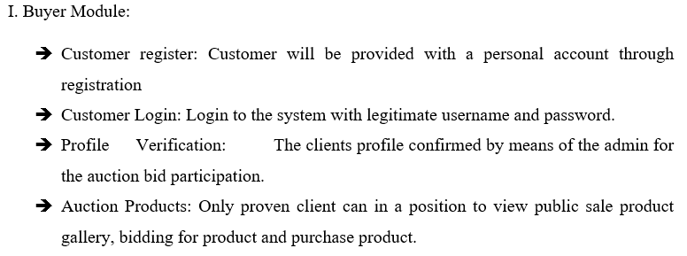

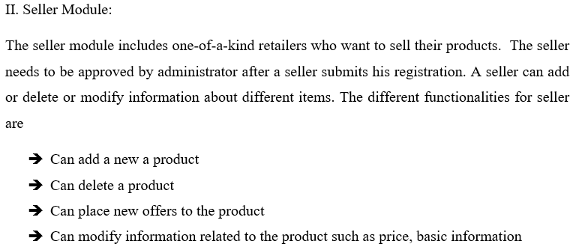

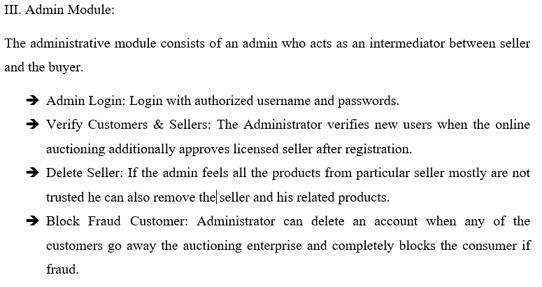

**3.2. BLOCK DIAGRAM**

A block diagram is a depiction of a system's major components or operations using blocks connected by lines that highlight the links between the modules.

In the Figure (1), diagram predicts the basic online auction process held during Auction. Sellers and Buyers account transferred to the system from the database, then the system checks if the logged in user is legit imitate or not, then after validation, both seller and buyer go into the auction mechanism or process.

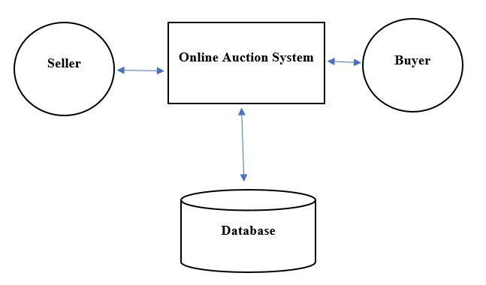

**Figure 1. Block Diagram**

**3.3. DATA FLOW DIAGRAM**

A data-flow diagram is a graphic representation of how data flows through a system or process. The DFD also provides information about each entity's inputs and outputs, as well as the process itself. The major goal is to demonstrate the interaction between the actor and the use cases. Its purpose is to portray the system requirements from the viewpoint of the user. The tasks carried out by the module are the use cases.

User Management work is to validate the user using their username and password while Auction Management work is to manage the auction i.e., items price, its details and Bid Management is to manage the bid i.e., the users that are bidding, the current bid price and all that.

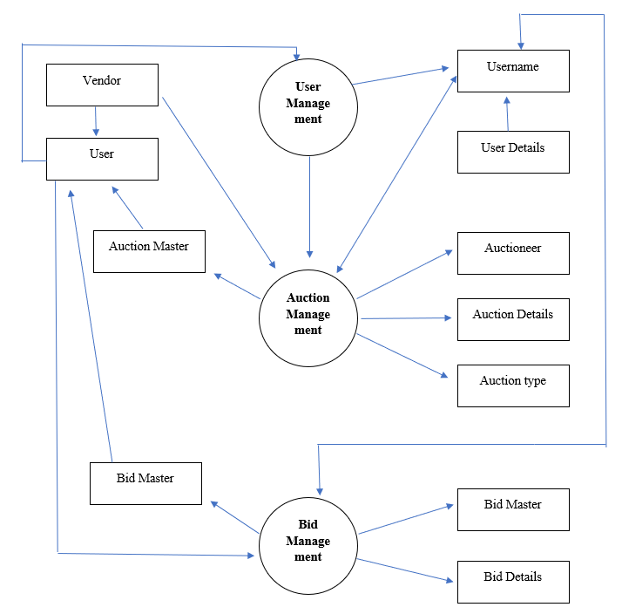

**Figure 2. Data Flow Diagram**

**3.4. METHODOLOGY**

It shows the web application's control flow that emphasizes the entities and rights available.

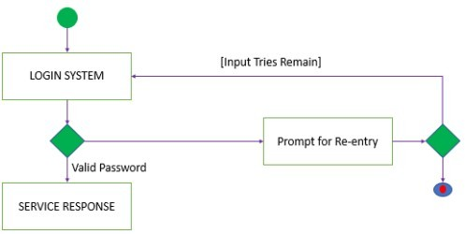

**Figure 3. Login System**

**3.5. UML DIAGRAM**

In the UML Diagram below, it depicts that the person entity has been used by all the modules and each module has their own functionality as well.

In the case of seller, it will be to add Product, delete Product and update Info while in case of Buyer, it will be search, bid, update Info and give Feedback and in case of admin, it will be add User, check Info and bug Report.

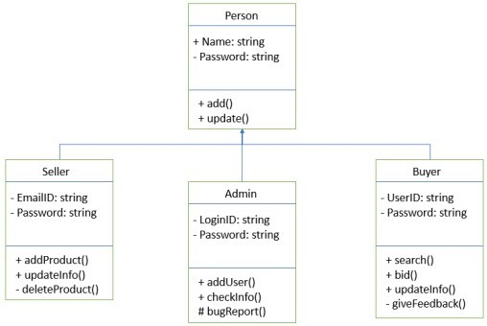

**Figure 4. UML Diagram**

**3.6. USE CASE DIAGRAM**

Activities that the Users (Seller and Purchaser) in an auction’s Use Case Diagram is shown in Figure 5. Users may choose after logging in, the technique of bidding and the kind of auction (auction, reverse auction). They can also share information about things or offer views about them. Purchaser's behavior Use Case Diagram is shown in Figure 6. It outlines the buyer's actions when they enter an auction after logging in.

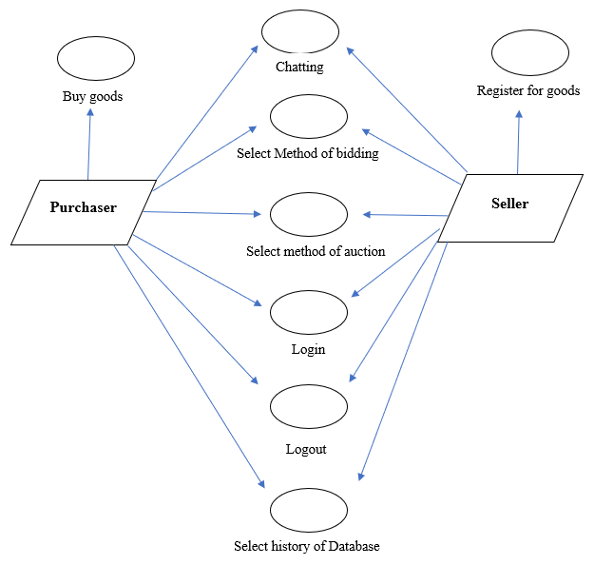

**Figure 5. Auction System’s Use Case Diagram**

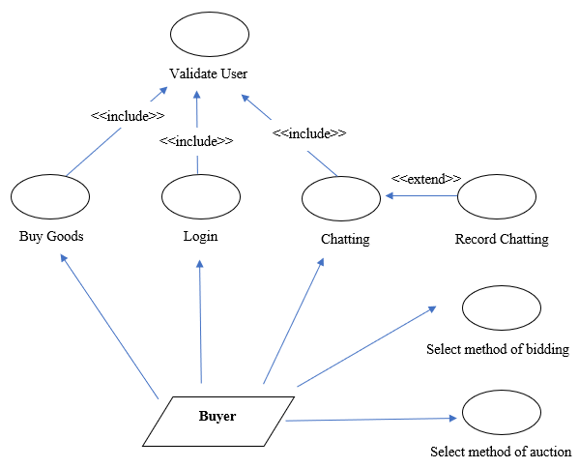

**Figure 6. Buyer’s Use Case Diagram**

**4. SYSTEM IMPLEMENTATION AND RESULT**

Now, in this part, we are going to discuss the algorithms that are being used to implement the Online Auction System which in turn will help us to understand the working architecture of Online Auction System.

THERE ARE FOUR ALGORITHMS: -

* Seller Submits Auction Specifics
* Seller’s Assessment Process
* During the Auction, Buyer’s Placed Bids
* Announcing the winning Bidder

**4.1. ALGORITHM 1 (Seller Submits Auction Specifics)**

Algorithm 1 will help us to understand the pre-auction process that seller has to go through in need to start the Auction.

If logged in account is in the database and is a Seller account, then, seller can add product for auction and can notify seller so that they can participate in the auction. Seller has to provide the starting price i.e., pre-auction price.

Else logged in account is not in the database or not a seller account, then it will not accept transaction from that account.

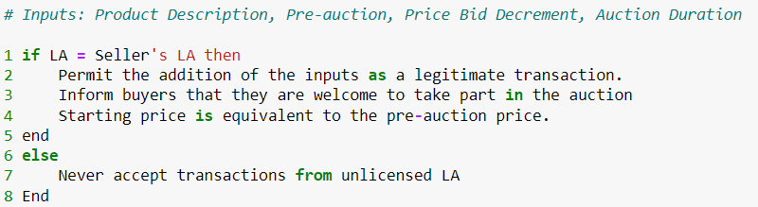

**Figure 7. Algorithm 1 (Seller Submits Auction Specifics)**

**4.2. ALGORITHM 2 (Seller’s Assessment Process)**

Algorithm 2 shows the steps where buyers can participate and submit their respective bids for the item.

If buyer participated and logged in account is equal to the seller’s account then allow the bids to get added and count buyers and also notify buyers that auction is still open.

Else logged in account not in the database or is not seller’s account or no buyer is participated, then, do not accept the transaction.

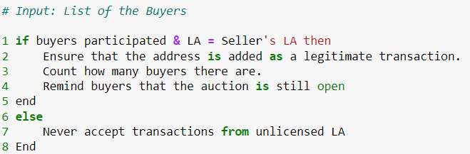

**Figure 8. Algorithm 2 (Seller’s Assessment Process)**

**4.3. ALGORITHM 3 (During the auction, buyers placed bids)**

Algorithm 3 depicts the steps needed to bid during auction time interval by the buyer.

If logged in account is in the database and is the buyer’s account and auction is still open, then we will add bid to the list of all bids with its respective buyer address.

Else logged in account not in the database or is not buyer’s account then, do not accept the transaction.

If New Bid is greater than or equal to (Leading Bid – Bid Decrement) then Leading Bid will equal new bid of respective buyer, else, leading bid remains the same.

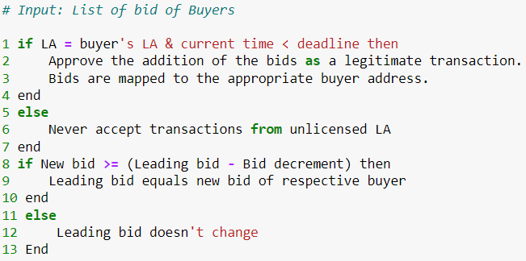

**Figure 9. Algorithm 3 (During the auction, buyers placed bids)**

**4.4. ALGORITHM 4 (Announcing the winning bidder)**

Algorithm 4 depicts the steps needed to announce the winner of the auction.

If the time meets the deadline and logged in account is in the database and is the seller’s account then notify sellers that auction is closed, person with highest bid will be announced as winner and the winning bid value will be transferred to the seller.

Else logged in account not in the database or is not equal to seller’s account then, do not accept the transaction.

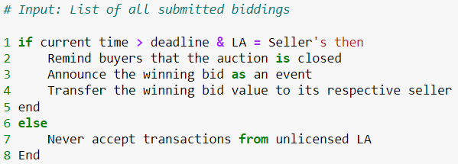

**Figure 10. Algorithm 4 (Announcing the winning bidder)**

**4.5. RESULT**

We have run all these algorithms on our system. These algorithms results in providing the comfort running of a system.

Algorithm 1 and Algorithm 2 runs from the seller side while Algorithm 3 runs from the bidder side and Algorithm 4 helps in predicting the winner of the auction. These 4 algorithms combine to form our Online Auction System.

The Machine in which we implemented the system contained 8 GB RAM, 4 GB GeForce GTX Graphics, I5 Processor and 1 TB SDD and the software we used was Visual Studio and the languages which have been used to implement system were HTML, CSS, React JS, Node JS, Express JS and Database used was MongoDB i.e., Mongoose and cloud database is MongoDB Atlas.

Our Project is divided into 2 parts – frontend and backend. Front End most part is done using React JS and some is done using HTML, CSS and Bootstrap while backend part is done using Node JS and Express JS and database is MongoDB.

All these algorithms are implemented using Node JS and Express JS on the server side of the code. Thus, the result obtained from the algorithms helped us in making the platform for web based Online Auction System. All of the Algorithms has improved its performance to the utmost level.

**5. CONCLUSION AND FUTURE WORK**

**5.1. CONCLUSION**

Here we present our design and Implementation for Online Auction System. The trust issues found in an online auction site is due to the susceptibility found on the system. So, we have proposed an online auction system where there will not be any chances of fraudulent non-genuine such as fraud users, non- genuine products and so more. So, this project hopes to clear all such doubts as per the user’s perception and provide the best design available till date.

In our study we are trying to expand the knowledge of online auctions i.e., the leading marketing practitioners has termed it as the most important research priority and online business.

**5.2. FUTURE WORK**

In future updated version there can be a system where customers have the ability to sort the comments i.e., positive, negative or neutral and also what characteristics of service are most important to be performed to the online auctions sellers and buyers, how could the sellers react to their negative comments and rebuild and update their services.

**6. REFERENCES**

1. Aldaej, R., Alfowzan, L., Alhashem, R., Alsmadi, M., Almarashdeh, I., Alshabanah, M., ... & Tayfour, M. F. (2018). Analyzing, Designing and Implementing a Web-Based Auction online System. ALDAEJ, R., ALFOWZAN, L., ALHASHEM, R., ALSMADI, MK, AL-MARASHDEH, I., BADAWI, UA, ALSHABANAH, M., ALRAJHI, D. & TAYFOUR, M, 8005-8013.
2. Adesola, F., Odun-Ayo, I., & Emetere, M. THE DESIGN AND IMPLEMENTATION OF A SECURE ONLINE SEALED-BID AUCTION SYSTEM.
3. Omar, I. A., Hasan, H. R., Jayaraman, R., Salah, K., & Omar, M. (2021). Implementing decentralized auctions using blockchain smart contracts. Technological Forecasting and Social Change, 168, 120786.
4. Badica, C., Ilie, S., Muscar, A., Badica, A., Sandu, L., Sbora, R., ... & Paprzycki, M. (2014). Distributed Agent-Based Online Auction System. Comput. Informatics, 33(3), 518-552.
5. Prathyusha, K., Anuradha, T., Nikitha, R. S., & Meghana, K. (2013). Detecting frauds in online auction system. International Journal of Advanced Research in Computer Science and Software Engineering, ISSN, 2277.
6. Jing, W., Shi, Y., Cong, N., & LinLin, Z. (2008, October). Architectural design of the Online Auction System with AOSAD. In 2008 IEEE International Conference on e-Business Engineering (pp. 5-12). IEEE.
7. Chan, H. C., Ho, I. S., & Lee, R. S. (2001, August). Design and implementation of a mobile agent-based auction system. In 2001 IEEE Pacific Rim Conference on Communications, Computers and Signal Processing (IEEE Cat. No. 01CH37233) (Vol. 2, pp. 740-743). IEEE.
8. Shirode, M. A., Chavan, A., Bansoda, S., Gadhave, V., & Tatkar, P. (2021). Implementing of Online Auction System. International Journal of Scientific Research & Engineering Trends (IJSRET), 7, 1623-1627.
9. Ren, C. (2009, June). Research and design of online auction system based on the campus network using uml. In 2009 Second Pacific-Asia Conference on Web Mining and Web-based Application (pp. 129-133). IEEE.
10. Aljaf, B. (2016). Online Auction System.
11. Weinberg, B. D., & Davis, L. (2005). Exploring the WOW in online-auction feedback. Journal of Business Research, 58(11), 1609-1621.
12. Sheldon, F. T., Jerath, K., Kwon, Y. J., & Baik, Y. W. (2002, August). Case study: Implementing a web based auction system using UML and component-based programming. In Proceedings 26th Annual International Computer Software and Applications (pp. 211-216). IEEE.
13. Fang, L., & Wang, Y. (2005, October). OICAS: an online iterative combinatorial auction system. In 2005 IEEE International Conference on Systems, Man and Cybernetics (Vol. 1, pp. 233-238). IEEE.
14. <https://www.ebay.com/>
15. <https://www.huuto.net/>
16. <https://en.wikipedia.org/wiki/Block_diagram>
17. https://en.wikipedia.org/wiki/Data-flow_diagram