**Name :: himanshu kumar**

**USN :: 1nt21is063**

**Sec :: A**

Aim: ORDINARY QUEUE IMPLEMENTATION USING ARRAY

Algorithm to insert any element in a queue:

Step 1: IF REAR = MAX - 1

Write OVERFLOW

Go to step

[END OF IF]

Step 2: IF FRONT = -1 and REAR = -1

SET FRONT = REAR = 0

ELSE

SET REAR = REAR + 1

[END OF IF]

Step 3: Set QUEUE[REAR] = NUM

Step 4: EXIT

Algorithm to delete an element from the queue:

Step 1: IF FRONT = -1 or FRONT > REAR

Write UNDERFLOW

ELSE

SET VAL = QUEUE[FRONT]

SET FRONT = FRONT + 1

[END OF IF]

Step 2: EXIT

Code:

#include<stdio.h>

#include<stdlib.h>

#define maxsize 5

void insert();

void delete();

void display();

int front = -1, rear = -1;

int queue[maxsize];

void main ()

{

int choice;

while(choice != 4)

{

printf("\n*************************Main Menu*****************************\n");

printf("\n=================================================================\n");

printf("\n1.insert an element\n2.Delete an element\n3.Display the queue\n4.Exit\n");

printf("\nEnter your choice ?");

scanf("%d",&choice);

switch(choice)

{

case 1:

insert();

break;

case 2:

delete();

break;

case 3:

display();

break;

case 4:

exit(0);

break;

default:

printf("\nEnter valid choice??\n");

}

}

}

void insert()

{

int item;

printf("\nEnter the element\n");

scanf("\n%d",&item);

if(rear == maxsize-1)

{

printf("\nOVERFLOW\n");

return;

}

if(front == -1 && rear == -1)

{

front = 0;

rear = 0;

}

else

{

rear = rear+1;

}

queue[rear] = item;

printf("\nValue inserted ");

}

void delete()

{

int item;

if (front == -1 || front > rear)

{

printf("\nUNDERFLOW\n");

return;

}

else

{

item = queue[front];

if(front == rear)

{

front = -1;

rear = -1 ;

}

else

{

front = front + 1;

}

printf("\nvalue deleted ");

}

}

void display()

{

int i;

if(rear == -1)

{

printf("\nEmpty queue\n");

}

else

{ printf("\nprinting values .....\n");

for(i=front;i<=rear;i++)

{

printf("\n%d\n",queue[i]);

}

}

}

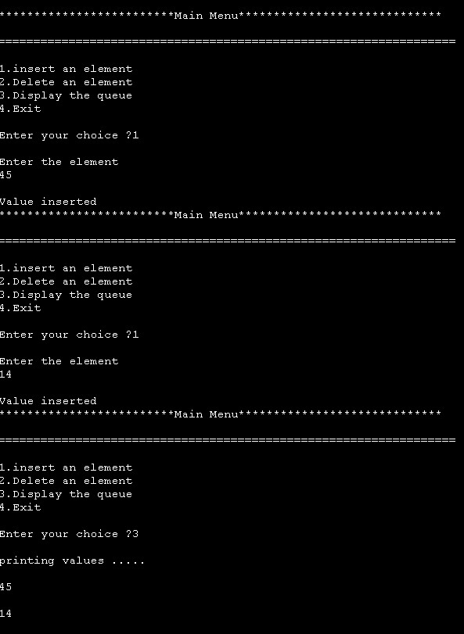

Link: <https://github.com/himanshu120299/Lab-assignment.git>