PROJECT REPORT

## (Project Term Jan-Apr 2020)

**STUDENT PERFORMANCE ANALYSIS SYSTEM**

Submitted by

### Kabita Singh Maan Registration Number :11702059 Himanshu Registration Number :11602657 Sarjaan Ahmad Registration Number :11612775

### Project Group Number: 6 Course Code: INT 402

Under the Guidance of

### (Mrs. Ankita Wadhwan)

**School of Computer Science and Engineering**



**TABLE OF CONTENTS**

TOPIC PG.NO

### Inner first page (i)

### Table of Contents (ii)

1. INTRODUCTION 1
2. OBJECTIVE 1
3. EXISTING SYSTEM 1
4. PROPOSED SYSTEM 1
5. REQUIREMENTS 2
6. FUNCTIONALITIES 2
7. MODULES 2
8. DIAGRAMS 3

# INTRODUCTION

This Student Performance Analysis System provides an easy way to students in searching the details of projects, academic attendance report and marks /percentage details with graph. Students can search the projects with project title or using guide name or with the academic year. All the student details and their performance related information is available.

Student’s academic performance play an important role in producing high qualities education with its academic achievement. Academic Performance achievement varies as different kind of students may have different level of performance achievement in an institution. The goal of student performance analysis system is to develop software that can give more benefits than traditional method to any educational institution for their development.

# OBJECTIVE

The objective of this Student Performance analysis is to provide the online interface for students, faculty for increasing the efficiency of school, college and other higher educational institutions record management. All authorized users can access and get their required details in less time span.

# EXISTING SYSTEM

This present system eliminates the traditional record and file management system. Improves the accessing period and less time while finding of any data related to particular student but in traditional management systems process is more and time consuming.4

# PROPOSED SYSTEM

The present system aims to overcome the drawbacks of the existing systems in the educational sector and implement a few additional features. The proposed system consists of 2 different modules namely as

* + Admin and Student

# REQUIREMENTS

### FUNCTIONAL REQUIREMENTS

Student performance analysis management system is to improve the efficiency of college information system and the main function is managing and maintenance of information systems. It will be ensured that the information entered is of correct format.

### PERFORMANCE REQUIREMENTS

The Proposed system that we are going to develop will be used as the as the chief performance system for helping the organization in managing the whole database of the student studying in the organization. Therefore, it is expected that the database would perform functionally all the requirements that are specified.

### SAFETY REQUIREMENTS

The database may get crashed at any certain time due to virus or operating system failure. Therefore, it is required to take the database backup.

We are going to develop a secured database. There are various categories of people namely Administrator, Student who will be viewing either all or some specific information from the database.

# FUNCTIONALITIES

The system includes a few functionalities that help the admins to get the sorted list of students easily and effectively. These functionalities include

* + Administrator Panel to add/ review/ sort/ delete student records.
  + Student Panel to review his/her data

# MODULES

* + Admin module
  + Student module

### Use Case Diagram:

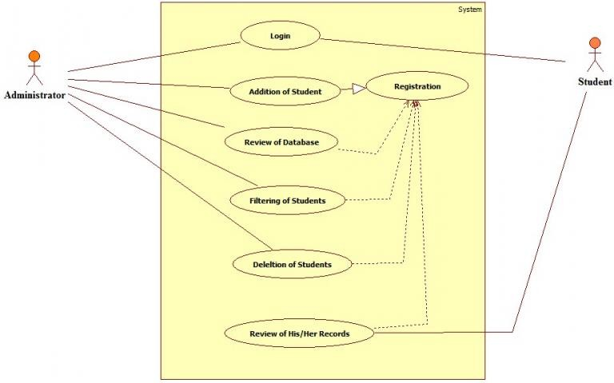

### Class Diagram:

