WEEK 6 — EVALUATION AND PROCESS IMPROVEMENT ANALYSIS
Logistics Operations Analytics | Final Week
Evaluation of the end-to-end data analysis workflow and proposed continuous-improvement roadmap

1. Executive Summary
This final-week report evaluates the logistics data-analysis workflow developed across the preceding tasks, from data collection and preprocessing through analysis, visualization, reporting and decision support. The evaluation identifies process weaknesses that can reduce analytical reliability or slow the movement from raw data to an operational decision. The assessment focuses on data quality, lineage, repeatability, analytical controls, visualization, governance, automation and the feedback loop between reported insights and subsequent action.
The current workflow already contains important controls: source preservation, raw/staging/validated/curated/analytical layers, quality gates, reconciliation, documented transformations, KPI definitions, statistical analysis and dashboard design. The main improvement opportunity is to connect these components into a stronger closed-loop operating model. The proposed future state adds automated data-quality monitoring, explicit ownership, reusable analytical tests, version-controlled KPI definitions, dashboard exception alerts, decision logs and post-action measurement.
The recommendations are designed to be practical for a Junior Data Analyst environment. They prioritize improvements that reduce manual effort, make analytical results reproducible, expose quality failures earlier and make it easier for stakeholders to trace a KPI from dashboard to source data. A 34-hour implementation roadmap is included.

2. Scope and Evaluation Framework
The evaluation covers the complete analytical lifecycle: collection, ingestion, validation, cleaning, standardization, transformation, KPI computation, statistical analysis, visualization, reporting and decision feedback. Each stage is assessed using five questions: Is the process defined? Is it repeatable? Is it measurable? Is ownership clear? Can a failure be detected and recovered without silently corrupting the result?
- Reliability — Can the same inputs and rules reproduce the same output?
- Data quality — Are completeness, validity, uniqueness, integrity and timeliness measured?
- Traceability — Can a reported KPI be traced back to its source and transformation?
- Efficiency — Which steps depend on repetitive manual work?
- Decision usefulness — Does the final output identify what changed, where and what requires action?

3. Current-State Process
The current process follows a layered approach: collect source data, preserve raw records, validate structure and quality, clean and standardize data, transform it into an analytical grain, calculate KPIs, visualize results and communicate findings. This architecture is fundamentally sound because it separates source evidence from business transformations and makes quality gates explicit.
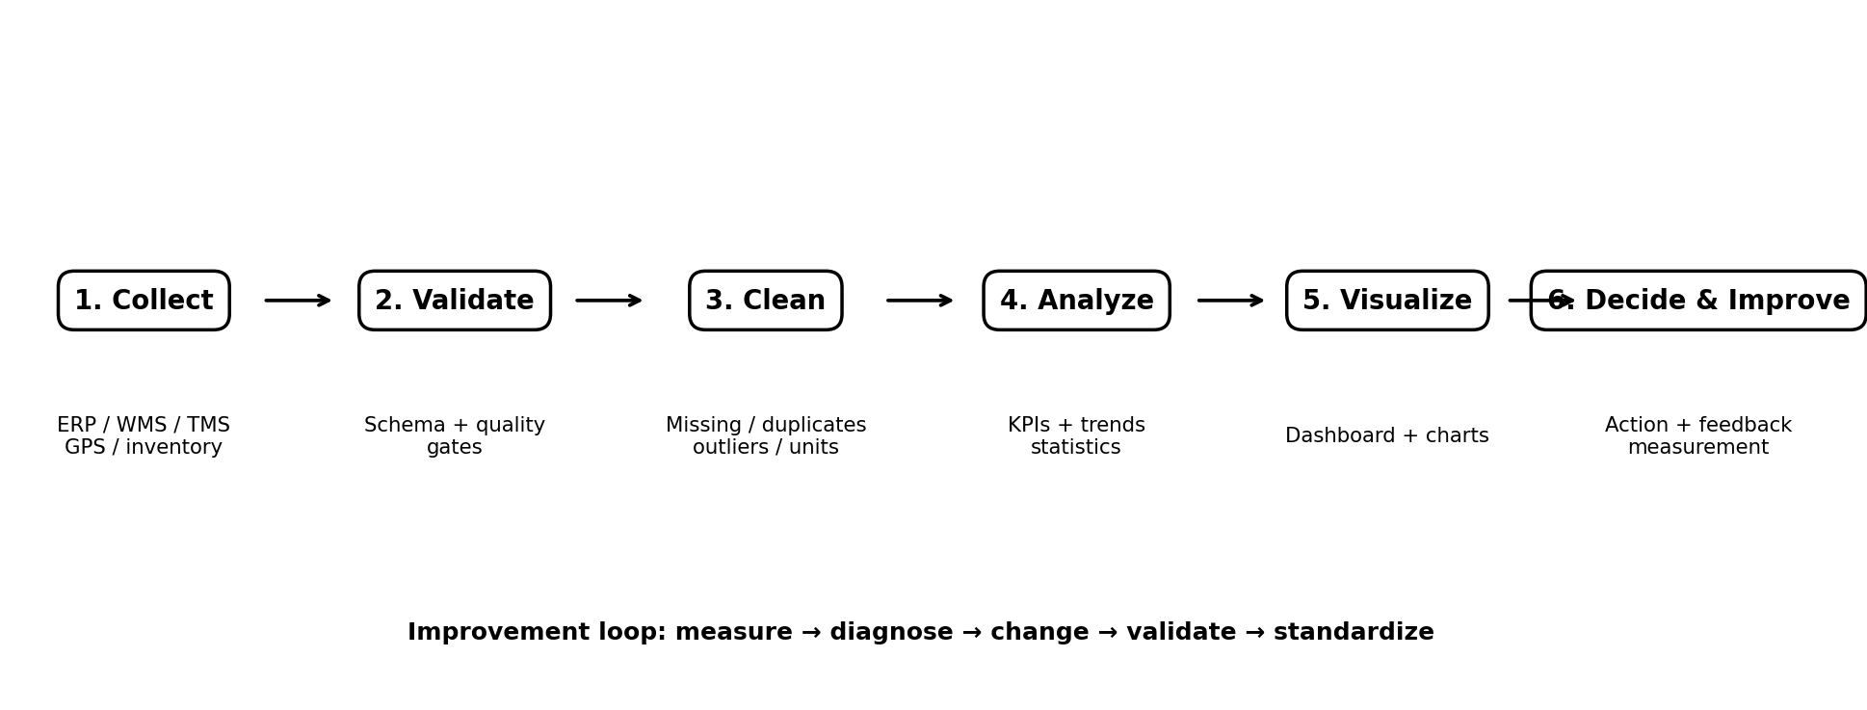
Figure 1. Existing workflow extended into a closed-loop improvement model.

4. Current-State Evaluation
Process Area | Current Practice | Assessment | Main Weakness | Improvement Need
Data collection | Multiple operational sources; extraction metadata retained | Defined | Manual/source changes can still interrupt collection | Automate ingestion monitoring and schema alerts
Data quality | Completeness, validity, duplicates, outliers and reconciliation checks | Defined | Rules may require manual execution and review | Automate recurring quality checks and scorecards
Data lineage | Raw, staging, validated, curated and analytical layers | Defined | Lineage can become difficult across many transformations | Add dataset/run IDs and KPI lineage mapping
Data cleaning | Documented missing-value, duplicate and normalization rules | Repeatable | Exception handling may still depend on analyst judgement | Create rule registry and exception workflow
Analysis | Descriptive, trend, segmentation and statistical methods | Repeatable | Repeated analysis can lead to duplicated code or inconsistent definitions | Reusable KPI functions and tested templates
Visualization | KPI cards, trends, comparisons and diagnostic views | Defined | Dashboard can become crowded or reactive | Adopt a standard visual hierarchy and alert-driven views
Reporting | Narrative connects findings to operational impact | Improving | Narrative can be separated from ongoing KPI monitoring | Link narrative findings to dashboard annotations and action logs
Decision feedback | Recommendations documented | Weakest area | No formal closed-loop measurement of actions | Add action owner, due date, expected KPI and post-action review

5. Process Maturity Assessment
A practical five-level maturity scale is used for this project: 1 = ad hoc, 2 = repeatable but manual, 3 = defined and documented, 4 = measured and partially automated, and 5 = optimized with continuous feedback. The scores below are an analytical assessment of the workflow designed in this project, not an audited organizational certification.
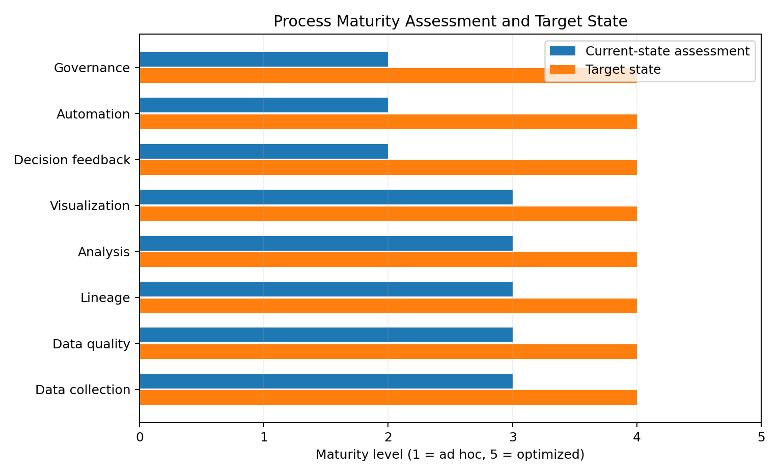
Figure 2. Current-state assessment and proposed target state.

6. Key Weaknesses and Root Causes
Weakness | Root Cause | Impact | Control
Manual quality checks | Recurring checks can depend on analyst execution. | Delayed detection, inconsistent execution | Automate rule execution and publish a quality score per batch.
KPI definition drift | Different reports can implement the same KPI differently. | Conflicting management numbers | Create a version-controlled KPI dictionary with numerator, denominator, grain and filters.
Weak feedback loop | Analysis ends at reporting instead of measurement after action. | Benefits cannot be verified | Track recommendation, owner, expected effect, deadline and post-action KPI.
Schema changes | Source systems may add, remove or rename fields. | Pipeline failures or incorrect joins | Schema-diff checks and versioned mappings.
Exception handling | Unusual records require case-by-case analyst judgement. | Slow processing and inconsistent treatment | Create standardized quarantine categories and escalation rules.
Dashboard overload | Too many visuals can reduce decision clarity. | Stakeholders miss important exceptions | Use KPI hierarchy, drill-down and exception-first design.
Reproducibility gaps | Manual spreadsheet transformations are difficult to reproduce. | Audit and rework burden | Move repeatable transformations to SQL/Python/Power Query with version control.
Late-arriving data | Backfills can change previously reported KPIs. | Trust and reporting instability | Watermarks, provisional labels and automated backfill refresh.

7. Best-Practice and Standards Review
The improvement design was compared with recognized data-quality and supply-chain data-management references. ISO 8000-61 defines a process reference model for data quality management, while ISO 8000-150 addresses roles and responsibilities for data quality management. ISO 8000-63 provides a structure for measuring data-quality management processes using goals, questions, indicators and metrics. ISO 8000-82 addresses the creation of data rules. These standards support the report's emphasis on defined processes, ownership, measurable controls and explicit rules.
For supply-chain visibility, GS1 EPCIS 2.0 provides a standard way for disparate applications to create and share visibility event data within and across enterprises. In practical terms, this supports consistent event semantics for logistics use cases rather than relying on unrelated free-text event descriptions.
The standards are used here as design references, not as a claim that a small analyst workflow must implement every part of an international standard.

8. Recommended Improvements
Improvement | How | Benefit | Priority | Roadmap
Automated data-quality pipeline | Run completeness, validity, uniqueness, integrity and freshness checks automatically. | Earlier failure detection; less manual QA | High | 0–30 days
KPI dictionary and semantic layer | Maintain one definition per KPI with grain, formula, filters, owner and version. | Prevents conflicting metrics | High | 0–30 days
Data-quality scorecard | Publish quality score by source and batch with threshold-based status. | Makes quality visible before analysis | High | 0–30 days
Quarantine and remediation workflow | Separate failed records and assign reason, owner and resolution status. | Reduces silent data loss | High | 0–30 days
Schema-drift monitoring | Compare incoming schema against approved version and flag changes. | Protects joins and transformations | High | 31–60 days
Reusable analytical templates | Standardize descriptive, trend, segmentation and statistical-analysis code. | Reduces duplicated work | Medium | 31–60 days
Dashboard exception alerts | Prioritize threshold breaches instead of displaying every metric equally. | Faster stakeholder response | High | 31–60 days
Decision/action log | Record recommendation, owner, deadline, expected KPI and result. | Creates closed-loop improvement | High | 61–90 days
Post-action measurement | Compare KPI before/after an intervention using a defined measurement window. | Tests whether improvement actually occurred | High | 61–90 days
Process maturity review | Reassess controls quarterly against the five-level scale. | Sustains continuous improvement | Medium | 90+ days

9. Proposed Future-State Workflow
The recommended future state keeps the existing layered architecture but adds automated control points and a formal feedback loop. The key change is that quality monitoring and decision measurement become part of the process rather than separate activities performed only when a problem occurs.
- Ingest → capture source, batch, timestamp and schema metadata.
- Profile → automatically calculate data-quality metrics.
- Gate → quarantine failed batches/records before analytical publication.
- Transform → apply versioned and tested business rules.
- Analyze → use reusable KPI and statistical-analysis functions.
- Visualize → publish standard dashboards with exception-first design.
- Decide → document recommendation, owner, expected impact and deadline.
- Measure → compare actual KPI movement with the expected effect.
- Learn → update rules, documentation and process controls based on evidence.

10. Proposed Governance Model
Role | Primary Responsibility | Control | Frequency
Junior Data Analyst | Profiling, KPI analysis, visualization, QA reporting | Quality score + analysis log | Each batch/report
Data Owner | Business definition, source accuracy, remediation | Rule approval + source sign-off | As required / monthly
System/Data Engineer | Pipelines, schema, automation and monitoring | Pipeline tests + schema alerts | Continuous
Business/Operations Owner | Interpretation and action decisions | Decision/action log | Weekly/monthly
Master-data Owner | Controlled codes and reference data | Mapping validation | Controlled updates

11. Metrics for Measuring Process Improvement
Metric | Definition | Direction
Data-quality pass rate | Passed records or batches / total | Increase while avoiding false passes
Mean time to detect (MTTD) | Time from data issue occurrence to detection | Reduce
Mean time to resolve (MTTR) | Time from detection to verified resolution | Reduce
Manual processing time | Analyst hours spent on repeatable preparation/QA | Reduce
Reconciliation failure rate | Batches failing source-to-curated reconciliation | Reduce
KPI definition consistency | Reports using approved KPI definitions | Target 100%
Dashboard freshness SLA | Reports meeting agreed freshness | Increase
Recommendation closure rate | Actions completed and reviewed / actions created | Increase
Post-action KPI coverage | Actions with measurable before/after KPI | Increase

12. Challenges and Limitations
- The evaluation is based on the analytical workflow designed for this internship project rather than an audited production logistics environment.
- No direct measurement of analyst hours, pipeline runtime, error rates or stakeholder response time was supplied; therefore, improvement benefits are stated as expected benefits rather than measured gains.
- Standards provide frameworks and principles, but implementation must be adapted to the organization's data architecture, risk profile and resources.
- Predictive or causal claims should not be introduced unless the underlying dataset and study design support them.
- Automation can create new failure modes; automated outputs therefore require testing, monitoring and controlled deployment.

13. 34-Hour Final-Week Roadmap
Activity | Hours | Deliverable
Review Weeks 2–5 workflow | 4 | Current-state process map and issue inventory
Evaluate data collection and quality controls | 5 | Data-quality/process assessment
Evaluate analysis and statistical workflow | 4 | Analysis-control review
Evaluate visualization and reporting | 4 | Dashboard/storytelling review
Research standards and best practices | 4 | Standards-to-practice mapping
Develop improvement recommendations | 5 | Prioritized improvement matrix
Design future-state roadmap and diagrams | 3 | Future-state process + implementation roadmap
Final QA and reflection | 5 | Submission-ready evaluation report
Total planned effort: 34 hours.

14. Reflection as a Junior Data Analyst
The progression from data collection to process improvement demonstrates that a Junior Data Analyst's role is not limited to producing charts or calculating KPIs. Reliable analytics depends on the quality of the upstream process, the clarity of business definitions, reproducibility of transformations, validity of analytical methods and the ability to communicate findings to decision-makers. The most important professional improvement identified through this project is the shift from one-time analysis toward a repeatable analytical system.
The next level of capability is therefore not simply learning another visualization or statistical technique. It is learning to design controls that make analytical work reliable: documented rules, automated checks, version control, traceability, measurable quality, clear ownership and feedback from business outcomes.

15. Conclusion
The evaluated logistics analytics process has a solid foundation: layered data handling, quality gates, KPI analysis, visualization and structured reporting. Its main weaknesses are not the absence of analytical techniques but gaps in automation, governance, KPI consistency, exception management and post-decision measurement. The proposed improvements therefore strengthen the process around the existing analytical framework instead of replacing it.
The recommended future state creates a closed loop in which data quality is measured before analysis, analytical outputs are traceable and reproducible, dashboards emphasize exceptions, recommendations have owners and deadlines, and the effect of actions is measured using defined KPIs. This approach provides a practical foundation for continuous process improvement in a logistics analytics environment.

16. References and Best-Practice Sources
- ISO 8000-61:2016 — Data quality: Data quality management: Process reference model: https://www.iso.org/standard/63086.html
- ISO 8000-150:2022 — Data quality: Roles and responsibilities: https://www.iso.org/standard/80753.html
- ISO 8000-63:2019 — Data quality: Process measurement: https://www.iso.org/standard/65344.html
- ISO/TS 8000-82:2022 — Data quality assessment: Creating data rules: https://www.iso.org/standard/78707.html
- GS1 EPCIS 2.0 — Supply-chain visibility event standard: https://ref.gs1.org/standards/epcis/2.0.0/
- World Bank — Logistics Performance Index: https://lpi.worldbank.org/

