WEEK 1 TASK
Data Analysis Strategy & Planning
Logistics Operations Analytics
Submission purpose
A practical, audit-friendly plan for turning logistics transaction, inventory, transport and tracking data into measurable operational improvements. The plan separates descriptive, diagnostic, predictive and decision-support work.

Prepared for: Logistics Data Analysis Assignment
Planning horizon: Week 1 (32-hour research and planning allocation)
Document date: 30 August 2026

1. Technical Summary
The recommended strategy is to treat logistics analysis as an end-to-end performance system rather than a collection of isolated charts. The primary objective is to identify where service failures, delays, excess inventory and logistics cost originate; quantify their operational impact; and establish a repeatable KPI framework for daily and weekly decisions.
The first analytical focus should be delivery reliability and order-flow bottlenecks because these connect directly to customer service and can be decomposed into order creation, allocation, picking, packing, dispatch, transit, delivery and exception/return handling. Inventory health and logistics cost should be analyzed in parallel so improvements in one area do not create unacceptable trade-offs elsewhere.
Recommended analytical principle
Do not optimize a single KPI in isolation. A reduction in delivery time is not a successful improvement if it materially increases freight cost, stockouts, damage, overtime or expedited shipments.

Decision questions
- Where and when are logistics delays occurring, and which process stages contribute most to total cycle time?
- Which lanes, carriers, warehouses, customers, SKUs or order types have disproportionate failure rates?
- How much inventory is available, where is it positioned, and where are stockouts or excess stock concentrated?
- Which operational drivers are associated with higher cost per order, shipment or kilometre?
- Which KPIs should be monitored daily, weekly and monthly, and what thresholds should trigger investigation?
- What data-quality controls are required before management decisions can safely rely on the analysis?

2. Scope and Logistics Problem Definition

2.1 In-scope operational domains
Domain | Core question | Primary data | Expected output
Order fulfilment | Why are orders late or incomplete? | Orders, status events, timestamps | Cycle-time decomposition, late-order drivers
Transport | Which lanes/carriers create delay or cost? | TMS, GPS, carrier invoices | Lane/carrier scorecards, transit analysis
Warehouse | Where do handling bottlenecks occur? | WMS scans, labour/activity logs | Pick/pack productivity, queue analysis
Inventory | Where are stockouts/excess stock occurring? | ERP/WMS inventory, receipts, demand | Inventory health and service-risk views
Exceptions | What causes failures, returns and damage? | Exception codes, claims, returns | Pareto of failure causes

2.2 Out-of-scope for Week 1
- Automated route optimization or vehicle-routing deployment.
- Production machine-learning forecasting without validated historical data.
- Real-time IoT architecture implementation.
- Financial accounting reconciliation beyond logistics-related cost fields.
- Causal claims requiring controlled experiments that are not supported by the available data.

2.3 Core analytical hypotheses
ID | Hypothesis | Test approach
H1 | Delivery lateness is concentrated in a small number of lanes, carriers, facilities or process stages. | Pareto analysis + stratified delay rates
H2 | High order cycle time is driven more by internal handling/waiting time than line-haul transit for some order segments. | Stage-duration decomposition
H3 | Stockouts and excess inventory are concentrated in a relatively small set of SKUs/locations. | ABC-style segmentation + inventory ageing
H4 | Higher logistics cost is associated with low load utilization, expedited shipping and poor lane/carrier performance. | Cost-driver analysis
H5 | A meaningful share of apparent operational problems are data-quality problems. | Data-quality profiling

3. Proposed Analysis Process
The workflow is designed to be reproducible: every KPI should have a defined numerator, denominator, timestamp logic, inclusion rule and owner.
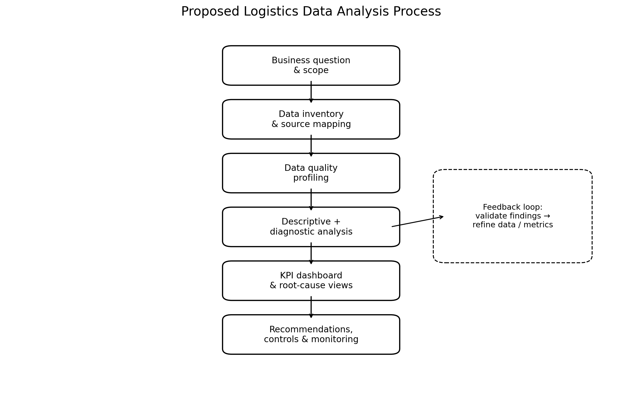
Figure 1. End-to-end logistics analysis process.

3.1 Step-by-step method
1. Frame the business question: Define the operational decision, affected process, unit of analysis, time horizon and success criteria.
2. Inventory data sources: Map systems, tables/files, owners, refresh frequency, primary keys and relationships.
3. Establish analytical grain: Decide whether the base unit is order, order line, shipment, package, inventory-day, SKU-location-day, trip or scan event.
4. Profile and validate data: Check completeness, uniqueness, validity, consistency, referential integrity and timestamp plausibility.
5. Build a canonical logistics dataset: Create standardized dimensions for date, facility, lane, carrier, SKU, customer segment and status/event types.
6. Calculate baseline KPIs: Establish current performance before attempting optimization.
7. Diagnose drivers: Segment performance and use Pareto, cohort, correlation and root-cause analysis.
8. Quantify business impact: Translate delay, stockout, excess inventory and damage into service and cost consequences where reliable cost data exists.
9. Visualize decision points: Create dashboards and exception views that tell users what changed, where, why and what needs action.
10. Recommend controls and next analyses: Define thresholds, ownership, monitoring cadence and follow-up modelling opportunities.

4. Data Sources and Data Architecture

4.1 Preferred internal sources
Source | Useful fields | Analytical purpose
ERP / Order Management | Order ID, order date, promised date, customer, SKU, quantity, priority, status | Order fulfilment and customer-service performance
WMS | Pick/pack timestamps, warehouse, bin/location, activity, inventory movements | Warehouse process efficiency and inventory movement
TMS / Carrier systems | Shipment ID, carrier, lane, dispatch, ETA, actual delivery, freight cost | Transport reliability and cost
GPS / Telematics | Vehicle location, trip start/end, distance, dwell and route events | Actual movement and dwell analysis
Inventory master | SKU, location, on-hand, reserved, damaged, safety stock, reorder point | Availability, ageing and stock-risk analysis
Procurement / Supplier data | PO dates, supplier, promised/actual receipt, quantity, purchase cost | Inbound reliability and supplier performance
Returns / Claims | Return reason, damage code, customer, shipment, resolution | Quality and failure analysis
External benchmark data | Country/region logistics benchmarks, macro conditions, public indicators | Context and benchmarking

4.2 Public data for benchmarking
The World Bank Logistics Performance Index (LPI) is suitable for external logistics context. The current LPI 2.0 uses actual supply-chain tracking data and covers 2023–2024; the older survey-based LPI covers six dimensions including customs, infrastructure, logistics services, tracking/tracing and timeliness. It should be treated as contextual benchmarking rather than a substitute for company-level operational data.
- World Bank LPI 2.0 — country-level supply-chain speed and connectivity indicators.
- World Bank DataBank — historical LPI indicators and downloadable data.
- Public shipment/order datasets — useful for practicing order-cycle, delivery-delay, inventory and exception analyses when company data is unavailable.
Data-source rule
Internal operational systems should remain the primary source for company decisions. Public datasets are best used for methodology practice, benchmarking or scenario testing because definitions and data-generating processes may differ.

5. Analytical Data Model
A star-schema-style analytical model is recommended because logistics reporting repeatedly slices facts by time, location, carrier, SKU and customer.
Table / layer | Example fields | Grain
Fact_Order | order_id, order_date, promised_date, customer_id, status | One row per order
Fact_Order_Line | order_id, sku_id, ordered_qty, shipped_qty | One row per order line
Fact_Shipment | shipment_id, order_id, carrier_id, dispatch_ts, delivery_ts, cost | One row per shipment
Fact_Event | shipment_id/order_id, event_type, event_ts, facility_id | One row per operational event
Fact_Inventory_Daily | date, sku_id, location_id, on_hand, reserved, damaged | One row per SKU-location-day
Dim_Date | date, week, month, quarter, holiday flag | One row per date
Dim_Carrier | carrier_id, mode, service level | One row per carrier
Dim_Location | facility_id, city, region, facility_type | One row per location
Dim_SKU | sku_id, category, weight, volume, ABC class | One row per SKU

5.1 Critical data-quality checks
- Uniqueness: order, shipment and event identifiers meet expected uniqueness rules.
- Completeness: promised date, dispatch time, delivery time, carrier, facility and quantity fields have monitored missingness.
- Validity: dates follow plausible event order; quantities and costs respect business constraints.
- Consistency: status codes, carrier names, facility IDs and SKU identifiers use controlled mappings.
- Referential integrity: shipment records link to valid orders; order lines link to valid SKUs.
- Outlier review: negative durations, extreme freight costs, impossible distances and duplicate scans require investigation.
- Time-zone control: timestamps are normalized to a documented standard before duration calculations.

6. Analytical Methods
Method | Use | Important control
Descriptive analytics | What happened? Trends, distributions, rates, percentiles. | Define denominator and time window.
Diagnostic analytics | Where and why? Segmentation, Pareto, cohorts, stage decomposition. | Compare like-for-like segments.
Correlation / association | What variables move together? | Do not interpret correlation as causation.
Root-cause analysis | Which operational causes are actionable? | Validate exception codes with operations.
Forecasting (later phase) | What is likely to happen? | Backtest against historical periods.
Predictive modelling (later phase) | Which future cases are at risk? | Prevent target leakage; assess calibration.
Optimization (later phase) | What action best meets the objective? | Document constraints and objective function.

7. KPI Framework
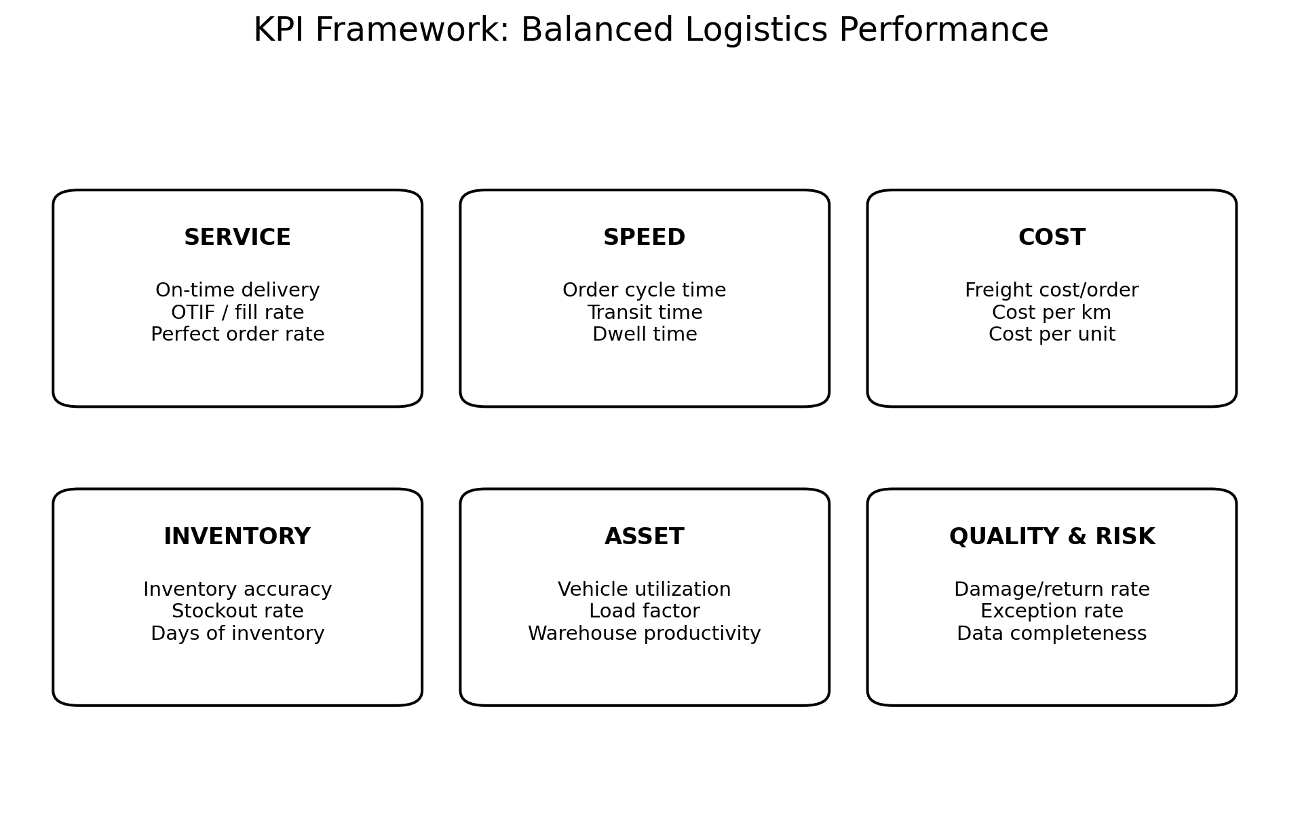
Figure 2. Balanced KPI framework for logistics operations.
KPI | Definition | Cadence | Why it matters
On-Time Delivery (OTD) | Delivered on/before promised date ÷ eligible delivered orders | Daily/weekly | Service reliability
OTIF | Orders delivered on time and in full ÷ eligible orders | Weekly | Combined service performance
Order Cycle Time | Delivery timestamp − order timestamp | Daily/weekly | End-to-end speed
Pick/Pack Cycle Time | Pack completion − defined upstream stage timestamp | Daily | Warehouse bottleneck detection
Transit Time | Delivery − dispatch | Daily/weekly | Carrier/lane performance
Dwell Time | End of wait − start of wait | Daily | Facility/process bottlenecks
Fill Rate | Units shipped ÷ units ordered | Daily/weekly | Product availability
Stockout Rate | Stockout events ÷ demand opportunities | Daily/weekly | Inventory service risk
Inventory Accuracy | Correct inventory records ÷ audited records | Weekly/monthly | Stock integrity
Days of Inventory | Average inventory ÷ average daily demand | Weekly/monthly | Inventory efficiency
Freight Cost / Order | Attributable freight cost ÷ shipments/orders | Weekly/monthly | Transport economics
Cost / km | Freight cost ÷ transport distance | Weekly/monthly | Lane efficiency
Load Utilization | Used capacity ÷ available capacity | Daily/weekly | Asset utilization
Damage/Return Rate | Damaged/returned units or orders ÷ shipped units/orders | Weekly/monthly | Quality
Exception Rate | Shipments/orders with exception ÷ eligible shipments/orders | Daily/monthly | Operational stability
Data Completeness | Non-null critical records ÷ expected critical records | Daily | Analytics reliability

7.1 KPI governance
- Every KPI has a single written definition and accountable owner.
- Denominators are explicit; rates without denominators are not decision-grade metrics.
- Thresholds are based on historical baseline, contractual SLA, target state or statistical control limits.
- KPI changes are version-controlled when business definitions change.
- Dashboards separate current performance, trend, exceptions and root-cause drill-down.

8. Visualization and Dashboard Design
The dashboard should answer four questions in order: What changed? Where? Why? What action is required?
View | Recommended visual | Decision supported
Executive KPI scorecard | KPI cards + sparklines | Is service/cost/inventory performance on target?
Delay Pareto | Sorted bars + cumulative percentage | Which causes contribute most to delays?
Lane/carrier matrix | Heatmap | Which lanes/carriers require investigation?
Cycle-time decomposition | Stacked bar / box plot | Which process stage consumes time?
Inventory health | ABC segmentation + ageing chart | Where is stock risk or excess concentrated?
Exception monitoring | Action table with flags | Which individual shipments/orders need action?
Geographic view | Map when location granularity is reliable | Where are bottlenecks geographically?
Visualization rule
Use maps only when geography adds decision value. For most operational diagnosis, a sorted table, Pareto chart, box plot or heatmap is often more precise than a map.

9. Timeline and Milestones
The following is a realistic initial execution plan after Week 1. It can be compressed or extended depending on data access and system complexity.
Period | Main work | Milestone
Week 1 | Research, scope, KPI definitions, source inventory, analytical design | Approved analysis charter + KPI dictionary
Week 2 | Data extraction, profiling, cleaning and reconciliation | Validated analytical dataset v1
Week 3 | Baseline descriptive analysis and segmentation | Baseline KPI pack + issue inventory
Week 4 | Diagnostic/root-cause analysis | Driver analysis + Pareto + bottleneck findings
Week 5 | Dashboard, recommendations and validation | Decision-ready dashboard + action plan
Week 6 | Monitoring controls, documentation and handover | Reusable pipeline/report + KPI governance

9.1 Week 1 — 32-hour work allocation
Activity | Hours
Research and domain understanding | 5
Problem framing and scope | 4
Data-source and data-model planning | 5
KPI definition and governance design | 5
Analytical-method selection | 4
Visualization/dashboard planning | 3
Timeline, risks and QA plan | 3
Drafting, review and final formatting | 3
Total | 32

10. Tools and Technology Stack
Tool | Use cases | Role
SQL | Extraction, joins, aggregation, KPI computation and transformations | Primary analytical query language
Python / pandas | Data profiling, statistics, automation and diagnostics | Repeatable analysis layer
Excel | Quick validation, reconciliation and business review | Stakeholder checking
Power BI / Tableau | Interactive dashboards and drill-downs | Presentation/monitoring layer
Git / version control | Track SQL, notebooks, definitions and changes | Reproducibility and auditability
Data warehouse / lakehouse | Centralized analytical storage | Scalable source of truth

11. Risks, Limitations and Robustness Checks
Risk | Why it matters | Mitigation
Timestamp inconsistency | Different systems record different event times or time zones. | Normalize timestamps; document event definitions.
Selection bias | Only successful shipments or selected carriers appear. | Reconcile against source control totals.
Survivorship bias | Cancelled/failed/returned orders are excluded. | Retain relevant lifecycle statuses.
Metric gaming | Teams optimize the measured KPI instead of the objective. | Use balanced KPIs and guardrails.
Confounding | Distance, product type, service and carrier mix move together. | Use stratification and multivariable analysis.
Data leakage | Future information enters predictive features. | Freeze features at prediction time.
Definition drift | Business rules change over time. | Version KPI definitions.
Benchmark mismatch | Public data uses different populations/definitions. | Use external data for context only.

11.1 Robustness checks
- Recalculate KPIs using alternative reasonable inclusion rules to test sensitivity.
- Compare mean, median and upper percentiles for cycle-time metrics; logistics durations are often right-skewed.
- Check whether conclusions persist across major facilities, carriers, lanes and customer segments.
- Reconcile aggregate totals to source-system control totals before publishing.
- Validate surprising findings with operational SMEs and sample-level record review.

12. Expected Analytical Deliverables
Deliverable | Minimum content
KPI dictionary | Metric definitions, formulas, filters, owners, cadence and thresholds.
Data inventory | Source systems, fields, keys, refresh frequency and data owner.
Data-quality report | Missingness, duplicates, invalid values, referential integrity and reconciliation.
Baseline analysis notebook / SQL | Reproducible calculations and documented assumptions.
Operational dashboard | KPI scorecard, trends, exceptions and drill-downs.
Root-cause analysis | Pareto of delay/exception causes and segment-level drivers.
Recommendation register | Finding → evidence → action → owner → expected impact → monitoring KPI.

13. Recommended Next Steps
- Confirm the exact logistics process being analyzed and define the primary decision owner.
- Obtain sample extracts from order, shipment, warehouse and inventory systems covering several months if available.
- Create the KPI dictionary before building the dashboard; dashboard formulas should not become undocumented business logic.
- Perform data-quality profiling before interpreting operational trends.
- Establish baseline OTD/OTIF, cycle time, fill rate, stockout rate and freight-cost metrics.
- Use Pareto and segmentation to identify the small number of lanes, facilities, carriers, SKUs or causes responsible for the largest share of issues.
- Validate findings against individual records and operational knowledge before recommending process changes.
- Only after the baseline is trusted, proceed to predictive forecasting, delay-risk scoring or optimization.

14. Further Questions for the Business / Data Owner
- What is the contractual definition of 'on time' for each service level?
- Should OTD/OTIF exclude customer-caused delays, force majeure or cancelled orders?
- Which timestamp is authoritative for dispatch and delivery?
- Are freight costs available at shipment level, including fuel surcharges and accessorials?
- How are split shipments and partial deliveries represented?
- How is inventory reserved, damaged and in-transit stock represented?
- Which exception codes are controlled and which are free-text?
- What action is expected when a KPI crosses threshold?
- Which systems are refreshed near real time versus batch?
- Who owns each KPI and who is accountable for acting on exceptions?

15. Research Sources and References
World Bank (2023). Logistics Performance Index 2023 — Connecting to Compete: Trade Logistics in an Uncertain Global Economy.
https://www.worldbank.org/en/news/press-release/2023/04/21/world-bank-releases-logistics-performance-index-2023
World Bank DataBank. Logistics Performance Index dataset and metadata.
https://databank.worldbank.org/source/logistics-performance-index-%28lpi%29
World Bank. Logistics Performance Index 2.0 — methodology and current indicator framework.
https://lpi.worldbank.org/en/about
World Bank Data. Ability to track and trace consignments indicator.
https://data.worldbank.org/indicator/LP.LPI.TRAC.XQ
Oracle. SCM Analytics — examples of order fulfilment, delivery and inventory KPIs.
https://www.oracle.com/fusion-data-intelligence/scm-analytics/
Source-use note
These sources support the planning framework and external benchmarking context. Company-level KPI targets should be derived from the organization's own historical performance, SLAs, cost structure and operating constraints rather than copied from public benchmarks.

Appendix A — Example KPI Threshold Logic
KPI | Green | Amber | Red / trigger
OTD | At/above target | Within agreed tolerance below target | Material breach or sustained decline
OTIF | At/above target | Small deviation | Sustained/material deviation
Cycle time | At/below target | Moderate increase | Large increase or high-tail deterioration
Stockout rate | Below target | Near threshold | Above threshold
Freight cost/order | At/below budget | Moderate variance | Material variance
Data completeness | ≥ agreed quality floor | Below floor but recoverable | Critical fields missing / pipeline unreliable
Exact numerical thresholds should be established after baseline measurement and stakeholder agreement. Arbitrary targets before profiling the operation would create false precision.

Appendix B — Definition of Done
- Business question and scope are approved.
- All primary data sources and owners are documented.
- Analytical grain and join logic are documented.
- Critical data-quality checks pass or exceptions are explicitly recorded.
- KPI definitions have denominators and inclusion rules.
- Baseline results reconcile to source-system totals.
- Major findings have segment-level evidence and record-level validation.
- Dashboard visuals are decision-oriented rather than decorative.
- Limitations and non-causal interpretations are documented.
- Recommendations identify an action, owner, expected impact and monitoring KPI.

