WEEK 2 TASK
Data Collection and Preprocessing Framework
Logistics Operations Analytics
Submission purpose
A practical framework for collecting, validating, cleaning, standardizing and transforming logistics data into an analysis-ready dataset. The design emphasizes traceability, reproducibility, source preservation, data-quality controls and contingency handling.

Prepared for: Junior Data Analyst — Logistics
Planning allocation: 34 hours
Document date: 30 August 2026

1. Technical Summary
The central principle of this Week 2 framework is that preprocessing is not simply 'cleaning a spreadsheet'. Logistics data is generated across multiple operational systems and physical events, so the analyst must preserve source evidence while creating a standardized analytical layer. The proposed approach separates raw, validated and curated layers, maintains data lineage, records every material transformation, and uses explicit quality gates before data reaches analysis.
The collection strategy begins with a data requirements specification tied to the Week 1 KPI framework. Required fields are mapped to operational sources such as ERP/order management, WMS, TMS/carrier feeds, GPS/telematics, inventory, procurement and returns/claims. Where possible, event-based visibility data should capture what happened, when, where and in what business context. GS1's EPCIS standard is specifically designed around supply-chain visibility events and can represent status, location, movement and chain-of-custody information. citeturn0search10turn0search12
The preprocessing layer covers schema validation, type conversion, duplicate handling, missing-value treatment, master-data standardization, unit normalization, timestamp normalization, outlier investigation, referential-integrity checks, derived-field creation and reconciliation to source control totals. The result is a documented, analysis-ready dataset with quality metrics and a remediation log.
Critical rule
Never silently delete, overwrite or 'fix' source records. Preserve raw data, create a transformed copy, document the rule, and retain enough information to reproduce the result.

2. Objectives
- Collect logistics data systematically from identified operational systems and external sources.
- Preserve source-level evidence and maintain lineage from raw records to analytical tables.
- Standardize identifiers, timestamps, units, codes and business definitions across systems.
- Detect and remediate missing, duplicate, invalid, inconsistent and anomalous records.
- Create a stable analytical grain suitable for KPI calculation and downstream modelling.
- Quantify data quality before analysis and block unreliable datasets from publication.
- Define contingency plans for incomplete feeds, system outages, schema changes and unresolved records.

3. Data Collection Scope and Requirements

3.1 Source-to-purpose mapping
Source | Collection mode | Key fields | Frequency | Primary use
ERP / OMS | API, database extract, scheduled CSV | order_id, order_ts, promised_ts, customer, SKU, qty, status | Daily / intraday | Orders, demand, service level
WMS | API/database/events | pick_ts, pack_ts, facility, bin, qty, inventory movement | Intraday | Warehouse cycle time and inventory
TMS / carrier | API/EDI/SFTP/database | shipment_id, carrier, lane, dispatch, ETA, delivery, cost | Intraday / daily | Transport performance
GPS / telematics | Streaming/API | vehicle, trip, GPS, distance, dwell, event_ts | Near real time | Movement, utilization, dwell
Inventory | ERP/WMS snapshot | SKU, location, on_hand, reserved, damaged | Daily / intraday | Stock health
Procurement | ERP/PO extract | PO, supplier, order/receipt dates, qty, cost | Daily | Inbound reliability
Returns / claims | Database/API | return_id, order, reason, damage, resolution | Daily | Quality and exception analysis
Master data | Reference tables/API | SKU, carrier, location, customer, codes | Daily / controlled | Standardization
External public data | Download/API | benchmark indicators, geography, codes | Periodic | Context and benchmarking

3.2 Data requirement specification
Before extraction, create a Data Requirement Specification (DRS). Each field should be mapped to a business purpose, source, owner, data type, expected range, allowed values, refresh frequency and quality rule.
DRS field | Example | Why required | Validation rule
order_id | ORD12345 | Primary order key | Non-null + unique at order grain
promised_delivery_ts | 2026-08-30 16:00 | OTD denominator / SLA | Valid timestamp; correct timezone
actual_delivery_ts | 2026-08-30 15:42 | OTD numerator | Cannot precede dispatch
quantity_ordered | 10 | Fill-rate denominator | Numeric; ≥0
quantity_shipped | 8 | Fill-rate numerator | Numeric; ≥0 and business-rule constrained
carrier_id | CAR014 | Carrier segmentation | Must exist in carrier master
origin_location | INDEL | Lane definition | Valid location code
freight_cost | ₹1250 | Cost KPI | Numeric; currency documented
event_ts | 2026-08-30 12:15 | Event sequence | Valid timestamp; event order plausible

4. End-to-End Collection and Preprocessing Workflow
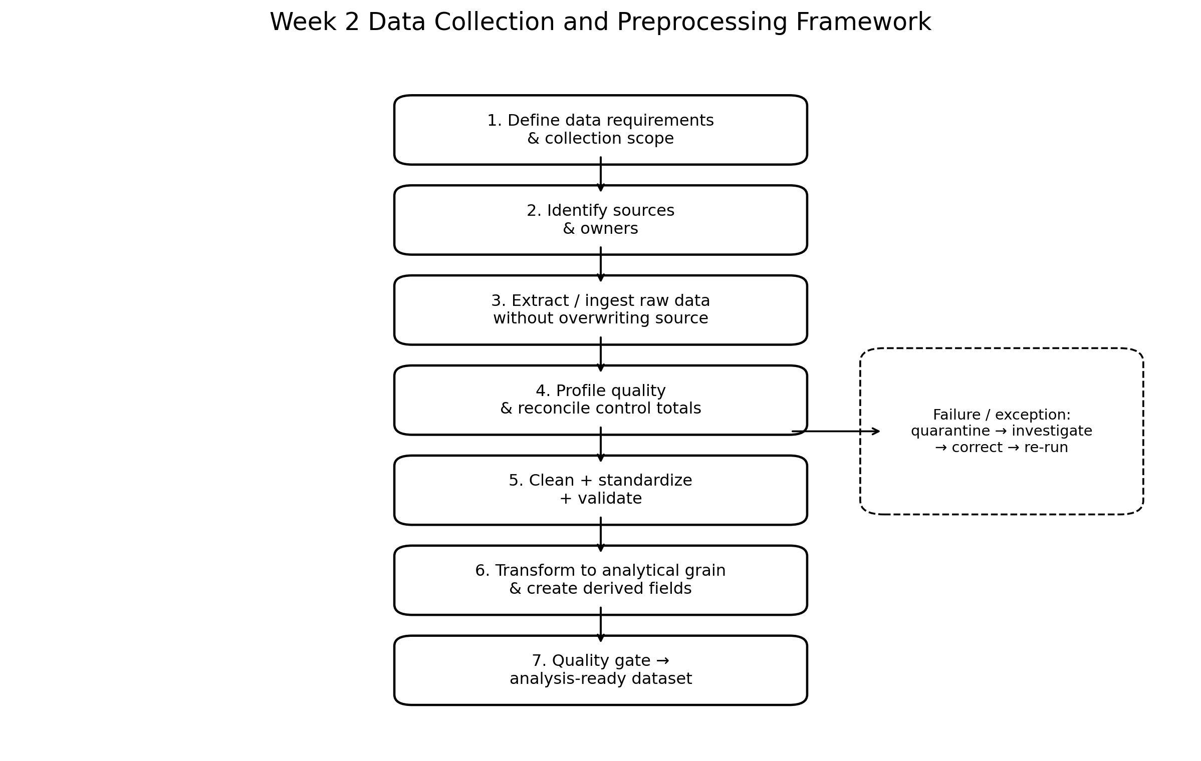
Figure 1. Proposed raw-to-analysis-ready workflow.

4.1 Processing layers
Layer | Purpose | Rule | Example
RAW | Immutable source copy | No business transformations | raw_shipments_20260830
STAGING | Schema/type normalization | Safe structural fixes only | timestamps parsed; column names standardized
VALIDATED | Quality checks and quarantine | Invalid records flagged or isolated | duplicate shipment IDs quarantined
CURATED | Business transformations | Documented joins/derived fields | order_cycle_hours, lane_key
ANALYTICAL | KPI-ready grain | Stable definitions and aggregates | shipment_fact, inventory_day_fact
SERVING | Dashboard/model output | Published only after quality gate | Power BI dataset / reporting table

5. Data Collection Methodology

5.1 Extraction principles
- Prefer system-of-record sources over manually maintained spreadsheets when both exist.
- Use incremental extraction where possible: collect new/changed records using event timestamp, update timestamp or change-data-capture mechanism.
- Retain extraction timestamp, source system, file/API version and batch identifier.
- Use stable business keys and surrogate keys only when necessary.
- Never overwrite previous raw batches; retain historical extracts for audit and reproducibility.
- Capture source metadata such as row count, file size, schema version, extraction status and checksum where practical.
- Establish control totals at extraction time: order count, shipment count, quantity, freight cost and inventory value where available.

5.2 Structured supply-chain data standards
Standardized identifiers and codes reduce ambiguity when data crosses organizational boundaries. GS1 states that visibility can be enabled by identifiers captured on standards-based labels/tags and synchronized across trading partners. EPCIS is designed as a visibility data standard and represents events involving products/assets, including what, when, where and why; EPCIS 2.0 can also represent status effects such as temperature and shocks. citeturn0search9turn0search12
UN/CEFACT also provides reference data models and data-exchange standards for supply-chain and multimodal transport processes. Its Supply Chain Reference Data Model is intended to provide common definitions and structures for information exchange, while UN/EDIFACT provides internationally agreed rules for electronic interchange of structured data. citeturn0search2turn0search3turn0search4
Practical implication
For a company dataset, the analyst does not need to implement every international standard. The immediate objective is to adopt consistent identifiers, code lists, event semantics and units so that different systems can be joined without repeatedly rewriting business logic.

6. Data Cleaning and Preprocessing Framework

6.1 Schema and structural validation
- Verify expected columns and detect added, removed or renamed fields.
- Validate data types: numeric quantities/costs, categorical codes, dates/timestamps and boolean flags.
- Standardize column naming conventions and character encoding.
- Check file/API row counts against expected volumes.
- Reject corrupted files or incomplete API responses rather than partially loading them as complete batches.

6.2 Missing values
Missing-data situation | Preferred response | Do not do | Example
Critical identifier missing | Reject/quarantine or source re-extract | Invent an ID | shipment_id is null
Optional descriptive field missing | Keep null + create missingness flag if useful | Replace blindly with mode | customer_segment
Numeric measure missing | Investigate source; impute only when justified | Use zero automatically | freight_cost
Time field missing | Derive only from a documented alternative event; otherwise flag | Use arbitrary date/time | delivery_ts
System-wide missingness spike | Treat as collection incident | Continue silently | GPS feed missing 40% records

6.3 Duplicate records
Duplicate handling must be based on the analytical grain and business key. A repeated file row is not necessarily a duplicate event: multiple scans or status events can be legitimate. Use exact duplicates, business-key duplicates and event-level duplicates as separate checks.
- Exact duplicate: all relevant fields identical → retain one record after audit logging.
- Business-key duplicate: same order/shipment key appears multiple times where uniqueness is expected → investigate source update logic.
- Event duplicate: same object + event type + timestamp + location repeated → deduplicate only if the business process confirms it is impossible/invalid.
- Versioned update: multiple records represent changes to the same entity → preserve history or select latest record using explicit effective timestamps.

6.4 Outlier detection
Outliers in logistics can be genuine operational events, data-entry errors or system failures. The correct approach is investigation first, exclusion second.
- Business-rule checks: negative distance, negative quantity, delivery before dispatch, impossible event sequence.
- Robust statistical checks: IQR rule, median absolute deviation (MAD), percentile thresholds.
- Segmented checks: compare cycle times within the same lane, carrier, facility, service level or shipment mode.
- Operational review: inspect the underlying records for extreme but plausible shipments.
- Treatment: correct from authoritative source, flag, cap/winsorize only when analytically justified, or exclude under a documented rule.

6.5 Normalization and standardization
- Units: convert weight, distance, volume and currency to documented standard units.
- Dates/times: parse consistently and normalize timezone; retain original timestamp if auditability is required.
- Text: trim whitespace, normalize case where appropriate and remove non-printing characters.
- Codes: map carrier/facility/SKU/status aliases to controlled master-data identifiers.
- Categories: use a data dictionary and avoid free-text categories in analytical dimensions.
- Numeric scaling: for modelling, consider standardization or min-max scaling only after understanding the algorithm's requirements; scaling is not automatically required for descriptive KPI analysis.

7. Logistics Data-Quality Issues and Contingency Plans
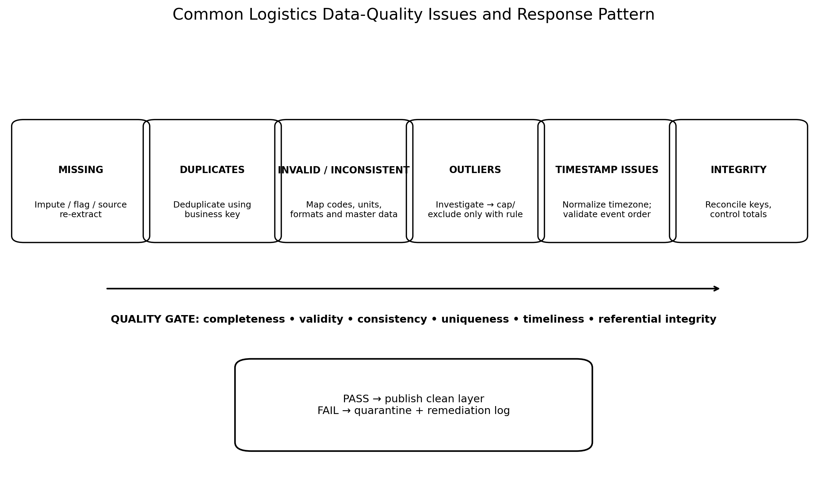
Figure 2. Quality issue response and publication gate.
Issue | Detection | Immediate action | Contingency | Escalation
Missing critical fields | Null-rate threshold | Quarantine affected records | Re-extract / use authoritative alternate source | Data owner
Duplicate shipments | Business-key count | Flag batch | Compare source version; retain latest valid record | System owner
Schema drift | Schema comparison | Stop or route to staging | Version mapping / manual review | Engineering + analyst
Timestamp anomalies | Event-order rules | Flag invalid events | Use authoritative event or exclude affected duration | Operations + data owner
Invalid master code | Lookup failure | Quarantine/unmapped bucket | Refresh master-data table | Master-data owner
Extreme values | Business + robust stats | Flag record | Source correction or documented treatment | Operations
Partial feed / outage | Row count/control total | Do not publish incomplete batch | Use previous validated snapshot with freshness label | System owner
Conflicting systems | Cross-source reconciliation | Do not choose silently | Apply source-of-truth hierarchy | Business owner
Late-arriving records | Load watermark | Mark provisional period | Backfill and re-run affected KPIs | Data engineering
Unit/currency mismatch | Schema + range rules | Stop transformation | Apply documented conversion table | Finance/data owner

7.1 Quality gates
- Gate 1 — Completeness: critical fields meet agreed thresholds.
- Gate 2 — Validity: types, ranges, codes and event order pass.
- Gate 3 — Uniqueness: keys behave as expected at each grain.
- Gate 4 — Integrity: joins and reference keys reconcile.
- Gate 5 — Timeliness: data freshness meets reporting SLA.
- Gate 6 — Reconciliation: counts, quantities and costs reconcile to source controls.
- Gate 7 — Business validation: material anomalies have been reviewed or explicitly disclosed.

8. Validation and Reconciliation Strategy
A clean-looking dataset is not necessarily correct. Reconciliation checks whether preprocessing preserved the business totals and relationships that matter.
Check | Example | Expected result | Failure response
Count reconciliation | Source shipments vs curated shipments | Difference within documented tolerance | Investigate dropped/duplicated records
Amount reconciliation | Source freight cost vs curated freight cost | Exact or explainable difference | Trace currency/filter/join logic
Quantity reconciliation | Ordered/shipped units | Difference explained by business rules | Check split shipments/returns
Referential integrity | Shipment → order | Near-100% valid where required | Quarantine orphan records
Temporal integrity | Order ≤ dispatch ≤ delivery | No impossible sequences | Investigate event definitions
Distribution check | Cycle time before vs after cleaning | Expected change; no unexplained distortion | Review outlier/missing-value treatment
Freshness | Latest event/extract timestamp | Within SLA | Hold publication or label stale data

9. Tools and Software Recommendations
Tool | Best use | Why recommended | Limitation / control
SQL | Extraction, joins, profiling, reconciliation | Works close to source data; scalable and reproducible | Requires disciplined version control and testing
Python + pandas | Cleaning, profiling, statistics, automation | Flexible for complex transformations and QA reports | Large datasets may require SQL/Spark instead
Power Query | Spreadsheet/Power BI ingestion and repeatable transformations | Accessible to analysts and supports repeatable ETL | Complex pipelines need stronger engineering controls
Power BI | Data-quality dashboards and business reporting | Useful for monitoring freshness, exceptions and KPIs | Not a replacement for source-level validation
Excel | Small-scale validation/reconciliation | Fast for manual review and stakeholder checks | High risk of manual errors at scale
Git | Version control for SQL/scripts/data dictionaries | Provides change history and reproducibility | Requires process discipline
Cloud warehouse/lakehouse | Central analytical storage | Supports scalable multi-source pipelines | Requires governance and access controls
Power Query is appropriate for repeatable analyst-level ingestion and transformation in Excel/Power BI. For production-scale pipelines, it should complement rather than replace SQL/Python-based testing, source control and data engineering governance.

10. Data Lineage, Documentation and Governance
- Maintain a data dictionary with field name, definition, source, type, allowed values, owner and sensitivity classification.
- Maintain a transformation log describing every material cleaning rule.
- Record batch/extraction IDs and processing timestamps.
- Document source-of-truth hierarchy when systems disagree.
- Maintain a quarantine table for records rejected by quality rules.
- Track quality metrics by batch so deterioration is visible over time.
- Version schemas and mappings when source systems change.
- Separate business-rule corrections from statistical transformations.
Artifact | Owner | Update trigger | Purpose
Data dictionary | Analyst/data owner | New/changed field | Shared meaning
Source inventory | Analyst | New source or system change | Collection control
Transformation log | Analyst | Any rule change | Reproducibility
Quality report | Analyst | Each batch | Publication decision
Quarantine log | Analyst/system | Rejected records | Remediation tracking
Master-data mapping | Data owner | New/changed code | Cross-system consistency

11. 34-Hour Week 2 Work Plan
Activity | Hours | Milestone
Research logistics data standards and collection practices | 5 | Research notes + source list
Define data requirements and source-to-field mapping | 5 | DRS and source inventory
Design raw/staging/validated/curated architecture | 4 | Layer design
Develop cleaning and missing-value framework | 4 | Cleaning decision matrix
Develop outlier, duplicate and normalization rules | 4 | Preprocessing rulebook
Design data-quality checks and contingencies | 4 | DQ control matrix
Design visuals and process documentation | 3 | Flowcharts + process map
Draft, review and final QA | 5 | Submission-ready DOC
Total | 34 | Week 2 complete

12. Implementation Checklist
- Data requirements document approved.
- Source owners and access methods identified.
- Raw data storage and naming convention established.
- Extraction batch metadata captured.
- Schema validation implemented.
- Missingness profiling completed.
- Duplicate detection implemented at the correct analytical grain.
- Master-data mappings validated.
- Timestamp and timezone rules documented.
- Units and currency standardized.
- Outlier rules documented and reviewed.
- Referential integrity checks completed.
- Source-to-curated reconciliation completed.
- Quality score and publication gate produced.
- Quarantine and remediation process established.
- Clean dataset is versioned and reproducible.

13. Key Risks and Mitigations
Risk | Impact | Mitigation
Manual spreadsheet dependency | Version confusion and silent edits | Use controlled templates; prefer database/API extraction.
System outages | Incomplete reporting period | Hold publication or use last validated snapshot with freshness flag.
Schema drift | Pipeline failures or wrong joins | Schema comparison and versioned mappings.
Poor master data | Incorrect segmentation and joins | Controlled reference tables and owner escalation.
Late-arriving events | KPIs change after publication | Watermarks and backfill policy.
Over-cleaning | Removal of real operational events | Investigate outliers before exclusion; retain raw layer.
Conflicting timestamps | Wrong cycle-time metrics | Document event semantics and source-of-truth hierarchy.
Unclear business definitions | Inconsistent KPIs | KPI/data dictionary signed off before production reporting.

14. Research Sources and References
GS1 — How does the GS1 System help enable supply chain visibility?
https://support.gs1.org/support/solutions/articles/43000734428-how-does-the-gs1-system-help-enable-supply-chain-visibility/
GS1 — What is Electronic Product Code Information Services (EPCIS)?
https://support.gs1.org/support/solutions/articles/43000755325-what-is-electronic-product-code-information-services-epcis-
GS1 — What is the link between EPC and EPCIS?
https://support.gs1.org/support/solutions/articles/43000734385-what-is-the-link-between-epc-and-epcis-
UNECE / UN/CEFACT — Supply Chain Reference Data Model BRS
https://unece.org/trade/documents/2017/01/standards/supply-chain-reference-data-model-brs
UNECE / UN/CEFACT — Supply Chain Management standards
https://unece.org/trade/standards/trade-and-uncefact/uncefact/supply-chain-management
UNECE — Package of Standards for data exchange along the supply chain
https://unece.org/trade/documents/2024/07/informal-documents/uncefact-package-standards-data-exchange-along-supply
World Bank — Logistics Performance Index Data Catalog
https://datacatalog.worldbank.org/search/dataset/0038649/logistics-performance-index
World Bank — LPI: Ability to track and trace consignments
https://databank.worldbank.org/metadataglossary/logistics-performance-index-%28lpi%29/series/LP.LPI.TRAC.XQ
Research note
The framework uses international supply-chain data standards as design references, not as a claim that every logistics organization must implement them. The World Bank LPI is used as an external context source; company-level preprocessing rules should be driven by the organization's own operational definitions, system architecture and data owners. The World Bank describes the LPI as covering dimensions including logistics-service quality, tracking/tracing and timeliness. citeturn0search1turn0search16

Appendix A — Example Data Quality Scorecard
Dimension | Metric | Example threshold | Owner | Action if failed
Completeness | % non-null critical fields | ≥99% critical identifiers; business-defined for optional fields | Data owner | Quarantine or re-extract
Uniqueness | Duplicate rate on expected unique keys | 0% unexplained duplicates | System owner | Investigate source/batch
Validity | % values passing rules | ≥99% | Data owner | Correct or quarantine
Integrity | % valid reference joins | ≥99% | Master-data owner | Refresh mapping
Timeliness | Freshness lag | Within agreed SLA | System owner | Hold/label stale data
Reconciliation | Difference vs source control totals | 0% or documented tolerance | Analyst | Trace transformation
Consistency | % records using approved codes/units | ≥99% | Data owner | Map/remediate
Thresholds are examples for governance design, not universal logistics standards. They should be calibrated after observing baseline data quality and business criticality.

Appendix B — Definition of Done
- Raw source data is preserved and traceable.
- All collection sources, owners and refresh methods are documented.
- Critical fields have explicit quality rules.
- Missing, duplicate, invalid and anomalous records have documented treatments.
- Units, timestamps, identifiers and codes are standardized.
- Source-to-curated reconciliation is complete.
- Quality failures are quarantined rather than silently discarded.
- Dataset is reproducible from documented transformations.
- Quality scorecard and publication decision are available.
- Clean dataset is ready for Week 3 exploratory/descriptive analysis.

