Maymyint
MCT/MCSE/MCP

12234 deersong drive, Jacksonvill, FL 32218
CELL: (407)314-9142
e-mail: may.myint@COMCAST.NET

tRAINING DIRECTOR/MANAGER/sR. tECHNICAL TRAINER

certification
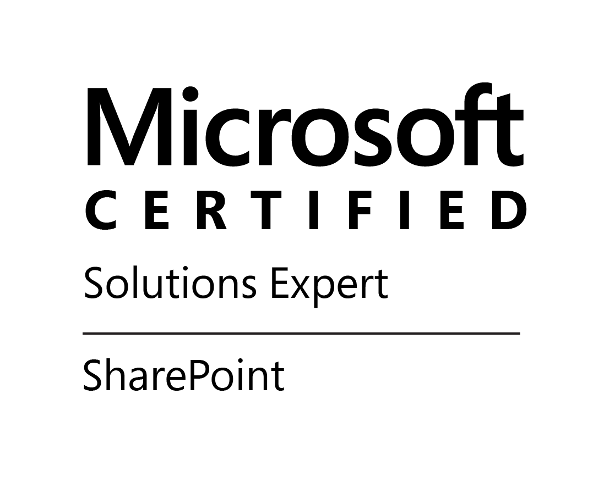 |  | 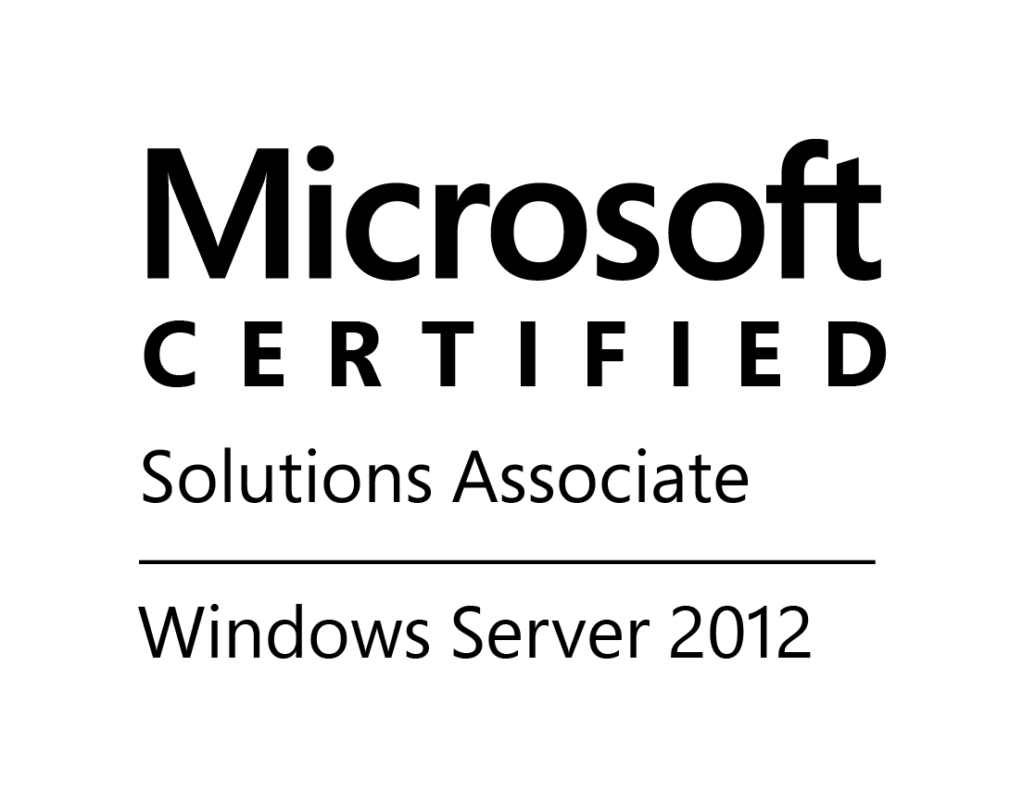 |  | 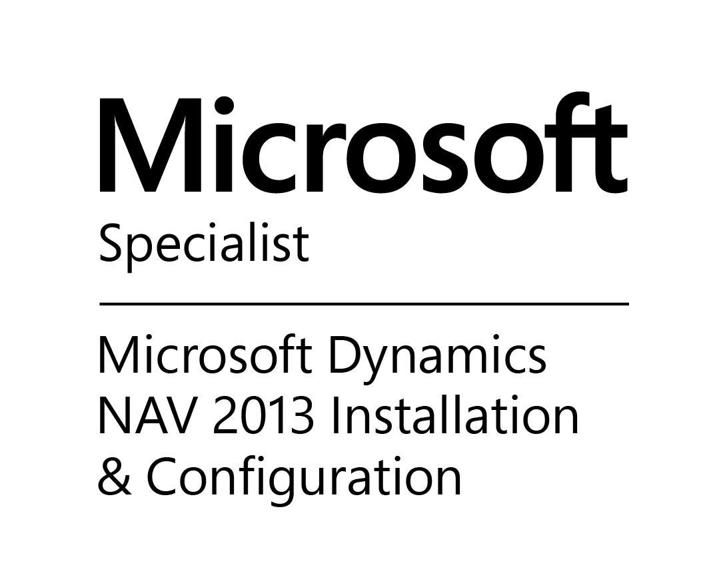

MCT: Microsoft Certified Trainer
- Microsoft Certified Trainer

MCSE: Microsoft Certified Solution Expert

Microsoft Certified Solutions Expert (MCSE) SharePoint 2013

MCSA: Microsoft Certified Solution Associate

Microsoft Certified Solutions Associate: Windows Server 2008

Microsoft Certified Solutions Associate: Windows Server 2012

MCTS: Microsoft Certified Technology Specialist

Microsoft Dynamics NAV 2009 C/Side Solution Development

Microsoft Dynamics CRM 2011 Installation and Deployment

MS: Microsoft Certified Technology Specialist

Managing Projects with Microsoft Project 2013

Microsoft Dynamics AX 2012 R3 Financials

Microsoft Dynamics GP 2013 Installation and Configuration

Microsoft Dynamics NAV 2013 Installation and Configuration

Microsoft Dynamics NAV 2013 Core Setup and Finance

MCTIP: Microsoft Certified IT Professional

Server Administrator on Windows Server 2008

Windows Server 2008 Network Infrastructure and Active Directory, Configuration

IBM Cloud Computing Infrastructure Architect

C5050-280-ENU: IBM Cloud Computing Infrastructure Architect V1

EDUCATION

RANGOON UNIVERISY Myanmar (Burma)

MBA - Master of Business Administration – Major Accounting and Finance

DE ANZA COLLEGE United States, CA

(Studied: Programming, Database and Instructional Design)

Expertise:

- Business Growth | - Revenue Generation
- Writing Government Grant | - Process Improvement
- Sales Forecasting | - Training & Development
- High Level Leadership | - Customer Service
- Technical Software Implementation | - Software Development
- Strategic Planning | - Curriculum Design
- Application Support | - Financial Planning

achievements

Management and Sales Revenue

- In depth understanding in instruction of design, budget management, Computer applications, Business methodologies, leadership and revenue generation
- Resourceful and creative with proven follow –through on projects
- Results driven technical training professional with broad based experience in recruiting, managing, and delivering software development.
- Core competencies and greatest contributions include generating revenue and building corporate training divisions for companies to include the obtainment of training grants (Incumbent Grant) for clients.
- Secured substantial accounts through marketing to key companies such as Merrill Lynch, CSX, Florida Community College of Jacksonville and JEA just to name a few.
- Generated $3.8 million in revenue for Verity Corporation and $2.1 million in training grants for Compucepts Inc.
- Orchestrated projects and over saw up to 127 employees and supervisors regionally and offshore.
- Tenacious aptitude to manage projects from creation to delivery.

Courses/Curriculum Taught
Taught over 500 classes in the following principals in both Live and Virtual Training for groups, one-on-one and train the trainers:

Microsoft Windows Server 2008, 2012,2016 | Microsoft Visual Studio 2008, 2010
Microsoft SQL Server 2008,2012,2016 | Microsoft Project 2013
Microsoft Dynamics CRM 4.0, 2011,2013,2016 | Programming in Visual Basic, C, Java and XML,SQL/PLSQL
Microsoft Dynamics AX 2009,2012, 2012 R2, 2012 R3 | Oracle DBA track
Microsoft SharePoint 2010, 2013, 2016 | Oracle Developer track
Microsoft Dynamics Nav 2009, 2013 | Microsoft Dynamics C/Side

Technical Skills

Languages: AVA, XML, HTML, Visual Basic, C, C++, Pascal and PL/SQL, SQL
Applications: Elite Change Management Software, Sales Force CRM, MS Project, MS Word, MS Excel, MS Power Point, MS Analysis Services, Dream Weaver, MS Outlook, SnagIt, Oracle 11i, Oracle Forms, Oracle Reports, Oracle Financial, Oracle Discoverer and Oracle Portal, ReportNet, Oracle ERP, SAP SCM Portal, SAP ERP, MS Analysis Services, .Net applications, Cognos Series 7, Cognos Business Intelligent, Liquid BPM (Liquid 4.0 Business Process Management), Crystal reports, Lectora, Blackboard, NextGen EMR/HER, Adobe Presenter, Captivate, Authorware, Flash, Siebel CRM, Articulate, Microsoft Dynamics AX, Microsoft Dynamics CRM, Microsoft Sharepoint
OS: Sun Solaris, UNIX, MS Win95, Win98, WinNT, Win2K, WinXP, and OS2
Database: Peoplesoft, SAP, Oracle, MS SQL Server, Sybase, Informix, MS Access, MS Dynamics
Learning Management: eLeap, Inspired, Capterra and Prosperity, Proprofs, Adobe Creative Suite
Delivery Tools: Adobe Connect, Webex, GoToMeeting, Globalmeet

Professional Experience

Academic Conquest LLC 2011-Present

SR. TRAINING DIRECTOR

Nicomp International, LLC (Consultant)

Managed and implement multiple clients’ projects such as Oracle Financial rollout, Microsoft SharePoint integration and developed custom courses.

- Delivered Microsoft Dynamics AX, Microsoft Dynamics Nav, Microsoft Dynamics CRM, Microsoft SharePoint, Microsoft SQL Server, Microsoft Project classes to clients
- Taught Live and On-Line classes using Skype for Business, GoToMeeting or WebEx
- Taught at Europe, Asia and USA
- Participate in Oracle User Productivity Kit 11.1 implementation and train the end user and administrators
- Admirable experience in developing online curriculum, technical courses, strategies and managing training programs
- Operational knowledge of Windows Server 2008 configurations
- Exceptional knowledge of computer applications and software structures
- Immense ability to explain complex issues to customers
- Ability to understand diverse training requirements for individual companies
Outstanding skills to work and lead a team
- Skilled to develop and execute all development activities regards to training
- Ability to explain complex concepts to audiences ranging in skill levels
- Ability to assess training requirements from diverse client companies

FOUNTAIN OF TRUTH RETREAT 2009-2010

(CONSULTANT)

- Coordinated with human resource department, analyzed job requirements and developed respective training programs accordingly both management and technical training
- Monitored all needs of organization and project, designed training requirements accordingly by using the learning management tools such as WebCT, Blackboard and Desire2Learn
- Assisted various teams and developed training programs that satisfied client needs.
- Managed all new employees and performed induction training for understanding working of organization.
- Reviewed progress of employees and assisted managers in estimating programs success with employees.
- Enhanced training programs when required and evaluated it on a regular basis.
- Recommend various –learning techniques in development of training programs.

Developed and taught the following Seminars and classes:

- Communication and Leadership, Managerial Culture, Leadership and Change, Opportunities of Diversity and Globalization, Basic Project Management skills, Personal One-on-One Mentoring, Creating an Inspiring Work Culture, Managing IT Projects

SCHOLASTIC BOOKFAIRS 2007 – 2009

SR. TRAINING DIRECTOR (CONSULTANT)
This position focused on designing, developing & coordinating training efforts from a corporate perspective to affiliate locations.
- Monitors and evaluates operations, programs, processes and/or practices for quality and effectiveness; makes recommendations for improvement
- Managed and delivered People Soft implementation and developed e-learning courses
- Managed 27 employees include offshore programmers
- Work with Subject Matter Experts to develop and deliver training to include products, services & business practices
- Provide consultation, makes recommendations, gives appropriate advice, and/or facilitates decisions
- Partner with HR, Recruiting, Operations and other key departments to address performance gaps
- Developed and managed multimillion-dollar Project budget
- Support the design and execution of learning at meetings and conferences
- Managed the cost effectiveness

SIEMENS CORPORATION

(CONSULTANT) 2006-2007
- Provide the system requirements and develop implementation plan
- Set up Learning Management System (ALP)
- Developed and delivered classes for end users
- Developed courses for employees’ transition into any mission-critical implementation and/or business process
- Created customer eLearning solutions that provided training over the Internet, Intranet, Local Area Network or on CD-Rom, on custom site
- Deployed the E-Learning course that deploy to over 500 users

PROFESSIONAL EXPERIENCE CONT.

VERITY INC. 2005 - 2006

SR. DIRECTOR, WORLD WIDE APPLICATION SYSTEMS & PROFESSIONAL & PROFESSIONAL SERVICES & EDUCATION

compucepts, Inc. 2002 - 2005

DIRECTOR, INFORMATION TECHNOLOGY AND TRAINING IMPLEMENTATION

TECHNOLOGY INSTITUTE OF THE SOUTH (Community College of Jacksonville) 2000 – 2002

PRACTICE MANAGER, CORPORATE TRAINING, DATABASE PROGRAMMING & INTERNET TECHNOLOGIES

ANGEL COMPUTING SERVICES 1996 -1999

Consultant (SELF EMPLOYED)

ORACLE CORPORATION 1992 -1995

TECHNICAL TRAINER

MAC CORPORATION 1990 -1991

TECHNICAL SUPPORT

NASA 1989 -1990
TECHNICAL SPECIALIST

