SMARTSPEND
Budget Management for College Students
MINOR PROJECT REPORT
Subject: Data Science Lab
Submitted by:
Student Name: HIMANSHU
UID: 26BCD10378
Section: 26BCD-6-B
Submitted to:
Faculty Name: SIMRANJEET SIR
Submission Date: 2 November 2026

Abstract
SmartSpend is a student budget management project designed to help college students manage their monthly income, track expenses, set savings goals, and reduce unnecessary spending. The project uses Microsoft Excel to record financial transactions, calculate total income and expenses, determine the remaining balance and savings rate, compare actual spending with category-wise budgets, and display results using charts and conditional formatting. Microsoft Word is used to prepare the project report, while Microsoft PowerPoint is used to present the objectives, features, analysis, and conclusions. The project uses sample student expense data for demonstration purposes. It illustrates how spreadsheet-based data analysis can help students understand their spending habits and make better budgeting decisions.

Demo and Code

Demonstration
The SmartSpend project was implemented using Microsoft Excel. The workbook contains three worksheets: Expense Tracker, Summary, and Budget.
The Expense Tracker sheet records each transaction with its date, description, category, type, amount, and payment method. The Summary sheet calculates total income, total expenses, remaining balance, and savings rate. It also displays a doughnut chart for the spending breakdown and a bar chart for comparing expenses across categories.
The Budget sheet compares the planned budget with actual spending for each category. Conditional formatting highlights categories that exceed their budget, while formulas calculate the remaining budget.

Excel Formulas Used
1. Total Income
=SUMIF('Expense Tracker'!D:D,"Income",'Expense Tracker'!E:E)
This formula adds the amounts of all transactions marked as Income.
2. Total Expenses
=SUMIF('Expense Tracker'!D:D,"Expense",'Expense Tracker'!E:E)
This formula adds the amounts of all transactions marked as Expense.
3. Remaining Balance
=B3-B4
This formula subtracts total expenses from total income.
4. Savings Rate
=IFERROR(B5/B3,0)
This formula calculates the remaining balance as a percentage of total income and prevents a division error when income is zero.
5. Category-wise Spending
=SUMIFS('Expense Tracker'!E:E,'Expense Tracker'!C:C,A9,'Expense Tracker'!D:D,"Expense")
This formula calculates spending for a particular category while excluding income transactions.
6. Budget Status
=IF(C2>B2,"OVER BUDGET",IF(C2=B2,"BUDGET USED","WITHIN BUDGET"))
This formula compares actual spending with the planned budget and displays the appropriate status.
7. Remaining Budget
=B2-C2
This formula shows how much budget remains in a category. A negative result indicates overspending.
8. Savings Goal Status
=IF(B5>=B19,"GOAL ACHIEVED","KEEP SAVING")
This formula compares the remaining balance with the savings goal entered in cell B19.
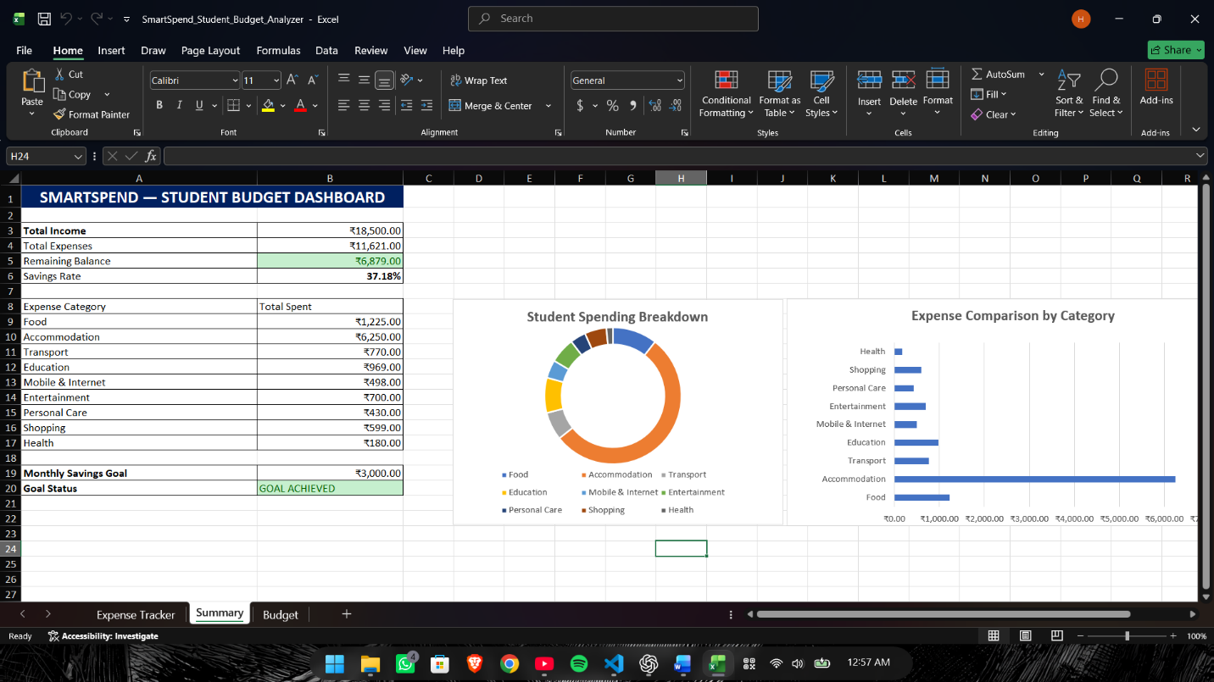 Figure 1: SmartSpend Summary Dashboard.

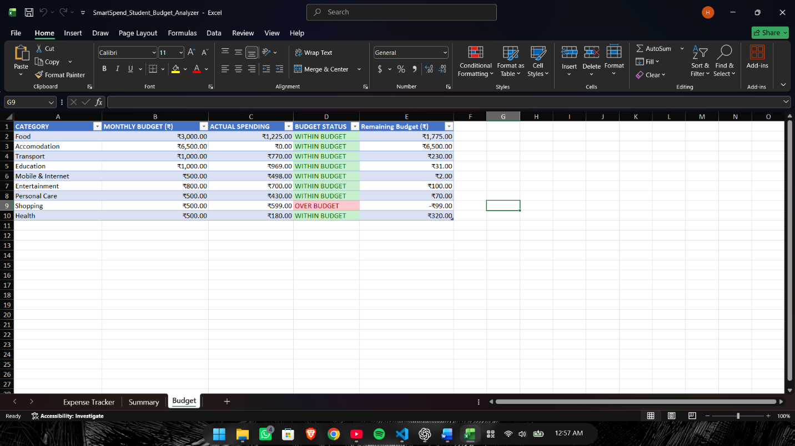Figure 2: SmartSpend Budget Dashboard.
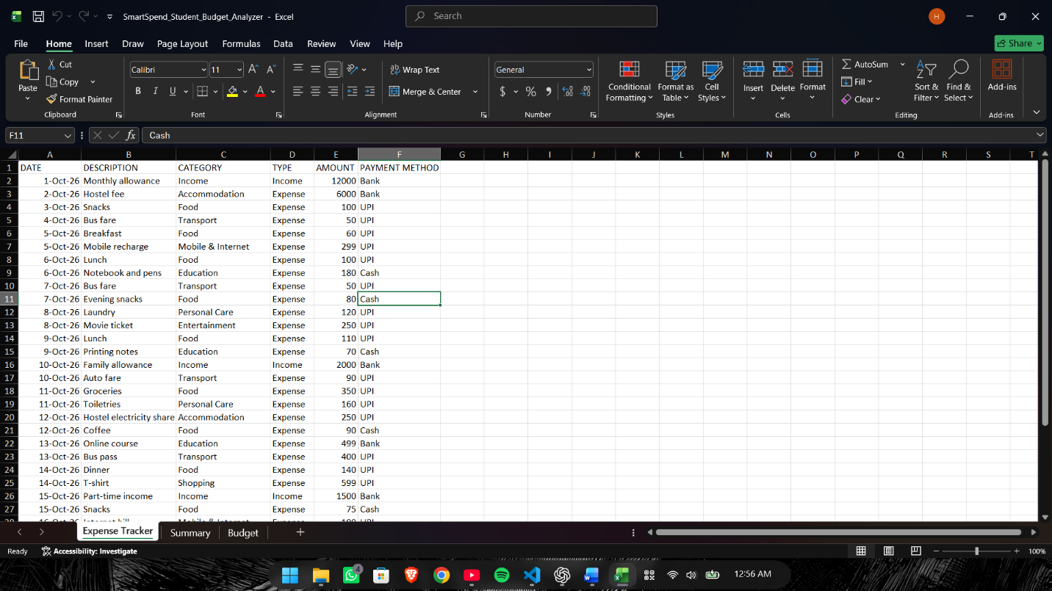Figure 3.1: SmartSpend Expense Tracker Dashboard.

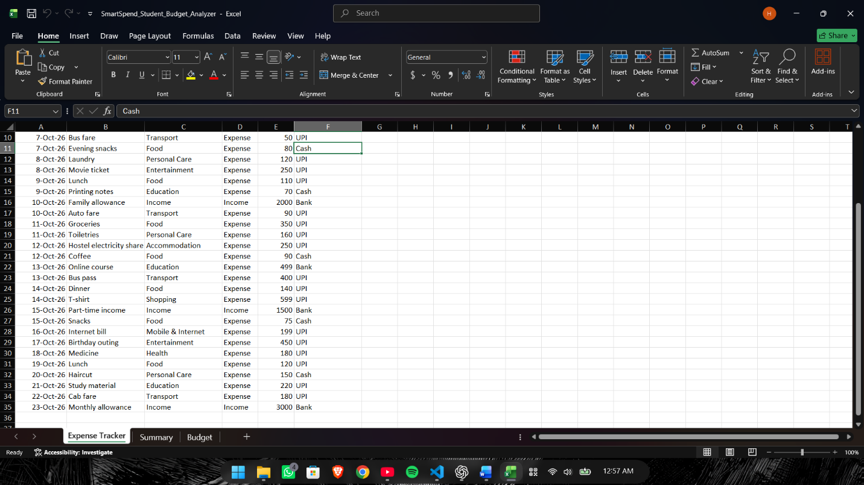
Figure 3.2: SmartSpend Expense Tracker Dashboard.

Project Objectives
The main objective of the SmartSpend project is to help college students manage their monthly finances by tracking income, monitoring expenses, setting budgets, and developing better saving habits.
The specific objectives of the project are:
- Track Income and Expenses: To maintain a record of student income and daily expenses using Microsoft Excel.
- Categorize Spending: To classify expenses into categories such as food, accommodation, transport, education, entertainment, shopping, personal care, and health.
- Calculate Financial Summary: To automatically calculate total income, total expenses, remaining balance, and savings rate using Excel formulas.
- Set Monthly Budgets: To establish spending limits for different expense categories and compare planned budgets with actual spending.
- Identify Overspending: To use conditional formatting and budget status formulas to identify categories where spending exceeds the allocated budget.
- Visualize Spending Patterns: To present expense data through doughnut and bar charts, making spending patterns easier to understand.
- Encourage Savings: To set a savings goal and monitor progress toward achieving it.
- Improve Financial Awareness: To help students recognize unnecessary expenses and make informed financial decisions.
- Apply Spreadsheet-Based Data Analysis: To demonstrate how Excel formulas, charts, and conditional formatting can convert raw transaction data into useful financial information.
The project aims to provide a simple and practical budgeting tool that students can use to understand their spending habits and manage their money more responsibly.

4. Technologies Implemented
The SmartSpend project uses Microsoft Office applications to develop a student budget management system. Microsoft Excel is the primary tool for data entry, calculations, analysis, and visualization. Microsoft Word is used to prepare the project documentation, while Microsoft PowerPoint is used to present the project to the audience.
4.1 Microsoft Excel
Microsoft Excel is the main tool used to develop the budget tracker. It stores student financial transactions in a structured worksheet and performs calculations using built-in formulas.
The following Excel features are used:
- Data Entry: Records transaction dates, descriptions, categories, types, amounts, and payment methods.
- SUMIF and SUMIFS: Calculate total income, total expenses, and category-wise spending.
- IF and IFERROR: Generate budget status messages, check savings goals, and prevent division errors.
- Cell References: Connect calculations across the Expense Tracker, Summary, and Budget worksheets.
- Conditional Formatting: Highlights overspending and positive financial balances using colors.
- Charts: Doughnut and bar charts visualize spending distribution and compare expenses across categories.
- Number Formatting: Displays monetary values in Indian Rupees and savings rates as percentages.
- Excel Tables: Organize transaction and budget data for easier reading and management.
4.2 Microsoft Word
Microsoft Word is used to prepare the project report. It provides tools for formatting headings, paragraphs, numbered lists, formulas, screenshots, and captions. The report documents the project's objectives, technologies, features, development process, and conclusion.
4.3 Microsoft PowerPoint
Microsoft PowerPoint is used to prepare the project presentation. It helps communicate the problem statement, objectives, budgeting process, Excel dashboard, analysis, financial literacy tips, and conclusions through organized slides.
4.4 Sample Dataset
The project uses fictional sample student financial transactions for demonstration and testing. The dataset includes income and expenses across categories such as food, accommodation, transport, education, entertainment, shopping, personal care, and health. It demonstrates how spreadsheet formulas can summarize financial information and identify spending patterns.
The project does not use real student survey data or external financial databases.

5. Project Features
SmartSpend provides several features that help college students record financial transactions, monitor their spending, and plan their monthly budgets. The system uses Microsoft Excel formulas, charts, and conditional formatting to present financial information in an understandable format.
5.1 Expense Tracking
The Expense Tracker worksheet records daily financial transactions, including the date, description, category, transaction type, amount, and payment method. This structured format helps students maintain an organized record of their income and expenses.
5.2 Income and Expense Calculation
Excel formulas automatically calculate total income and total expenses from the recorded transactions. The calculations update when the underlying transaction data changes.
5.3 Remaining Balance
The remaining balance is calculated by subtracting total expenses from total income. This helps students understand how much money remains after their recorded spending.
5.4 Savings Rate
The savings rate expresses the remaining balance as a percentage of total income. This metric helps students understand the proportion of their income that remains unspent.
5.5 Category-wise Expense Analysis
Expenses are grouped into categories such as food, accommodation, transport, education, entertainment, shopping, personal care, and health. The Summary worksheet calculates spending for each category to help identify major expenses.
5.6 Monthly Budget Planning
The Budget worksheet allows students to set spending limits for different expense categories. It compares the planned budget with actual spending to show whether the student is staying within the allocated limits.
5.7 Automatic Budget Alerts
Formula-based status messages identify categories that are within budget, exactly at the budget limit, or over budget. Conditional formatting uses green and red colors to make these results easier to identify.
5.8 Visual Dashboard
The Summary worksheet presents important financial figures alongside a doughnut chart and a bar chart. The doughnut chart shows the distribution of expenses, while the bar chart compares spending across categories.
5.9 Savings Goal Tracking
Students can enter a monthly savings goal and compare it with their remaining balance. The workbook displays a status message indicating whether the target has been achieved.
5.10 Simple and Accessible Design
The workbook uses organized worksheets, formatted tables, currency values, clear headings, and color-coded alerts. These features make the budgeting system easier for students to understand and maintain.
Overall, SmartSpend combines transaction recording, financial calculations, budget monitoring, and data visualization in a single Excel workbook.

6. Development Process
The SmartSpend project was developed in a series of steps using Microsoft Excel. The development process involved organizing sample financial data, creating formulas, setting budget limits, applying conditional formatting, and presenting the results through charts.
6.1 Planning and Requirement Identification
The first step was to identify common financial management challenges faced by college students, such as tracking daily expenses, controlling unnecessary spending, planning monthly budgets, and saving money. Based on these requirements, the project was designed to include transaction tracking, financial summaries, budget comparisons, and savings goal tracking.
6.2 Dataset Preparation
A fictional dataset of student financial transactions was prepared for demonstration. Each transaction contains a date, description, category, transaction type, amount, and payment method. The dataset includes both income and expenses so that the workbook can calculate the overall financial position.
6.3 Creating the Expense Tracker
An Excel worksheet named Expense Tracker was created to store the transactions in a structured table. Categories were used to classify expenses, while the transaction type distinguishes income from expenses. This structure supports the formulas used in the other worksheets.
6.4 Developing the Summary Worksheet
A Summary worksheet was created to display total income, total expenses, remaining balance, and savings rate. SUMIF and SUMIFS formulas were used to summarize transactions based on their type and category. The remaining balance was calculated by subtracting expenses from income.
6.5 Creating the Budget Worksheet
A Budget worksheet was developed to define planned spending limits for individual categories. The actual spending for each category was calculated using SUMIFS. An IF formula compares actual spending with the budget and displays a suitable status message.
6.6 Applying Conditional Formatting
Conditional formatting was applied to make important results easier to recognize. Green formatting identifies categories that remain within their budgets, while red formatting highlights overspending. Similar formatting was used to emphasize a positive remaining balance and the savings goal status.
6.7 Data Visualization
A doughnut chart was inserted to display the distribution of expenses across categories. A bar chart was created to compare category-wise spending. These visualizations help users identify major spending areas more quickly than by examining the raw transaction table alone.
6.8 Savings Goal Implementation
A savings goal was entered in the Summary worksheet. An IF formula compares the remaining balance with the specified goal and displays either GOAL ACHIEVED or KEEP SAVING. This provides a simple way to demonstrate savings target monitoring.
6.9 Testing and Verification
The workbook was checked to confirm that the formulas returned the expected totals, category spending matched the transaction data, budget status messages responded to the comparisons, and charts displayed the category values. Sample data was used to test the workbook's functionality.
The development process demonstrates how spreadsheet formulas, conditional formatting, and charts can be combined to create a practical student budget management system.

7. Conclusion
The SmartSpend project successfully demonstrates how Microsoft Excel can be used to develop a practical budget management system for college students. The project provides an organized way to record income and expenses, categorize spending, calculate the remaining balance and savings rate, and compare actual expenses with planned budgets.
The use of Excel formulas automates financial calculations, while conditional formatting highlights overspending and helps users identify categories that require attention. Doughnut and bar charts make spending patterns easier to understand, and the savings goal feature encourages students to plan their finances more effectively.
The project also demonstrates the practical application of data organization, spreadsheet formulas, conditional formatting, and data visualization. Microsoft Word was used to document the development process, and Microsoft PowerPoint will be used to present the project and its features.
The workbook uses fictional sample data for educational purposes. Although it provides a useful budgeting prototype, its results do not represent actual spending patterns of all college students.
In conclusion, SmartSpend can help students become more aware of their financial habits, plan their monthly expenses, and develop better saving practices. Future improvements could include month-specific savings analysis, interactive filters, and data collected through an anonymous student survey.

