***Mohanlal Sukhadiya University***

*(University College of Science)*



Project Report

BCA 5th Semester

Section ‘B’

Topic

“City – Tour”

Submitted to: Submitted by: Mr Jitesh Kumar sir Himanshu Chouhan

# Declaration

I here by declare that the work which is being presented in the project on “City Tour Packages Ordering System” in partial fulfilment of requirement of the degree Bachelor of computer application BCA, Mohanlal sukhadiya university (raj) is an authentic and original record of my own work carried out by me for a period of BCA 5th semester.

## *Acknowledgment*

It is an honor for me to thank all those people who made this possible. I want to thank my advisor. This would not be possible without their help and support.

I also want to thank all my faculties (Mr. Jitesh Sir) and friend for their constant help throughout the whole time. I could not have done it without their help.

**Tableof contain**

1. Declaration
2. Acknowledgement
3. Introduction
4. Abstract
5. Overall Description
6. Aim and Object
7. System Analysis
8. Feasibility Study
9. Configuration
10. Technology
11. Used Module
12. Scope and Purpose

13.Design Phase

14.Technology Overview

15.Creating database And Inserting Data

16.Admin Page

17.Biblography

### INTRODUCTION

It is very typical to establish a small-scale business with less resources to provide quality services. Now a days people are attracted to online business. Let us assume if there is any online business where customers can order their needs and the goods will reach them at the expected time. The customers of today are not only attracted because placing an order online is very convenient but also because they have visibility into the items offered, likewise booking a online package system customers can order their favourite package and this database will be the barrier for the customers and we provide the services.

Our solution provides booking process for the customer. The Items list and categories of the foods are available in the database so that a customer can place an order with multiple items. Once the order is placed restaurant employees process the order and deliver it to the customer at the expected delivery time. at the end of the order customer will know about the amount how much he had to pay for the restaurant for the order. Once the Order is delivered customer can provide the feedback to the restaurant.

### Abstract

Online Ordering Pizza System can be used by Ordering Pizza to the existing restaurant of customer easily. Achieving this objective is difficult using a manual system as the information is scattered, can be redundant and collecting relevant information may be very time consuming. All these problems are solved using this project.

**OVERALL DESCRIPTION 1 Product Perspective**:

The website Student Information System is aimed towards recording a considerable number of student records and needs online assistance for managing records of students. Website should be user-friendly, ‘quick to learn’ and reliable website for the above purpose. Student Information System is intended to be a stand-alone product and should not depend on the availability of other website. The system will also have an administrator who has full-fledged rights with regards to performing all actions related to control and management of the website.

1. **Product Functions**:

There are two different users who will be using this product:

* + Administrator who can view and edit the details of any restaurants.
  + Restaurant who can view their details as well as they can edit their details. The features that are available to the Administrator are:
  + An Administrator can login into the system and perform any of the available operations.
  + Can enable/disable restaurants.
  + Can edit restaurants information to the database.
  + Can make search for a specific restaurant.
  + Can access all the details of the restaurants.
  + The features that are available to the customer are:
  + Customer can login into the system and can perform any of the available options.
  + Can view his/her personal details.
  + Can edit his/her personal details
  + Can upload his/her resume.
  + Can upload his/her image.

1. **User Classes and Characteristics:**

There are mainly two kinds of users for the product. The users include:

* + Administrator
  + Student

1. **Operating Environment:**

The product can run on any browser.

1. **Constraints:** 
   * Every user must be comfortable using computer.
   * All operations are in English so user must have basic knowledge of English

### Aim and Objective

Aim -> The aim of project is to create a dynamic website which allows product information to be updated directly through an interface. Objectives ->

The goal of this application is

* Our goal is to deliver a database with a user interface (website) where customers can select various ingredients for their own pizza and place their order. The order will be sent to the “restaurant” where the pizza will be made. The focus is to create an “easy to use” website, which will allow a first-time customer to complete their order with ease.
* To develop an easy-to-use web-based interface where users can search for pizza, view a complete description of the pizza and order the pizzas.
* • A user can view the complete specification of the product along with various images.

### System Analysis

**EXISTING SYSTEM:**

System Analysis is a detailed study of the various operations performed by a system and their relationships within and outside of the system. Here the key question is- what all problems exist in the present system? What must be done to solve the problem? Analysis begins when a user or manager begins a study of the program using existing system.

During analysis, data collected on the various files, decision points and transactions handled by the present system.

The commonly used tools in the system are Data Flow Diagram, interviews, etc. Training, experience and common sense are required for collection of relevant information needed to develop the system. A good analysis model should provide not only the mechanisms of problem understanding but also the frame work of the solution. Thus, it should be studied thoroughly by collecting data about the system. Then the proposed system should be analysed thoroughly in accordance with the needs.

**System analysis can be categorized into four parts:-**

1.System planning and initial investigation

2.Information Gathering

3.Applying analysis tools for structured analysis

4.Feasibility study

5.Cost/ Benefit analysis.

In the current system we need to keep a number of records related to the student and want to enter the details of the student and the marks manually.

**PROPOSED SYSTEM:**

In our proposed system we have the provision for adding the details of the students by themselves. So, the overhead of the restaurant’s authorities. Another advantage of the system is that it is very easy to edit the details of the customers and delete a customer when it found unnecessary. The pizzas of the customers are added in the database and so customers can also view the pizzas whenever they want.

Our proposed system has several advantages

1.User friendly interface

2.Fast access to database

3.Less error

4.More Storage Capacity

5.Search facility

6.Look and Feel Environment 7.Quick transaction All

the manual difficulties in managing the customer details in a restaurant have been rectified by implementing computerization.

### Feasibility Study

Whatever we think need not be feasible. It is wise to think about the feasibility of any problem we undertake. Feasibility is the study of impact, which happens in the organization by the development of a system. The impact can be either positive or negative. When the positives nominate the negatives, then the system is considered feasible. Here the feasibility study can be performed in two ways such as technical feasibility and Economical Feasibility.

### • TECHNICAL FEASIBILITY

We can strongly say’s that it is technically feasible, since there will not be much difficulty in getting required resources for the development and maintaining the system as well. All the resources needed for the development of the software as well as the maintenance of the same is available in the organization here we are utilizing the resources which are available already**.**

• **ECONOMIC FEASIBILITY:**

Development of this application is highly economically feasible. The organization needed not spend much money for the development of the system already available. The only thing is to be done is making an environment for the development with an effective supervision. If we are doing so, we can attain the maximum usability of the corresponding resources. Even after the development, the organization will not be being condition to invest more in the organization. Therefore, the system is economically feasible.

### CONFIGURATION

**HARDWARE CONFIGURATION:**

* Intel Pentium IV processor or equivalent or higher
* 512 MB Ram or Higher
* 20 GB HDD or Higher
* Network Connectivity

**SOFTWARE CONFIGURATION:**

* PHP 5.0
* APACHE HTTP Server
* Dreamweaver, FrontPage for Front End Programming
* Microsoft Windows or Linux

### Technology used

**Front end technologies**

**1. Html**

* HTML stands for Hyper Text Markup Language
* HTML is the standard markup language for creating Web pages
* HTML describes the structure of a Web page
* HTML consists of a series of elements
* HTML elements tell the browser how to display the content
* HTML elements label pieces of content such as "this is a heading", "this is a paragraph", "this is a link", etc.

### 2. JavaScript

JavaScript is the world's most popular programming language.

JavaScript is the programming language of the Web. JavaScript is easy to learn

**3.CSS**

* CSS stands for Cascading Style Sheets
* CSS describes how HTML elements are to be displayed on screen, paper, or in other media
* CSS saves a lot of work. It can control the layout of multiple web pages all at once
* External stylesheets are stored in CSS files

### Back-end technologies

**1.PHP**

* PHP is an acronym for "PHP: Hypertext Preprocessor"
* PHP is a widely-used, open-source scripting language
* PHP scripts are executed on the server
* PHP is free to download and use

**2. My sql**

* SQL stands for Structured Query Language
* SQL lets you access and manipulate databases
* SQL became a standard of the American National Standards Institute (ANSI) in 1986, and of the International Organization for Standardization (ISO) in 1987
* SQL can execute queries against a database
* SQL can retrieve data from a database
* SQL can insert records in a database
* SQL can update records in a database
* SQL can delete records from a database
* SQL can create new databases
* SQL can create new tables in a database
* SQL can create stored procedures in a database
* SQL can create views in a database
* SQL can set permissions on tables, procedures, and views

## • Data Flow Diagram

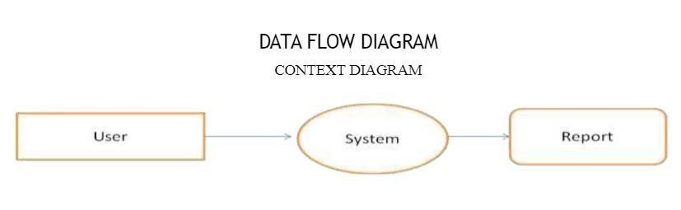

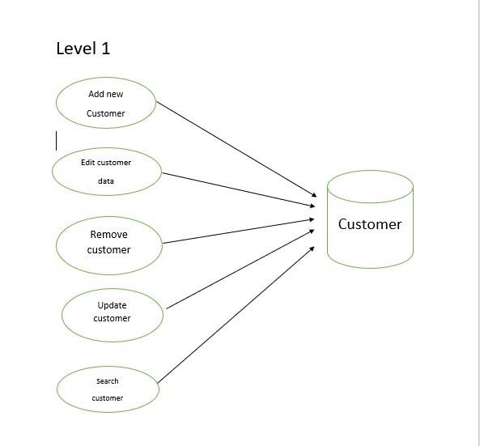

**Used Modul**

**1. Administrator:**

Responsible for managing customer records.

* Login into the website
* Update customer details
* Search customer details
* Display customer details
* Enable/Disable customer

**2**. **Customer:** Has the access rights to view and edit their personal details. • Login into the website

* Display customer details
* Edit their details
* Upload their images
* Upload their resumes

### Customer login page

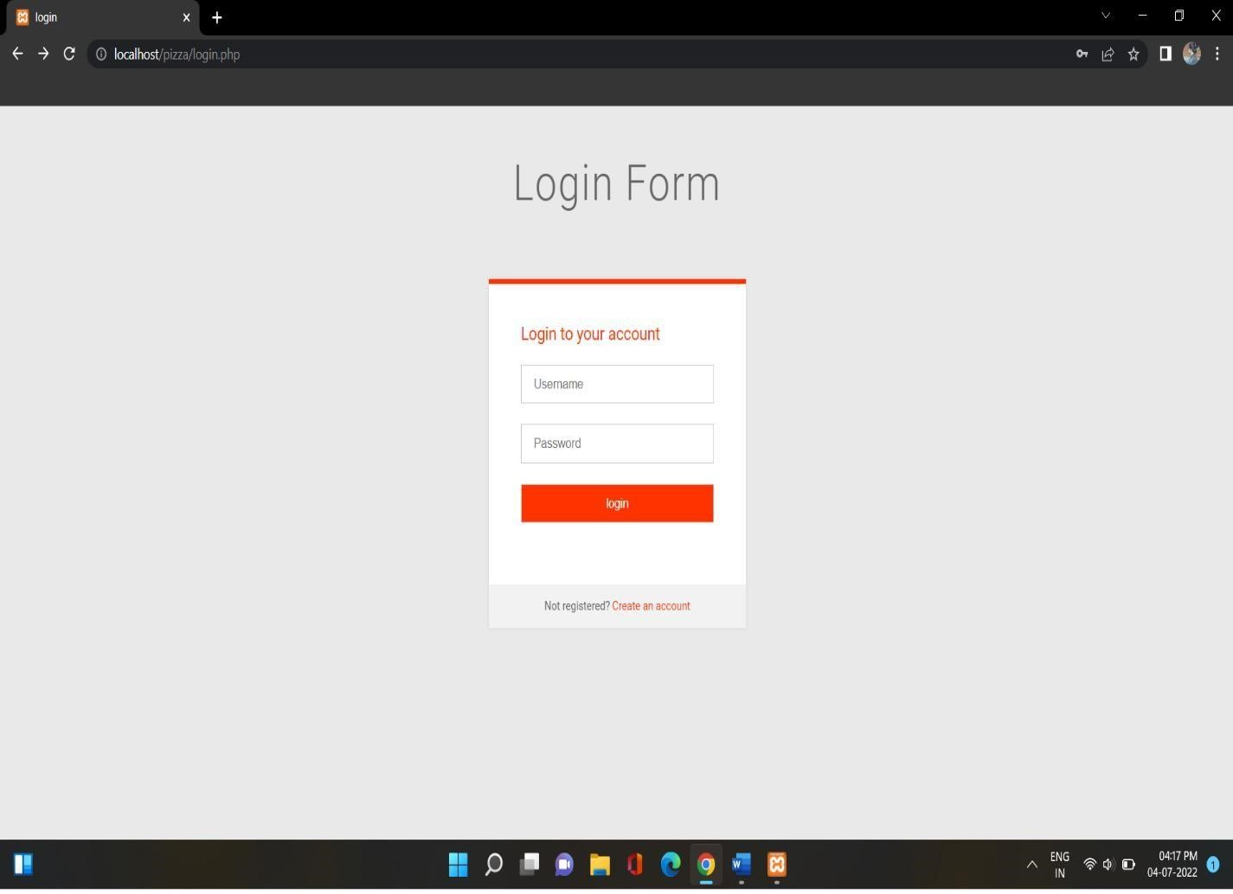

### Customer Registration

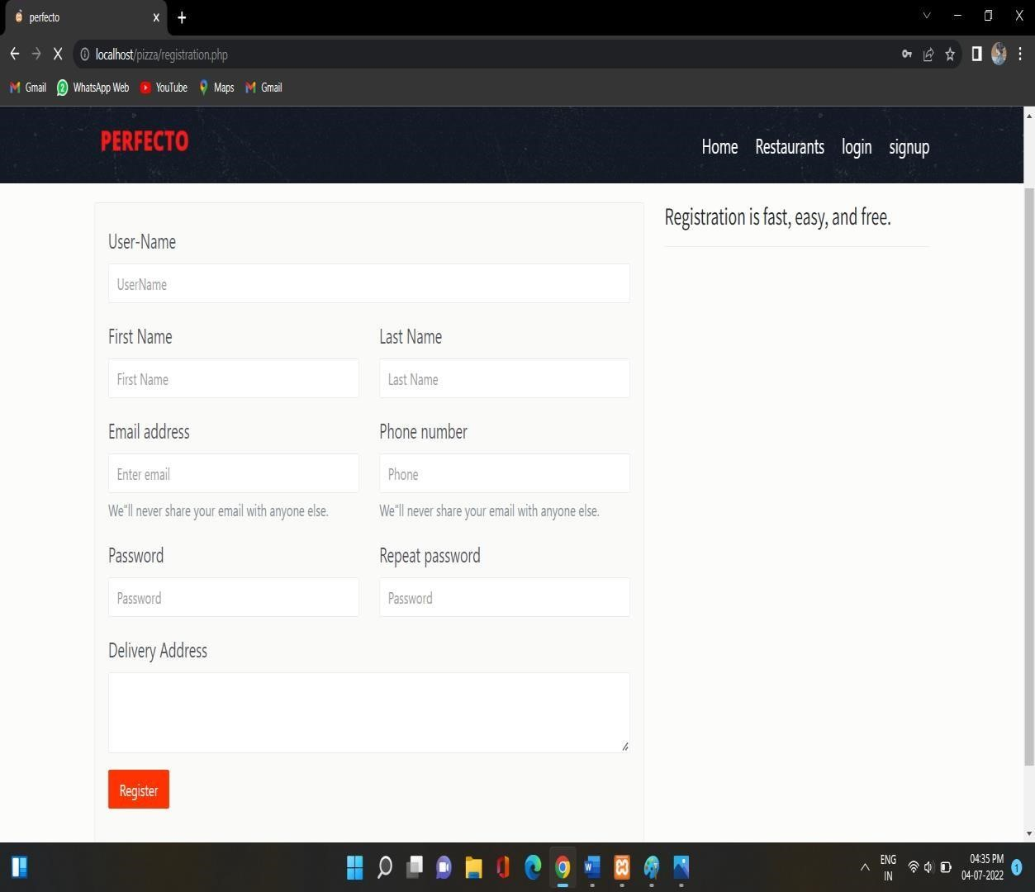

### Admin login page

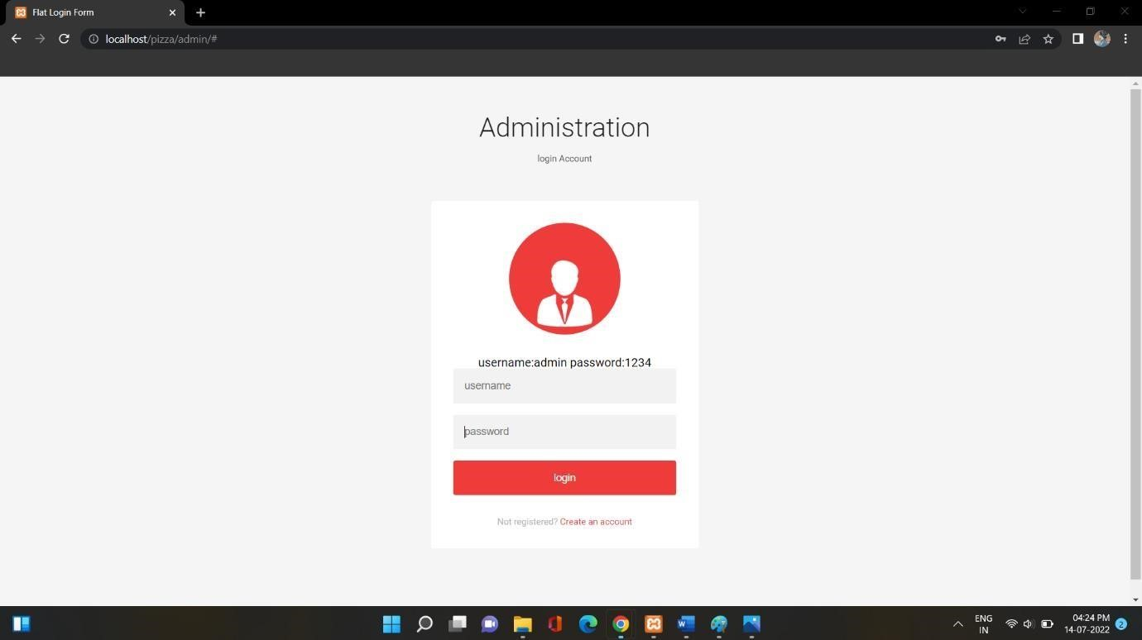

### Admin Registration

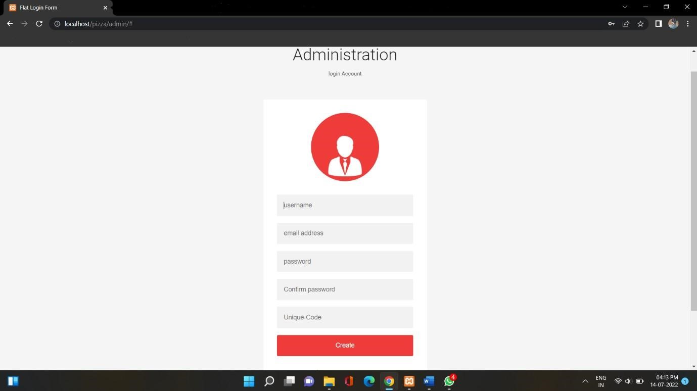

**Database Of Admin login**

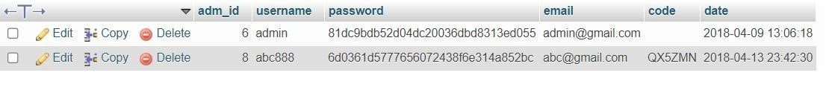

**Detail In Data Base**

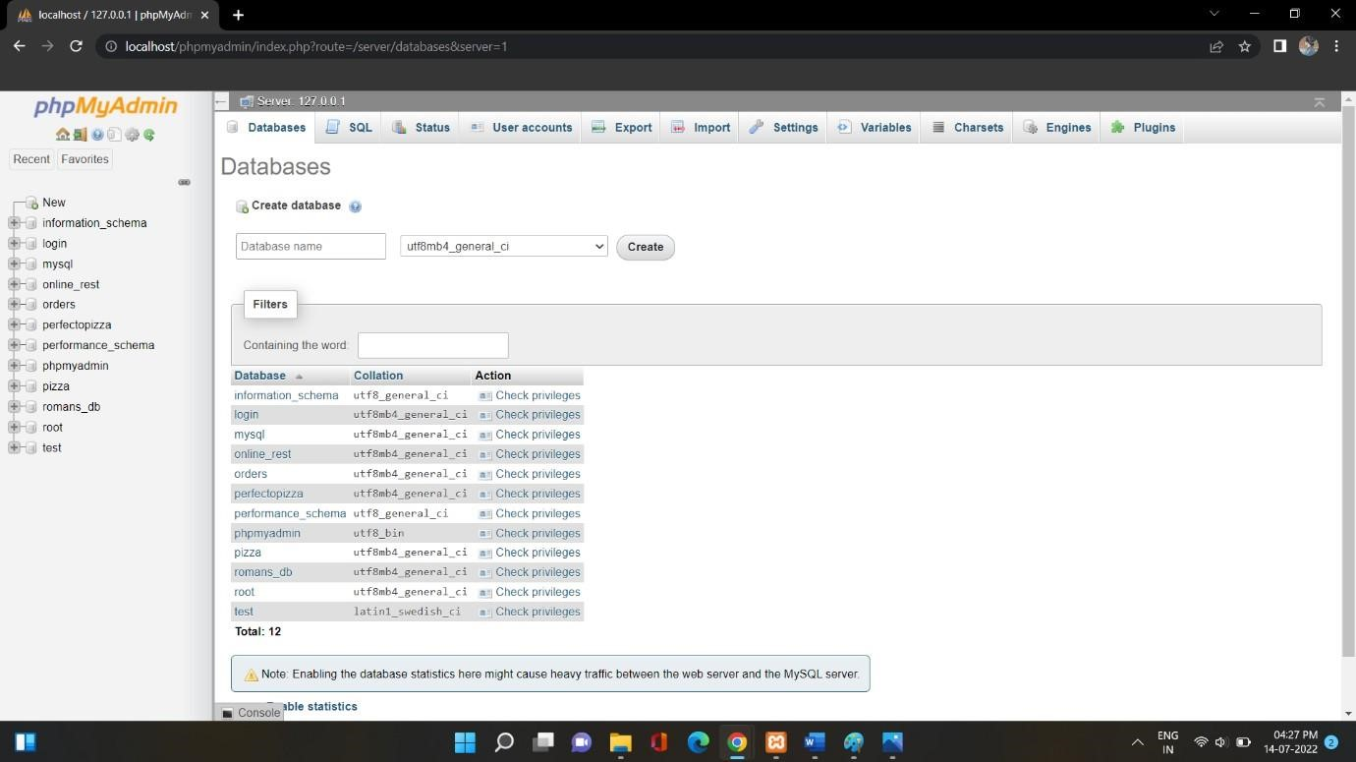

## Front Page of Web-site

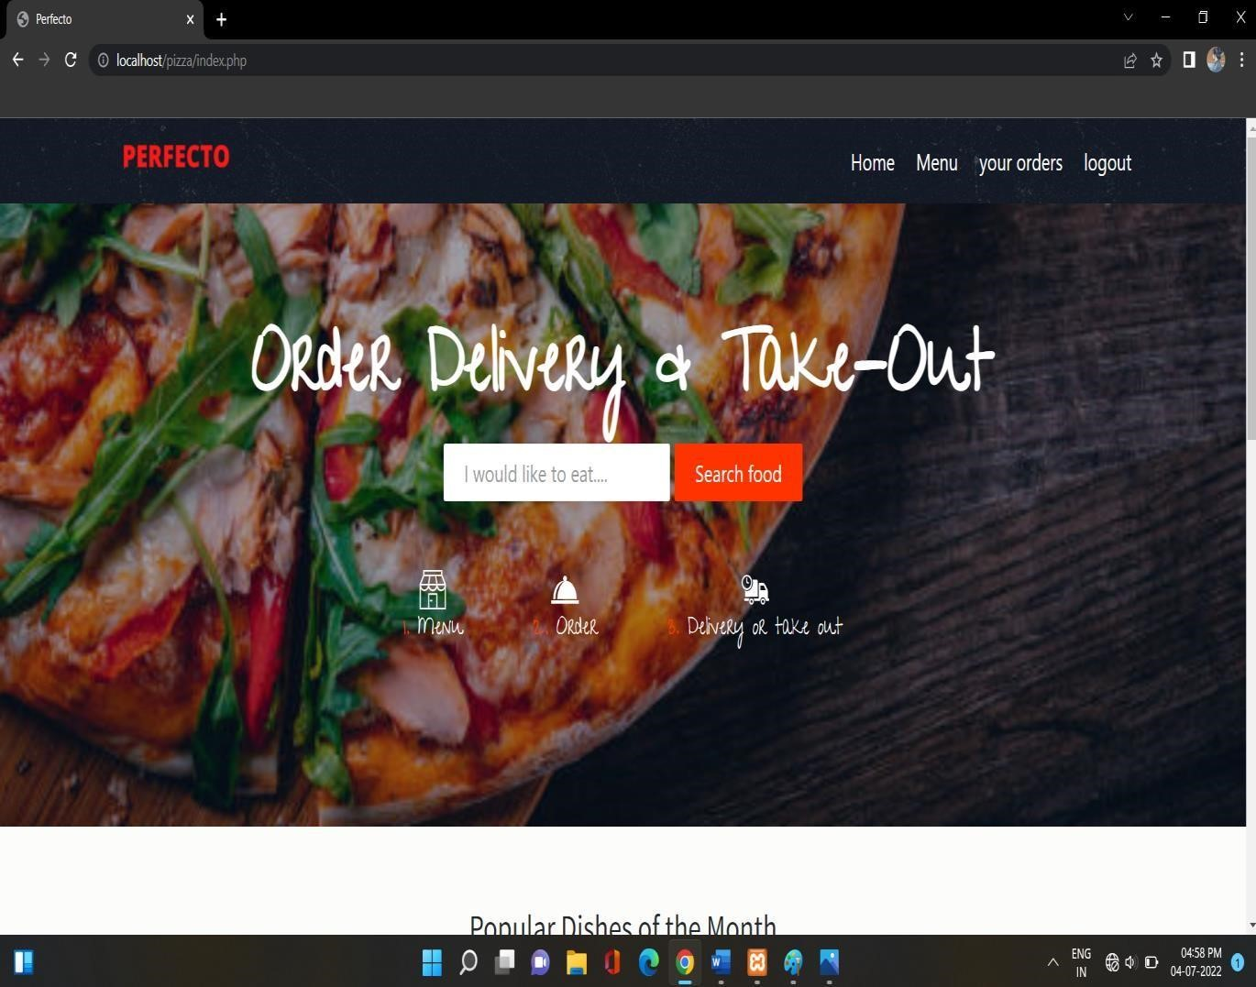

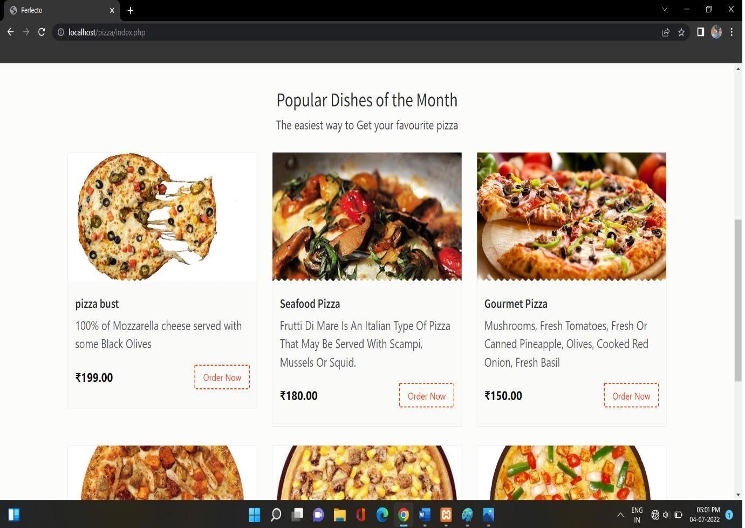

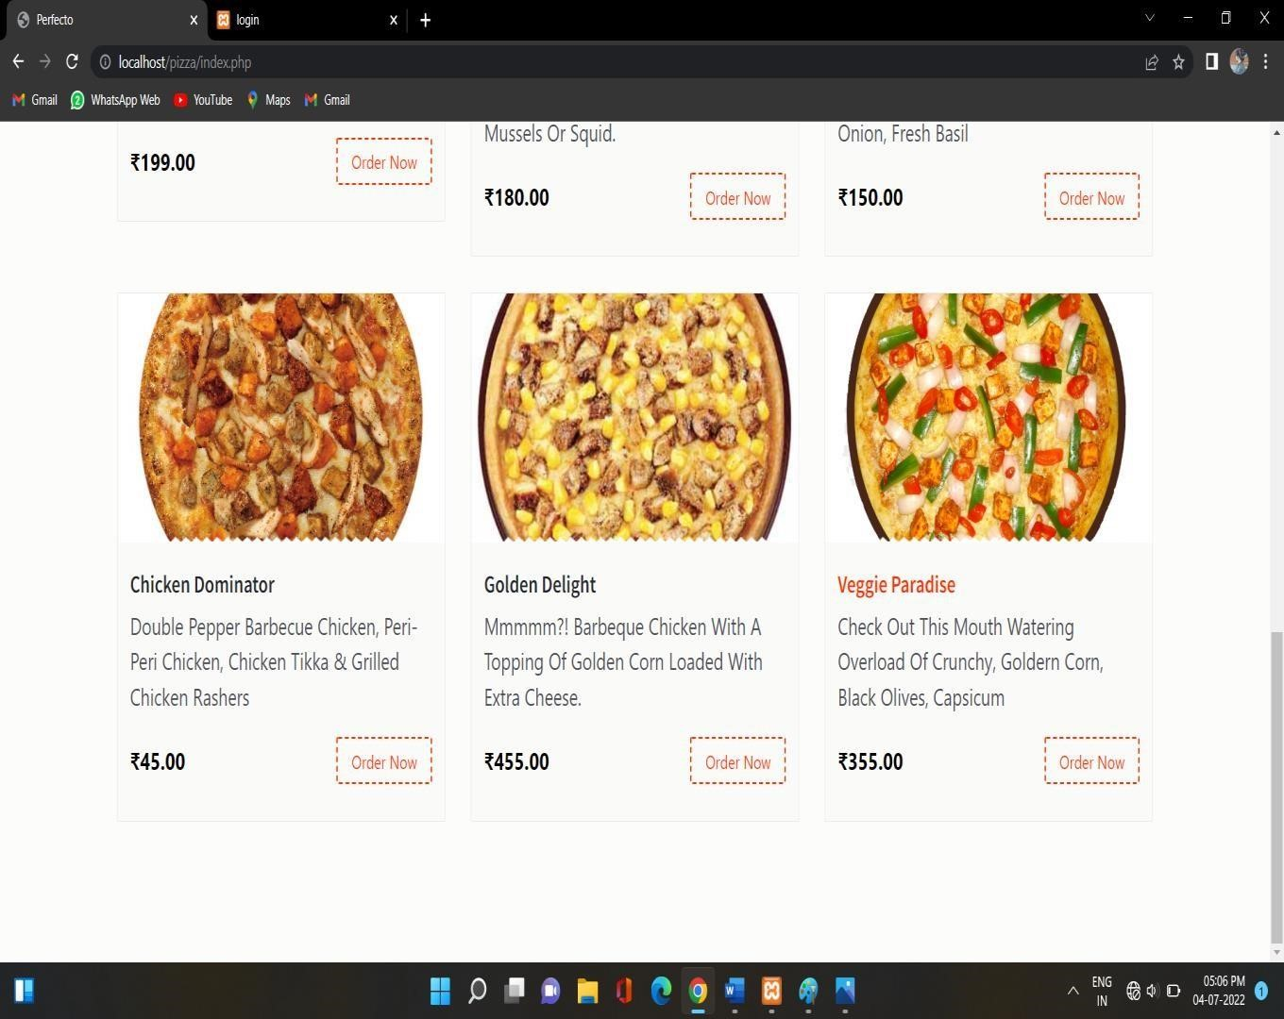

### Restaurant

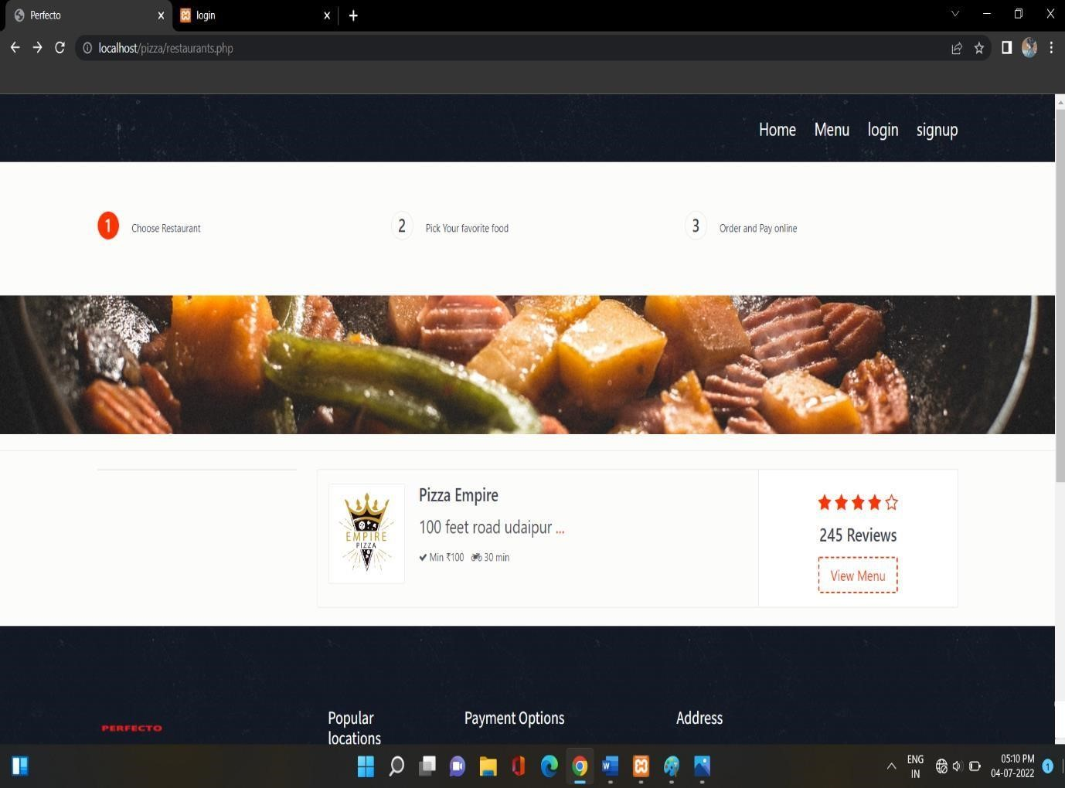

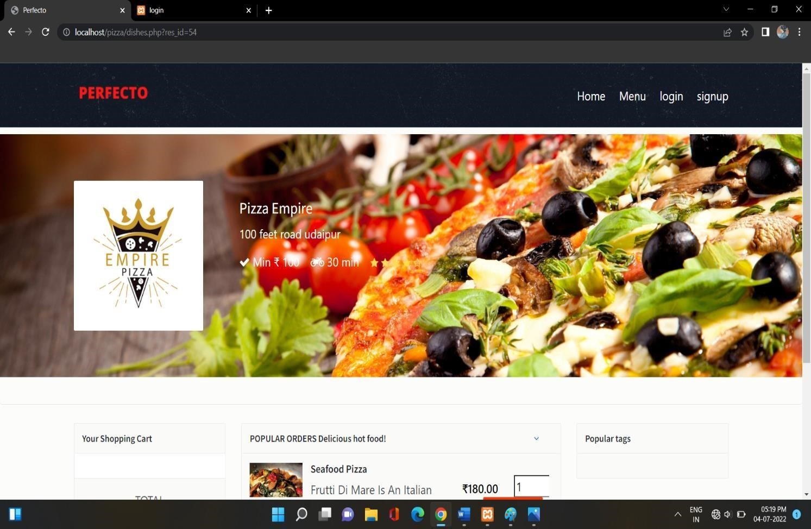

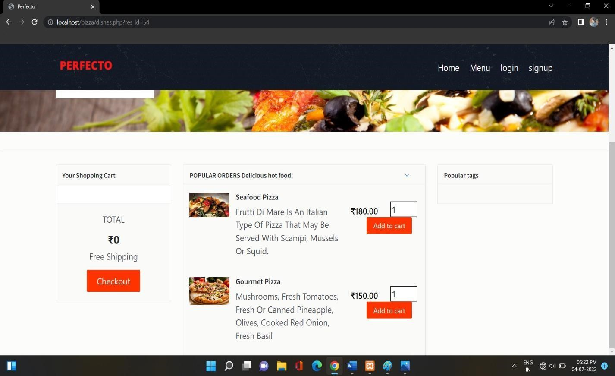

## Scope and purpose

The purpose of the design phase is to develop a clear understanding of what the developer want people to gain from his/her project. As you the developer work on the project, the test for every design decision should be "Does this feature fulfill the ultimate purpose of the project?" A purpose statement affects the design process by explaining what the developer wants the project to do, rather than describing the project itself. The Design Document will verify that the current design meets all of the explicit requirements contained in the system model as well as the implicit requirements desired by the customer.

**Design Phase**

**1.System Design**

### 1.1) Overall System Design Objectives

The overall system design objective is to provide an efficient, modular design that will reduce the system’s complexity, facilitate change and result in an easy implementation. This will be accomplished by designing strongly cohesion system with minimal coupling. In addition, this document will provide interface design models that are consistent user friendly and will provide straight forward transition through the various system functions.

### 1.2) Structure of Design Document

* System Architecture Design – The System architecture section has detailed diagram of the system, server and client architecture.
* Data Design – The data Design include an ERD as well as Database design.
* Functional Design Description – This section has the functional partitioning from the SRS, and goes into great detail to describe each function.

**2. System Architecture Design**

#### 2.1) System Architecture

The SIMS is a system which contain major part which include: student Detail, Student image and the input by the user the system acts and the rest resume. The user selects one of the available options as an input to the system. According to

But the normal student or users can only acce ss of the functions are performed accordingly. The administrator can operate on any student details.

their details of all the functionalities

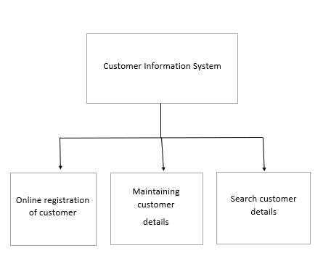

## ARCHITECTURE DIAGRAM

### 3. Data Design

**3.1) Entity Relationship Diagram**:

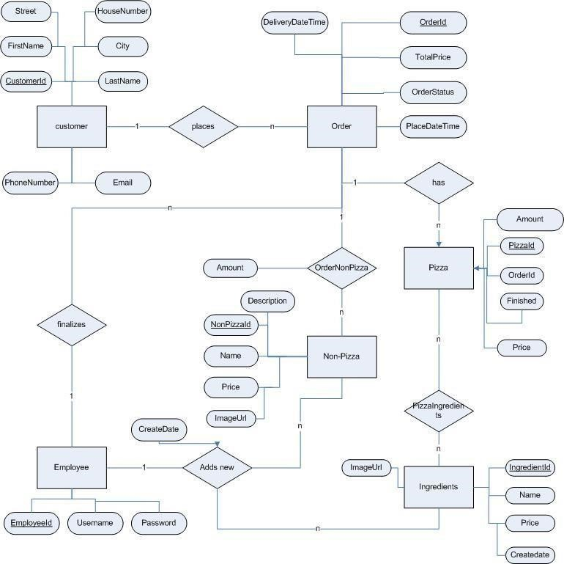

### 4. Functional Design Description

**4.1 Data Flow Diagram:**

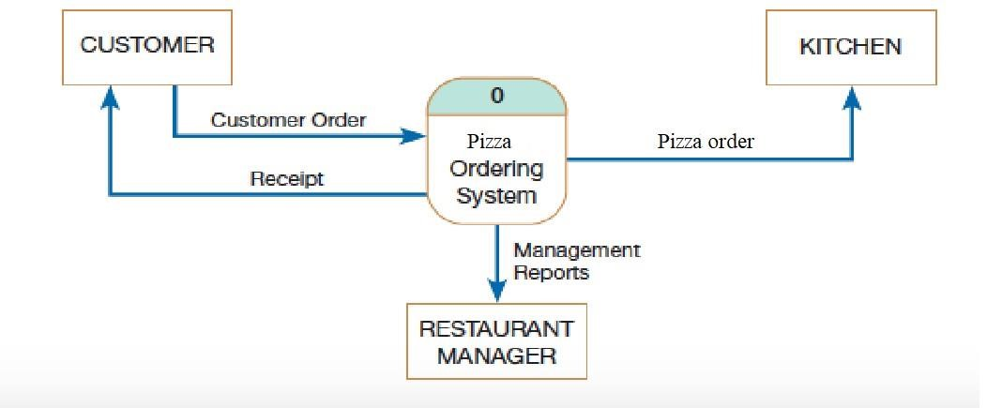

DATA FLOW DIAGRAM

## 5. Conclusion

Hence, we can conclude that the design phase of the SIMS gives us the information of all the processes used in the project and their relation

### Creating a Database and Inserting Data

Now that we have run and tested Apache and PHP, the next step is running MySQL and creating a database and table which will hold information to be used by our website. In order to start MySQL, navigate to the xampp directory and run the mysql_start.bat batch file. The XAMPP package contains an application called phpMyAdmin which allows developers to administer and maintain MySQL databases. We will be using phpMyAdmin to create a database and table, and enter test data. Before testing phpMyAdmin, make sure that both Apache and MySQL are running by opening their

respective batch files: apache_start.bat and mysql_start.bat. Along with Apache and MySQL running in the background, we type http://localhost/phpMyAdmin/ into our web browser. If successful we will be presented with a phpMyAdmin start page similar to the one shown below.

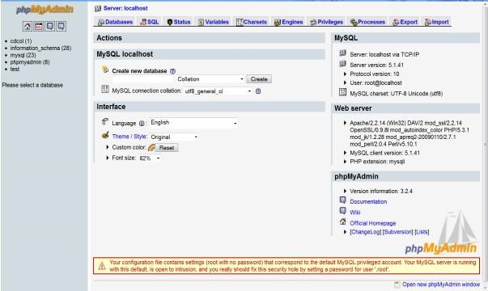

### phpMyAdmin start page

The first step with phpMyAdmin running is creating a new database. We create a new database by directly executing SQL statements as shown below. The successful execution of the sql query creates a database ‘customer’ with two tables in it. The tables are admin login and customer information. We also inserted values in the admin table. The screenshot below shows the successful execution of the query thus creation of a database named Customer.

Thus, we have learned to create a database in MYSQL by executing sql statements. After creating the database and tables we are now ready to use them in our website “Online Pizza Ordering System”.

### Bibliography

* PHP book by Vasvani (TMH publications).
* Beginning PHP5 by WROX.
* [www.google.com.](http://www.google.com/)
* [www.wikipedia.com](http://www.wikipedia.com/)
* [www.w3schools.com](http://www.w3schools.com/)
* Informatics practices by Sumita Arora.
* Head First PHP & MySQL by Lynn Beighley and

Michael Morrison(O’Reilly)