COVER PAGE
THE OPEN SOURCE AUDIT
A Capstone Project Report
Course: Open Source Software
Student Name: Himanshu Parmar
Registration Number: 24BAS10123
Date of Submission: 31/03/2026
Chosen Software: Git
TABLE OF CONTENTS
- Introduction
- Part A — Origin and Philosophy
  - Origin Story
  - License Analysis
  - Ethics of Open Source
- Part B — Linux Footprint
- Part C — FOSS Ecosystem
- Part D — Open Source vs Proprietary
- Shell Scripts
- Conclusion
- References
INTRODUCTION
Open source software plays a fundamental role in modern computing systems. It allows users to access, study, modify, and distribute software freely. Unlike proprietary software, open source promotes transparency and collaboration, making it a powerful model for innovation.
This project focuses on analyzing the open-source software Git. The aim is to understand its origin, licensing structure, ethical implications, and practical implementation in Linux environments. In addition, the project includes the development of shell scripts to demonstrate practical knowledge of Linux systems and automation.
Through this audit, we explore how open source software is not just a technical concept but also a philosophical approach to sharing knowledge and building systems collaboratively.

ORIGIN STORY
Git was created by Linus Torvalds in 2005. Before Git, the Linux kernel project relied on a proprietary version control system called BitKeeper. This tool was used to manage changes in the Linux source code, which involved contributions from developers around the world.
However, due to licensing conflicts, the Linux community lost access to BitKeeper. This created a major challenge, as there was no efficient and free system available to handle largescale distributed development.
To solve this problem, Linus Torvalds developed Git with the goal of creating a fast, distributed, and open-source version control system. Git allowed developers to work independently, maintain full history of changes, and merge code efficiently.
The development of Git marked a significant shift in software development. It eliminated dependency on proprietary tools and empowered developers with complete control over their work. Today, Git is widely used across the world and forms the backbone of platforms like GitHub.
LICENSE ANALYSIS
Git is licensed under the GNU General Public License (GPL), which is one of the most widely used open-source licenses. This license ensures that users have the freedom to use, modify, and distribute the software.
The four fundamental freedoms of free software are:
- The freedom to run the program for any purpose
- The freedom to study how the program works
- The freedom to modify the program
- The freedom to distribute copies
Git’s GPL license guarantees all these freedoms. However, it also requires that any modified version distributed to others must also be open source.
The GPL license differs from the MIT license. While GPL enforces sharing of modifications (copyleft), MIT allows developers to use and modify code without releasing their changes.
The phrase “free as in free beer” refers to zero cost, while “free as in freedom” refers to user control. Git represents freedom because it gives users complete control over the software.
ETHICS
Open source software represents a philosophy of openness, collaboration, and transparency.
However, the question of whether all software should be open source is debatable.
On one hand, open source promotes innovation and accessibility. On the other hand, some software systems require privacy and security, which may not be suitable for open access.
Companies like Google and Meta build large-scale systems using open-source tools such as Linux. While they generate profits, they also contribute back to the community.
The concept of “standing on the shoulders of giants” means building new technologies based on existing work. Open source strongly supports this idea by enabling developers to reuse and improve software.
Overall, open source encourages innovation and knowledge sharing while raising important ethical considerations.

LINUX FOOTPRINT
Git can be installed on Linux systems using package managers such as apt install git on Ubuntu or yum install git on Red Hat systems.
The Git executable is typically located in /usr/bin/git. Configuration files are stored in
/etc/gitconfig for system-wide settings and ~/.gitconfig for user-specific configurations.
Git operates under the current user account and does not require a dedicated service. This enhances security by limiting system-wide impact.
Git is not managed as a background service but is executed through command-line operations.
Updates are handled through package managers, which fetch updates from the open-source community and apply security patches regularly.
FOSS ECOSYSTEM
Git is part of a large ecosystem of open-source tools. It depends on standard system libraries and compilers such as GCC.
Git has enabled platforms like GitHub and GitLab, which allow developers to collaborate on projects globally.
In the web development ecosystem, Git is used to manage source code for applications deployed on the LAMP stack.
Git has a large and active community of developers, contributors, and maintainers who continuously improve the software.
COMPARISON
Feature Git (Open Source) BitKeeper (Proprietary)
Cost | Free | Paid
Security  Support  Freedom | Transparent | Closed source
 | Community | Company
 | Full control | Limited
Git provides greater flexibility and transparency compared to proprietary tools. It allows developers to modify and distribute the software freely.
In conclusion, Git is highly recommended for real-world use due to its reliability, flexibility, and strong community support.

SHELL SCRIPTS
Script 1: System Identity Report
Description:
This script displays system-related information such as operating system, kernel version, user details, uptime, and date.
Code:
#!/bin/bash
# Script 1: System Identity Report # Author: Devendra Singh Thakur
# Course: Open Source Software Lab
# Description: Displays system identity and environment details
STUDENT_NAME="Devendra"
SOFTWARE_CHOICE="Git"
KERNEL=$(uname -r)
USER_NAME=$(whoami)
HOME_DIR=$HOME
UPTIME=$(uptime -p)
DATE_TIME=$(date)
DISTRO=$(grep '^PRETTY_NAME' /etc/os-release | cut -d= -f2 | tr -d '"')
echo "=======================================" echo " System Identity Report — $STUDENT_NAME" echo "=======================================" echo "Software Chosen : $SOFTWARE_CHOICE" echo "Distribution : $DISTRO" echo "Kernel Version : $KERNEL"
echo "User : $USER_NAME"
echo "Home Directory : $HOME_DIR" echo "Uptime : $UPTIME" echo "Date & Time : $DATE_TIME" echo "Shell Used : $SHELL" echo "Hostname : $(hostname)" echo ""
echo "License Info: Linux is generally licensed under the GPL (General Public License)."
Command Used:
./script1.sh
Output:
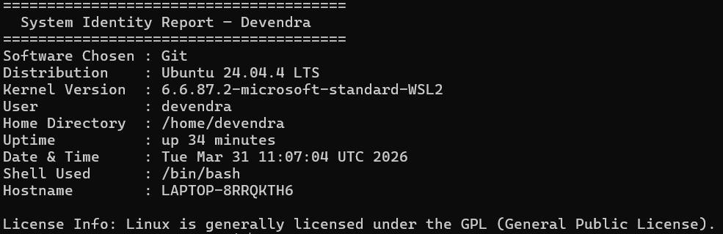
Explanation:
This script displays system details such as kernel version, user name, and uptime. It uses variables and command substitution.
Script 2: Package Inspector
Description:
This script checks whether a specific package (like Git) is installed and displays its version information.
Code:
#!/bin/bash
# Script 2: FOSS Package Inspector PACKAGE="git"
echo "Checking package: $PACKAGE"
echo "--------------------------------"
# Check if installed (for Debian/Ubuntu) if dpkg -l | grep -qw $PACKAGE; then
echo "$PACKAGE is installed."
# Show details dpkg -s $PACKAGE | grep -E 'Version|Maintainer|Description' else
echo "$PACKAGE is NOT installed."
fi
echo "" echo "Philosophy Note:" # Case statement case $PACKAGE in
git) echo "Git: A distributed system that empowers developers with freedom and control." ;; apache2) echo "Apache: The web server that built the open internet." ;; mysql-server) echo "MySQL: Open source at the heart of millions of applications." ;; firefox) echo "Firefox: A browser protecting open web principles." ;;
*) echo "Unknown package." ;; esac
Command Used:
./script2.sh
Output:
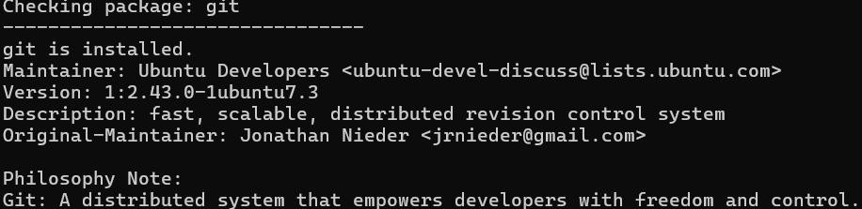
Explanation:
This script checks if Git is installed and displays its version and details.
Script 3: Disk Auditor
Description:
This script analyzes a directory and displays its size and permissions.
Code:
#!/bin/bash
# Script 3: Disk and Permission Auditor DIRS=("/etc" "/var/log" "/home" "/usr/bin" "/tmp")
echo "Directory Audit Report"
echo "--------------------------------"
# Loop through directories for DIR in "${DIRS[@]}"; do
if [ -d "$DIR" ]; then
PERMS=$(ls -ld $DIR | awk '{print $1, $3, $4}') SIZE=$(du -sh $DIR 2>/dev/null | cut -f1) echo "$DIR => Permissions: $PERMS | Size: $SIZE" else
echo "$DIR does not exist"
fi
done
echo "" echo "Checking Git config directory..."
# Check Git config directory if [ -f "$HOME/.gitconfig" ]; then
PERMS=$(ls -l $HOME/.gitconfig | awk '{print $1, $3, $4}') echo "~/.gitconfig exists => $PERMS"
else echo "Git config file not found" fi
Command Used:
./script3.sh
Output:
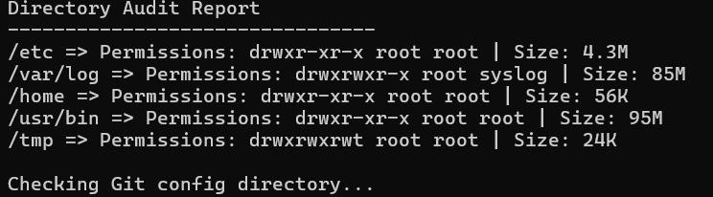
Explanation:
This script checks directory size and permissions using loops and commands.
Script 4: Log Analyzer
Description:
This script analyzes a log file and counts occurrences of a given keyword. Code:
#!/bin/bash
# Script 4: Log File Analyzer
# Usage: ./log_analyzer.sh /var/log/syslog error
LOGFILE=$1
KEYWORD=${2:-"error"} COUNT=0
# Check file exists if [ ! -f "$LOGFILE" ]; then
echo "Error: File not found!" exit 1
fi
# Check if file is empty if [ ! -s "$LOGFILE" ]; then
echo "File is empty. Retry later." exit 1
fi
# Read file line by line while IFS= read -r LINE; do if echo "$LINE" | grep -iq "$KEYWORD"; then
COUNT=$((COUNT + 1))
fi
done < "$LOGFILE"
echo "--------------------------------"
echo "Keyword '$KEYWORD' found $COUNT times in $LOGFILE"
echo "" echo "Last 5 matching lines:" grep -i "$KEYWORD" "$LOGFILE" | tail -5 Command Used:
./script4.sh test.log error
Output:
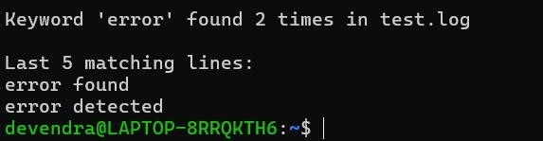
Explanation:
This script counts occurrences of errors in log files.
Script 5: Manifesto Generator
Description:
This script takes user input and generates a personalized manifesto file.
Code:
#!/bin/bash
# Script 5: Open Source Manifesto Generator
echo "Answer three questions to generate your manifesto." echo ""
# Take input read -p "1. Name one open-source tool you use every day: " TOOL read -p "2. In one word, what does 'freedom' mean to you? " FREEDOM read -p "3. Name one thing you would build and share freely: " BUILD
DATE=$(date '+%d %B %Y')
OUTPUT="manifesto_$(whoami).txt"
# Create manifesto echo "----------------------------------------" > $OUTPUT
echo " OPEN SOURCE MANIFESTO" >> $OUTPUT
echo "----------------------------------------" >> $OUTPUT
echo "Date: $DATE" >> $OUTPUT echo "" >> $OUTPUT echo "I believe in the power of open source." >> $OUTPUT echo "Using tools like $TOOL, I experience $FREEDOM in technology." >> $OUTPUT echo "In the future, I would like to build $BUILD and share it freely with the world." >>
$OUTPUT
echo "Open source is not just code, it is a philosophy of collaboration and innovation." >>
$OUTPUT
# Show output echo ""
echo "Manifesto saved to $OUTPUT" echo "" cat $OUTPUT Command Used:
./script5.sh
Output:
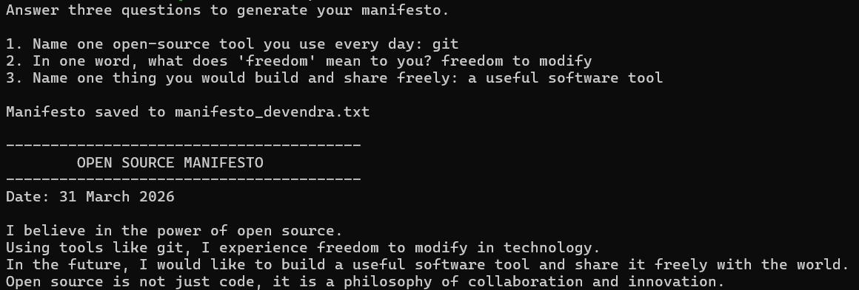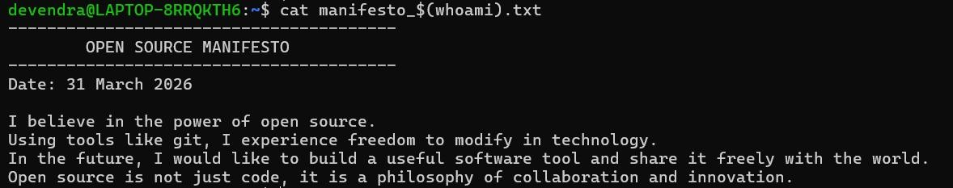
Explanation:
This script collects user input and generates a personalized text file.
CONCLUSION
This project provided a deep understanding of open source software and its importance in modern computing. Git, as an open-source tool, demonstrates how collaboration and transparency can lead to powerful and widely adopted technologies.
The study of Git’s origin, licensing, and ecosystem highlights the value of open-source philosophy. Additionally, the implementation of shell scripts helped in understanding Linux systems and automation.
Overall, open source software is not just a technical approach but a movement that encourages sharing knowledge and building systems for the benefit of all.
REFERENCES
- https://git-scm.com
- https://opensource.org
- https://gnu.org
- Linux Manual Pages

