**MAHARAJA SURAJMAL INSTITUTE**

Affiliated to GGSIP University & NAAC ‘A’ grade accredited



DEPARTMENT OF COMPUTER APPLICATION

**FUNDAMENTALS OF COMPUTER AND IT**

**PRACTICAL FILE**

SUBJECT CODE – BCA 173

**Submitted by : Himanshu**   **Submitted to :- Mr. S.P. Chauhan**

**Enrollment no : 00221202021 Assistant Professor , MSI**

**Sem : 1st Sec : 2nd shift**  **Sign :- ________________**

***---------------------------------------------------------------------------------------------------------------------------------------------------------------***

**Index**

|  |  |  |  |
| --- | --- | --- | --- |
| **S. No.** | **Practical** | **Date** | **Sign** |
| 1. | ***Ques.*** *What is MS Word …….?*  ***Ques.***  *Define characteristics of MS Word .*  ***Ques.*** *Explain the interface of MS Word.* | 12/12/21 |  |
| 2. | ***Ques.*** *Create a Resume.* | 14/12/21 |  |
| 3. | ***Ques.***   * *Type the paragraph above as it is using "Calibri font", font size: 12* * *Change the font type to "Lucida Calligraphy and size to 14* * *Alignment to your paragraph to right margin* * *Save this file as ms-word doc in "my documents” folder using save as option* * *Edit some part of your document and save again using save option.* * *Close the file* * *Open this file again using open option from office button* * *View the file you have created using print preview option* * *Take a print out of this document through print option.* * *Create a new file using new option* * *Select some part of your document of PRACTICAL-1 and copy it is new file created in*   *bullet 1. Use shortcut keys for copy and paste*   * *Highlight "Microsoft Word is a word processor developed by Microsoft”.* * *Search for word "document" wing find option* * *Replace the word Microsoft with MS* | 17/12/21 |  |
| 4. | ***Ques.***   * *Select your document by using select all option and change the font size of your document.* * *Underline the Microsoft-word" using underline option.* * *Draw a line through the middle of the selected text using strikethrough option.* * *Create small number below the text baseline of the word -Multi-Tool" using subscript (ctrl+=) as shown below*   ***Multi-Tool1***   * *Create small number above the text baseline using superscript (ctrl+shift++) as shown below.*   ***Multi-Tool2*** | 20/12/21 |  |
| 5. | ***Ques.*** *Explain about following commands of MS Word:*   1. *The file tab* 2. *Ribbon tabs* 3. *Groups* 4. *Dialog box launcher* | 22/12/21 |  |
| 6. | ***Ques.*** *What is Paragraph? Explain about Paragraph marks, Soft paragraph line break marks.*  *Write the paragraphs and do following:*  *There are different types of computer systems nowadays for different purpose according to the user needs. However we can classify them into different groups based on different aspects. We can find four different type of computers based on size. These are large* *computers that are most powerful. They can complete tasks very soon and are optimized to complete given tasks quickly Mainframe Computers These are the largest computers and can support hundreds of users simultaneously. These are powerful computers and optimized to run maximum number of applications at one time. These are medium sized computers-smaller than mainframe but much larger than personal computers. They can be the best solution for medium scale organizations Micro Computers Micro computers are the smallest when is concerned. They range from Desktop, Laptop up to the palm top and even smaller ones. Because micro computers we developed to support single person, they are often called personal computers (PCs).*   1. *Divide 4 paragraph for the above test and justify Alignment* 2. *Make Drop Cap the first letter of the second paragraph Make 13 line spacing for third paragraph* 3. *Change font size on 17 points for the last paragraph* 4. *Apply numbers for the last two sentences for 4th paragraph* 5. *Set up the per layout an Landscape orientation and set up 150° and Right 1.05* | 23/12/21 |  |
| 7. | ***Ques.*** *Create table as below and shading the first row. Insert an Octagon and write your name in the center:*   * *Create margin at the top & bottom 1.1 inch and right & left 1.5 inch* * *Create landscape orientation & A4 paper size* * *Insert Period Ill column after Period II* * *Insert Thursday row bellow Wednesday row* * *Insert page number center align and Arial font* * *Insert watermark "Hello world"* * *Table font "Times new roman" and 13 size* | 28/12/21 |  |
| 8. | 1. ***Ques.*** *What are styles and what do I use them for? Write 5 pages word documents of 3 chapters first two pages of chapter-1, second 2 pages of chapter-2 and last one page of Chapter-3 with following styles:* 2. *Paragraph with Normal styles having "Aerial Font", 11 size and 115 line spacing with d 6cm left indent* 3. *Heading 1 with 1" level numbering with "Times New Roman" font, size 14, bold, 12mm spacing before and 6mm spacing after "Heading 1”* 4. *Heading 2 with 2 level numbering with Aerial font, size 12, bold, 6mm spacing before 2.16mm spacing after "Heading 2”* 5. *Heading 3 with 3 level numbering with Aerial font, size 11, 6mm spacing before and 3mm spacing after “Heading 1”* 6. *Documents should have total of 5 pages with "Heading 1 "Heading 2" and "Heading 3”. Each "Heading I” in each page should have with minimum of 2 "Heading 2” and 3 “Heading 3” in each "Heading 2" See example below* 7. *Each Chapter will have separate header with their Chapter number and footer with page number*  * *Create "Table of content in the top of document with page numbering in roman in footer.* * *Create one Table in each page and also create "Table of Figures" just below the Table of Contents* | 31/12/21 |  |
| 9. | ***Ques.*** *Design display board and logo by using Word Art and print it.* | 03/01/22 |  |
| 10. | ***Ques.*** *Create a College Identity Card*. | 05/01/22 |  |
| 11. | Assignment 1  **Ques.** *Create a spreadsheet for a super market private limited having the following entries:-*   1. *Serial No.* 2. *Product ID* 3. *Product Name* 4. *Product Type* 5. *Quantity* 6. *Price per unit* 7. *Total price*   *Enter atleast 20 records. All the entries should be bold and underlined. Find the total bill generated.* | 06/01/22 |  |
| 12. | Assignment 2  **Ques*.*** *Make a marksheet of 12 students of BCA course having fields:*   1. *Serial no* 2. *Name* 3. *Marks in 5 subjects*   *and perform the following questions.*   1. *Sort the record in ascending order of marks.* 2. *Sort the record in descending order of names.* 3. *Find the minimum marks of each subject and replace it by the text “put more efforts” using find and replace option.* 4. *Add 3 columns total marks, percentage and grades apply formula to calculate them.* 5. *Filter records to display marks more than 60%* | 08/01/22 |  |
| 13. | *Assignment 3*  ***Ques.*** *Design mark sheet for students of 12th class, which consists of information S.No , Rollno , Name , Section, Maths, Physics, chemistry, Computer Science for each subject internal , external and marks recorded. Using the formula calculate:*   1. *Total marks of each subject and give grade as (A>=90 , B between 80 and 90 , C between 70 and 60, D between 60 and 40 , E otherwise .* 2. *Total marks of all subjects and total percentage. Depending on total percentage write in the remarks (“Excellent”>=90 , “Very Good” between 80 and 90, “Good” between 70 and 80 , “Fair” between 70 and 60, “Poor” otherwise.* 3. *If student got more than 50 marks as total in each subject than status must be “Pass’ otherwise “Fail”.* 4. *Highlight the cells with of percentage with different colors with the rule stated in (ii).* 5. *Count the number of Excellent , Very Good , Good , Fair and Poor.* | 11/01/22 |  |
| 14. | *Assignment 4*  ***Ques.*** *An organization pays monthly salary, which consists of basic salary, allowances and deductions as per detail given below (minimum 15 employee):*   1. *HRA is 30% of Basic.* 2. *DA is 20% of Basic.* 3. *Conveyance allowance is:-* 4. *Rs. 1000/- if basic is less than or equals to Rs. 10000/-* 5. *Rs. 2500/- if basic is greater than Rs.10000/- and less than Rs.20000/-* 6. *Rs. 4000/- if basic is greater than 20000/-* 7. *Entertainment allowance is:-* 8. *Rs. 1500/- if basic is less than or equal to Rs. 10000/-* 9. *Rs. 3000/- if basic is greater than 10000/-* 10. *PF deduction is 7% of basic.* 11. *IT deduction is 20% of basic.* 12. *Gross salary as Basic + HRA + DA + Conveyance + Entertainment* 13. *Net salary = Gross Salary – Deductions*   *Make the spread sheet of above using formulas & conditions. Also calculate followings using function.*   1. *Number of employee having net salary more than or equals to Rs.50000/-* 2. *Number of employee having salary less than Rs.50000/- k) Number of employee having basic less than or equals to Rs.10000/- and Gross salary 15000/-* 3. *Number of employee having basic more than Rs.20000/- and Gross salary 40000/-* | 18/01/22 |  |
| 15. | *Assignment 5*  ***Ques.*** *Enter the date of birth and MSI offline joining dates of your class friends (minimum 15). Apply the date formulas to calculate the following: -*   1. *Year of birth, day and month* 2. *Year of joining MSI, day and month* 3. *Add 5 years, 2 months and 10 days to date of birth* 4. *Add 2 years, 6 months and 20 days to MSI joining dates.* 5. *Calculate the followings between DTOB and date of joining MSI.*  * *Number of days* * *Number of months* * *Number of years* * *Number of days ignoring years* * *Number of days ignoring months* * *Number of months ignoring years*  1. *Calculate difference between DOB and MSI joining date in years, month and days.* | 22/01/22 |  |
| 16. | *Assignment 6*  ***Ques.*** *Enter the date of birth and MSI offline joining dates of your class friends (minimum 15). Apply the date formulas to calculate the following: -*   1. *Age of each student in years.*  * *Using displaying today’s date* * *Without using today’s date* * *Using date function on a specific date.*  1. *Calculate age of each student in years, month and days.* 2. *Calculate age of each student in days, month and years.* 3. *Calculate the number of weekdays of date of DOB and MSI joining date.* 4. *Calculate the name of day and month of DOB and MSI joining date.* | 25/01/22 |  |
| 17. | *Assignment 7*  ***Ques.*** *Prepare a shopping mall bill/invoice with columns Serial No. item name, no of items, rate, discount, amount, GST am=nd grand total.*  ***Ques.*** *A company pays a monthly salary to its employees which consists of basic salary, allowance and deductions, HRA is 30% of basic salary, DA is 20% of basic salary & TA 10% of basic salary calculate the following:-*   * *Gross salary = basic salary + HRA + DA + TA* * *Net salary = Gross salary – Tax, if (basic salary PA<=2 lakhs: No tax, if basic salary PA >2 & <=5lakhs: 10% Tax, if basic salary PA>5lakhs: 25% Tax.* | 30/01/22 |  |
| 18. | ***Ques.*** *What is MS Dos? What is the use of MS Dos. Write some advantages of MS Dos?*  ***Ques.*** *What are internal and External commands in MS Dos?* | 07/02/22 |  |
| 19. | ***Ques.*** *Power point presentation.* | 19/02/22 |  |

***practical 1***

***Ques.* *What is MS Word …….?***

Microsoft Word is a [word processing software](https://en.wikipedia.org/wiki/Word_processor) developed by [Microsoft](https://en.wikipedia.org/wiki/Microsoft). It is a Graphical word processing program that users can type with. Its purpose is to allow users to type and save documents. Similar to other word processors, it has helpful tools to make documents.

It's designed primarily for text-based documents. In Word, you type text and see roughly how it will appear on someone else's computer screen or on paper. You can change the font, colour, size and other style settings for text using Word's built-in options.

Software developers Richard Brodie and Charles Simonyi released the Multi-Tool Word for the UNIX operating system in 1983. Later that year, the program was rewritten to run on personal computers under MS-DOS and was renamed Microsoft Word.

***Ques. Define characteristics of MS Word*** .

**A few characteristics of MS Word are as follows:-**

* Font Style, Size and Colour.
* Header and Footer.
* Insert Images.
* Add tables and bulleted lists.
* Set a page layout.
* Add Word Art.
* Convert a List to a Table
* Convert a Bulleted List to SmartArt
* Create a Custom Tab

***Ques.* Explain the interface of MS Word**.

* **The office button:-**

It is located in the upper left-hand corner, The office button displays commands for opening, saving, and printing a document. Clicking the Office Button also displays a list of recently used documents.

* **Quick access tool bar:-**

It is located to the right of the office button. The Quick Access Toolbar holds the commands you use over and over again such as: save, undo and repeat.

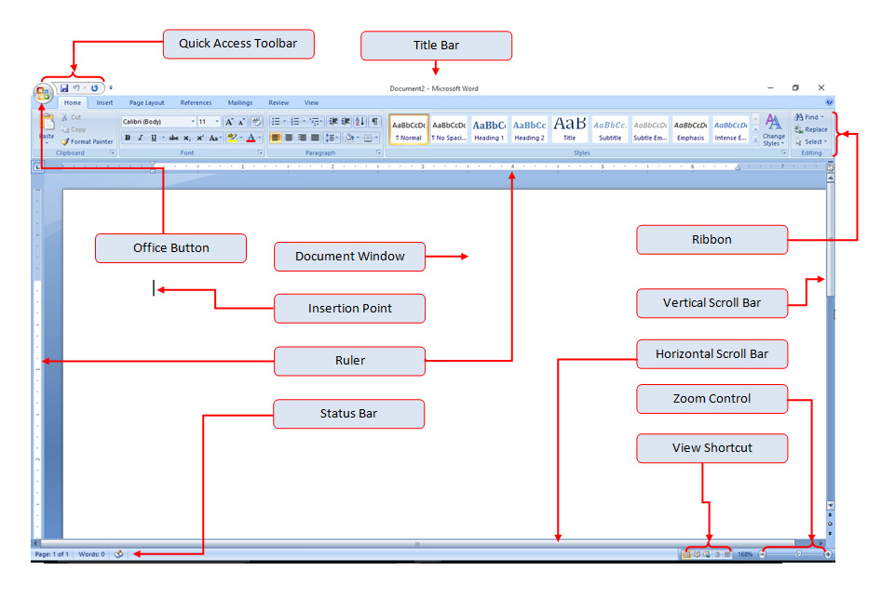

* **Title bar:-**

It is located at the top of the document. The title bar displays the name of the document that you are currently working on.

* **View button:-**

It is located in the bottom right hand corner. These buttons allow you to change the view of the document.

* **Status bar:-**

Located in the bottom left hand corner of the document window is the status bar. It is a customizable bar that displays information.

***practical 2***

***Ques.*** Create a Resume.

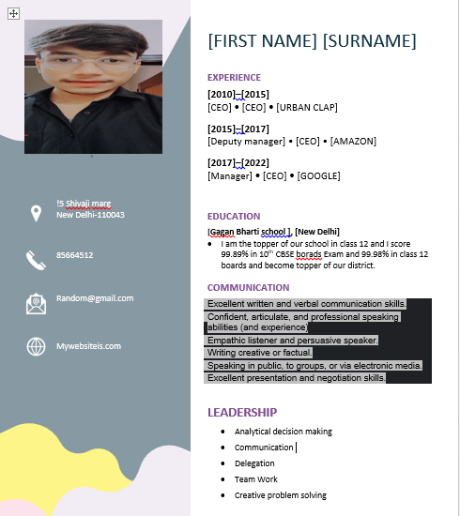

***practical 3***

***Ques.***

* Type the paragraph above as it is using "Calibri font", font size: 12
* Change the font type to "Lucida Calligraphy and size to 14
* Alignment to your paragraph to right margin
* Save this file as ms-word doc in "my documents” folder using save as option
* Edit some part of your document and save again using save option.
* Close the file
* Open this file again using open option from office button
* View the file you have created using print preview option
* Take a print out of this document through print option.
* Create a new file using new option
* Select some part of your document of PRACTICAL-1 and copy it is new file created in

bullet 1. Use shortcut keys for copy and paste

* Highlight "Microsoft Word is a word processor developed by Microsoft”.
* Search for word "document" wing find option
* Replace the word Microsoft with MS

***Output:-***

**The Benefits of Music: How the Science of Music Can Help You**

**Patients with memory loss can often remember songs and specific song lyrics. Doctors will often use music and lyric recall to help individuals retrieve lost memories. Certain music can trigger particularly unique memories- music from a specific time period will trigger memories from that time period. Want to** **remember something from the past? Listen to songs you listened to during that time! Music and its effect on memory has been a heated debate in the scientific world, but researchers now have evidence that the processing of music and language, specifically memorizing information, rely on some of the same brain systems. Researchers have also uncovered evidence that suggests the music we heard as teenagers has a greater emotional bind to our brain than anything we’ll listen to as adults.**

**The Benefits of Music: How the Science of Music Can Help You Patients with memory loss can often remember songs and specific song lyrics.** **Doctors will often use music and lyric recall to help individuals retrieve lost memories.** Certain music can trigger particularly unique memories- music from a specific time period will trigger memories from that time period. Want to remember something from the past? Listen to songs you listened to during that time! Music and its effect on memory has been a heated debate in the scientific world, but researchers now have evidence that the processing of music and language, specifically memorizing information, rely on some of the same brain systems. Researchers have also uncovered evidence that suggests the music we heard as teenagers has a greater emotional bind to our brain than anything we’ll listen to as adults.

* Patients with memory loss can often remember songs and specific song lyrics. Doctors will often use music and lyric recall to help individuals retrieve lost memories.
* Certain music can trigger particularly unique memories- music from a specific time period will trigger memories from that time period.

**MS Word is a word processor developed by Microsoft.**

***practical 4***

***Ques.***

* **Select your document by using select all option and change the font size of your document.**
* **Underline the Microsoft-word" using underline option.**
* **Draw a line through the middle of the selected text using strikethrough option.**
* **Create small number below the text baseline of the word -Multi-Tool" using subscript (ctrl+=) as shown below**

**Multi-Tool1**

* **Create small number above the text baseline using superscript (ctrl+shift++) as shown below.**

**Multi-Tool2**

***Output:-***

~~The Benefits of Music:~~ How the Science of Music Can Help You

Patients with memory loss can often remember songs and specific song lyrics. Doctors will often use music and lyric recall to help individuals retrieve lost memories**.** Certain music can trigger particularly unique memories- music from a specific time period will trigger memories from that time period. Want to remember something from the past? Listen to songs you listened to during that time! Music and its effect on memory has been a heated debate in the scientific world, but researchers now have evidence that the processing of music and language, specifically memorizing information, rely on some of the same brain systems. Researchers have also uncovered evidence that suggests the music we heard as teenagers has a greater emotional bind to our brain than anything we’ll listen to as adults.

**MS Word is a word processor developed by Microsoft**

MULTI-TOOL2 MULTI-TOOL1

***practical 5***

***Ques.*** Explain about following commands of MS Word:

1. The file tab
2. Ribbon tabs
3. Groups
4. Dialog box launcher

***Output:-***

1. ***The File Tab:***

In [Microsoft Word](https://www.computerhope.com/jargon/m/microsoft-word.htm) and other [Microsoft Office](https://www.computerhope.com/jargon/o/office.htm) products, the File tab is a section on the Office [Ribbon](https://www.computerhope.com/jargon/r/ribbon.htm) that gives you access to file functions. For example, from the File tab, you can access the *Open*, *Save*, *Close*, *Properties*, and *Recent* file options. The File tab is the blue button in the upper-left corner.

When viewing the properties of a computer file, the top of the window contains one or more [tabs](https://www.computerhope.com/jargon/t/tab.htm) called file tabs. Some software applications may integrate into the properties window, adding additional file tabs and information or functionality. Each file tab provides specific details about the file, including the information listed below.

File tab file details

* Type of file (e.g., [text file](https://www.computerhope.com/jargon/t/textfile.htm), [Word file](https://www.computerhope.com/jargon/w/word.htm), [HTML file](https://www.computerhope.com/jargon/h/html.htm), etc.).
* [File name](https://www.computerhope.com/jargon/f/filename.htm).
* Size of the file (in [KB](https://www.computerhope.com/jargon/k/kilobyte.htm), [MB](https://www.computerhope.com/jargon/m/megabyte.htm) or [GB](https://www.computerhope.com/jargon/g/gigabyte.htm)).
* When the file was created and last modified.
* Where the file is located.
* Any security on the file (access restrictions).

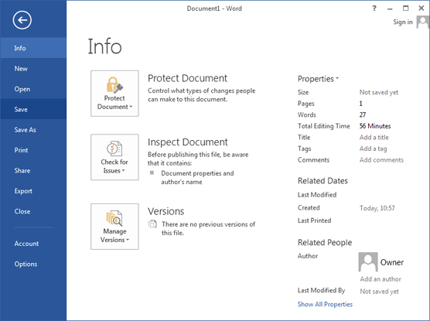

1. **Ribbon tabs:**

The Ribbon is a user interface element which was introduced by Microsoft in Microsoft Office 2007. It is located below the Quick Access Toolbar and the Title Bar. It comprises seven tabs; Home, Insert, Page layout, References, Mailing, Review and View. Each tab has specific groups of related commands. It gives you quick access to the commonly used commands that you need to complete a task.

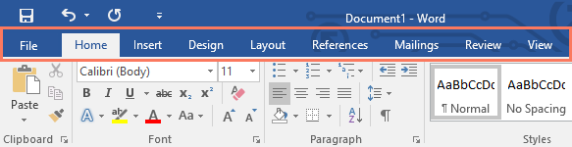

The Ribbon contains seven tabs:

### Home Tab:

The Home tab is the default tab in Microsoft Word. It has five groups of related commands; Clipboard, Font, Paragraph, Styles and Editing. It helps you change document settings like font size, adding bullets, adjusting styles and many other common features.

* **Insert Tab:**

Insert Tab is the second tab in the Ribbon. As the name suggests, it is used to insert or add extra features in your document. It is commonly used to add tables, pictures, clip art, shapes, page number, etc. The Insert tab has seven groups of related commands; Pages, Tables, Illustrations, Links, Header & Footer, Text and Symbols.

* **Page Layout Tab:**

It is the third tab in the Ribbon. This tab allows you to control the look and feel of your document, i.e. you can change the page size, margins, line spacing, indentation, documentation orientation, etc. The Page Layout tab has five groups of related commands; Themes, Page Setup, Page Background, Paragraph and Arrange.

* **References Tab**:

It is the fourth tab in the Ribbon. It allows you to enter document sources, citations, bibliography commands, etc. It also offers commands to create a table of contents, an index, table of contents and table of authorities. The References tab has six groups of related commands; Table of Contents, Footnotes, Citations & Bibliography, Captions, Index and Table of Authorities.

* **Mailings Tab:**

It is the fifth tab in the ribbon. It is the least-often used tab of all the tabs available in the Ribbon. It allows you merge emails, writing and inserting different fields, preview results and convert a file into a PDF format. The Mailings tab has five groups of related commands; Create, Start Mail Merge, Write & Insert Fields, Preview Results and Finish.

* **Review Tab:**

It is the sixth tab in the Ribbon. This tab offers you some important commands to modify your document. It helps you proofread your content, to add or remove comments, track changes, etc. The Review tab has six groups of related commands; Proofing, Comments, Tracking, Changes, Compare and Protect.

* **View Tab:**

The View tab is located next to the Review tab. This tab allows you to switch between Single Page and Two Page views. It also enables you to control various layout tools like boundaries, guides, rulers. Its primary purpose is to offers you different ways to view your document. The View tab has five groups of related commands; Document Views, Show/Hide, Zoom, Window and Macros.

1. **Groups:**

Grouping lets you rotate, flip, move, or resize multiple shapes or objects as though they're a single shape or object.

How to Group shapes, pictures, or other objects

1. Press and hold CTRL and select shapes, pictures, or other objects to group. The Wrap Text option for each object must be other than In line with Text.
2. Do one of the following:

* Go to Picture Format or Picture Tools Format > Group > Group.
* Go to Shape Format or Drawing Tools Format > Group > Group.

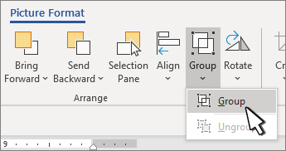

**iv. Dialog Box launcher:**

A dialog box launcher is a button in the ribbon of Microsoft Word, used to reveal additional tools available for use in that section of the Ribbon. Because there isn't room to show all tools in the Ribbon, you can click the dialog box launcher to see the features and options that are hidden. In the picture of the Excel Ribbon below, there are four dialog box launchers highlighted by red boxes.

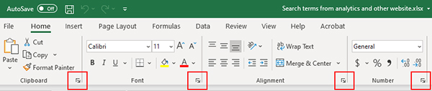

### To add a dialog box launcher to a Ribbon group:

### Select the Ribbon code file (.vb or .cs file) in ****Solution Explorer****.

### On the ****View**** menu, click ****Designer****.

### In the Ribbon Designer, right-click any group, and then click ****Add DialogBoxLauncher****.

***practical 6***

***Ques.*** **What is Paragraph? Explain about Paragraph marks, Soft paragraph line break marks.**

**Write the paragraphs and do following:**

**There are different types of computer systems nowadays for different purpose according to the user needs. However we can classify them into different groups based on different aspects. We can find four different type of computers based on size. These are large computers that are most powerful. They can complete tasks very soon and are optimized to complete given tasks quickly Mainframe Computers These are the largest computers and can support hundreds of users simutaneously. These are powerful computers and optimized to run maximum number of applications at one time. These are medium sized computers-smaller than mainframe but much larger than personal computers. They can be the best solution for medium scale organizations Micro Computers Micro computers are the smallest when su is concerned. They range from Desktop, Laptop up to the palm top and even smaller ones. Because micro computers we developed to support single person, they are often called personal computers (PCs).**

1. **Divide 4 paragraph for the above test and justify Alignment**
2. **Make Drop Cap the first letter of the second paragraph Make 13 line spacing for third paragraph**
3. **Change font size on 17 points for the last paragraph**
4. **Apply numbers for the last two sentences for 4th paragraph**
5. **Set up the per layout an Landscape orientation and set up 150° and Right 1.05**

***Output:-***

A paragraph is a section of [text](https://www.computerhope.com/jargon/t/text.htm) containing one or more sentences, which together express a single idea or unit of information. In modern [typesetting](https://www.computerhope.com/jargon/t/typeset.htm), a paragraph is usually [delimited](https://www.computerhope.com/jargon/d/delimite.htm) by a visual separator or paragraph break. The separator may be a [line break](https://www.computerhope.com/jargon/l/linebrea.htm), vertical spacing such as a blank line, [indentation](https://www.computerhope.com/jargon/i/indent.htm) of the first word, a [horizontal](https://www.computerhope.com/jargon/h/horizont.htm) line, or some combination.

**Paragraph mark:-**

Also known as a pilcrow or paragraph mark, the paragraph symbol (¶) is a type of formatting mark in Microsoft Word. When you have paragraph marks switched on, a paragraph symbol appears at the end of each paragraph when you hit return. They won't appear on your document when you print it.

**Soft Paragraph line break mark:-**

A soft return or soft wrap is the break resulting from line wrap or word wrap (whether automatic or manual), whereas a hard return or hard wrap is an intentional break, creating a new paragraph. With a hard return, paragraph-break formatting can (and should) be applied (either indenting or vertical whitespace).

There are different types of computer systems nowadays for different purpose according to the user needs. However we can classify them into different groups based on different aspects. We can find four different type of computer based on size.

These are large computers that are most powerful. They can complete tasks very soon and are optimized to complete given tasks quickly. Mainframe Computers. These are the largest computers and can support hundreds at one time.

These are medium sized computers - smaller than mainframe but much larger than personal computers. They can be the best solution for medium scale organizations. Micro Computers. Micro Computers are the smallest when size is concerned.

1. They range from Desktop, Laptop up to the palm top and even smaller ones.
2. Because micro computers are developed to support single person, they are often called personal computers (PCs).

***practical 7***

***Ques.*** Create table as below and shading the first row. Insert an Octagon and write your name in the center:

|  |  |  |  |  |
| --- | --- | --- | --- | --- |
| **Day** | **Period I** | **Period II** | **Period IV** | **Period V** |
| Sunday | Math | Science | English | Computer |
| Monday | Science | Computer | Math | English |
| Tuesday | English | Math | Computer | Science |
| Wednesday | Computer | Science | Math | English |
| Friday | Math | Science | English | Computer |

* **Create margin at the top & bottom 1.1 inch and right & left 1.5 inch**
* **Create landscape orientation & A4 paper size**
* **Insert Period Ill column after Period II**
* **Insert Thursday row bellow Wednesday row**
* **Insert page number center align and Arial font**
* **Insert watermark "Hello world"**
* **Table font "Times new roman" and 13 size**

***Output:-***

**KING**

DO NOT COPY

|  |  |  |  |  |  |
| --- | --- | --- | --- | --- | --- |
| **Day** | **Period I** | **Period II** | **Period III** | **Period IV** | **Period V** |
| Sunday | Math | Science |  | English | Computer |
| Monday | Science | Computer |  | Math | English |
| Tuesday | English | Math |  | Computer | Science |
| Wednesday | Computer | Science |  | Math | English |
| Thursday |  |  |  |  |  |
| Friday | Math | Science |  | English | Computer |

***practical 8***

***Ques.*** *What are styles and what do I use them for? Write 5 pages word documents of 3 chapters first two pages of chapter-1, second 2 pages of chapter-2 and last one page of Chapter-3 with following styles:*

* *Paragraph with Normal styles having "Aerial Font", 11 size and 115 line spacing with d 6cm left indent*
* *Heading 1 with 1" level numbering with "Times New Roman" font, size 14, bold, 12mm spacing before and 6mm spacing after "Heading 1”*
* *Heading 2 with 2 level numbering with Aerial font, size 12, bold, 6mm spacing before 2.16mm spacing after "Heading 2”*
* *Heading 3 with 3 level numbering with Aerial font, size 11, 6mm spacing before and 3mm spacing after “Heading 1”*
* *Documents should have total of 5 pages with "Heading 1 "Heading 2" and "Heading 3”. Each "Heading I” in each page should have with minimum of 2 "Heading 2” and 3 “Heading 3” in each "Heading 2" See example below*
* *Each Chapter will have separate header with their Chapter number and footer with page number*
* *Create "Table of content in the top of document with page numbering in roman in footer.*
* *Create one Table in each page and also create "Table of Figures" just below the Table of Contents*

**Table of contents**

Contents…………………………………………………………………………………………………………………………………1

1. Unit-01: Introduction to computer…………………………………………………………………………………………………2
   * 1. Introduction of Computer…………………………………………………………………………………………………2
     2. Characterstics of Computer ……………………………………………………………………………………………..2
     3. History of Computer…………………………………………………………………………………………………………2
     4. Generations of Computer…………………………………………………………………………………………………2
     5. Digital and Analog Computer……………………………………………………………………………………………2
     6. Classification of Computer based on size…………………………………………………………….……………2
     7. The Computer System………………………………………………………………………………………………………2
     8. Application of Computers…………………………………………………………………………………………………2
2. Unit-02: Computer Hardware………………………………………………………………………………………………………3
   * 1. Introduction…………………………………………………………………………………………………………………….3
        1. Central Processing Unit…………………………………………………………………………………………..…3
        2. Components of CPU……………………………………………………………………………………………….…3
        3. Instruction Format…………………………………………………………………………………………………….3
     2. Mainframe Computer………………………………………………………………………………………………………3
        1. Instruction Set………………………………………………………………………………………………………..…3
        2. Instruction Cycle…………………………………………………………………………………………….…………3
        3. Microprocessor…………………………………………………………………………………………………………3

***Ques.*** What are the styles what do I use them for?

Built-in styles are combinations of formatting characteristics that you can apply to text to quickly change its appearance. For example, applying the Heading 1 style might make text bold, Arial, and 16 point, and applying the Heading 2 style makes text bold, italic, Arial, and 14 point.

It was easy to spot her. All you needed to do was look at her socks. They were never a matching pair. One would be green while the other would be blue. One would reach her knee while the other barely touched her ankle. Every other part of her was perfect, but never the socks. They were her micro act of rebellion.

Chapter - 1

# *Word For Windows*

Word for Windows is available stand-alone or as part of the Microsoft Office suite. Word contains rudimentary desktop publishing capabilities and is the most widely used word processing program on the market. Word files are commonly used as the format for sending text documents via e-mail because almost every user with a computer can read a Word document by using the Word application, a Word viewer or a word processor that imports the Word format (see Microsoft Word Viewer).

Word 6 for Windows NT was the first 32-bit version of the product, released with Microsoft Office for Windows NT around the same time as Windows 95. It was a straightforward port of Word 6.0. Starting with Word 95, releases of Word were named after the year of its release, instead of its version number.

## Word for Mac

The Mac was introduced January 24, 1984, and Microsoft introduced Word 1.0 for Mac a year later, on January 18, 1985. The DOS, Mac, and Windows versions are quite different from each other. Only the Mac version was WYSIWYG and used a graphical user interface, far ahead of the other platforms. Each platform restarted its version numbering at "1.0". There was no version 2 on the Mac, but version 3 came out on January 31, 1987, as described above. Word 4.0 came out on November 6, 1990, and added automatic linking with Excel, the ability to flow text around graphics and a WYSIWYG page view editing mode. Word 5.1 for Mac, released in 1992 ran on the original 68000 CPU and was the last to be specifically designed as a Macintosh application. The later Word 6 was a Windows port and poorly received. Word 5.1 continued to run well until the last Classic MacOS. Many people continue to run Word 5.1 to this day under an emulated Mac classic system for some of its excellent features like document generation and renumbering or to access their old files.

### Word For Windows

Word for Windows is available stand-alone or as part of the Microsoft Office suite. Word contains rudimentary desktop publishing capabilities and is the most widely used word processing program on the market. Word files are commonly used as the format for sending text documents via e-mail because almost every user with a computer can read a Word document by using the Word application, a Word viewer or a word processor that imports the Word format (see Microsoft Word Viewer).

Word 6 for Windows NT was the first 32-bit version of the product, released with Microsoft Office for Windows NT around the same time as Windows 95. It was a straightforward port of Word 6.0. Starting with Word 95, releases of Word were named after the year of its release, instead of its version number.

## Word for Mac

**The Mac was introduced January 24, 1984, and Microsoft introduced Word 1.0 for Mac a year later, on January 18, 1985. The DOS, Mac, and Windows versions are quite different from each other. Only the Mac version was WYSIWYG and used a graphical user interface, far ahead of the other platforms. Each platform restarted its version numbering at "1.0". There was no version 2 on the Mac, but version 3 came out on January 31, 1987, as described above. Word 4.0 came out on November 6, 1990, and added automatic linking with Excel, the ability to flow text around graphics and a WYSIWYG page view editing mode. Word 5.1 for Mac, released in 1992 ran on the original 68000 CPU and was the last to be specifically designed as a Macintosh application. The later Word 6 was a Windows port and poorly received. Word 5.1 continued to run well until the last Classic MacOS. Many people continue to run Word 5.1 to this day under an emulated Mac classic system for some of its excellent features like document generation and renumbering or to access their old files**.

### Word for Mobile

Word Mobile is a [word processor](https://en.wikipedia.org/wiki/Word_processor) that allows creating and editing documents. It supports basic formatting, such as bolding, changing font size, and changing colors (from red, yellow, or green). It can add comments, but can't edit documents with tracked changes. It can't open password protected documents, change the typeface, text alignment, or style (normal, heading 1); create bulleted lists; insert pictures; or undo.

# Word For Windows

Word for Windows is available stand-alone or as part of the Microsoft Office suite. Word contains rudimentary desktop publishing capabilities and is the most widely used word processing program on the market. Word files are commonly used as the format for sending text documents via e-mail because almost every user with a computer can read a Word document by using the Word application, a Word viewer or a word processor that imports the Word format (see Microsoft Word Viewer).

Word 6 for Windows NT was the first 32-bit version of the product, released with Microsoft Office for Windows NT around the same time as Windows 95. It was a straightforward port of Word 6.0.

**Chapter -2**

# Word For Windows

*Word for Windows is available stand-alone or as part of the Microsoft Office suite. Word contains rudimentary desktop publishing capabilities and is the most widely used word processing program on the market. Word files are commonly used as the format for sending text documents via e-mail because almost every user with a computer can read a Word document by using the Word application, a Word viewer or a word processor that imports the Word format (see Microsoft Word Viewer).*

*Word 6 for Windows NT was the first 32-bit version of the product, released with Microsoft Office for Windows NT around the same time as Windows 95. It was a straightforward port of Word 6.0. Starting with Word 95, releases of Word were named after the year of its release, instead of its version number*.

## Word for Mac

The Mac was introduced January 24, 1984, and Microsoft introduced Word 1.0 for Mac a year later, on January 18, 1985. The DOS, Mac, and Windows versions are quite different from each other. Only the Mac version was WYSIWYG and used a graphical user interface, far ahead of the other platforms. Each platform restarted its version numbering at "1.0". There was no version 2 on the Mac, but version 3 came out on January 31, 1987, as described above. Word 4.0 came out on November 6, 1990, and added automatic linking with Excel, the ability to flow text around graphics and a WYSIWYG page view editing mode. Word 5.1 for Mac, released in 1992 ran on the original 68000 CPU and was the last to be specifically designed as a Macintosh application. The later Word 6 was a Windows port and poorly received. Word 5.1 continued to run well until the last Classic MacOS. Many people continue to run Word 5.1 to this day under an emulated Mac classic system for some of its excellent features like document generation and renumbering or to access their old files.

### Word for Mobile

Word Mobile is a word processor that allows creating and editing documents. It supports basic formatting, such as bolding, changing font size, and changing colors (from red, yellow, or green). It can add comments, but can't edit documents with tracked changes. It can't open password protected documents, change the typeface, text alignment, or style (normal, heading 1); create bulleted lists; insert pictures; or undo.

# 

Chapter – 3

# Word For Windows

Word for Windows is available stand-alone or as part of the Microsoft Office suite. Word contains rudimentary desktop publishing capabilities and is the most widely used word processing program on the market. Word files are commonly used as the format for sending text documents via e-mail because almost every user with a computer can read a Word document by using the Word application, a Word viewer or a word processor that imports the Word format (see Microsoft Word Viewer).

Word 6 for Windows NT was the first 32-bit version of the product, released with Microsoft Office for Windows NT around the same time as Windows 95. It was a straightforward port of Word 6.0. Starting with Word 95, releases of Word were named after the year of its release, instead of its version number.

## Word for Mac

The Mac was introduced January 24, 1984, and Microsoft introduced Word 1.0 for Mac a year later, on January 18, 1985. The DOS, Mac, and Windows versions are quite different from each other. Only the Mac version was WYSIWYG and used a graphical user interface, far ahead of the other platforms. Each platform restarted its version numbering at "1.0". There was no version 2 on the Mac, but version 3 came out on January 31, 1987, as described above. Word 4.0 came out on November 6, 1990, and added automatic linking with Excel, the ability to flow text around graphics and a WYSIWYG page view editing mode. Word 5.1 for Mac, released in 1992 ran on the original 68000 CPU and was the last to be specifically designed as a Macintosh application. The later Word 6 was a Windows port and poorly received. Word 5.1 continued to run well until the last Classic MacOS. Many people continue to run Word 5.1 to this day under an emulated Mac classic system for some of its excellent features like document generation and renumbering or to access their old files.

### Word for Mobile

Word Mobile is a word processor that allows creating and editing documents. It supports basic formatting, such as bolding, changing font size, and changing colors (from red, yellow, or green). It can add comments, but can't edit documents with tracked changes. It can't open password protected documents, change the typeface, text alignment, or style (normal, heading 1); create bulleted lists; insert pictures; or undo.

# Word For Windows

Word for Windows is available stand-alone or as part of the Microsoft Office suite. Word contains rudimentary desktop publishing capabilities and is the most widely used word processing program on the market. Word files are commonly used as the format for sending text documents via e-mail because almost every user with a computer can read a Word document by using the Word application, a Word viewer or a word processor that imports the Word format (see Microsoft Word Viewer).

Word 6 for Windows NT was the first 32-bit version of the product, released with Microsoft Office for Windows NT around the same time as Windows 95. It was a straightforward port of Word 6.0. Starting with Word 95, releases of Word were named after the year of its release, instead of its version number.

## Word for Mac

The Mac was introduced January 24, 1984, and Microsoft introduced Word 1.0 for Mac a year later, on January 18, 1985. The DOS, Mac, and Windows versions are quite different from each other. Only the Mac version was WYSIWYG and used a graphical user interface, far ahead of the other platforms. Each platform restarted its version numbering at "1.0". There was no version 2 on the Mac, but version 3 came out on January 31, 1987, as described above. Word 4.0 came out on November 6, 1990, and added automatic linking with Excel, the ability to flow text around graphics and a WYSIWYG page view editing mode. Word 5.1 for Mac, released in 1992 ran on the original 68000 CPU and was the last to be specifically designed as a Macintosh application. The later Word 6 was a Windows port and poorly received. Word 5.1 continued to run well until the last Classic MacOS. Many people continue to run Word 5.1 to this day under an emulated Mac classic system for some of its excellent features like document generation and renumbering or to access their old files.

### Word for Mobile

Word Mobile is a word processor that allows creating and editing documents. It supports basic formatting, such as bolding, changing font size, and changing colors (from red, yellow, or green). It can add comments, but can't edit documents with tracked changes. It can't open password protected documents, change the typeface, text alignment, or style (normal, heading 1); create bulleted lists; insert pictures; or undo.

***practical 9***

***Ques.*** Design display board and logo by using Word Art and print it.



Statistics and Computer Science Department

Bachelor of Science in Computer Science and Information Technology

(BSc CSIT)

त्रिभुवन विश्वविद्यालय

पाटन संयुक्त क्यामापस

Phone: 3894724748

4895349534

945834905

Bachelor in Information Technology

(BIT)

***practical 10***

***Ques.*** Create a College Identity Card.



heyyyID

**TRIBHUVAN UNIVERSITY**

**Patan Multiple CAMPUS**

**NO ENTRY WITHOUT ID CARD**

ID. No. : BIT 1002

Name : Sumit

Level : Graduate

Roll No. : 4752

Faculty : Science

Contact No. : 878457845

--------------

ss

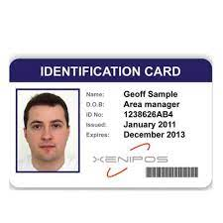

**Student Identity Card**

***Ms excel***

***Theory:-***

Ms excel is an electronic spreadsheet program used for organizing / manipulating data to generate information from stored data of any organization.

1. The active sheet of Ms excel is structured in row and column.
2. Total number of rows in worksheet = 1048576
3. Total number of columns in worksheet = 16384

Column width = 255 characters

row height = 409 points

Number of characters in a cell = 32767

Header or footer = 255

Hyperlink = 65530

Zoom = 10% - 400%

Sort reference = 64

1. Every cell has unique address i.e. column name followed by row number.
2. The formula bar stores the content of the active cell.

**Steps to create customized autofill:-**

Logo button (file tab)

Excel option (option)

Child window (advanced)

Popular (general)

Added custom list

**Features:-**

* easy to use
* time sharing ( as is has many inbuilt functions and formula’s)
* error free
* password protected
* what if analysis (allow automatic recalculation of data when modified)
* easy formatting
* sorting

**Rules to write formula in Ms excel:-**

* It must begin with a equal to (=) sign.
* It is not case sensitive.
* Values are calculated from left to right for some type of ranking.
* Can write values lor address name of cell in formula bar.
* Write values in formula or reference i.e. address of cell.

**Operators:-**

^ 🡪 Exponent

* 🡪 Multiplication

/ 🡪 Division

+ 🡪 Addition

- 🡪 Subtraction

= 🡪 Equal to

< 🡪 Less than

> 🡪 Greater than

<= 🡪 Less than equal to

>= 🡪 Greater than equal to

<> 🡪 Not equal to

**Operator precedence:-**

1. ( )
2. ^
3. * & /
4. + & -

**Logical operators:-**

* **AND :-** output will be true if and only if all inputs are true.
* **OR :-** output will be true even if single input is true.
* **NOT :-** output will be true if input is false and vice versa.

**Logical operations on range of values:-**

**Syntax :-**  =logical operator (condition)

**Example :-**  =And(B1 > 40, B2 <= 5)

=OR(B1 > 40, B2 <= 5)

=NOT(B1 > 40)

**Address of a cell can be given in following ways:-**

1. **Relative reference :-** when we write the actual name of the cell in the formula. **For example: - B**1, C2, F3
2. **Absolute reference:-** reference of cell will not change i.e. cell name will remain same while copying or drag and drop. **For example: - &**A&1
3. **Mixed referencing :-** some references may change and some may not.

**For example: -** &B&2 + C2

**Functions:-**

It consist of function name followed by parentheses ( ) in which we pass arguments / values.

1. **Sum ( ):-** it will return the total range of given cell as values.

**Syntax:-** = sum(value1 : value2)

(address / name of cell)

**Example:-** = sum(C2 : C10)

= sum(C2 :C10, 100)

1. **Sumif ( ):-** it sum ups the value based on the given condition.

**Syntax:-** = sumif(range, arg1, arg2)

**Example:-** = sumif(C2 : C10, “>30”)

= sumif(B2 :B16, “=A”, C2 : C16)

1. **Sumifs ( ):-** it sum ups the value of the given range on multiple criteria’s i.e. more than one condition.

**Syntax:-** = sumifs(arg1, arg2, arg3, arg4……….)

**Example:-** = sumifs(C2 : C10, A2 : A10 “F1”, B2 : B10, “F2”)

1. **Average ( ):-** this function calculates the average of given range of numbers i.e. arithmetic mean.

**Syntax:-** = average (range)

**Example:-** = average (C2 : C45)

It only stand on numbers and ignore any other value such as text or

empty cell or logical values.

1. **Averagea ( ):-** this function will return average of group of numbers but it will also evaluate “True” to 1 and “False” to 0.

**Syntax:-** = averagea (range)

**Example:-** = averagea (C2 : C45)

1. **Averageif ( ):-** to calculate average of a number based on the given condition.

**Syntax:-** = averageif (arg1, arg2 arg3)

**Example:-** = averageif (A2 : A45, “P” C2 : C10)

1. **Averageifs ( ):-** to calculate average of a number according to multiple condition.

**Syntax:-** = averageif (arg1, arg2 arg3, arg4, arg5………….)

**Example:-** = averageif (A2 : A15, B2 : B15 “>90” C2 : C15, “<=100”)

1. **Count ( ):-** it counts the number of cells having numeric values.

**Syntax:-** = count (range)

**Example:-** = count (A2 : A23)

1. **Counta ( ):-** it counts the number of cells having both numeric values as well as character values.

**Syntax:-** = counta (range)

**Example:-** = counta (A2 : A23)

1. **Countblank( ):-** it counts the number of blank cells within specified range.

**Syntax:-** = countblank (range)

**Example:-** = countblank (A2 : A23)

1. **Countif( ):-** it counts the number of values under specific condition.

**Syntax:-** = countif (arg1, arg2)

**Example:-** = countif (A2 : A23, “>=20”)

1. **Countifs ( ):-** it counts the number of values under multiple conditions.

**Syntax:-** = countifs (arg1, arg2, arg3, arg4,…………..)

**Example:-** = countifs (A2 : A23, “>=20”, B2 : B23, “>=27”)

1. **Large ( ):-** to find largest value of all numbers, according to given condition.

**Syntax:-** = large (arg1, arg2)

**Example:-** = large (D2 : D33, 2)

1. **Small ( ):-** to find smallest value of all numbers, according to given condition.

**Syntax:-** = small (arg1, arg2)

**Example:- =** small (C2 : C23, 3)

**Errors:-**

* #### :- column width is not enough to display the number.
* # div/o :- division by 0 is an invalid operation.
* # value :- formula contains an invalid operation.
* # N/A :- data is not valid.

**Percentage display with % symbol:-**

* **Normal syntax :-** G2/4 & “%”
* **Formula :-** average (C2 : F2)/100

Select entire column

Right click, format cell

Number

percentage

**wildcard characters:-**

* * :- to match any string
* ? :- to match number of characters

**Example :-** = average (A2 : A10, “*N”, C2 : C12)

= average (A2 : A10, “singh*”, C2 : C12)

= average (A2 : A10, “ar??”, C2 : C12)

= average (A2 : A10, “????”, C2 : C12)

**Unique records:-** it returns a list of unique values from a range or array

Data

Filter

Advanced

Unique records only

**Date:-**

* Today() :- current date of system
* Now() :- current date and time of system
* Year() :- return year from date
* Month() :- return month from date
* Day() :- return day from date

**Add number of day’s to current date:-**

Example:- =B2 + 15

Or

=Day(B2) + 15

**Add number of months:-**

Example:- =Month(B2) + 4

**Add number of year, month and date to current date:-**

Example:- =Date(year, month, day)

=Date(year(B2) + 2, month(B2) + 4, day(B2) + 10)

**Datedif( ) :-** used to calculate difference between 2 dates.

**Syntax:-** = datedif (arg1, arg2, arg3)

To calculate number of days, month, and year between two dates.

**Example:- =** datedif(C2, B2, “d”)

= datedif(C2, B2, “m”)

= datedif(C2, B2, “y”)

To calculate number of days ignoring years.

**Example:- =** datedif(C2, B2, “yd”)

To calculate number of days ignoring years.

**Example:-** = datedif(C2, B2, “md”)

To calculate number of years between DTOB and current date.

**Example:-** = datedif(C2, B2, “y”)

= datedif(C2, today(), “y”)

To calculate number of years between DTOB and a date.

**Example:-** = datedif(C2, date(2024,03,13), “y”)

**To concatenate (&):-** to insert string between A4 & D4

**Example:-** = A4 & “IS” & D4

To find year, month, and days difference between DOB & current date.

**Example:-** = datedif(C2, B2, “y”) & “yrs” & datedif(C2, B2, “ym”) & “month” & datedif(C2, B2, “md”) & “day”

To find which day of the week following is.

**Example:-** = weekday(B2)

=text(B2, “dddd”) 🡪day of the given date

**Time:-**

* =Hour()
* =Minute()
* =Second()
* =Now() – today() :- will return current time

**Add number of hour on min or second:-**

* =Hour() + 2
* =Minute() + 10
* =Second() + 25

**Add hour & minute & second:-**

Example:- =time(hour, minute, second)

***practical 11***

***Ques.*** Create a spreadsheet for a super market private limited having the following entries:-

1. Serial No.
2. Product ID
3. Product Name
4. Product Type
5. Quantity
6. Price per unit
7. Total price

Enter atleast 20 records. All the entries should be bold and underlined. Find the total bill generated.

***Notes:-***

* Total price :- =E2*F2
* Grand total :- =SUM(G2:G21)

**Output**

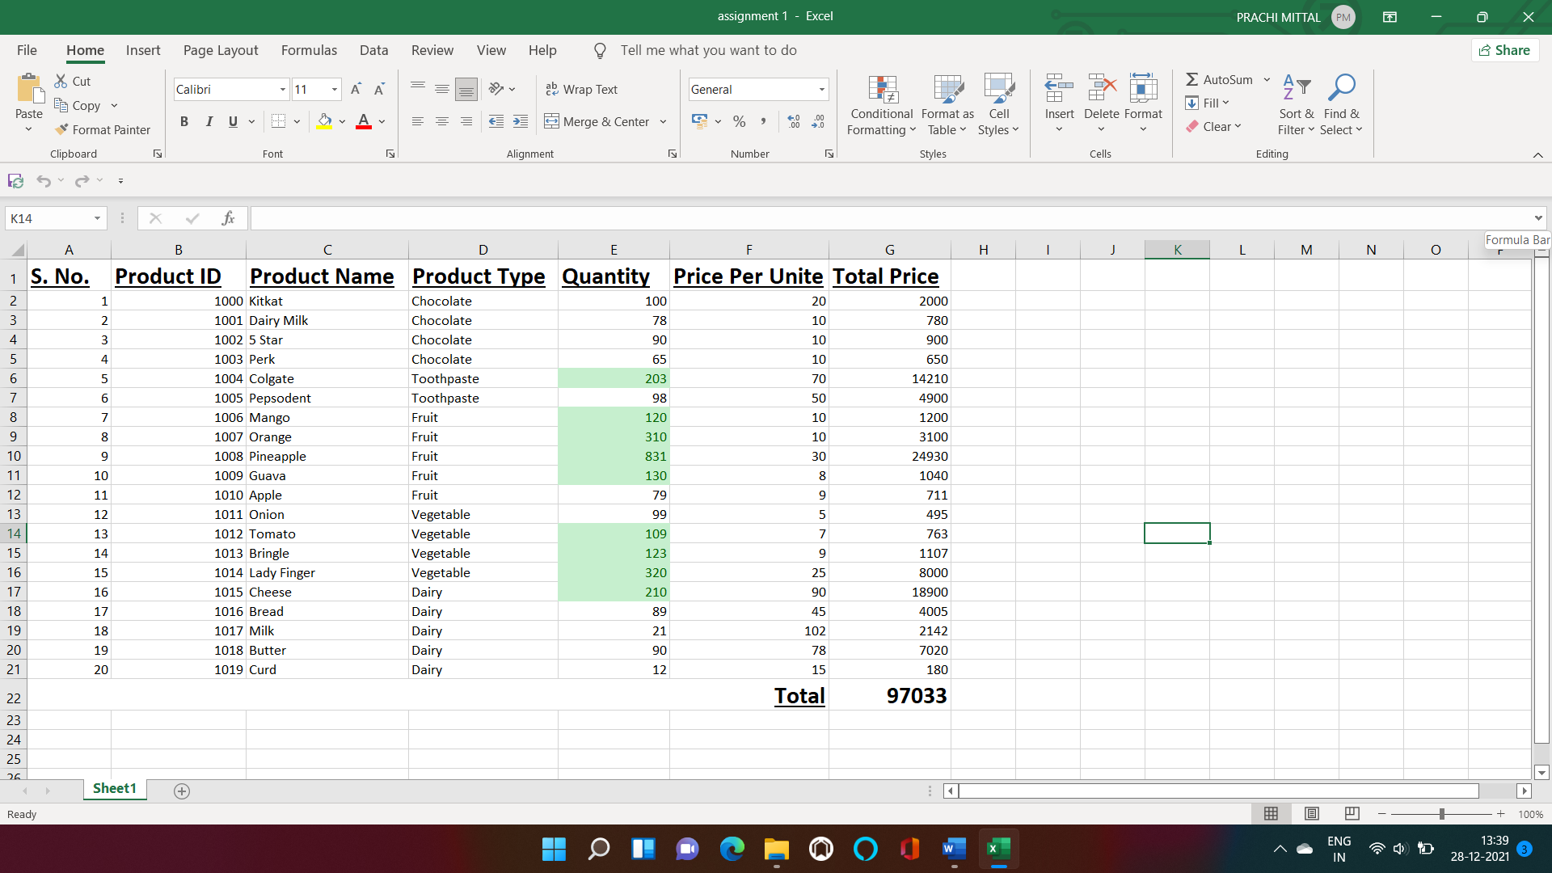

***Practical 12***

**Ques.** Make a marksheet of 12 students of BCA course having fields:

Serial no

Name

Marks in 5 subject and perform the following questions.

Sort the record in ascending order of marks.

Sort the record in descending order of names.

Find the minimum marks of each subject and replace it by the text “put more efforts” using find and replace option.

Add 3 columns total marks, percentage and grades apply formula to calculate them.

Filter records to display marks more than 60%

***Notes:-***

* Total marks :- =SUM(C2:G2)
* Percentage :- =AVERAGE(H2/500)*100
* Grade :- =IF(I2>=90,"A",IF(I2>=75,"B",IF(I2>=60,"C",

IF(I2>=50,"D",IF(I2>=40,"E", IF(I2<40,"Fail"))))))

**Output**

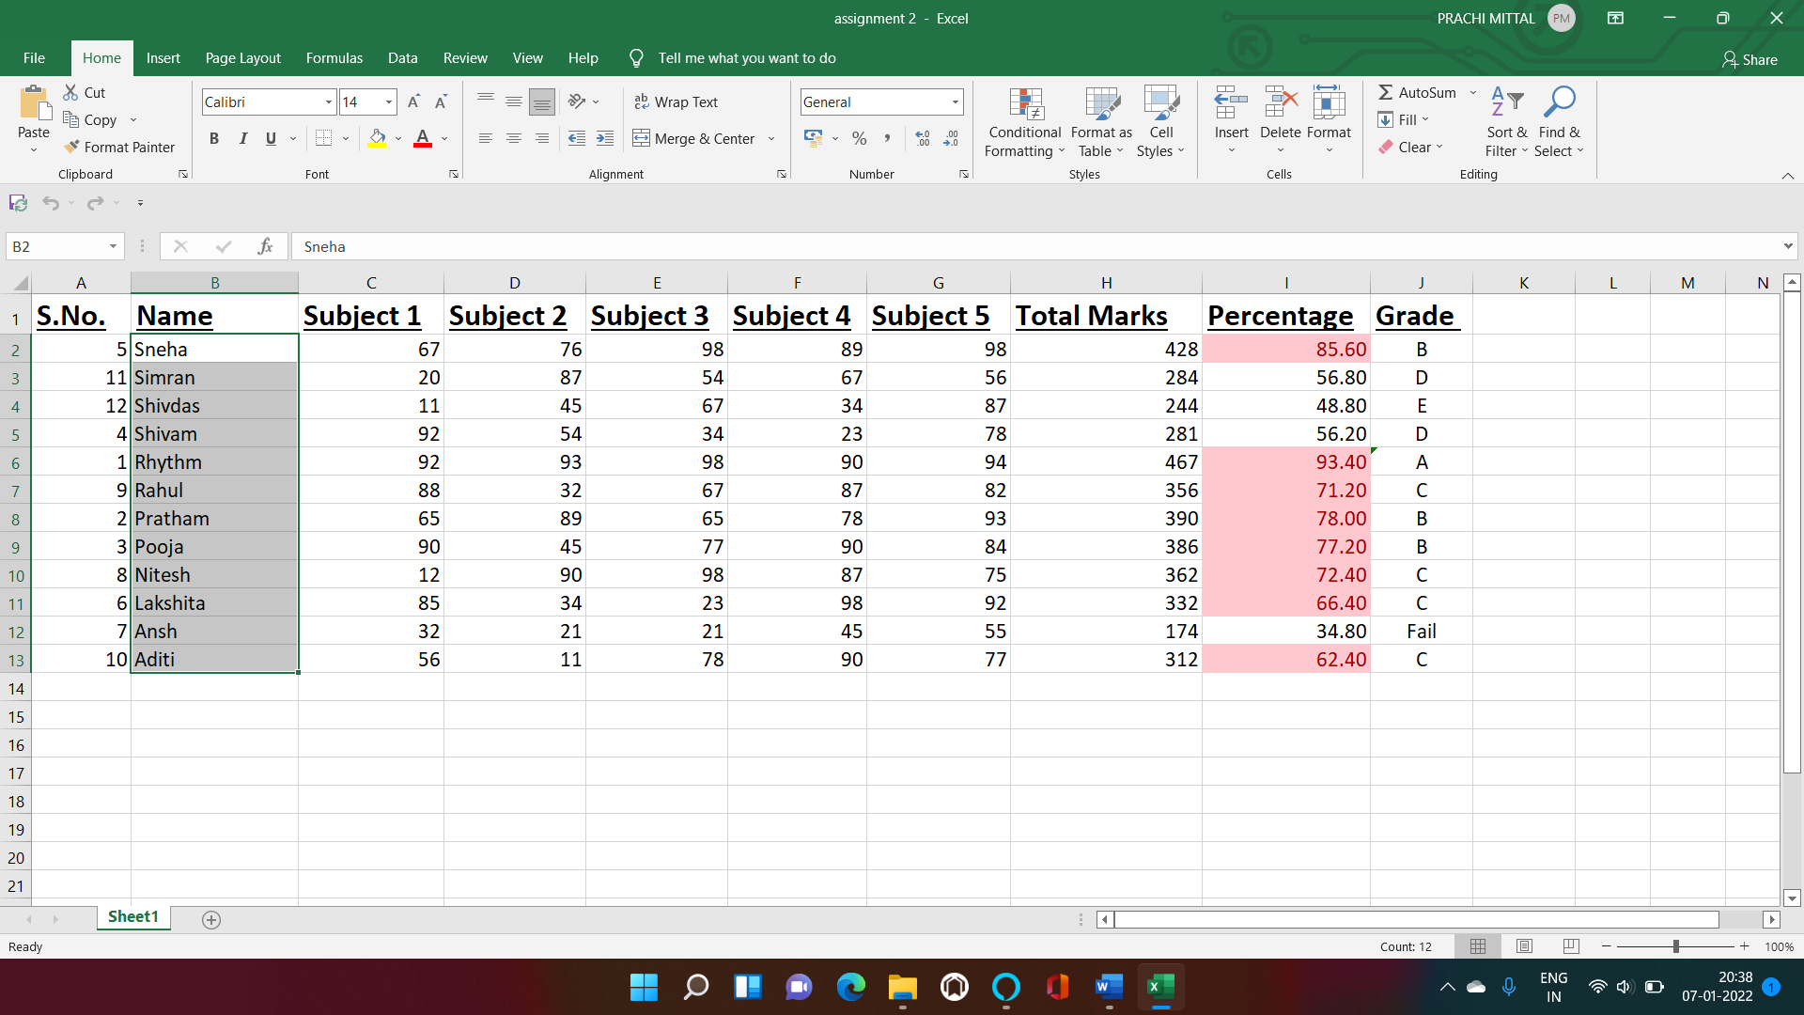

***Practical 13***

**Ques.** Design mark sheet for students of 12th class, which consists of information S.No , Rollno , Name , Section, Maths, Physics, chemistry, Computer Science for each subject internal , external and marks recorded. Using the formula calculate:

1. Total marks of each subject and give grade as (A>=90 , B between 80 and 90 , C between 70 and 60, D between 60 and 40 , E otherwise .
2. Total marks of all subjects and total percentage. Depending on total percentage write in the remarks (“Excellent”>=90 , “Very Good” between 80 and 90, “Good” between 70 and 80 , “Fair” between 70 and 60, “Poor” otherwise.
3. If student got more than 50 marks as total in each subject than status must be “Pass’ otherwise “Fail”.
4. Highlight the cells with of percentage with different colors with the rule stated in (ii).

Count the number of Excellent , Very Good , Good , Fair and Poor.

***Notes:-***

* Total marks :- =SUM(G3,J3,M3,P3)
* Percentage :- =AVERAGE((Q3)/400)*100
* Grade :- =IF(R3>=90,"A",IF(R3>=80,"B",IF(R3>=70,"C",

IF(R3>=50,"D",IF(R3<50,"E")))))

* Remarks :- =IF(R3>=90, "Excellent", IF(R3>=80, "Very Good", IF(R3>=70, "Good", IF(R3>=60, "Fair", "Poor"))))
* Status :- =IF(AND(G3>=50,J3>=50,M3>=50,P3>=50),

"Pass","Fail")

* Count :- =COUNTIF(T$3:T$12, W3)

**Output**

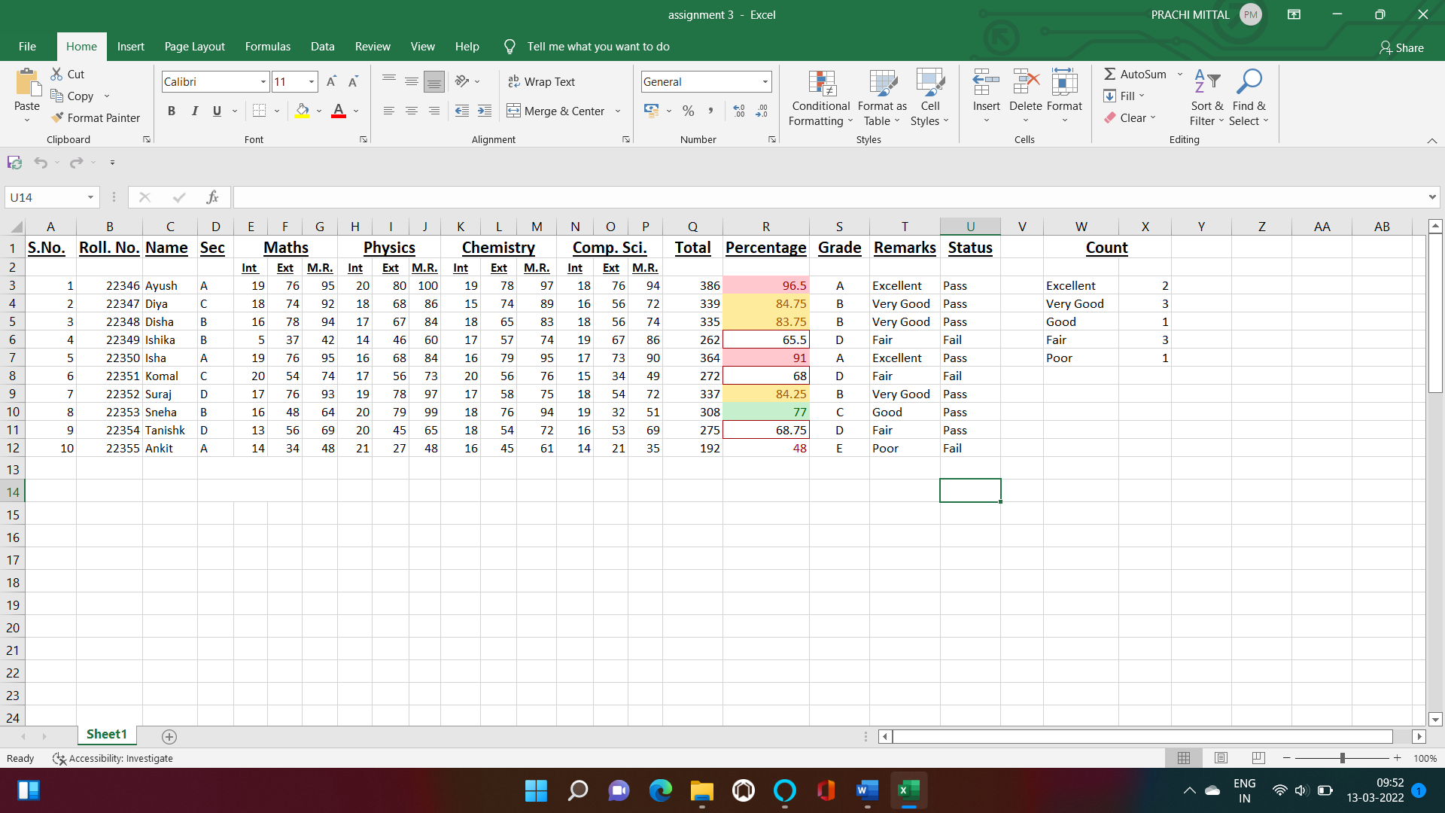

***practical 14***

**Ques.** An organization pays monthly salary, which consists of basic salary, allowances and deductions as per detail given below (minimum 15 employee):

1. HRA is 30% of Basic.
2. DA is 20% of Basic.
3. Conveyance allowance is:-
4. Rs. 1000/- if basic is less than or equals to Rs. 10000/-
5. Rs. 2500/- if basic is greater than Rs.10000/- and less than Rs.20000/-
6. Rs. 4000/- if basic is greater than 20000/-
7. Entertainment allowance is:-
8. Rs. 1500/- if basic is less than or equal to Rs. 10000/-
9. Rs. 3000/- if basic is greater than 10000/-
10. PF deduction is 7% of basic.
11. IT deduction is 20% of basic.
12. Gross salary as Basic + HRA + DA + Conveyance + Entertainment
13. Net salary = Gross Salary – Deductions

Make the spread sheet of above using formulas & conditions. Also calculate followings using function.

1. Number of employee having net salary more than or equals to Rs.50000/-
2. Number of employee having salary less than Rs.50000/- k) Number of employee having basic less than or equals to Rs.10000/- and Gross salary 15000/-
3. Number of employee having basic more than Rs.20000/- and Gross salary 40000/-

***Notes:-***

* HRA :- =E$4*D6
* DA :- =F$4*D6
* Conveyance :- =IF(D6<=10000,G$4,IF(D6<20000,G$3,G$2))
* Entertainment :- =IF(D6<=10000,H$4,H$3)
* Gross salary :- =SUM(D6:H6)
* PF :- =J$4*D6
* IT :- =K$4*D6
* Net salary :- =I6-(J6+K6)
* Net salary >=50000 :- =COUNTIF(L6:L20,">=50000")
* Net salary <50000 :- =COUNTIF(L6:L20,"<50000")
* Basic Salary<=10000 :- =COUNTIFS(D6:D20,"<=10000",

I6:I20,"=15000")

* Basic salary>20000 :- =COUNTIFS(D6:D20,">20000",

I6:I20,"=40000")

**Output**

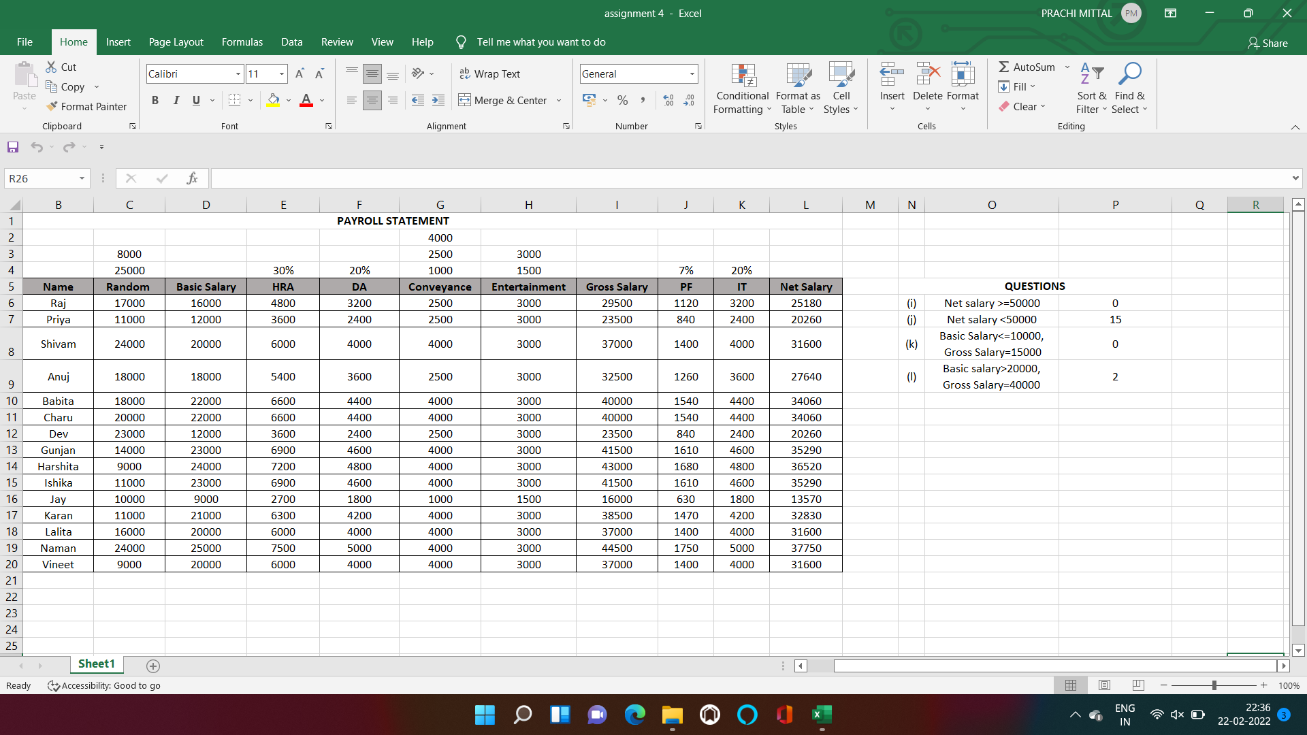

***practical 15***

**Ques.** Enter the date of birth and MSI offline joining dates of your class friends (minimum 15). Apply the date formulas to calculate the following: -

1. Year of birth, day and month
2. Year of joining MSI, day and month
3. Add 5 years, 2 months and 10 days to date of birth
4. Add 2 years, 6 months and 20 days to MSI joining dates.
5. Calculate the followings between DTOB and date of joining MSI.

* Number of days
* Number of months
* Number of years
* Number of days ignoring years
* Number of days ignoring months
* Number of months ignoring years

1. Calculate difference between DOB and MSI joining date in years, month and days.

***Notes:-***

* Year of birth :- =Year(B2)
* Day of birth :- =DAY(B2)
* Month of birth :- =MONTH(B2)
* Year of joining :- =YEAR(C2)
* Day of joining :- =DAY(C2)
* Month of joining :- =MONTH(C2)
* Adding to DOB :- =DATE(YEAR(B2)+5,

MONTH(B2)+2,DAY(B2)+10)

* Adding to joining :- =DATE(YEAR(C2)+2,

MONTH(C2)=6,DAY(C2)+20)

* No. of days :- =DATEDIF(B2,C2,"d")
* No. of months :- =DATEDIF(B2,C2,"m")
* No. of years :- =DATEDIF(B2,C2,"y")
* No. of days ignoring years :- =DATEDIF(B2,C2,"yd")
* No. of days ignoring months :- =DATEDIF(B2,C2,"md")
* No. of months ignoring years :- =DATEDIF(B2,C2,"ym")

**Output**

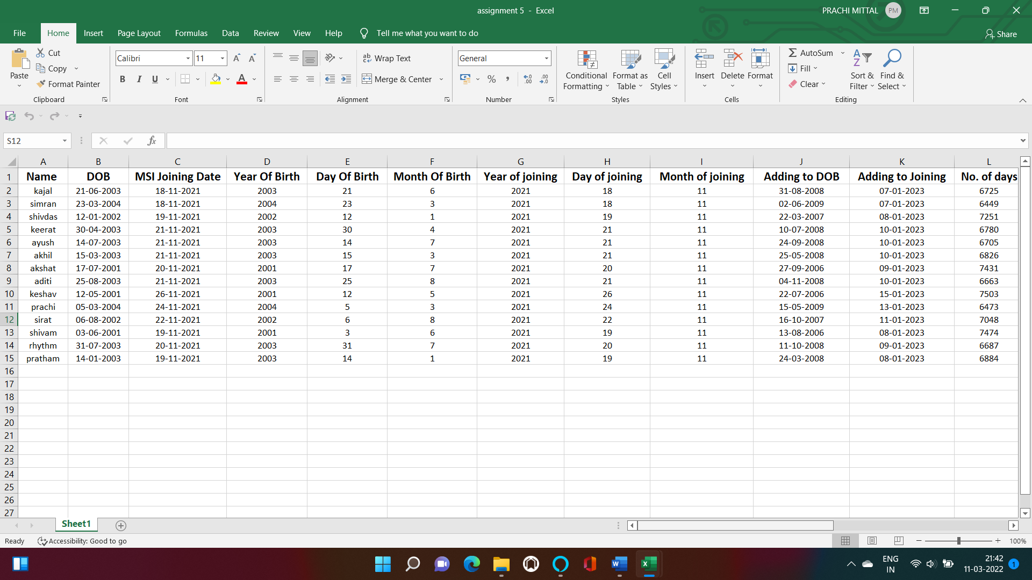

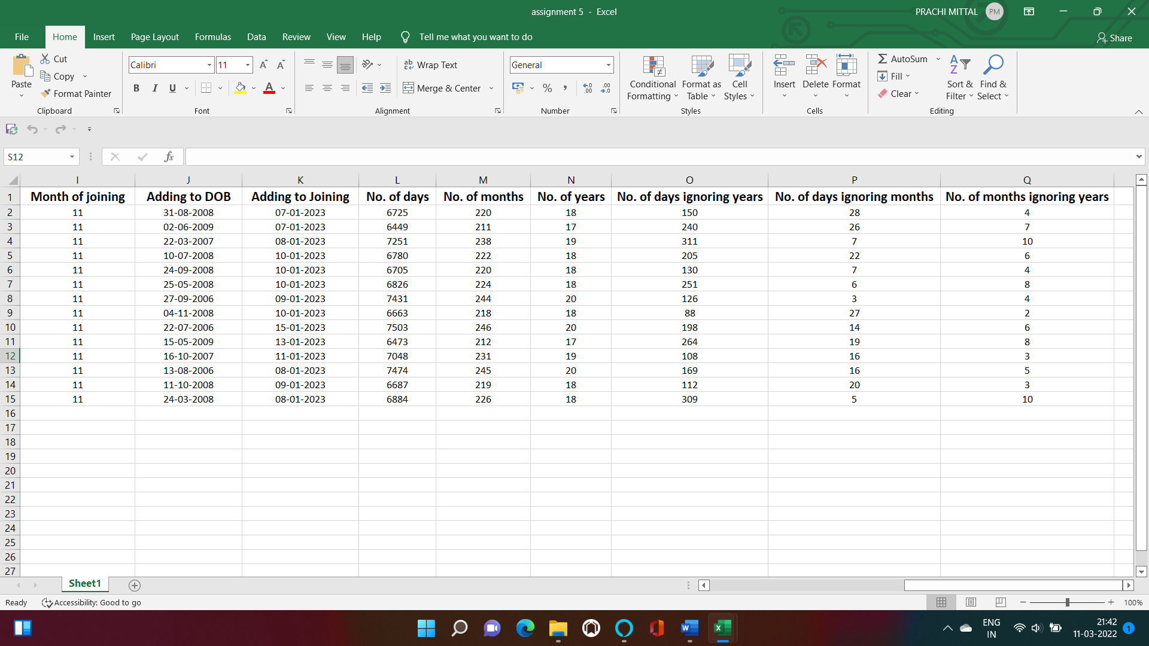

***practical 16***

**Ques.** Enter the date of birth and MSI offline joining dates of your class friends (minimum 15). Apply the date formulas to calculate the following: -

1. Age of each student in years.

* Using displaying today’s date
* Without using today’s date
* Using date function on a specific date.

1. Calculate age of each student in years, month and days.
2. Calculate age of each student in days, month and years.
3. Calculate the number of weekdays of date of DOB and MSI joining date.
4. Calculate the name of day and month of DOB and MSI joining date.

***Notes:-***

* Age in years (using today's date) :- =DATEDIF(B2,TODAY(),"y") & "year"
* Age in years (without using today's date) :- =DATEDIF

(B2,DATE(2024,3,14),"y") & "year"

* Age in years (using specific date) :- =DATEDIF(B2,C2,"y") & "year"
* Age in years, months and days :- =DATEDIF(B2,TODAY(),"y") & "year" & DATEDIF(B2,TODAY(),"ym") & "months" & DATEDIF(B2,TODAY(),"md") & "days"
* Age in days, months and years :- =DATEDIF(B2,TODAY(),"md") & "days" & DATEDIF(B2,TODAY(),"ym") & "months" & DATEDIF(B2,TODAY(),"y") & "years"
* No. of weekdays of DOB :- =WEEKDAY(B2)
* No. of weekdays of joining :- =WEEKDAY(C2)
* Name of day and month of DOB :- =TEXT(B2,"ddddddd") & TEXT(B2,"mmmmmmm")
* Name of day and month of joining :- =TEXT(C2,"ddddddd") & TEXT(C2,"mmmmmmm")

**Output**

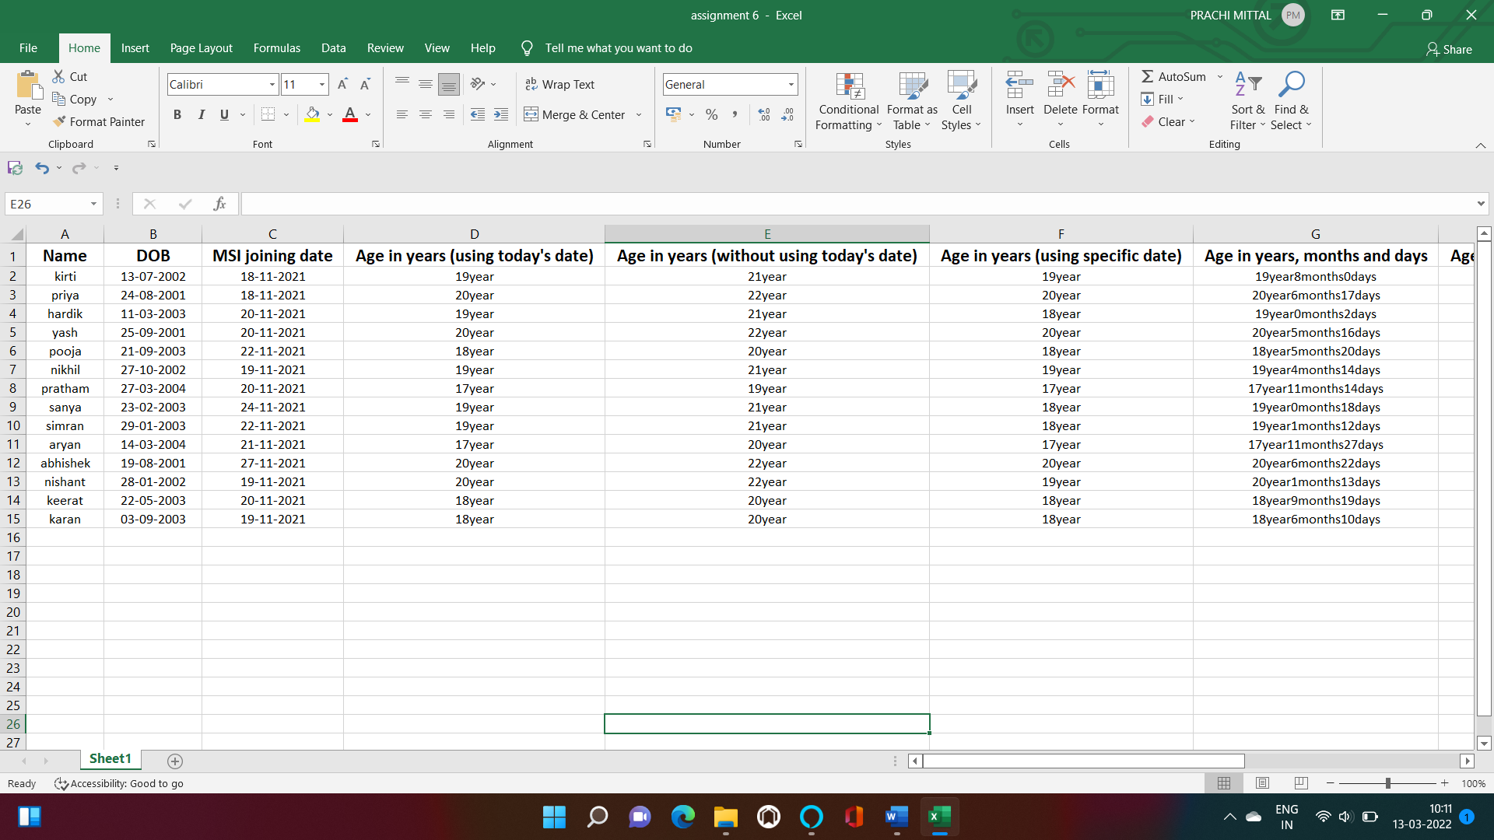

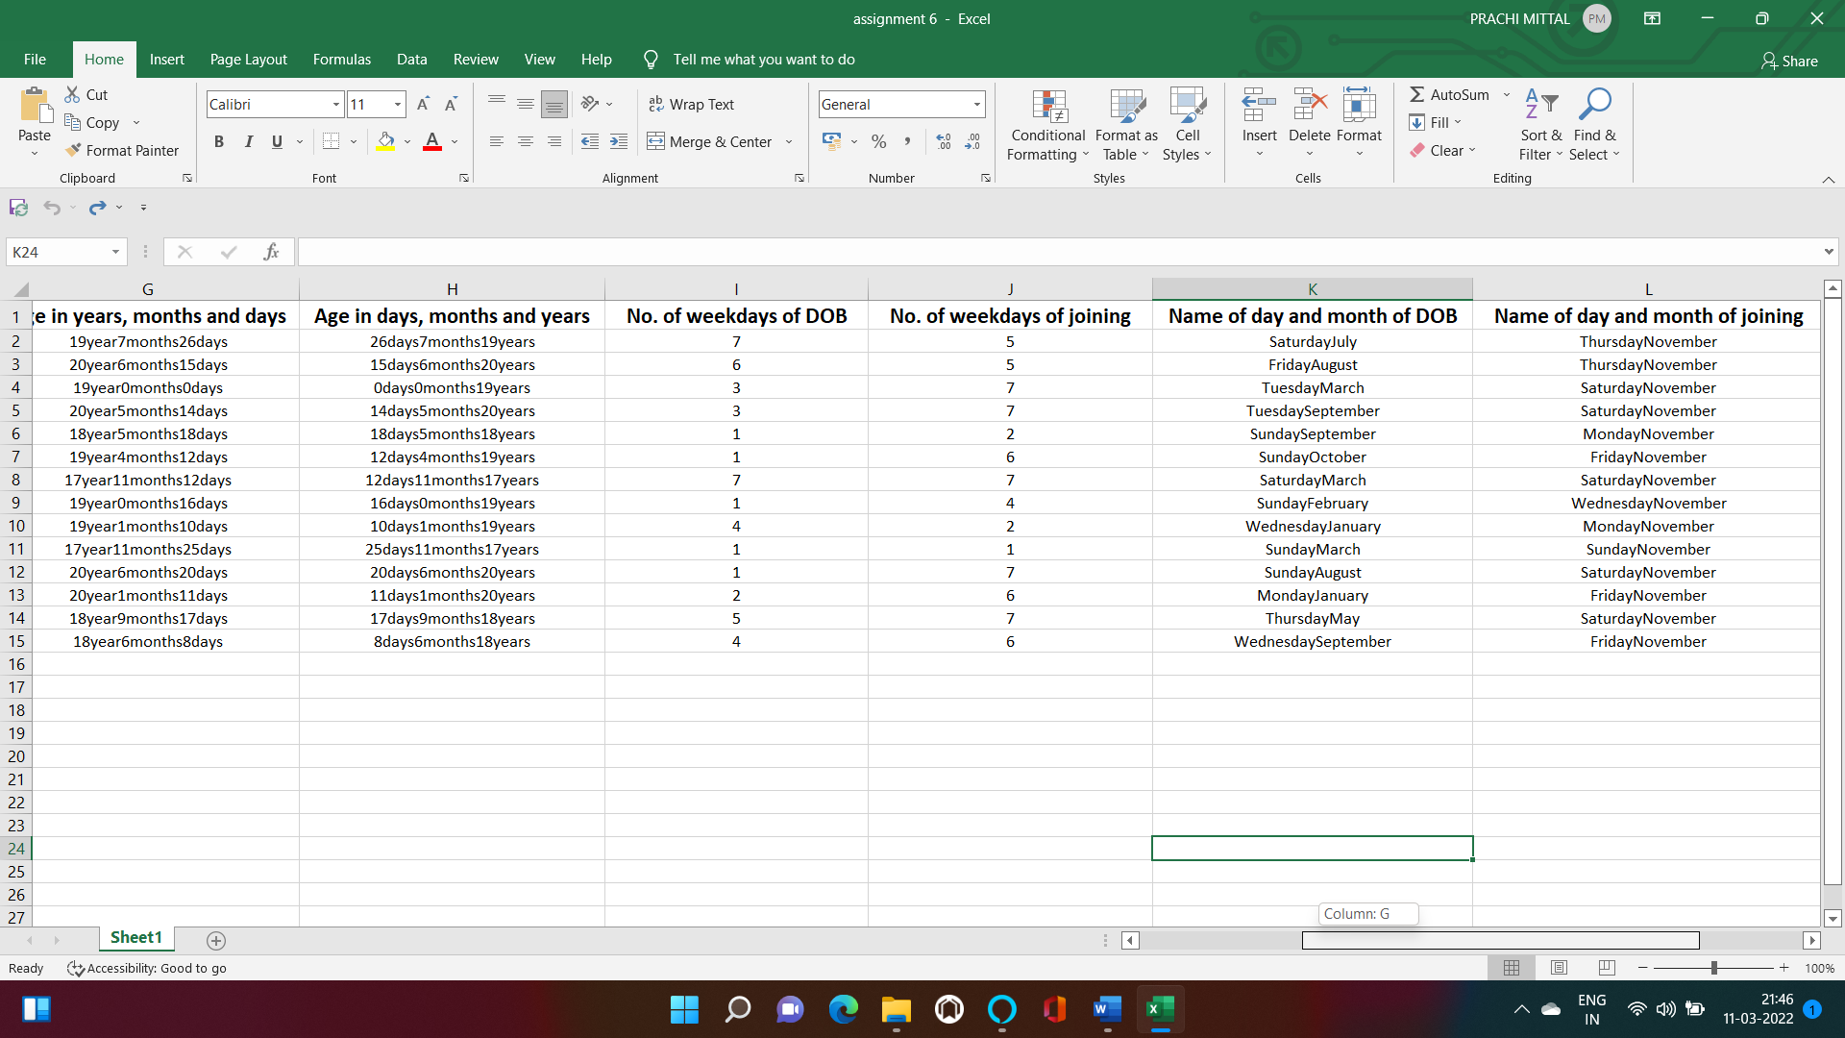

***practical 17***

**Ques.** Prepare a shopping mall bill/invoice with columns Serial No. item name, no of items, rate, discount, amount, GST and grand total.

***Notes:-***

* Discount :- =IF(F3>=300,F3*0.1,

IF(F3>=200,F3*0.06,IF(F3>=100,F3*0.04,"0")))

* Amount :- =C3*D3
* GST :- =100*0.18
* Total :- =SUM(F3:G3)-E3
* Grand total :- =SUM(H3:H12)

**Output**

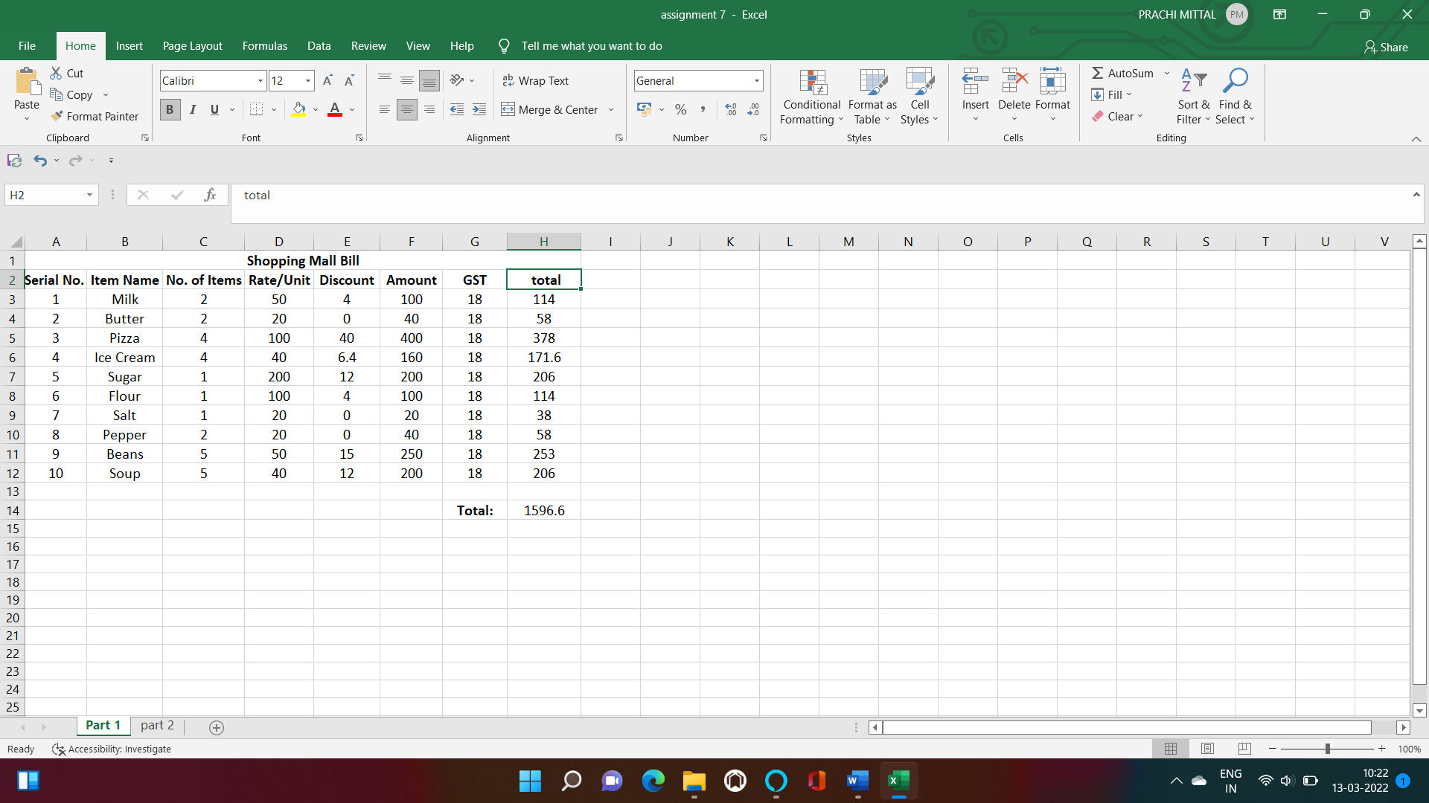

**Ques.** A company pays a monthly salary to its employees which consists of basic salary, allowance and deductions, HRA is 30% of basic salary, DA is 20% of basic salary & TA 10% of basic salary calculate the following:-

* Gross salary = basic salary + HRA + DA + TA
* Net salary = Gross salary – Tax, if (basic salary PA<=2 lakhs: No tax, if basic salary PA >2 & <=5lakhs: 10% Tax, if basic salary PA>5lakhs: 25% Tax.

***Notes:-***

* HRA :- =0.3*C3
* DA :- =0.2*C3
* TA :- =0.1*C3
* Annual :- =C3*12
* HRA (annual) :- =D3*12
* DA (annual) :- =E3*12
* TA (annual) :- =F3*12
* Tax :- =IF(G3 > 500000,0.25*G3,

IF(AND(G3<=500000,G3>200000),0.1*G3,"0"))

* Gross salary (annual) :- =SUM(G3:J3)
* Net salary (annual) :- =L3-K3

**Output**

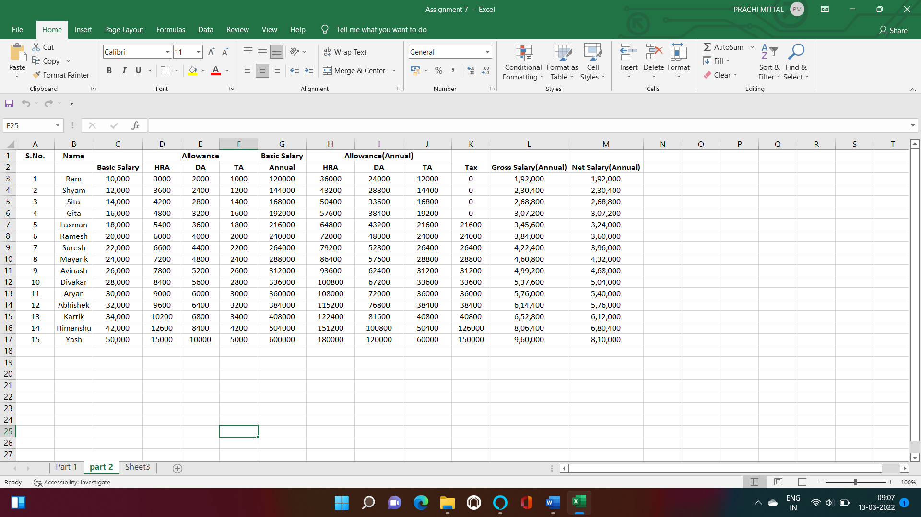

***practical 18***

***Ms Dos***

**Ques.** What is MS Dos? What is the use of MS Dos. Write some advantages of MS Dos?

*Any operating system which runs from the hard disk drive is termed as Disk Operating System (D.O.S). This also refers to the specific family of disk operating system which is also known as MS-DOS or Microsoft disk operating system. Anything which commands and controls the computer’s hardware and its peripheral devices with control over the program and its functionality is known as the operating system. MS-DOS (acronym for Microsoft Disk Operating System) is an operating system for x86-based personal computers mostly developed by Microsoft. Collectively, MS-DOS, its rebranding as IBM PC DOS, and some operating systems attempting to be compatible with MS-DOS, are sometimes referred to as "DOS" (which is also the generic acronym for disk operating system).*

***Advantages:***

• We have direct access to the BIOS and its underlying hardware.

• Due to its size, it will “boot” much faster than any windows version, thus it will run in a smaller system.

• It is very lightweight so it does not have the overhead of the multitasking operating system.

• It is good for making workarounds for managing an MS system, and for combining programs.

**Disadvantages:**

• No multi-tasking supported by the OS.

• Difficulty in memory access when addressing more than 640 MB of RAM.

• Interrupt levels for hardware needs to be managed by our self.

**Ques.** What are internal and External commands in MS Dos?

**Internal :-** an internal command is an MS-DOS command that is stored in the system memory and loaded from the command.com or cmd.exe. The illustration shows how commands contained within command.com are part of the command.com file. However, with the external commands, each command is a separate file.

### Most Commonly Used Internal DOS Commands

#### DATE :-

This command is used to display the system current date setting and prompt you to enter a new date. The syntax is: **DATE  [/T | date]**

[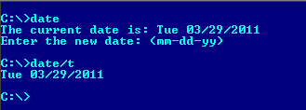](http://2.bp.blogspot.com/-OnXO1INlteQ/TZGTJmAU2GI/AAAAAAAAD8c/K1kdyUlLVe0/s1600/dos-date-command.PNG)

If you type DATE without parameters then it displays current date and prompts to enter new date. We should give new date in mm-dd-yy format. If you want to keep the same date just Press ENTER. DATE command with /T switch tells the command to just output the current system date, without prompting for a new date.

#### TIME :-

This command is used to displays or set the system time.  
The syntax is: **TIME   [/T | time]**

[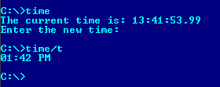](http://2.bp.blogspot.com/-I5jJZMVIRFc/TZGUjDZWteI/AAAAAAAAD8o/g5MIVqVZ8Zc/s1600/DOS-Time-command.png)

Same as DATE command, typing TIME with no parameters displays the current time and a prompt for a new one. Press ENTER to keep the same time. TIME command used with /T switch tells the command to just output the current system time, without prompting for a new time.

#### TYPE :-

This command is used to display the contents of a text file or files. The syntax is: **TYPE   [drive:][path]filename**  
Now, lets try to display the contents of the file named filename we’ve created earlier using COPY CON command.

[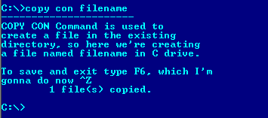](http://3.bp.blogspot.com/-pW45cmBe6rk/TZGZwwAQWlI/AAAAAAAAD9A/MV0TVCy1ToE/s1600/copy-con-command.png)

#### CLS :-

It is used to clear the screen. Syntax is **CLS**

[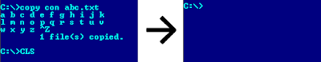](http://2.bp.blogspot.com/-IqOM8cAyu50/TZGcTLcaBLI/AAAAAAAAD9M/6iIqzgv2J9s/s1600/copy-con-cls-commands.png)

#### VOL :-

It displays the disk volume label and serial number, if they exist for the drive specified. If no drive is specified it displays for the active drive.  
Syntax is **VOL  [drive:]**

[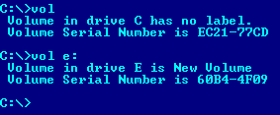](http://1.bp.blogspot.com/-MVQhHQJ_grU/TZG5fSzwZcI/AAAAAAAAD9k/A2U8cQ9NzMo/s1600/VOL-dos-command.png)

#### DEL/ERASE :-

Used to delete one or more files.  
Syntax is **DEL   [/P]   [/F]   [/S]   [/Q]   [/A[[:]attributes]] names**

[Most Commonly Used Internal and External DOS Commands 1](http://1.bp.blogspot.com/-OUBEuPDDg9A/TZG-eAERQFI/AAAAAAAAD9w/69gRWJjI9s4/s1600/del-command-with-prompt-p.png)

**External :-** An external command is an MS-DOS command that is not included in command.com. External commands are commonly external either because they require large requirements or are not commonly used commands. The illustration shows each of the external commands are separate files.

### Most Commonly Used Internal DOS Commands

#### EDIT :-

This command is used to modify or change the data of a file.  
Syntax is **EDIT  [/B]  [/H]  [/R]  [/S]  [filename(s)]**

Using switch /B you can force the edit in monochrome mode. /H displays the maximum number of lines possible for your system hardware. Whereas using /R and /S one can load files in read-only mode and force the use of short filenames respectively. [filename(s)] is used to specify file(s) to go edit. You can use wildcards (* and ?) to specify multiple files.

#### DISKCOPY :-

This command copies the contents of one floppy from the source drive to a formatted or un-formatted floppy disk in the destination drive. This command copies the data from particular position on the source disk to exactly the same position on the destination disk. **Syntax:-  Diskcopy  A:  B:**copies contents of A: to B: drive. This command can be used with /V switch which verifies that the disk is copied correctly.

#### DELTREE :-

This command is used to remove a directory along with its contents.  
Syntax is **deltree [drive:path]**  
here, [drive:path] specifies the directory name to be deleted. All the subdirectories and files in this directory will be deleted without prompt and there’s not getting back. So, keep caution while using this command.

#### FORMAT :-

This command creates a new root directory and a File Allocation Table (FAT) for the disk. In order for MS-DOS to be able to use a new disk you must use this command to format the disk.

1. **RESTORE :-**

The RESTORE command restores files that were backed up by using BACKUP command. Syntax: **RESTORE   drive1  drive2:path**  
Here drive1 specifies the drive on which backup files are stored.  
drive2:path specifies the path to which those backup files will be restored.  
Using backup command with /S switch is used to restore all backup files to their original directories and sub-directories.

#### DOSKEY :-

This command is generally used to edits command lines and recalls commands.  
Syntax is **DOSKEY  [/REINSTALL]  [/HISTORY] [text]**

Here, /REINSTALL installs new copy of doskey, /HISTORY is used to display all previously given commands stored in [memory](https://www.tech-wonders.com/2010/08/units-of-measure-for-digital.html). And [text] specifies the commands you want to record.

***practical 19***

***Ques.*** Power point presentation.

