Name: Himanshu Mishra Class/Roll No: D15A/47

Experiment 02 MAD and PWA Lab

**Aim:** To design Flutter UI by including common widgets.

# Theory:

Flutter widgets are built using a modern framework that takes inspiration from React. The central idea is that you build your UI out of widgets. Widgets describe what their view should look like given their current configuration and state.

When a widget’s state changes, the widget rebuilds its description, which the framework diffs against the previous description in order to determine the minimal changes needed in the underlying render tree to transition from one state to the next. When you made any alteration in the code, the widget rebuilds its description by calculating the difference between the previous and current widget to determine the minimal changes for rendering in the UI of the app.

Widgets are nested with each other to build the app. It means the root of your app is itself a widget, and all the way down is a widget also. For example, a widget can display something, can define design, can handle interaction, etc.

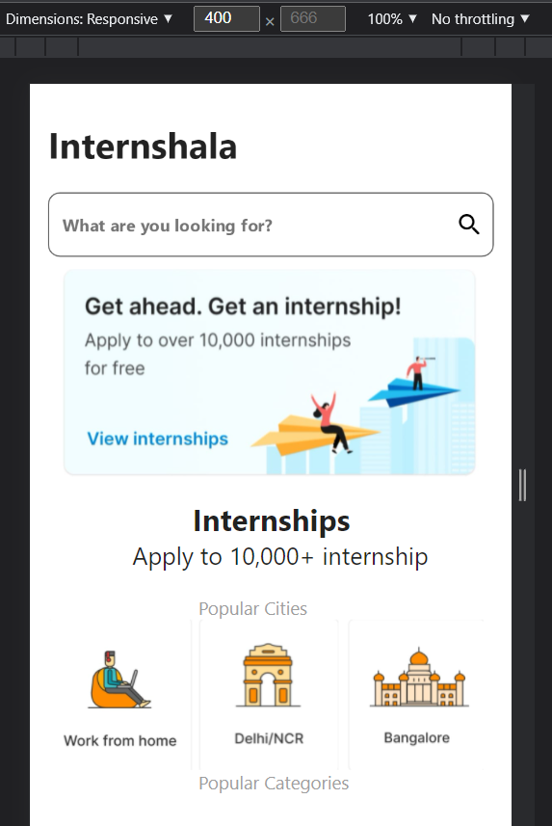

**Internshala App**

**Column:**

A widget that displays its children in a vertical array. To cause a child to expand to fill the available vertical space, wrap the child in an [Expanded](https://api.flutter.dev/flutter/widgets/Expanded-class.html) widget.

The [Column](https://api.flutter.dev/flutter/widgets/Column-class.html) widget does not scroll (and in general it is considered an error to have more children in a [Column](https://api.flutter.dev/flutter/widgets/Column-class.html) than will fit in the available room). If you have a line of widgets and want them to be able to scroll if there is insufficient room, consider using a [ListView](https://api.flutter.dev/flutter/widgets/ListView-class.html)

Eg.

Column(

children: const <Widget>[ Text('Deliver features faster'), Text('Craft beautiful UIs'), Expanded(

child: FittedBox(

fit: BoxFit.contain, *// otherwise the logo will be tiny*

child: FlutterLogo(),

),

), ],

)

1. **Container:**

A container first surrounds the child with [padding](https://api.flutter.dev/flutter/widgets/Container/padding.html) (inflated by any borders present in the [decoration](https://api.flutter.dev/flutter/widgets/Container/decoration.html)) and then applies additional [constraints](https://api.flutter.dev/flutter/widgets/Container/constraints.html) to the padded extent (incorporating the width and height as constraints, if either is non-null). The container is then surrounded by additional empty space described from the [margin](https://api.flutter.dev/flutter/widgets/Container/margin.html).

During painting, the container first applies the given [transform](https://api.flutter.dev/flutter/widgets/Container/transform.html), then paints the [decoration](https://api.flutter.dev/flutter/widgets/Container/decoration.html) to fill the padded extent, then it paints the child, and finally paints the [foregroundDecoration](https://api.flutter.dev/flutter/widgets/Container/foregroundDecoration.html), also filling the padded extent.

Containers with no children try to be as big as possible unless the incoming constraints are unbounded, in which case they try to be as small as possible. Containers with children size

themselves to their children. The width, height, and [constraints](https://api.flutter.dev/flutter/widgets/Container/constraints.html) arguments to the constructor override this.

**Syntax:**

Container(  
 margin:  
 **const** EdgeInsets.symmetric(horizontal: 15, vertical:  
 10),  
 child: Column(  
 mainAxisAlignment: MainAxisAlignment.**start**,  
 crossAxisAlignment: CrossAxisAlignment.**start**,  
 children: [  
 Container(  
 margin: **const** EdgeInsets.symmetric(  
 horizontal: 0, vertical: 20),  
 child: **const** Text(  
 **'Internshala'**,  
 style: TextStyle(  
 fontSize: 30, fontWeight: FontWeight.*bold*),  
 ),  
 ),

1. **TextField**

A material design text field. A text field lets the user enter text, either with a hardware keyboard or with an on-screen keyboard.

The text field calls the onChanged callback whenever the user changes the text in the field. If the user indicates that they are done typing in the field (e.g., by pressing a button on the soft keyboard), the text field calls the onSubmitted callback.

Eg.

**const** TextField( obscureText: **true**,

decoration: InputDecoration( border: OutlineInputBorder(), labelText: 'Password',

),

)

# ListView

ListView is the most commonly used scrolling widget. It displays its children one after another in the scroll direction. In the cross axis, the children are required to fill the ListView. If non-null, the itemExtent forces the children to have the given extent in the scroll direction.

If non-null, the prototypeItem forces the children to have the same extent as the given widget in the scroll direction. Specifying an itemExtent or a prototypeItem is more efficient than letting the children determine their own extent because the scrolling machinery can make use of the foreknowledge of the children's extent to save work, for example when the scroll position changes drastically.

Eg.

ListView(

padding: **const** EdgeInsets.all(8), children: <Widget>[

Container( height: 50,

color: Colors.amber[600],

child: **const** Center(child: Text('Entry A')),

),

Container( height: 50,

color: Colors.amber[500],

child: **const** Center(child: Text('Entry B')),

),

Container( height: 50,

color: Colors.amber[100],

child: **const** Center(child: Text('Entry C')),

),

],

)

# Code:

**import "package:flutter/material.dart"**;  
**import 'dart:math' as** math;  
**class** HomeScreen **extends** StatefulWidget {  
 **static const** String *id* = **'search_screen'**;  
 **const** HomeScreen({Key? key}) : **super**(key: key);  
 @override  
 _HomeScreenState createState() => _HomeScreenState();  
}  
**class** _HomeScreenState **extends** State<HomeScreen> {  
 **final topGenres** = [  
 {  
 **"title"**: **""**,  
 **"image"**: **"/assets/images/internhome.jpeg"**,  
 },  
 ];  
 **final browseGenres** = [  
 {  
 **"title"**: **"Work from home"**,  
 **"image"**: **"/assets/images/Delhi.jpeg"**,  
 },  
 {  
 **"title"**: **"Delhi"**,  
 **"image"**: **"/assets/images/work.jpeg"**,  
 },  
 {  
 **"title"**: **"Bangalore"**,  
 **"image"**: **"/assets/images/Bangalore.jpeg"**,  
 },  
 ];  
 @override  
 Widget build(BuildContext context) {  
 **return** Scaffold(  
 extendBody: **true**,  
 backgroundColor: Colors.*white*,  
  
 body: SafeArea(  
 child: ListView(  
 children: [  
 Column(  
 crossAxisAlignment: CrossAxisAlignment.**start**,  
 mainAxisAlignment: MainAxisAlignment.**start**,  
 children: [  
 Container(  
 margin:  
 **const** EdgeInsets.symmetric(horizontal: 15, vertical:  
 10),  
 child: Column(  
 mainAxisAlignment: MainAxisAlignment.**start**,  
 crossAxisAlignment: CrossAxisAlignment.**start**,  
 children: [  
 Container(  
 margin: **const** EdgeInsets.symmetric(  
 horizontal: 0, vertical: 20),  
 child: **const** Text(  
 **'Internshala'**,  
 style: TextStyle(  
 fontSize: 30, fontWeight: FontWeight.*bold*),  
 ),  
 ),  
 TextField(  
 decoration: InputDecoration(  
 filled: **true**,  
 fillColor: Colors.*white*,  
 hintText: **"What are you looking for?"**,  
 hintStyle: TextStyle(  
 letterSpacing: 0.1,  
 fontSize: 14,  
 color: Colors.*grey*.**shade600**,  
 fontWeight: FontWeight.*bold*,  
 ),  
 border: OutlineInputBorder(  
 borderRadius: BorderRadius.circular(10)),  
 suffixIcon: **const** Icon(  
 Icons.*search_rounded*,  
 color: Colors.*black*,  
  
 )),  
 ),  
  
 Wrap(  
 children: [  
 **for** (int i = 0; i < **topGenres**.**length**; i++)  
 FractionallySizedBox(  
 widthFactor: 1,  
 child: Container(  
 height: 200.0,  
 child: Column(  
 mainAxisAlignment:  
 MainAxisAlignment.**center**,  
 children: [  
 Transform.rotate(  
 angle: 0,  
 origin: **const** Offset(0, 0),  
 child: Image(  
 image: NetworkImage(  
 **'**${**topGenres**[i][**'image'**]}**'**),  
 width: 350,  
 height: 200,  
 ),  
 ),  
  
 ]),  
 ),  
 ),  
 ],  
 ),  
 Container(  
 margin: **const** EdgeInsets.fromLTRB(120, 0, 0, 0),  
 child: **const** Text(  
 **'Internships'**,  
 style: TextStyle(  
 fontWeight: FontWeight.*bold*, fontSize: 25),  
 ),  
 ),  
 Container(  
 margin: **const** EdgeInsets.fromLTRB(70, 0, 0, 20),  
 child: **const** Text(  
 **'Apply to 10,000+ internship'**,  
 style: TextStyle(  
 fontWeight: FontWeight.*normal*, fontSize: 20),  
 ),  
 ),  
 Container(  
 margin: **const** EdgeInsets.fromLTRB(125, 0, 0, 0),  
 child: **const** Text(  
 **'Popular Cities'**,  
 style: TextStyle(  
 color: Colors.*grey*,  
 fontWeight: FontWeight.*normal*, fontSize: 15),  
  
 ),  
 ),  
 Wrap(  
 children: [  
 **for** (int i = 0; i < **browseGenres**.**length**; i++)  
 FractionallySizedBox(  
 widthFactor: 0.33,  
 child: Container(  
 height: 125.0,  
 decoration: BoxDecoration(  
  
 borderRadius: BorderRadius.circular(10)),  
  
 child: Column(  
 crossAxisAlignment:  
 CrossAxisAlignment.**stretch**,  
 mainAxisAlignment:  
 MainAxisAlignment.**center**,  
 children: [  
  
 Transform.rotate(  
 angle: 0,  
 origin: **const** Offset(0, 0),  
 child: Image(  
  
 image: NetworkImage(  
 **'**${**browseGenres**[i][**'image'**]}**'**),  
 width: 70,  
 height: 125,  
 ),  
 ),  
 Container(  
 padding: **const** EdgeInsets.symmetric(  
 horizontal: 0, vertical: 0),  
 ),  
 ]),  
 ),  
 ),  
 ],  
 ),  
 Container(  
 margin: **const** EdgeInsets.fromLTRB(125, 0, 0, 0),  
 child: **const** Text(  
 **'Popular Categories'**,  
 style: TextStyle(  
 color: Colors.*grey*,  
 fontWeight: FontWeight.*normal*, fontSize: 15),  
  
 ),  
 ),  
 ],  
 ),  
 ),  
 ],  
 ),  
 ],  
 ),  
 ),);  
 }  
}