# **ATAL BIHARI VAJPAYEE - INDIAN INSTITUTE OF INFORMATION TECHNOLOGY AND MANAGEMENT GWALIOR - 474015**

# 

**Machine Learning Techniques to improve Intrusion detection**

A Project report,

Submitted in partial fulfillment of the requirements for B. Tech

Project

by

**Himanshu Pandey(2018IMT-038)**

*Under the supervision of:*

Dr. Saumya Bhadauriya

# 

# **CONTENTS**

# 

# Background Information 2

# Motivation 2

# Objectives 3

# Techniques 3

# Datasets 3

# Programming Languages 3

# Timeline/Gantt Chart 4

# ***Background***

During the 1970s, the growth of computer networks created new problems related to the monitoring of user activities and access. Intrusion Detection Systems have two categories: signature-based detection (or “misuse detection”) and anomaly detection. In signature-based detection, the data monitored by the IDS is compared to known patterns of attacks and it can only detect known attacks while anomaly detection builds a model of normal behavior of the system and then looks for deviations in the monitored data. Anomaly detection has a wider aspect but it can also detect unknown attacks which can generate irrelevant alarms.

A number of machine learning techniques have come into picture to detect anomaly. Some of them can rely on algorithms with the ability to learn directly from the data, without being explicitly programmed. Despite of so many advantages, these algorithms are rarely deployed just because of higher false positivity rate. Indeed, even a false positive rate of 1% can create so many false alarms on a high traffic network that they become impossible for an administrator to process.

# ***Motivation***

With the passage of the time, a number of various computer attacks are stretching their arms with an intention to harm the targeted system. For a company, antiviruses or firewalls are no longer sufficient to ensure the security of the systems of the company. Now we need multiple layers of security to ensure truly secured systems among which one of the most important layers is provided by Intrusion Detection System (IDS) which is designed to protect its target against any potential attack through a continuous monitoring of the system. In our thesis, we are going to deploy machine learning models which can detect known attacks through supervised intrusion detection and unknown attacks through unsupervised intrusion detection. Further, in the thesis model will be deployed to predict bandwidth utilization and at last all the machine learning techniques will be compared in detecting intrusions so that we can com up with better and efficient algorithms and others can have a knowledge to which algorithm is to be used in case of intrusion detection.

# ***Objectives***

1. Techniques for Supervised Intrusion Detection
2. Techniques for Unsupervised Intrusion Detection
3. Predicting Bandwidth Utilization
4. To check the performance of Machine Learning techniques in detecting intrusions by comparing their sensitivity, specificity and accuracy.

# ***Techniques***

* Cascade-structured neural networks
* Naive ensemble learning
* Transfer learning
* Protocol-based intrusion detection
* The Autoregressive Integrated Moving Average (ARIMA)
* The Multilayer Perceptron (MLP)
* The Long Short-Term Memory network (LSTM)

***Datasets***

* KDD Cup 9
* NSL-KDD
* CICIDS2017
* CSE-CIC-IDS2018

***Programming Language***

* Octave
* Python
* Matlab

***Timeline***

**GNATT CHART**

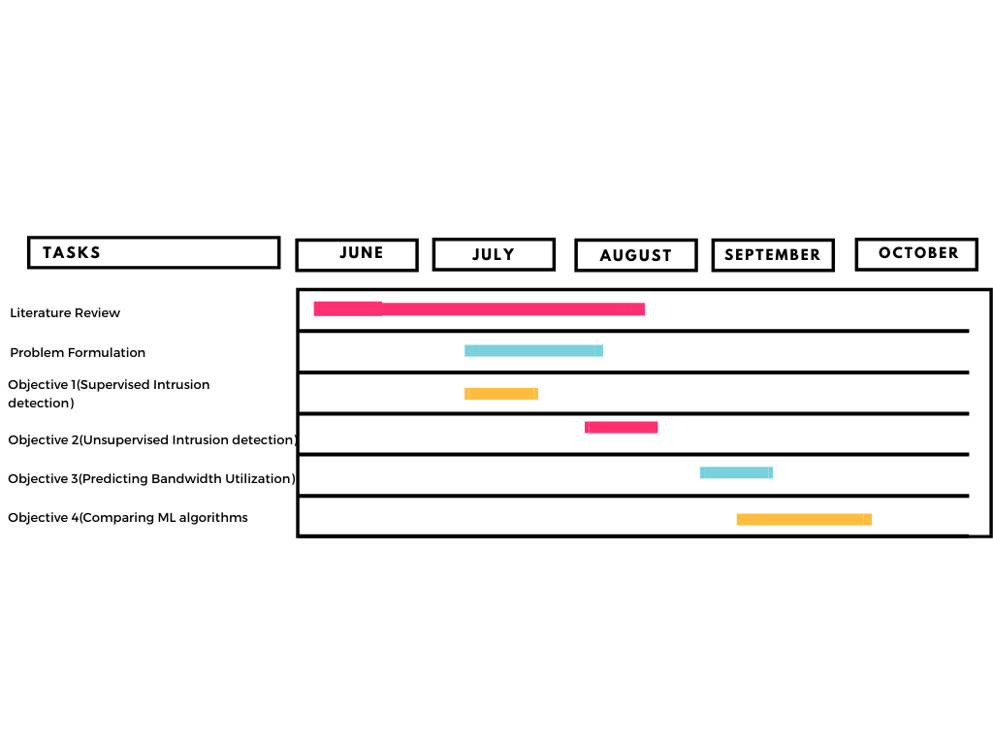

# ***Abstract***

3-Dimensional integrated circuits based on Through Silicon vias have attracted lots of interest due to its unique advantages. As increasing complexity and miniaturization have led to a transition in the semiconductor industry from 2D to 3D technology. Due to continuously scaling down of the feature size , the reliability of Cu-TSVs is becoming a serious issue. To overcome this issue Carbon Nanotube (CNT) has been proposed as a filling conductivity material for TSVs due to its properties of high thermal conductivity and ampacity. For increasing the performance of 3D ICs Carbon Nanotube and copper composite as TSV and Graphene nanoribbons as interconnect are used.

The CNT/GNR interface and copper-CNT/GNR interface offers 80.5% and 64.2% lower interface resistance than its copper counterpart. The thermal conductivity obtained by copper-CNT composite is better than copper because self-heating effects are eliminated to a large extent. We trace the research and development of Cu/CNT and offer our perspectives on Cu/CNT’s potential to meet demands for materials outperforming copper for next-generation applications.

To Predict the Thermal conductivity and electrical conductivity of the Cu-CNT composite and GNR Interconnect in many different aspects we are working to creating a model with the help of an artificial neural network , a machine learning algorithm

## 

## Background Information/Motivation

Interconnect delays, bandwidth and power consumption are increasingly dominating IC performance due to increases in chip size and reduction in the minimum feature size, in spite of new materials like Cu with low-k dielectric. Thereby severely limiting chip performance unless a paradigm shift from present interconnect architecture is introduced. One such promising technique is three-dimensional (3-D) ICs with multiple active Si layers and vertical interconnects. It is shown that significant improvement in performance and reduction in wire-limited chip area can be achieved with 3-D ICs if some long horizontal interconnects can be replaced by short vertical inter-layer interconnects. We also address the thermal concerns due to increased power density for 3-D circuits.

Copper (Cu) is usually used for electronic devices that require higher thermal dissipation than possible aluminum. However, Cu is difficult to extrude, stamp or machine, thus it is a more common process powder metallurgy technique. Pure sintered Cu has lower thermal conductivity (300-330 W/m.K) than the monocrystal pure copper (401 W/m.K), due to the existence of grain boundaries and defects in polycrystals structures. Due to its high exceptional strength, low coefficient of thermal expansion and ultra-high thermal conductivity(3000-6000W/m.K) Carbon Nanotube(CNT) is one of the most promising materials in the field of advanced materials. The avg thermal conductivity of multilayer CNT is 3000W/m.K, which is approximately 8 times higher than that of pure Cu(401W/m.K). So adding a small number of CNTs to the Cu matrix is expected to contribute strongly to improving the overall thermal conductivity which in turn can be used as a heat dissipator in advanced electronics devices.

Next-generation macro and microscale applications aiming for higher functionality, efficiency, and sustainability demand materials outperforming copper. There is a growing need to replace heavy copper electrical and data wiring in vehicles with lighter alternatives for improved fuel efficiency. 3D IC integration helps us in many aspects like this promise to speed up communication between layered chips, compared to the planar layout. 3D IC also addresses the scaling challenge by stacking 2D dies and connecting them in the 3rd dimension.

## 

## Literature Survey

During the past few decades, CNT/Cu based composite materials have fascinated the worldwide research community with their phenomenal mechanical and thermal properties. In addition, CNT/Cu composites have shown remarkable electrical properties and have become a booming candidate in the present electrical, semiconductor and packaging industries. Though several research groups have developed CNT/Cu composites with high conductive properties, very few could even come closer to the benchmark conductivity of pure Cu conductors. The conductivity of the composite has shown dependency on several key factors, including CNT alignment, CNT dispersion and material interface, which can be shaped during its fabrication procedures. Each of these factors has shown a significant interdependency and effective tailoring of those factors can result in better composites with enhanced electrical properties while retaining its mechanical robustness. High flexibility and the improved fatigue life have opened the pathways for CNT/Cu composites into flexible/wearable electronics where CNT/Cu has been introduced into energy storage, energy conversion and sensing systems.

In this new generation, the requirement of 3D IC is an important technique to achieve “more than Moore” integration. It is encouragingly indicated that Cu/CNT performances (electrical, thermal, and mechanical) reported so to rival that of Cu, proving the material’s viability as a Cu alternative. The Cu-CNT composite as TSV as interconnects are considered to improve the performance of 3D IC. We analyze all the electrical components of all these materials. We found that the resistance of CNT is less than Cu-CNT composite and Cu by 57.2% and 72.9% respectively. And also the CNT/GNR interface and Cu-CNT/GNR interface offers 80.5% and 64.2% lower interface resistance than copper. Cu-CNT and CNT composite have less heating effect than Cu. According to all of these aspects the use of 3D ICs in future is very feasible.

## Project Objectives

The below are the project's key goals:

* Developing an algorithm to analyze the performance based on the proportion of Cu and CNT.
* To develop a machine learning model to predict the values of electrical and thermal conductivities offered by the composite.
* To develop a machine learning model to predict the values of effective conductivity of CNT forest.
* To develop algorithms to predict the transmission characteristics of CU/CNT composite TSVs.
* To analyzed the interface resistance offered by Cu, CNT and composite
* To replace copper with Cu/CNT that is lighter and with superior electrical, mechanical and thermal properties in applications ranging from data and electricity cables to interconnects.

## System Architecture/Methodology

In this section the methodology to compute electrical and thermal properties of GNR interconnects , and the description of individual properties of copper and CNTs are shown. And also the model to describe the effect of fraction of CNT on the thermal and electrical conductivities.

* GNR Interconnect

The total resistance of GNR can be given by:

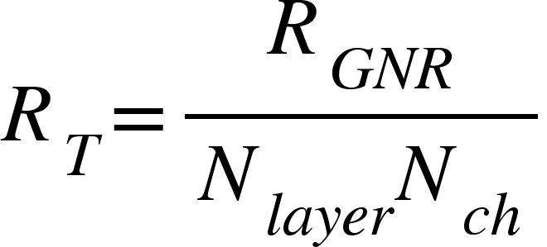

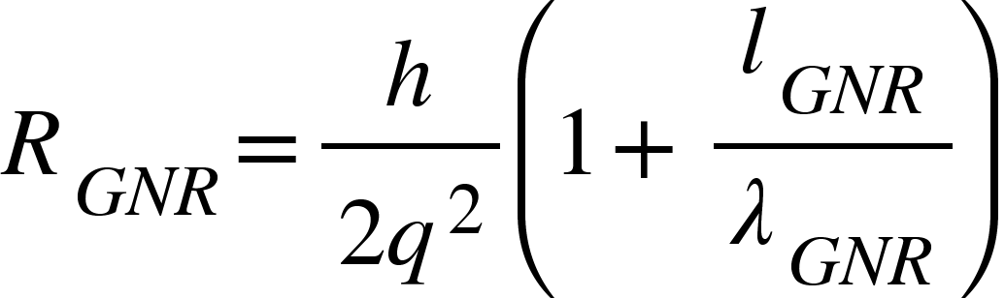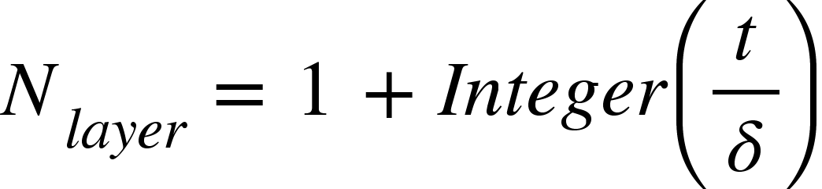

where

Given Nch is the number of conducting channels.

The thermal conductivity of the arm-chair GNR can be computed by :

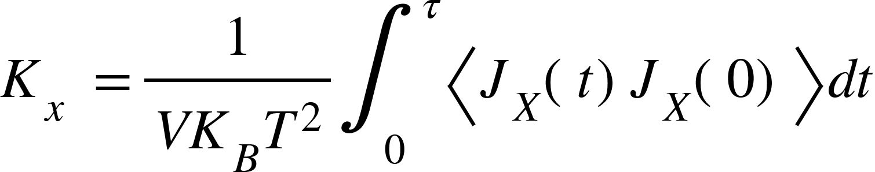

where, V stands for volume of the interconnect, KB is the Boltzmann constant, T is the temperature, Jx is the heat flux in the x direction.

* Copper TSV

Electrical Resistance :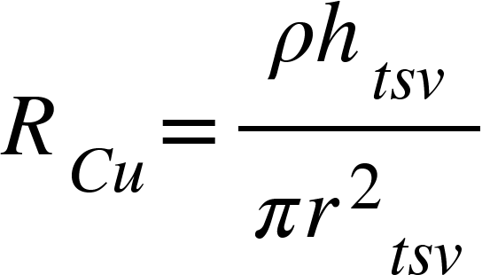

where, ρ is the resistivity of copper, htsv is the height of the TSV and rtsv is the radius.

Thermal Resistance: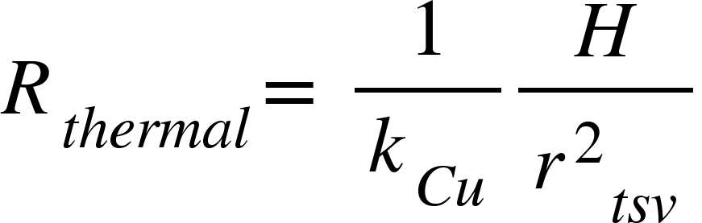

where kcu is the thermal conductivity of copper.

* CNT TSV

Impedance: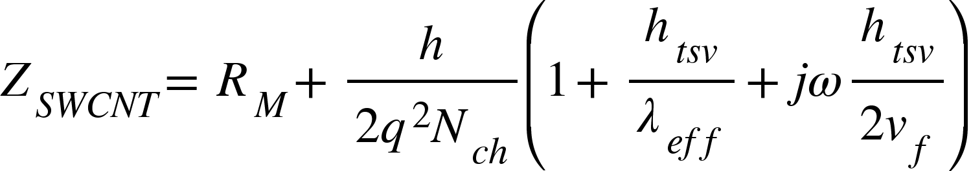

where, h is Planck’s constant, q is electron charge, Nch is the number of conducting channels, vf is the fermi-velocity, htsv is the height of TSV, λeff (= 1000 DCNT ) is the effective mean free path and Nch is the number of channels per shell.

* Cu-CNT Composite TSV:

Electrical or thermal conductivity:

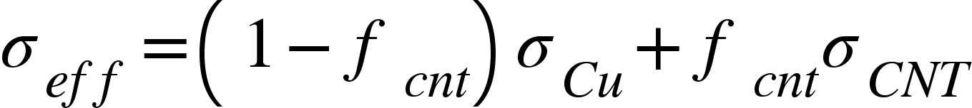

Where, σ cu is the conductivity of copper and σ CNT is the conductivity of CNT within the composite, fcnt is the ratio of the CNT to the total area of TSV is termed as the CNT filling ratio and is given as :

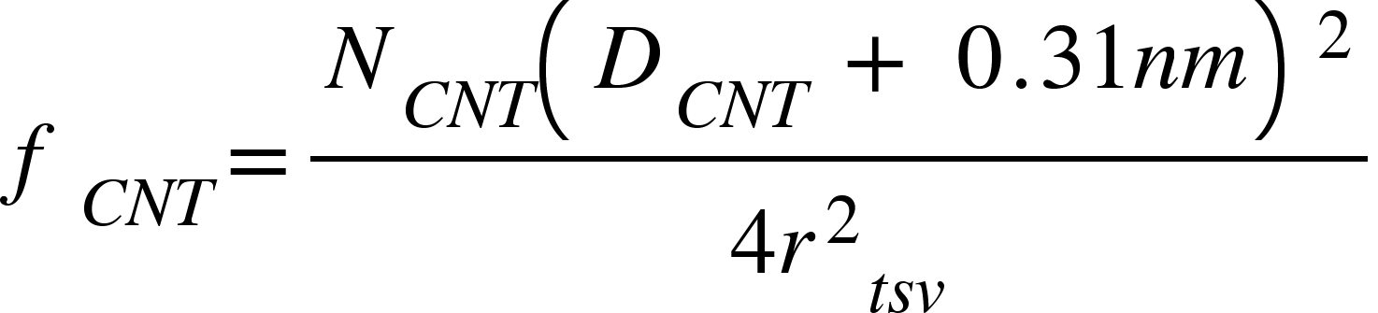

and

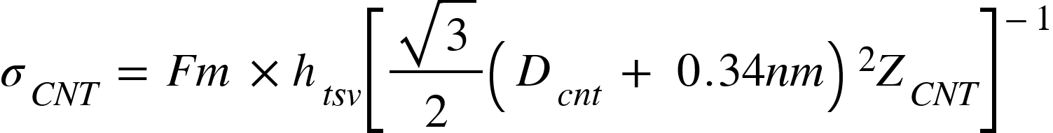

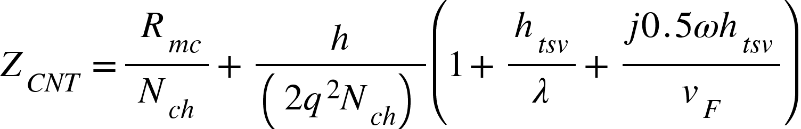

Given

And 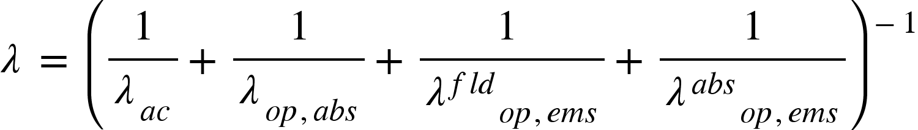

Where 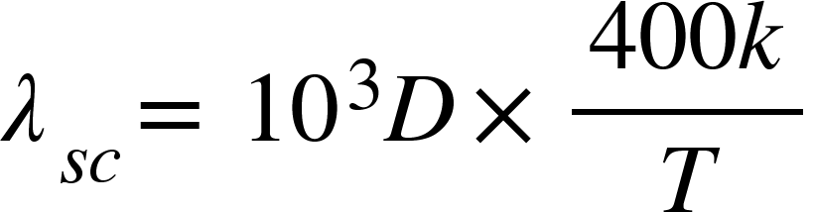

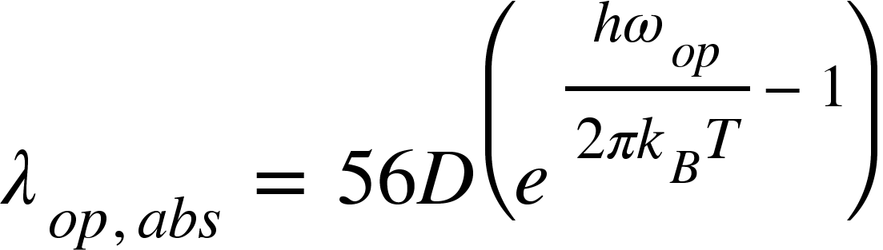

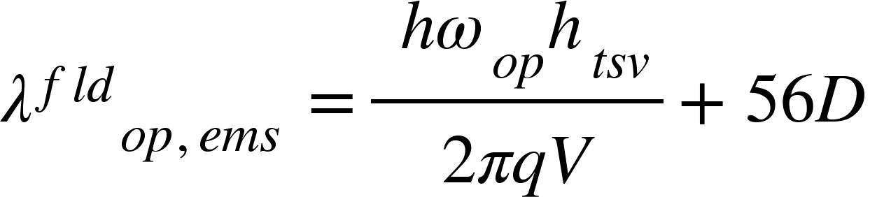

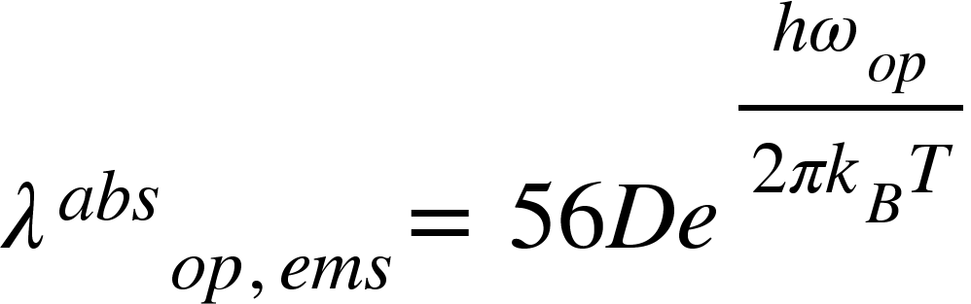

* Parasitic Capacitance of TSV:



Where,

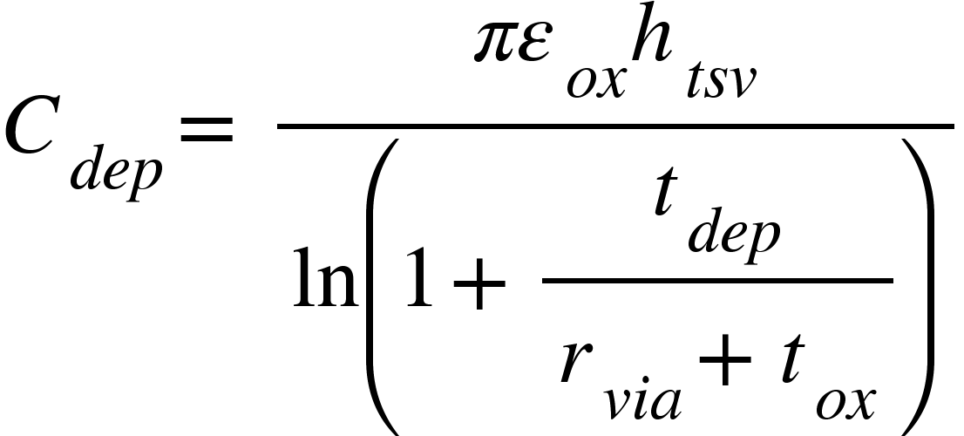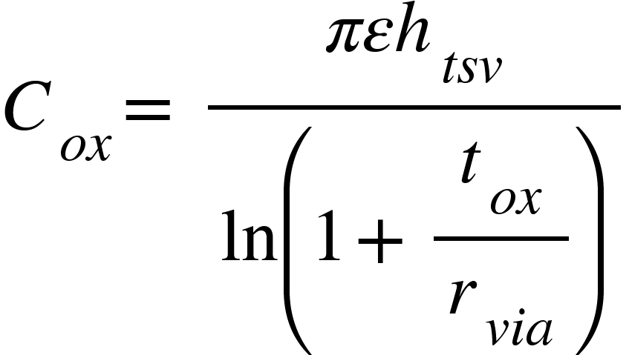

Temperature dependent silicon conductivity is given by:

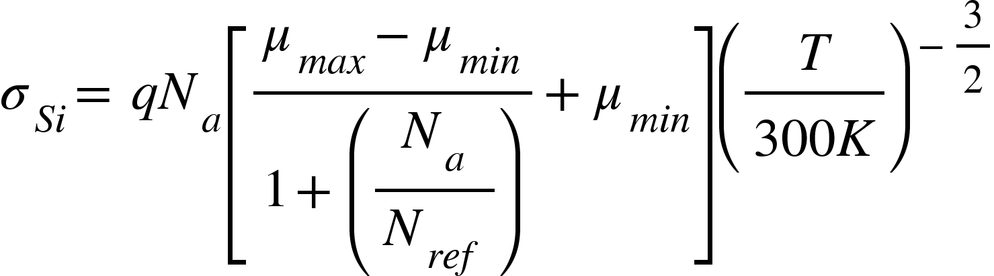

Total impedance of TSV pair:



Where 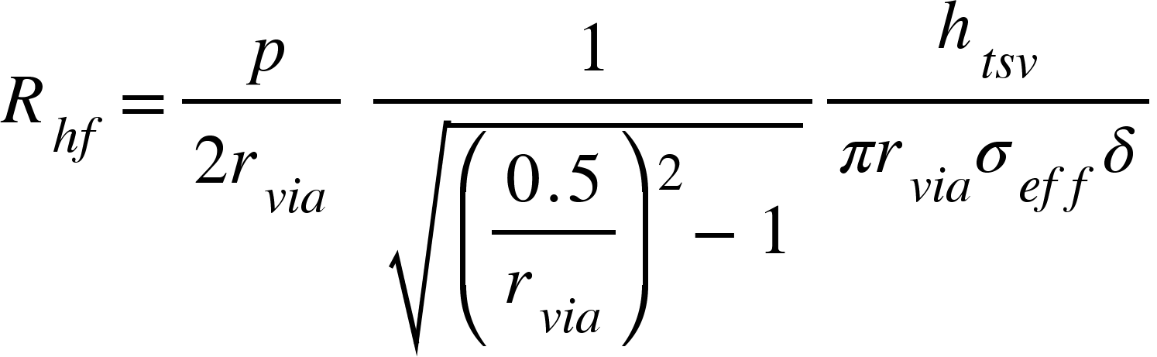

Block diagram/ Figures Used:

**Fig1**.Schematic of a pair of Cu/CNT composite TSVs together with its equivalent circuit mode**l**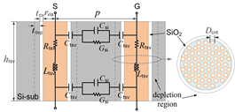

Fig.1 shows the schematic of a signal-ground Cu/CNT composite TSV pair and its equivalent circuit model. Here, the ground TSV serves as the currentreturning path. rvia and htsv denote the TSV radius and height, p is the pitch between two TSVs, and tox and tdep are the thicknesses of oxide and depletion layers, respectively. Dcnt is the CNT diameter, while it represents the utmost diameter for the MWCNT case.

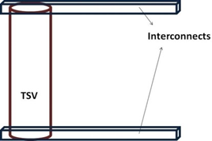

**Fig2**.Simplified interconnect and TSV structure for analysis**.**

Fig.2 shows a simple structure consisting of a TSV sandwiched between two interconnect layers for simple analysis. The temperature at the top surface of the interconnect is set to 373K. The material used as interconnect is GNR whose electrical and thermal properties are mentioned in Table 1. Three different cases of TSVs are considered that include Cu, CNT and Cu-CNT composite.

**Fig3**.Cross-section v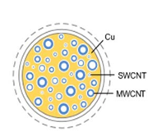

Fig.3 The cross sectional view of Cu-CNT composite can be seen in Figure 2. Cu-CNT TSV can be fabricated by co-depositing Cu with CNT.

Implementation details-Setup and Tools Used

We have implemented our project on the Anaconda IDE and Jupyter platform to run our python codes:

* **Code for Electrical and Thermal Analysis of Cu-CNT Composite TSV and GNR Interconnects:**

import numpy as np

import pandas as pd

import scipy as sp

from scipy import constants as spc

import math

D=int(input())

T=int(input())

h_tsv=int(input())

V=int(input())

lambda_ac=1000*D*400/T

lambda_op_abs=56*D*((np.exp(0.18/((spc.physical_constants['Boltzmann constant in eV/K'][0])*T))-1))

lambda_op_abs

lambda_fld_op_ems=(0.18*h_tsv/spc.e*V)+56*D

spc.k

spc.physical_constants['Boltzmann constant in eV/K'][0]

lambda_abs_op_ems=56*D*np.exp(0.18/((spc.physical_constants['Boltzmann constant in eV/K'][0])*T))

print(lambda_ac, lambda_op_abs, lambda_fld_op_ems, lambda_abs_op_ems)

lambda_ac

lambda_value=(lambda_ac*lambda_op_abs*lambda_fld_op_ems*lambda_abs_op_ems)/(lambda_ac+lambda_op_abs+lambda_fld_op_ems+lambda_abs_op_ems)

# Calculating N_ch

I = input('Enter Your Character S for SWCNT and M for MWCNT \n')[0]

print(I)

D_T=1300

a=0.000204

b=0.425

if I=='S':

N_ch=2

else:

if D<(D_T/T):

N_ch=2/3

else:

N_ch=a*T*D+b

# Calculating Z_cnt

R_mc=float(input('Enter the value of R_mc:'))

v_f=input('Enter the value of v_f: ')

j=input('Enter the value of j: ')

w=input('Enter the value of w: ')

Z_cnt=(R_mc/N_ch)+(spc.h/(((2)*(spc.e**2)*N_ch)*(1+(h_tsv/lambda_value)+(j*0.5*w*h_tsv/v_f))))

F_m=1

D_cnt=float(input())

Z_cnt=1

f_cnt=1

sigma_cu=1

sigma_cnt=1

sigma_cnt=F_m*h_tsv*1/((1.73/2)*(D_cnt+0.34)*(D_cnt+0.34)*Z_cnt)

sigma_eff=(1-f_cnt)*sigma_cu+f_cnt*sigma_cnt

# Calculating parasitic capacitance of TSV

h_tsv=50

h_tsy=1

t_ox=500

t_dep=1

r_via=2.5

C_ox=(spc.pi*3.9*spc.epsilon_0*h_tsv)/(np.log(1+(t_ox/r_via)))

C_dep=(spc.pi*3.9*spc.epsilon_0*h_tsy)/(np.log(1+(t_dep/(r_via+t_ox))))

C_q=193 #which is neglected in our study due to much larger value.

C_tsv=(1/((1/C_ox)+(1/C_dep)+(1/C_q)))

# Calculating silicon conductivity

N_a=1

mu_max=495

mu_min=47.7

N_ref=6.3*10**16

T=int(input())

sigma_si=spc.e*N_a*((mu_max-mu_min)/(1+np.power((N_a/N_ref),0.76))+mu_min)*np.power((T/300),(-1.5))

## Internal Resistance of TSV

row=int(input())

p=15

delt=int(input())

R_hf=row*h_tsv/(2*r_via)*np.sqrt(((0.5*p/r_via)**2)-1)*spc.pi*r_via*sigma_eff*delt

#Constants

rhow=0.00000172

h_tsv=0.0000005

r_tsv=np.arange(0.5,2.5,0.5)

r_tse=r_tsv*0.000001

#Plotting graph of Electrical Resistance offered by Cu.

def f(r_tse):

R_cu=(rhow*h_tsv)/(spc.pi*(r_tse*r_tse))

return R_cu

def graph(formula, r_tsv):

x = np.array(r_tsv)

y = formula(x*0.000001)

plt.plot(x, y)

plt.ylabel('Resistance(in ohm)')

plt.title('Fig4. Electrical Resistance offered by Cu',y=-0.3)

plt.xlabel('Radius(in nanometer)')

plt.show()

graph(f,r_tsv)

#Plotting graph of Parametric analysis of fraction of CNT in the composite with electrical resistance

f_cnt=np.arange(0.1,1,0.1)

def f1(f_cnt):

sigma_eff=(1-f_cnt)*0.004+f_cnt*0.175

return sigma_eff

def graph_2(f1,f_cnt):

x=np.array(f_cnt)

y=f1(x)

plt.plot(x,y)

plt.ylabel('Resistance (in ohm)')

plt.title('Fig5. Parametric analysis of fraction of CNT in the composite with electrical resistance',y=-0.3)

plt.xlabel('f_cnt')

plt.show()

graph_2(f1,np.arange(0.0,1.0,0.1))

Techniques used

|  |  |  |
| --- | --- | --- |
| **Name** | **Used For** | **Open-Source** |
| Python | Programming Language | Yes |
| Scikit-Learn | Framework/Library | Yes |
| Matplotlib | Visualization Library | Yes |
| Seaborn | Visualization Library | Yes |
| NumPy | Mathematical Computation | Yes |
| Anaconda | IDE | Yes |

## Testing details

* We have used python as a programming language to develop the artificial neural network model and to plot the data in graphical forms.
* We have developed the codes for all the formulas which requires the value of unknown variables to be put into .
* Further we would be creating an artificial neural network model to predict the electrical and thermal conductivities of Cu-CNT Interconnects .
* We Will train our model on the 60% of the provided data and then test it on the remaining 40% data further calculating the accuracy of our model.
* The results were analysed using our ML Model which accounts for contributions from thermal interface resistance at metal–CNT boundary as well as aspect ratio of carbon nanotubes.

To test our results, we have used several constants which are given in the tables below:

1. COMSOL Material Properties

## Table 1

|  |  |
| --- | --- |
| **Electrical Resistivity (Ω***m* **)** | |
| Copper | 1 .7 2 × 1 0 − 8 |
| Carbon Nanotube | 6.17 × 10−8 |
| Graphene Nanotubes | 1 .1 × 1 0 − 8 |
| **Thermal Conductivity (**W **/**  m K2**)** | |
| Copper | 400 |
| Carbon Nanotube | 1750 |
| Graphene Nanotubes | 700 |

**Table.1** The properties of Cu and CNT and GNR are mentioned

2. Sensitivity coefficients of the proposed Cu/CNT composite TSV pair at 1GHz, 10GHz, and 20GHz:

Table 2

|  |  |  |  |
| --- | --- | --- | --- |
| **Variables** | **1Ghz** | **10GHz** | **20GHz** |
| *t*ox | 5×103 | 9*.*5×104 | 9×104 |
| *r*via | −1×103 | −1*.*9×104 | −1*.*6×104 |
| *p* | −150 | −100 | −900 |
| *D*cnt | 4×104 | 1*.*8×105 | 1*.*4×105 |
| *h*tsv | 1 103 | 3 103 | 3 103 |

**Table.2** Summarizes the sensitivity coefficients with respect to these design parameters at 1 GHz, 10 GHz, and 20 GHz, respectively. It is found that the CNT diameter and the oxide are the key factors among these design parameters.

# Result and discussion

Previously researchers used COMSOL Multiphysics techniques to evaluate electrical and thermal properties of interconnect and TSV.

* Electrical Analysis:

1. In all the three cases of Cu,CNT and Cu-CNT composite as TSVs, it is observed that the resistance decreases by increasing the radius of the TSV.
2. Resistance offered by copper is least due to its high electrical conductivity.
3. Increasing the content of CNT in the composite increases the resistance.
4. The interface resistance offered by Cu/GNR is higher than that of CNT/GNR. This is due to the similar bonding structure of CNT and GNR.

* Thermal Analysis:

1. In case of copper TSVs, the temperature rises up to 380K at a certain height; this indicates the formation of hotspots due to poor thermal conductivity offered by copper.
2. In case of CNT TSVs the heat is dissipated quickly due to the highest thermal conductivity offered by carbon-based material.
3. Cu-CNT composite offers thermal conductivity intermediate to that of Cu and CNT.
4. More the fraction of CNT in the composite, the better is the thermal conductivity.

Based on the circuit model, a number of results were found on the effective conductivity and transmission characteristics of Cu/CNT composite TSV pair.

* Electrical Conductivity:

1. The conductivity of an ideally packed SWCNT forest with Fm = 0.414 is equal to that of Cu.
2. As Fm is smaller than 0.414, the conductivity of Cu/SWCNT composite drops with the increase of fcnt, while a reverse trend can be observed for SWCNT composite with Fm larger than 0.414.
3. The conductivity of Cu/MWCNT composite would be always larger than that of Cu, and increases as the CNT diameter increases.
4. The conductivity of Cu/MWCNT composite would be always larger than that of Cu, and increases as the CNT diameter increases.

## Transmission Characteristics:

1. The electrical performance can be improved by increasing the silicon capacitance due to the inhibited leakage current into the silicon substrate.
2. TSV capacitance is slightly increased by increasing the temperature.

Graphs developed from our Model:



From the equation , , we plotted the graph between radius and resistance keeping the value of height as 50nanometer . It was found that resistance decreases with increasing radius.It is shown in fig.4

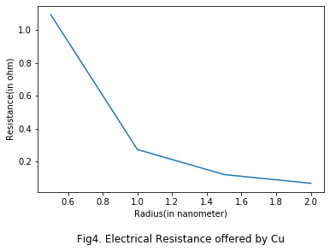

# 

# 

To compute the effective overall electrical or thermal conductivity offered by the composite , we used :



And plotted the graph between f_cnt and sigma_effective from our python code which is shown in the figure.5

. 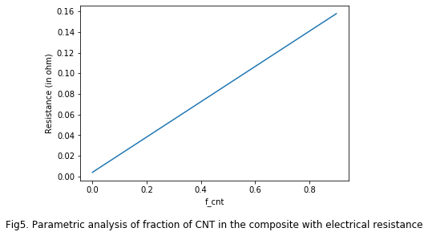

# 

# Conclusion

From the given two papers we have reached to many conclusions which are listed below:

* The electrical properties of Cu, CNT and copper-CNT composite when used as TSVs are analyzed.
* The problem of heat crowding and hotspot generation is mostly eliminated by the use of CNTs in the composite.
* The CNT/GNR interface and Cu-CNT/GNR interface offers 80.5% and 64.2% lower interface resistance than its copper counterpart due to similar bonding structure between CNTs and GNRs.
* The temperature in case of copper rises to 380 K which shows that self-heating effects are more in copper as compared to CNT and Cu-CNT composite.
* Cu/MWCNT composite TSVs can provide better conductivity and thermal stability than Cu ones.
* Oxide liner is an important factor, and therefore, the liner should be treated carefully in the design of high-performance Cu/CNT composite TSVs.

## Limitation

* Our model only predicts the thermal and electrical conductivity of the Cu-CNT composite and GNR interconnect.
* It works only for a single type of composite, there are many more CNT composite and there electrical properties that help in the performance enhancement for semiconductor fields which are not predicted by this model.
* It is difficult to obtain a dense CNT bundle with all metallic CNTs due to limitations in the processing techniques.
* It is difficult to grow a dense CNT bundle having metallic fraction ( FM ) equal to unity because of fabrication limitations.

## Future work

Optimizing the Machine Learning Model to improve on the sensitivity and precision to get more accurate results and fix bugs to bring out the most robust algorithm for this model and increase reliability. Also The results of this study can serve as a basis for future semiconductor 3D package technology development.

# References :

[1] FU Kai, ZHENG Jie, ZHAO Wen sheng, HU Yue and WANG Gaofeng:Analysis of Transmission Characteristics of Copper/Carbon Nanotube Composite Through-Silicon Via Interconnects* (School of Electronics and Information, Hangzhou Dianzi University, Hangzhou 310018, China)

[2] Komal Sable ,Manodipan Sahoo, Member, IEEE:Electrical and Thermal Analysis of Cu-CNT Composite TSV and GNR Interconnects. Dept. of Electronics and Communication Engineering Dhanbad IIT (ISM), Dhanbad Jharkhand, India

[3] J. U. Knickerbocker, P. S. Andry, B. Dang, et al., “Three Dimensional silicon integration,” Proceedings of the IEEE, Vol.52, No.6, pp.553–569, 2008.

[4] H. Liang, H. Chang, Y. Li, et al., “Optimized mid-bond order for 3D-stacked ICs considering failed bonding,” Chinese Journal of Electronics, Vol.24, No.2, pp.224–228, 2015.

[5] K. L. Shen, Z. G. Yu and Y. Bai, “Optimization strategy for TSV-based 3D SoC testing,” Acta Electronica Sinica, Vol.44, No.1, pp.155–159, 2016 (in Chinese).

[6] Y. M. Ouyang, C. L. Sun, Q. Chen, et al., “Fault Tolerant method of critical communication components in 3D NoC: A review,” Acta Electronica Sinica, Vol.44, No.12, pp.3053–3063, 2016 (in Chinese).

[7] W. S. Zhao and W. Y. Yin, “Carbon-based interconnects for RF nano-electronics,” Wiley Encyclopedia of Electrical and Electronics Engineering, pp.1–20, 2012.

[8] T. Wang, S. Chen, D. Jiang, et al., “Through-silicon vias filled with densified and transferred carbon nanotube forests,” IEEE Electron Device Letters, Vol.33, No.3, pp.420–422, 2012.

[9] G. F. Wang, W. S. Zhao and L. L. Sun, “Overview of carbon based passives,” Acta Electronica Sinica, Vol.45, No.12, pp.3037–3045, 2017 (in Chinese).

[10] W. S. Zhao, W. Y. Yin and Y. X. Guo, “Electromagnetic compatibility-oriented study on through silicon single-walled carbon nanotube bundle via (TS-SWCNTTBV) arrays,” IEEE Transaction on Electromagnetic Compatibility, Vol.54, No.1, pp.149–157,2012.

[11] W. S. Zhao, L. Sun, W. Y. Yin, et al., “Electrothermal modeling and characterization of submicron through-silicon carbon nanotube bundle vias for three-dimensional ICs,” Micro & Nano Letters, Vol.9, No.2, pp.123–126, 2014.

[12] L. Qian, Z. Zhu and Y. Xia, “Study on transmission characteristics of carbon nanotube through silicon via interconnect,” IEEE Microwave Wireless Component Letters, Vol.24, No.12, pp.830–832, 2014.

[13] Y. Feng and S. L. Burkett, “Fabrication and electrical performance of through silicon via interconnects filled with a copper/carbon nanotube composite,” Journal of Vacuum Science & Technology B, Vol.33, No.2, p.022004, 2015.

[14] Y. Chai, P. C. H. Chan, Y. Fu, et al., “Copper/carbon nanotube composite interconnect for enhanced electromigration resistance,” Proc.of 58th Electronic Components and Technology Conference, Lake Buena Vista, FL, USA, pp.412–420, 2008.

[15] G. Katti, M. Stucchi, D. Velenis, et al., “Temperature Dependent modeling and characterization of through-silicon via capacitance,” IEEE Electron Device Letters, Vol.32, No.4, pp.563–565, 2011.

[16] C. Li, F. Zhang, M. Di, Z. Pan and A. Wang, "Developing 3D Heterogeneous Structures for Future Chips," 2019 International Conference on IC Design and Technology (ICICDT), SUZHOU, China, 2019, pp. 1-4. H. Simpson, Dumb Robots, 3rd ed., Springfield: UOS Press, 2004, pp.6-9.

[17] D. H. Kim, K. Athikulwongse and S. K. Lim, "Study of Through-SiliconVia Impact on the 3-D Stacked IC Layout," in IEEE Transactions on Very Large Scale Integration (VLSI) Systems, vol. 21, no. 5, pp. 862-874, May 2013.

[18] J. Jeong, S. Jang, W. Choi, Y. Kim and K. Chun, "Thermal structure design for enhanced heat spreading in 3D ICs," IEEE 2013 Tencon - Spring, Sydney, NSW, 2013, pp. 544-547.

[19] W. Steinhogl, G. Schindler, G. Steinlesberger, M. Traveling, and M. Engelhardt, “Comprehensive study of the resistivity of copper wires with lateral dimensions of 100 nm and smaller,“ Journal of Applied Physics, vol. 97, no. 2, 2005.

[20] C. Xu, H. Li and K. Banerjee, "Modeling, Analysis, and Design of Graphene Nano-Ribbon Interconnects," in IEEE Transactions on Electron Devices, vol. 56, no. 8, pp. 1567-1578, Aug. 2009.

[21] D. Jiang, W. Mu, S. Chen, Y. Fu, K. Jeppson and J. Liu, "Vertically Stacked Carbon Nanotube-Based Interconnects for Through Silicon Via Application," in IEEE Electron Device Letters, vol. 36, no. 5, pp. 499- 501, May 2015.

[22] J. Lee et al., "Understanding Electromigration in Cu-CNT Composite Interconnects: A Multiscale Electrothermal Simulation Study," in IEEE Transactions on Electron Devices, vol. 65, no. 9, pp. 3884-3892, Sept. 2018.

[23] C. Subramaniam, T. Yamada, K. Kobashi, A. Sekiguchi, D. N. Futaba, M. Yumura, and K. Hata, ”One hundred fold increase in current carrying capacity in a carbon nanotube copper composite,” Nature Communications, vol. 4, no. 2202, Jul. 2013.

[24] R. M. Sundaram, A.Sekiguchi, M.Sekiya, T. Yamada and K.Hata, “Copper/carbon nanotube composites: Research trends and outlook,” Royal Society Open Science, vol. 5, no. 11, Nov. 2018.

[25] J. Heremans, J.-P. Issi, I. Zabala-Martinez, M. Shayegan, and M. Dresselhaus, “Thermoelectric properties of a dilute graphite donor intercalation compound,” Physics LettersA, vol. 84, no. 7, pp. 387–389, Aug. 1981.

[26] J. Park, and V.Prakasha, “Thermal transport in 3D pillared SWCNT– graphene nanostructures,” Journal of Materials Research, vol. 28, no. 7, Apr 14, 2013.

[27] W. M. Chanu, V. Prasad and D. Das, "Performance analysis of temperature dependent GNR interconnect," 2016 20th International Symposium on VLSI Design and Test (VDAT), Guwahati, 2016, pp. 1-5.



