**How to download browser downloads for Windows**

**Introduction:** This document explains how to download Browser drivers to work with Selenium. Download information for following drivers will be explained:

1. ChromeDriver
2. FirefoxDriver
3. InternetExplorer
4. Microsoft

**Prerequisites:** In the programs, all downloaded files are extracted in **C:\BDrivers**

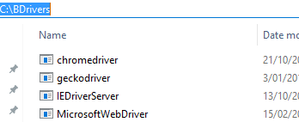

1. **ChromeDriver**
   1. Download ChromeDriver from <http://www.seleniumhq.org/download/>

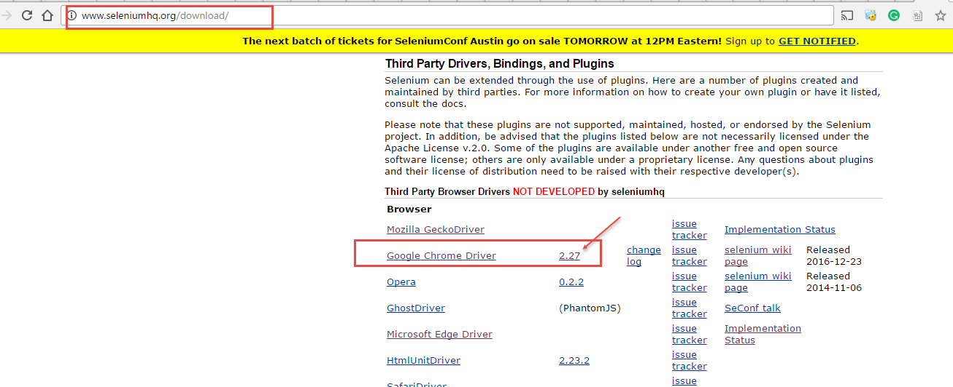

1. **FirefoxDriver** 
   1. Download geckoDriver from <https://github.com/mozilla/geckodriver/releases>

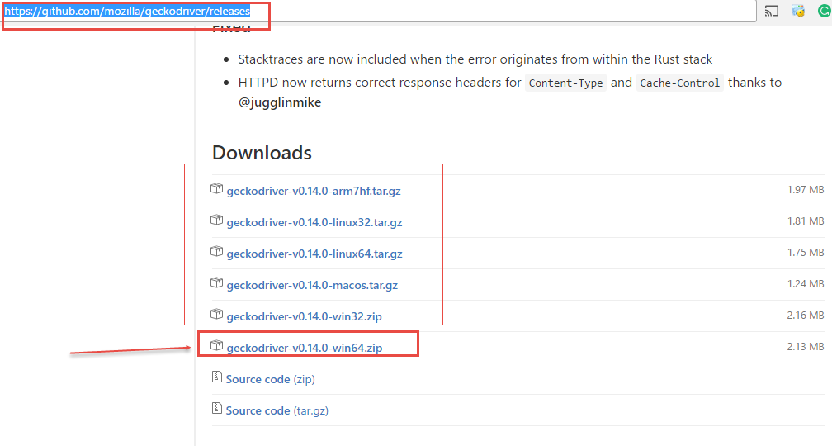

1. **InternetExplorer**
   1. **Download Internet explorer driver from** <http://www.seleniumhq.org/download/>

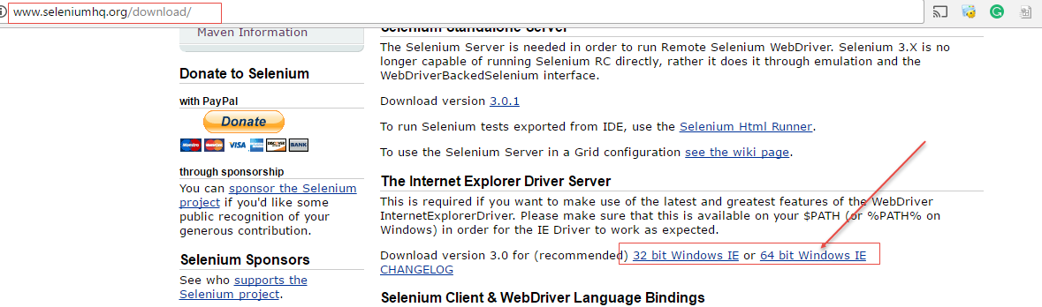

* 1. **IMPORTANT:** update the path variable to add the path where the internetexplorer driver exists

So if you follow the same structure, it would be **C:\BDrivers.**

1. **Micsoft Edge Driver**
   1. **Download Edge driver from** <https://developer.microsoft.com/en-us/microsoft-edge/tools/webdriver/>

