**Himanshu Kumar**

* **Address**: Nad, Sasaram Bihar(821113)  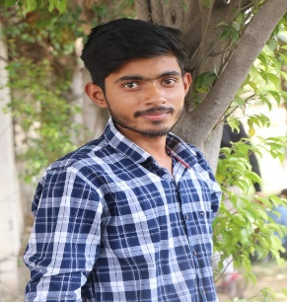
* **Phone**: 6204561606
* **Email**: himanshukumar6204561@gmail.com
* **D.O.B**:10/09/2003
* **Branch/Stream**: Computer Science and Engineering
* **Linkedin Profile Link**: www.linkedin.com/in/himanshu-kumar-299191228

**Career Objective**

To have a simple living. To Work, Learn, and Grow for the betterment of the industry and myself. To solve real-time issues by implementing the best technologies at most possible perfection with my technical knowledge.

**Academic Details**

|  |  |  |  |  |  |
| --- | --- | --- | --- | --- | --- |
|  | Name of Examination | Year of Passing | Board/University | Institution | Percentage/CGPA |
| **Graduation** | Btech | 2024 | Kurukshetra University | Panipat Institute of Engineering  And Technology Panipat | 7.5CGPA (till 5th semester) |
| **Senior Secondary** | 12th | 2020 | CBSE | A.B.R. College | 63% |
| **Secondary School** | 10th | 2018 | CBSE | P.N.P.S | 57.5% |

# Soft skills

* Team work
* Adaptability
* Leadership

# Industrial Training/ Internship

* Successfully ongoing 1 month internship in Web Development at “CODSOFT” (20thJuly –20th August 2023)
* I have completed a python bootcamp 2020 on Skillzcafe
* I have completed SQL and RELATIOAL DATABASE issued by cognitive class

# Computer Skills

* Programming Language:- C, C++,Python
* Data Base:- My SQL
* OS:- Window and Linux
* Subject Known:- DBMS Computer Network
* Basics of HTML, CSS, Javascript

# Technical Project

# **CAR CATALOGUE(**Find your best car from our website and also we gives you customer support, and I work in this project as a front end developer)

1. Own PORTFOLIO(using JAVA, CSS, HTML and basics of PHP

# Hobbies and Interest

* Web Surfing to Learn new things
* Organizing files and folders of my computer in leisure time
* Playing Cricket
* Dancing

Place:

Date: Signature: Himanshu Kr.