**Activity 1**

**FRAGMENT**

AndroidManifest.xml

*<?***xml version="1.0" encoding="utf-8"***?>*<**manifest package="com.codepath.mypizza"  
 xmlns:android="http://schemas.android.com/apk/res/android"**>  
  
 <**application  
 android:allowBackup="true"  
 android:icon="@mipmap/ic_launcher"  
 android:label="@string/app_name"  
 android:supportsRtl="true"  
 android:theme="@style/AppTheme"**>  
 <**activity android:name=".MainActivity"**>  
 <**intent-filter**>  
 <**action android:name="android.intent.action.MAIN"**/>  
  
 <**category android:name="android.intent.category.LAUNCHER"**/>  
 </**intent-filter**>  
 </**activity**>  
 </**application**>  
  
</**manifest**>

MainActivity.java

**package** com.codepath.mypizza;  
  
**import** android.content.res.Configuration;  
**import** android.os.Bundle;  
**import** android.support.v4.app.FragmentTransaction;  
**import** android.support.v7.app.AppCompatActivity;  
**import** android.util.Log;  
**import** android.widget.Toast;  
  
**import** com.codepath.mypizza.fragments.PizzaDetailFragment;  
**import** com.codepath.mypizza.fragments.PizzaMenuFragment;  
  
**public class** MainActivity **extends** AppCompatActivity **implements** PizzaMenuFragment.OnItemSelectedListener {  
  
 @Override  
 **protected void** onCreate(Bundle savedInstanceState) {  
 **super**.onCreate(savedInstanceState);  
 setContentView(R.layout.***activity_main***);  
  
  
 Log.*d*(**"DEBUG"**, getResources().getConfiguration().**orientation** + **""**);  
  
 **if** (savedInstanceState == **null**) {  
   
 PizzaMenuFragment firstFragment = **new** PizzaMenuFragment();  
  
   
 FragmentTransaction ft = getSupportFragmentManager().beginTransaction();  
 ft.add(R.id.***flContainer***, firstFragment);   
 ft.commit();   
 }  
  
 **if**(getResources().getConfiguration().**orientation** == Configuration.***ORIENTATION_LANDSCAPE***){  
 PizzaDetailFragment secondFragment = **new** PizzaDetailFragment();  
 Bundle args = **new** Bundle();  
 args.putInt(**"position"**, 0);  
 secondFragment.setArguments(args);   
 FragmentTransaction ft2 = getSupportFragmentManager().beginTransaction();  
 ft2.add(R.id.***flContainer2***, secondFragment);   
 ft2.commit();   
 }  
 }  
  
 @Override  
 **public void** onPizzaItemSelected(**int** position) {  
 Toast.*makeText*(**this**, **"Called By Fragment A: position - "**+ position, Toast.***LENGTH_SHORT***).show();  
  
   
 PizzaDetailFragment secondFragment = **new** PizzaDetailFragment();  
  
 Bundle args = **new** Bundle();  
 args.putInt(**"position"**, position);  
 secondFragment.setArguments(args);   
  
  
 **if**(getResources().getConfiguration().**orientation** == Configuration.***ORIENTATION_LANDSCAPE***){  
 getSupportFragmentManager()  
 .beginTransaction()  
 .replace(R.id.***flContainer2***, secondFragment)   
   
 .commit();  
 }**else**{  
 getSupportFragmentManager()  
 .beginTransaction()  
 .replace(R.id.***flContainer***, secondFragment)   
 .addToBackStack(**null**)

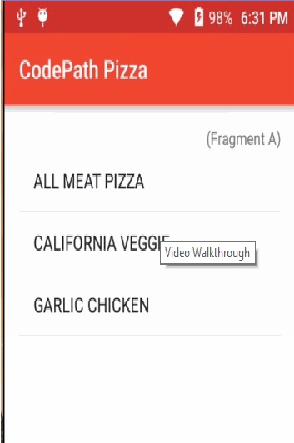

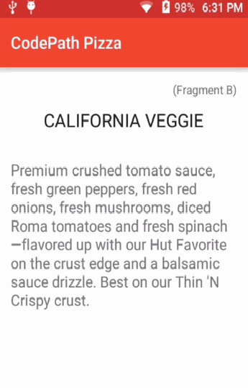

**Activity 2**

**Sqlite Database**

AndroidManifest.xml

<?xml version="1.0"?>

-<RelativeLayout tools:context="com.sample.foo.sqliteexample.MainActivity" android:paddingBottom="@dimen/activity_vertical_margin" android:paddingTop="@dimen/activity_vertical_margin" android:paddingRight="@dimen/activity_horizontal_margin" android:paddingLeft="@dimen/activity_horizontal_margin" android:layout_height="match_parent" android:layout_width="match_parent" xmlns:tools="http://schemas.android.com/tools" xmlns:android="http://schemas.android.com/apk/res/android">

<ListView android:layout_height="wrap_content" android:layout_width="match_parent" android:layout_above="@+id/addNew" android:layout_centerVertical="true" android:layout_centerHorizontal="true" android:id="@+id/listView1"> </ListView>

<Button android:layout_height="wrap_content" android:layout_width="wrap_content" android:layout_centerHorizontal="true" android:id="@+id/addNew" android:text="@string/Add_New" android:textSize="@dimen/text_size" android:padding="@dimen/activity_vertical_margin" android:layout_margin="@dimen/activity_vertical_margin" android:layout_alignParentBottom="true"/>

</RelativeLayout>

MainActivity.java

package com.sample.foo.sqliteexample;

import android.content.Intent;

import android.database.Cursor;

import android.support.v7.app.ActionBarActivity;

import android.os.Bundle;

import android.view.View;

import android.widget.AdapterView;

import android.widget.Button;

import android.widget.ListView;

import android.widget.SimpleCursorAdapter;

public class MainActivity extends ActionBarActivity {

public final static String KEY_EXTRA_CONTACT_ID = "KEY_EXTRA_CONTACT_ID";

private ListView listView;

ExampleDBHelper dbHelper;

@Override

protected void onCreate(Bundle savedInstanceState) {

super.onCreate(savedInstanceState);

setContentView(R.layout.activity_main);

Button button = (Button) findViewById(R.id.addNew);

button.setOnClickListener(new View.OnClickListener() {

@Override

public void onClick(View view) {

Intent intent = new Intent(MainActivity.this, CreateOrEditActivity.class);

intent.putExtra(KEY_EXTRA_CONTACT_ID, 0);

startActivity(intent);

}

});

dbHelper = new ExampleDBHelper(this);

final Cursor cursor = dbHelper.getAllPersons();

String [] columns = new String[] {

ExampleDBHelper.PERSON_COLUMN_ID,

ExampleDBHelper.PERSON_COLUMN_NAME

};

int [] widgets = new int[] {

R.id.personID,

R.id.personName

};

SimpleCursorAdapter cursorAdapter = new SimpleCursorAdapter(this, R.layout.person_info,

cursor, columns, widgets, 0);

listView = (ListView)findViewById(R.id.listView1);

listView.setAdapter(cursorAdapter);

listView.setOnItemClickListener(new AdapterView.OnItemClickListener() {

@Override

public void onItemClick(AdapterView<?> listView, View view,

int position, long id) {

Cursor itemCursor = (Cursor) MainActivity.this.listView.getItemAtPosition(position);

int personID = itemCursor.getInt(itemCursor.getColumnIndex(ExampleDBHelper.PERSON_COLUMN_ID));

Intent intent = new Intent(getApplicationContext(), CreateOrEditActivity.class);

intent.putExtra(KEY_EXTRA_CONTACT_ID, personID);

startActivity(intent);

}

});

}

}

DatabaseHelper.java

package com.sample.foo.sqliteexample;

import android.content.ContentValues;

import android.content.Context;

import android.database.Cursor;

import android.database.DatabaseUtils;

import android.database.sqlite.SQLiteDatabase;

import android.database.sqlite.SQLiteOpenHelper;

import java.util.ArrayList;

import java.util.HashMap;

/**

* Created by obaro on 02/04/2015.

*/

public class ExampleDBHelper extends SQLiteOpenHelper {

public static final String DATABASE_NAME = "SQLiteExample.db";

private static final int DATABASE_VERSION = 2;

public static final String PERSON_TABLE_NAME = "person";

public static final String PERSON_COLUMN_ID = "_id";

public static final String PERSON_COLUMN_NAME = "name";

public static final String PERSON_COLUMN_GENDER = "gender";

public static final String PERSON_COLUMN_AGE = "age";

public ExampleDBHelper(Context context) {

super(context, DATABASE_NAME , null, DATABASE_VERSION);

}

@Override

public void onCreate(SQLiteDatabase db) {

db.execSQL(

"CREATE TABLE " + PERSON_TABLE_NAME +

"(" + PERSON_COLUMN_ID + " INTEGER PRIMARY KEY, " +

PERSON_COLUMN_NAME + " TEXT, " +

PERSON_COLUMN_GENDER + " TEXT, " +

PERSON_COLUMN_AGE + " INTEGER)"

);

}

@Override

public void onUpgrade(SQLiteDatabase db, int oldVersion, int newVersion) {

db.execSQL("DROP TABLE IF EXISTS " + PERSON_TABLE_NAME);

onCreate(db);

}

public boolean insertPerson(String name, String gender, int age) {

SQLiteDatabase db = this.getWritableDatabase();

ContentValues contentValues = new ContentValues();

contentValues.put(PERSON_COLUMN_NAME, name);

contentValues.put(PERSON_COLUMN_GENDER, gender);

contentValues.put(PERSON_COLUMN_AGE, age);

db.insert(PERSON_TABLE_NAME, null, contentValues);

return true;

}

public int numberOfRows() {

SQLiteDatabase db = this.getReadableDatabase();

int numRows = (int) DatabaseUtils.queryNumEntries(db, PERSON_TABLE_NAME);

return numRows;

}

public boolean updatePerson(Integer id, String name, String gender, int age) {

SQLiteDatabase db = this.getWritableDatabase();

ContentValues contentValues = new ContentValues();

contentValues.put(PERSON_COLUMN_NAME, name);

contentValues.put(PERSON_COLUMN_GENDER, gender);

contentValues.put(PERSON_COLUMN_AGE, age);

db.update(PERSON_TABLE_NAME, contentValues, PERSON_COLUMN_ID + " = ? ", new String[] { Integer.toString(id) } );

return true;

}

public Integer deletePerson(Integer id) {

SQLiteDatabase db = this.getWritableDatabase();

return db.delete(PERSON_TABLE_NAME,

PERSON_COLUMN_ID + " = ? ",

new String[] { Integer.toString(id) });

}

public Cursor getPerson(int id) {

SQLiteDatabase db = this.getReadableDatabase();

Cursor res = db.rawQuery("SELECT * FROM " + PERSON_TABLE_NAME + " WHERE " +

PERSON_COLUMN_ID + "=?", new String[]{Integer.toString(id)});

return res;

}

public Cursor getAllPersons() {

SQLiteDatabase db = this.getReadableDatabase();

Cursor res = db.rawQuery( "SELECT * FROM " + PERSON_TABLE_NAME, null );

return res;

}

}

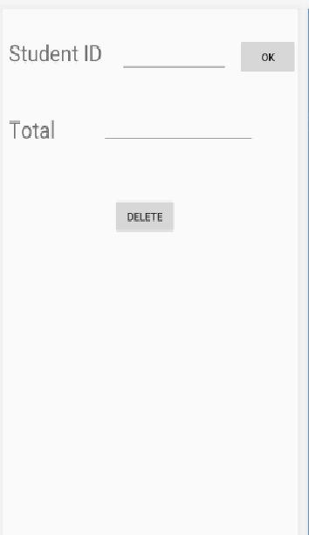

Activity 3

Localization

MainActivity.xml

<?xml version="1.0" encoding="utf-8"?>

<LinearLayout xmlns:android="http://schemas.android.com/apk/res/android"

xmlns:app="http://schemas.android.com/apk/res-auto"

xmlns:tools="http://schemas.android.com/tools"

android:layout_width="match_parent"

android:layout_height="match_parent"

tools:context=".MainActivity"

android:orientation="vertical"

android:layout_margin="20dp">

<TextView

android:layout_width="wrap_content"

android:layout_height="wrap_content"

android:layout_marginVertical="20dp"

android:text="@string/hindi"

android:textSize="30dp"

android:textStyle="bold"

android:textColor="#000"

android:layout_gravity="center"/>

<TextView

android:layout_width="wrap_content"

android:layout_height="wrap_content"

android:layout_marginVertical="20dp"

android:text="@string/urdu"

android:textSize="30dp"

android:textStyle="bold"

android:textColor="#000"

android:layout_gravity="center"/>

<TextView

android:layout_width="wrap_content"

android:layout_height="wrap_content"

android:layout_marginVertical="20dp"

android:text="@string/punjabi"

android:textSize="30dp"

android:textStyle="bold"

android:textColor="#000"

android:layout_gravity="center"/>

</LinearLayout>

String.xml

<resources>

<string name="app_name">HimanshuLocale</string>

<string name="hindi">Hindi</string>

<string name="urdu">Urdu</string>

<string name="punjabi">Punjabi</string>

</resources>

Hindi.xml

<?xml version="1.0" encoding="utf-8"?>

<resources>

<string name="app_name">स्थान</string>

<string name="hindi">हिंदी</string>

</resources>

Urdu.xml

<?xml version="1.0" encoding="utf-8"?>

<resources>

<string name="app_name">مقامی</string>

<string name="urdu">اردو</string>

</resources>

Punjabi.xml

<?xml version="1.0" encoding="utf-8"?>

<resources>

<string name="app_name">ਲੋਕੇਲ</string>

<string name="punjabi">ਪੰਜਾਬੀ</string>

</resources>

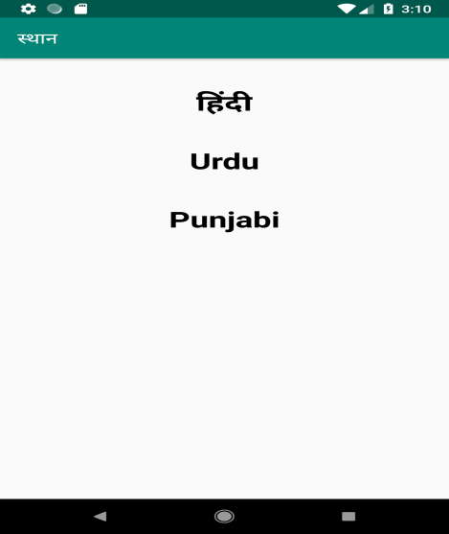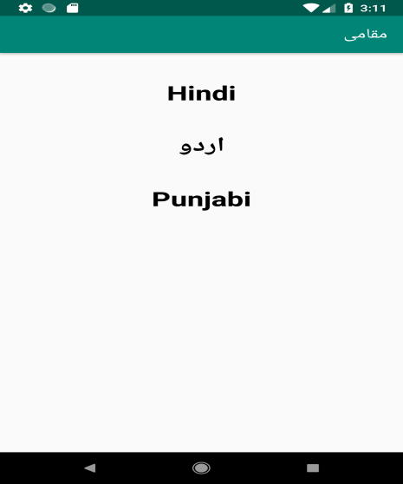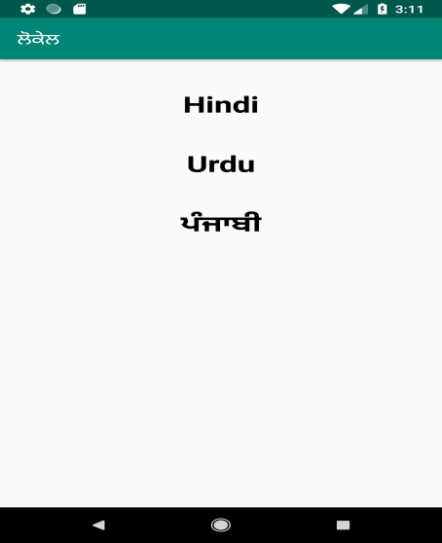

Activity 4

Collapsing Tool Bar

AndroidManifest.xml

<android.support.design.widget.CoordinatorLayout

android:id="@+id/main_content"

xmlns:android="http://schemas.android.com/apk/res/android"

xmlns:app="http://schemas.android.com/apk/res-auto"

android:layout_width="match_parent"

android:layout_height="match_parent">

<android.support.v7.widget.RecyclerView

android:id="@+id/rvToDoList"

android:layout_width="match_parent"

android:layout_height="match_parent"/>

<android.support.design.widget.FloatingActionButton

android:layout_width="wrap_content"

android:layout_height="wrap_content"

android:layout_gravity="bottom|right"

android:layout_margin="16dp"

android:src="@mipmap/ic_launcher"

app:layout_anchor="@id/rvToDoList"

app:layout_anchorGravity="bottom|right|end"/>

</android.support.design.widget.CoordinatorLayout>

(Expanding and Collapsing Toolbar)

<android.support.design.widget.CoordinatorLayout xmlns:android="http://schemas.android.com/apk/res/android"

xmlns:app="http://schemas.android.com/apk/res-auto"

android:id="@+id/main_content"

android:layout_width="match_parent"

android:layout_height="match_parent"

android:fitsSystemWindows="true">

<android.support.v7.widget.Toolbar

android:id="@+id/toolbar"

android:layout_width="match_parent"

android:layout_height="?attr/actionBarSize"

app:popupTheme="@style/ThemeOverlay.AppCompat.Light" />

</android.support.design.widget.CoordinatorLayout>

(Creating Collapsing Effect)

<android.support.design.widget.AppBarLayout

android:layout_width="match_parent"

android:layout_height="wrap_content"

android:fitsSystemWindows="true"

android:theme="@style/ThemeOverlay.AppCompat.Dark.ActionBar">

<android.support.design.widget.CollapsingToolbarLayout

android:id="@+id/collapsing_toolbar"

android:layout_width="match_parent"

android:layout_height="match_parent"

android:fitsSystemWindows="true"

app:contentScrim="?attr/colorPrimary"

app:expandedTitleMarginEnd="64dp"

app:expandedTitleMarginStart="48dp"

app:layout_scrollFlags="scroll|exitUntilCollapsed">

<android.support.v7.widget.Toolbar

android:id="@+id/toolbar"

android:layout_width="match_parent"

android:layout_height="?attr/actionBarSize"

app:layout_scrollFlags="scroll|enterAlways"></android.support.v7.widget.Toolbar>

</android.support.design.widget.CollapsingToolbarLayout>

</android.support.design.widget.AppBarLayout>

MainActivity.java

public class Item {

private int mDrawableRes;

private String mTitle;

public Item(@DrawableRes int drawable, String title) {

mDrawableRes = drawable;

mTitle = title;

}

public int getDrawableResource() {

return mDrawableRes;

}

public String getTitle() {

return mTitle;

}

}

public class ItemAdapter extends RecyclerView.Adapter<ItemAdapter.ViewHolder> {

private List<Item> mItems;

public ItemAdapter(List<Item> items, ItemListener listener) {

mItems = items;

mListener = listener;

}

public void setListener(ItemListener listener) {

mListener = listener;

}

@Override

public ViewHolder onCreateViewHolder(ViewGroup parent, int viewType) {

return new ViewHolder(LayoutInflater.from(parent.getContext())

.inflate(R.layout.adapter, parent, false));

}

@Override

public void onBindViewHolder(ViewHolder holder, int position) {

holder.setData(mItems.get(position));

}

@Override

public int getItemCount() {

return mItems.size();

}

public class ViewHolder extends RecyclerView.ViewHolder implements View.OnClickListener {

public ImageView imageView;

public TextView textView;

public Item item;

public ViewHolder(View itemView) {

super(itemView);

itemView.setOnClickListener(this);

imageView = (ImageView) itemView.findViewById(R.id.imageView);

textView = (TextView) itemView.findViewById(R.id.textView);

}

public void setData(Item item) {

this.item = item;

imageView.setImageResource(item.getDrawableResource());

textView.setText(item.getTitle());

}

@Override

public void onClick(View v) {

if (mListener != null) {

mListener.onItemClick(item);

}

}

}

public interface ItemListener {

void onItemClick(Item item);

}

}

RecyclerView recyclerView = (RecyclerView) findViewById(R.id.design_bottom_sheet);

ArrayList<Item> items = new ArrayList<>();

items.add(new Item(R.drawable.cheese_1, "Cheese 1"));

items.add(new Item(R.drawable.cheese_2, "Cheese 2"));

ItemAdapter itemAdapter = new ItemAdapter(items, null);

recyclerView.setAdapter(itemAdapter);

recyclerView.setLayoutManager(new LinearLayoutManager(this));

CoordinatorLayout coordinatorLayout = (CoordinatorLayout) findViewById(R.id.main_content);

final BottomSheetBehavior behavior = BottomSheetBehavior.from(recyclerView);

fab.setOnClickListener(new View.OnClickListener() {

@Override

public void onClick(View view) {

if(behavior.getState() == BottomSheetBehavior.STATE_COLLAPSED) {

behavior.setState(BottomSheetBehavior.STATE_EXPANDED);

} else {

behavior.setState(BottomSheetBehavior.STATE_COLLAPSED);

}

}

});

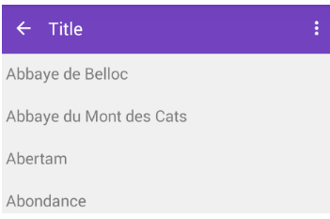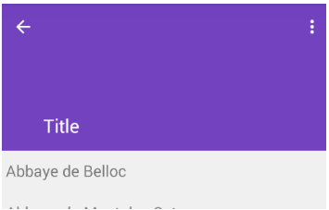

Activity 5

Google Map

ActivityMain.xml

***<?*xml version="1.0"encoding="utf-8"*?>***

<**RelativeLayout xmlns:android="http://schemas.android.com/apk/res/android"**

**xmlns:app="http://schemas.android.com/apk/res-auto"**

**xmlns:tools="http://schemas.android.com/tools"**

**android:layout_width="match_parent"**

**android:layout_height="match_parent"**

**tools:context=".MainActivity"**>

<**TextView**

**android:layout_width="wrap_content"**

**android:layout_height="wrap_content"**

**android:id="@+id/locationText"**

**android:text=""**

**android:textColor="#000"**

**android:textSize="17sp"**

**android:textAlignment="center"**

**android:layout_centerInParent="true"**

**android:layout_above="@+id/getLocationBtn"**

**android:layout_marginBottom="10dp"**

**android:padding="10dp"**/>

<**Button**

**android:layout_width="wrap_content"**

**android:layout_height="wrap_content"**

**android:text="Get Current Location"**

**android:layout_centerInParent="true"**

**android:background="#FFFFFF"**

**android:padding="10dp"**

**android:id="@+id/getLocationBtn"**/>

<**Button**

**android:layout_width="wrap_content"**

**android:layout_height="wrap_content"**

**android:text="Show In Map"**

**android:layout_marginTop="450dp"**

**android:layout_marginLeft="150dp"**

**android:background="#ffffff"**

**android:onClick="maps"**

**android:padding="10dp"**/>

</**RelativeLayout**>

MainActivity.java

**package com.example.myapplication;**

**import** android.content.Context;

**import** android.content.Intent;

**import** android.content.pm.PackageManager;

**import** android.location.Address;

**import** android.location.Geocoder;

**import** android.location.Location;

**import** android.location.LocationListener;

**import** android.location.LocationManager;

**import** android.support.v4.app.ActivityCompat;

**import** android.support.v4.content.ContextCompat;

**import** android.support.v7.app.AppCompatActivity;

**import** android.os.Bundle;

**import** android.view.View;

**import** android.widget.Button;

**import** android.widget.TextView;

**import** android.widget.Toast;

**import** java.util.List;

**import** java.util.Locale;

**public class** MainActivity **extends** AppCompatActivity **implements** LocationListener {

Button getLocationBtn;

TextView locationText;

LocationManager locationManager;

@Override

**protected void** onCreate(Bundle savedInstanceState) {

**super**.onCreate(savedInstanceState);

getSupportActionBar().hide();

setContentView(R.layout.activity_main);

getLocationBtn = (Button)findViewById(R.id.getLocationBtn);

locationText = (TextView)findViewById(R.id.locationText);

**if** (ContextCompat.checkSelfPermission(getApplicationContext(), android.Manifest.permission.ACCESS_FINE_LOCATION) != PackageManager.PERMISSION_GRANTED && ActivityCompat.checkSelfPermission(getApplicationContext(), android.Manifest.permission.ACCESS_COARSE_LOCATION) != PackageManager.PERMISSION_GRANTED) {

ActivityCompat.requestPermissions(**this**, **new** String[]{android.Manifest.permission.ACCESS_FINE_LOCATION, android.Manifest.permission.ACCESS_COARSE_LOCATION}, 101);

}

getLocationBtn.setOnClickListener(**new** View.OnClickListener() {

@Override

**public void** onClick(View v) {

getLocation();

}

});

}

**void** getLocation() {

**try** {

locationManager = (LocationManager) getSystemService(Context.LOCATION_SERVICE);

locationManager.requestLocationUpdates(LocationManager.NETWORK_PROVIDER, 5000, 5, **this**);

}

**catch**(SecurityException e) {

e.printStackTrace();

}

}

@Override

**public void** onLocationChanged(Location location) {

locationText.setText(**"Latitude: "**+ location.getLatitude() + **"\nLongitude: "**+ location.getLongitude());

**try** {

Geocoder geocoder = **new** Geocoder(**this**, Locale.getDefault());

List<Address> addresses = geocoder.getFromLocation(location.getLatitude(), location.getLongitude(), 1);

locationText.setText(locationText.getText() + **"\n"**+addresses.get(0).getAddressLine(0)+**", "**+

addresses.get(0).getAddressLine(1)+**", "**+addresses.get(0).getAddressLine(2));

}**catch**(Exception e)

{

}

}

@Override

**public void** onProviderDisabled(String provider) {

Toast.*makeText*(MainActivity.**this**, **"Please Enable GPS and Internet"**, Toast.***LENGTH_SHORT***).show();

}

@Override

**public void** onStatusChanged(String provider, **int** status, Bundle extras) {

}

@Override

**public void** onProviderEnabled(String provider) {

}

**public void** maps(View v){

Intent intent = **new** Intent(getApplicationContext() , MapsActivity.**class**);

startActivity(intent);

}

}

MapsActivity.java

**package com.example.myapplication;**

**import** android.support.v4.app.FragmentActivity;

**import** android.os.Bundle;

**import** com.google.android.gms.maps.CameraUpdateFactory;

**import** com.google.android.gms.maps.GoogleMap;

**import** com.google.android.gms.maps.OnMapReadyCallback;

**import** com.google.android.gms.maps.SupportMapFragment;

**import** com.google.android.gms.maps.model.LatLng;

**import** com.google.android.gms.maps.model.MarkerOptions;

**public class** MapsActivity **extends** FragmentActivity **implements** OnMapReadyCallback {

**private** GoogleMap **mMap**;

@Override

**protected void** onCreate(Bundle savedInstanceState) {

**super**.onCreate(savedInstanceState);

setContentView(R.layout.***activity_maps***);

SupportMapFragment mapFragment = (SupportMapFragment) getSupportFragmentManager()

.findFragmentById(R.id.***map***);

mapFragment.getMapAsync(**this**);

}

@Override

**public void** onMapReady(GoogleMap googleMap) {

**mMap** = googleMap;

LatLng location = **new** LatLng(26.8093874, 75.8611599);

**mMap**.addMarker(**new** MarkerOptions().position(location).title(**"Marker in Location"**));

**mMap**.moveCamera(CameraUpdateFactory.*newLatLng*(location));

}

GoogleMapsActivity.xml

<resources>

***TODO: Before you run your application, you need a Google Maps API key.***

<**string name="google_maps_key"templateMergeStrategy="preserve"translatable="f**alse” INSERT YOUR Api key </**string**>

</resources>

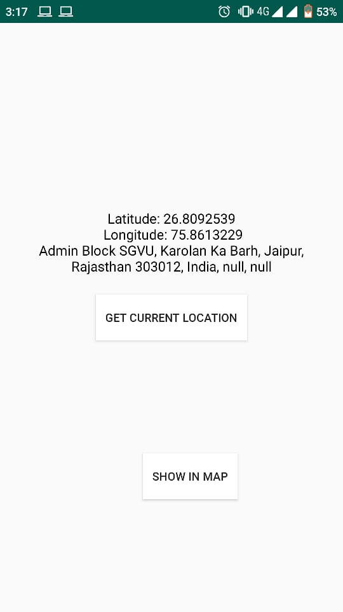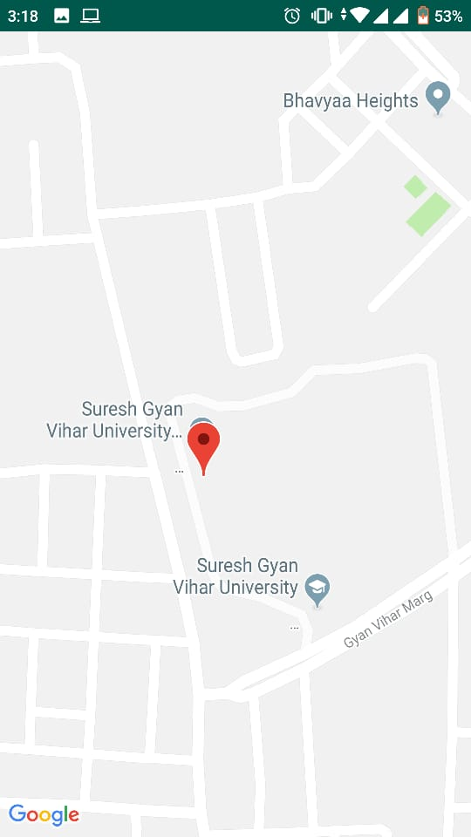

Activity 6

Analog Clock

MainActivity.java

package com.example.himanshu.analog;

import android.graphics.Color;

import android.os.Bundle;

import android.support.v7.app.AppCompatActivity;

import java.util.Calendar;

public class MainActivity extends AppCompatActivity {

@Override

protected void onCreate(Bundle savedInstanceState) { super.onCreate(savedInstanceState); setContentView(R.layout.activity_main);

Calendar calendar = Calendar.getInstance();

calendar.add(Calendar.HOUR, -2);

MyAnalogClock vectorAnalogClock = findViewById(R.id.clock);

vectorAnalogClock.setCalendar(calendar)

. setDiameterInDp(400.0f)

.setOpacity(1.0f)

.setShowSeconds(true)

.setColor(Color.BLACK);

}}

AndroidManifest.xml

<?xml version="1.0" encoding="utf-8"?>

<FrameLayout xmlns:android="http://schemas.android.com/apk/res/android" xmlns:tools="http://schemas.android.com/tools" android:layout_width="match_parent" android:layout_height="match_parent"

tools:context=".MainActivity" android:id="@+id/root" android:orientation="vertical">

<com.turki.alwaysonlibrarycontainer.MyAnalogClock android:layout_width="wrap_content" android:layout_height="wrap_content" android:id="@+id/clock" android:layout_gravity="center"/>

</FrameLayout>

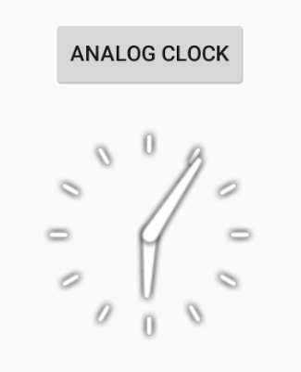

Activity 7

Digital Clock

MainActivity.java

package com.example.himanshu.digitalclock;

import android.os.Bundle;

import android.support.v7.app.AppCompatActivity;

import android.view.View; import android.widget.Button; import android.widget.DigitalClock;

public class DigitalClockExample extends AppCompatActivity {

DigitalClock digitalClock1;

Button showAnotherDigitalClock;

@Override

protected void onCreate(Bundle savedInstanceState) { super.onCreate(savedInstanceState); setContentView(R.layout.android_digital_clock_example);

DigitalClock digitalClock = (DigitalClock) findViewById(R.id.digitalClock);

digitalClock1 = (DigitalClock) findViewById(R.id.digitalClock1);

digitalClock1.setVisibility(View.INVISIBLE);

showAnotherDigitalClock = (Button) findViewById(R.id.showDigitalClock);

}

public void showDigitalClock(View view) { digitalClock1.setVisibility(View.VISIBLE); showAnotherDigitalClock.setText("Another DigitalClock");

}}

AndroidManifest.xml

<?xml version="1.0" encoding="utf-8"?>

<LinearLayout xmlns:android="http://schemas.android.com/apk/res/android" android:layout_width="match_parent" android:layout_height="match_parent"

android:layout_margin="16dp" android:orientation="vertical">

<TextView android:id="@+id/textView12" android:layout_width="wrap_content" android:layout_height="wrap_content" android:text="DigitalClock Example" android:textAppearance="?android:attr/textAppearanceLarge" android:textSize="30sp" />

<LinearLayout android:layout_width="wrap_content" android:layout_height="wrap_content" android:layout_marginBottom="30”

android:layout_marginTop="70dp" android:orientation="horizontal">

<TextView android:id="@+id/textView13" android:layout_width="wrap_content" android:layout_height="wrap_content" android:text="Digital Clock: "

android:textAppearance="?android:attr/textAppearanceLarge" android:textColor="#666"

android:textSize="26sp" />

<DigitalClock

android:id="@+id/digitalClock" android:layout_width="wrap_content" android:layout_height="wrap_content" android:layout_marginLeft="6dp" android:textColor="#a90505" android:textSize="24sp" />

</LinearLayout>

<LinearLayout android:layout_width="fill_parent" android:layout_height="wrap_content" android:layout_marginBottom="30dp" android:layout_marginTop="20dp" android:gravity="center_horizontal" android:orientation="vertical">

android:id="@+id/showDigitalClock" android:layout_width="wrap_content" android:layout_height="wrap_content" android:onClick="showDigitalClock" android:text="Show Another DigitalClock"

android:textAppearance="?android:attr/textAppearanceLarge" android:textColor="#666"

android:textSize="20sp" />

<DigitalClock

android:id="@+id/digitalClock1" android:layout_width="wrap_content" android:layout_height="wrap_content" android:layout_marginTop="20dp" android:textColor="#a90505" android:textSize="40sp" />

</LinearLayout>

<TextView android:id="@+id/textView14" android:layout_width="fill_parent" android:layout_height="fill_parent" android:autoLink="web" android:gravity="bottom|center" android:text="ViralAndroid.com"

android:textAppearance="?android:attr/textAppearanceLarge" android:textSize="24sp" />

</LinearLayout>

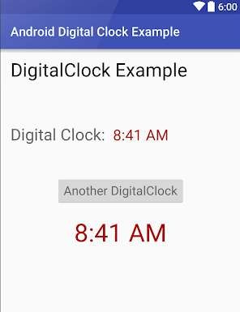

Activity 8

Sensor

AndroidManifest.xml

<android.support.v4.widget.DrawerLayout

xmlns:android="http://schemas.android.com/apk/res/android"

xmlns:tools="http://schemas.android.com/tools"

android:id="@+id/drawer_layout"

android:layout_width="match_parent"

android:layout_height="match_parent"

tools:context="be.hcpl.android.sensors.MainActivity">

<FrameLayout

android:id="@+id/container"

android:layout_width="match_parent"

android:layout_height="match_parent"

android:padding="20dp"/>

<fragment android:id="@+id/navigation_drawer"

android:layout_width="@dimen/navigation_drawer_width"

android:layout_height="match_parent"

android:layout_gravity="start"

android:name="be.hcpl.android.sensors.NavigationDrawerFragment" />

</android.support.v4.widget.DrawerLayout>

MainActivity.java

package be.hc.android.sensors;

import android.os.Bundle;

import android.support.v4.app.Fragment;

import android.support.v4.app.FragmentManager;

import android.support.v4.widget.DrawerLayout;

import android.support.v7.app.ActionBar;

import android.support.v7.app.ActionBarActivity;

import android.view.Menu;

import android.view.MenuItem;

public class MainActivity extends ActionBarActivity

implements NavigationDrawerFragment.NavigationDrawerCallbacks {

private NavigationDrawerFragment mNavigationDrawerFragment;

private Fragment mContentFragment;

@Override

protected void onCreate(Bundle savedInstanceState) {

super.onCreate(savedInstanceState);

setContentView(R.layout.activity_main);

mNavigationDrawerFragment = (NavigationDrawerFragment)

getSupportFragmentManager().findFragmentById(R.id.navigation_drawer);

mNavigationDrawerFragment.setUp(

R.id.navigation_drawer,

(DrawerLayout) findViewById(R.id.drawer_layout));

}

@Override

public void onNavigationDrawerItemSelected(int position) {

if( mNavigationDrawerFragment != null )

mContentFragment = (Fragment)mNavigationDrawerFragment.getNavigationFragments().getItem(position);

if( mContentFragment== null )

mContentFragment = new WelcomeFragment();

switchFragment(mContentFragment);

}

public void switchFragment(Fragment fragment) {

FragmentManager fragmentManager = getSupportFragmentManager();

fragmentManager.beginTransaction()

.replace(R.id.container, fragment)

.addToBackStack(fragment.getClass().getSimpleName())

.commit();

mContentFragment = fragment;

}

public void restoreActionBar() {

ActionBar actionBar = getSupportActionBar();

actionBar.setNavigationMode(ActionBar.NAVIGATION_MODE_STANDARD);

actionBar.setDisplayShowTitleEnabled(true);

}

@Override

public boolean onCreateOptionsMenu(Menu menu) {

if (!mNavigationDrawerFragment.isDrawerOpen()) {

getMenuInflater().inflate(R.menu.main, menu);

restoreActionBar();

return true;

}

return super.onCreateOptionsMenu(menu);

}

@Override

public boolean onOptionsItemSelected(MenuItem item) {

int id = item.getItemId();

if (id == R.id.action_settings) {

return true;

}

return super.onOptionsItemSelected(item);

}

