A

Project Report

on

**Weather Forecast Log Management System**

Developed by

**Jaimish Trivedi - Department of IT, DDUniversity**

**Himanshu Vaghela -Department of IT, DDUniversity**

**Guided By**

**Internal Guide:**

**Prof. Roshni M. Raval**

**Department of Information Technology**

**Faculty of Technology**

**DD University**



**Department of Information Technology**

**Faculty of Technology, Dharmsinh Desai University**

**College Road, Nadiad-387001**

**October-2019**

1. TABLE OF CONTENTS
3. **I. Certificate I**
4. **II. Acknowledgement II**
5. **1. SYSTEM OVERVIEW 1**
6. 1.1 Current system 2
7. 1.2 Objectives of the Proposed System 3
8. 1.3 Advantages of the Proposed system (over current) 4
9. **2. E-R DIAGRAM 5**
10. 2.1 Entities…………………………………………………………………………..5
11. 2.2 Relationships……………………………………………………………………6
12. 2.3 Mapping Constraints……………………………………………………………6
13. **3. DATA DICTIONARY 7**
14. **4. SCHEMA DIAGRAM 8**
15. **5. DATABASE IMPLEMENTION 9**
16. 5.1 Create Schema 9
17. 5.2 Insert Data values 9
18. 5.3 Queries (Based on functions, group by, having, joins, sub query etc.) 10
19. 5.4 PL/SQL Blocks (Procedures and Functions) 10
20. 5.5 Views 11
21. 5.6 Functions 12
22. 5.7 Procedures 14
23. 5.8 Triggers 15
24. 5.9 Cursors. 16
25. **6. FUTURE ENHANCEMENTS OF THE SYSTEM 18**
26. **7. BIBLIOGRAPHY 20**

## DHARMSINH DESAI UNIVERSITY

## NADIAD-387001, GUJARAT



## CERTIFICATE

### This is to certify that the project entitled “Weather Forecast Log Management System” is a bonafied report of the work carried out by

1) Mr. *Jaimish**Trivedi*, Student ID No: _______

2) Mr. *Himanshu Vaghela*, Student ID No: _______

of Department of Information Technology, semester V, under the guidance and supervision for the subject Database Management System. They were involved in Project training during academic year 2019-2020.

Prof. Roshni M. Raval

(Project Guide)

Department of Information Technology,

Faculty of Technology,

Dharmsinh Desai University, Nadiad

Date:

Prof. Vipul Dabhi

Head , Department of Information Technology,

Faculty of Technology,

Dharmsinh Desai University, Nadiad

## Date:

**ACKNOWLEDGEMENT**

This Project being the first undertaken by us and it was unforgettable and educative experience.We take this oppurtunity to thank all those who have generously helped us to give a proper shape to our project.

Our Sincerest Appreciation Must Be Extended To DDIT, Nadiad. We Also Want To Thanks Faculties Of The College, They Have Been Very Kind & Helpful To Us.

We Are Thankful To Prof. R. M. Raval  for giving valuable and constructive suggestions during the planning and development of this Project.

**1. SYSTEM OVERVIEW**

A Weather Forecast Log Management System is a system to display forecasted data of weather to the user.

Functionalities:-

1. Report current weather conditions, including the overall weather status (i.e. sunny, partially cloudy, cloudy, etc.) air temperature, humidity, wind speed and direction, a “feels-like” temperature, barometric pressure, and visibility. It should also report general information like sunrise and sunset times and the day’s high and low temperatures.
2. Display hourly details (temperature, humidity, precipitation, overall weather condition) for the next 24 hours.
3. Show a basic daily forecast (daily high and low temperatures, weather conditions, and sunrise/sunset times) for each day in the next week or two.
4. Allow users to select their city and any other cities where they want to see the weather.
5. Let users to see data in the measurement units of their choice. For example, U.S. users would probably prefer Fahrenheit temperatures and wind speeds shown in miles per hour, but Canadian and European users would prefer Celsius and kilometers per hour.
6. Show a basic daily forecast (daily high and low temperatures, weather conditions, and sunrise/sunset times) for each day in the next week or two.
7. Allow users to select their city and any other cities where they want to see the weather.
8. What is the maximum and minimum temperature on a particular date at particular city.
9. What is the weather status of a city on a particular day.
10. A server gets weather information from which satellites.
11. On which location maximum servers are there and they belong to which weather station.
12. Windspeed in a city on particular hour.
13. Name of satellites which sends data to particular server.
14. What is sunrise and sunset time of cities that are having latitude greater than some value.
15. On a particular server how many employees are working.
16. Display hourly details for the next 24 hours.
17. Let users to see data in the measurement units of their choice.

**2. E-R DIAGRAM**

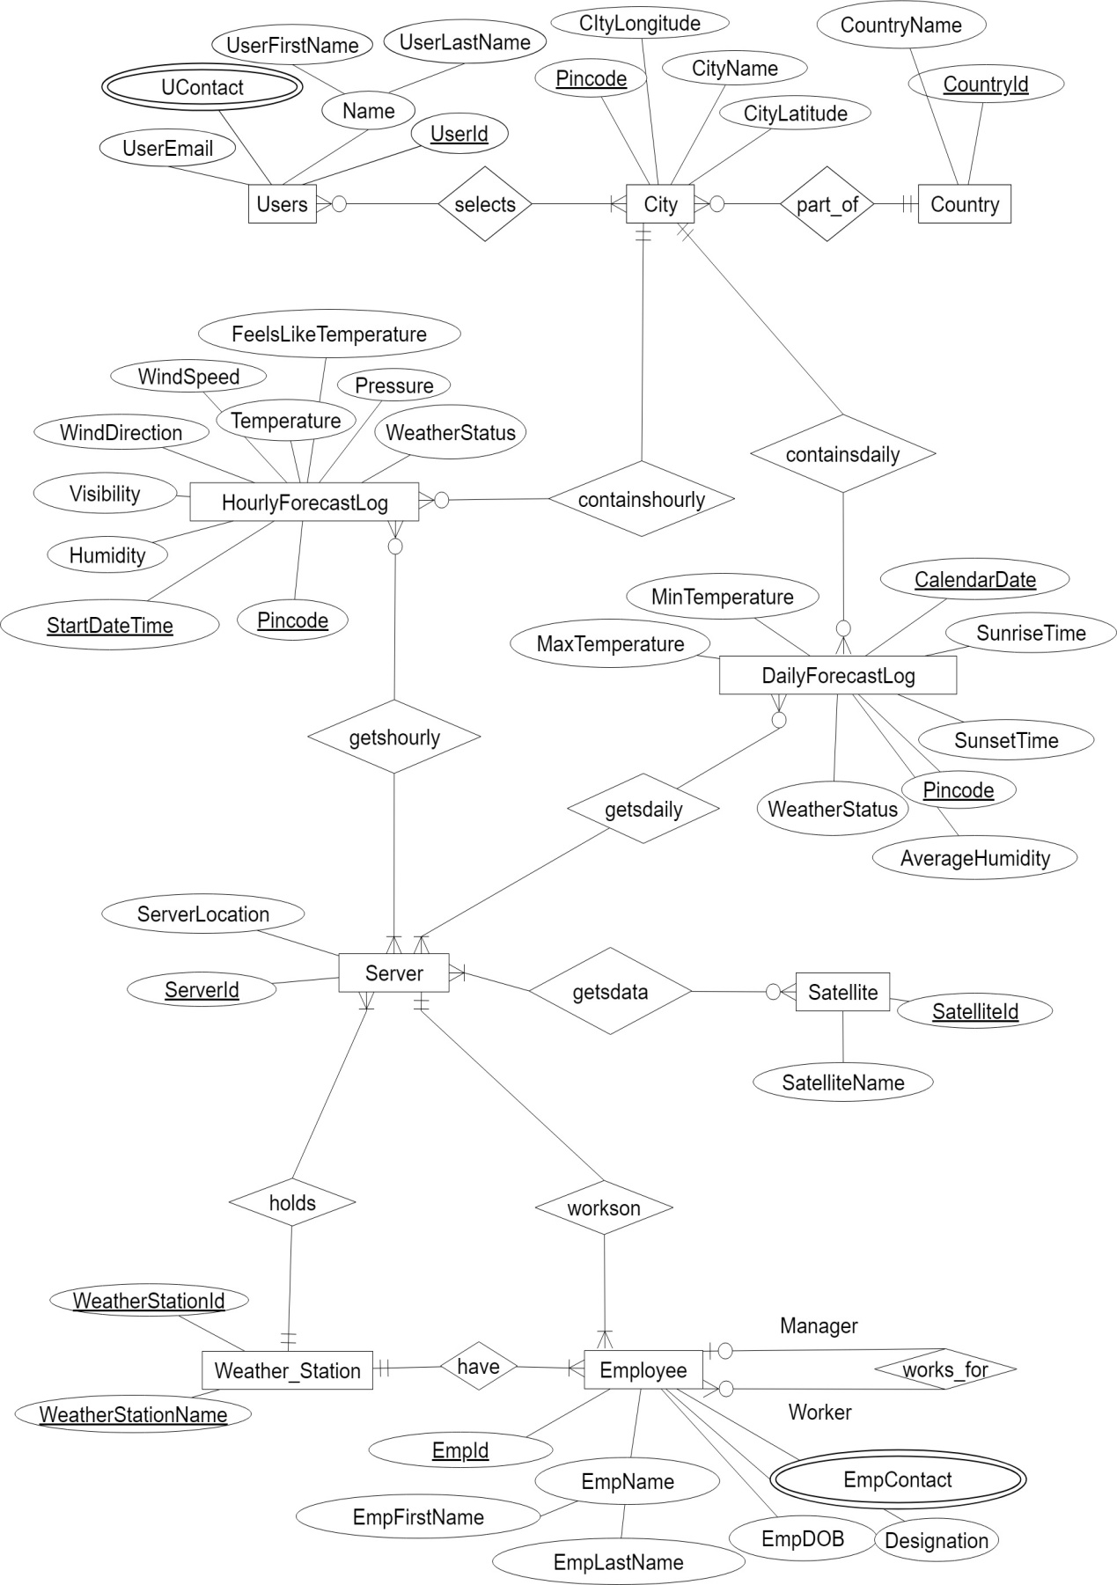

Fig 2.1 E-R Diagram Of Weather Forecast Log Management System

* 1. Entities
* User
* City
* Country
* HourlyForecastLog
* DailyForecastLog
* Server
* WeatherStation
* Employee
  1. Relationships
* selects
* partof
* containshourly
* containsdaily
* getshourly
* getsdaily
* getsfrom
* holds
* workson
* worksfor
* has
  1. Mapping Constraints

1 to Many :- City and HourlyForecastLog

City and DailyForecastLog

WeatherStation and Server

WeatherStation and Employee

Many to 1:- City and Country

Employee(Worker) and Employee(Manager)

Employee and Server

Many to Many:- User and City

Server and DailyForecastLog

Server and HourlyForecastLog

Server and Satellite

**3. DATA DICTIONARY**

|  |  |  |  |  |  |  |  |
| --- | --- | --- | --- | --- | --- | --- | --- |
| TableName | Attributes | Field Size/  Scale,  Precision | Data Type | Constraint | Description | | Example |
| Users | UsersId | 5 | VARCHAR2 | P.K., Not null | User identification | U101 | |
|  | FirstName | 10 | VARCHAR2 | Not null | User’s First name | Alex | |
|  | LastName | 10 | VARCHAR2 | Not null | User’s Last  Name | Dempsy | |
| Country | CountryId | 5 | VARCHAR2 | P.K., Not null | Country Identification Number | CTR100 | |
|  | CountryName | 10 | VARCHAR2 | Not null | Name of the country | India | |
| SATELLITE | SatelliteId | 5 | VARCHAR2 | P.K., Not null | Satellite Identification Number | SAT100 | |
|  | SatelliteName | 10 | VARCHAR2 | Not null | Name of the Satellite | ISR-300 | |
| WEATHER STATION | WeatherStationId | 5 | VARCHAR2 | P.K., Not null | Weather Station ID | W100 | |
|  | WeatherStationName | 10 | VARCHAR2 | Not null | Weather Station Name | Cellular | |
| USERS  UCONTACT | UContact | 10 | Number | P.K., Not null | User Contact | 1234567890 | |
|  | UsersId | 5 | VARCHAR2 | P.K., Not null,F.K. | User identification | U101 | |
| CITY | CityPincode | 6 | Number | P.K., Not null | Pincode number of a city | 382443 | |
|  | CityName | 10 | VARCHAR2 | Not null | City Name | Baroda | |
|  | CityLatitude | 5,2 | Number | Not null | Latitude of a city | 39.02 | |
|  | CityLongitude | 5,2 | Number | Not null | Longitude of a city | -119.47 | |
|  | CountryId | 5 | VARCHAR2 | F.K., Not null | Country Identification Number | CTR100 | |
| SELECTS | UsersId | 5 | VARCHAR2 | P.K., F.K., Not null | User Identification Number | U100 | |
|  | CityPincode | 6 | NUMBER | P.K., F.K., Not null | Pincode of a city | 382443 | |
| HOURLY FORECAST LOG | StartDateTime | - | TIMESTAMP | P.K., Not null | Starting Date and Time of A Hourly Report | 02-JAN-2019  12:32:45 | |
|  | Humidity | 5,2 | NUMBER(5,2) | Not null | Humidity in % | 64 | |
|  | Visibility | 10 | VARCHAR2(10) | Not null | Visibility in km | 6 | |
|  | Pressure | 5,2 | NUMBER(5,2) | Not null | Air Pressure in mBar | 1006 | |
|  | WindSpeed | 5,2 | NUMBER(5,2) | Not null | WindSpeed in km/h | 3 | |
|  | WindDirection | 2 | VARCHAR2(2) | Not null | Direction of wind |  | |
|  | Temperature | 5,2 | NUMBER(5,2) | Not null | Temperature  in degree celcius | 40 | |
|  | FeelsLikeTemperature | 5,2 | NUMBER(5,2) | Not null | Normal Atmosphere Temperature in degree celcius | 34 | |
|  | WeatherStatus | 10 | VARCHAR2(10) | Not null | Status of environment | Sunny | |
|  | CityPincode | 6 | NUMBER | P.K., F.K., Not null | Pincode of a city | 382443 | |
| DAILY FORECAST LOG | CalendarDate | - | DATE | P.K., Not Null | Report Date | 03-JAN-2000 | |
|  | SunriseTime | - | TIMESTAMP | Not Null | Sunrise Time | 06:20:10 | |
|  | SunsetTime | - | TIMESTAMP | Not Null | Sunset Time | 17:02:34 | |
|  | AverageHumidity | 5,2 | NUMBER | Not Null | Average Humidity in % | 67 | |
|  | MaxTemperature | 5,2 | NUMBER | Not Null | Maximum Temperature of a day | 40 | |
|  | MinTemperature | 5,2 | NUMBER | Not Null | Minimum Temperature of a day | 20 | |
|  | WeatherStatus | 10 | VARCHAR2 | Not Null | Status of environment | Rainy | |
|  | CityPincode | 6 | NUMBER | P.K., F.K., Not null | Pincode of a city | 382443 | |
| EMPLOYEE | EmployeeId | 5 | VARCHAR2 | P.K., Not null | Employee Identification number | E100 | |
|  | EmpFirstName | 10 | VARCHAR2 | Not null | First name of an employee | Tracy | |
|  | EmpLastName | 10 | VARCHAR2 | Not null | Last name of an employee | Davis | |
|  | EmpDOB | - | DATE | Not null | Date of birth of an employee | 01-JAN-1993 | |
|  | ServerId | 5 | VARCHAR2 | Not null | Server Identification Number | S100 | |
|  | WeatherStationId | 5 | VARCHAR2 | F.K., Not null | Weather Station ID no. | W100 | |
|  | ManagerId | 5 | VARCHAR2 | F.K., Not null | Manager ID no. | M100 | |
| EMPLOYEEEMPCONTACT | EmpContact | 10 | NUMBER | P.K., Not null | Employee contact no.1 | 1234567890 | |
|  | EmployeeId | 5 | VARCHAR2 | P.K., F.K., Not null | Employee ID no. | E100 | |
| GETS_FROM | SatelliteId | 5 | VARCHAR2 | P.K., F.K., Not null | Satellite Identification Number | SAT100 | |
|  | ServerId | 5 | VARCHAR2 | P.K., F.K., Not null | Server Identification Number | S100 | |
| GETS_HOURLY | CityPincode | 6 | Number | P.K., F.K., Not null | Pincode number of a city | 382443 | |
|  | StartDateTime |  | TIMESTAMP | P.K., F.K., Not null | Starting Date and Time of A Hourly Report | 02-JAN-2019  12:32:45 | |
|  | ServerId | 5 | VARCHAR2 | P.K., F.K., Not null | Server Identification Number | S100 | |
| GETS_DAILY | CityPincode | 6 | Number | P.K., F.K., Not null | Pincode number of a city | 382443 | |
|  | CalendarDate |  | DATE | P.K., Not Null | Report Date | 03-JAN-2000 | |
|  | ServerId | 5 | VARCHAR2 | P.K., F.K., Not null | Server Identification Number | S100 | |

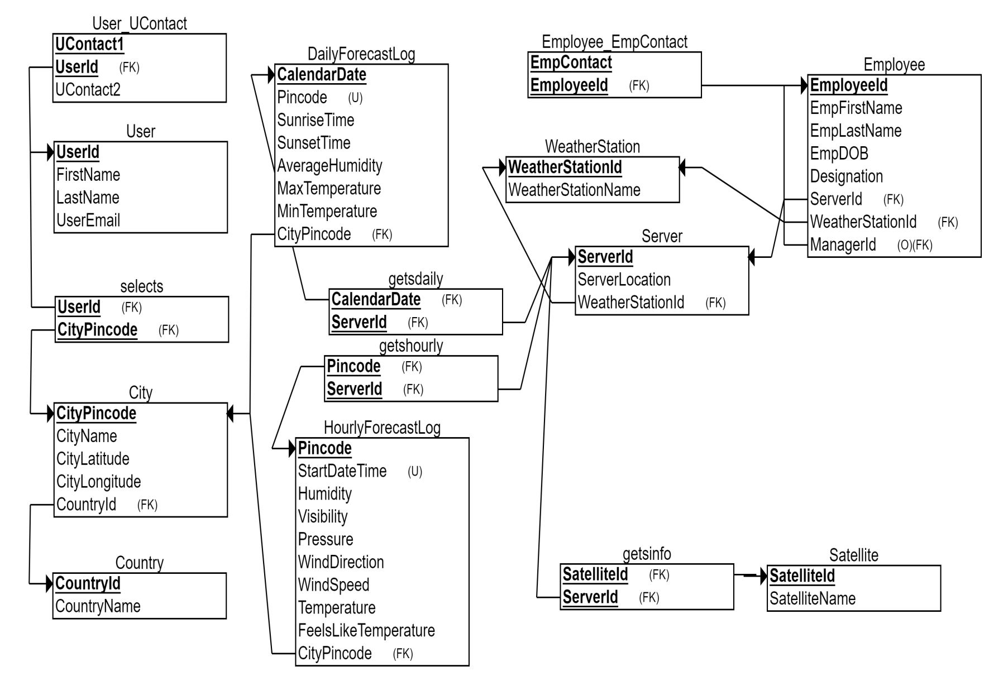**4. SCHEMA DIAGRAM**

Fig 4.1 Schema Diagram Of Weather Forecast Log Management System

**5.DATABASE IMPLEMENTION**

**5.1 CREATE TABLE**

CREATE TABLE Users

(

UsersId VARCHAR2(5) NOT NULL,

FirstName VARCHAR2(10) NOT NULL,

LastName VARCHAR2(10) NOT NULL,

UsersEmail VARCHAR2(30) NOT NULL,

PRIMARY KEY (UsersId)

);

CREATE TABLE Country

(

CountryId VARCHAR2(5) NOT NULL,

CountryName VARCHAR2(10) NOT NULL,

PRIMARY KEY (CountryId)

);

CREATE TABLE Satellite

(

SatelliteId VARCHAR2(5) NOT NULL,

SatelliteName VARCHAR2(10) NOT NULL,

PRIMARY KEY (SatelliteId)

);

CREATE TABLE WeatherStation

(

WeatherStationId VARCHAR2(5) NOT NULL,

WeatherStationName VARCHAR2(10) NOT NULL,

PRIMARY KEY (WeatherStationId)

);

CREATE TABLE UsersUContact

(

UContact NUMBER(10) NOT NULL,

UsersId VARCHAR2(5) NOT NULL,

PRIMARY KEY (UContact1, UsersId),

FOREIGN KEY (UsersId) REFERENCES Users(UsersId)

);

CREATE TABLE City

(

CityPincode NUMBER(6) NOT NULL,

CityName VARCHAR2(10) NOT NULL,

CityLatitude NUMBER(5,2) NOT NULL,

CityLongitude NUMBER(5,2) NOT NULL,

CountryId VARCHAR2(5) NOT NULL,

PRIMARY KEY (CityPincode),

FOREIGN KEY (CountryId) REFERENCES Country(CountryId)

);

CREATE TABLE Server

(

ServerLocation VARCHAR2(10) NOT NULL,

ServerId VARCHAR2(5) NOT NULL,

WeatherStationId VARCHAR2(5) NOT NULL,

PRIMARY KEY (ServerId),

FOREIGN KEY (WeatherStationId) REFERENCES WeatherStation(WeatherStationId)

);

CREATE TABLE Selects

(

UsersId VARCHAR2(5) NOT NULL,

CityPincode NUMBER(6) NOT NULL,

PRIMARY KEY (UsersId, CityPincode),

FOREIGN KEY (UsersId) REFERENCES Users(UsersId),

FOREIGN KEY (CityPincode) REFERENCES City(CityPincode)

);

CREATE TABLE HourlyForecastLog

(

StartDateTime TIMESTAMP NOT NULL,

Humidity NUMBER(5,2) NOT NULL,

Visibility VARCHAR2(10) NOT NULL,

Pressure NUMBER(5,2) NOT NULL,

WindSpeed NUMBER(5,2) NOT NULL,

WindDirection VARCHAR2(2) NOT NULL,

Temperature NUMBER(5,2) NOT NULL,

FeelsLikeTemperature NUMBER(5,2) NOT NULL,

WeatherStatus VARCHAR2(20) NOT NULL,

CityPincode NUMBER(6,0) NOT NULL,

PRIMARY KEY (CityPincode, StartDateTime),

FOREIGN KEY (CityPincode) REFERENCES City(CityPincode),

);

CREATE TABLE DailyForecastLog

(

CalendarDate DATE NOT NULL,

SunriseTime TIMESTAMP NOT NULL,

SunsetTime TIMESTAMP NOT NULL,

AverageHumidity NUMBER(5,2) NOT NULL,

MaxTemperature NUMBER(5,2) NOT NULL,

MinTemperature NUMBER(5,2) NOT NULL,

WeatherStatus VARCHAR2(20) NOT NULL,

CityPincode NUMBER(6) NOT NULL,

PRIMARY KEY (CalendarDate,CityPincode),

FOREIGN KEY (CityPincode) REFERENCES City(CityPincode),

);

CREATE TABLE getshourly

(

ServerId VARCHAR2(5) NOT NULL,

StartDateTime TIMESTAMP NOT NULL,

CityPincode NUMBER(6) NOT NULL,

PRIMARY KEY (ServerId, StartDateTime, CityPincode),

FOREIGN KEY (ServerId) REFERENCES Server(ServerId),

FOREIGN KEY (StartDateTime, CityPincode) REFERENCES HourlyForecastLog(StartDateTime, CityPincode)

);

CREATE TABLE getsdaily

(

ServerId VARCHAR2(5) NOT NULL,

CalendarDate DATE NOT NULL,

CityPincode NUMBER(6) NOT NULL,

PRIMARY KEY (ServerId, CalendarDate, CityPincode),

FOREIGN KEY (ServerId) REFERENCES Server(ServerId),

FOREIGN KEY (CalendarDate, CityPincode) REFERENCES DailyForecastLog(CalendarDate, CityPincode)

);

CREATE TABLE getsfrom

(

SatelliteId VARCHAR2(5) NOT NULL,

ServerId VARCHAR2(5) NOT NULL,

PRIMARY KEY (SatelliteId, ServerId),

FOREIGN KEY (SatelliteId) REFERENCES Satellite(SatelliteId),

FOREIGN KEY (ServerId) REFERENCES Server(ServerId)

);

CREATE TABLE Employee

(

EmployeeId VARCHAR2(5) NOT NULL,

EmpFirstName VARCHAR2(20) NOT NULL,

EmpLastName VARCHAR2(20) NOT NULL,

EmpDOB DATE NOT NULL,

Designation VARCHAR2(20) NOT NULL,

ServerId VARCHAR2(5) NOT NULL,

WeatherStationId VARCHAR2(5) NOT NULL,

ManagerId VARCHAR2(5),

PRIMARY KEY (EmployeeId),

FOREIGN KEY (ServerId) REFERENCES Server(ServerId),

FOREIGN KEY (WeatherStationId) REFERENCES WeatherStation(WeatherStationId),

FOREIGN KEY (worksfor_EmployeeId) REFERENCES Employee(EmployeeId)

);

CREATE TABLE Employee_EmpContact

(

EmpContact NUMBER(10) NOT NULL,

EmployeeId VARCHAR2(5) NOT NULL,

PRIMARY KEY (EmpContact1, EmployeeId),

FOREIGN KEY (EmployeeId) REFERENCES Employee(EmployeeId)

);

5.2 Insert Queries (Based on functions, group by, having, joins, sub query etc.)

BEGIN

Insert into Users(FirstName, LastName, UsersId,UsersEmail)

Values ('Himanshu', 'Vaghela', 'U1','hv@gmail.com');

Insert into Users(FirstName, LastName, UsersId,UsersEmail)

Values ('Jaimish', 'Trivedi', 'U2','JT@gmail.com');

Insert into Users(FirstName, LastName, UsersId,UsersEmail)

Values ('Sameep', 'Baraiya', 'U3','sb@gmail.com');

Insert into Users(FirstName, LastName, UsersId,UsersEmail)

values ('Adil', 'Otha', 'U4','ao@gmail.com');

Insert into Users(FirstName, LastName, UsersId,UsersEmail)

Values ('Aayush', 'Panchal', 'U5','ap@gmail.com');

Insert into Users(FirstName, LastName, UsersId,UsersEmail)

Values ('Bhupendra', 'Dabhi', 'U6','bd@gmail.com');

END

BEGIN.

Insert into Country(CountryId,CountryName)

Values ('CY1','India');

Insert into Country(CountryId,CountryName)

Values ('CY2','China');

Insert into Country(CountryId,CountryName)

Values ('CY3','Thailand');

Insert into Country(CountryId,CountryName)

Values ('CY4','Singapore');

Insert into Country(CountryId,CountryName)

Values ('CY5','Germany');

Insert into Country(CountryId,CountryName)

Values ('CY6','USA');

Insert into Country(CountryId,CountryName)

Values ('CY7','Canada');

Insert into Country(CountryId,CountryName)

Values ('CY8','UK');

END

BEGIN

Insert into Satellite(SatelliteId,SatelliteName)

Values('S1','Aryabhatta');

Insert into Satellite(SatelliteId,SatelliteName)

Values('S2','Bhaskara1');

Insert into Satellite(SatelliteId,SatelliteName)

Values('S3','Bhaskara2');

Insert into Satellite(SatelliteId,SatelliteName)

Values('S4','IRS1A');

Insert into Satellite(SatelliteId,SatelliteName)

Values('S5','INSAT1C')

END

BEGIN

Insert into WeatherStation

Values('WS1','Ahmedabad');

Insert into WeatherStation

Values('WS2','Rajkot');

Insert into WeatherStation

Values('WS3','Bhavnagar');

Insert into WeatherStation

Values('WS4','Porbandar');

Insert into WeatherStation

Values('WS5','Surat');

Insert into WeatherStation

Values('WS6','Nashik');

Insert into WeatherStation

Values('WS7','Mumbai');

END

BEGIN

Insert into Usersucontact(Usersid,UContact)

Values('U1',7623927428);

Insert into Usersucontact(Usersid,UContact)

Values('U2',7227008511);

Insert into Usersucontact(Usersid,UContact)

Values('U3',9284675963);

Insert into Usersucontact(Usersid,UContact)

Values('U4',7849135933);

Insert into Usersucontact(Usersid,UContact)

Values('U5',8645436943);

Insert into Usersucontact(Usersid,UContact)

Values('U6',9876541232);

END

BEGIN

Insert into City(CityName,CityLongitude,CityLatitude,CityPincode,CountryId)

Values('Ahmedabad',85.43,57.76,380027,'CY1');

Insert into City(CityName,CityLongitude,CityLatitude,CityPincode,CountryId)

Values('Nadiad',156.23,57.36,380078,'CY1');

Insert into City(CityName,CityLongitude,CityLatitude,CityPincode,CountryId)

Values('Rajkot',128.23,58.36,380045,'CY1');

Insert into City(CityName,CityLongitude,CityLatitude,CityPincode,CountryId)

Values('Surat',138.23,51.36,380745,'CY1');

Insert into City(CityName,CityLongitude,CityLatitude,CityPincode,CountryId)

Values('Bhavnagar',198.23,23.46,380063,'CY1');

Insert into City(CityName,CityLongitude,CityLatitude,CityPincode,CountryId)

Values('Mumbai',185.23,90.26,380041,'CY1');

Insert into City(CityName,CityLongitude,CityLatitude,CityPincode,CountryId)

Values('Hyderabad',170.23,35.86,380086,'CY1');

END

BEGIN

Insert into Server(ServerId,ServerLocation,SatelliteId,WeatherStationId)

Values('SE3','BhavnagariArea','S3','WS3');

Insert into Server(ServerId,ServerLocation,SatelliteId,WeatherStationId)

Values('SE2','RajkotRotary','S2','WS2');

Insert into Server(ServerId,ServerLocation,SatelliteId,WeatherStationId)

Values('SE1','RTOCIRCLE','S1','WS1');

END

BEGIN

Insert into Selects

Values('U1',380027);

Insert into Selects

Values('U1',380078);

Insert into Selects

Values('U1',380041);

Insert into Selects

Values('U2',380027);

Insert into Selects

Values('U3',380063);

Insert into Selects

Values('U4',380063);

Insert into Selects

Values('U5',380027);

Insert into Selects

Values('U6',380027);

END

BEGIN

INSERT INTO

HourlyForecastLog(StartDateTime,Humidity,Visibility,Pressure,WindSpeed,WindDirection,Temperature,FeelsLikeTemperature,WeatherStatus,CityPincode,ServerId)

VALUES(timestamp '2019-08-01 06:14:00.74',10,'High',10,10,'NE',10,8,'Sunny',380027,'SE1');

INSERT INTO

HourlyForecastLog(StartDateTime,Humidity,Visibility,Pressure,WindSpeed,WindDirection,Temperature,FeelsLikeTemperature,WeatherStatus,CityPincode,ServerId)

VALUES(timestamp '2019-08-01 07:14:00',7,'High',7,7,'NE',7,7,'Sunny',380027,'SE1');

INSERT INTO

HourlyForecastLog(StartDateTime,Humidity,Visibility,Pressure,WindSpeed,WindDirection,Temperature,FeelsLikeTemperature,WeatherStatus,CityPincode,ServerId)

VALUES(timestamp '2019-08-01 05:14:00.74',10,'High',5,5,'NE',5,5,'Sunny',380027,'SE1');

INSERT INTO

HourlyForecastLog(StartDateTime,Humidity,Visibility,Pressure,WindSpeed,WindDirection,Temperature,FeelsLikeTemperature,WeatherStatus,CityPincode,ServerId)

VALUES(timestamp '2019-08-01 04:14:00.74',4,'High',4,4,'NE',4,4,'Sunny',380027,'SE1');

INSERT INTO

HourlyForecastLog(StartDateTime,Humidity,Visibility,Pressure,WindSpeed,WindDirection,Temperature,FeelsLikeTemperature,WeatherStatus,CityPincode,ServerId)

VALUES(timestamp '2019-08-01 03:14:00.74',10,'High',3,3,'NE',3,3,'Sunny',380027,'SE1');

INSERT INTO

HourlyForecastLog(StartDateTime,Humidity,Visibility,Pressure,WindSpeed,WindDirection,Temperature,FeelsLikeTemperature,WeatherStatus,CityPincode,ServerId)

VALUES(timestamp '2019-08-01 02:14:00.74',10,'High',2,2,'NE',2,2,'Sunny',380027,'SE1');

INSERT INTO

HourlyForecastLog(StartDateTime,Humidity,Visibility,Pressure,WindSpeed,WindDirection,Temperature,FeelsLikeTemperature,WeatherStatus,CityPincode,ServerId)

VALUES(timestamp '2019-08-01 01:14:00.74',1,'High',1,1,'NE',1,1,'Sunny',380027,'SE1');

INSERT INTO

HourlyForecastLog(StartDateTime,Humidity,Visibility,Pressure,WindSpeed,WindDirection,Temperature,FeelsLikeTemperature,WeatherStatus,CityPincode,ServerId)

VALUES(timestamp '2019-08-01 00:14:00.74',10,'High',0,0,'NE',0,0,'Sunny',380027,'SE1');

END

BEGIN

insert into DailyForecastLog(CalendarDate,ServerId,Weatherstatus,CityPincode,SunriseTime,SunsetTime,AverageHumidity,MinTemperature,MaxTemperature)

values(to_date ('27/AUGUST/2019'),'SE1','Sunny',380027, timestamp '2019-08-27 06:00:08.74', timestamp '2019-08-27 19:14:00.74',27,20,30);

insert into DailyForecastLog(CalendarDate,ServerId,Weatherstatus,CityPincode)

values(to_date ('28/AUGUST/2019'),'SE1','Rainy',380027, timestamp '2019-08-28 06:00:08.74', timestamp '2019-08-28 19:15:00.74',28,20,30);

insert into DailyForecastLog(CalendarDate,ServerId,Weatherstatus,CityPincode)

values(to_date ('29/AUGUST/2019'),'SE1','Cloudy',380027, timestamp '2019-08-29 06:00:08.74', timestamp '2019-08-29 19:16:00.74',29,20,30);

insert into DailyForecastLog(CalendarDate,ServerId,Weatherstatus,CityPincode)

values(to_date ('30/AUGUST/2019'),'SE1','Sunny',380027, timestamp '2019-08-30 06:00:08.74', timestamp '2019-08-30 19:17:00.74',30,20,30);

insert into DailyForecastLog(CalendarDate,ServerId,Weatherstatus,CityPincode)

values(to_date ('31/AUGUST/2019'),'SE1','Sunny',380027, timestamp '2019-08-31 06:00:08.74', timestamp '2019-08-31 19:18:00.74',31,20,30);

END

BEGIN

Insert into Employee(EmployeeId,EmpFirstName,EmpLastName,Designation,EmpDOB,ServerId,WeatherStationId,ManagerId)

values(

'E1','King','Puri','CEO','25/AUGUST/1997','SE1','WS1',NULL);

Insert into Employee(EmployeeId,EmpFirstName,EmpLastName,Designation,EmpDOB,ServerId,WeatherStationId,ManagerId)

values(

'E2','Suresh','Puri','HRManager','05/AUGUST/1997','SE1','WS1','E1');

Insert into Employee(EmployeeId,EmpFirstName,EmpLastName,Designation,EmpDOB,ServerId,WeatherStationId,ManagerId)

values(

'E3','Mahesh','Puri','Electrician','25/MAY/1997','SE1','WS1','E2');

Insert into Employee(EmployeeId,EmpFirstName,EmpLastName,Designation,EmpDOB,ServerId,WeatherStationId,ManagerId)

values(

'E4','Jayesh','Puri','Programmer','15/JULY/1997','SE1','WS1','E2');

END

BEGIN

Insert into EmployeeEmpContact(EmployeeId,EmpContact)

Values('E1',1234567890);

Insert into EmployeeEmpContact(EmployeeId,EmpContact)

Values('E1',456123890);

Insert into EmployeeEmpContact(EmployeeId,EmpContact)

Values('E2',326123890);

Insert into EmployeeEmpContact(EmployeeId,EmpContact)

Values('E3',126123890);

Insert into EmployeeEmpContact(EmployeeId,EmpContact)

Values('E4',456743890);

END

BEGIN

Insert into EmployeeEmpContact(EmployeeId,EmpContact)

Values('E1',9826623561);

Insert into EmployeeEmpContact(EmployeeId,EmpContact)

Values('E1',9887623561);

Insert into EmployeeEmpContact(EmployeeId,EmpContact)

Values('E1',9834923561);

Insert into EmployeeEmpContact(EmployeeId,EmpContact)

Values('E2',9875323561);

Insert into EmployeeEmpContact(EmployeeId,EmpContact)

Values('E2',9895123561);

END

BEGIN

Insert into getshourly(ServerId,StartDateTime,CityPincode)

Values('SE1','01-AUG-19 12.14.00.740000 AM',380027);

Insert into getshourly(ServerId,StartDateTime,CityPincode)

Values('SE1','01-AUG-19 01.14.00.740000 AM',380027);

Insert into getshourly(ServerId,StartDateTime,CityPincode)

Values('SE1','01-AUG-19 02.14.00.740000 AM',380027);

Insert into getshourly(ServerId,StartDateTime,CityPincode)

Values('SE1','01-AUG-19 03.14.00.740000 AM',380027);

Insert into getshourly(ServerId,StartDateTime,CityPincode)

Values('SE1','01-AUG-19 04.14.00.740000 AM',380027);

Insert into getshourly(ServerId,StartDateTime,CityPincode)

Values('SE1','01-AUG-19 05.14.00.740000 AM',380027);

Insert into getshourly(ServerId,StartDateTime,CityPincode)

Values('SE1','01-AUG-19 06.14.00.740000 AM',380027);

Insert into getshourly(ServerId,StartDateTime,CityPincode)

Values('SE1','01-AUG-19 07.14.00.000000 AM',380027);

END

BEGIN

Insert into getsdaily(ServerId,CalendarDate,CityPincode)

Values('SE1','27-AUG-19 ',380027);

Insert into getsdaily(ServerId,CalendarDate,CityPincode)

Values('SE1','28-AUG-19 ',380027);

Insert into getsdaily(ServerId,CalendarDate,CityPincode)

Values('SE1','29-AUG-19 ',380027);

Insert into getsdaily(ServerId,CalendarDate,CityPincode)

Values('SE1','30-AUG-19 ',380027);

Insert into getsdaily(ServerId,CalendarDate,CityPincode)

Values('SE1','31-AUG-19 ',380027);

END

BEGIN

Insert into getsfrom(ServerId,SatelliteId)

Values('SE1','S1');

Insert into getsfrom(ServerId,SatelliteId)

Values('SE2','S1');

Insert into getsfrom(ServerId,SatelliteId)

Values('SE3','S2');

END

**6. FUTURE ENHANCEMENTS OF THE SYSTEM**

Furthermore our system can be integrated with thirdparty website through which it can directly get the data instead of relying only on Satellites.

For Audit purpose LastUpdatedOn attribute can be added to DailyForecastLog and HourlyForecastLog to make sure the data user have at the moment is the latest one.

**7. BIBLIOGRAPHY**

For our project we have referred many sources from the Internet for the code snippets, logic tips from various books as well as from websites.

Many of the logics used in our project are indeed provided in textbooks which we have referred and the concepts from these books have helped in making efficient and reliable database system design.

Reference books :-

Data Base System Concepts byHenry F.Korth & A.Silberschatz. 2nd Ed. McGraw-Hill 1991.

SQL, PL/SQL The programming language of Oracle by Ivan Bayross, BPB Publications.