

**PROJECT REPORT**

## *ON

**“Agriculture Loan Portal”**

## *IN

**\*“DEPARTMENT OF COMPUTER SCIENCE”**

## *SUBMITTED IN PARTIAL FULFILLMENT OF THE DEGREE

**\*OF**

## *BE(CSE)

**Under the Guidance of: Submitted By:**

**Name: Parvesh Kumar Name: Himanshu Sharma**

**Designation: Course Coordinator University ID No.:1811981143**

**Department: Computer Science**

ChitkaraUniversity, HimachalPradesh



***Agriculture Loan Portal***

***Acknowledgement-***

## We are over helmed in all humbleness and gratefulness to acknowledge our depth to all those who have helped us to put these ideas, well above the level of simplicity and into something creative.

## In the accomplishment of this project successfully, many people have best owned upon me their support, this time we are utilizing to thank all the team members and other internet sources who have been concerned with project. We are really grateful to our college staff and Virtusa officials who gave us this opportunity to work on this wonderful Agriculture Loan project which has provided valuable information. Also, We would like to earnestly acknowledge the sincere efforts of our team members for their support system and consideration.



***Preface-***

## As a part of Computer Science Engineering Circular and in order to gain some practical knowledge in the field of software development, we are required to make a report on our project which is “*Agriculture Loan*”. The basic objective behind doing this project is to get knowledge tools of different tools of Web Development.

## In this project report we have included various features of Agriculture Loan. Doing this project report helped us to enhance our knowledge regarding the work in to the Web Development. Through this report we come to know about importance of team work and role of devotion towards the work. This report is prepared with the view to include all the details regarding the project that we carried out.

## The initial portion is the login page of Agriculture Loan. Agriculture Loan is a white-label Loan app solution that is based on the popular on-demand online loan portal. As the term *'Agriculture Loan’* suggests, it will basically provide a facility for the farmers to apply for the agriculture loan. Agriculture loan portal targets the people who need a loan for their farming.

## The project has been made by our efforts that we have learned in our project period. This project contains a major role of Angular for frontend and spring boot for backend.

***Keywords- Loan, customer, Agriculture, application, Admin, user.***



***Contents***

1.0 Acknowledgement…………………………………………………………2

Preface……………………………………………………………………..3

2.0 Introduction To Project……………………………………………………5-8

2.1 Background…………………………………………………………….5-7

2.2 Problem Statement……………………………………………………..8

3.0 Software and Hardware Requirement Analysis………………………….9-18

3.1 Methods……………………………………………………………….9-10

3.2 Programming/Working Environments……………………………….10-13

3.3 Requirements To Run The Project……………………………………14-18

4.0 Database Analyzing, Design and Implementation……………………….18-19

5.0 Program’s Structure Analyzing and GUI Constructing………………….20-27

6.0 Conclusion……………………………………………………………….27-28

7.0 Future Scope…………………………………………………………….29

8.0 References………………………………………………………………..30

***Introduction to project –***

Internet and connection go hand in hand right from the start. The role of infrastructure is crucial for agriculture development and for taking the production dynamics to the next level. It is only through the development of infrastructure, especially at the post harvest stage that the produce can be optimally utilized with opportunity for value addition and fair deal for the farmers. Development of such infrastructure shall also address the vagaries of nature, the regional disparities, development of human resource and realization of full potential of our limited land resource. Farmer Portal facilitates a single window solution to the farmers and stakeholders to disseminate the information about the loan.

The Agriculture sector plays a major role not only in the economy of our country but also in providing livelihoods to millions of rural folk. We support the farmer by way of Short term credit for financing crop production, by helping with purchase of seeds, fertilizers, pesticides etc. All types of crops are supported, from staples like rice to cash crops like sugarcane and cotton including multiple cropping.

**2.1: Background-**

This application is built to help customers to apply agriculture loan online. Agricultural loans are availed by a farmer to fund seasonal agricultural operations or related activities like animal farming, pisci-culture or purchase of land or agricultural tools. This type of loan also helps buying inputs such as fertilizers, seeds, insecticides etc and engaging labour for cultivating and harvesting the crops. In addition, purchasing of land, or purchasing of agricultural tools, storage of produce and transport, cost of ploughing land for sowing, weeding, and transplantation also are included under purview of agricultural loans.

# 

# Farmers can avail an agricultural loan starting at a very low price.  These are long term loan schemes which a farmer can avail to meet their non-seasonal expenses. One can avail this loan to buy or upgrade equipment such as windmills, solar power, etc. When borrowing an agriculture loan, applicants will only have to submit a few documents such as a valid photo identity proof, proof of residence, etc. These documents can be submitted along with one’s application form. Admin will verify user’s application form and the documents submitted by user, after which user loan application will be approved. The loan amount will be disbursed to user account soon after this.

# JWT Authentication has been used for proper Login Authentication. It is a JSON Web Token (JWT) is a JSON encoded representation of a claim(s) that can be transferred between two parties. The claim is digitally signed by the issuer of the token, and the party receiving this token can later use this digital signature to prove the ownership on the claim.

There will be only 2 types of users in the project. First one will be **Admin** and others will be **Customer. Customer** can create their profile and apply for the loan and **Admin** can see all the applied loans and checks all the data provided from the user. After that Admin can accept or reject the loan.

**Users Of The System:**

* Admin
* Customer

**Customer:**

* Customer can apply for Agriculture loans online.
* The Customers can fill their profile.
* The Customers will have an option to upload the document proofs such as Aadhaar card, pan card, pay slips, bank statements etc.
* The Customers can apply for Agriculture loans through the portal.
* Once the loan application is filled. The customers can submit for further approval process.
* Customer can provide reviews.

**Admin:**

* The admin can see list of applied loans
* The admin can view the list of documents submitted and either approve/disapprove the loan application.
* Once the loan is sanctioned, the repayment schedule should get generated automatically.
* The admin should have provision to generate reports.

**Given below is the UML Usecase Diagram of the project:**

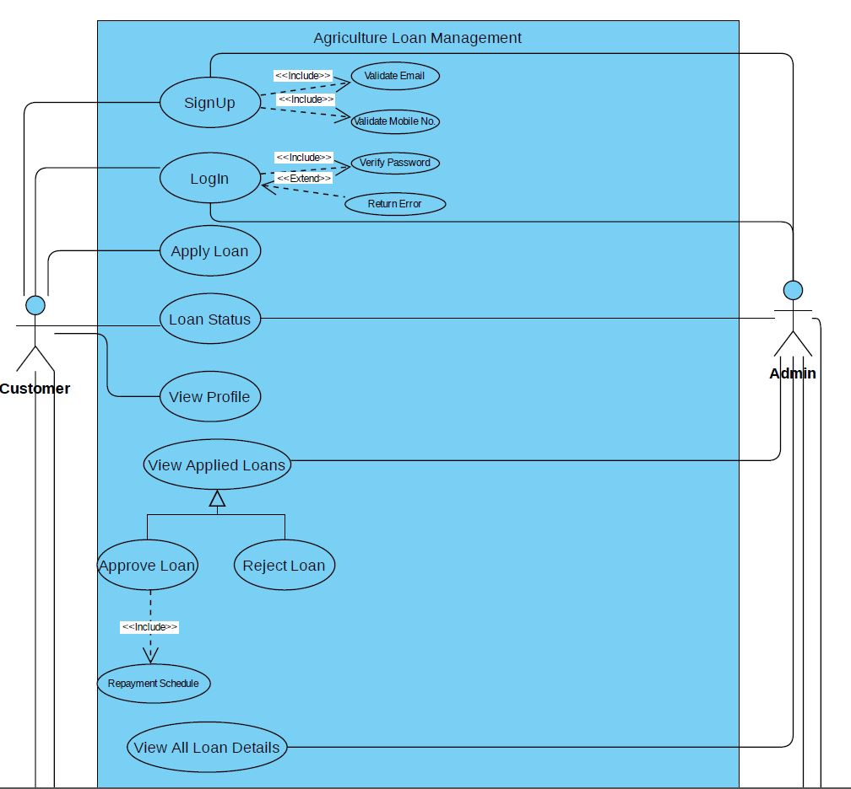

# 2.2: Problem Statement-

# Over the past few decades, modern technology has changed. In India, mostly farmers depend on the loan facility provided by the banks to sustain their farming business. These loan facilities would help them to buy farm equipment for modernization and for constructing storage units. The farmers required the loan facilities in all stages of agricultural activities. The Indian government provides assistance to solve the financial problems and also facilitate to get the loan easily. Yet, the farmers are facing challenges to obtain loan facilities from the banks. The loan facility has been assisting people to sustain their business or venturing into new business. Farmers are another form of business people which grows crops and sell it to customers. Farming has been the backbone of human presence, since time immemorial. It has likewise observed much progression over the years.

# Nowadays, people are going online for any of their needs. Online Banking is one of the facility that banks provide for people to be available 24/7. Online banking allows a user to conduct financial transactions via the Internet. Online banking offers customers almost every service traditionally available through a local branch including deposits, transfers, and online bill payments. Apply loan is one of the feature that internet banking provides. Online banking allows a user to conduct financial transactions via the Internet. Consumers aren't required to visit a bank branch in order to complete most of their basic banking transactions such as loan status, apply loan etc.

# A customer needs a device, an Internet connection to register. Once registered, the consumer sets up a password to begin using the service. It makes it easy for farmers to get their work done from home.



|  |  |
| --- | --- |
|  |  |
| Front End | Angular 10+, Bootstrap, CSS, Angular Material |
| Server Side | Spring Boot |
| Database | MySQL |

***3.Software and Hardware Requirement Specifications –***

# 

# 3.1 Methods : -

# Within computer programming, the acronym CRUD stands for create, read, update and delete. These are the four basic functions of persistent storage. Also, each letter in the acronym can refer to all functions executed in relational database applications and mapped to a standard HTTP method, SQL statement or DDS operation.It can also described user-interface conventions that allow viewing, searching and modifying information through computer-based forms and reports. In essence, entities are read, created, updated and deleted. Those same entities can be modified by taking the data from a service and changing the setting properties before sending the data back to the service for an update. Plus, CRUD is data-oriented and the standardized use of HTTP action verbs.

# CREATE procedures: It performs the INSERT statement to create a new record. Create allows you to add new rows/records to a database/table. If the record does not exist, the create operation adds it to the database.

# READ procedures:. Read is the operation that allows us to see the recipe we just created. It does not alter data. It simply displays it. Read consists of a function that queries our database and fetches all our records. It reads the table records based on the primary keynoted within the input parameter

# UPDATE procedures: Update is the operation that allows us to modify existing data and records within a table. We can update a single field within a record or multiple fields at once. It is also possible to update multiple records at once too. : It executes an UPDATE statement on the table based on the specified primary key for a record within the WHERE clause of the statement.

# DELETE procedures: Delete is the operation that allows us to remove records from a table. It deletes a specified row in the WHERE clause.

# The CRUD acronym identifies all of the major functions that are inherent to relational databases and the applications used to manage them, which include Oracle Database, Microsoft SQL Server, MySQL, and others. A relational database consists of tables with rows and columns. In a relational database, each row of a table is known as a tuple or a record. Each column of the table represents a specific attribute or field. The four CRUD functions can be called by users to perform different types of operations on selected data within the database. This could be accomplished using code or through a graphical user interface.

# 3.2 Programming/Working Environments : -

# To create a CRUD Application there are many environments available to program and deploy it. The best environments for angular is VS Code and Eclipse for Spring Boot.

**3.2.1 VS Code:-**

## Visual Studio Code combines the simplicity of a source code editor with powerful developer tooling, like IntelliSense code completion and debugging. It is a free-editor that helps the programmer write code, helps in debugging and corrects the code using the Intelli-sense method  It provides many Extensions like live server and auto saving which saves a lot of time and makes it easy to debug your code in a very easy way. VS Code helps to be instantly productive with syntax highlighting, bracket-matching, auto-indentation, box-selection, snippets, and more. Intuitive keyboard shortcuts, easy customization and community-contributed keyboard shortcut mappings let the user to navigate the code with ease. VS Code is not limited to only these productive features. There are many more. Some of widely popular are listed below.

## download (1).jpg

# VS Code Supports multiple programming languages. So earlier, programmers needed Web-Support: a different editor for different languages, but it has built-in multi-language support. This also means it easily detects if there’s any fault or cross-language reference, it’ll be able to detect it easily. It can detect if any snippet of code is left incomplete. Also, common variable syntaxes and variable declarations are made automatically. Ex: If a certain variable is being used in the program and the user has forgotten to declare, Intelli-sense will declare it for the user.

# It is used here for all the Frontend work. [Angular](https://angular.io/) is a popular web development platform developed by Google. The Visual Studio Code editor supports Angular IntelliSense and code navigation out of the box.

# Installing Node.JS has tool NPM which allows you to download required Angular2 libraries. It is not required to install NodeJS but Without NPM or similar tool you will have to download libraries and it's dependencies manually which is really a cumbersome and time-consuming task.

# 3.2.2 Eclipse:-

# Eclipse is an integrated development environment used in computer programming. It contains a base workspace and an extensible plug-in system for customizing the environment. It is the second-most-popular IDE for Java development. The Eclipse IDE is famous for our Java Integrated Development Environment (IDE).

# The Eclipse platform which provides the foundation for the Eclipse IDE is composed of plug-ins and is designed to be extensible using additional plug-ins. Developed using Java, the Eclipse platform can be used to develop rich client applications, integrated development environments and other tools. Eclipse can be used as an IDE for any programming language for which a plug-in is available. Eclipse provides the [rich client platform](https://en.wikipedia.org/wiki/Rich_client_platform) (RCP) for developing general-purpose applications.

# To those who develop in java nowadays, it’s almost impossible to miss [Spring](https://spring.io/) framework and more specifically [Spring Boot](https://spring.io/projects/spring-boot). Using this [development stack](https://en.wikipedia.org/wiki/Solution_stack), we gain more productivity and agility from small to large sized java projects. In this guide I’ll demonstrate how to install, configure eclipse and create a simple Hello-World using java, eclipse and spring boot.

# A Spring Boot project can be created in many ways. It’s a crucial concept required for Micro services and is an integral part of its course curriculum.

# 

# To make it even easier to write modern Spring Boot applications, the latest generation of the Spring Tools for the Eclipse IDE are well suited for getting started with Spring Boot and working on large microservice applications that are based on Spring Boot. This article walks you through the most important features of the tooling and provides great insight into a number of tips and tricks along the way. You can install the Spring Tools for Eclipse IDE into an existing Eclipse installation using the Eclipse Marketplace. Just open the marketplace client in Eclipse, search for Spring Tools and install the “Spring Tools (aka Spring IDE and Spring Tool Suite)” entry.

# The basic steps to create spring project in Eclipse are:-

# Install Eclipse IDE for Enterprise Java and Web Developer

# Create a Spring Boot Project in Spring Initializr

# Import Spring Boot Project in Eclipse IDE

# Search “maven” and choose Existing Maven Project

# Choose Next

# Click on the Browse button and select the extracted zip

# Click on the Finish button and we are done creating the Spring Boot project

**3.3 Requirements To Run The Application: -**

# 3.3.1 Node JS:-

# As an asynchronous event-driven JavaScript runtime, Node.js is designed to build scalable network applications. Node JS is must required to use Angular in VS Code.

# To install and use the command line interface as well as run the Angular application server, you'll need the [Node.js](https://nodejs.org/) JavaScript runtime and [npm](https://www.npmjs.com/) (the Node.js package manager) installed.

# Node.js is an open-source backend JavaScript runtime environment that allows the JavaScript to run outside the browser. Some of the main advantages of Node.js are

# Node.js can generate dynamic page content

# Node.js can create, open, read, write, delete, and close files on the server

# Node.js can collect form data

# Node.js can add, delete, modify data in your database

# It is a popular tool for almost any kind of project. Node.js runs the V8 JavaScript engine, the core of Google Chrome, outside of the browser. This allows Node.js to be very performant. A Node.js app runs in a single process, without creating a new thread for every request. Node.js provides a set of asynchronous I/O primitives in its standard library that prevent JavaScript code from blocking and generally, libraries in Node.js are written using non-blocking paradigms, making blocking behavior the exception rather than the norm. npm with its simple structure helped the ecosystem of Node.js proliferate, and now the npm registry hosts over 1,000,000 open source packages you can freely use.

## download (2).png

## 

**3.3.2 Angular CLI:-**

In order to be able to easily create an angular project you must leverage the Angular CLI. The Angular CLI makes it easy to create an application that already works, right out of the box. The nice thing about using Angular CLI is that it follows the Angular best practices.

The Angular CLI is a command-line interface tool that you use to initialize, develop, scaffold, and maintain Angular applications.

**npm install @angular/cli**

**3.3.3 Angular Material UI:-**

Angular Material is a UI component library for Angular JS developers. Angular Material components help in constructing attractive, consistent, and functional web pages and web applications while adhering to modern web design principles like browser portability, device independence, and graceful degradation. It helps in creating faster, beautiful, and responsive websites. It is specially designed for AngularJS developers. It helps to design the application in a structured manner. Its components help to construct attractive, consistent, and functional web pages and web applications. It is used to create a responsive and faster website.



**3.3.4 Spring Tools in Eclipse:-**

# Eclipse provides spring tools to enable spring boot projects. To make it even easier to write modern Spring Boot applications, the latest generation of the Spring Tools for the Eclipse IDE are well suited for getting started with Spring Boot and working on large micro service applications that are based on Spring Boot. This article walks you through the most important features of the tooling and provides great insight into a number of tips and tricks along the way.

**3.3.5 My SQL Workbench:-**

# In this Project, for database My SQL is used. My SQL Workbench is a visual database design tool that integrates SQL development, administration, database design, creation and maintenance into a single integrated development environment for the My SQL database system. It allows you to see the user data in database and can edit it manually. My SQL Workbench enables a DBA, developer, or data architect to visually design, model, generate, and manage databases. It includes everything a data modeler needs for creating complex ER models, forward and reverse engineering, and also delivers key features for performing difficult change management and documentation tasks that normally require much time and effort. My SQL Workbench delivers visual tools for creating, executing, and optimizing SQL queries. \

**3.3.6 Postman:-**

Postman is an application used for API testing. It is an HTTP client that tests HTTP requests, utilizing a graphical user interface, through which we obtain different types of responses that need to be subsequently validated. Postman offers many endpoint interaction methods. The following are some of the most used, including their functions:

# GET: Obtain information

# POST: Add information

# PUT: Replace information

# PATCH: Update certain information

# DELETE: Delete information

Postman will be used in this project to test API Endpoints and check their responses.





***4.Database Analyzing, Design and Implementation –***

# For database purpose, this project requires MY SQL. MySQL is an open-source relational database management system. A database is a structured collection of data. It may be anything from a simple shopping list to a picture gallery or a place to hold the vast amounts of information in a corporate network. In particular, a relational database is a digital store collecting data and organizing it according to the relational model. In this model, tables consist of rows and columns, and relationships between data elements all follow a strict logical structure. An RDBMS is simply the set of software tools used to actually implement, manage, and query such a database.

# User data and loan information will be stored in the database and user as well as admin can fetch the data anytime. User can add, edit, update and delete the data from database.

Given below is the Entity Relationship Diagram of the project



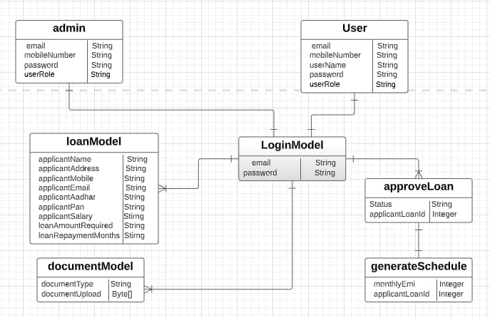

**Fig. Entity Relationship Diagram**



***5.Program’s Structure Analyzing and GUI Constructing –***

The Program’s Structure depends only on two types of users: Admin & User.

Admin will have a different interface and user will have different one.

Customer can have following options:

* Customer can apply for Agriculture loans online.
* The Customers can fill their profile.
* The Customers will have an option to upload the document proofs such as Aadhaar card, pan card, pay slips, bank statements etc.
* The Customers can apply for Agriculture loans through the portal.
* Once the loan application is filled. The customers can submit for further approval process.
* Customer can provide reviews.

And the Admin can have following options:

* The admin can see list of applied loans
* The admin can view the list of documents submitted and either approve/disapprove the loan application.
* Once the loan is sanctioned, the repayment schedule will get generated automatically.
* The admin can have provision to generate reports.

***5.1 Login Page:***

The Login page will be the first page rendered when the application loads. Manual routing will be restricted using Authguard. Unless logged in to the system user can not navigate to any other page. To navigate to the admin side, use admin/admin as the username and password.



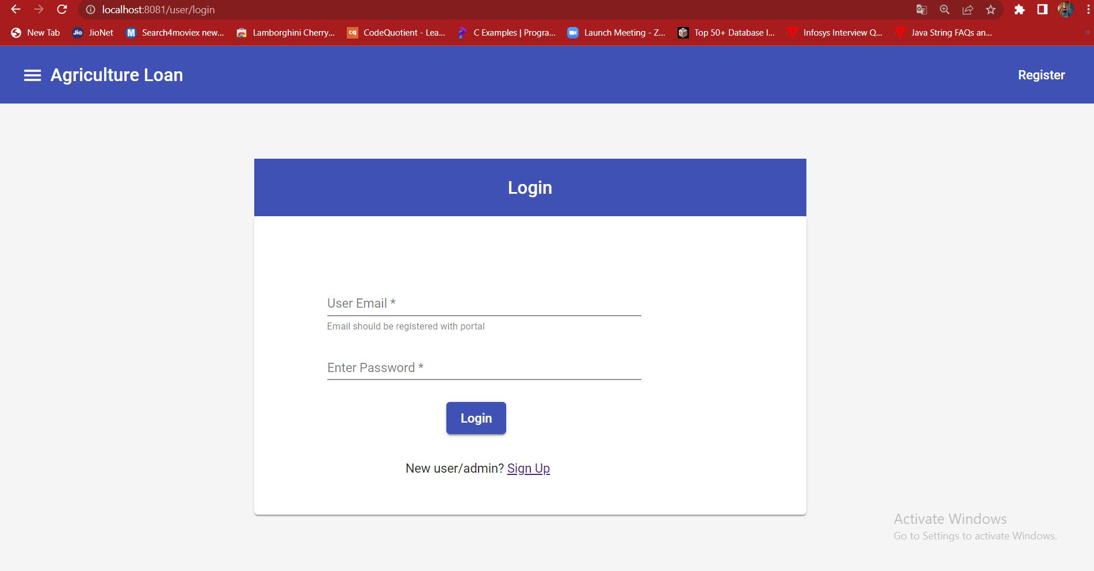

***Fig. Login Page***

***5.2 Signup Page:***

As a new to the website, user’s can register them as a normal user through signup page. Signup page contains Email, Username, Mobile Number and Password fields. There will be basic email and mobile number validation. User can not register with wrong email and mobile number and also username should be different. 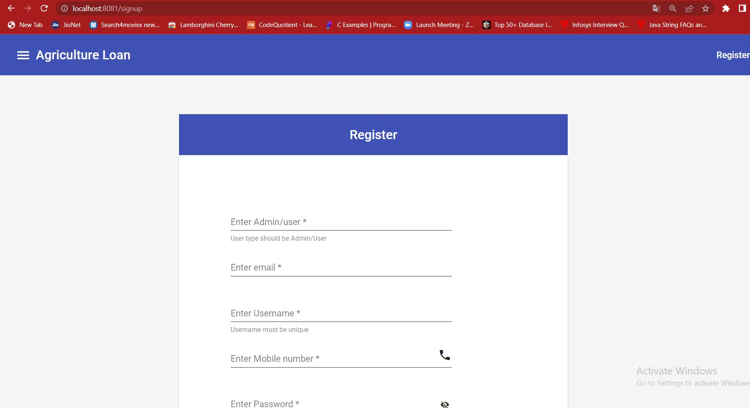

 ***Fig. Signup Page***

***5.3 User’s Home:***

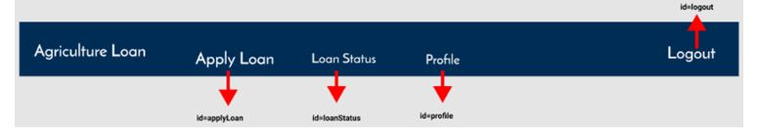

For Normal User Interface, there will be three important buttons through which user can apply for loan, checks loan status and can also edit their profile.

***5.4 Apply Loan Form:***

In the loan form Applicant can fill up their details and at the end upload the mandatory documents. All the fields here are required. No field can be empty. At the end after submitting the form, User will get a Auto generated Loan ID. User have to take a note of it and can track the loan in future.

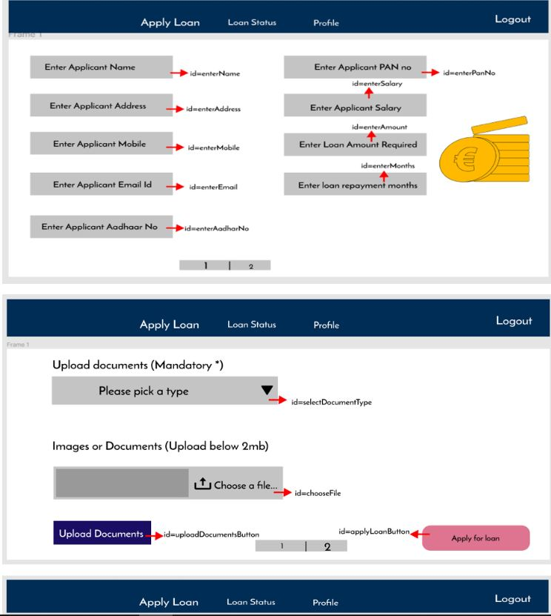



***5.5 Loan status:***

After applying for the loan user can track their loan status by entering loan id which they got after submitting the form. User can check status either the loan is approved or rejected.

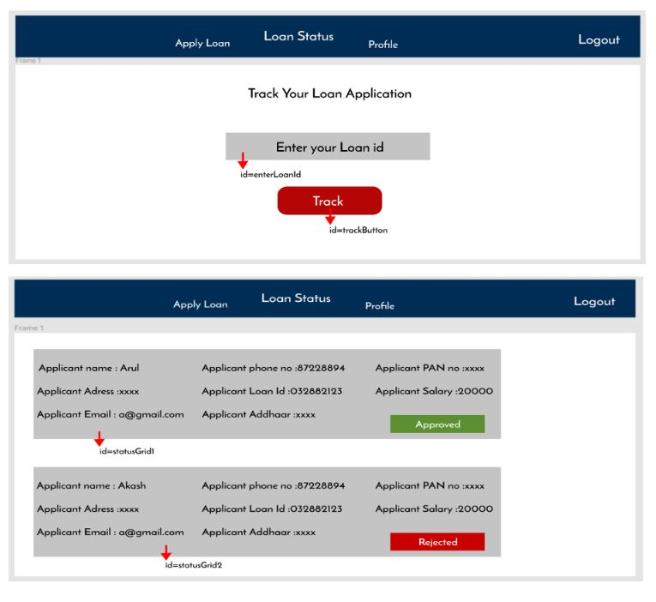

***5.6 Profile:***

User can check their profile by clicking on **Profile** button. It also contains your loan id.

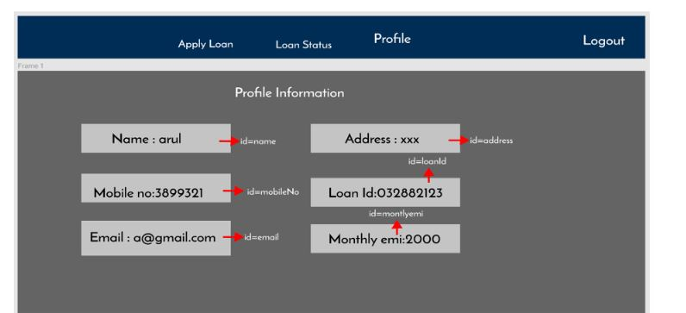

On the other hand **Admin** side is different from any other normal user. Admin can accept or reject the loan.

***5.7 Admin Home:***

Admin’s home page mainly contains only two options i.e. Applied loans and loan details.

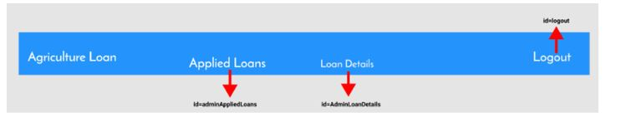

***5.8 Applied Loan:***

Admin can see a list of applied loans and can accept and reject the loans according to the information provided.

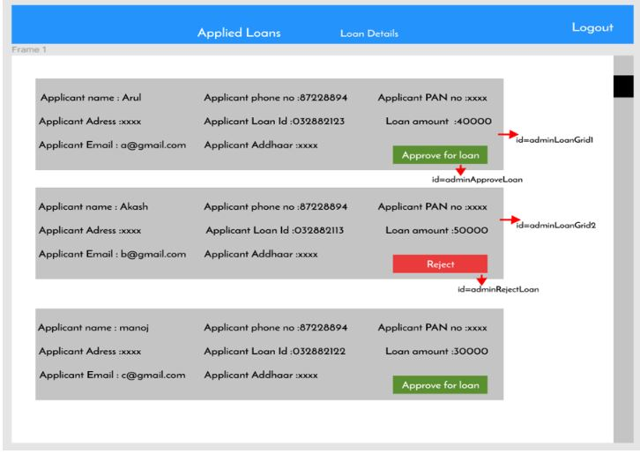

***5.9 Loan Details:***

Admin can see a list of loans that admin has accepted and rejected previously.

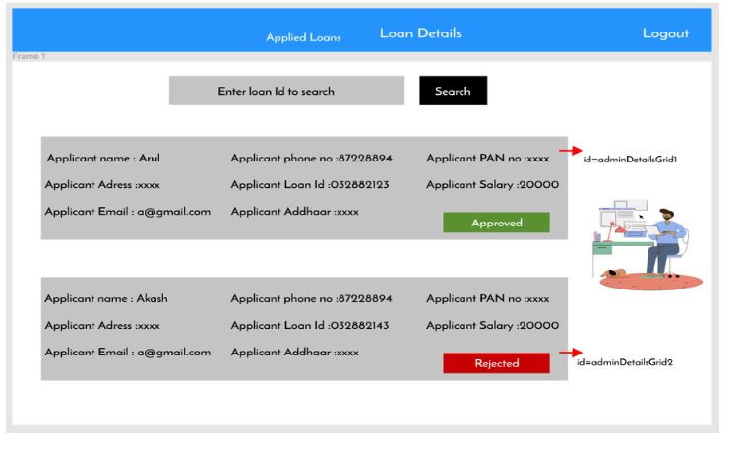

***6.Conslusion–***

In India, mostly farmers depend on the loan facility provided by the banks to sustain their farming business. These loan facilities would help them to buy farm equipment for modernization and for constructing storage units. The farmers required the loan facilities in all stages of agricultural activities. Farmers can avail an agricultural loan starting at a very low price.  These are long term loan schemes which a farmer can avail to meet their non-seasonal expenses. One can avail this loan to buy or upgrade equipment such as windmills, solar power, etc. When borrowing an agriculture loan, applicants will only have to submit a few documents such as a valid photo identity proof, proof of residence, etc. These documents can be submitted along with one’s application form.

Admin will verify user’s application form and the documents submitted by user, after which user loan application will be approved. The loan amount will be disbursed to user account soon after this. These type of applications can help farmers a lot for their needs. They do not have to go to banks and requesting for the loan. They can easily avail the services from their home.

***7.Future Scope–***

As Agriculture Loan plays a very important role in any countries economy because if farmers gets the loan for their crops then only they can grow and supply. Online Loan portal is the best solution for farmers to go digital for their work. As this portal can be very important to farmers, It needs some more enhancement and features. While the given features are the basic functional features expected, the below ones can be nice to have add-on features for future.

* Filters for like Low to High or showcasing buses based on the customer’s price range, specific Company etc.
* Email integration for intimating new personalized offers to customers.
* Multi-factor Authentication for the sign-in process.
* Payment Gateway.

# *8.References–*

# 1. Shylendra, H., S. 1995. Farm Loan Waivers: A Distributional and Impact Analysis of the Agricultural and Rural Debt Relief Scheme, 1990

# 2. Kanz, M. 2012. What Does Debt Relief Do for Development? Evidence from India's Bailout Program for Highly-Indebted Rural Households’

# <https://angular.io/>

# <https://material.angular.io/>

[**https://code.visualstudio.com/docs/nodejs/angular-tutorial**](https://code.visualstudio.com/docs/nodejs/angular-tutorial)

# <https://spring.io/projects/spring-boot>

# <https://www.eclipse.org/>

# <https://www.mysql.com/>

# <https://developer.mozilla.org/en-US/docs/Glossary/CRUD>

# <https://virtusacoetraining.examly.io/mycourses/details?id=0c43e1f2-705b-4df1-9856-6dddd9d62833&type=mycourses>