**Fashion** is a popular style or practice, especially in [clothing](https://en.wikipedia.org/wiki/Clothing), [footwear](https://en.wikipedia.org/wiki/Footwear), [accessories](https://en.wikipedia.org/wiki/Fashion_accessory), [makeup](https://en.wikipedia.org/wiki/Makeup), [body](https://en.wikipedia.org/wiki/Human_body) and **Bollywood is defining its presence well on the fashion circuit** for years. Be it Dimple Kapadia's crop top and short skirt in the movie Bobby or Sridevi's white saree in Chandni and how can we forget, Kareena Kapoor's long tee-shirt with patiala salwar in Jab We Met? We just cannot deny the fact that we have always taken clues from Bollywood when it comes to fashion. Recently, Bollywood fashion has achieved an all-new high, with wardrobes we would all love to have. These are only a couple of such.

This one needs to beat the rundown, isn't that right? Veronica's proud closet was a genuine impression of the lighthearted young lady she was. Attractive, intense and adaptable, her closet was an impeccable blend of gathering dresses and palazzos. Truth be told, it was Veronica who made palazzo pants a pattern.

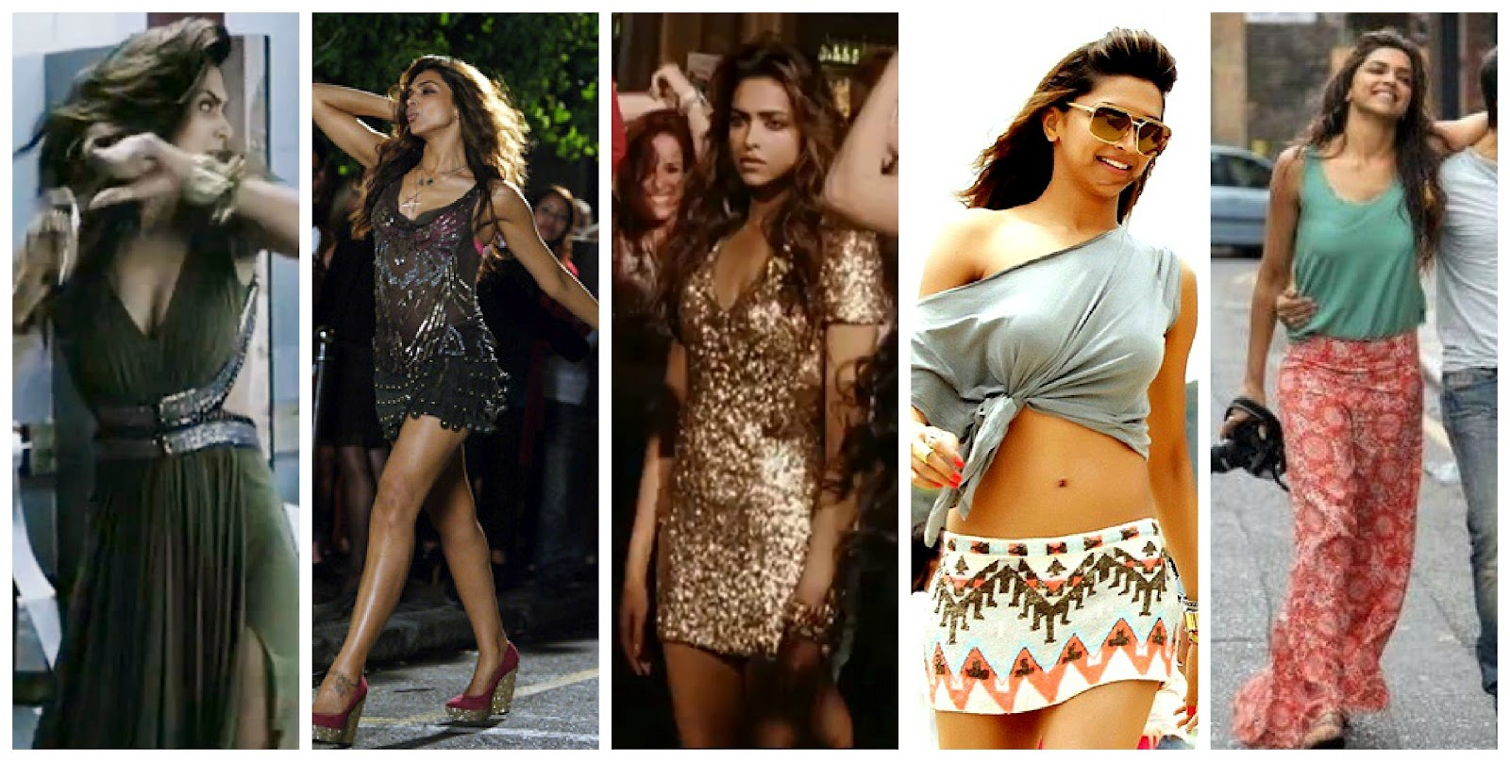

From the ideal party dresses to dazzling sarees, Aisha had every young lady's fantasy closet. It would not be wrong to say that the role was played by Bollywood's fashion icon whose personal wardrobe is no less than the character's. 

Hrithik Roshan took his hotness remainder to the following level with his character Arjun in the motion picture ZNMD. In spite of the fact that Arjun had numerous hindrances and needed to figure out how to give up and appreciate life, he did as such looking super hot each and every minute. That is a critical lesson we learnt from Arjun; that regardless of what you do, you should dependably stay chic.

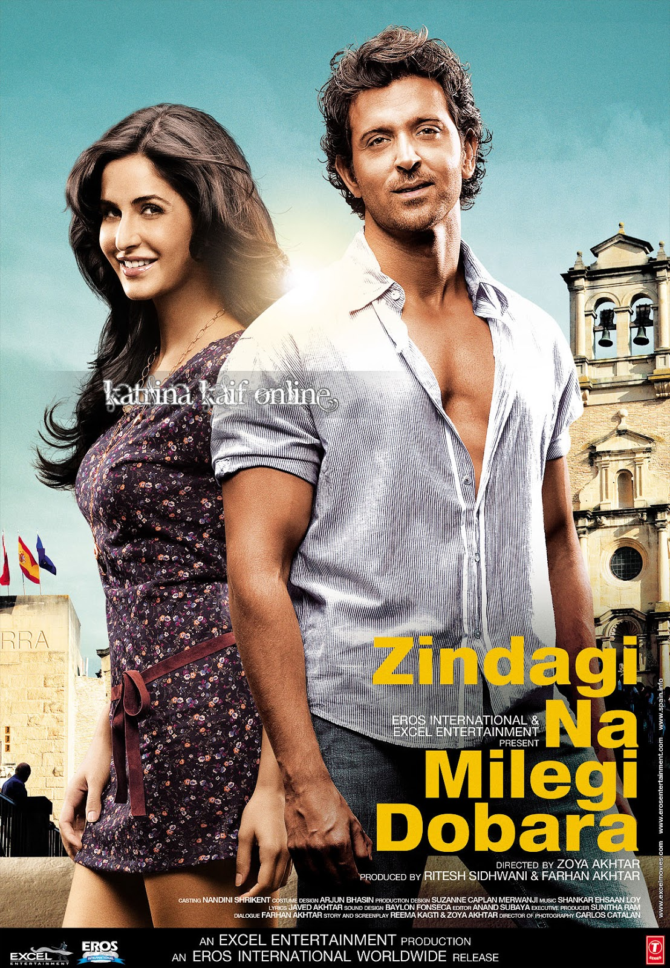

This bubbly physiotherapist re-imagined proficient dressing. While out on a private treatment visit, she kept her closet agreeable and proficient, yet brilliant and chipper simply like herself. Who can overlook her hot pink night robe?



Hope you have not forgotten that beautiful blue saree she wore to the "shelter" she dragged Manu to on the grounds that she was tired of her marriage? Very beautiful! It wasn't just her stunning sarees. Notwithstanding when Tanu came back to her town to process her coming up short marriage, she was enhanced in spunky kurtas and denim coats. Not only this, she looked completely stunning even as she strolled down lost roads amidst the night crying over her soon-to-be-ex-Husband.

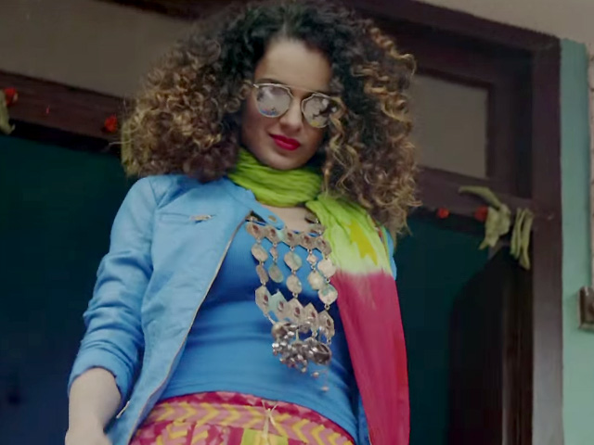

Daughter of a business tycoon, and a successful businesswoman herself, Ayesha dressed like she meant business. With her perfectly fitted dresses, to-die-for jumpsuits and comfortably chic dresses to lounge in, her wardrobe screamed 'Respect me, bitch!'



In truth, the motion picture wasn't her best nor was the character huge. Be that as it may, her closet was a 'must have' for all the boho chic fashionistas. She even made a plain cocoa shirt look fun. 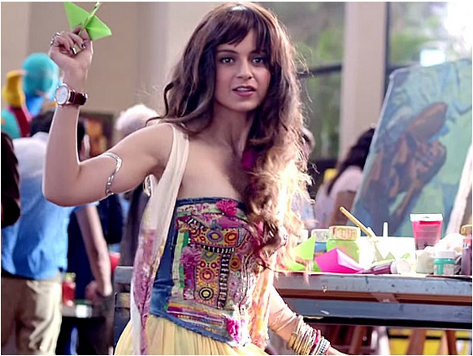

His fresh shirts and superbly creased trousers framed only the sort of a closet an ex armed force officer would wear. Akshay Kumar pulled off the earnestness of Ranjit Katyal with panache, and his closet made him look so much more sizzling while he assumed the part. In spite of the way that Airlift was a magnificent film, he made it somewhat hard to concentrate on the plot. 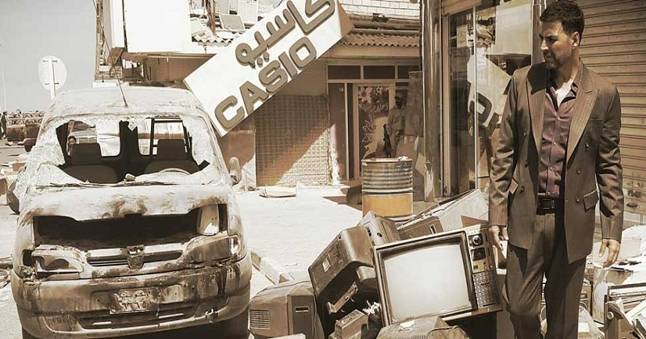

Tara had the most spectacular dresses. From her frilly grayish dress to her blue sundress and stripy shirts, she characterized our late spring closet for the year. The main inquiry is, would anyone be able to else pull off the serenely chic closet and in addition Deepika Padukone?

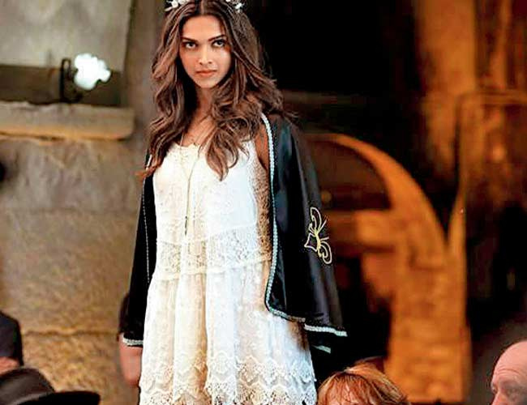

Whoever said men can't wear pastels has been demonstrated wrong by this heartthrob. It takes a courageous man to wear a water hued suit. Summer is the ideal climate to add some water to your closet, anyway. 