Blockchain Shipment Management Tracking System

- Background/ Problem Statement

Today’s supply chains are global networks that generally include manufacturers, suppliers, logistics companies, and retailers that work together to deliver products to consumers. As modern supply chains continue to expand, they also are becoming more complex and disparate. Typically, traditional supply chains use paper-based and disjointed data systems that lead to information silos and make tracking products a time-consuming task. Lack of traceability and transparency is an industry-wide challenge that leads to delays, errors, and increased costs.
Our Blockchain-Based Shipment Management Tracking System is designed by keeping the above-mentioned problem in mind. The objective is to track all changes in the shipment and inform the related parties about the changes. A blockchain technology-based system can be used to track movements in the supply chain and validate the same on a real-time basis. This will improve tracking, and also result in quicker, real-time transactions.

- Working of the Project

This is a Dotnet-Based project that consists of two modules, including Admin and User.

The admin can log in using their credentials. They will have the access to add, update, view and delete various users, including Shippers, Consignees, Freight Forwarders, Shipping Lines, etc. They can view the courier details and transactions by searching the tracking ID. They can also check for any manipulation in the data.

The users can log in using their credentials. Only the shipper will have the access to add, update, view and delete couriers. All the users can check the shipment details and view the list of transactions of each courier through the tracking ID. They can add a new transaction as well along with the sender, receiver, product dimensions, size, quality, etc.

This a DotNet Project where the Frontend involves Html, CSS, and JavaScript and the Backend involves ASP.net. The database used is MSSQL and IDE is Visual Studio.

- Advantages

- The system is easy to maintain.
- It is user-friendly.
- The system helps to improve communication and transparency.
- It can amplify security.
- It offers quality assurance.

- System Description

The system comprises 2 major modules with their sub-modules as follows:
- Admin:
- Login:
- The admin can log in using their credentials.
- Manage User:
- The admin can add, update, delete and view users.
- The different types of users include Shippers, Consignees, Freight Forwarders, Shipping Lines, etc.
- View Couriers:
- The admin can search for couriers by entering the Tracking Id.
- Here, they can view the courier details and all the transactions.
- They can also check for any manipulations in the data.

- User
- Login:
- The users can log in using their credentials.
- Manage Courier:
- Only the Shipper is allowed to add, update, delete and view couriers.
- Transactions:
- The users can view the list of transactions for each courier by searching the tracking Id.
- They can add a new Transaction along with the sender, receiver, product dimensions, size, quality, etc.
- Track your shipment:
- The user can view the courier details and the transaction list by searching the Tracking Id.

- Project Life Cycle

The waterfall model is a classical model used in the system development life cycle to create a system with a linear and sequential approach. It is termed a waterfall because the model develops systematically from one phase to another in a downward fashion. The waterfall approach does not define the process to go back to the previous phase to handle changes in requirements. The waterfall approach is the earliest approach that was used for software development.

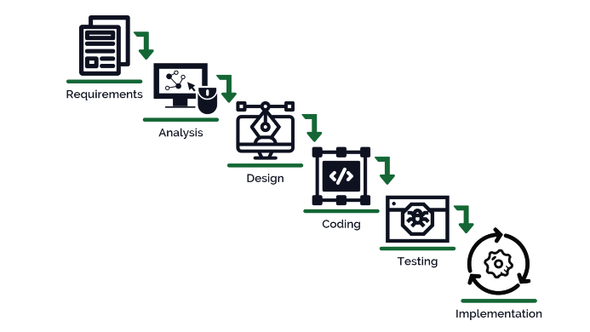

- System Requirements

- Hardware Requirement

- Laptop or PC
- Windows 7 or higher
- I3 processor system or higher
- 4 GB RAM or higher
- 100 GB ROM or higher

- Software Requirement

- Laptop or PC
- Visual Studio 2019
- SQL Server Management Studio latest

- Limitations/Disadvantages

- The system can produce inaccurate results if any data is entered wrong.

- Application –

- Our project can track any changes in the shipment and inform the concerned departments about the same.

- Reference

- https://www.infosys.com/oracle/Insights/documents/product-tracking-tracing.pdf
- https://aws.amazon.com/blockchain/blockchain-for-supply-chain-track-and-trace/
- https://gazelle.in/block-chain-shipment-tracking/
- https://www.researchgate.net/publication/341880037_Blockchain-based_applications_in_shipping_and_port_management_a_literature_review_towards_defining_key_conceptual_frameworks

