26,27.00 1,320.002,42,0002,14,42496,890 5 , 631.1

NEmamaiel : HIMANSHU9121990@GMAIL.COM **Card No: 4893 77XX XXXX 0837**

: HIMANSHU GUPTA  **Statement for HDFC Bank Credit Card**

Address : B-193 JANTA FLATS AVANTIKA SECTOR-1 ROHINI **Statement Date:21/01/2023 AAN : 0001014550012640831**

DELHI-110085 NDH

**Payment Due Date Total Dues Minimum Amount Due**

GST No : 10/02/2023 26,277.00 1,320.00

In case you wish to update the personal details,please write a letter to

The Manager, HDFC Bank Card Division, # 8, L B Road, Thiruvanmiyur,

Chennai – 600041 **Credit Limit Available Credit Limit Available Cash Limit** 2,42,000 2,14,424 96,800

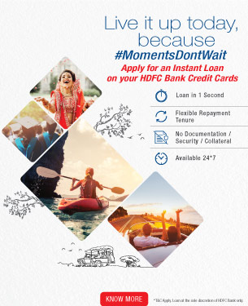

**Account Summary**



**Opening Payment/ Purchase/ Finance**



**Total Dues Balance Credits Debits Charges**

9,563.11 22,494.58 39,208.86 0.00 26,277.00 **Past Dues (If any)**



|  |
| --- |
| **Minimum Overlimit 3 Months+ 2 Months 1 Month Current Dues**  **Amount Due** |
|  |

0.00 0.00 0.00 0.00 1,320.00 1,320.00



**IMPORTANT INFORMATION**



1. BANK WILL REPORT YOU AS DEFAULTER TO CREDIT AGENCIES IF YOU MISS PAYMENT FOR MINIMUM AMOUNT BY 3 DAYS FROM THE DUE DATE
2. REVISED:MOST IMP.TERMS & CONDITIONS WEF. 1 JAN 2023-READ GENERAL T&C|SCHEDULE OF CHARGES & REWARD POINTS ON HDFCBANK.COM

**Domestic Transactions**



|  |  |  |  |
| --- | --- | --- | --- |
|  |  |  | |
|  |  |  | |
|  |  |  | |
|  |  |  | |
|  |  |  | |
|  |  |  | |
|  |  |  | |
|  |  |  | |
|  |  |  | |
|  |  |  | |
|  |  |  | |
|  |  |  | |
|  |  |  | |
|  |  |  | |
|  |  |  | |
|  |  |  | |
|  |  |  | |
|  |  |  | |
|  |  |  | |
|  |  |  | |
|  |  |  |

|  |  |  |  |
| --- | --- | --- | --- |
| **Date** | **Transaction Description** | **Amount (in Rs.)** | |
|  |  |  | |
|  | **HIMANSHU GUPTA** |  | |
| 22/12/2022 | LIC BILLDESK MUMBAI | 12,010.00 | |
| 24/12/2022 | IGL MUMBAI | 3,251.24 | |
| 29/12/2022 | AMAZON PAY INDIA PRIVATE WWW.AMAZON | 1,703.00 | |
| 31/12/2022 | IGL MUMBAI | 2,467.84 | |
| 31/12/2022 | IGL MUMBAI | 832.97 | |
| 01/01/2023 | NETBANKING TRANSFER (Ref# 00000000000101012998031) | 9,563.00 Cr | |
| 01/01/2023 | Paytm NOIDA | 2,999.00 | |
| 02/01/2023 | SETHI AUTO SERVICE STATDELHI | 368.65 | |
| 09/01/2023 | MEENAKSHI INDIAN OIL DELHI | 503.88 | |
| 09/01/2023 | PETRO SURCHARGE WAIVER | 4.99 Cr | |
| 10/01/2023 | AMAZON PAY INDIA PRIVATE WWW.AMAZON | 480.00 | |
| 11/01/2023 | SPAY REVERSAL LIC India 332183454 (Ref# ST230190083000010126850) | 12,010.00 Cr | |
| 11/01/2023 | SpayNBBPS 332183454 LIC I 30102157 | 12,010.00 | |
| 12/01/2023 | SATGURU MEDIWAYS NEW DELHI | 298.00 | |
| 12/01/2023 | AMAZON PAY INDIA PRIVATE WWW.AMAZON | 480.00 Cr | |
| 12/01/2023 | SITA PROVISION STORE NEW DELHI | 590.00 | |
| 13/01/2023 | AMAZON PAY INDIA PRIVATE WWW.AMAZON | 432.00 | |
|  |  |  |

**Domestic Transactions**

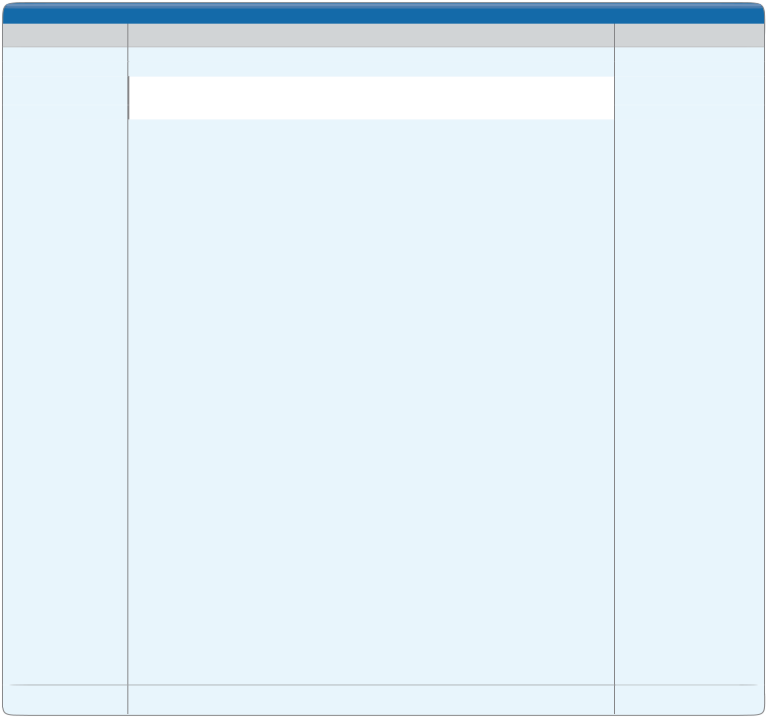

**Date Transaction Description Amount (in Rs.)**

**HIMANSHU GUPTA**

14/01/2023 IGL-MANGOLPURI DELHI 463.28 14/01/2023 PETRO SURCHARGE WAIVER 4.59 Cr 18/01/2023 AMAZON PAY INDIA PRIVATE WWW.AMAZON 432.00 Cr 20/01/2023 BATA INDIA LIMITED NEW DELHI 799.00

**Reward Points Summary**



**Points expiring in Points expiring in Opening Balance Earned Disbursed Adjusted/Lapsed Closing Balance**

**next 30 days next 60 days** 854 568 0 170 1,252 0 0

* Note : All contents of the Statement will be deemed to be correct and accepted by you, unless you inform us of any discrepancies within 30 days from the date of this statement
* The available credit limit showed herein takes into account charges incurred but not billed



**Offers on your Credit Card**

* Get up to 3X Reward Points/1% CashBack, additionally on Flipkart via HDFC Bank SmartBuy. Valid till 31st January 2023. TCA
* Get up to 10X Reward Points/5% CashBack on Flight & Hotel bookings via HDFC Bank SmartBuy. Valid till 31st January 2023. TCA
* Get Discounted Vouchers of 150+ Brands and get up to 5X Reward Points/5% CashBack additionally, on HDFC Bank SmartBuy. Valid till 31st January 2023. TCA
* Get 3X Reward Points/5% CashBack on all your train bookings at IRCTC via HDFC Bank SmartBuy. Valid till 31st January 2023. TCA
* Automate your bill payments on SmartPay and get upto Rs. 2,600 on cashback and voucher. Valid till 31st January 2023. TCA

Terms & Conditions apply, visit www.offers.smartbuy.hdfcbank.com for offer details

**Important Information**

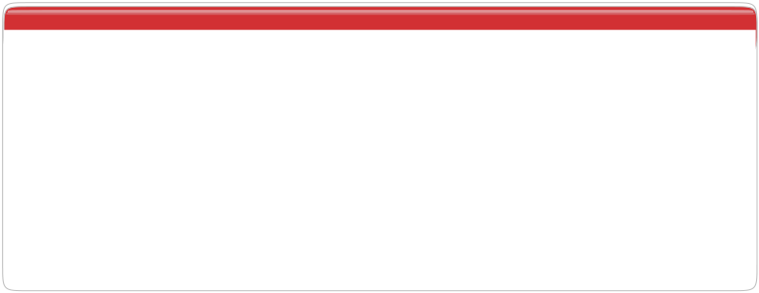

* The "Available Credit Limit" shown in this statement takes into account charges incurred but not due. Please ensure that at least the "Minimum Amount Due" reaches us by the "Due Date".
* If the minimum amount due or part amount less than the total amount due is paid, interest charges are applicable (including fresh purchases, if any) on an average daily reducing balance method.
* To Hotlist your credit card, login into Netbanking or call our phone banking numbers, please [click here](http://www.hdfcbank.com/personal/find-your-nearest/find-phone-banking?ifn=no)
* Credit Information Companies (CICs) are approved by the Reserve Bank of India to facilitate an effective and informed credit risk assessment, Bank reserves the right to include your name in the list of defaulters and share the conduct of your credit card account with these CICs and statutory bodies in accordance with the CIC(Regulation)Act 2005.

To know the Voluntary Codes as prescribed by the "The Banking Codes and Standards Board of India (BCSBI)" , please

* [click here](http://www.hdfcbank.com/assets/popuppages/corporate.htm?openpopupinside=yes)
* How to read GST entry in your Credit Card statement:

|  |  |  |  |  |
| --- | --- | --- | --- | --- |
| **GST Entry** | **GST Type** | **Invoice Number** | **GST Rate %** | **State Code** |
| SGST-VPS************ - RATE 9.0 -33**** | SGST | VPS************ | 9.0 | 33 |

**Other offers on your Credit Card**



Choose from over 350 merchants to shop Relish a truly appetizing experience with from, pick from a wide collection of HDFC Bank credit cards.

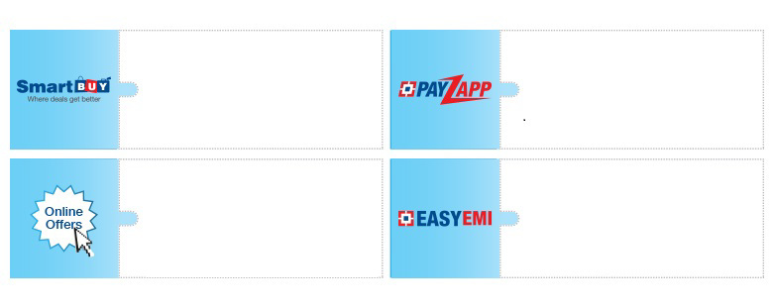

brands, pay your bills online, book travel

tickets and more

Avail delightful online deals and Simplify your payments with convenient discounts at select outlets EasyEMI offers on a variety of purchases

[Statement and Payment](http://www.hdfcbank.com/assets/pdf/Statement_Payment_Related_Info.pdf) [MITC (Most Impt Terms &](https://www.hdfcbank.com/content/api/contentstream/723fb80a-2dde-42a3-9793-7ae1be57c87f/Personal/Pay/Cards/Credit%20Card/Credit%20Card%20Landing%20Page/Manage%20Your%20Credit%20Cards%20PDFs/MITC%201.64.pdf)



[Payment Options](https://www.hdfcbank.com/personal/pay/bill-payments/hdfc-bank-credit-card-bill-payment) [Customer Rights Policy](https://www.hdfcbank.com/assets/pdf/Customer_Rights_Policy.pdf) [related information](http://www.hdfcbank.com/assets/pdf/Statement_Payment_Related_Info.pdf) [Conditions)](https://www.hdfcbank.com/content/api/contentstream/723fb80a-2dde-42a3-9793-7ae1be57c87f/Personal/Pay/Cards/Credit%20Card/Credit%20Card%20Landing%20Page/Manage%20Your%20Credit%20Cards%20PDFs/MITC%201.64.pdf)



For HDFC Bank