UNIT 01
INTRODUCTION TO
DATA SCIENCE AND
MACHINE LEARNING
STUDENT NOTES by Himanshu Singh
Syllabus coverage:
Fundamentals of Artificial Intelligence • Need and Applications of Data Science • Data Mining • Data Preparation • Machine Learning • Types and Applications of Machine Learning

Learn the concept → Understand the example → Revise the key point

A. How to Use These Notes
- Before class: read the headings and study the diagrams.
- During class: add the teacher’s examples in the blank space beside each topic.
- After class: use the “Key Point”, “Memory Aid” and comparison tables for revision.
- Before examination: attempt the MCQs, short-answer and long-answer questions without looking at the notes.
STUDY RULE | Do not only memorize definitions. Always connect each concept with one real-life example and one suitable application.

B. Learning Outcomes
- Define Artificial Intelligence, Data Science, Data Mining and Machine Learning.
- Explain why organizations need Data Science and where it is applied.
- Describe the stages of data preparation and the Data Science life cycle.
- Differentiate supervised, unsupervised, semi-supervised and reinforcement learning.
- Select a suitable learning type for a simple real-world problem.
- Identify basic ethical issues such as privacy, bias and transparency.

C. Contents
1. Data, Information and Intelligence
2. Fundamentals of Artificial Intelligence
3. Need and Applications of Data Science
4. Data Mining
5. Data Preparation
6. Machine Learning Fundamentals
7. Types of Machine Learning
8. Applications and Problem Selection
9. Integrated Case Study
10. Responsible Data Science and AI
11. Quick Revision and Glossary
12. Self-Assessment

1. Data, Information and Intelligence

1.1 What is Data?
Data consists of raw facts, observations or measurements collected about people, objects, events or processes. Data may be a number, word, image, sound, video, location, sensor reading or transaction record.
EXAMPLE | “78” is data. When we know that 78 is a student’s examination mark, it becomes meaningful information.

Term | Meaning | Example
Data | Raw fact without complete context | 78, 92%, “CSE”, 30 July
Information | Processed or organized data with meaning | A student scored 78 marks
Knowledge | Understanding gained by interpreting information | The student performs well but needs improvement in one topic
Decision | An action based on knowledge | Provide targeted practice and feedback

1.2 Forms of Data
Form | Description | Examples
Structured | Organized in rows and columns with a fixed schema | Database table, spreadsheet, marksheet
Semi-structured | Has tags or keys but not a strict table format | JSON, XML, email headers
Unstructured | Has no predefined tabular structure | Images, audio, video, documents, social posts

MEMORY AID | Structured = table; Semi-structured = tagged; Unstructured = free-form.

1.3 What is Intelligence?
Intelligence is the ability to perceive, learn, reason, solve problems, communicate and take suitable action. In computing, these abilities are represented using rules, search, optimization, statistical models and learning algorithms.
- Perception: understanding images, sound, text or sensor input.
- Reasoning: drawing conclusions from facts and rules.
- Learning: improving performance from experience or data.
- Planning: choosing steps to achieve a goal.
- Communication: understanding and generating human language.

2. Fundamentals of Artificial Intelligence

2.1 Definition
Artificial Intelligence (AI) is a branch of computer science concerned with creating systems that can perform tasks normally associated with human intelligence, such as recognizing patterns, understanding language, solving problems and making decisions.
KEY POINT | AI is the broad field. Machine Learning is one important approach used to create AI systems.

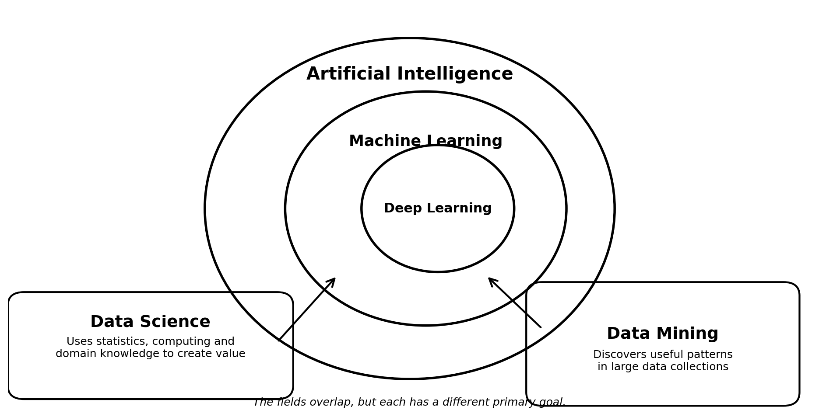
Figure 1: Relationship among AI, Machine Learning, Deep Learning, Data Science and Data Mining.

2.2 Main Capabilities of AI
Capability | What the system does | Example
Perception | Interprets visual, audio or sensor input | Face recognition, speech recognition
Knowledge representation | Stores facts and relationships in usable form | Knowledge graph, expert system
Reasoning | Uses rules or evidence to reach a conclusion | Medical decision support
Learning | Improves using data or feedback | Spam filter
Planning and action | Chooses a sequence of actions | Robot navigation
Natural language processing | Understands or produces language | Chatbot, translation

2.3 Narrow AI and General AI
Type | Meaning | Current status / example
Narrow AI | Designed for one limited task or domain | Common today: recommendation, face recognition, navigation
General AI | Hypothetical system with broad human-like ability across many tasks | Not currently available as a demonstrated general-purpose human-level system

EXAM TIP | Most systems used in daily life are Narrow AI. A system can be excellent at one task but unable to perform unrelated tasks.

2.4 Major Approaches in AI
- Rule-based systems: use IF–THEN rules prepared by experts.
- Search and optimization: explore possible solutions and select a good one.
- Machine Learning: learn patterns from data.
- Deep Learning: use multi-layer neural networks, especially for images, text and speech.
- Hybrid systems: combine rules, learning and human knowledge.

2.5 AI Problem-Solving Cycle
1. Receive input or observe the environment.
2. Represent the problem in a usable form.
3. Apply rules, search, optimization or a learned model.
4. Select a decision, output or action.
5. Use feedback to improve future performance.

2.6 Applications and Limitations
Area | Application
Education | Adaptive learning, automated feedback, student-support analytics
Healthcare | Image analysis, risk estimation, hospital resource planning
Banking | Fraud detection, credit-risk support, customer service
Transport | Route planning, traffic prediction, driver assistance
Agriculture | Crop monitoring, disease detection, yield estimation
Industry | Predictive maintenance, quality inspection, robotics

CAUTION | AI can make confident mistakes. Its output depends on data quality, design, objective and operating conditions. Human oversight remains important.

3. Need and Applications of Data Science

3.1 Definition
Data Science is an interdisciplinary field that uses data, statistics, computing, visualization and domain knowledge to understand problems, discover patterns, make predictions and support decisions.
Foundation | Role in Data Science
Statistics and Mathematics | Summarize data, estimate uncertainty and test relationships
Programming and Computing | Collect, clean, process and model data efficiently
Domain Knowledge | Interpret results correctly in the real application area
Communication and Visualization | Explain findings through charts, reports and dashboards

FORMULA | Data Science = Data + Methods + Computing + Domain Knowledge + Communication

3.2 Why is Data Science Needed?
- Very large amounts of digital data are generated by websites, mobile apps, sensors, machines and transactions.
- Manual examination of all records is slow and may miss important patterns.
- Organizations need evidence-based decisions rather than only intuition.
- Prediction helps plan demand, resources, risk and maintenance.
- Personalization improves services for different users.
- Monitoring helps detect unusual events, fraud and changing trends.
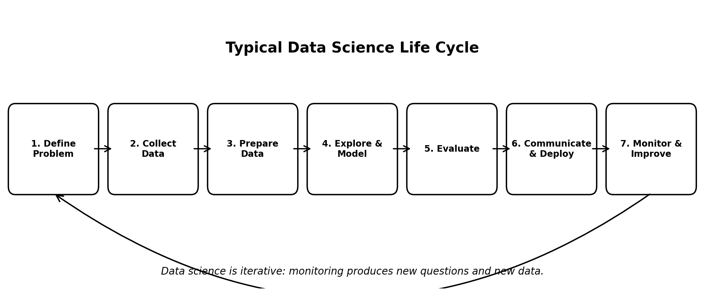
Figure 2: Typical Data Science life cycle. The process is iterative, not strictly one-way.

3.3 Data Science Life Cycle
Stage | Main question | Typical work
1. Define problem | What decision or question matters? | Convert a broad issue into a measurable objective
2. Collect data | What evidence is available? | Databases, files, APIs, surveys, sensors
3. Prepare data | Is the data reliable and usable? | Clean, integrate, transform and engineer features
4. Explore and model | What patterns or predictions are possible? | Statistics, visualization and ML algorithms
5. Evaluate | Is the result accurate, useful and fair? | Metrics, validation, error analysis
6. Communicate / deploy | How will people use the result? | Report, dashboard, application or workflow
7. Monitor | Does performance remain acceptable? | Track drift, errors and impact

3.4 Four Types of Analytical Questions
Type | Question | Example
Descriptive | What happened? | How many students passed?
Diagnostic | Why did it happen? | Why did pass percentage fall?
Predictive | What is likely to happen? | Which students may need support?
Prescriptive | What action should be taken? | Which intervention may improve results?

3.5 Applications of Data Science
Domain | Examples
Business and Retail | Customer segmentation, demand forecasting, recommendation
Education | Result analysis, attendance patterns, personalized learning
Healthcare | Disease-risk analysis, patient-flow planning, medical research
Government | Public-service planning, transport analysis, resource allocation
Science and Environment | Climate analysis, biodiversity monitoring, experiment data
Cybersecurity | Anomaly detection, suspicious-login analysis, threat monitoring

4. Data Mining

4.1 Meaning
Data Mining is the process of discovering useful patterns, relationships, trends and unusual cases in large data collections. It is an important stage within the broader Data Science process.
KEY POINT | Data Science covers the complete problem-solving life cycle. Data Mining mainly focuses on discovering patterns from prepared data.

4.2 Knowledge Discovery in Databases (KDD)
1. Selection: choose relevant data.
2. Cleaning: correct errors and inconsistencies.
3. Transformation: convert data into a suitable form.
4. Data mining: apply methods to discover patterns.
5. Evaluation: check whether patterns are valid and useful.
6. Presentation: communicate the discovered knowledge.

4.3 Common Data Mining Tasks
Task | Purpose | Example
Classification | Assign records to known categories | Spam / not spam
Regression | Predict a numeric value | Future sales
Clustering | Group similar records without labels | Customer groups
Association | Find items or events that occur together | Products bought together
Anomaly detection | Find rare or unusual cases | Suspicious transaction
Summarization | Create a compact description of data | Monthly performance profile

4.4 Association Rule Example
Suppose a shop observes that customers who buy bread and butter also often buy milk. A rule may be written as: {Bread, Butter} → {Milk}. The rule shows co-occurrence; it does not prove that bread causes milk purchase.
- Support: how frequently the item combination appears in all transactions.
- Confidence: how often the right-hand item appears when the left-hand items appear.
Field | Data Science | Data Mining | Machine Learning
Scope | Complete data-to-decision process | Pattern discovery from data | Algorithms that learn from data or feedback
Main output | Insight, report, model or deployed solution | Rules, groups, trends or anomalies | Predictive or decision-making model
Includes preparation? | Yes, as a major stage | Usually uses selected and prepared data | Required before training but not the complete field

5. Data Preparation

5.1 Meaning and Importance
Data preparation is the process of converting raw data into a clean, consistent and analysis-ready form. In real projects, this stage often requires more effort than model training because poor data produces unreliable results.
MEMORY AID | Garbage In, Garbage Out (GIGO): incorrect or biased input data leads to incorrect or biased output.

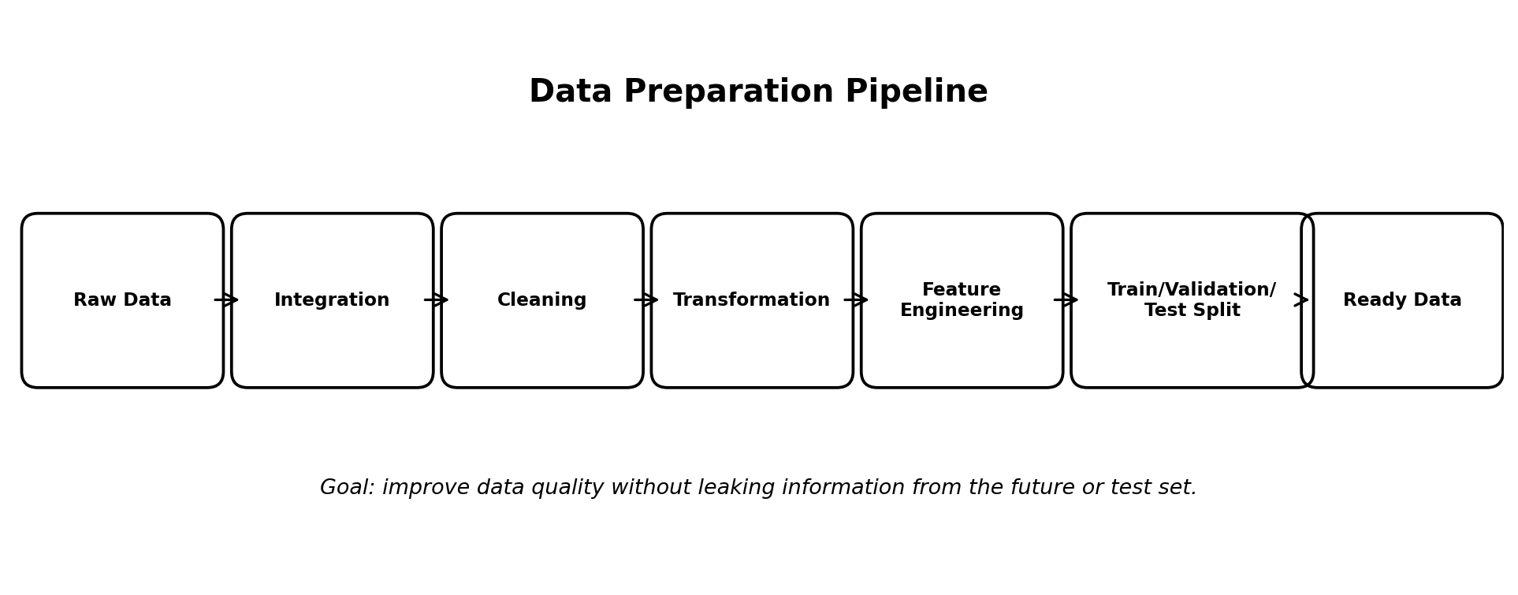
Figure 3: Main stages in a data preparation pipeline.

5.2 Data Quality Dimensions
Dimension | Question
Accuracy | Does the value correctly represent reality?
Completeness | Are important values present?
Consistency | Do formats, labels and units agree across sources?
Validity | Does the value follow allowed rules or ranges?
Uniqueness | Are duplicate records avoided?
Timeliness | Is the data recent enough for the purpose?

5.3 Main Data Preparation Operations
Operation | What it means | Examples
Cleaning | Correct or handle data-quality problems | Missing values, duplicates, spelling errors, invalid ranges
Integration | Combine data from multiple sources | Join attendance and marks using student_id
Transformation | Change representation or scale | Date conversion, normalization, category encoding
Feature engineering | Create useful input variables | Attendance percentage, average test score
Feature selection | Keep relevant variables | Remove ID columns or redundant features
Reduction | Reduce size or complexity | Sampling, aggregation, dimensionality reduction

5.4 Handling Common Problems
- Missing values: remove the record only when justified, fill using a suitable value, or keep an explicit “unknown” category.
- Duplicates: identify repeated records and retain the authoritative record.
- Inconsistent labels: standardize entries such as “CSE”, “Computer Science” and “computer science”.
- Outliers: investigate extreme values before removing them; an outlier may be an error or a genuine rare event.
- Invalid values: apply domain rules, such as marks between 0 and 100.
- Incorrect data types: convert text dates, numeric strings and Boolean values into suitable types.
CAUTION | Never remove an outlier only because it is unusual. First determine whether it is an error, a valid rare case or an important event.

5.5 Feature, Label and Dataset Split
Term | Meaning | Student example
Feature (input) | Variable used to make a prediction | Attendance, internal marks, assignment score
Label / target (output) | Value the model should predict | Pass / fail
Training set | Data used to learn the model | Earlier student records used for learning
Validation set | Data used to tune choices | Used to compare settings or models
Test set | Unseen data used for final evaluation | Held-out records not used in training

EXAM TIP | Data leakage occurs when information unavailable at prediction time enters the training process. It gives unrealistically high performance.

5.6 Worked Cleaning Example
Raw record | Problem | Possible action
Course = “CSE”, “Computer Science”, “cse” | Inconsistent category labels | Map all to one standard label
Attendance = 112% | Invalid range | Verify source and correct; do not silently accept
Marks = “Absent” in numeric column | Mixed data type | Represent absence according to institutional policy
Same student appears twice | Duplicate | Use student_id and verify the authoritative record
One score is blank | Missing value | Investigate reason; choose a justified treatment

6. Machine Learning Fundamentals

6.1 Definition
Machine Learning (ML) is a method of building systems that learn patterns from data or feedback and improve their performance on a task without requiring every decision rule to be written manually.
Traditional Programming | Machine Learning
Rules + Data → Output | Data + Correct Outputs → Learned Model
Developer explicitly writes decision logic | Algorithm estimates decision logic from examples
Suitable when rules are clear and stable | Useful when patterns are complex or too numerous to write manually

EXAMPLE | Instead of writing thousands of rules for spam email, an ML model learns from examples labeled “spam” and “not spam”.

6.2 Essential Terms
Term | Meaning
Dataset | A collection of records used for analysis or learning
Sample / instance | One record or observation
Feature | An input variable describing a sample
Label / target | The correct output to be predicted
Algorithm | A method used to learn from data
Model | The learned pattern or function produced by training
Training | Process of learning model parameters from data
Prediction / inference | Using the trained model on new input
Metric | A numerical measure of performance

6.3 General ML Workflow
1. Define the task and success measure.
2. Collect relevant and ethically usable data.
3. Prepare the data and create features.
4. Split data into training, validation and test sets.
5. Choose a simple baseline and candidate algorithms.
6. Train the model.
7. Evaluate using suitable metrics and error analysis.
8. Check fairness, privacy, robustness and practical usefulness.
9. Deploy with appropriate human oversight.
10. Monitor performance and update when conditions change.

6.4 Generalization, Underfitting and Overfitting
Concept | Meaning | Result
Generalization | Performs well on new, unseen data | Desired behavior
Underfitting | Model is too simple or insufficiently trained | Poor on training and test data
Overfitting | Model memorizes training details and noise | Good training result but poor test result

MEMORY AID | Underfitting = model learns too little. Overfitting = model memorizes too much. Generalization = model learns the useful pattern.

6.5 Basic Evaluation Measures
Task | Common measures | Simple meaning
Classification | Accuracy, precision, recall, F1-score | How correctly categories are predicted
Regression | MAE, MSE, RMSE, R² | How close predicted numbers are to actual values
Clustering | Silhouette score and practical interpretation | How meaningful and separated the groups are

EXAM TIP | Accuracy alone may be misleading when one class is rare. Example: fraud, disease or at-risk students.

7. Types of Machine Learning
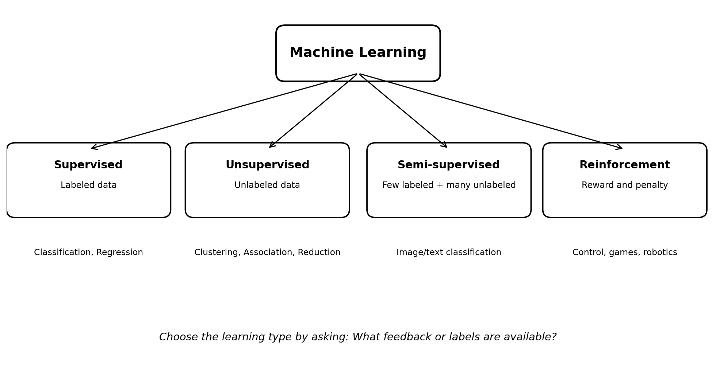
Figure 4: Major types of Machine Learning based on the feedback available to the learner.

7.1 Supervised Learning
Supervised learning uses labeled examples. Each training sample contains input features and the correct output. The model learns a mapping from inputs to outputs.
Task | Output | Examples
Classification | Category or class | Spam/not spam, pass/fail, disease present/absent
Regression | Continuous numeric value | House price, temperature, sales, delivery time

MEMORY AID | Classification = class/category. Regression = real numeric value.

7.2 Unsupervised Learning
Unsupervised learning works with data that has no known target label. The system discovers hidden structure, groups, associations or compact representations.
Task | Purpose | Example
Clustering | Group similar samples | Student learning-profile groups
Association | Find events or items that occur together | Market basket analysis
Dimensionality reduction | Represent many variables using fewer dimensions | Visualization and compression
Anomaly detection | Identify unusual patterns | Network intrusion or fraud review

7.3 Semi-supervised Learning
Semi-supervised learning combines a small amount of labeled data with a larger amount of unlabeled data. It is useful when raw data is easy to collect but expert labeling is costly.
- Medical images labeled by specialists.
- Large image collections with labels for only a small subset.
- Speech or text data where manual annotation takes time.

7.4 Reinforcement Learning
In reinforcement learning, an agent interacts with an environment, takes actions and receives rewards or penalties. It learns a policy that aims to maximize long-term reward.
Element | Meaning | Example in a game
Agent | Learner or decision maker | Game-playing program
Environment | World in which the agent acts | Game board
State | Current situation | Current board position
Action | Choice made by the agent | Move a piece
Reward | Feedback after an action | Points, win or loss
Policy | Strategy for choosing actions | Rule learned for selecting moves

Learning type | Training information | Main goal | Example
Supervised | Labeled data | Predict known output | Email classification
Unsupervised | Unlabeled data | Discover structure | Customer clustering
Semi-supervised | Few labels + many unlabeled samples | Improve learning with limited labels | Medical image classification
Reinforcement | Rewards from interaction | Learn a sequence of actions | Robot navigation

8. Applications and Problem Selection

8.1 Match the Problem with the Learning Type
Problem statement | Expected output | Suitable type
Predict whether an email is spam | Spam / not spam | Supervised classification
Estimate next month’s electricity demand | Numeric demand value | Supervised regression
Group customers by buying behavior | Natural customer groups | Unsupervised clustering
Find products commonly bought together | Association rules | Unsupervised association mining
Use a few labeled X-rays and many unlabeled X-rays | Disease category | Semi-supervised learning
Teach a robot to reach a destination through trial and feedback | Sequence of actions | Reinforcement learning

8.2 Common Applications
Application | Possible data | Possible ML task
Recommendation system | Clicks, ratings, purchases | Ranking / prediction / clustering
Fraud detection | Transaction time, amount, location | Classification or anomaly detection
Predictive maintenance | Sensor readings and failure history | Classification or regression
Image recognition | Labeled images | Classification
Demand forecasting | Historical sales, season, price | Regression / time-series prediction
Language translation | Source and target sentences | Sequence learning

SELECTION RULE | First identify the required output: category, number, group, association or sequence of actions. Then choose the learning type.

8.3 AI vs ML vs Data Science: One Example
Consider an online shopping recommendation feature:
- Data Science: defines the business question, prepares customer data, evaluates impact and communicates results.
- Data Mining: discovers products frequently purchased together or customer segments.
- Machine Learning: trains a model to predict which products a user may prefer.
- Artificial Intelligence: is the broader goal of providing intelligent, adaptive recommendations.

9. Integrated Case Study: Student Support Analytics

9.1 Problem Statement
A college wants to identify students who may need academic support before the final examination. The purpose is to provide help early, not to punish or permanently label students.

9.2 Possible Data
- Attendance records
- Internal examination marks
- Assignment completion
- Practical performance
- Previous semester results
- Support sessions already provided

9.3 Data Preparation
1. Join different tables using student_id.
2. Remove confirmed duplicate records.
3. Check attendance and marks for impossible values.
4. Standardize course and semester labels.
5. Create features such as attendance percentage and average internal score.
6. Exclude irrelevant or unfair variables.
7. Split data so that future information does not leak into training.

9.4 Possible ML Formulations
Question | Formulation
Will the student require support? | Binary classification
What final score is expected? | Regression
What learning profiles exist? | Clustering
Which attendance and assessment patterns occur together? | Association analysis

9.5 Evaluation and Responsible Use
- Check how many genuinely at-risk students are identified (recall).
- Review false alarms to avoid unnecessary anxiety or stigma.
- Allow teachers to verify records and override incorrect output.
- Protect student data and limit access.
- Evaluate whether the support intervention improves outcomes.
KEY POINT | A prediction should support a human decision; it should not automatically determine a student’s future.

10. Responsible Data Science and AI

10.1 Main Concerns
Concern | Meaning | Good practice
Privacy | Personal data may be exposed or misused | Collect minimum necessary data and control access
Bias and fairness | Some groups may receive systematically worse results | Check data representation and compare errors across groups
Transparency | Users may not understand how a result was produced | Document data, methods, limitations and intended use
Security | Data or models may be attacked or stolen | Use authentication, encryption and monitoring
Accountability | Responsibility may become unclear | Assign human owners and review processes
Reliability | Performance may fall when conditions change | Monitor errors and data drift

10.2 Responsible Development Checklist
- Is the problem worth solving with data or AI?
- Do we have permission and a valid purpose for using the data?
- Is the data accurate, representative and sufficiently recent?
- Which people may be helped or harmed by errors?
- Can a human review or correct the output?
- How will performance, fairness and security be monitored?
CAUTION | A highly accurate model may still be unsuitable if it violates privacy, creates unfair treatment or cannot be used safely.

11. Quick Revision and Glossary

11.1 One-Page Concept Summary
Concept | One-line revision
Artificial Intelligence | Broad field of creating systems that perform intelligent tasks.
Data Science | Complete process of using data to understand problems and support decisions.
Data Mining | Discovery of useful patterns, trends and anomalies in data.
Data Preparation | Cleaning, integrating and transforming raw data into usable form.
Machine Learning | Algorithms that learn patterns from data or feedback.
Supervised Learning | Learns from labeled input-output examples.
Unsupervised Learning | Discovers structure in unlabeled data.
Semi-supervised Learning | Uses few labeled and many unlabeled examples.
Reinforcement Learning | Learns actions using rewards and penalties.
Classification | Predicts a category.
Regression | Predicts a numeric value.
Clustering | Groups similar samples without known labels.

11.2 Important Differences
Pair | Difference
AI vs ML | AI is the broad goal/field; ML is a data-driven approach within AI.
Data Science vs Data Mining | Data Science is the full life cycle; Data Mining focuses on pattern discovery.
Classification vs Regression | Classification predicts categories; regression predicts continuous numbers.
Supervised vs Unsupervised | Supervised uses labels; unsupervised has no known target labels.
Training vs Testing | Training teaches the model; testing measures performance on unseen data.
Feature vs Label | Feature is an input; label is the target output.

11.3 Glossary
Term | Meaning
Algorithm | A step-by-step computational method.
Anomaly | An unusual record or pattern that differs strongly from normal data.
Bias | A systematic tendency that may produce unfair or inaccurate results.
Data leakage | Use of information during training that would not be available at prediction time.
Deep Learning | ML based on multi-layer neural networks.
Feature engineering | Creating useful input variables from existing data.
Inference | Using a trained model to make a prediction.
Model | A learned mathematical representation used for prediction or decision-making.
Outlier | An observation far from most other observations.
Overfitting | Learning training details so closely that new-data performance becomes poor.

12. Self-Assessment

12.1 Multiple-Choice Questions
1. Which term refers to raw facts and observations?
a) Model b) Data c) Knowledge d) Decision
2. Most AI systems used today are:
a) General AI b) Narrow AI c) Human intelligence d) None
3. Which field covers the complete data-to-decision process?
a) Data Science b) Data entry c) Networking d) Operating system
4. Finding products that occur together is mainly:
a) Regression b) Association mining c) Compilation d) Encryption
5. Which is a data-quality dimension?
a) Accuracy b) Animation c) Inheritance d) Recursion
6. Predicting pass/fail is:
a) Regression b) Classification c) Clustering d) Compression
7. Predicting house price is:
a) Regression b) Classification c) Association d) Reinforcement
8. Grouping customers without labels is:
a) Supervised learning b) Clustering c) Regression d) Rule writing
9. Which learning type uses rewards and penalties?
a) Reinforcement b) Supervised c) Unsupervised d) Semi-structured
10. A model that performs well on training data but poorly on new data is:
a) Generalized b) Overfitted c) Encrypted d) Normalized
11. Information unavailable at prediction time entering training is:
a) Data leakage b) Sampling c) Visualization d) Clustering
12. Which set is used for final evaluation on unseen data?
a) Training set b) Test set c) Duplicate set d) Rule set

12.2 Short-Answer Questions
1. Define Artificial Intelligence with one example.
2. What is Data Science? Write any four foundations of Data Science.
3. Why is data preparation important?
4. Differentiate structured and unstructured data.
5. Write the stages of the Data Science life cycle.
6. What is Data Mining? List four common tasks.
7. Differentiate classification and regression.
8. What is overfitting?
9. Explain semi-supervised learning with one use case.
10. List four responsible-AI concerns.

12.3 Long-Answer Questions
1. Explain the fundamentals, capabilities, applications and limitations of Artificial Intelligence.
2. Explain the need for Data Science and describe its life cycle with a suitable example.
3. Describe the complete data preparation process and common data-quality problems.
4. Explain supervised, unsupervised, semi-supervised and reinforcement learning with applications.
5. Develop a simple Data Science plan for identifying students who may require academic support.

12.4 Classroom / Homework Activities
Activity | Task
Data audit | Take a small marksheet and identify missing values, duplicates and invalid values.
Problem matching | Write five real-life problems and identify classification, regression, clustering or association.
Life-cycle map | Choose one college problem and describe all stages from problem definition to monitoring.
Ethics discussion | Explain one benefit and one possible harm of using AI in education.

12.5 MCQ Answer Key
1-b, 2-b, 3-a, 4-b, 5-a, 6-b, 7-a, 8-b, 9-a, 10-b, 11-a, 12-b
FINAL REVISION | For every topic, remember: definition → main features → example → application → limitation or caution.

