UNIT 02
DATA PREPROCESSING,
ANALYSIS AND
VISUALIZATION
STUDENT NOTES
Syllabus coverage:
Mean Removal • Scaling • Normalization • Binarization • One-Hot Encoding • Label Encoding • Loading and Summarizing Data • Univariate and Multivariate Plots • Training and Test Data • Performance Measures

Understand the data → Prepare it correctly → Visualize it → Evaluate the model

A. How to Use These Notes
- Start with the basics: learn sample, feature, target, numeric data and categorical data before studying transformations.
- Work through every calculation: the small numerical examples explain what the library functions do internally.
- Run the Python code: type the programs yourself and compare the input with the transformed output.
- Revise with comparisons: pay special attention to scaling versus normalization and label versus one-hot encoding.
- Test yourself: attempt the MCQs, short questions and practical exercises at the end.
STUDY RULE | For every preprocessing technique, remember three things: why it is needed, what it changes, and when it should be used.

B. Learning Outcomes
- Explain why raw data usually requires preprocessing.
- Perform mean removal, standardization, min-max scaling, normalization and binarization.
- Convert categorical data using label encoding and one-hot encoding.
- Load and summarize a dataset with pandas.
- Choose suitable univariate and multivariate plots.
- Differentiate training data and test data and avoid data leakage.
- Calculate and interpret common classification and regression measures.

C. Contents
1. Basic Dataset Concepts
2. Data Preprocessing Overview
3. Mean Removal and Scaling
4. Normalization and Binarization
5. Encoding Categorical Data
6. Loading and Summarizing a Dataset
7. Univariate Data Visualization
8. Multivariate Data Visualization
9. Training Data and Test Data
10. Performance Measures
11. Complete Practical Workflow
12. Quick Revision and Glossary
13. Self-Assessment

1. Basic Dataset Concepts

1.1 What is a Dataset?
A dataset is an organized collection of related observations. In a table, each row usually represents one observation and each column represents one characteristic of that observation.
Student_ID | Hours_Studied | Attendance | Department | Result
S01 | 2 | 68 | CSE | Fail
S02 | 5 | 82 | IT | Pass
S03 | 7 | 91 | CSE | Pass
S04 | 3 | 74 | ECE | Fail

Term | Meaning | Example from table
Sample / observation | One row of the dataset | The complete record of student S02
Feature | An input variable used to describe or predict | Hours_Studied, Attendance, Department
Target / label | The output that a model tries to predict | Result
Numeric feature | A feature represented by numbers | Attendance = 82
Categorical feature | A feature containing categories or names | Department = IT

MEMORY AID | Rows are samples. Columns are variables. Input columns are features. The output column is the target.

1.2 Why Data Needs Preparation
- Features may use very different ranges, such as age in years and income in thousands.
- Machine-learning algorithms generally require numbers, but datasets may contain text categories.
- Values may be missing, duplicated, inconsistent or incorrectly typed.
- A model may learn misleading patterns if test data influences preprocessing.
- Charts and summaries are needed to understand distributions, relationships and unusual values.

2. Data Preprocessing Overview

2.1 Meaning
Data preprocessing is the set of operations used to convert raw data into a clean and suitable form for analysis or machine learning. It improves consistency, comparability and model reliability.
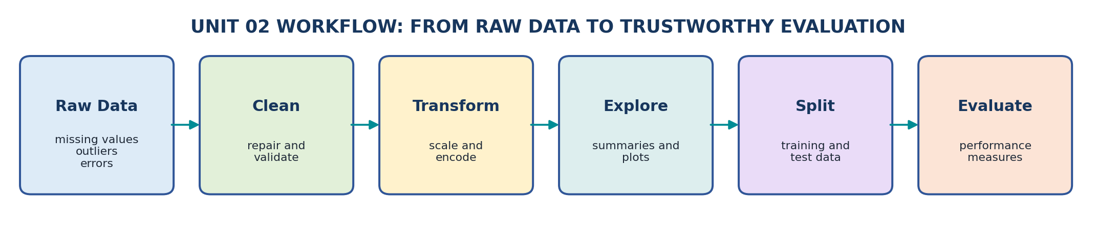
Figure 1: A simple workflow from raw data to model evaluation.
Problem in data | Possible preprocessing operation
Features have different scales | Standardization or min-max scaling
Rows have different vector lengths | Normalization
Only yes/no information is required | Binarization
Categories are written as text | Label, ordinal or one-hot encoding
Values are missing or duplicated | Cleaning and validation
Dataset is too large or complex | Selection, sampling or reduction

KEY POINT | Preprocessing does not mean changing data randomly. Every transformation must be selected according to the data type, algorithm and problem objective.

3. Mean Removal and Scaling

3.1 Mean Removal (Centering)
Mean removal subtracts the mean of a feature from every value. After centering, the transformed feature has a mean of zero.
FORMULA | Centered value = Original value - Mean of the feature

Example: values = [10, 20, 30, 40]. Mean = (10 + 20 + 30 + 40) / 4 = 25.
Original value | Calculation | Centered value
10 | 10 - 25 | -15
20 | 20 - 25 | -5
30 | 30 - 25 | 5
40 | 40 - 25 | 15

KEY POINT | Mean removal changes the centre of the feature but does not automatically make its standard deviation equal to 1.

3.2 Standardization
Standardization first removes the mean and then divides by the standard deviation. The transformed feature normally has mean 0 and standard deviation 1.
FORMULA | z = (x - mean) / standard deviation

- Useful for: algorithms affected by feature scale, such as k-nearest neighbours, support vector machines, logistic regression and many gradient-based methods.
- Result: values are not restricted to a fixed range; negative and positive values are common.
- Outliers: because mean and standard deviation are affected by extreme values, standardization can also be influenced by outliers.
Python: mean removal and standardization
import numpy as np
from sklearn.preprocessing import StandardScaler
X = np.array([[10], [20], [30], [40]])
scaler = StandardScaler()
X_standard = scaler.fit_transform(X)
print(scaler.mean_)
print(X_standard)

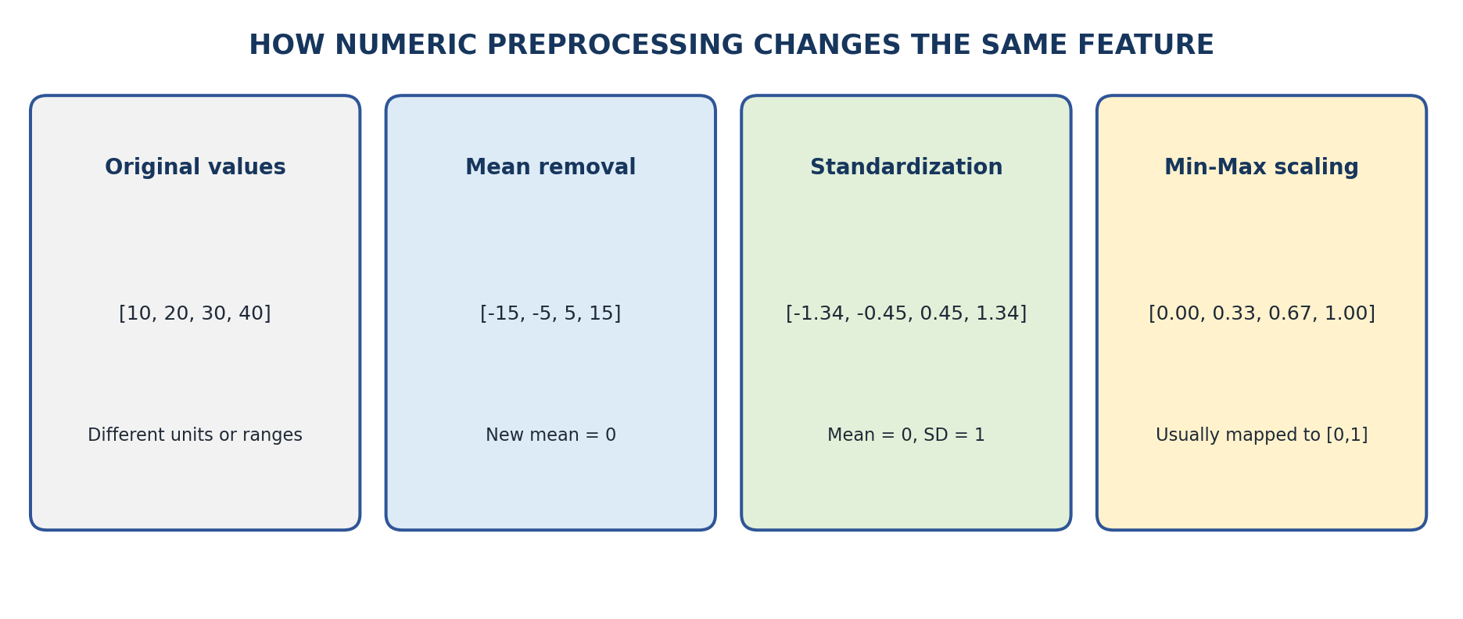
Figure 2: Comparison of centering, standardization and min-max scaling.

3.3 Min-Max Scaling
Min-max scaling maps each feature into a selected range, commonly 0 to 1. The smallest training value becomes 0 and the largest becomes 1.
FORMULA | x_scaled = (x - minimum) / (maximum - minimum)

For [10, 20, 30, 40], minimum = 10 and maximum = 40. The scaled value of 20 is (20 - 10) / (40 - 10) = 0.33.
Python: min-max scaling
import numpy as np
from sklearn.preprocessing import MinMaxScaler
X = np.array([[10], [20], [30], [40]])
scaler = MinMaxScaler(feature_range=(0, 1))
X_scaled = scaler.fit_transform(X)
print(X_scaled)

Method | Main transformation | Usual result | Important point
Mean removal | Subtract feature mean | Mean becomes 0 | Scale is unchanged
Standardization | Subtract mean and divide by SD | Mean 0, SD 1 | No fixed minimum/maximum
Min-max scaling | Use feature minimum and maximum | Usually values in [0,1] | Extreme values determine the range

EXAM TIP | Scaling is normally performed column by column because each column represents a different feature.

4. Normalization and Binarization

4.1 Normalization
Normalization rescales each sample so that the complete row has unit length. It is different from feature scaling because it works row by row rather than column by column.
FORMULA | L2 norm of [a, b] = sqrt(a^2 + b^2). Normalized row = row / its L2 norm.

Example: row = [3, 4]. L2 norm = sqrt(3^2 + 4^2) = 5. Normalized row = [3/5, 4/5] = [0.6, 0.8].
Original row | L2 norm | Normalized row
[3, 4] | 5 | [0.6, 0.8]
[5, 12] | 13 | [0.385, 0.923]

Python: row normalization
import numpy as np
from sklearn.preprocessing import Normalizer
X = np.array([[3, 4], [5, 12]])
normalizer = Normalizer(norm='l2')
X_normal = normalizer.transform(X)
print(X_normal)

WHEN USEFUL | Normalization is often useful when direction or relative proportions matter more than total magnitude, such as some text-vector and similarity problems.

Question | Scaling | Normalization
Works on | Each feature / column | Each sample / row
Main purpose | Make features comparable | Make sample length equal to 1
Uses information from other rows? | Yes, feature statistics are learned from training data | No, each row is transformed using its own values
Typical tool | StandardScaler or MinMaxScaler | Normalizer

4.2 Binarization
Binarization converts numeric values into two values, usually 0 and 1, according to a threshold. Values greater than the threshold become 1; other values become 0.
RULE | Output = 1 when value > threshold; otherwise output = 0.

Example: marks = [35, 48, 62, 80] and threshold = 50. Output = [0, 0, 1, 1].
Python: binarization
import numpy as np
from sklearn.preprocessing import Binarizer
X = np.array([[35], [48], [62], [80]])
binarizer = Binarizer(threshold=50)
print(binarizer.transform(X))

CAUTION | Binarization removes information. After conversion, 62 and 80 both become 1, so their original difference is lost.

5. Encoding Categorical Data

5.1 Why Encoding is Needed
Many machine-learning algorithms operate on numbers. Therefore, text categories such as department, city or colour must be represented numerically without creating false meaning.
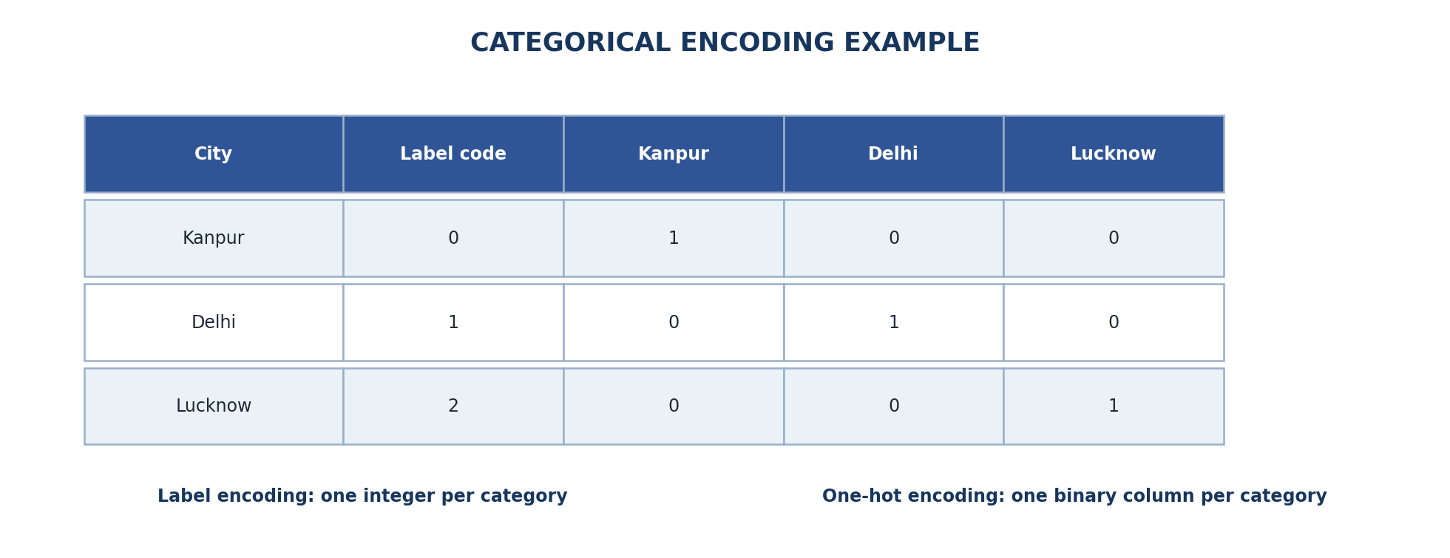
Figure 3: Label codes and one-hot columns for the same city categories.

5.2 Label Encoding
Label encoding assigns one integer to each class. It is mainly appropriate for the target variable in a classification problem.
Original target | Encoded target
Fail | 0
Pass | 1
Excellent | 2

Python: label encoding a target
from sklearn.preprocessing import LabelEncoder
y = ['Fail', 'Pass', 'Pass', 'Excellent']
encoder = LabelEncoder()
y_encoded = encoder.fit_transform(y)
print(encoder.classes_)
print(y_encoded)

CAUTION | Do not automatically use LabelEncoder for an unordered input feature such as City. Codes 0, 1 and 2 can incorrectly suggest order or distance.

5.3 One-Hot Encoding
One-hot encoding creates one binary column for every category. Each sample receives 1 in the column representing its category and 0 in the other category columns.
City | City_Delhi | City_Kanpur | City_Lucknow
Kanpur | 0 | 1 | 0
Delhi | 1 | 0 | 0
Lucknow | 0 | 0 | 1

Python: one-hot encoding an input feature
import numpy as np
from sklearn.preprocessing import OneHotEncoder
X = np.array([['Kanpur'], ['Delhi'], ['Lucknow']])
encoder = OneHotEncoder(sparse_output=False, handle_unknown='ignore')
X_encoded = encoder.fit_transform(X)
print(encoder.get_feature_names_out())
print(X_encoded)

Point | Label encoding | One-hot encoding
Output | One integer column | One binary column per category
Best basic use | Target labels | Unordered input categories
Possible problem | May create false order for input data | Can create many columns when categories are numerous
Example | Pass -> 1 | City_Kanpur -> 1

MEMORY AID | LabelEncoder is generally for y (target). OneHotEncoder is generally for categorical columns in X (features).

6. Loading and Summarizing a Dataset

6.1 Loading a CSV File
pandas represents tabular data using a DataFrame. The read_csv() function loads a comma-separated values file into a DataFrame.
Python: load a dataset
import pandas as pd
df = pd.read_csv('students.csv')
print(df.head())

Command | Purpose
df.head() | Display the first 5 rows
df.tail() | Display the last 5 rows
df.shape | Return (number of rows, number of columns)
df.columns | Display column names
df.dtypes | Display the data type of each column
df.info() | Print a compact summary of columns, non-null counts and data types
df.describe() | Calculate numeric summary statistics

OUTPUT READING | If df.shape returns (150, 5), the dataset contains 150 rows and 5 columns.

6.2 Numerical Summary
Statistic | Meaning
count | Number of non-missing values
mean | Arithmetic average
std | Standard deviation; indicates spread
min | Smallest value
25% | First quartile
50% | Median
75% | Third quartile
max | Largest value

Python: common summaries and quality checks
print(df.describe())
print(df['Department'].value_counts())
print(df.isnull().sum())
print(df.duplicated().sum())

Question about data | Useful command
How many rows and columns? | df.shape
What are the column names? | df.columns
Which columns are numeric or text? | df.dtypes or df.info()
What is the average and spread? | df.describe()
How many records belong to each category? | df[column].value_counts()
How many values are missing? | df.isnull().sum()
How many duplicate rows exist? | df.duplicated().sum()

STUDY HABIT | Never start modelling immediately after loading a file. First inspect rows, shape, data types, missing values, duplicates and summary statistics.

7. Univariate Data Visualization

7.1 Meaning
A univariate plot studies one variable at a time. It helps us understand frequency, centre, spread, skewness and possible outliers.
Data type / purpose | Suitable plot | What it shows
One categorical variable | Bar chart / count plot | Frequency of each category
One numeric variable | Histogram | Shape and frequency distribution
One numeric variable | Box plot | Median, quartiles, spread and possible outliers
Ordered values over time | Line plot | Trend across time or sequence

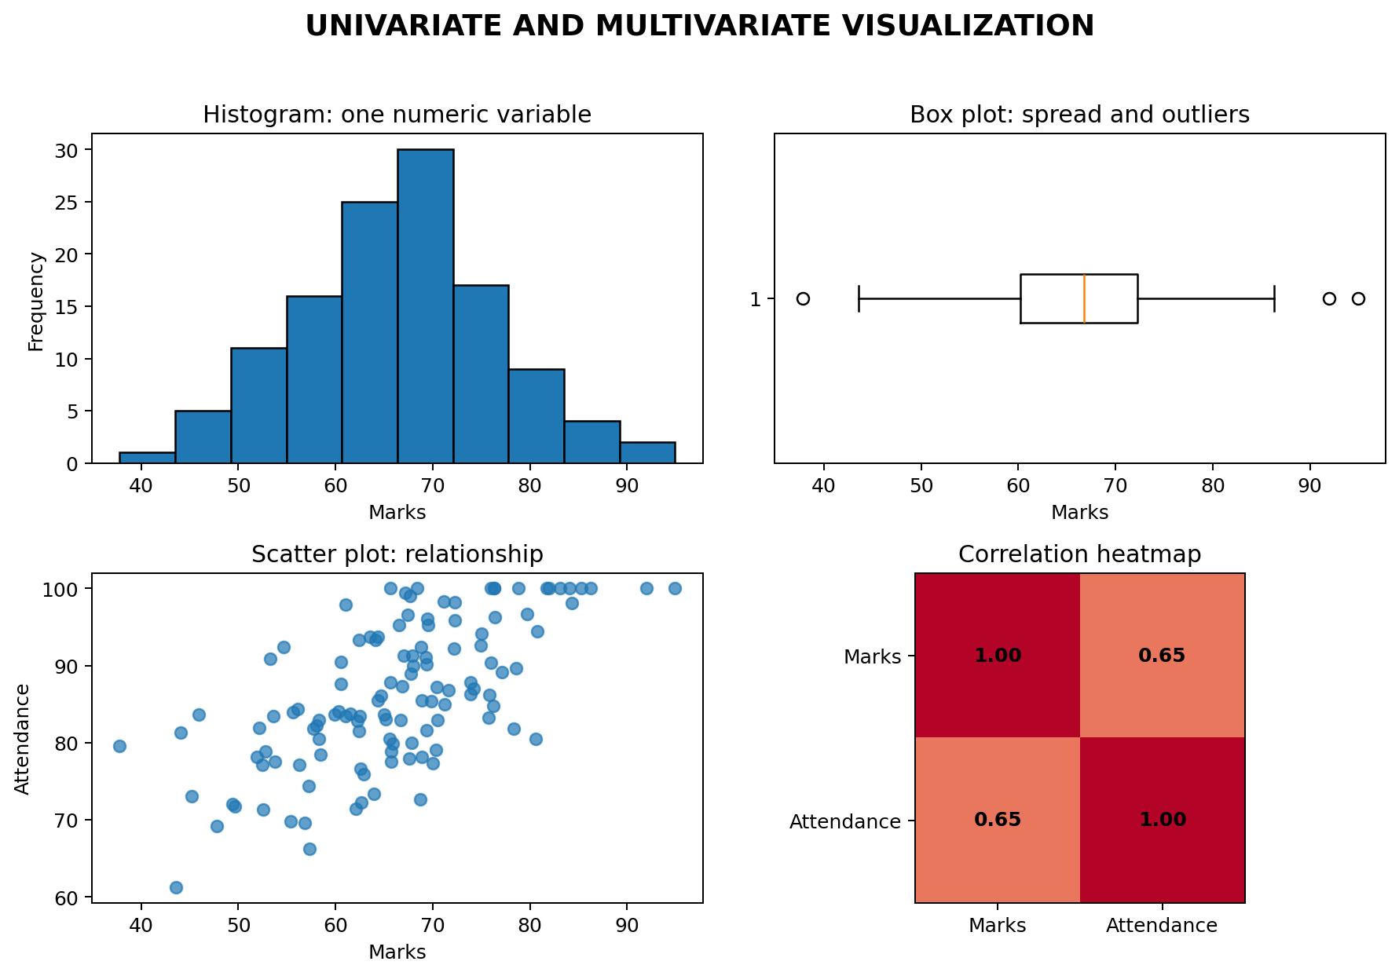
Figure 4: Examples of histogram, box plot, scatter plot and correlation heatmap.

7.2 Histogram
A histogram divides numeric values into intervals called bins and shows how many observations fall in each interval. It is used for continuous or numeric data, not category names.
Python: histogram
import matplotlib.pyplot as plt
df['Marks'].plot(kind='hist', bins=8, edgecolor='black')
plt.xlabel('Marks')
plt.title('Distribution of Marks')
plt.show()

7.3 Bar Chart
Python: bar chart for category counts
df['Department'].value_counts().plot(kind='bar')
plt.xlabel('Department')
plt.ylabel('Number of students')
plt.title('Students by Department')
plt.show()

7.4 Box Plot
A box plot summarizes a numeric distribution through quartiles. Points far from the main range may be shown as possible outliers, but they should be investigated rather than automatically deleted.
Python: box plot
df['Marks'].plot(kind='box')
plt.title('Box Plot of Marks')
plt.show()

EXAM TIP | Bar charts compare categories. Histograms show the distribution of numerical values grouped into bins.

8. Multivariate Data Visualization

8.1 Meaning
A multivariate plot studies two or more variables together. It is used to identify relationships, group differences, interactions and patterns that are not visible in one variable alone.
Plot | Variables compared | Main use
Scatter plot | Two numeric variables | Study direction, strength and pattern of association
Grouped / stacked bar chart | Two categorical variables or category plus aggregate | Compare subgroups
Box plot by category | One numeric and one categorical variable | Compare distributions across groups
Pair plot | Several numeric variables | View many pairwise relationships
Correlation heatmap | Several numeric variables | Display a correlation matrix

8.2 Scatter Plot
Python: scatter plot
import matplotlib.pyplot as plt
plt.scatter(df['Hours_Studied'], df['Marks'])
plt.xlabel('Hours Studied')
plt.ylabel('Marks')
plt.title('Hours Studied vs Marks')
plt.show()

8.3 Correlation Heatmap
Correlation measures the direction and strength of a linear relationship between numeric variables. Its value ranges from -1 to +1.
Correlation value | Basic interpretation
Near +1 | Strong positive linear relationship
Near 0 | Weak or no linear relationship
Near -1 | Strong negative linear relationship

Python: simple correlation heatmap
import matplotlib.pyplot as plt
corr = df.select_dtypes(include='number').corr()
plt.imshow(corr, vmin=-1, vmax=1, cmap='coolwarm')
plt.colorbar()
plt.xticks(range(len(corr.columns)), corr.columns, rotation=45)
plt.yticks(range(len(corr.columns)), corr.columns)
plt.title('Correlation Heatmap')
plt.tight_layout()
plt.show()

CAUTION | Correlation does not prove causation. Two variables can move together because of coincidence, a third variable or a complex relationship.

9. Training Data and Test Data

9.1 Why Split a Dataset?
A model must be evaluated on data that it did not use for learning. Therefore, the available dataset is commonly divided into training data and test data.
Part | Purpose | Typical proportion
Training data | Used to learn model parameters and fit preprocessing operations | About 70% to 80%
Test data | Used for final evaluation on unseen examples | About 20% to 30%
Validation data (when used) | Used for model selection and tuning before final testing | Taken separately or created through cross-validation

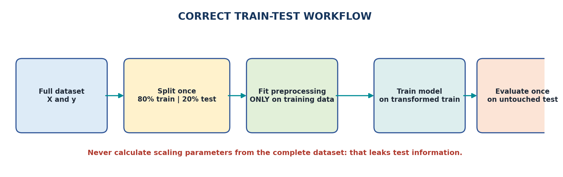
Figure 5: Correct order for splitting, preprocessing, training and evaluation.
Python: train-test split
from sklearn.model_selection import train_test_split
X = df[['Hours_Studied', 'Attendance']]
y = df['Result']
X_train, X_test, y_train, y_test = train_test_split(
X, y,
test_size=0.20,
random_state=42,
stratify=y
)
print(X_train.shape)
print(X_test.shape)

Argument | Meaning
test_size=0.20 | 20% of records are placed in the test set
random_state=42 | Makes the random split reproducible
stratify=y | Keeps class proportions similar in training and test sets

9.2 Data Leakage
Data leakage occurs when information that should be unavailable during training enters the learning process. Leakage produces unrealistically good evaluation results and poor performance on truly new data.
RULE | Split first. Fit scalers and encoders only on training data. Use the fitted objects to transform the test data.

Correct fitting of a scaler
from sklearn.preprocessing import StandardScaler
scaler = StandardScaler()
X_train_scaled = scaler.fit_transform(X_train)
X_test_scaled = scaler.transform(X_test) # no fit on test data

10. Performance Measures

10.1 Classification and Regression
Problem type | Output | Example
Classification | A category or class | Pass / Fail, Spam / Not Spam
Regression | A continuous numeric value | Marks, price, temperature

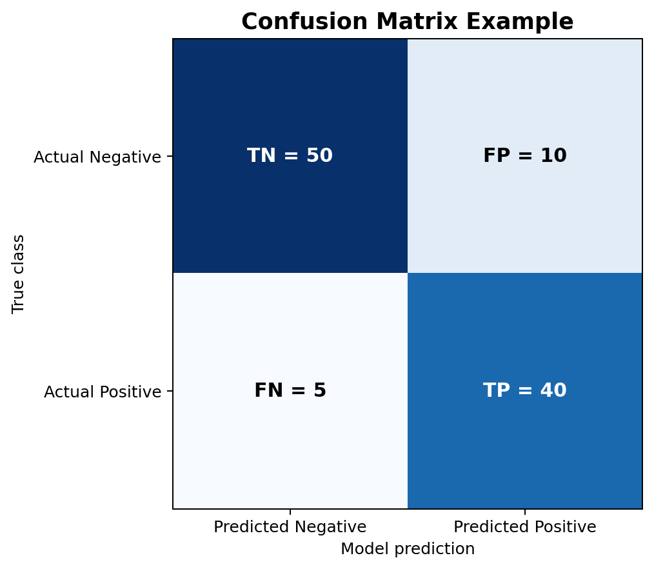
Figure 6: Confusion matrix terms for binary classification.
Term | Meaning
True Positive (TP) | Positive case correctly predicted as positive
True Negative (TN) | Negative case correctly predicted as negative
False Positive (FP) | Negative case incorrectly predicted as positive
False Negative (FN) | Positive case incorrectly predicted as negative

10.2 Classification Measures
Measure | Formula | Meaning
Accuracy | (TP + TN) / Total | Overall fraction of correct predictions
Precision | TP / (TP + FP) | Of predicted positives, how many were correct?
Recall | TP / (TP + FN) | Of actual positives, how many were found?
F1-score | 2 x Precision x Recall / (Precision + Recall) | Balance between precision and recall

Using the confusion matrix in Figure 6: TP = 40, TN = 50, FP = 10 and FN = 5.
Measure | Calculation | Result
Accuracy | (40 + 50) / 105 | 0.857 or 85.7%
Precision | 40 / (40 + 10) | 0.800 or 80.0%
Recall | 40 / (40 + 5) | 0.889 or 88.9%
F1-score | 2 x 0.800 x 0.889 / (0.800 + 0.889) | About 0.842

CHOOSING A METRIC | Accuracy can be misleading when one class is much more common. Use precision, recall, F1-score and the confusion matrix to understand the types of errors.

Python: classification measures
from sklearn.metrics import accuracy_score, precision_score
from sklearn.metrics import recall_score, f1_score, confusion_matrix
print(accuracy_score(y_test, y_pred))
print(precision_score(y_test, y_pred, pos_label='Pass'))
print(recall_score(y_test, y_pred, pos_label='Pass'))
print(f1_score(y_test, y_pred, pos_label='Pass'))
print(confusion_matrix(y_test, y_pred))

10.3 Regression Measures
Measure | Meaning | Better value
MAE: Mean Absolute Error | Average absolute difference between actual and predicted values | Smaller
MSE: Mean Squared Error | Average squared error; gives more weight to large errors | Smaller
RMSE: Root Mean Squared Error | Square root of MSE; same unit as the target | Smaller
R-squared (R2) | Proportion of target variation explained relative to a mean baseline | Closer to 1, interpreted with context

FORMULAS | MAE = average(|actual - predicted|); MSE = average((actual - predicted)^2); RMSE = sqrt(MSE).

Python: regression measures
from sklearn.metrics import mean_absolute_error
from sklearn.metrics import mean_squared_error, r2_score
mae = mean_absolute_error(y_test, y_pred)
mse = mean_squared_error(y_test, y_pred)
rmse = mse ** 0.5
r2 = r2_score(y_test, y_pred)
print(mae, mse, rmse, r2)

11. Complete Practical Workflow

11.1 Iris Classification Example
The following program loads the Iris dataset, summarizes it, creates a training-test split, standardizes the numeric features, trains a logistic-regression classifier and evaluates accuracy. A Pipeline keeps preprocessing and modelling in the correct order.
Complete scikit-learn practical
import pandas as pd
from sklearn.datasets import load_iris
from sklearn.model_selection import train_test_split
from sklearn.pipeline import Pipeline
from sklearn.preprocessing import StandardScaler
from sklearn.linear_model import LogisticRegression
from sklearn.metrics import accuracy_score, confusion_matrix
# 1. Load data
iris = load_iris(as_frame=True)
X = iris.data
y = iris.target
# 2. Summarize data
print(X.head())
print(X.shape)
print(X.describe())
print(y.value_counts())
# 3. Split data
X_train, X_test, y_train, y_test = train_test_split(
X, y, test_size=0.20, random_state=42, stratify=y
)
# 4. Build preprocessing + model pipeline
model = Pipeline([
('scaler', StandardScaler()),
('classifier', LogisticRegression(max_iter=1000))
])
# 5. Train and predict
model.fit(X_train, y_train)
y_pred = model.predict(X_test)
# 6. Evaluate
print('Accuracy:', accuracy_score(y_test, y_pred))
print('Confusion matrix:
', confusion_matrix(y_test, y_pred))

1. load_iris(as_frame=True) provides the feature table and target in pandas form.
2. train_test_split creates unseen test examples.
3. StandardScaler learns mean and standard deviation only from training data because it is inside the pipeline.
4. LogisticRegression learns class boundaries from the transformed training data.
5. accuracy_score and confusion_matrix evaluate predictions on the test set.
PRACTICE EXTENSION | Replace StandardScaler with MinMaxScaler. Run the program again and compare the test result. Then draw a histogram for each Iris feature.

11.2 Recommended Order for Any Small Project
1. Define the target and identify features.
2. Load the dataset and inspect its first rows.
3. Check shape, data types, missing values, duplicates and class counts.
4. Create suitable univariate and multivariate plots.
5. Split the dataset into training and test parts.
6. Fit preprocessing operations on training data only.
7. Train the selected model.
8. Predict test data and calculate suitable performance measures.
9. Interpret errors and improve the workflow without using the test set repeatedly.

12. Quick Revision and Glossary

12.1 One-Page Revision
Topic | Remember this
Mean removal | Subtract column mean; new mean becomes 0
Standardization | Column-wise; mean 0 and standard deviation 1
Min-max scaling | Column-wise; commonly maps values to 0 to 1
Normalization | Row-wise; sample vector receives unit length
Binarization | Convert values to 0/1 using a threshold
Label encoding | Convert target classes to integer labels
One-hot encoding | Create one binary feature for every input category
Univariate plot | Study one variable
Multivariate plot | Study relationships among two or more variables
Training data | Used to learn preprocessing and model parameters
Test data | Held back for final evaluation
Accuracy | Overall correctness
Precision | Correctness of positive predictions
Recall | Coverage of actual positive cases
F1-score | Balance of precision and recall
MAE / RMSE | Regression error measures in target units

MASTER MEMORY AID | Columns are scaled. Rows are normalized. Categories are encoded. Training data teaches. Test data checks.

12.2 Glossary
Term | Simple meaning
Bin | An interval used in a histogram
Category | A named group such as CSE, IT or ECE
Data leakage | Unfair use of unavailable test information during training
Distribution | How values are spread and how frequently they occur
Fit | Learn parameters from data
Outlier | A value far from the main pattern
Pipeline | An ordered sequence of preprocessing and modelling steps
Random state | A fixed seed that makes random results reproducible
Stratification | Preserving class proportions during splitting
Transform | Apply a learned or defined data conversion

13. Self-Assessment

13.1 Multiple-Choice Questions
1. Which operation subtracts the feature mean from every value?
A. Binarization
B. Mean removal
C. One-hot encoding
D. Testing
2. Standardization normally produces a feature with:
A. Mean 0 and SD 1
B. Values only 0 and 1
C. One column per category
D. No negative values
3. Which technique usually works row by row?
A. Min-max scaling
B. Standardization
C. Normalization
D. Label encoding
4. Which encoder is generally used for an unordered input category?
A. OneHotEncoder
B. StandardScaler
C. Binarizer
D. Normalizer
5. Which pandas command reports rows and columns?
A. df.shape
B. df.mean_only()
C. df.plot_all()
D. df.labels
6. A histogram is mainly used for:
A. One numeric variable
B. Only text categories
C. Model training
D. Encoding
7. Which plot studies two numeric variables together?
A. Scatter plot
B. Pie chart only
C. One-hot table
D. Confusion matrix only
8. The test set should be used to:
A. Learn scaler statistics
B. Fit the model repeatedly
C. Evaluate unseen-data performance
D. Create the target
9. Which measure answers: Of actual positives, how many were found?
A. Precision
B. Recall
C. MAE
D. R2
10. Which is a regression measure?
A. RMSE
B. Recall
C. Precision
D. Confusion matrix

13.2 Short-Answer Questions
1. Define data preprocessing and state two reasons for using it.
2. Differentiate mean removal and standardization.
3. Differentiate scaling and normalization.
4. Explain binarization with a numerical example.
5. Why can label encoding be unsuitable for an unordered input feature?
6. Write any five pandas commands used for dataset summarization.
7. Differentiate a histogram and a bar chart.
8. What is the purpose of training and test data?
9. Define data leakage.
10. Differentiate precision and recall.

13.3 Long-Answer Questions
1. Explain mean removal, standardization and min-max scaling with formulas, examples and Python syntax.
2. Explain normalization, binarization, label encoding and one-hot encoding. State the correct use of each.
3. Describe the steps used to load and summarize a dataset using pandas.
4. Explain univariate and multivariate plots with suitable examples.
5. Explain the correct training-test workflow and the problem of data leakage.
6. Explain a confusion matrix and calculate accuracy, precision, recall and F1-score.
7. Explain MAE, MSE, RMSE and R-squared for regression evaluation.

13.4 Practical Exercises
1. Create a NumPy array [15, 25, 35, 45] and apply StandardScaler and MinMaxScaler.
2. Normalize the rows [3, 4] and [8, 15] using L2 normalization.
3. Binarize marks [32, 49, 50, 63, 91] using threshold 50 and explain the result.
4. One-hot encode the departments CSE, IT, ECE and CSE.
5. Load any CSV file and print head, shape, data types, describe, missing counts and duplicate counts.
6. Create a histogram, bar chart, box plot and scatter plot from a small student dataset.
7. Split a classification dataset into 75% training and 25% test data using stratification.
8. Train a simple classifier and report accuracy and confusion matrix.

13.5 MCQ Answer Key
Question | Answer | Reason in one line
1 | B | Mean removal subtracts the feature mean.
2 | A | Standardization centres and scales to unit standard deviation.
3 | C | Normalization usually transforms each sample independently.
4 | A | One-hot encoding avoids false order among nominal categories.
5 | A | shape returns the row-column dimensions.
6 | A | A histogram displays a numeric distribution.
7 | A | A scatter plot compares two numeric variables.
8 | C | The test set estimates performance on unseen data.
9 | B | Recall measures the fraction of actual positives found.
10 | A | RMSE is a regression error measure.

FINAL CHECK | Can you explain why scaling is column-wise, normalization is row-wise, and preprocessing must be fitted only on training data? If yes, the central ideas of Unit 02 are clear.

END OF UNIT 02
Revise concepts, run the programs, and interpret every output.

