UNIT 03
STATISTICAL INFERENCE,
EXPLORATORY DATA ANALYSIS
AND THE DATA SCIENCE PROCESS
BEGINNER-FRIENDLY STUDENT NOTES
Syllabus coverage:
Populations and Samples • Statistical Models • Probability Distributions • Statistical Inference • Parametric and Non-Parametric Methods • Distance Metrics • EDA Tools and Philosophy • Data Science Process

Ask a clear question → Explore the evidence → Measure uncertainty → Communicate honestly

A. How to Use These Notes
- Begin with the vocabulary: understand population, sample, variable, parameter, statistic and probability before studying tests.
- Do the small calculations: manual examples show what formulas and Python functions actually calculate.
- Read graphs as questions: do not only name a plot; state what pattern, difference or unusual value it reveals.
- Check assumptions: a statistical method is useful only when its conditions are reasonable for the data.
- Revise actively: cover the answers and attempt the quick checks, MCQs and exam questions yourself.
STUDY RULE | For every concept, remember: meaning, purpose, assumptions, small example and interpretation.

B. Learning Outcomes
- Differentiate population, sample, census, parameter and statistic.
- Explain sampling error, sampling bias and why statistical inference is required.
- Recognize major types of statistical modelling and probability distributions.
- Explain estimation, confidence intervals, hypothesis tests and p-values at an introductory level.
- Select parametric or non-parametric methods according to data and assumptions.
- Calculate and interpret common distance and similarity measures.
- Use summary statistics, plots and graphs for exploratory data analysis.
- Explain the philosophy of EDA and follow the complete iterative data science process.

C. Contents
1. Essential Statistics Basics
2. Populations and Samples
3. Statistical Inference Basics
4. Types of Statistical Modelling
5. Probability Distributions
6. Parametric and Non-Parametric Methods
7. Distance Metrics
8. Exploratory Data Analysis Tools
9. Philosophy of EDA
10. The Data Science Process
11. Integrated Python Practical
12. Formula Sheet and Glossary
13. Self-Assessment

1. Essential Statistics Basics

1.1 What is Statistics?
Statistics is the science of collecting, organizing, summarizing, analysing and interpreting data so that decisions can be made under uncertainty. Statistics does not remove uncertainty; it helps us describe and manage it.
Part | Main purpose | Examples
Descriptive statistics | Describe the data that were observed | Tables, graphs, mean, median, standard deviation
Inferential statistics | Use sample evidence to learn about a population | Estimation, confidence intervals, hypothesis tests

MEMORY AID | Descriptive = describe the observed data. Inferential = infer beyond the observed sample.

1.2 Data, Variables and Observations
Term | Meaning | Example
Observation / case | One measured unit or row | One student record
Variable | A characteristic measured for every case | Age, marks, department
Quantitative variable | Numeric values for which arithmetic is meaningful | Height, income, attendance
Categorical variable | Names or groups | City, blood group, course
Discrete variable | Countable values | Number of absences
Continuous variable | Values across an interval | Weight or time

1.3 Levels of Measurement
Scale | Meaning | Example | Suitable summaries
Nominal | Categories without order | Department, colour | Count, percentage, mode
Ordinal | Ordered categories; gaps not necessarily equal | Low, medium, high | Median, rank, percentages
Interval | Equal differences; no true zero | Temperature in Celsius | Mean, SD, differences
Ratio | Equal differences and a meaningful zero | Age, distance, income | All arithmetic summaries

KEY POINT | The type and measurement scale of a variable influence which graph, distance metric and statistical method should be used.

2. Populations and Samples

2.1 Basic Terms
Term | Simple meaning | Example
Population | The complete group we want to understand | All students in a university
Target population | The exact group to which conclusions should apply | All first-year students in 2026
Sample | A smaller observed subset of the population | 300 selected students
Census | Collecting data from every population member | University-wide enrollment census
Parameter | An unknown numerical fact about the population | Population mean attendance
Statistic | A number calculated from the sample | Sample mean attendance

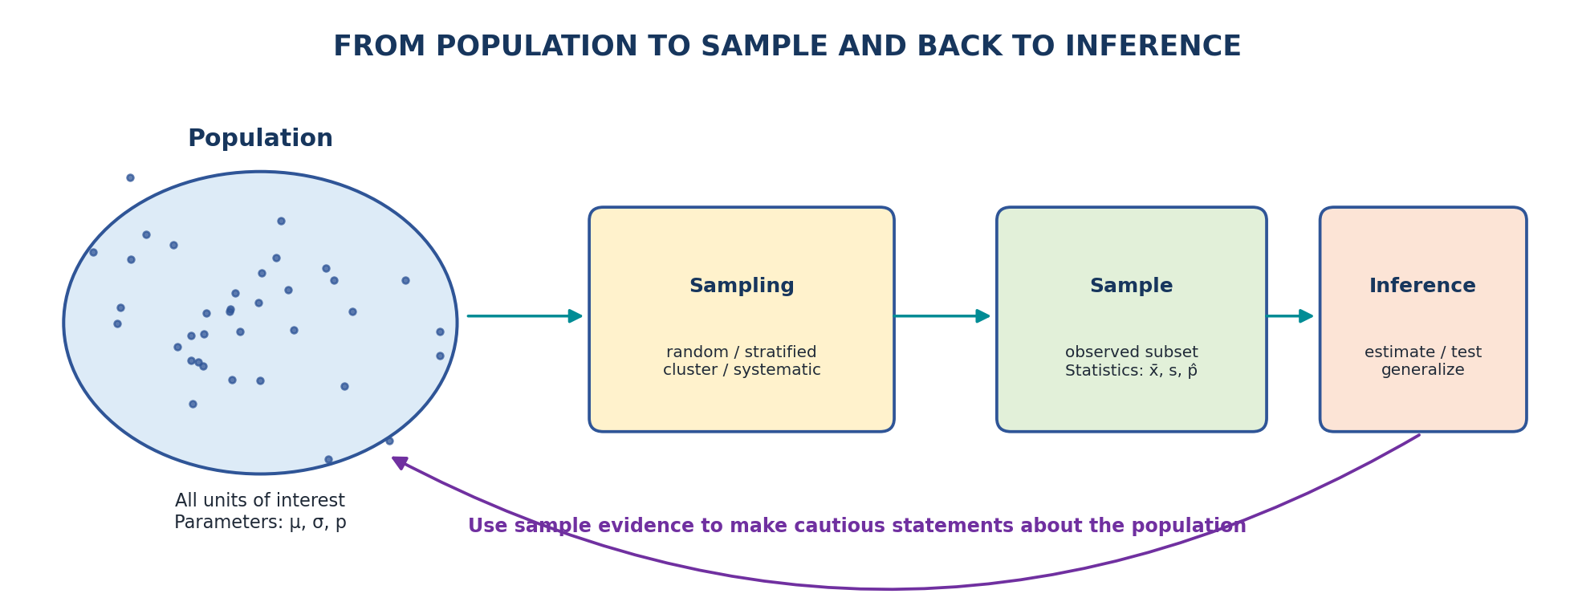
Figure 1: A sample supplies evidence used to learn about a wider population.
MEMORY AID | Population gives parameters. Sample gives statistics. Statistics are used to estimate parameters.

2.2 Why Use a Sample?
- A census may require too much time, money or effort.
- The population may be extremely large or continuously changing.
- Some measurements are destructive, such as testing the lifetime of a bulb until it fails.
- A carefully selected sample can provide useful estimates with measurable uncertainty.

2.3 Common Sampling Methods
Method | How it works | Simple example
Simple random | Every unit has a known equal chance | Randomly choose roll numbers
Systematic | Choose every k-th unit after a random start | Every 10th name on a list
Stratified | Divide into groups and sample from each | Sample separately from each department
Cluster | Randomly select whole groups | Select colleges, then survey students inside them
Convenience | Use the easiest available cases | Survey students present in one class
Volunteer | People choose to respond | Open online opinion poll

CAUTION | Convenience and volunteer samples are easy to collect but may not represent the target population. A large biased sample can still produce a wrong conclusion.

2.4 Sampling Error and Bias
Concept | Meaning | Can a larger sample solve it?
Sampling error | Natural difference caused by observing only a subset | Usually reduced, if sampling is sound
Selection bias | Some population members are systematically over- or under-represented | Not automatically
Measurement bias | The measuring tool or question systematically distorts values | No; improve measurement
Non-response bias | Respondents differ from non-respondents | Not automatically

EXAMPLE | Tasting one spoon from a well-stirred pot shows sampling variation. Tasting only the top oily layer shows selection bias.

3. Statistical Inference Basics

3.1 What is Statistical Inference?
Statistical inference is the process of using a sample to estimate, compare or test statements about a population. Because another sample would give a slightly different result, inference must include uncertainty.
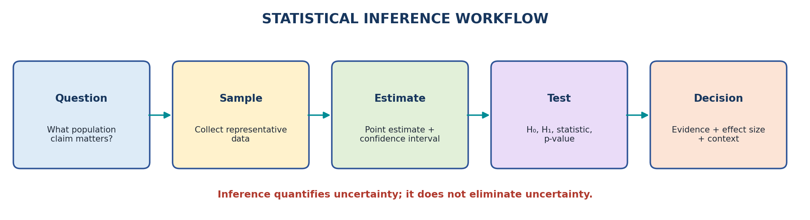
Figure 2: From a population question to evidence, uncertainty and interpretation.

3.2 Point Estimate and Standard Error
A point estimate is one sample value used to estimate a population parameter. The sample mean estimates the population mean. The standard error measures how much the estimate would vary across repeated samples.
FORMULA | Estimated standard error of a sample mean: SE = s / sqrt(n), where s is sample standard deviation and n is sample size.

Example: delivery times are 28, 32, 31, 35 and 29 minutes. The sample mean is 31 minutes. If the sample standard deviation is about 2.74, then SE = 2.74 / sqrt(5) = about 1.23 minutes.
Measure | What it describes
Standard deviation | Variation among individual observations
Standard error | Uncertainty or sample-to-sample variation of an estimate

3.3 Confidence Interval
A confidence interval gives a plausible range for a population parameter by combining an estimate with a margin of error. A narrower interval means greater precision, provided the method assumptions are reasonable.
GENERAL FORM | Estimate +/- critical value x standard error

Example: sample mean = 72, standard error = 2 and approximate 95% critical value = 1.96. The interval is 72 +/- 1.96 x 2 = [68.08, 75.92].
INTERPRETATION | A 95% confidence procedure is designed so that about 95% of intervals produced in repeated valid samples contain the true parameter.

3.4 Hypothesis Testing
A hypothesis test evaluates whether the observed data are reasonably compatible with a reference claim called the null hypothesis.
Term | Meaning
Null hypothesis (H0) | Reference or no-effect claim assessed by the test
Alternative hypothesis (H1) | Competing claim supported when evidence against H0 is strong
Test statistic | A standardized measure of disagreement between data and H0
p-value | Under H0 and the test assumptions, probability of a result at least as extreme as observed
Significance level (alpha) | A chosen threshold such as 0.05 for deciding whether evidence is statistically significant
Effect size | The magnitude of a difference or relationship

CAUTION | A p-value is not the probability that H0 is true. A small p-value also does not prove that an effect is practically important.

3.5 Type I and Type II Errors
Actual condition / decision | Do not reject H0 | Reject H0
H0 is true | Correct decision | Type I error: false positive
H0 is false | Type II error: false negative | Correct detection; called statistical power

MEMORY AID | Type I = false alarm. Type II = missed detection.

4. Types of Statistical Modelling

4.1 What is a Statistical Model?
A statistical model is a simplified mathematical description of how data may be generated. It represents systematic patterns plus unexplained random variation. A model is selected to answer a specific question; it is not a perfect copy of reality.
EXAMPLE | In y = b0 + b1x + error, b0 + b1x represents the expected relationship and error represents unexplained variation.

4.2 Models Classified by Purpose
Purpose | Main question | Typical result | Example
Descriptive | What happened or what pattern exists? | Summary, graph, segment | Describe marks by department
Inferential / explanatory | What population relationship or effect is supported? | Estimate, confidence interval, test | Estimate mean difference between teaching methods
Predictive | What will happen for a new case? | Predicted value/class and performance metric | Predict student pass/fail
Prescriptive | What action should be taken? | Recommended decision under constraints | Choose an intervention plan

4.3 Common Model Families
Model family | Suitable outcome / structure | Examples
Regression | Continuous numeric target | Linear regression, polynomial regression
Classification | Categorical target | Logistic regression, decision tree, KNN
Count model | Non-negative event counts | Poisson regression
Time-series model | Time-ordered observations | Moving average, ARIMA
Survival model | Time until an event | Kaplan-Meier, Cox regression
Unsupervised model | No labelled target | Clustering, PCA

4.4 Model Assumptions and Evaluation
- Assumptions: conditions about independence, distribution, linearity or equal variance that support valid interpretation.
- Fit: how well the model represents observed data.
- Generalization: how well it works on new data, not merely the training data.
- Interpretability: whether humans can understand the relationship or decision.
- Simplicity: a more complex model should be used only when it gives meaningful improvement.
KEY POINT | The best model is not always the most complicated model. It must match the question, data, assumptions and intended use.

5. Types of Probability Distributions

5.1 Probability Basics
Probability measures uncertainty using values from 0 to 1. A random variable assigns a number to an uncertain outcome. A probability distribution lists or describes the possible values and their probabilities.
Concept | Discrete random variable | Continuous random variable
Possible values | Countable values | Any value within intervals
Examples | Number of defects, pass/fail | Height, temperature, waiting time
Function | Probability mass function (PMF) | Probability density function (PDF)
Exact-value probability | May be greater than 0 | Normally 0; use intervals

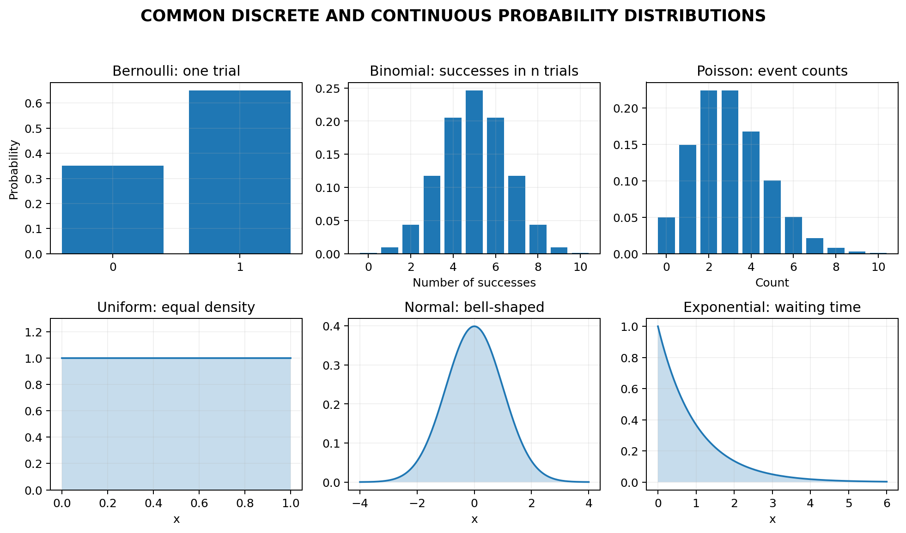
Figure 3: Common distribution shapes and the situations they can represent.

5.2 Mean, Variance and Shape
- Expected value / mean: the long-run centre or probability-weighted average.
- Variance: average squared distance from the mean.
- Standard deviation: square root of variance, measured in the original unit.
- Skewness: asymmetry of a distribution. Right-skewed data have a longer right tail.
- Kurtosis / tails: describes tail weight and concentration relative to a reference shape.

5.3 Important Discrete Distributions
Distribution | What it models | Parameters | Example
Bernoulli | One trial with two outcomes, 0 or 1 | p = probability of success | One student passes or fails
Binomial | Number of successes in fixed n independent trials | n and p | Passes among 20 independent candidates
Poisson | Number of events in a fixed exposure | lambda = expected count | Calls received per hour

FORMULAS | Bernoulli mean = p. Binomial mean = n*p. Poisson mean = lambda and variance = lambda.

BINOMIAL CONDITIONS | Fixed number of trials, two outcomes, independent trials and constant success probability.

5.4 Important Continuous Distributions
Distribution | Shape / support | Main use | Parameters
Uniform | Flat over [a,b] | Values equally likely over a fixed range | Minimum a, maximum b
Normal | Symmetric bell shape | Measurements and sampling distributions under suitable conditions | Mean mu, standard deviation sigma
Exponential | Right-skewed, x >= 0 | Waiting time between constant-rate events | Rate lambda; mean 1/lambda

FORMULA | z-score = (x - mu) / sigma. It states how many standard deviations a value lies above or below the mean.

For an approximately normal distribution, about 68% of observations lie within 1 standard deviation of the mean, about 95% within 2, and about 99.7% within 3. This rule is approximate and should not be used for strongly non-normal data.

5.5 How to Choose a Distribution
Data situation | Candidate distribution | Question to check
One yes/no outcome | Bernoulli | Are there exactly two states?
Successes in fixed trials | Binomial | Are trials independent with stable p?
Event count per time/space | Poisson | Is a stable average rate plausible?
Symmetric measurement | Normal | Is the shape roughly bell-like without extreme tails?
Waiting time | Exponential | Is the event rate approximately constant?
Random value within fixed limits | Uniform | Are equal-length intervals equally likely?

Python: probability distributions with SciPy
from scipy import stats
# Probability of exactly 8 successes in 10 trials, p=0.8
print(stats.binom.pmf(8, n=10, p=0.8))
# Probability of at most 2 events when average count is 3
print(stats.poisson.cdf(2, mu=3))
# Probability that Normal(mean=60, sd=8) is below 70
print(stats.norm.cdf(70, loc=60, scale=8))

6. Parametric and Non-Parametric Methods

6.1 Parametric Methods
Parametric methods assume that data follow a distribution described by a small number of parameters, often a normal distribution with a mean and variance. When assumptions are reasonable, these methods can be efficient and powerful.
- Often use numeric values directly and focus on means or model coefficients.
- May assume normality, independence, linearity or equal variances.
- Examples: z-test, t-test, ANOVA, Pearson correlation and linear regression.

6.2 Non-Parametric Methods
Non-parametric methods make fewer or weaker distributional assumptions. Many use ranks, signs, medians or counts instead of raw numeric values. They are useful for ordinal data, strong skewness, extreme outliers or small samples when parametric assumptions are doubtful.
- Examples: Mann-Whitney U, Wilcoxon signed-rank, Kruskal-Wallis, Spearman rank correlation and chi-square test.
- They are not completely assumption-free; independence and suitable sampling still matter.
- They may answer a different question from their parametric counterpart.
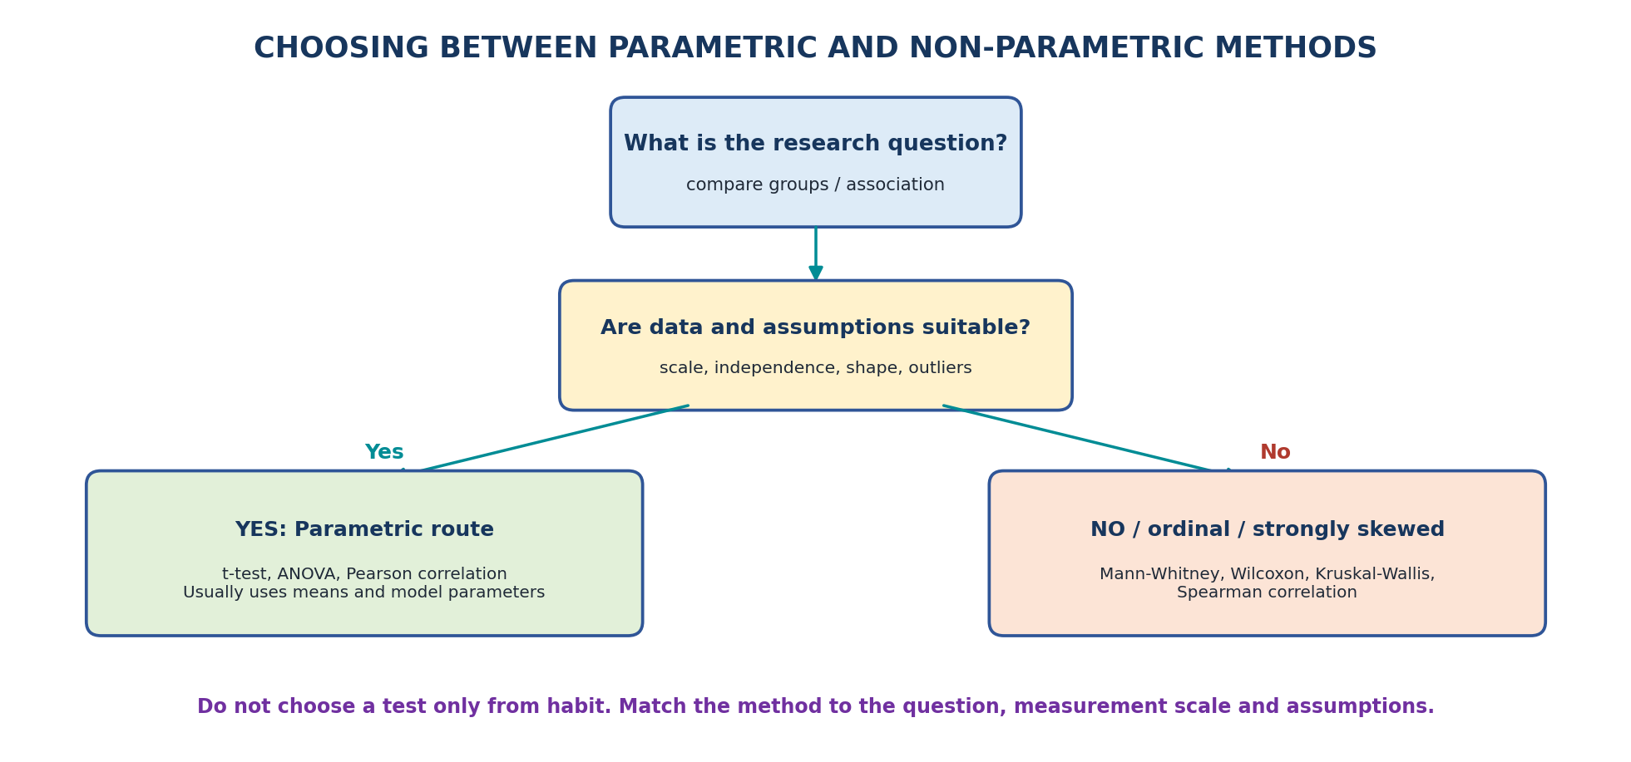
Figure 4: A practical decision path for choosing a statistical method.
Point | Parametric | Non-parametric
Distribution assumptions | Usually stronger | Usually fewer or weaker
Data often used | Interval/ratio numeric data | Ordinal, ranks, signs or categories
Main summaries | Means, variances, coefficients | Medians, ranks, counts
Power when assumptions hold | Often higher | May be lower for the same parametric target
Robustness to skew/outliers | Can be sensitive | Often more robust
Examples | t-test, ANOVA, Pearson | Mann-Whitney, Kruskal-Wallis, Spearman

6.3 Common Method Pairs
Research situation | Parametric method | Non-parametric alternative
Compare two independent groups | Independent-samples t-test | Mann-Whitney U test
Compare paired measurements | Paired t-test | Wilcoxon signed-rank test
Compare 3 or more independent groups | One-way ANOVA | Kruskal-Wallis test
Measure association between two numeric variables | Pearson correlation | Spearman rank correlation

CAUTION | Do not select a test only by checking whether p > 0.05 in a normality test. Also examine plots, sample size, outliers, study design and the exact question.

Python: parametric and non-parametric comparison
from scipy import stats
group_a = [62, 65, 68, 70, 72]
group_b = [58, 60, 61, 63, 66]
print(stats.ttest_ind(group_a, group_b, equal_var=False))
print(stats.mannwhitneyu(group_a, group_b, alternative='two-sided'))

7. Distance Metrics

7.1 Meaning of Distance and Similarity
A distance metric measures how different two data points are. A small distance means the points are close according to the chosen definition. Distance is important in K-nearest neighbours, clustering, recommendation, anomaly detection and information retrieval.
KEY POINT | There is no universally best distance. The correct metric depends on feature type, scale and the meaning of similarity in the problem.

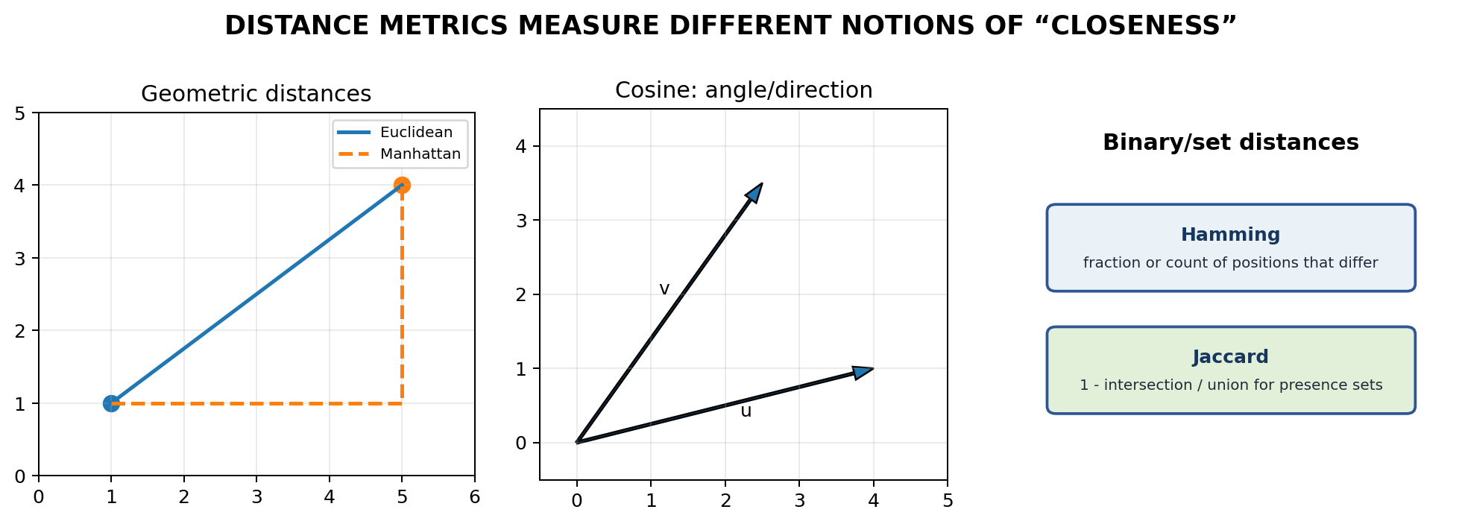
Figure 5: Different distance measures can view the same pair of points differently.

7.2 Euclidean Distance
FORMULA | d(x,y) = sqrt(sum((x_i - y_i)^2))

For A=(1,2) and B=(4,6): d = sqrt((4-1)^2 + (6-2)^2) = sqrt(9+16) = 5. Euclidean distance represents straight-line distance.

7.3 Manhattan Distance
FORMULA | d(x,y) = sum(|x_i - y_i|)

For A=(1,2) and B=(4,6): d = |4-1| + |6-2| = 3+4 = 7. It resembles moving along city blocks.

7.4 Minkowski and Chebyshev Distance
- Minkowski distance: a general family controlled by p. p=1 gives Manhattan and p=2 gives Euclidean.
- Chebyshev distance: the largest absolute coordinate difference. For A and B above, max(3,4)=4.

7.5 Cosine Distance
Cosine similarity compares the angle between vectors and focuses on direction rather than magnitude. It is common for text vectors. Cosine distance is commonly defined as 1 - cosine similarity.
FORMULA | cosine similarity = (x dot y) / (||x|| * ||y||); cosine distance = 1 - similarity

7.6 Hamming and Jaccard Distance
Metric | Best suited for | Meaning | Example
Hamming | Equal-length binary or categorical sequences | Fraction or count of positions that differ | 10110 vs 10011 differ at 2 positions
Jaccard | Sets or binary presence/absence data | 1 - intersection/union | A={a,b,c}, B={b,c,d}: similarity=2/4=0.5

7.7 Mahalanobis Distance
Mahalanobis distance accounts for feature scale and correlation. A movement along a naturally variable direction may count less than the same movement along a stable direction. It requires a reliable covariance estimate and is more advanced than ordinary Euclidean distance.
Metric | Core idea | Typical use
Euclidean | Straight-line numeric distance | KNN and clustering on scaled numeric data
Manhattan | Sum of coordinate differences | High-dimensional or grid-like movement
Cosine | Difference in direction | Text and sparse vectors
Hamming | Mismatched positions | Binary codes or sequences
Jaccard | Difference in set membership | Binary presence/absence or item sets
Mahalanobis | Scale- and correlation-aware distance | Multivariate anomaly detection

EXAM TIP | Scale numeric features before using Euclidean or Manhattan distance; otherwise a feature measured in large units can dominate the result.

Python: common distance measures
import numpy as np
from scipy.spatial import distance
x = np.array([1, 2])
y = np.array([4, 6])
print('Euclidean:', distance.euclidean(x, y))
print('Cityblock:', distance.cityblock(x, y))
print('Cosine distance:', distance.cosine(x, y))
A = {1, 2, 3}
B = {2, 3, 4}
jaccard_similarity = len(A & B) / len(A | B)
print('Jaccard distance:', 1 - jaccard_similarity)

8. Exploratory Data Analysis: Basic Tools

8.1 What is EDA?
Exploratory Data Analysis (EDA) is the systematic process of examining a dataset before formal modelling. It uses summaries, plots and questions to understand data quality, distributions, relationships, unusual values and possible explanations.
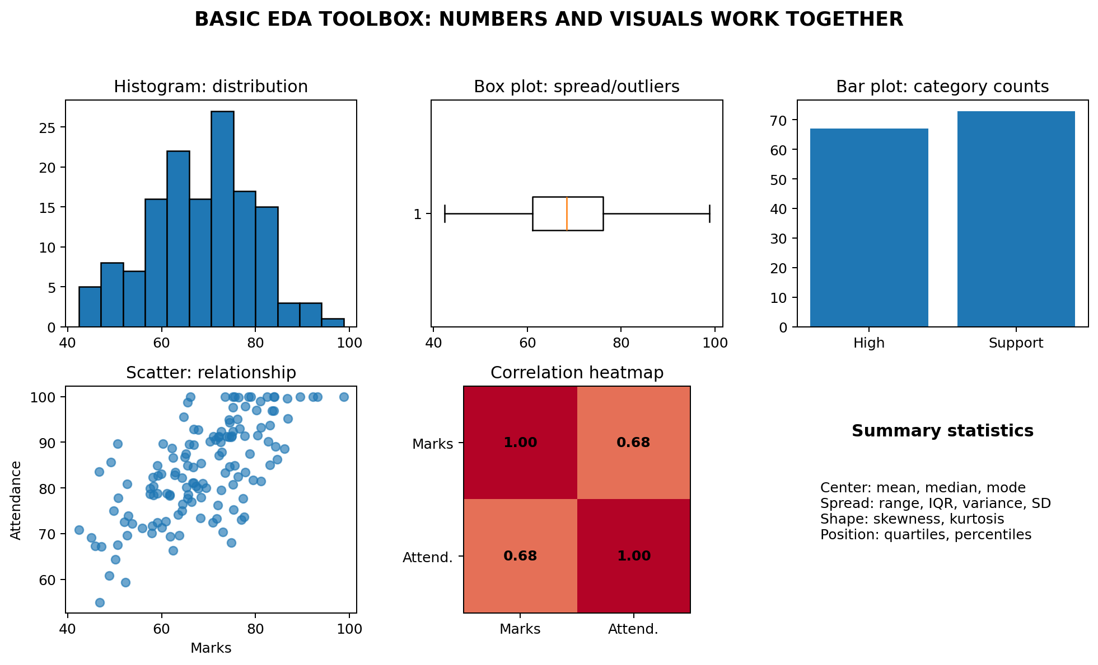
Figure 6: EDA combines data-quality checks, numerical summaries and multiple visual views.

8.2 Questions Asked During EDA
- How many rows and columns are present?
- What does each variable mean and what is its data type?
- Are values missing, duplicated, impossible or inconsistent?
- What are the centre, spread, shape and unusual values of each variable?
- How do variables relate to one another?
- Do patterns change across groups or time?
- Could a pattern be caused by data collection, leakage or a third variable?

8.3 Summary Statistics
Measure | Meaning | Sensitive to outliers?
Count | Number of non-missing observations | No
Mean | Arithmetic average | Yes
Median | Middle ordered value | Less sensitive
Mode | Most frequent value/category | Usually less sensitive
Range | Maximum - minimum | Very sensitive
Variance / standard deviation | Average squared spread / its square root | Sensitive
Interquartile range (IQR) | Q3 - Q1; spread of middle 50% | More robust
Percentile | Value below which a stated percentage lies | Depends on percentile

FORMULA | Mean = sum(x)/n. Range = max-min. IQR = Q3-Q1. Sample variance = sum((x-x_bar)^2)/(n-1).

KEY POINT | Use mean and standard deviation for roughly symmetric data without severe outliers. Use median and IQR for strongly skewed data or data with extreme values.

8.4 Univariate Plots
Plot | Variable type | What it helps reveal
Bar chart | Categorical | Counts or percentages by category
Histogram | Numeric | Distribution shape, centre, spread and modes
Box plot | Numeric | Median, IQR and potential outliers
Density plot | Continuous numeric | Smoothed distribution shape
Line plot | Time-ordered numeric | Trend, cycles and sudden changes

8.5 Bivariate and Multivariate Plots
Plot | Variables | Use
Scatter plot | Two numeric variables | Direction, strength, non-linearity and clusters
Grouped box plot | Numeric plus categorical | Compare distributions across groups
Stacked/grouped bar | Two categorical variables | Compare category proportions
Correlation heatmap | Several numeric variables | Scan pairwise linear correlations
Pair plot | Several numeric variables | View many distributions and relationships
Faceted plot | Variables split by a group | Check whether a pattern changes by subgroup

CAUTION | Correlation does not prove causation. A relationship can arise from confounding, selection bias, reverse direction or coincidence.

8.6 A Basic EDA Sequence
1. Understand the meaning, unit and source of each variable.
2. Inspect shape, data types and a few rows.
3. Check missing values, duplicates and impossible values.
4. Summarize numeric and categorical variables.
5. Plot individual variable distributions.
6. Explore relationships relevant to the question.
7. Investigate unusual values and subgroup differences.
8. Record findings, limitations and next questions.
Python: a beginner EDA checklist
import pandas as pd
import matplotlib.pyplot as plt
# Replace with your file path
df = pd.read_csv('students.csv')
print(df.shape)
print(df.head())
print(df.info())
print(df.isna().sum())
print(df.describe(include='all'))
# Univariate plot
df['marks'].hist(bins=10)
plt.xlabel('Marks')
plt.ylabel('Frequency')
plt.show()
# Bivariate plot
df.plot.scatter(x='attendance', y='marks')
plt.show()

9. Philosophy of Exploratory Data Analysis

9.1 EDA is a Way of Thinking
EDA is not a fixed collection of charts. Its philosophy is to remain curious, use multiple views, question assumptions, search for surprises and let the data suggest better questions. The analyst should not force the data to confirm the first expectation.
- Be curious: ask what is unusual and why it may have occurred.
- Use multiple representations: a table, histogram and box plot can reveal different aspects of the same variable.
- Be sceptical: check whether a pattern could be caused by errors, missing data or selection.
- Explore subgroups: an overall trend can hide opposite trends inside groups.
- Document decisions: record filtering, transformations and exclusions so the work is reproducible.
- Separate discovery from proof: a pattern discovered during EDA should be validated with fresh data or a carefully designed confirmatory analysis.

9.2 Exploratory versus Confirmatory Analysis
Point | Exploratory analysis | Confirmatory analysis
Purpose | Discover patterns and generate hypotheses | Test a pre-specified hypothesis
Questions | Flexible and evolving | Defined before examining outcomes
Methods | Many summaries and visual views | Formal model/test with planned assumptions
Risk | Finding patterns by chance | Invalid inference if plan is changed after seeing results
Good practice | Label findings as exploratory | Use independent validation or pre-specified analysis

MEMORY AID | EDA asks: “What might be happening?” Confirmatory analysis asks: “Does planned evidence support this exact claim?”

9.3 Common EDA Mistakes
- Looking only at averages and ignoring distributions.
- Deleting outliers without investigating their cause.
- Using too many charts without a question.
- Ignoring missingness patterns and data collection processes.
- Treating correlation as proof of cause.
- Reporting an exploratory discovery as if it had been predicted in advance.
- Choosing axes, bins or colour scales that exaggerate a pattern.

10. The Data Science Process

10.1 Why a Process is Needed
A data science project is more than training an algorithm. It begins with a decision or problem, and it continues through data collection, analysis, modelling, communication, deployment and monitoring. The process is iterative: findings often require earlier steps to be revised.
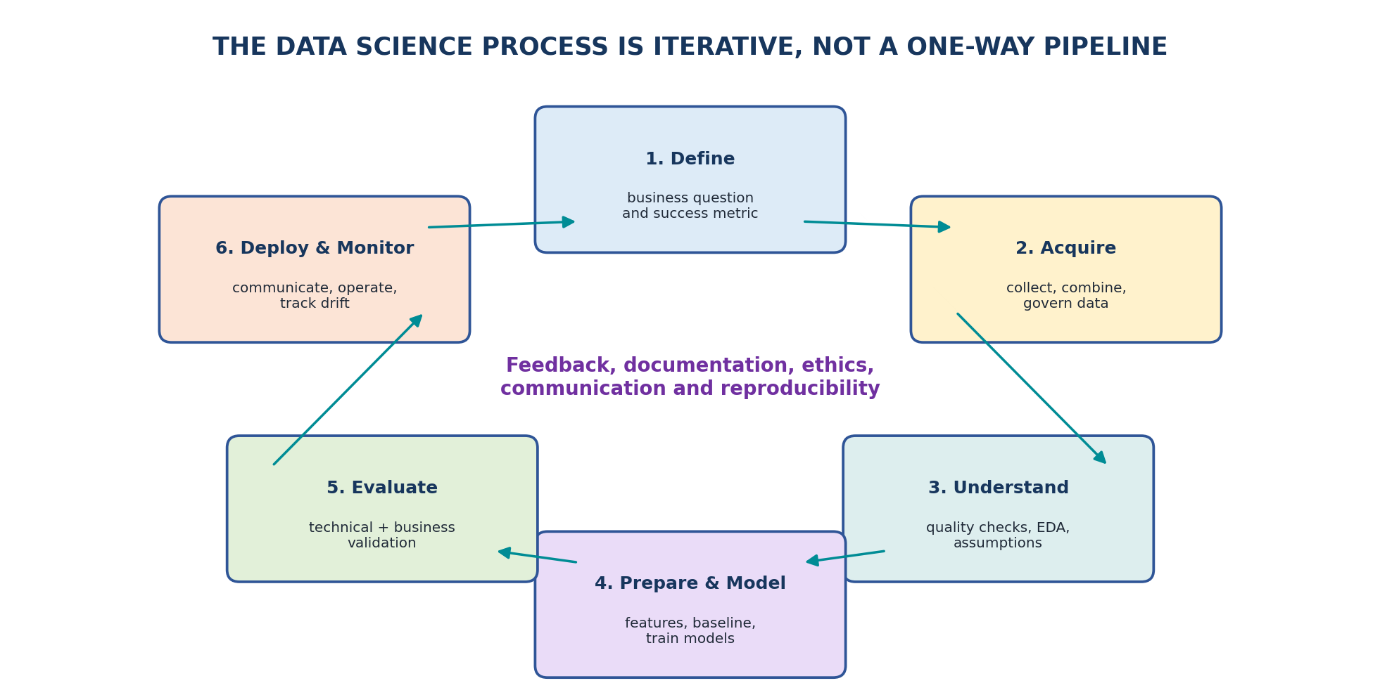
Figure 7: The data science process is iterative rather than a one-way pipeline.

10.2 Main Stages
Stage | Main questions | Typical output
1. Problem understanding | What decision is needed? Who will use the result? What is success? | Problem statement, scope, metric and constraints
2. Data collection | What data are needed? From where? With what permissions? | Source inventory and raw data
3. Data understanding | What do variables mean? How were they measured? | Data dictionary and quality report
4. Preparation | How should missing values, errors and formats be handled? | Clean analysis-ready dataset
5. EDA | What patterns, relationships and anomalies exist? | Findings, plots and new questions
6. Feature engineering | What useful representations can be created? | Model input features
7. Modelling | Which baseline and candidate models fit the objective? | Trained models
8. Evaluation | Does performance generalize and satisfy practical needs? | Metrics, error analysis and validation
9. Communication / deployment | How will findings or predictions be used? | Report, dashboard, application or API
10. Monitoring | Does data or performance change over time? | Alerts, retraining and maintenance plan

10.3 Problem Statement Template
TEMPLATE | For [user/stakeholder], use [available data] to [estimate/predict/understand] [outcome] so that [decision/action] improves, while respecting [constraints, fairness, privacy and cost].

10.4 Baseline, Validation and Communication
- Baseline: a simple rule or model used as the minimum comparison. A complex model must beat a meaningful baseline.
- Validation: evaluate on data not used to fit the model and analyse errors across important groups.
- Communication: state the question, data, method, result, uncertainty, limitations and recommended action.
- Monitoring: watch for changing inputs, reduced performance, unfair impacts and operational failures.
KEY POINT | A technically accurate model can still fail if it answers the wrong question, uses biased data or cannot support a real decision.

10.5 Mini Case: Student Support
Process step | Example decision
Problem | Identify students who may need academic support early enough for useful intervention
Data | Attendance, assessment history, assignment submission and course context
EDA | Check missingness, class imbalance, subgroup patterns and leakage from future information
Model | Begin with a transparent baseline and a simple classification model
Evaluation | Use recall, precision and subgroup error analysis, not accuracy alone
Action | Offer supportive counselling or resources; never treat a prediction as proof
Monitoring | Check whether data and model performance change each semester

RESPONSIBLE USE | Predictions about people require privacy, fairness, human review and a beneficial intervention. A risk score should support—not replace—responsible human judgement.

11. Integrated Python Practical

11.1 Objective
Use a small student dataset to calculate summaries, create EDA plots, measure relationships, compare groups and compute distances. The example is for learning; conclusions from a real study require a sound sampling design and domain understanding.
Complete beginner practical
import numpy as np
import pandas as pd
import matplotlib.pyplot as plt
from scipy import stats
from scipy.spatial import distance
# 1. Create a small dataset
df = pd.DataFrame({
'hours': [2, 3, 4, 5, 6, 7, 8, 3, 6, 7],
'attendance': [58, 64, 70, 76, 82, 88, 92, 68, 84, 90],
'marks': [42, 48, 55, 63, 69, 78, 86, 51, 72, 81],
'group': ['A','A','A','A','A','B','B','B','B','B']
})
# 2. Basic understanding and summaries
print(df.head())
print(df.info())
print(df.describe())
print(df.groupby('group')['marks'].agg(['count','mean','median','std']))
# 3. Univariate EDA
df['marks'].hist(bins=5, edgecolor='black')
plt.title('Distribution of Marks')
plt.xlabel('Marks'); plt.ylabel('Frequency')
plt.show()
# 4. Bivariate EDA
df.plot.scatter(x='attendance', y='marks')
plt.title('Attendance and Marks')
plt.show()
# 5. Correlation (linear association)
print('Pearson:', stats.pearsonr(df['attendance'], df['marks']))
print('Spearman:', stats.spearmanr(df['attendance'], df['marks']))
# 6. Compare two independent groups
A = df.loc[df['group']=='A', 'marks']
B = df.loc[df['group']=='B', 'marks']
print('Welch t-test:', stats.ttest_ind(A, B, equal_var=False))
print('Mann-Whitney:', stats.mannwhitneyu(A, B, alternative='two-sided'))
# 7. Distance between first two students using hours and attendance
x = df.loc[0, ['hours','attendance']].to_numpy(dtype=float)
y = df.loc[1, ['hours','attendance']].to_numpy(dtype=float)
print('Euclidean:', distance.euclidean(x, y))
print('Manhattan:', distance.cityblock(x, y))

11.2 How to Interpret the Output
1. Use describe() to check centre, spread and possible range problems.
2. Use the histogram to see whether marks are symmetric, skewed, clustered or unusual.
3. Use the scatter plot to inspect direction and form before interpreting correlation.
4. Pearson correlation measures linear association; Spearman measures monotonic rank association.
5. A group test result must be interpreted together with group summaries, effect size, assumptions and study design.
6. The distance calculation is dominated by attendance because attendance has a larger numeric scale; scaling would be needed for fair comparison.
PRACTICE | Modify one extreme mark, rerun summaries and compare how the mean, median, Pearson correlation and Spearman correlation change.

12. Quick Revision, Formula Sheet and Glossary

12.1 One-Line Revision
Concept | One-line meaning
Population | Complete group about which a conclusion is required
Sample | Observed subset used as evidence
Parameter | Population numerical value
Statistic | Sample numerical value
Inference | Learning about a population from sample data
Probability distribution | Possible random-variable values and their probabilities
Parametric method | Method based on a specified distributional/model form
Non-parametric method | Method using fewer distribution assumptions, often ranks or counts
Distance metric | Rule for quantifying difference between points
EDA | Question-driven exploration using summaries and visualizations
Data science process | Iterative path from problem definition to monitoring

12.2 Formula Sheet
Formula | Meaning
Mean = sum(x) / n | Arithmetic average
Range = maximum - minimum | Total observed spread
IQR = Q3 - Q1 | Spread of the middle 50%
Sample variance = sum((x-x_bar)^2)/(n-1) | Average squared sample spread
SE(mean) = s/sqrt(n) | Estimated uncertainty of sample mean
Confidence interval = estimate +/- critical value x SE | Estimate with margin of error
z = (x-mu)/sigma | Standardized position
Euclidean = sqrt(sum((x_i-y_i)^2)) | Straight-line distance
Manhattan = sum(|x_i-y_i|) | City-block distance
Cosine distance = 1 - cosine similarity | Difference in vector direction
Jaccard similarity = intersection/union | Overlap between sets

12.3 Glossary
Term | Student-friendly meaning
Assumption | A condition required for a method or interpretation
Bias | Systematic error that pushes results in a direction
Confidence interval | A sample-based range showing estimate precision
Confounder | A third variable related to both an apparent cause and outcome
Distribution | Pattern of possible values and their frequency/probability
Effect size | Magnitude of a difference or relationship
Hypothesis | A testable statement about a population or process
Outlier | An observation unusually far from most others
p-value | Compatibility measure between data and H0 under test assumptions
Robust method | A method less affected by departures or extreme values
Skewness | Asymmetry in a distribution
Statistical power | Probability of detecting a real effect under stated conditions

13. Self-Assessment

13.1 Multiple-Choice Questions
1. A number calculated from a sample is called a:
A. Parameter
B. Statistic
C. Census
D. Population
2. Which sampling method ensures planned representation from important groups?
A. Convenience
B. Volunteer
C. Stratified
D. Cluster only
3. Which measure is usually most robust to an extreme outlier?
A. Mean
B. Median
C. Range
D. Variance
4. A binomial distribution models:
A. Waiting time
B. Successes in fixed binary trials
C. Continuous temperature
D. Any category
5. A small p-value is best described as:
A. The probability H0 is false
B. Stronger incompatibility with H0 under assumptions
C. Proof of practical importance
D. The effect size
6. Which test is a non-parametric alternative to an independent t-test?
A. Pearson correlation
B. Mann-Whitney U
C. Paired t-test
D. Linear regression
7. Which distance focuses primarily on vector direction?
A. Euclidean
B. Manhattan
C. Cosine
D. Hamming
8. A histogram is mainly used for:
A. One numeric variable
B. Two categorical variables only
C. Text paragraphs
D. Set intersection
9. EDA findings discovered after many searches should usually be:
A. Treated as final proof
B. Hidden
C. Validated on fresh evidence
D. Converted directly to causation
10. The first stage of a data science process should be:
A. Choose deep learning
B. Define the problem and decision
C. Deploy a dashboard
D. Remove all outliers
ANSWER KEY | 1-B, 2-C, 3-B, 4-B, 5-B, 6-B, 7-C, 8-A, 9-C, 10-B

13.2 Very Short and Short Questions
1. Define population and sample with one example.
2. Differentiate a parameter and a statistic.
3. What is the difference between sampling error and bias?
4. State four conditions of a binomial distribution.
5. What does a standard error measure?
6. What is a p-value? Mention one common misinterpretation.
7. Differentiate parametric and non-parametric methods.
8. Calculate Euclidean and Manhattan distance between (2,3) and (5,7).
9. When is cosine distance more useful than Euclidean distance?
10. Differentiate a histogram and a bar chart.
11. State five questions asked during EDA.
12. Why is the data science process iterative?

13.3 Long-Answer Questions
1. Explain population, sample, sampling frame, parameter, statistic, sampling methods, sampling error and bias with examples.
2. Explain point estimation, standard error, confidence intervals, hypothesis testing, p-values and Type I/Type II errors.
3. Discuss the main discrete and continuous probability distributions and give a suitable application of each.
4. Compare parametric and non-parametric methods and explain how you would choose between them.
5. Explain Euclidean, Manhattan, Minkowski, cosine, Hamming, Jaccard and Mahalanobis distances.
6. Describe the tools and philosophy of EDA. Explain how exploratory analysis differs from confirmatory analysis.
7. Explain every stage of the data science process using one real-world case study.

13.4 Practical Exercises
1. Create a pandas DataFrame with 20 student records. Produce shape, data types, missing-value counts and descriptive summaries.
2. Plot a histogram and box plot of marks. Write three observations about centre, spread and unusual values.
3. Create a scatter plot of study hours and marks. Calculate Pearson and Spearman correlation and interpret them carefully.
4. Compare marks of two classes using summaries, box plots, a t-test and Mann-Whitney test. State assumptions and limitations.
5. Calculate Euclidean, Manhattan and cosine distances for three student feature vectors before and after scaling.
6. Choose a public dataset and prepare a one-page EDA report containing the problem, data quality, summaries, plots, findings and limitations.

