DATA SCIENCE AND MACHINE LEARNING

UNIT 04
MACHINE LEARNING
ALGORITHMS
BEGINNER-FRIENDLY STUDENT NOTES
Syllabus coverage:
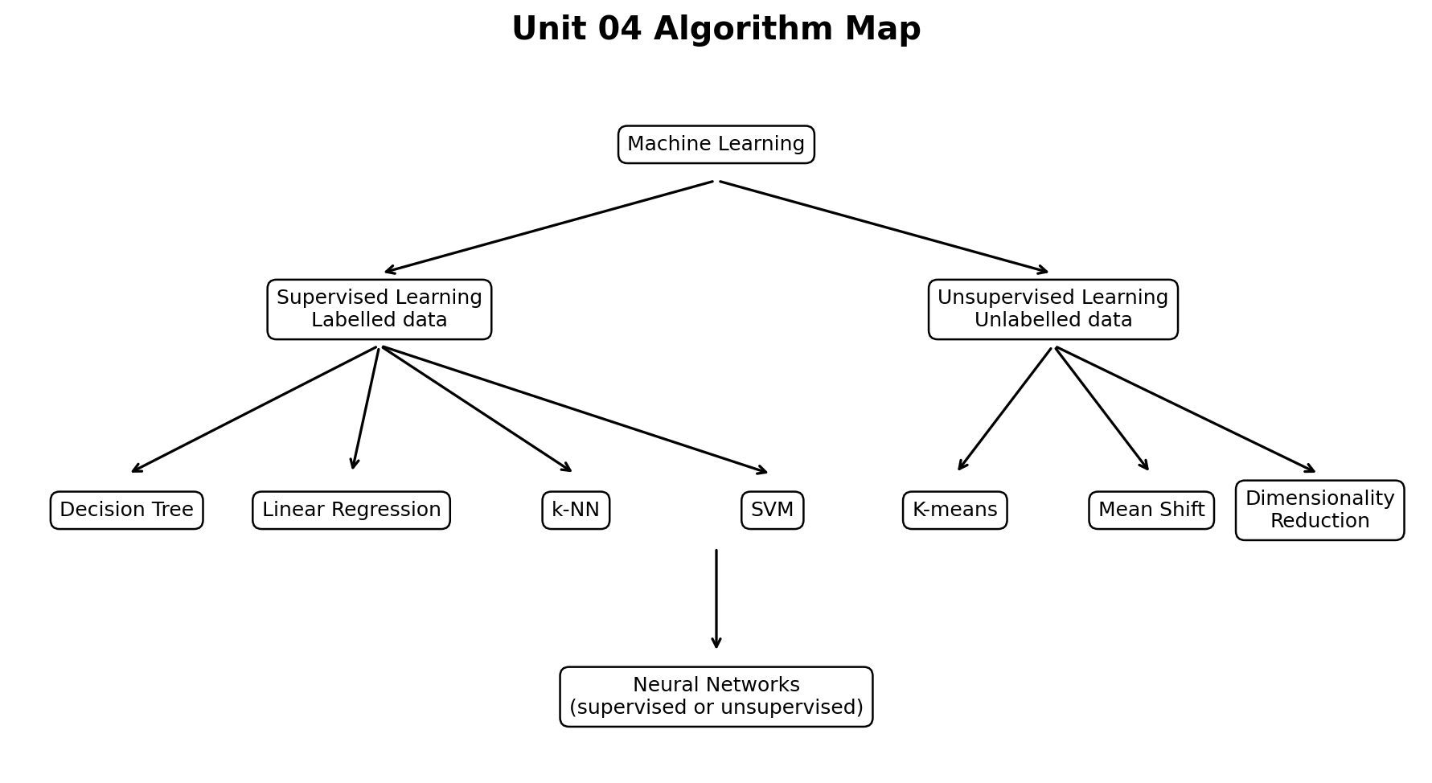
Unit 04 algorithm map: supervised algorithms learn from labelled data, while unsupervised algorithms discover structure in unlabelled data.
Learn the idea -> Follow the steps -> Read the code -> Interpret the result

A. How to Use These Notes
- Start with the problem type. First decide whether the required output is a class, a number, a group, or a smaller representation of the data.
- Understand the intuition before memorising formulas. Ask what information the algorithm uses and how it produces an answer.
- Work through each small numerical example by hand. Manual calculation makes the Python output meaningful.
- Run the Python examples and change one hyperparameter at a time. Observe how the prediction or grouping changes.
- Revise using the comparison tables, memory aids, formula sheet, quick checks and practice questions.

B. Learning Outcomes
- Differentiate supervised and unsupervised learning and identify classification, regression, clustering and dimensionality-reduction tasks.
- Explain the basic working of Decision Tree, Linear Regression, k-NN and SVM.
- Explain how K-means and Mean Shift create clusters from unlabelled data.
- Describe dimensionality reduction and the basic idea of Principal Component Analysis (PCA).
- Identify neurons, layers, weights, bias, activation functions, loss and backpropagation in a neural network.
- Select an introductory algorithm according to the target, data size, feature scale, interpretability and shape of the pattern.
- Implement small examples using NumPy, pandas and scikit-learn and interpret predictions and basic evaluation results.

C. Contents
1. Machine Learning Basics
2. A Common Workflow and Algorithm Selection
3. Decision Tree
4. Linear Regression
5. k-Nearest Neighbours (k-NN)
6. Support Vector Machine (SVM)
7. K-means Clustering
8. Mean Shift Algorithm
9. Dimensionality Reduction and PCA
10. Introduction to Neural Networks
11. Algorithm Comparison and Selection Guide
12. Integrated Python Practical
13. Formula Sheet and Glossary
14. Self-Assessment and Answer Key

1. Machine Learning Basics
Before studying individual algorithms, understand the words used in every machine learning problem.

1.1 What is a Machine Learning Algorithm?
A machine learning algorithm is a procedure that searches data for a useful pattern. During training, it creates or adjusts a model. The trained model then makes predictions or discovers structure in new data.
REMEMBER: Algorithm and model are not the same
The algorithm is the learning procedure. The model is the learned result. For example, Decision Tree is an algorithm; the particular tree created from a student dataset is the model.

1.2 Essential Vocabulary
Term | Simple meaning | Student example
Observation / sample | One row or one case in a dataset | One student
Feature (X) | Input information used for learning | Attendance, study hours, assignment score
Target (y) | Output that a supervised model must learn | Pass/Fail or final marks
Label | A categorical target value | Pass, Fail
Prediction | Output produced by the trained model | Predicted Pass
Parameter | Value learned from training data | Regression slope or network weight
Hyperparameter | Setting chosen before or during training | Tree depth, k in k-NN, number of clusters
Training | Learning patterns from examples | Fit model on training records
Inference / prediction | Using the trained model | Predict a new student result

1.3 Supervised and Unsupervised Learning
Point | Supervised learning | Unsupervised learning
Target available? | Yes. Every training example has a known output. | No target label is supplied.
Main question | Can we predict a known kind of output? | Can we discover hidden structure?
Common tasks | Classification and regression | Clustering and dimensionality reduction
Examples in this unit | Decision Tree, Linear Regression, k-NN, SVM | K-means, Mean Shift, PCA
Example | Predict Pass/Fail | Group students by learning behaviour

1.4 Four Problem Types
Problem type | Output | Example | Suitable introductory algorithms
Classification | A category or class | Spam / Not spam; Pass / Fail | Decision Tree, k-NN, SVM, Neural Network
Regression | A continuous number | House price; final marks | Linear Regression, Decision Tree Regressor, Neural Network
Clustering | A group discovered by the algorithm | Customer segments | K-means, Mean Shift
Dimensionality reduction | Fewer features representing most information | Reduce 20 measurements to 2 components | PCA

QUICK CHECK
1. Predicting the exact temperature is classification or regression?
2. Grouping unlabelled shops by buying pattern is supervised or unsupervised?
3. What is the difference between a parameter and a hyperparameter?

2. A Common Workflow and Algorithm Selection
Different algorithms learn in different ways, but a reliable machine learning project follows a common sequence.
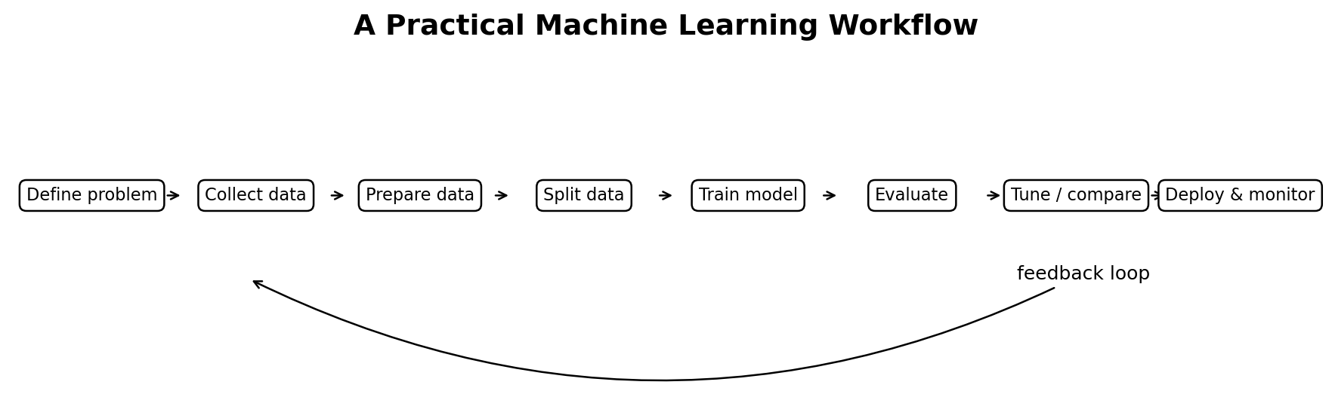
Figure 1: A basic machine learning workflow. Evaluation can send us back to data preparation or model selection.

2.1 Step-by-Step Workflow
1. Define the real problem and the expected output.
2. Collect representative data and understand each feature.
3. Clean missing values, duplicates and incorrect values.
4. Encode categorical features and scale features when required.
5. For supervised learning, split the data into training and test sets.
6. Fit the model only on the training data.
7. Predict test data and evaluate using suitable measures.
8. Tune hyperparameters, compare alternatives and check errors.
9. Explain limitations and monitor performance after deployment.

2.2 Training Data, Test Data and Generalisation
Training data teaches the model. Test data is kept separate and is used to estimate how well the learned pattern works on unseen cases. A model that performs well only on the training set has not generalised properly.
Condition | Meaning | Typical sign
Underfitting | Model is too simple to learn the pattern | Low training and low test performance
Good fit | Model learns useful pattern and generalises | Good and reasonably close training/test performance
Overfitting | Model memorises noise or details | Very high training but much lower test performance

CAUTION: Data leakage
Do not use information from the test set while fitting preprocessing steps or tuning the model. Leakage gives unrealistically high evaluation results.

2.3 Which Algorithms Need Feature Scaling?
Algorithm | Scaling importance | Why
Decision Tree | Usually not required | A tree compares one feature with a threshold.
Linear Regression | Helpful, especially for interpretation and numerical stability | Features may use very different units.
k-NN | Very important | Distances are dominated by large-scale features.
SVM | Very important | The margin and kernel depend on distances/dot products.
K-means | Very important | Clusters are created from distances to centroids.
Mean Shift | Important | Density neighbourhoods depend on feature distances.
PCA | Usually important | Large-variance units can dominate the components.
Neural Network | Very important | Optimisation is easier when inputs have comparable scales.

Safe split-and-scale pattern
from sklearn.model_selection import train_test_split
from sklearn.preprocessing import StandardScaler

X_train, X_test, y_train, y_test = train_test_split(
X, y, test_size=0.20, random_state=42, stratify=y
)

scaler = StandardScaler()
X_train_scaled = scaler.fit_transform(X_train)
X_test_scaled = scaler.transform(X_test) # transform only

3. Decision Tree
A Decision Tree predicts by asking a sequence of simple questions, similar to a flowchart.
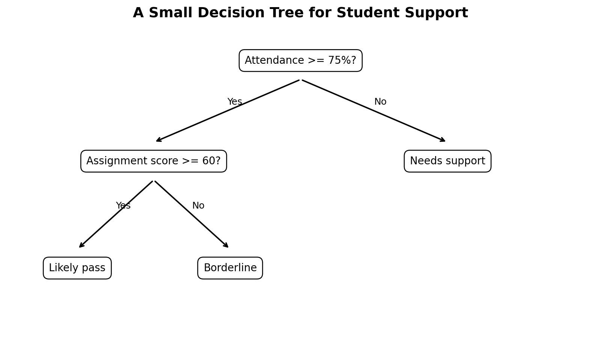
Figure 2: A decision tree contains a root, internal decision nodes, branches and leaf predictions.

3.1 Intuition
Suppose a teacher wants to predict whether a student will pass. The tree may first ask “Attendance >= 75%?” If yes, it may next ask “Assignment score >= 60?” Each answer follows a branch until a leaf gives the prediction.
Part | Meaning
Root node | First question asked by the tree
Internal node | A later question or test
Branch | Outcome of a question
Leaf node | Final prediction
Depth | Longest path from root to a leaf

3.2 How Does the Tree Select a Question?
The algorithm tests possible questions and chooses a split that makes the child groups purer. A pure group mostly contains one class. Gini impurity and entropy are common impurity measures.
Gini impurity
Gini = 1 - sum(p_i^2)
p_i is the proportion of class i in the node. Gini is 0 for a completely pure node.
Example: A node has 6 Pass and 4 Fail. Gini = 1 - (0.6^2 + 0.4^2) = 0.48.

Entropy
Entropy = - sum(p_i log2 p_i)
Entropy is also 0 for a pure node. Higher values mean more mixing.
Example: For 50% Pass and 50% Fail, entropy = 1 bit.

3.3 Small Split Example
Attendance | Assignment | Result
82 | 75 | Pass
78 | 68 | Pass
72 | 62 | Pass
65 | 55 | Fail
58 | 48 | Fail
50 | 44 | Fail

The question “Attendance >= 70?” separates all three Pass records from all three Fail records. Both resulting nodes are pure, so this is an excellent split for this small dataset. Real datasets are usually less perfect.

3.4 Overfitting and Tree Control
Hyperparameter | Effect
max_depth | Limits how many levels the tree may grow.
min_samples_split | Minimum samples required before a node can split.
min_samples_leaf | Minimum samples allowed in a leaf.
criterion | Impurity rule such as gini or entropy.
ccp_alpha | Controls cost-complexity pruning.

EXAM TIP: Why a deep tree can fail
A very deep tree can create leaves for tiny accidental patterns. It may perfectly classify training data but fail on new students. Control depth and compare test performance.

3.5 Python Example
Python example
from sklearn.datasets import load_iris
from sklearn.model_selection import train_test_split
from sklearn.tree import DecisionTreeClassifier
from sklearn.metrics import accuracy_score

X, y = load_iris(return_X_y=True)
X_train, X_test, y_train, y_test = train_test_split(
X, y, test_size=0.20, random_state=42, stratify=y
)

model = DecisionTreeClassifier(max_depth=3, random_state=42)
model.fit(X_train, y_train)
pred = model.predict(X_test)
print('Accuracy:', accuracy_score(y_test, pred))

Advantages | Limitations
Easy to explain as rules | Can overfit easily
Handles non-linear relationships | Small data changes can alter the tree
Little preprocessing required | Greedy splits are not always globally best
Works for classification and regression | Complex trees may be unstable

QUICK CHECK
1. What does a leaf contain?
2. Why is Gini 0 in a pure node?
3. Name two hyperparameters used to control overfitting.

4. Linear Regression
Linear Regression predicts a numerical value by fitting a straight line or a linear plane through the data.
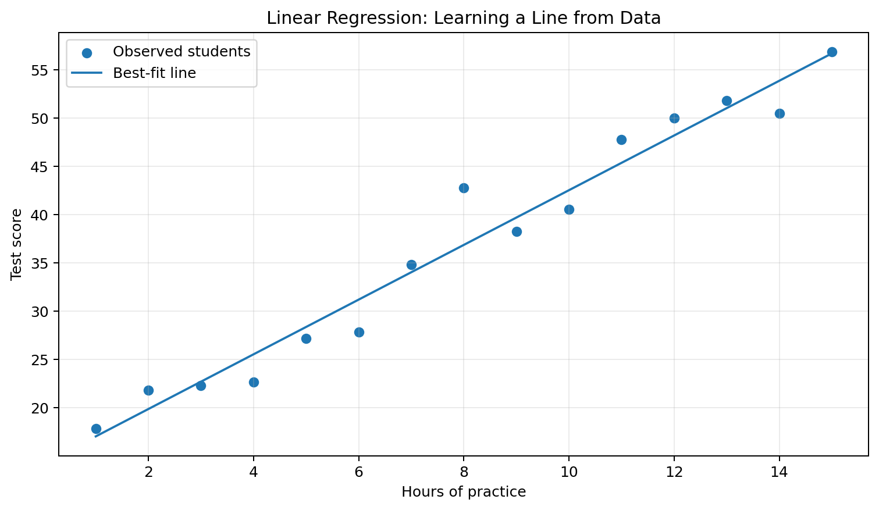
Figure 3: Linear regression chooses a line that keeps prediction errors as small as possible.

4.1 The Linear Equation
Simple linear regression
y_hat = b0 + b1 x
y_hat is the predicted value, b0 is the intercept, b1 is the slope and x is the input feature.
Example: If predicted marks = 20 + 5 x study_hours, then 6 hours gives 20 + 5(6) = 50 marks.

The slope tells how much the prediction changes when x increases by one unit. A positive slope means y tends to increase; a negative slope means y tends to decrease.

4.2 Residuals and Best-Fit Line
Residual
residual = actual y - predicted y
A residual is the vertical error made for one observation. Positive means the model predicted too low; negative means it predicted too high.
Example: Actual marks = 62, predicted marks = 58, residual = 4.

Mean Squared Error
MSE = (1/n) sum((y_i - y_hat_i)^2)
MSE averages squared prediction errors. Smaller values are better, but the unit is squared.
Example: Errors 2, -1, 3 give MSE = (4 + 1 + 9) / 3 = 4.67.

4.3 R-squared in Simple Language
R-squared (R2) compares the regression model with a simple baseline that always predicts the mean target value. R2 = 1 means perfect predictions on the evaluated data. R2 = 0 means the model is no better than the mean baseline. A negative value means it is worse than that baseline.
IMPORTANT: Association is not causation
A useful regression relationship does not prove that changing x causes y to change. Hidden variables and study design still matter.

4.4 Assumptions at an Introductory Level
- The relationship is approximately linear.
- Observations are reasonably independent.
- Residual spread is roughly constant across prediction levels.
- Extreme outliers do not dominate the fitted line.
- For formal inference, residual distribution assumptions may also matter.

4.5 Python Example
Python example
import numpy as np
from sklearn.linear_model import LinearRegression
from sklearn.metrics import mean_absolute_error, mean_squared_error, r2_score

X = np.array([[1], [2], [3], [4], [5], [6]])
y = np.array([24, 31, 36, 42, 47, 55])

model = LinearRegression()
model.fit(X, y)
pred = model.predict(X)

print('Intercept:', model.intercept_)
print('Slope:', model.coef_[0])
print('MAE:', mean_absolute_error(y, pred))
print('MSE:', mean_squared_error(y, pred))
print('R2:', r2_score(y, pred))
print('Prediction for 7 hours:', model.predict([[7]])[0])

Advantages | Limitations
Fast and easy to interpret | Cannot naturally learn strongly curved patterns
Good baseline for numerical prediction | Sensitive to influential outliers
Coefficients show direction and size | Correlation does not establish causation
Works with multiple features | Highly related features can complicate interpretation

5. k-Nearest Neighbours (k-NN)
k-NN predicts a new case by looking at the most similar stored training cases.
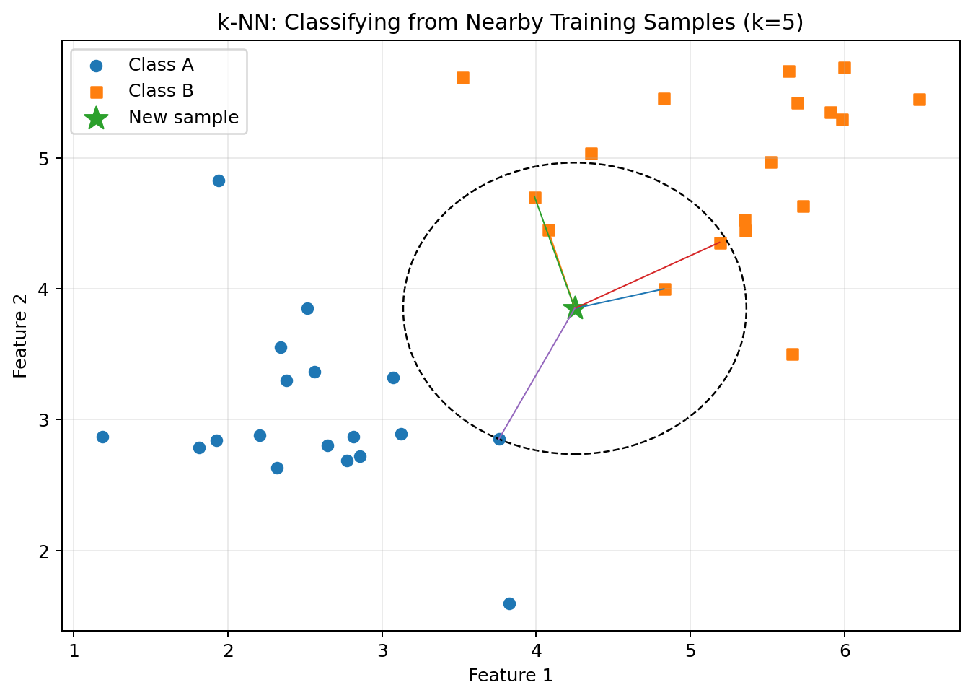
Figure 4: The new point receives a prediction from its nearest neighbours.

5.1 Intuition and Steps
1. Choose k, the number of neighbours.
2. Measure the distance from the new point to every training point.
3. Select the k smallest distances.
4. For classification, use majority vote. For regression, average neighbour targets.
5. Return the predicted class or value.
Euclidean distance in two dimensions
d = sqrt((x2 - x1)^2 + (y2 - y1)^2)
Euclidean distance is the straight-line distance between two points.
Example: Distance from A(2,3) to B(5,7) = sqrt(3^2 + 4^2) = 5.

5.2 Manual Classification Example
Point | Coordinates | Class | Distance from P(4,4)
A | (2, 3) | Blue | sqrt(5) = 2.24
B | (3, 5) | Blue | sqrt(2) = 1.41
C | (6, 5) | Red | sqrt(5) = 2.24
D | (7, 7) | Red | sqrt(18) = 4.24

For k = 3, the nearest points are B (Blue), A (Blue) and C (Red). Blue receives two votes, so P is classified as Blue.

5.3 Choosing k
Small k | Large k
Flexible and sensitive to local detail | Smoother decision boundary
Can be affected by noise | May ignore important local structure
Higher risk of overfitting | Higher risk of underfitting

CAUTION: Why scaling is essential
Suppose Age ranges from 18 to 60 but Annual Income ranges from 100000 to 2000000. Income differences will dominate Euclidean distance unless features are scaled.

5.4 Python Example with a Pipeline
Python example
from sklearn.datasets import load_iris
from sklearn.model_selection import train_test_split
from sklearn.pipeline import make_pipeline
from sklearn.preprocessing import StandardScaler
from sklearn.neighbors import KNeighborsClassifier
from sklearn.metrics import accuracy_score

X, y = load_iris(return_X_y=True)
X_train, X_test, y_train, y_test = train_test_split(
X, y, test_size=0.20, random_state=42, stratify=y
)

model = make_pipeline(
StandardScaler(),
KNeighborsClassifier(n_neighbors=5)
)
model.fit(X_train, y_train)
pred = model.predict(X_test)
print('Accuracy:', accuracy_score(y_test, pred))

Advantages | Limitations
Simple and intuitive | Prediction becomes slow for large training sets
No complex training stage | Stores the training data
Can learn irregular boundaries | Sensitive to scaling and irrelevant features
Supports classification and regression | Performance drops in very high dimensions

6. Support Vector Machine (SVM)
SVM tries to separate classes with a boundary that leaves the widest possible margin.
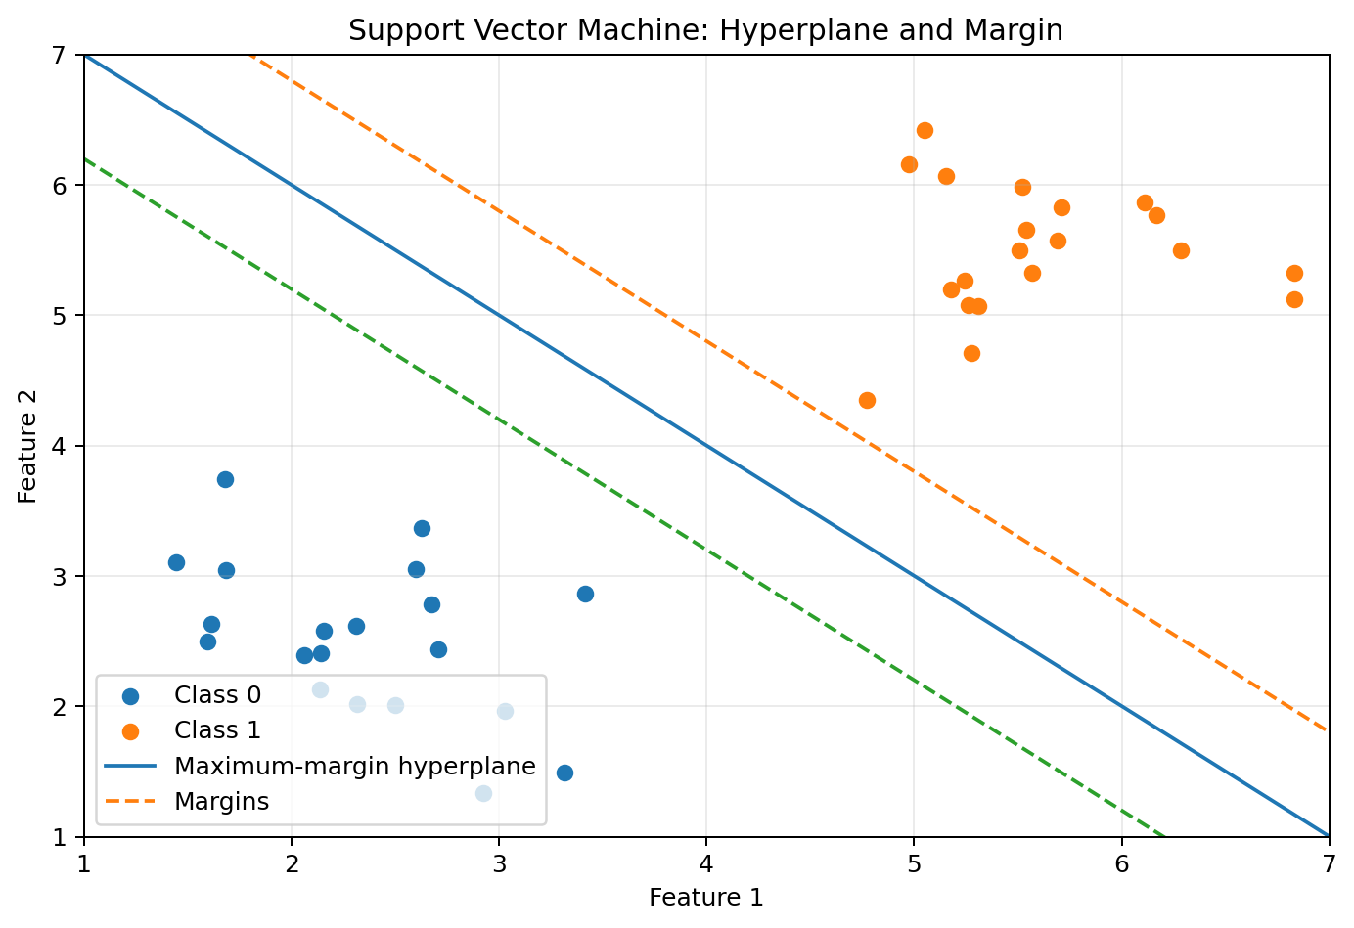
Figure 5: The support vectors are the closest points to the separating boundary and determine the maximum margin.

6.1 Hyperplane, Margin and Support Vectors
Term | Meaning
Hyperplane | The separating boundary. In 2D it is a line; in 3D it is a plane.
Margin | Distance between the boundary and the closest points from each class.
Support vectors | Training points closest to the boundary. They strongly determine its position.

Among many possible separating lines, SVM prefers the one with the widest margin because a wider margin often gives better generalisation.

6.2 Soft Margin and C
Real data may overlap, so SVM can allow some margin violations. The hyperparameter C controls the balance between a wide margin and training errors.
C value | Typical behaviour
Small C | Allows more violations and prefers a wider, smoother margin.
Large C | Punishes violations more strongly and tries harder to classify training points correctly.

6.3 Kernel Idea
If classes cannot be separated by a straight boundary, a kernel lets SVM represent a non-linear boundary. Common kernels are linear, polynomial and radial basis function (RBF). The RBF kernel is a common default for non-linear problems.
MEMORY AID: C and gamma are different
C controls the penalty for errors. With an RBF kernel, gamma controls how locally each training point influences the boundary. Very large values can produce an overly complex boundary.

6.4 Python Example
Python example
from sklearn.datasets import load_iris
from sklearn.model_selection import train_test_split
from sklearn.pipeline import make_pipeline
from sklearn.preprocessing import StandardScaler
from sklearn.svm import SVC
from sklearn.metrics import accuracy_score

X, y = load_iris(return_X_y=True)
X_train, X_test, y_train, y_test = train_test_split(
X, y, test_size=0.20, random_state=42, stratify=y
)

model = make_pipeline(
StandardScaler(),
SVC(kernel='rbf', C=1.0, gamma='scale')
)
model.fit(X_train, y_train)
pred = model.predict(X_test)
print('Accuracy:', accuracy_score(y_test, pred))

Advantages | Limitations
Effective in high-dimensional spaces | Feature scaling is important
Flexible non-linear kernels | Training can be slow on very large datasets
Uses important boundary points | Hyperparameters require careful tuning
Strong classifier for clear margins | Harder to explain than a small tree

QUICK CHECK
1. What are support vectors?
2. What is the purpose of the margin?
3. Why do SVM inputs normally require scaling?

7. K-means Clustering
K-means divides unlabelled observations into k groups by repeatedly updating cluster centres called centroids.
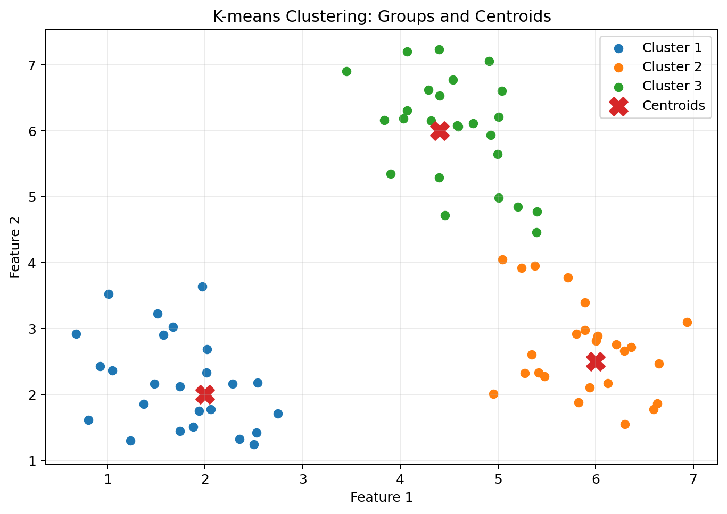
Figure 6: K-means alternates between assigning points to the nearest centroid and updating each centroid.

7.1 Algorithm Steps
1. Choose the number of clusters k.
2. Initialise k centroid positions.
3. Assign every point to its nearest centroid.
4. Replace each centroid with the mean of the points assigned to it.
5. Repeat assignment and update until the centroids stop changing significantly.

7.2 One-Dimensional Worked Example
Data points: 1, 2, 3, 10, 11, 12. Choose k = 2 and initial centroids c1 = 2 and c2 = 10.
Iteration | Cluster 1 | Cluster 2 | New centroids
1 | 1, 2, 3 | 10, 11, 12 | c1 = 2, c2 = 11
2 | 1, 2, 3 | 10, 11, 12 | No change; algorithm stops

The final clusters are the low-value group {1,2,3} and the high-value group {10,11,12}. The cluster numbers 0 and 1 are only identifiers; they do not carry a natural order.

7.3 Objective and Choosing k
Within-cluster squared error (inertia)
Inertia = sum of squared distances from each point to its assigned centroid
K-means tries to make clusters compact by reducing this value. Inertia always decreases when k increases, so it cannot select k alone.

- Elbow method: plot inertia for several k values and look for a point of diminishing improvement.
- Silhouette score: compares how close a point is to its own cluster versus other clusters.
- Domain knowledge: select a number of groups that can actually support a decision.

7.4 Important Limitations
- k must be selected in advance.
- Results can depend on initial centroids; multiple initialisations help.
- It works best for roughly compact, similar-sized clusters.
- Outliers can move the mean centroids.
- Feature scaling strongly affects distance and cluster formation.

7.5 Python Example
Python example
from sklearn.datasets import load_iris
from sklearn.preprocessing import StandardScaler
from sklearn.cluster import KMeans
from sklearn.metrics import silhouette_score

X, _ = load_iris(return_X_y=True)
X_scaled = StandardScaler().fit_transform(X)

model = KMeans(n_clusters=3, n_init=10, random_state=42)
labels = model.fit_predict(X_scaled)

print('Inertia:', model.inertia_)
print('Silhouette:', silhouette_score(X_scaled, labels))
print('First labels:', labels[:10])

8. Mean Shift Algorithm
Mean Shift discovers dense regions and does not require the number of clusters to be specified directly.
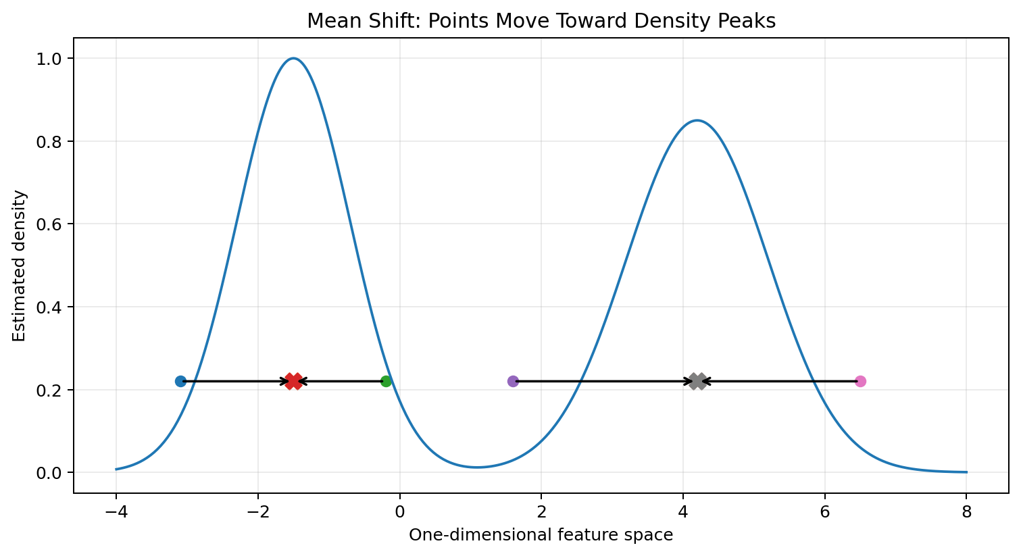
Figure 7: Mean Shift repeatedly moves a search window towards a nearby density peak.

8.1 Intuition
Imagine placing a circular window over a scatter plot. Calculate the mean position of the points inside the window and shift the window centre to that mean. Repeating this movement takes the centre towards a dense peak. Windows reaching the same peak form one cluster.

8.2 Bandwidth
Bandwidth controls the neighbourhood size. It is the most important Mean Shift setting.
Bandwidth | Typical effect
Too small | Many small clusters; sensitive to local noise
Reasonable | Density peaks represent meaningful groups
Too large | Different groups may merge into a few broad clusters

8.3 K-means versus Mean Shift
Point | K-means | Mean Shift
Number of clusters | k is supplied in advance | Emerges from density and bandwidth
Cluster centre | Arithmetic mean centroid | Density mode
Main control | k | Bandwidth
Speed | Usually faster | Often more computationally expensive
Best-known behaviour | Compact groups | Dense regions with unknown count

8.4 Python Example
Python example
from sklearn.datasets import make_blobs
from sklearn.preprocessing import StandardScaler
from sklearn.cluster import MeanShift, estimate_bandwidth

X, _ = make_blobs(
n_samples=200, centers=3, cluster_std=0.70, random_state=42
)
X_scaled = StandardScaler().fit_transform(X)

bandwidth = estimate_bandwidth(X_scaled, quantile=0.20)
model = MeanShift(bandwidth=bandwidth, bin_seeding=True)
labels = model.fit_predict(X_scaled)

print('Estimated clusters:', len(set(labels)))
print('Cluster centres:', model.cluster_centers_)

KEY IDEA: No target does not mean no evaluation
Clustering has no known y label during training, but we can still inspect plots, silhouette score, stability, cluster sizes and whether groups are useful for the real task.

9. Dimensionality Reduction and PCA
Dimensionality reduction represents data with fewer variables while trying to preserve useful information.
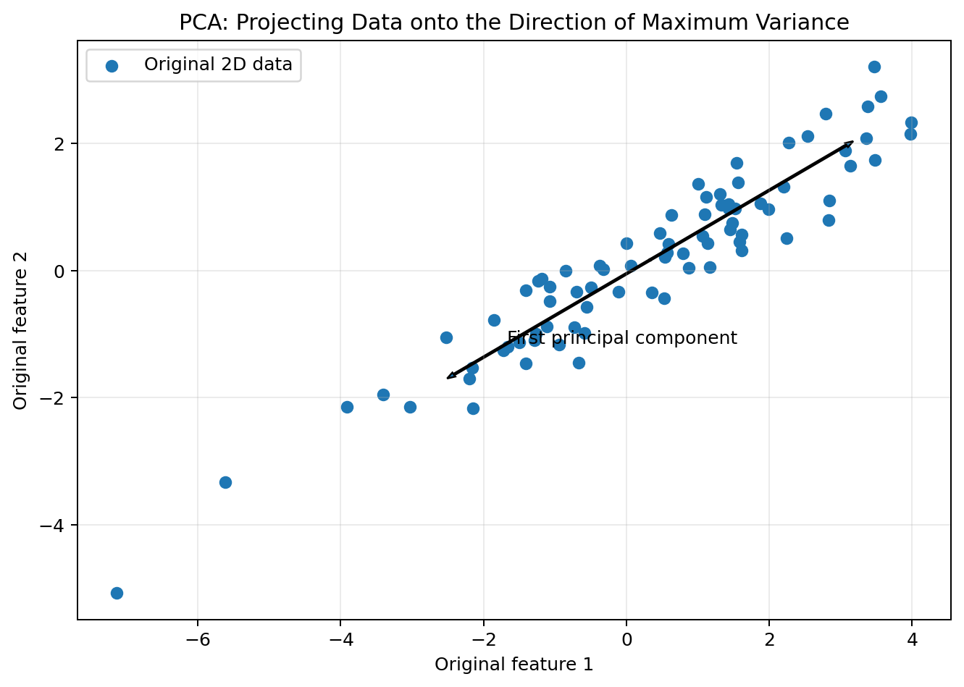
Figure 8: PCA rotates the coordinate system and keeps directions containing the greatest variation.

9.1 Why Reduce Dimensions?
- Visualise high-dimensional data in two or three dimensions.
- Reduce storage and computation.
- Remove redundancy from strongly correlated features.
- Reduce noise and sometimes improve downstream learning.
- Help distance-based methods when many irrelevant dimensions are present.

9.2 Feature Selection versus Feature Extraction
Method | What it does | Interpretation
Feature selection | Keeps a subset of original columns | Selected features retain their original names
Feature extraction | Creates new variables from the originals | New components combine several original features

PCA is a feature-extraction method. Principal components are new axes, not selected original columns.

9.3 Basic PCA Idea
1. Standardise features when their units or scales differ.
2. Centre the data around its mean.
3. Find the direction with maximum variance: Principal Component 1 (PC1).
4. Find a perpendicular direction with the next highest variance: PC2.
5. Keep enough components to preserve an acceptable amount of total variance.
REMEMBER: Components are ordered
PC1 explains the largest possible variance. PC2 explains the largest remaining variance while being perpendicular to PC1. Later components explain progressively less.

9.4 Explained Variance Ratio
The explained variance ratio reports the fraction of total variance captured by each component. For example, [0.72, 0.18] means PC1 explains 72% and PC2 explains 18%; together they preserve 90% of the variance.

9.5 Python Example
Python example
from sklearn.datasets import load_iris
from sklearn.pipeline import make_pipeline
from sklearn.preprocessing import StandardScaler
from sklearn.decomposition import PCA

X, y = load_iris(return_X_y=True)

pca_model = make_pipeline(
StandardScaler(),
PCA(n_components=2)
)
X_2d = pca_model.fit_transform(X)

pca = pca_model.named_steps['pca']
print('New shape:', X_2d.shape)
print('Explained variance ratio:', pca.explained_variance_ratio_)
print('Total preserved:', pca.explained_variance_ratio_.sum())

Advantages | Limitations
Reduces feature count | Components may be difficult to interpret
Useful for visualisation | PCA is linear and may miss curved structure
Can remove correlated redundancy | High variance is not always the most predictive information
May speed later algorithms | Scaling and data leakage must be handled carefully

10. Introduction to Neural Networks
A neural network learns by combining many simple weighted calculations arranged in layers.
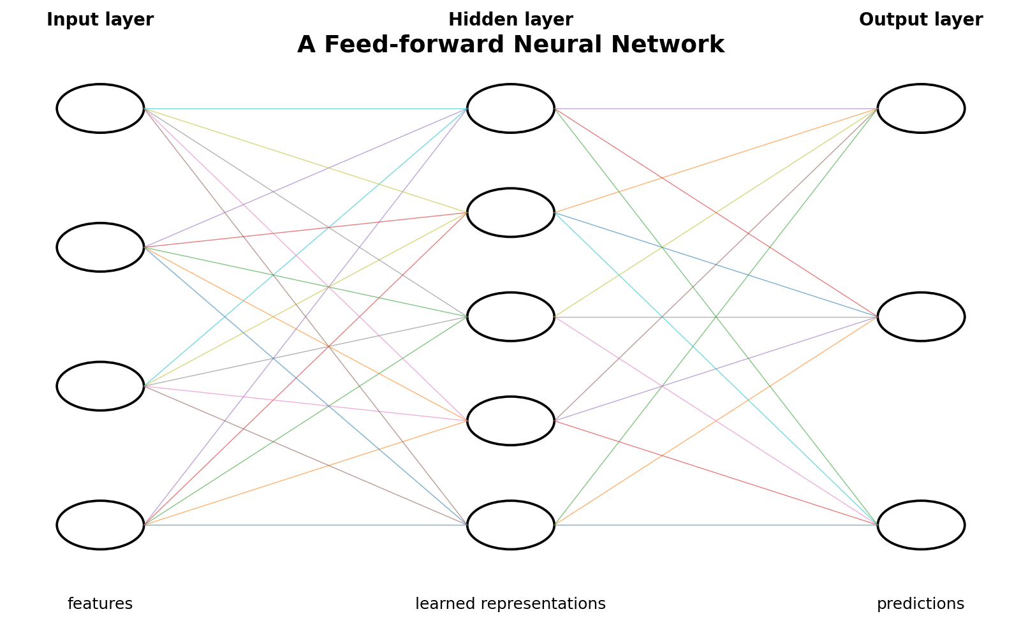
Figure 9: Inputs pass through hidden neurons to an output layer. Training adjusts weights and biases.

10.1 Artificial Neuron
Neuron calculation
z = w1 x1 + w2 x2 + ... + wn xn + b; output = activation(z)
Each input is multiplied by a weight. The bias shifts the result. An activation function adds non-linearity.
Example: With x1=2, x2=3, w1=0.5, w2=-0.2 and b=0.4, z = 1 - 0.6 + 0.4 = 0.8.

Part | Role
Input layer | Receives feature values
Hidden layer | Learns intermediate patterns
Output layer | Produces class scores or numerical predictions
Weight | Controls the strength and direction of an input connection
Bias | Allows a neuron to shift its activation threshold
Activation function | Introduces non-linearity
Loss function | Measures prediction error during training

10.2 Activation Functions
Activation | Basic idea | Common use
ReLU | max(0, z) | Hidden layers
Sigmoid | Maps z between 0 and 1 | Binary probability output
Tanh | Maps z between -1 and 1 | Some hidden layers
Softmax | Converts scores into class probabilities summing to 1 | Multiclass output

10.3 Training Cycle
1. Forward pass: calculate predictions using current weights.
2. Loss: compare predictions with known targets.
3. Backpropagation: calculate how each weight contributed to error.
4. Optimisation: update weights to reduce the loss.
5. Repeat for many epochs using batches of training examples.
Term | Meaning
Epoch | One complete pass through the training dataset
Batch | A subset used for one parameter update
Learning rate | Step size used when changing weights
Hidden units | Number of neurons in a hidden layer
Regularisation | Methods that reduce overfitting

10.4 Python Example: Multi-Layer Perceptron
Python example
from sklearn.datasets import load_iris
from sklearn.model_selection import train_test_split
from sklearn.pipeline import make_pipeline
from sklearn.preprocessing import StandardScaler
from sklearn.neural_network import MLPClassifier
from sklearn.metrics import accuracy_score

X, y = load_iris(return_X_y=True)
X_train, X_test, y_train, y_test = train_test_split(
X, y, test_size=0.20, random_state=42, stratify=y
)

model = make_pipeline(
StandardScaler(),
MLPClassifier(
hidden_layer_sizes=(16,),
max_iter=1000,
random_state=42
)
)
model.fit(X_train, y_train)
pred = model.predict(X_test)
print('Accuracy:', accuracy_score(y_test, pred))

KEY IDEA: Neural network is a family, not one fixed model
The number of layers, neurons, activations, loss functions and training settings define the architecture. A small MLP is suitable for introductory tabular examples; deep networks may use many specialised layers.

Advantages | Limitations
Learns complex non-linear relationships | Usually requires scaling and tuning
Flexible for classification and regression | Less interpretable than simple models
Can model interactions automatically | Can require more data and computation
Foundation of modern deep learning | May overfit without validation and regularisation

QUICK CHECK
1. What is the role of a weight?
2. Why is an activation function used?
3. What happens during backpropagation?

11. Algorithm Comparison and Selection Guide
There is no universally best algorithm. Select a reasonable starting model, evaluate it fairly and compare alternatives.
Algorithm | Task | Scaling | Interpretability | Important setting
Decision Tree | Classification / regression | Usually no | High for small trees | max_depth
Linear Regression | Regression | Helpful | High | Regularisation / features
k-NN | Classification / regression | Essential | Medium | n_neighbors
SVM | Classification / regression | Essential | Low-Medium | C, kernel, gamma
K-means | Clustering | Essential | Medium | n_clusters
Mean Shift | Clustering | Important | Medium | bandwidth
PCA | Dimensionality reduction | Usually essential | Low-Medium | n_components
Neural Network | Classification / regression | Essential | Low | layers, learning rate

11.1 Quick Selection Rules
Situation | Good first choice | Reason
Need simple explainable rules | Small Decision Tree | Predictions can be followed through questions
Predict a number with an approximately linear pattern | Linear Regression | Fast, transparent baseline
Local similarity is meaningful and data is not huge | k-NN | Uses nearby cases directly
Clear class boundary in scaled data | SVM | Max-margin classifier
Need k compact groups | K-means | Simple and efficient clustering
Number of dense groups is unknown | Mean Shift | Cluster count emerges from bandwidth
Too many correlated numeric features | PCA | Creates fewer components
Complex non-linear pattern with enough data | Neural Network | Flexible function approximator

11.2 Questions to Ask Before Choosing
- Is a target label available?
- Is the target categorical or numerical?
- How many observations and features are available?
- Are features on very different scales?
- Is an explainable model required?
- Is the expected pattern linear, local, tree-like, margin-based or highly non-linear?
- How much training time, prediction time and memory are available?
- Which evaluation measure reflects the real cost of mistakes?
PRACTICAL RULE: Start with a baseline
A complex algorithm is not automatically better. Begin with a simple baseline, use the same train/test split, preprocess correctly and compare models using suitable measures.

12. Integrated Python Practical
This practical compares supervised classifiers on the Iris dataset, then applies PCA and K-means to the same feature data.

12.1 Install and Import
Step 1: imports
# Run once in a terminal if the packages are not installed:
# pip install numpy pandas matplotlib scikit-learn

import pandas as pd
from sklearn.datasets import load_iris
from sklearn.model_selection import train_test_split
from sklearn.pipeline import make_pipeline
from sklearn.preprocessing import StandardScaler
from sklearn.metrics import accuracy_score, classification_report

12.2 Load and Understand the Dataset
Step 2: dataset
iris = load_iris(as_frame=True)
df = iris.frame

print(df.head())
print(df.shape)
print(df['target'].value_counts())
print(iris.target_names)

X = df.drop(columns='target')
y = df['target']

12.3 Create One Fair Train-Test Split
Step 3: split
X_train, X_test, y_train, y_test = train_test_split(
X, y,
test_size=0.20,
random_state=42,
stratify=y
)

12.4 Compare Three Classifiers
Step 4: model comparison
from sklearn.tree import DecisionTreeClassifier
from sklearn.neighbors import KNeighborsClassifier
from sklearn.svm import SVC

models = {
'Decision Tree': DecisionTreeClassifier(
max_depth=3, random_state=42
),
'k-NN': make_pipeline(
StandardScaler(), KNeighborsClassifier(n_neighbors=5)
),
'SVM': make_pipeline(
StandardScaler(), SVC(kernel='rbf', C=1.0)
)
}

for name, model in models.items():
model.fit(X_train, y_train)
pred = model.predict(X_test)
print(name, 'accuracy =', accuracy_score(y_test, pred))

INTERPRETATION: Fair comparison
All models use the same training and test observations. Scaling is placed inside pipelines for k-NN and SVM so it is fitted only on training data.

12.5 Apply PCA and K-means
Step 5: representation and clustering
from sklearn.preprocessing import StandardScaler
from sklearn.decomposition import PCA
from sklearn.cluster import KMeans
from sklearn.metrics import silhouette_score

X_scaled = StandardScaler().fit_transform(X)
X_2d = PCA(n_components=2).fit_transform(X_scaled)

cluster_model = KMeans(
n_clusters=3, n_init=10, random_state=42
)
clusters = cluster_model.fit_predict(X_2d)

print('Reduced shape:', X_2d.shape)
print('Silhouette:', silhouette_score(X_2d, clusters))
print(pd.crosstab(clusters, y))

The crosstab compares discovered cluster IDs with known species labels only for interpretation. K-means did not use y while creating clusters, and cluster numbers do not have to match class numbers.

12.6 Optional Visualisation
Step 6: plot clusters
import matplotlib.pyplot as plt

plt.scatter(X_2d[:, 0], X_2d[:, 1], c=clusters)
plt.xlabel('Principal Component 1')
plt.ylabel('Principal Component 2')
plt.title('K-means Clusters after PCA')
plt.show()

13. Formula Sheet and Glossary

13.1 Formula Sheet
Concept | Formula / rule | Use
Gini impurity | 1 - sum(p_i^2) | Measures class mixing in a tree node
Entropy | - sum(p_i log2 p_i) | Alternative tree impurity measure
Linear regression | y_hat = b0 + b1 x | Predicts a number from a line
Residual | y - y_hat | Error for one prediction
MSE | (1/n) sum((y - y_hat)^2) | Average squared regression error
Euclidean distance | sqrt(sum((a_i-b_i)^2)) | Distance in k-NN and clustering
Neuron input | z = sum(w_i x_i) + b | Weighted combination before activation
ReLU | max(0,z) | Common hidden-layer activation

13.2 Glossary
Term | Meaning
Activation function | Function that adds non-linearity to a neural network neuron.
Bandwidth | Neighbourhood size controlling Mean Shift density estimation.
Centroid | Mean position representing a K-means cluster.
Classification | Supervised prediction of a category.
Cluster | Group of observations with similar feature patterns.
Component | New direction created by a dimensionality-reduction method such as PCA.
Decision boundary | Region or line separating predicted classes.
Epoch | One full pass through neural-network training data.
Feature | Input variable used by a model.
Generalisation | Ability to perform well on unseen data.
Hyperparameter | User-controlled setting such as k, C or max_depth.
Inertia | K-means sum of squared distances to assigned centroids.
Kernel | SVM method for representing non-linear decision boundaries.
Label | Known categorical target value.
Margin | Gap between an SVM boundary and closest class points.
Model | Pattern learned by an algorithm from data.
Overfitting | Learning training details that do not generalise.
Parameter | Value learned during training.
Regression | Supervised prediction of a continuous number.
Support vector | Training point that helps determine the SVM boundary.
Target | Output variable a supervised model learns to predict.
Unsupervised learning | Learning structure without known target labels.
Weight | Learned strength of a neural-network connection.

14. Self-Assessment and Answer Key

14.1 Multiple-Choice Questions
1. Which task predicts a continuous value?
A. Classification B. Regression C. Clustering D. PCA
2. Which algorithm usually does not require feature scaling?
A. k-NN B. SVM C. Decision Tree D. K-means
3. A final prediction node in a decision tree is called a:
A. Root B. Leaf C. Margin D. Centroid
4. Gini impurity of a pure node is:
A. 0 B. 0.5 C. 1 D. Undefined
5. In y_hat = b0 + b1x, b1 is the:
A. Target B. Slope C. Residual D. Cluster
6. k-NN classification normally uses:
A. Mean target B. Majority vote C. Maximum margin D. Principal component
7. The closest SVM points to the boundary are:
A. Centroids B. Support vectors C. Outliers D. Components
8. Which SVM setting controls error penalty?
A. k B. C C. Bandwidth D. n_components
9. K-means requires the user to provide:
A. Class labels B. Number of clusters k C. Regression slope D. Support vectors
10. The representative centre of a K-means group is a:
A. Centroid B. Kernel C. Leaf D. Neuron
11. Mean Shift cluster count mainly depends on:
A. Tree depth B. Bandwidth C. R2 D. Epoch
12. PCA creates:
A. Only class labels B. New principal components C. Tree branches D. Cluster targets
13. PC1 captures:
A. Minimum possible variance B. Maximum possible variance C. Only target variance D. No variance
14. A neural-network bias is:
A. A data error B. An adjustable offset C. A cluster number D. A test set
15. Backpropagation is used to:
A. Choose k B. Update weights using error information C. Create centroids D. Sort neighbours
16. An epoch means:
A. One feature B. One full pass through training data C. One test record D. One hidden neuron
17. Very high training and low test performance suggests:
A. Underfitting B. Overfitting C. Perfect generalisation D. Clustering
18. Which method is unsupervised?
A. Linear Regression B. SVC C. K-means D. Decision Tree Classifier
19. Which algorithms are strongly distance-based?
A. k-NN and K-means B. Tree and Linear Regression only C. Decision Tree and PCA only D. None
20. A simple model used for comparison is called a:
A. Baseline B. Kernel C. Support vector D. Mode

14.2 Short-Answer Questions
1. Differentiate an algorithm and a model.
2. Differentiate classification and regression with one example each.
3. Why is a separate test set required?
4. Explain root, branch and leaf in a decision tree.
5. What is a residual in linear regression?
6. Why is feature scaling important for k-NN?
7. What are support vectors?
8. Write the five main steps of K-means.
9. What is bandwidth in Mean Shift?
10. Differentiate feature selection and feature extraction.
11. What does explained variance mean in PCA?
12. Name the main parts of an artificial neuron.

14.3 Long-Answer Questions
1. Explain Decision Tree classification with impurity, split selection, overfitting controls, advantages and limitations.
2. Explain Linear Regression using the line equation, residuals, MSE, R2, assumptions and a suitable example.
3. Describe k-NN classification with a manual distance example. Discuss k selection, scaling, strengths and limitations.
4. Explain SVM using hyperplane, margin, support vectors, C and kernels.
5. Compare K-means and Mean Shift clustering.
6. Explain PCA, its steps, explained variance, uses and limitations.
7. Draw and explain a feed-forward neural network. Describe forward pass, loss, backpropagation and weight update.
8. Compare all Unit 04 algorithms according to task, scaling, interpretability and important hyperparameters.

14.4 Practical Exercises
1. Train DecisionTreeClassifier on the Iris dataset. Change max_depth from 1 to 5 and compare training and test accuracy.
2. Create a small study-hours dataset and use LinearRegression to predict marks for a new value.
3. Train k-NN for k = 1, 3, 5, 7 and 9. Record test accuracy and identify the best k for the chosen split.
4. Compare linear and RBF SVM pipelines on a classification dataset.
5. Apply K-means for k = 2 to 6 and record inertia and silhouette score.
6. Apply PCA to four Iris features and preserve two components. Plot the transformed data.
7. Train MLPClassifier with one hidden layer and compare its result with a Decision Tree.

14.5 MCQ Answer Key
1-5 | 6-10 | 11-15 | 16-20
1-B, 2-C, 3-B, 4-A, 5-B | 6-B, 7-B, 8-B, 9-B, 10-A | 11-B, 12-B, 13-B, 14-B, 15-B | 16-B, 17-B, 18-C, 19-A, 20-A

14.6 One-Minute Revision
- Tree asks questions; Linear Regression fits a line.
- k-NN follows nearby examples; SVM maximises margin.
- K-means needs k; Mean Shift needs bandwidth.
- PCA creates fewer components; Neural Networks combine weighted neurons.
- Scale distance-, margin-, component- and gradient-based methods.
- Evaluate on unseen data and compare against a baseline.

Further Reading
The Python examples use the scikit-learn estimator and pipeline style. Official reference: scikit-learn User Guide
Documentation interface checked in July 2026. The concepts remain applicable across machine learning software, but exact defaults may vary by version.

