UNIT 05
MINING SOCIAL-NETWORK GRAPHS,
DATA SCIENCE AND ETHICAL ISSUES
BEGINNER-FRIENDLY STUDENT NOTES
Syllabus coverage:
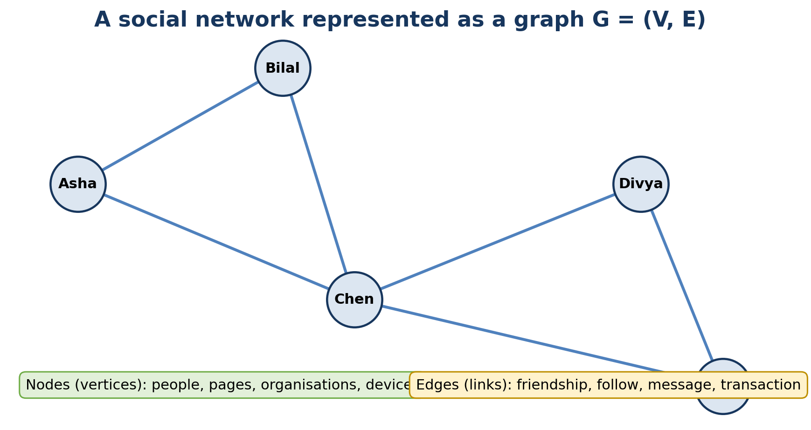
A social network can be modelled as nodes connected by edges.
UNIT MESSAGE: Central idea
Graph analysis studies relationships, not only individual records. Ethical data science asks whether those relationships should be collected, analysed and acted upon, and how harm can be prevented.
Data Science and Machine Learning
Student learning material

A. How to Use These Notes
- Start with a real network. Think of students connected by friendship, web pages connected by hyperlinks, or devices connected by communication.
- Draw small graphs by hand. Mark nodes, edges, neighbours, paths and communities before using formulas.
- Read formulas as questions. For example, degree asks “How many direct connections does this node have?”
- Run the Python examples. Change one edge and observe how degree, density, clustering and communities change.
- Study ethics with the technical topic. A graph may reveal hidden groups or relationships; this creates responsibilities for consent, security and fair use.
- Revise actively. Use the memory aids, quick checks, formula sheet, glossary and examination questions.

B. Learning Outcomes
- Represent a social network as a graph G = (V, E) and identify nodes, edges and graph types.
- Use edge lists, adjacency lists and adjacency matrices to store small graphs.
- Calculate degree, density, path length, common neighbours, Jaccard similarity and local clustering coefficient.
- Explain graph clustering, community structure and modularity in simple language.
- Describe greedy modularity, label propagation, Girvan-Newman, Louvain idea and clique-based community discovery.
- Differentiate community detection from graph partitioning and explain cut edges, balance and spectral ideas.
- Discuss privacy, security and ethical risks in social-network data science.
- Summarise the development of data science and the skills of next-generation data scientists.
- Create and analyse a small social-network graph using Python and NetworkX.

C. Contents
1. Foundations: Social Networks as Graphs
2. Graph Representation and Basic Measurements
3. Neighbourhood Properties in Graphs
4. Graph Clustering and Community Structure
5. Direct Discovery of Communities
6. Partitioning of Graphs
7. Privacy in Social-Network Data
8. Security of Data and Models
9. Ethics and Responsible Data Science
10. A Look Back at Data Science
11. Next-Generation Data Scientists
12. Integrated NetworkX Practical
13. Quick Revision, Formula Sheet and Glossary
14. Self-Assessment and Answer Key

1. Foundations: Social Networks as Graphs
A social network contains entities and relationships. A graph is a mathematical structure that represents those entities as nodes and the relationships as edges. This representation lets us ask questions such as: Who is highly connected? Which groups are tightly linked? Which connections act as bridges?
Graph model | G = (V, E)  V is the set of vertices or nodes. E is the set of edges or links between nodes.

1.1 Nodes and Edges
Graph element | Meaning | Social-network examples
Node / vertex | An entity represented in the network | person, account, page, organisation, device
Edge / link | A relationship or interaction between two nodes | friendship, follow, message, transaction, citation
Node attribute | Information attached to a node | department, city, account type, age group
Edge attribute | Information attached to an edge | message count, date, rating, interaction strength

KEY IDEA: Rows versus relationships
A normal table is good at describing individual objects. A graph is especially useful when the relationships among objects are central to the problem.

1.2 Common Graph Types
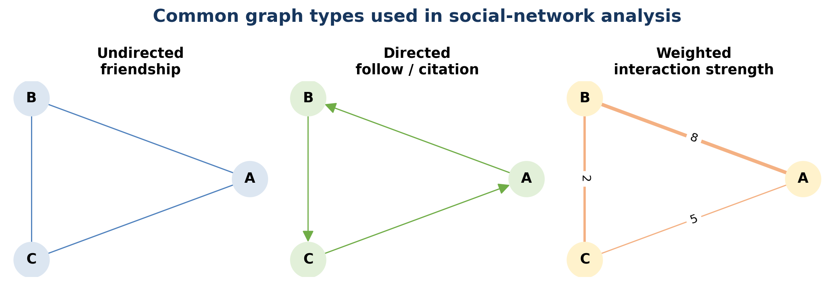
Common graph types used in social-network analysis.
Type | Meaning | Example
Undirected graph | An edge has no direction | A and B are friends
Directed graph | An edge points from one node to another | A follows B; B may not follow A
Weighted graph | An edge stores strength, count or cost | A sent B 18 messages
Signed graph | An edge can be positive or negative | trust / distrust; like / dislike
Temporal graph | Nodes or edges change over time | daily communication network
Bipartite graph | Nodes belong to two different sets | students connected to courses

1.3 A Small Example
Suppose Asha is connected to Bilal and Chen. Bilal is connected to Chen. Chen is connected to Divya. Then:
- The nodes are {Asha, Bilal, Chen, Divya}.
- The edges are {(Asha, Bilal), (Asha, Chen), (Bilal, Chen), (Chen, Divya)}.
- Asha, Bilal and Chen form a triangle.
- Chen is a bridge between the triangle and Divya.
QUICK CHECK: In a directed follower network, A follows B. Does this automatically mean B follows A?
Answer: No. Direction matters, so the reverse edge must be present separately.

2. Graph Representation and Basic Measurements

2.1 Edge List, Adjacency List and Matrix
Representation | Example | Strength | Limitation
Edge list | A-B, A-C, B-C, C-D | Simple and compact for sparse graphs | Finding all neighbours may require a search
Adjacency list | A: B,C; C: A,B,D | Fast access to a node's neighbours | Less convenient for some matrix operations
Adjacency matrix | Rows and columns are nodes; 1 means edge | Easy matrix-based computation | Uses n x n space, often wasteful for sparse graphs

2.2 Degree
Undirected degree | deg(v) = number of edges incident on node v  Degree measures the number of direct connections.

Directed degree | in-degree(v) = incoming edges; out-degree(v) = outgoing edges  A popular account may have high in-degree; an active follower may have high out-degree.

In the small graph above, Chen connects to Asha, Bilal and Divya, so deg(Chen) = 3. A node with high degree is locally well connected, but it is not always globally influential.

2.3 Density
Undirected density | Density = 2m / [n(n - 1)]  n is the number of nodes and m is the number of edges. Density lies between 0 and 1 for a simple undirected graph.

For n = 4 nodes and m = 4 edges: density = 2(4) / [4(3)] = 8/12 = 0.667. About two-thirds of all possible undirected edges are present.

2.4 Paths, Distance and Components
Term | Simple meaning
Walk | A sequence of connected nodes; nodes or edges may repeat
Path | A route through connected nodes without repeating nodes in the usual simple-path definition
Shortest-path distance | Minimum number or cost of edges needed to travel between two nodes
Connected component | A maximal set of nodes where every pair is connected by some path
Bridge edge | An edge whose removal increases the number of connected components
Diameter | The greatest shortest-path distance among connected node pairs

REMEMBER: Connection does not mean closeness
Two people may be in the same connected component but still be many steps apart. Graph distance measures those steps.

2.5 Introductory Centrality Ideas
Measure | Question it asks | Caution
Degree centrality | Who has many direct connections? | May miss quiet bridge nodes
Betweenness centrality | Who often lies on shortest routes? | Depends on shortest-path assumption
Closeness centrality | Who is a short distance from others? | Needs care in disconnected graphs
PageRank / eigenvector idea | Who is connected to important nodes? | Importance is recursively defined

QUICK CHECK: Can a node have low degree but high betweenness?
Answer: Yes. A node with only two links may connect two otherwise separate communities and lie on many shortest paths.

3. Neighbourhood Properties in Graphs
A neighbourhood describes the nodes immediately or nearly connected to a chosen node. Neighbourhood properties are useful for friend recommendation, link prediction, fraud analysis and local community understanding.
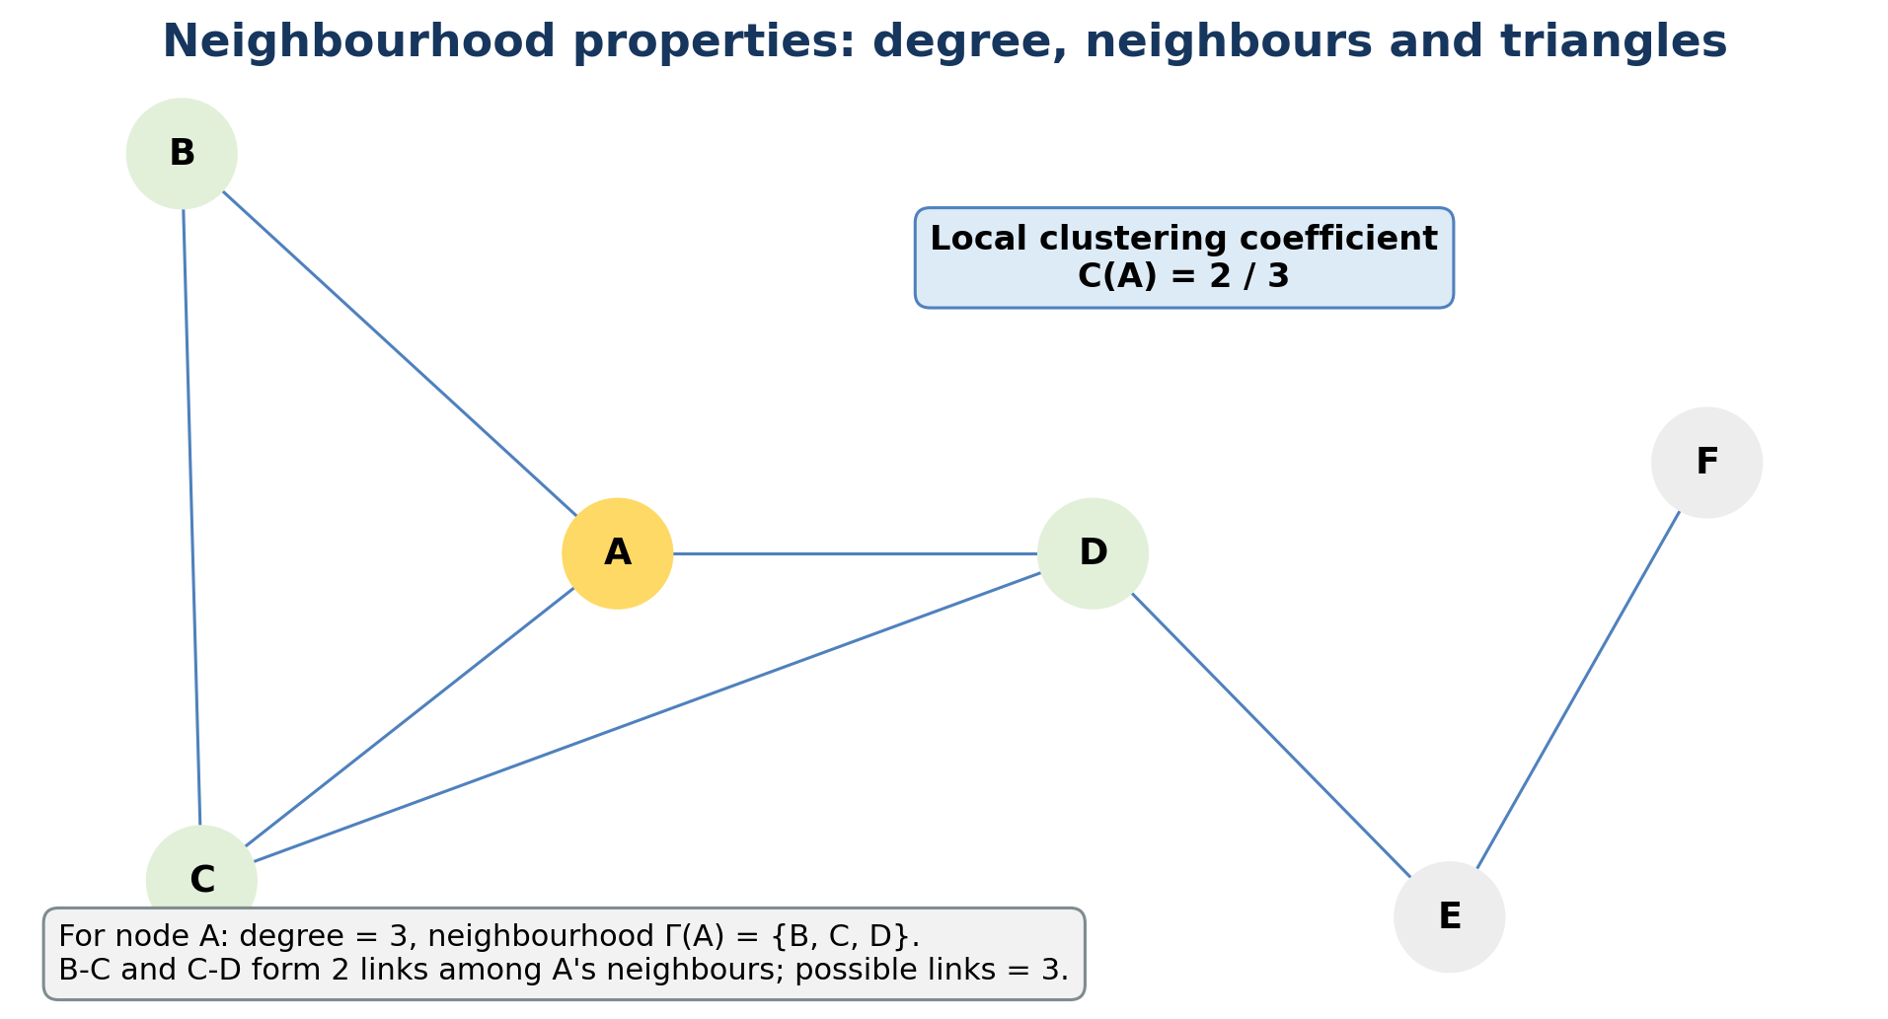
Degree, neighbours, triangles and local clustering around a selected node.

3.1 One-Hop and k-Hop Neighbourhoods
- One-hop neighbours: nodes connected directly to the selected node.
- Two-hop neighbours: nodes reachable using at most two edges.
- k-hop neighbourhood: all nodes within k steps.
- Ego network: the selected ego node, its neighbours and usually the edges among those neighbours.

3.2 Common Neighbours and Link Prediction
Common neighbours | CN(u, v) = |N(u) intersection N(v)|  A larger count suggests that u and v share more contacts and may be more likely to connect.

Jaccard similarity | J(u, v) = |N(u) intersection N(v)| / |N(u) union N(v)|  Jaccard adjusts the common-neighbour count by the total size of the two neighbourhoods.

Example: N(A) = {B, C, D} and N(E) = {C, D, F}. Common neighbours are {C, D}, so CN(A,E) = 2. The union is {B,C,D,F}, so J(A,E) = 2/4 = 0.5.

3.3 Triangles and Local Clustering Coefficient
Local clustering | C(v) = actual links among neighbours / possible links among neighbours  If deg(v) = k, the number of possible links among neighbours is k(k - 1)/2.

Suppose A has neighbours B, C and D. Among these neighbours, B-C and C-D exist, but B-D does not. Actual links = 2; possible links = 3; therefore C(A) = 2/3.
KEY IDEA: What clustering coefficient tells us
A high local clustering coefficient means “my neighbours also know one another.” It measures local closure, not the number of communities in the entire graph.

3.4 Neighbourhood Features in Data Science
Feature | Possible use
Degree / weighted degree | activity or interaction intensity
Number of common neighbours | friend or collaborator recommendation
Jaccard similarity | normalised neighbourhood overlap
Triangle count | local cohesion and trust signals
Ego-network density | how tightly connected a person's local circle is
Neighbour attributes | peer influence, homophily and local context

QUICK CHECK: If a node has degree 1, what is its usual local clustering coefficient?
Answer: 0, because it does not have a pair of neighbours that could be connected.

4. Graph Clustering and Community Structure
A community is a group of nodes with relatively many connections inside the group and relatively few connections to other groups. Communities may represent friend circles, departments, interest groups, fraud rings or research fields.
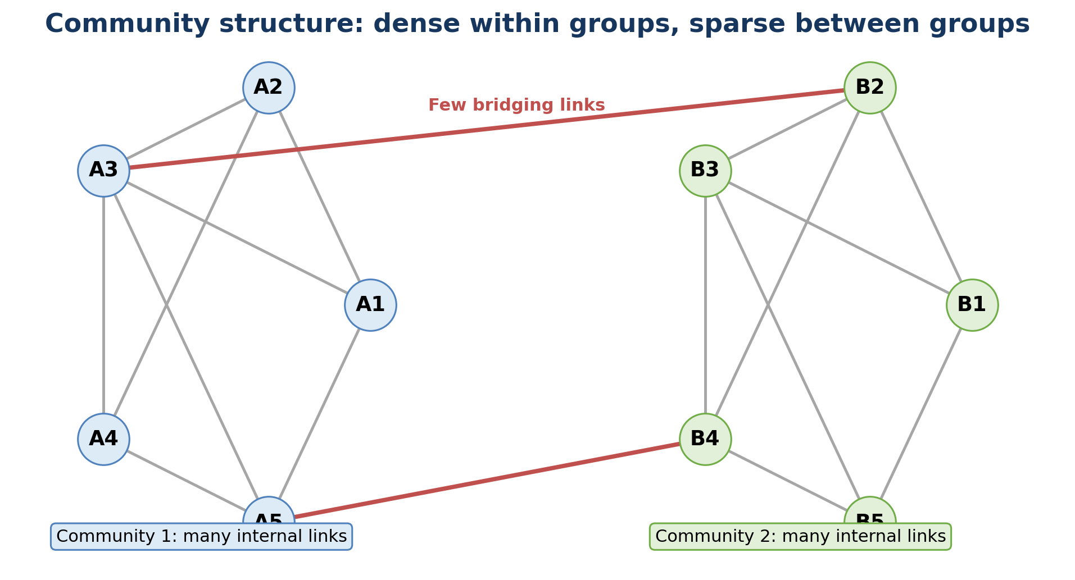
Community structure: dense internal connections and only a few bridging links.

4.1 Graph Clustering versus Ordinary Clustering
Aspect | Ordinary data clustering | Graph clustering / community detection
Input | Feature vectors such as height, marks and income | Nodes plus relationships
Similarity | Usually calculated from feature distance | Often inferred from edges and topology
Goal | Group similar records | Find densely or meaningfully connected node groups
Typical methods | K-means, hierarchical clustering | Modularity, label propagation, Girvan-Newman, spectral methods

4.2 Modularity in Simple Language
Modularity compares the number of edges found inside proposed communities with the number expected in a random graph that preserves node degrees approximately. A higher value usually indicates stronger community structure, but it should not be treated as a perfect universal score.
Conceptual modularity | Q = observed within-community connection minus expected within-community connection  Positive, larger Q often suggests a meaningful partition; interpretation depends on graph size and resolution.

4.3 Hard, Soft and Overlapping Communities
Community type | Meaning | Example
Hard / disjoint | Each node belongs to exactly one community | assigning each employee to one department
Overlapping | A node may belong to several communities | a student belongs to sports, coding and music groups
Hierarchical | Small communities are nested inside larger ones | class inside department inside university
Dynamic | Membership changes with time | temporary project or event groups

4.4 Challenges
- No single “correct” community structure may exist.
- Different algorithms can produce different partitions.
- Large communities may hide smaller meaningful groups; very small groups may be unstable.
- Direction, weight, sign and time can change the interpretation.
- A mathematically strong cluster may not have a meaningful real-world label.
- Graph data may be incomplete, sampled or intentionally manipulated.
CAUTION: Do not over-interpret a cluster
An algorithm returns a structural pattern. A domain expert must decide whether the pattern represents a genuine social group, a technical artefact or a harmful stereotype.

5. Direct Discovery of Communities in Graphs
Direct community-discovery algorithms work on the graph structure to identify groups. They differ in the pattern they optimise, their speed and whether they allow overlapping or hierarchical communities.
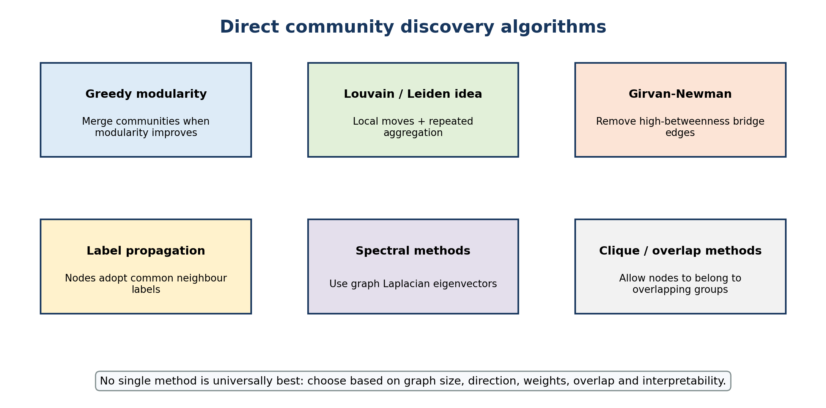
Major approaches to direct community discovery.

5.1 Greedy Modularity Maximisation
1. Start with each node as its own community.
2. Consider merging pairs of communities.
3. Choose the merge that gives the greatest increase in modularity.
4. Repeat until no allowed merge improves the objective.
Strength: easy to explain and useful for many undirected graphs. Limitation: a greedy decision made early may prevent a better later arrangement, and modularity can miss small communities in large networks.

5.2 Label Propagation
1. Give every node an initial label.
2. Update a node to the label most common among its neighbours.
3. Continue until labels become stable or an iteration limit is reached.
4. Nodes sharing a final label form a community.
Strength: fast and scalable. Limitation: random update order or ties may lead to different answers across runs.

5.3 Girvan-Newman Method
Girvan-Newman is a divisive method. It repeatedly removes the edge with the highest edge betweenness, because such an edge often acts as a bridge between communities. As bridge edges are removed, the graph splits into components.
- Strength: produces a hierarchy and is visually intuitive.
- Limitation: recomputing edge betweenness is expensive for large graphs.
- Use: small teaching examples and situations where bridge interpretation matters.

5.4 Louvain / Leiden Idea
The Louvain family repeatedly moves nodes to nearby communities when modularity improves, then compresses each community into a super-node and repeats. Leiden improves aspects of community connectivity and refinement. The main idea is fast multi-level aggregation for large networks.

5.5 Clique and Overlap-Based Methods
A clique is a set of nodes where every pair is connected. Clique-percolation methods join adjacent k-cliques and can allow a node to belong to overlapping communities. They are useful when memberships naturally overlap, but dense-clique requirements can be restrictive.

5.6 Comparison
Method | Core idea | Good for | Main caution
Greedy modularity | merge groups that improve modularity | introductory partitioning | resolution and greedy choices
Label propagation | adopt common neighbour labels | large graphs and speed | unstable across runs
Girvan-Newman | remove high-betweenness bridges | small graphs and hierarchy | computationally expensive
Louvain / Leiden | multi-level modularity optimisation | large networks | result depends on resolution and implementation
Clique methods | connect overlapping dense cliques | overlapping membership | may ignore loose communities

5.7 NetworkX Example
import networkx as nx
G = nx.karate_club_graph()
communities = nx.community.greedy_modularity_communities(G)
for i, group in enumerate(communities, start=1):
print(f"Community {i}:", sorted(group))
score = nx.community.modularity(G, communities)
print("Modularity:", round(score, 3))
Greedy modularity community discovery on the built-in karate-club graph.
QUICK CHECK: Does a high modularity score prove that the detected groups are socially meaningful?
Answer: No. It supports structural separation, but domain interpretation and data-quality checks are still required.

6. Partitioning of Graphs
Graph partitioning divides nodes into a specified number of blocks while trying to minimise connections between blocks. Unlike open-ended community detection, partitioning often includes engineering constraints such as equal size, workload balance or a fixed number of parts.
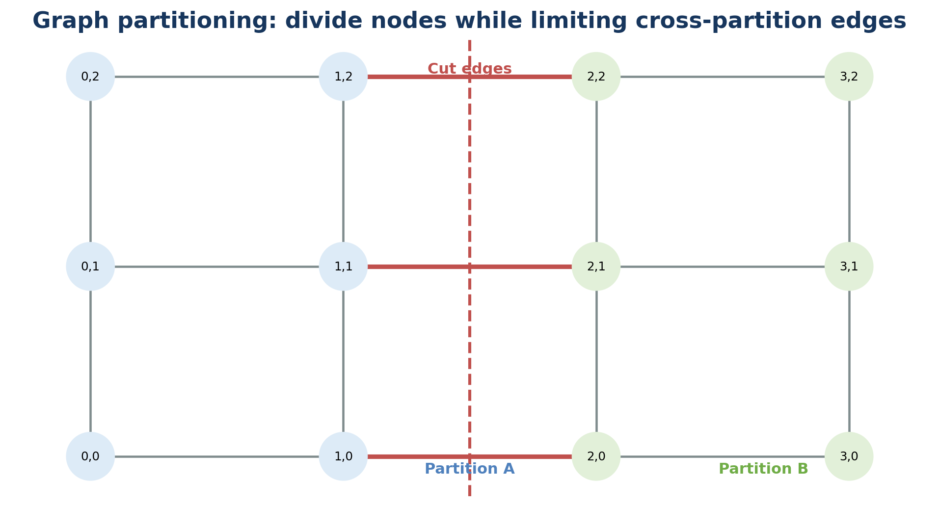
Graph partitioning aims to limit cross-partition or cut edges.

6.1 Cut, Balance and Objective
Cut size | cut(A, B) = number or total weight of edges crossing from A to B  A small cut means few links are broken by the partition.

A trivial minimum cut could place one node alone and all remaining nodes together. Balanced partitioning therefore adds a requirement that the parts have similar sizes or weights.

6.2 Community Detection versus Partitioning
Question | Community detection | Graph partitioning
Number of groups | often discovered from structure | often specified in advance
Balance | not necessarily balanced | frequently important
Objective | dense internal groups, modularity or related structure | small cut plus balance or capacity constraints
Example | discover friend circles | divide a computation across two servers

6.3 Kernighan-Lin Idea
1. Start with a two-way partition, often balanced.
2. Estimate the improvement from swapping nodes between the two parts.
3. Choose swaps that reduce cut cost while preserving balance.
4. Repeat until no useful improvement remains.

6.4 Spectral Partitioning Idea
Spectral methods form a graph matrix such as the Laplacian and use an eigenvector to place nodes on a numerical line. Nodes with similar coordinates are grouped together. The method connects graph structure with linear algebra and often reveals global separation.

6.5 Applications
- parallel and distributed computing
- road, power and communication network design
- image segmentation
- database sharding
- circuit layout
- creating training, validation or experimental graph splits while controlling leakage

6.6 NetworkX Example
import networkx as nx
from networkx.algorithms.community import kernighan_lin_bisection
G = nx.barbell_graph(6, 1)
left, right = kernighan_lin_bisection(G, seed=42)
print("Partition A:", sorted(left))
print("Partition B:", sorted(right))
print("Cut edges:", list(nx.edge_boundary(G, left, right)))
A two-way graph partition using Kernighan-Lin bisection.
IMPORTANT: Avoid graph leakage
In link-prediction and node-classification experiments, randomly splitting rows may allow connected information to leak across sets. The splitting design must match the real deployment situation.

7. Privacy in Social-Network Data
Privacy concerns a person's control, expectations and rights regarding information about them. Social-network graphs can reveal sensitive relationships even when names are removed, because structural patterns may allow re-identification.
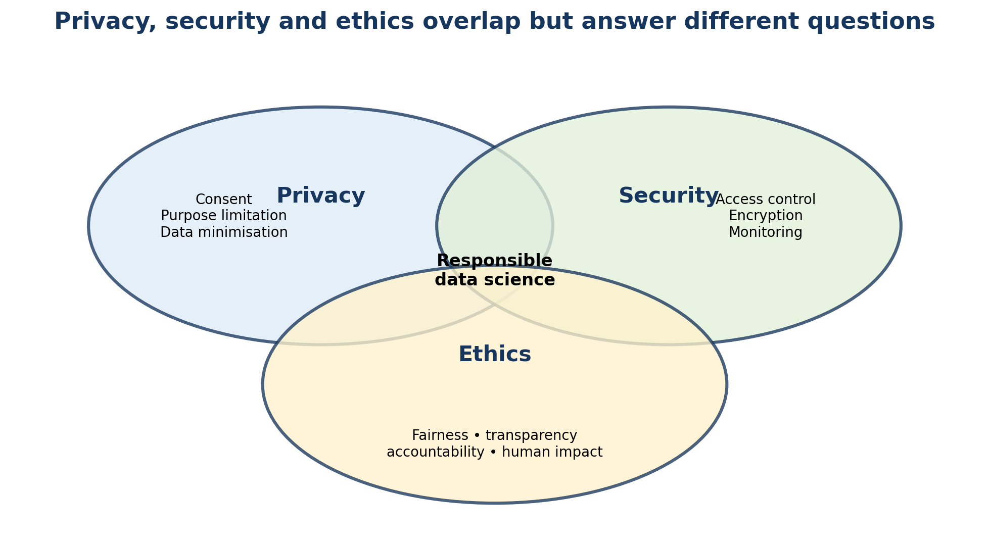
Privacy, security and ethics overlap but answer different questions.

7.1 Personal and Sensitive Information
Data type | Examples in a network
Direct identifiers | name, email, phone, account ID
Quasi-identifiers | age group, locality, occupation, unusual degree pattern
Relationship data | friendship, contact, transaction, co-location
Inferred data | political interest, health association, vulnerability, community membership
Content and metadata | message text, timestamps, device, location, reaction history

7.2 Why Removing Names Is Not Enough
A unique combination of degree, neighbours, timestamps or public information may identify a supposedly anonymous node. Graph structure is difficult to anonymise because removing or changing edges can reduce both risk and analytical usefulness.

7.3 Privacy Principles
Principle | Student-friendly question
Purpose specification | Why are we collecting this graph?
Data minimisation | What is the least data needed?
Consent and lawful basis | Do people understand or authorise the use?
Use limitation | Are we using data only for the stated purpose?
Retention limitation | How long should nodes and edges be kept?
Access and correction | Can people see or correct important information?
Privacy by design | Did protection begin before data collection?
Accountability | Who is responsible if harm occurs?

7.4 Privacy Protection Approaches
- Access control: restrict who can view raw nodes, edges and attributes.
- Pseudonymisation: replace direct identifiers with controlled codes.
- Aggregation: publish group statistics rather than individual links.
- Edge or attribute generalisation: reduce precision, for example using age bands instead of exact age.
- Differential privacy idea: add carefully calibrated randomness so one person has limited effect on a released result.
- Synthetic data: create artificial graph data, while still testing whether privacy leakage remains.
- Secure analysis environments: keep raw data in controlled systems and export only reviewed results.
ETHICAL NOTE: Consent is not the only test
Even when a dataset is technically available or consent was obtained, the analyst must still consider power imbalance, secondary use, vulnerable groups and foreseeable harm.
QUICK CHECK: Why can an anonymised social graph still be risky?
Answer: Because unique structural patterns and external information may be combined to re-identify nodes or infer sensitive relationships.

8. Security of Data and Models
Security protects data, systems and models against unauthorised access, alteration, destruction and disruption. Privacy asks whether data use respects people; security asks whether assets are protected. Weak security can cause severe privacy harm.

8.1 Main Security Goals
Goal | Meaning | Example control
Confidentiality | only authorised users can access data | encryption and access control
Integrity | data and results are not improperly changed | hashing, validation and audit logs
Availability | systems and data remain usable | backups, redundancy and recovery plans
Authenticity | users and sources are genuine | multi-factor authentication and signed records
Traceability | important actions can be reviewed | logging and version control

8.2 Threats in Social Networks
Threat | What happens | Possible defence
Account compromise | attacker takes control of a real account | MFA, anomaly detection, recovery process
Scraping and data exfiltration | large amounts of data are copied | rate limits, access monitoring, minimised exposure
Phishing and social engineering | relationships are used to gain trust | training, verification, warning systems
Sybil attack | many fake identities manipulate the network | identity signals, behavioural detection
Bots and coordinated behaviour | automated accounts amplify content | graph and temporal anomaly analysis
Data poisoning | malicious records alter model training | provenance, validation, robust monitoring
Inference attack | hidden attributes or membership are guessed | limit outputs, privacy testing, aggregation

8.3 Secure Data-Science Practice
1. Classify data according to sensitivity.
2. Collect and store only necessary fields and edges.
3. Encrypt data in transit and at rest.
4. Apply least-privilege access and multi-factor authentication.
5. Separate development, testing and production environments.
6. Keep dependency, model and dataset versions recorded.
7. Validate inputs and monitor unusual access or graph changes.
8. Prepare backup, incident-response and notification procedures.
9. Delete data securely when retention ends.
KEY IDEA: Security is a lifecycle activity
A secure project is not created by one password at the end. Security decisions begin during data collection and continue through storage, modelling, deployment and retirement.

9. Ethics and Responsible Data Science
Ethics examines what should be done, who may benefit, who may be harmed and who is responsible. A technically accurate graph model can still be unethical if it is used without fair process, appropriate purpose or meaningful safeguards.

9.1 Core Ethical Ideas
Idea | Meaning in practice
Fairness | avoid unjustified disadvantage across people or groups
Transparency | state data sources, purpose, limitations and automated involvement
Explainability | provide understandable reasons appropriate to the audience
Accountability | assign owners who can answer for decisions and correct harm
Human agency | preserve meaningful human review and avenues to challenge outcomes
Beneficence | seek useful social or organisational benefit
Non-maleficence | prevent avoidable harm
Proportionality | use methods whose intrusiveness matches the importance of the goal

9.2 How Bias Enters a Graph Project
Stage | Possible bias or harm
Problem definition | the target may represent an unfair or vague concept
Data collection | some communities may be missing or over-surveilled
Edge definition | a “friend” or “risk link” may be poorly defined
Sampling | API or snowball sampling may distort the network
Feature engineering | proxies may encode protected characteristics
Algorithm | resolution or objective may favour certain group sizes
Interpretation | clusters may be given unsupported labels
Deployment | predictions may change behaviour and reinforce the original pattern

9.3 A Responsible Graph-Analysis Checklist
- Define a legitimate, specific and proportionate purpose.
- Identify stakeholders, including people who may not be direct users.
- Document data source, consent or authority, sampling and known gaps.
- Test whether nodes, edges and labels accurately represent the real concept.
- Compare performance and errors across relevant groups and contexts.
- Protect raw data and limit access to sensitive graph outputs.
- Use human review for high-impact decisions and provide appeal or correction routes.
- Communicate uncertainty, alternative explanations and limitations.
- Monitor impacts after deployment and stop the system when risks become unacceptable.

9.4 Case Study: Identifying “At-Risk” Students
A college builds a communication graph and identifies students with weak connections, hoping to offer support. The idea may help isolated students, but it can also create privacy and fairness risks.
Question | Responsible consideration
Purpose | Is the goal supportive outreach rather than punishment?
Data | Were messages collected lawfully and minimised? Is content needed, or only approved interaction counts?
Accuracy | Does low degree truly mean social isolation? What about offline friendships?
Fairness | Are remote, disabled, commuting or language-minority students represented differently?
Action | Should a counsellor review the signal before contact?
Transparency | Can students understand what data is used and correct errors?
Retention | When will the graph and risk labels be deleted?

RESPONSIBILITY: A score is not a person
Community labels, centrality rankings and risk scores are simplified measurements. They should support careful human judgement, not replace a person's context or dignity.

10. A Look Back at Data Science
Data science grew from statistics, databases, scientific computing, visualisation, machine learning and domain practice. Its focus expanded from analysing stored tables to working with large, streaming, unstructured, multimodal and relational data.
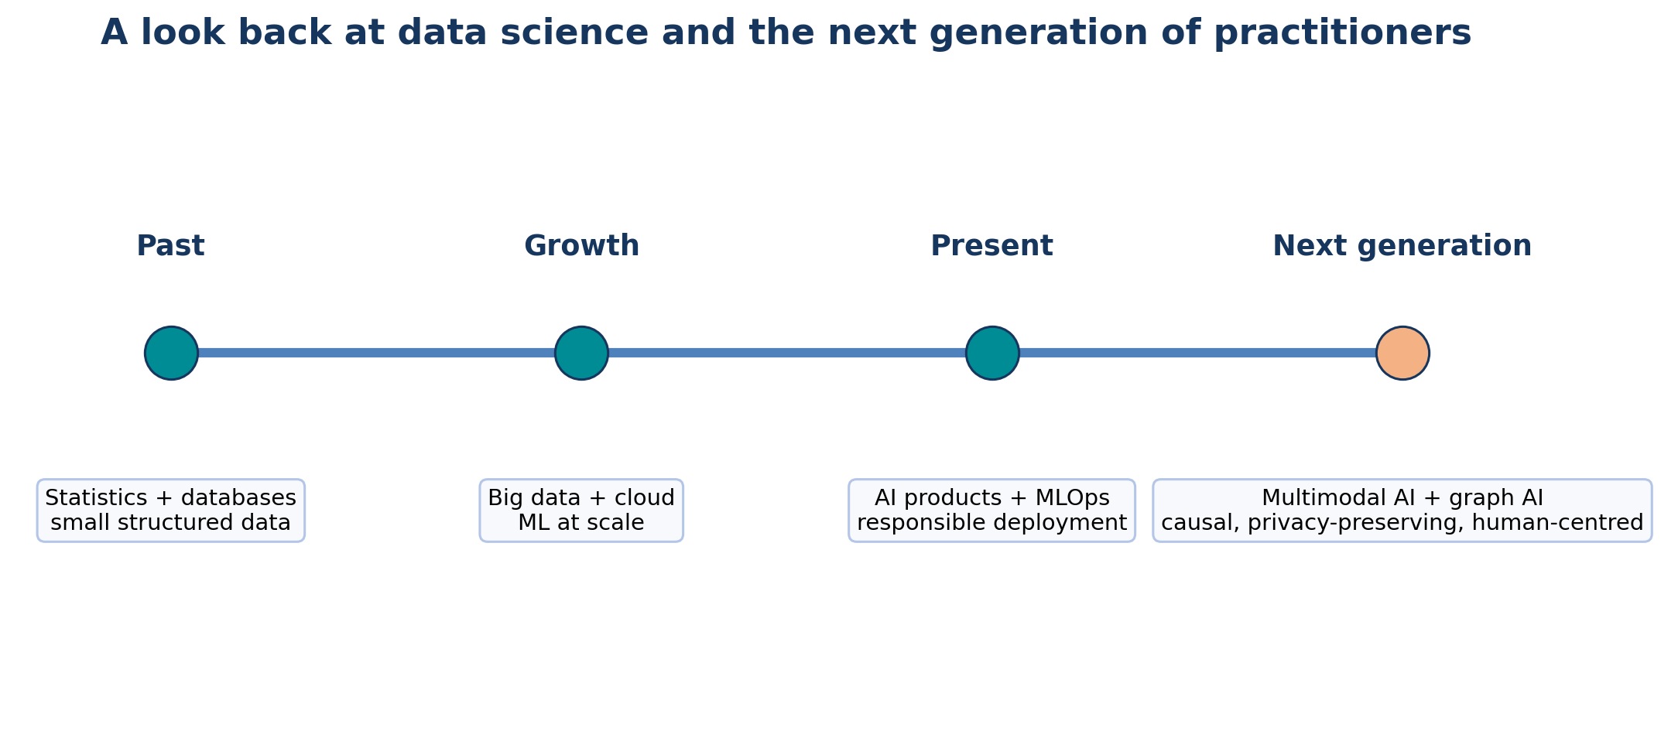
A simplified timeline from traditional statistics and databases to next-generation data science.

10.1 What Remains Constant
- A clear problem is more valuable than a fashionable algorithm.
- Data quality and measurement determine what can be learned.
- Exploratory analysis is necessary before modelling.
- Evaluation must match the real decision and its costs.
- Domain knowledge is needed to interpret patterns.
- Reproducibility, communication, privacy, security and ethics are part of technical quality.

10.2 The Data-Science Process Revisited
1. Understand the real problem and stakeholders.
2. Define measurable questions and success criteria.
3. Collect or access appropriate data.
4. Clean, integrate and document the data.
5. Explore using tables, plots and graph measures.
6. Build simple baselines and suitable models.
7. Evaluate performance, robustness, fairness and risk.
8. Communicate findings and uncertainty.
9. Deploy carefully, monitor changes and maintain documentation.
10. Retire systems and data responsibly when they are no longer justified.

10.3 Why Graph Data Matters
Many modern problems are relational: recommendations depend on user-item links, fraud depends on transaction patterns, knowledge systems connect entities, and biological or infrastructure systems contain networks. Next-generation data science therefore combines tables, text, images, time series and graphs.

11. Next-Generation Data Scientists
The next-generation data scientist is not only a model builder. The role combines statistical reasoning, software engineering, domain understanding, responsible AI, communication and continuous learning.

11.1 Skill Areas
Skill area | What a student should develop
Mathematics and statistics | probability, inference, optimisation, linear algebra and uncertainty
Programming and data systems | Python, SQL, APIs, version control, testing and cloud basics
Machine learning and AI | classical models, neural networks, graph ML, evaluation and monitoring
Data engineering | pipelines, quality checks, metadata, lineage and scalable processing
Responsible practice | privacy, cybersecurity, fairness, governance and impact assessment
Domain understanding | ability to translate real processes into meaningful measurements
Communication | visualisation, reports, explanations and stakeholder dialogue
Professional habits | reproducibility, documentation, teamwork and lifelong learning

11.2 Working with Generative and Automated AI Tools
- Use AI tools to accelerate coding, documentation and exploration, but verify every important output.
- Protect confidential data; do not paste sensitive graph data into unapproved tools.
- Record prompts, tool versions and human changes when reproducibility matters.
- Test generated code for correctness, security, bias and licence constraints.
- Keep humans responsible for problem definition, evidence quality and high-impact decisions.

11.3 New Directions
Direction | Introductory meaning
Graph neural networks | learn node, edge or graph representations using neighbourhood information
Multimodal data science | combine text, images, audio, tables and graphs
Causal data science | ask what would happen under an intervention, not only what is associated
Privacy-enhancing computation | analyse data while reducing exposure of raw records
Edge and federated learning | move some computation closer to devices or distributed data
AI governance and assurance | document, evaluate and audit systems throughout their lifecycle

CAREER TIP: Best preparation
Learn durable foundations, practise complete projects, explain your reasoning, and treat ethical and security requirements as design constraints rather than optional additions.

12. Integrated NetworkX Practical

12.1 Objective
Create a small social graph, inspect its neighbourhood properties, discover communities and visualise the result.

12.2 Installation
pip install networkx matplotlib

12.3 Complete Program
import networkx as nx
import matplotlib.pyplot as plt
# 1. Create an undirected social graph
G = nx.Graph()
G.add_edges_from([
("Asha", "Bilal"), ("Asha", "Chen"),
("Bilal", "Chen"), ("Chen", "Divya"),
("Divya", "Esha"), ("Esha", "Farhan"),
("Divya", "Farhan"), ("Bilal", "Gita")
])
# 2. Basic summary
print("Nodes:", G.number_of_nodes())
print("Edges:", G.number_of_edges())
print("Density:", round(nx.density(G), 3))
print("Degrees:", dict(G.degree()))
# 3. Neighbourhood measures
print("Neighbours of Chen:", list(G.neighbors("Chen")))
print("Clustering of Chen:", round(nx.clustering(G, "Chen"), 3))
print("Shortest path Asha to Farhan:", nx.shortest_path(G, "Asha", "Farhan"))
# 4. Community discovery
communities = list(nx.community.greedy_modularity_communities(G))
print("Communities:", [sorted(c) for c in communities])
print("Modularity:", round(nx.community.modularity(G, communities), 3))
# 5. Give each community a number for drawing
node_group = {}
for group_id, group in enumerate(communities):
for node in group:
node_group[node] = group_id
pos = nx.spring_layout(G, seed=7)
nx.draw(
G, pos, with_labels=True,
node_color=[node_group[n] for n in G.nodes()],
cmap=plt.cm.Set2,
node_size=1800,
font_size=9
)
plt.title("Small Social Network and Detected Communities")
plt.show()
Complete beginner practical: construction, measures, communities and visualisation.

12.4 How to Read the Output
- The number of nodes and edges gives the graph size.
- Density tells how many possible links are present.
- Degree shows direct connectivity for each person.
- Neighbours of Chen are the directly linked people.
- Clustering of Chen shows how strongly Chen's neighbours connect to one another.
- The shortest path gives a minimum-step route.
- Greedy modularity returns groups of nodes; modularity summarises structural separation.
- The colours in the drawing indicate detected groups, not known personal categories.

12.5 Practice Modifications
1. Add the edge (Gita, Asha). Recalculate density and communities.
2. Remove the edge (Chen, Divya). Check connected components and paths.
3. Convert the graph to nx.DiGraph() and add directed follow relationships.
4. Add a weight attribute representing message count and calculate weighted degree.
5. Compare greedy modularity with the first level of nx.community.girvan_newman(G).
6. Write a paragraph describing one privacy risk and one ethical safeguard for this dataset.
LAB RULE: Interpret before concluding
An algorithmic community is a hypothesis about graph structure. Check whether it is stable, meaningful and appropriate to name before reporting it.

13. Quick Revision, Formula Sheet and Glossary

13.1 One-Page Concept Map
Topic | Remember this
Graph | nodes plus relationships: G = (V, E)
Degree | number of direct connections
Density | fraction of possible graph edges that exist
Neighbourhood | nodes near a selected node
Common neighbours | shared contacts of two nodes
Clustering coefficient | how strongly a node's neighbours connect with one another
Community | relatively dense internal group with fewer outside links
Modularity | observed internal connectivity compared with random expectation
Partition | division of nodes into blocks, often with balance constraints
Privacy | appropriate collection, use and control of personal information
Security | protection against unauthorised access, change and disruption
Ethics | responsible choices about benefit, harm, fairness and accountability

13.2 Formula Sheet
Undirected density | 2m / [n(n - 1)]  m = edges; n = nodes.

Directed density | m / [n(n - 1)]  For a simple directed graph without self-loops.

Common neighbours | |N(u) intersection N(v)|  Count of nodes adjacent to both u and v.

Jaccard | |N(u) intersection N(v)| / |N(u) union N(v)|  Neighbourhood overlap between 0 and 1.

Local clustering | links among neighbours / possible links among neighbours  Possible links = k(k - 1)/2 for undirected degree k.

Cut size | number or weight of edges crossing partitions  Lower cut is often preferred, subject to balance.

13.3 Glossary
Term | Meaning
Adjacency | the relationship of being directly connected by an edge.
Betweenness | a measure based on how often a node or edge lies on shortest paths.
Bridge | an edge whose removal separates a connected part of a graph.
Centrality | a family of measures that describe structural importance.
Clique | a node set where every pair is connected.
Community | a group with relatively strong internal connectivity.
Component | a maximal connected portion of a graph.
Cut | edges crossing from one partition to another.
Degree | number of incident edges; in-degree and out-degree apply to directed graphs.
Density | proportion of possible graph edges that are present.
Edge | a relationship or interaction between nodes.
Ego network | a selected node and its local neighbourhood.
Homophily | tendency of similar nodes to connect.
Jaccard similarity | intersection divided by union of two neighbourhoods.
Modularity | a score comparing within-community edges with random expectation.
Neighbour | a node directly connected to another node.
Partition | a division of nodes into non-overlapping blocks.
Path | a sequence of connected nodes.
Re-identification | linking anonymous data back to a person or entity.
Sybil attack | use of many fake identities to manipulate a network.
Vertex | another word for node.

14. Self-Assessment and Answer Key

14.1 Multiple-Choice Questions
1. In G = (V, E), V represents:
a) values b) vertices c) variables only d) validation data
2. A Twitter/X-style follow relationship is naturally represented by:
a) directed edge b) undirected edge only c) no edge d) matrix row only
3. The degree of a node in an undirected graph is:
a) number of communities b) number of incident edges c) graph diameter d) number of attributes
4. The density of a simple undirected graph with n nodes and m edges is:
a) m/n b) 2m/[n(n-1)] c) n/m d) m²
5. Common neighbours are mainly useful for understanding:
a) neighbourhood overlap b) data type conversion c) regression slope d) image pixels
6. A high local clustering coefficient means:
a) the node has no neighbours b) its neighbours are strongly connected to one another c) the graph is directed d) all nodes are identical
7. A community generally has:
a) many internal links and fewer external links b) no internal links c) only one node d) equal node labels
8. Girvan-Newman discovers communities by repeatedly:
a) adding random nodes b) removing high edge-betweenness links c) sorting attributes d) scaling features
9. Label propagation updates a node using:
a) the most common neighbour label b) its age c) regression residual d) test accuracy
10. Graph partitioning frequently requires:
a) balanced parts and a small cut b) maximum missing values c) only categorical data d) a neural network
11. Removing names from graph data always guarantees anonymity:
a) true b) false
12. Data minimisation means:
a) delete every dataset b) collect only data necessary for the purpose c) reduce screen size d) maximise attributes
13. Confidentiality, integrity and availability are core concepts of:
a) security b) clustering c) regression d) visualisation
14. A Sybil attack involves:
a) many fake identities b) a balanced cut c) feature scaling d) a confidence interval
15. Ethical accountability asks:
a) who is answerable and can correct harm b) how to add edges c) how to sort nodes d) how to install Python

14.2 Very Short and Short-Answer Questions
1. Define a graph, node and edge with one social-network example.
2. Differentiate directed and undirected graphs.
3. What is an adjacency list?
4. Define degree and weighted degree.
5. Calculate the density of an undirected graph with 5 nodes and 6 edges.
6. What is a one-hop neighbourhood?
7. Explain common neighbours and Jaccard similarity.
8. What does a local clustering coefficient measure?
9. Define a graph community.
10. Explain modularity in simple language.
11. Write the basic steps of label propagation.
12. Why is Girvan-Newman called a divisive method?
13. Differentiate graph clustering and graph partitioning.
14. What is a cut edge between partitions?
15. Why can anonymised graph data still reveal identities?
16. Differentiate privacy, security and ethics.
17. What is a Sybil attack?
18. List four principles of responsible data science.
19. Why should algorithmic communities not be automatically given social labels?
20. List five skills needed by a next-generation data scientist.

14.3 Long-Answer Questions
1. Explain social networks as graphs. Discuss graph types and representations with examples.
2. Explain neighbourhood properties: degree, common neighbours, Jaccard similarity and clustering coefficient, with a worked example.
3. Discuss graph clustering and the meaning, uses and limitations of community structure.
4. Compare greedy modularity, label propagation, Girvan-Newman, Louvain/Leiden and clique-based methods.
5. Explain graph partitioning, cut size, balance, Kernighan-Lin and spectral partitioning.
6. Discuss privacy risks and protection approaches for social-network graph data.
7. Explain major security threats in social networks and secure data-science controls.
8. Discuss fairness, transparency, explainability and accountability in graph analytics.
9. Trace the evolution of data science and explain what remains constant despite new technologies.
10. Describe the technical and professional skills of next-generation data scientists.

14.4 Practical Exercises
1. Create a NetworkX graph of at least eight classmates using fictional names. Print nodes, edges, degree and density.
2. Find shortest paths and connected components in a graph before and after removing one bridge edge.
3. Calculate common neighbours and Jaccard similarity for three node pairs.
4. Calculate local clustering coefficients and explain why values differ.
5. Run greedy modularity and Girvan-Newman on the same graph and compare results.
6. Partition a barbell graph with Kernighan-Lin and list the cut edges.
7. Create a short privacy and ethics impact note for a friend-recommendation system.
8. Analyse how adding fake bot nodes could change degree rankings and community results.

14.5 MCQ Answer Key
Question | Answer | Reason
1 | b | V is the vertex or node set.
2 | a | Following is directional.
3 | b | Degree counts incident edges.
4 | b | This is the undirected simple-graph density formula.
5 | a | Common neighbours measure shared local contacts.
6 | b | It describes connections among the node's neighbours.
7 | a | Communities are relatively dense internally.
8 | b | It removes bridge-like high-betweenness edges.
9 | a | Labels spread through neighbouring nodes.
10 | a | Partitioning often minimises cuts under balance constraints.
11 | b | Structure and external information can enable re-identification.
12 | b | Only necessary data should be collected.
13 | a | They are core information-security goals.
14 | a | A Sybil attacker creates many fake identities.
15 | a | Accountability assigns responsibility and remedy.

14.6 Answers to Selected Numerical Questions
Density for 5 nodes and 6 undirected edges: 2m/[n(n-1)] = 12/(5 x 4) = 12/20 = 0.6.
Jaccard example: N(A) = {B,C,D}; N(E) = {C,D,F}; intersection size = 2; union size = 4; J(A,E) = 0.5.
Clustering example: a node has three neighbours and two of the three possible neighbour-neighbour edges exist; C = 2/3.

References and Further Reading
• NetworkX stable documentation: Graph types, algorithms and community functions
• NIST Artificial Intelligence Risk Management Framework
• OECD AI Principles
• OECD Privacy Principles
FINAL REVISION: End-of-unit revision strategy
Draw one graph, calculate its local measures, identify possible communities, propose a partition, and then write one privacy risk, one security control and one ethical safeguard. This single exercise connects the complete unit.

