Project: **QR_GENERATOR**

**Purpose:** “Generate QR CODE FOR ANY TEXT OR LINK AND SAVE IT AS IMAGE.”

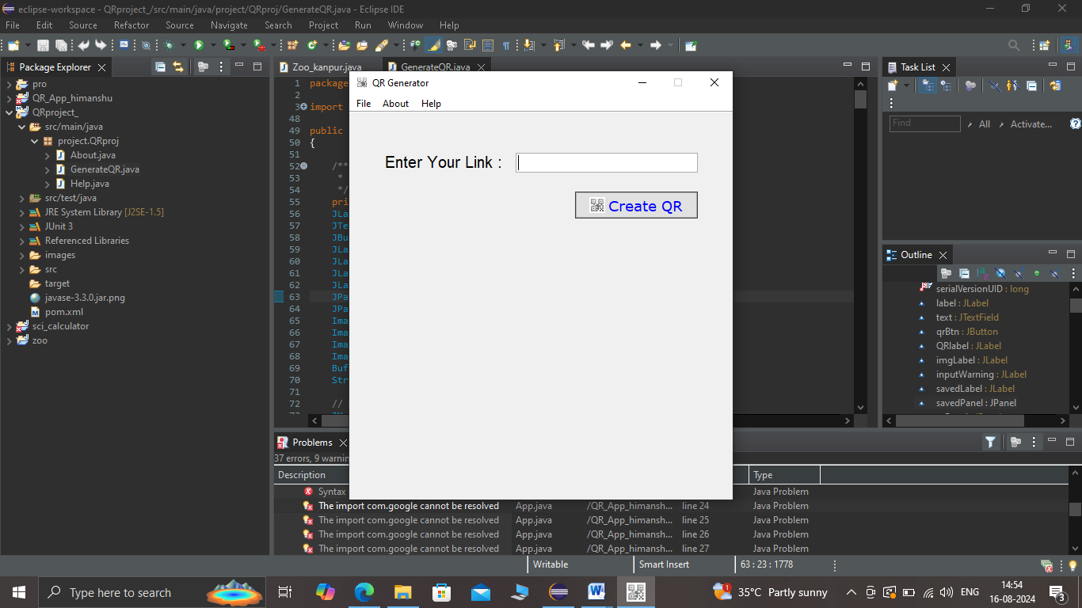

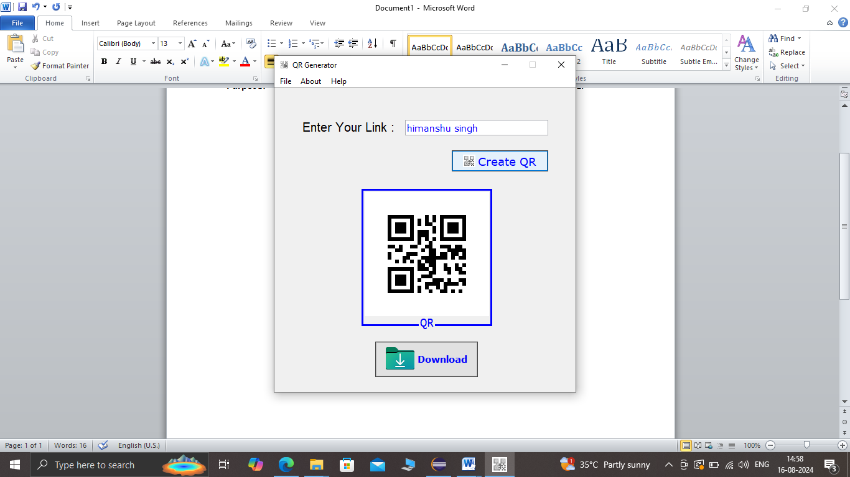

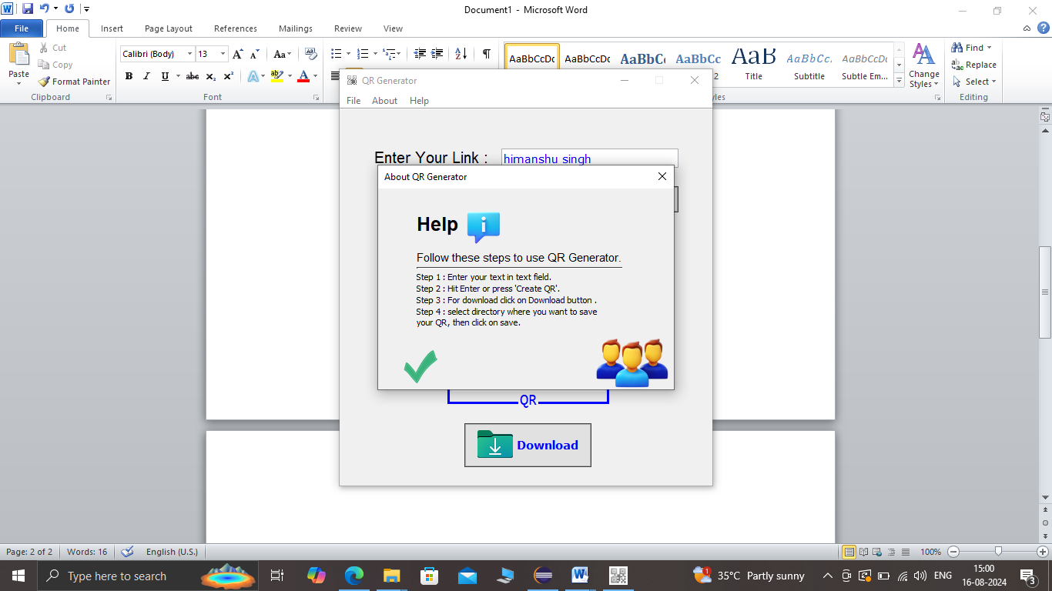

This project is developed by SVInfotech for educational purpose.

We have used Eclipse IDE to develop this Project.

Package name: project.QRproj

Classes used: GenerateQR.JAVA

ABOUT.JAVA

HELP.JAVA

LIBRARY USED : COM.ZXING LIBRARY

**SOURCE CODE: GENERATEQR.JAVA**

package project.QRproj;

import java.awt.Color;

import java.awt.Desktop;

import java.awt.FlowLayout;

import java.awt.Font;

import java.awt.event.ActionEvent;

import java.awt.event.ActionListener;

import java.awt.event.KeyEvent;

import java.awt.event.KeyListener;

import java.awt.event.MouseEvent;

import java.awt.event.MouseListener;

import java.awt.image.BufferedImage;

import java.io.File;

import java.io.IOException;

import java.net.URISyntaxException;

import java.nio.file.Files;

import java.nio.file.StandardCopyOption;

import java.util.HashMap;

import java.util.Map;

import javax.swing.BorderFactory;

import javax.swing.ImageIcon;

import javax.swing.JButton;

import javax.swing.JComponent;

import javax.swing.JDialog;

import javax.swing.JFileChooser;

import javax.swing.JFrame;

import javax.swing.JLabel;

import javax.swing.JMenu;

import javax.swing.JMenuBar;

import javax.swing.JMenuItem;

import javax.swing.JOptionPane;

import javax.swing.JPanel;

import javax.swing.JTextField;

import javax.swing.KeyStroke;

import javax.swing.UIManager;

import javax.swing.UnsupportedLookAndFeelException;

import javax.swing.border.TitledBorder;

import com.google.zxing.BarcodeFormat;

import com.google.zxing.EncodeHintType;

import com.google.zxing.MultiFormatWriter;

import com.google.zxing.WriterException;

import com.google.zxing.client.j2se.MatrixToImageWriter;

import com.google.zxing.common.BitMatrix;

import com.google.zxing.qrcode.decoder.ErrorCorrectionLevel;

public class GenerateQR extends JFrame

{

/**

*

*/

private static final long serialVersionUID = 1L;

JLabel label;

JTextField text;

JButton qrBtn;

JLabel QRlabel;

JLabel imgLabel;

JLabel inputWarning;

JLabel savedLabel;

JPanel savedPanel;

JPanel qrPanel;

ImageIcon downloadIcon = new ImageIcon("images/download.png");

ImageIcon qrImage = new ImageIcon("images/getQRBtn.png");

ImageIcon savedImage = new ImageIcon("images/saved.png");

ImageIcon qrIcon ;

BufferedImage brImg;

String savedFilePath;

// MENU

JMenuBar menuBar;

JMenu fileMenu;

JMenu aboutMenu;

JMenu helpMenu;

JMenuItem newItem;

JMenuItem saveItem;

JMenuItem exitItem;

public static JMenuItem aboutItem;

public static JMenuItem helpItem;

// MENU DONE

JButton downloadBtn;

boolean downloadable = false;

boolean downloaded = false;

boolean readyToSave = false;

JDialog aboutDialog;

public GenerateQR() {

this.setDefaultCloseOperation(JFrame.EXIT_ON_CLOSE);

this.setLayout(null);

this.setResizable(false);

this.setTitle("QR Generator");

ImageIcon logo = new ImageIcon("images/qrIcon.jpg");

this.setIconImage(logo.getImage());

this.setBounds(300,100,500,550);

// ---------------- ctrl+ s ----------------------------

this.getRootPane().registerKeyboardAction(new ActionListener() {

public void actionPerformed(ActionEvent e) {

if(downloadable && (inputWarning.getText().isEmpty())) {

downloadQR();

}

}

}, KeyStroke.getKeyStroke(KeyEvent.VK_S, KeyEvent.CTRL_DOWN_MASK), JComponent.WHEN_IN_FOCUSED_WINDOW);

// -------------------------------------------------------

// MENU

menuBar = new JMenuBar();

fileMenu = new JMenu(" File");

aboutMenu = new JMenu(" About");

helpMenu = new JMenu(" Help ");

newItem = new JMenuItem(" New");

newItem.setIcon(new ImageIcon("images/newFile.png"));

newItem.addActionListener(new ActionListener() {

public void actionPerformed(ActionEvent e) {

text.setText("");

text.revalidate();

text.repaint();

inputWarning.setText("");

saveItem.setEnabled(false);

qrPanel.removeAll();

qrPanel.revalidate();

qrPanel.repaint();

savedPanel.removeAll();

savedPanel.revalidate();

savedPanel.repaint();

}

});

saveItem = new JMenuItem(" Save");

saveItem.setIcon(new ImageIcon("images/save.png"));

saveItem.setEnabled(false);

saveItem.addActionListener(new ActionListener() {

public void actionPerformed(ActionEvent e) {

downloadQR();

}

});

exitItem = new JMenuItem(" Exit");

exitItem.setIcon(new ImageIcon("images/exit.png"));

exitItem.addActionListener(new ActionListener() {

public void actionPerformed(ActionEvent e) {

System.exit(0);

}

});

aboutItem = new JMenuItem("About");

aboutItem.setIcon(new ImageIcon("images/setting.png"));

aboutItem.addActionListener(new ActionListener() {

public void actionPerformed(ActionEvent e) {

try {

new About();

}catch(URISyntaxException es) {

}

}

});

helpItem = new JMenuItem("Help");

helpItem.setIcon(new ImageIcon("images/help.png"));

helpItem.addActionListener(new ActionListener() {

public void actionPerformed(ActionEvent e) {

new Help();

}

});

fileMenu.add(newItem);

fileMenu.add(saveItem);

fileMenu.add(exitItem);

aboutMenu.add(aboutItem);

helpMenu.add(helpItem);

menuBar.add(fileMenu);

menuBar.add(aboutMenu);

menuBar.add(helpMenu);

// MENU FINISHED

qrPanel = new JPanel();

qrPanel.setBounds(95, 145,300, 350);

qrPanel.setLayout(new FlowLayout(FlowLayout.CENTER, 1, 15));

label = new JLabel();

label.setText("Enter Your Link : ");

label.setFont(new Font("Arial", Font.PLAIN,20));

label.setBounds(45, 55, 200, 17);

text = new JTextField();

text.setFont(new Font("Verdana", Font.PLAIN,15));

text.setForeground(Color.blue);

text.setBounds(210,51,230,25);

text.setEditable(true);

text.addKeyListener(new KeyListener() {

public void keyReleased(KeyEvent e) {

if(e.getKeyCode() == 10) {

createAndShowQR();

}

}

public void keyPressed(KeyEvent e) {}

public void keyTyped(KeyEvent e) {}

});

inputWarning = new JLabel();

inputWarning.setBounds(210,79,230,15);

inputWarning.setForeground(Color.red);

inputWarning.setFont(new Font("Arial",Font.ITALIC, 13));

qrBtn = new JButton("Create QR");

qrBtn.setIcon(qrImage);

qrBtn.setBounds(285,100,155,34);

qrBtn.setFocusable(false);

qrBtn.setToolTipText("Create QR");

qrBtn.setFont(new Font("Verdana",Font.PLAIN, 18));

qrBtn.setBackground(Color.darkGray);

qrBtn.setForeground(Color.blue);

qrBtn.setOpaque(true);

qrBtn.addActionListener(new ActionListener() {

public void actionPerformed(ActionEvent e) {

downloaded = false;

saveItem.setEnabled(true);

createAndShowQR();

}

});

downloadBtn = new JButton();

downloadBtn.setText("Download");

downloadBtn.setIcon(downloadIcon);

downloadBtn.setMnemonic('b');

downloadBtn.setToolTipText("Save QR Image");

downloadBtn.setFocusable(false);

downloadBtn.setFont(new Font("Verdana",Font.BOLD, 15));

downloadBtn.setBackground(Color.darkGray);

downloadBtn.setForeground(Color.blue);

downloadBtn.setOpaque(true);

downloadBtn.setBounds(68,245,170,50);

downloadBtn.addActionListener(new ActionListener() {

public void actionPerformed(ActionEvent e) {

downloadQR();

}

});

savedLabel = new JLabel("saved");

savedLabel.setIcon(savedImage);

savedLabel.setHorizontalTextPosition(JLabel.CENTER);

savedLabel.setFont(new Font("Verdana",Font.BOLD, 12));

savedLabel.setVerticalTextPosition(JLabel.BOTTOM);

savedLabel.setIconTextGap(-2);

savedLabel.setBounds(0,0,50,70);

savedPanel = new JPanel();

savedPanel.add(savedLabel);

savedPanel.setBounds(390,390,70,90);

this.add(label);

this.add(text);

this.add(qrBtn);

this.add(inputWarning);

this.setJMenuBar(menuBar);

this.setLocationRelativeTo(null);

this.setVisible(true);

}

protected void downloadQR() {

JFileChooser fileChooser = new JFileChooser("../");

int response = fileChooser.showSaveDialog(this);

File source = new File("images/qr.png");

File dest ;

if(response == JFileChooser.APPROVE_OPTION) {

dest = new File(savedFilePath = fileChooser.getSelectedFile().getAbsolutePath()+".png");

try {

Files.copy(source.toPath(),dest.toPath(),StandardCopyOption.REPLACE_EXISTING);

savedPanel.add(savedLabel);

this.add(savedPanel);

downloaded=true;

this.revalidate();

this.repaint();

} catch (IOException e1) {

JOptionPane.showMessageDialog(null, "Enter valid location","Alert !", JOptionPane.WARNING_MESSAGE);

}

}

}

private void createAndShowQR() {

String input = text.getText();

if (input.isEmpty()) {

savedPanel.removeAll();

savedPanel.revalidate();

savedPanel.repaint();

saveItem.setEnabled(false);

inputWarning.setText("text field is empty, enter some text.");

qrPanel.removeAll();

qrPanel.revalidate();

qrPanel.repaint();

return;

}

saveItem.setEnabled(true);

if(!(savedLabel.getText().isEmpty())) {

this.remove(savedPanel);

this.revalidate();

this.repaint();

}

if(!(inputWarning.getText().isEmpty())) {

inputWarning.setText("");

}

try {

brImg = createQR(input);

showImage(brImg);

downloadable = true;

} catch (WriterException e1) {

e1.printStackTrace();

} catch (IOException e1) {

e1.printStackTrace();

}

}

private BufferedImage createQR(String input) throws WriterException, IOException {

//Encoding charset to be used

String charset = "UTF-8";

Map<EncodeHintType, ErrorCorrectionLevel> hashMap = new HashMap<EncodeHintType, ErrorCorrectionLevel>();

//generates QR code with Low level(L) error correction capability

hashMap.put(EncodeHintType.ERROR_CORRECTION, ErrorCorrectionLevel.L);

BitMatrix matrix = (new MultiFormatWriter()).encode(new String(input.getBytes(charset), charset), BarcodeFormat.QR_CODE, 200, 200);

BufferedImage qrImage = MatrixToImageWriter.toBufferedImage(matrix);

File file = new File("images/qr.png");

MatrixToImageWriter.writeToPath(matrix, "png", file.toPath());

return qrImage;

}

public void showImage(BufferedImage qrImage) {

qrIcon = new ImageIcon(qrImage);

imgLabel = new JLabel();

qrPanel.removeAll();

final int qrPositionX = (qrPanel.getWidth()/2)-(qrIcon.getIconWidth()/2);

final int qrPositionY = (qrPanel.getHeight()/2)-(qrIcon.getIconHeight()/2);

imgLabel.setIcon(qrIcon);

imgLabel.setHorizontalAlignment(JLabel.CENTER);

imgLabel.setVerticalAlignment(JLabel.CENTER);

imgLabel.setBounds(qrPositionX,qrPositionY - (qrPositionY/2),qrIcon.getIconWidth()+15, qrIcon.getIconHeight()+20);

imgLabel.setBorder(BorderFactory.createTitledBorder(BorderFactory.createLineBorder(Color.BLUE,3),

"QR",

TitledBorder.CENTER ,

TitledBorder.BOTTOM,

new Font("consolas", Font.PLAIN, 20),

Color.BLUE));

imgLabel.addMouseListener(new MouseListener() {

public void mouseReleased(MouseEvent e) {}

public void mousePressed(MouseEvent e) {}

public void mouseExited(MouseEvent e) {

if(downloaded) {

imgLabel.setBorder(BorderFactory.createTitledBorder(BorderFactory.createLineBorder(Color.BLUE,3),

"QR",

TitledBorder.CENTER ,

TitledBorder.BOTTOM,

new Font("consolas", Font.PLAIN, 20),

Color.BLUE));

}

}

public void mouseEntered(MouseEvent e) {

if(downloaded) {

imgLabel.setBorder(BorderFactory.createTitledBorder(BorderFactory.createLineBorder(Color.GREEN,3),

"click to open",

TitledBorder.CENTER ,

TitledBorder.BOTTOM,

new Font("consolas", Font.PLAIN, 20),

Color.BLUE));

}

}

public void mouseClicked(MouseEvent e) {

if(e.getButton() == MouseEvent.BUTTON1 && downloaded) {

openImage();

}

}

});

qrPanel.add(imgLabel);

qrPanel.add(downloadBtn);

this.add(qrPanel);

qrPanel.revalidate();

qrPanel.repaint();

}

public void keyTyped(KeyEvent e) {

}

public void keyPressed(KeyEvent e) {

}

public void keyReleased(KeyEvent e) {

}

private void openImage() {

File file = new File(savedFilePath);

if(file.exists()) {

Desktop dt = Desktop.getDesktop();

try {

dt.open(file);

} catch (IOException e) {

JOptionPane.showMessageDialog(null, "Something went wrong...!","Error !", JOptionPane.ERROR_MESSAGE);

}

}else {

JOptionPane.showMessageDialog(null, "Image not available at saved location!","Error !", JOptionPane.ERROR_MESSAGE);

}

}

public static void main(String[] args) {

try {

UIManager.setLookAndFeel(UIManager.getSystemLookAndFeelClassName());

} catch (ClassNotFoundException e) {

} catch (InstantiationException e) {

} catch (IllegalAccessException e) {

} catch (UnsupportedLookAndFeelException e) {

}

new GenerateQR();

}

}

**SOURCE CODE OF ABOUT.JAVA:**

package project.QRproj;

import java.awt.Color;

import java.awt.Desktop;

import java.awt.Font;

import java.awt.GridLayout;

import java.awt.event.ActionEvent;

import java.awt.event.ActionListener;

import java.awt.event.WindowEvent;

import java.awt.event.WindowListener;

import java.io.IOException;

import java.net.URI;

import java.net.URISyntaxException;

import javax.swing.ImageIcon;

import javax.swing.JButton;

import javax.swing.JDialog;

import javax.swing.JFrame;

import javax.swing.JLabel;

import javax.swing.JOptionPane;

import javax.swing.JPanel;

import javax.swing.SwingConstants;

public class About extends JDialog {

/**

*

*/

private static final long ***serialVersionUID*** = 1L;

public About() throws URISyntaxException {

this.setDefaultCloseOperation(JFrame.***DISPOSE_ON_CLOSE***);

this.setLayout(null);

this.setTitle("About QR Generator");

this.setSize(400,250);

this.setResizable(false);

this.setLocationRelativeTo(null);

this.setAlwaysOnTop(true);

this.addWindowListener(new WindowListener() {

public void windowOpened(WindowEvent e) {

GenerateQR.*aboutItem*.setEnabled(false);

}

public void windowIconified(WindowEvent e) {

// **TODO** Auto-generated method stub

}

public void windowDeiconified(WindowEvent e) {

// **TODO** Auto-generated method stub

}

public void windowDeactivated(WindowEvent e) {

// **TODO** Auto-generated method stub

}

public void windowClosing(WindowEvent e) {

// **TODO** Auto-generated method stub

}

public void windowClosed(WindowEvent e) {

GenerateQR.*aboutItem*.setEnabled(true);

}

public void windowActivated(WindowEvent e) {

// **TODO** Auto-generated method stub

}

});

JLabel titleLabel = new JLabel();

titleLabel.setText("QR Generator");

titleLabel.setFont(new Font("Times New Roman", Font.***PLAIN***, 35));

titleLabel.setForeground(Color.***blue***);

titleLabel.setIcon(new ImageIcon("images/qrIcon.jpg"));

titleLabel.setIconTextGap(20);

titleLabel.setHorizontalTextPosition(JLabel.***RIGHT***);

titleLabel.setVerticalTextPosition(JLabel.***CENTER***);

titleLabel.setBounds(58,20,300,50);

JPanel textPanel = new JPanel();

textPanel.setBounds(50, 90, 281, 110);

textPanel.setLayout(new GridLayout(4,1,0,3));

JLabel line1 = new JLabel();

line1.setFont(new Font("Arial", Font.***PLAIN***,17));

line1.setText("<html>product of <strong><i>svintotech</i></strong><hr></html>");

line1.setHorizontalAlignment(SwingConstants.***CENTER***);

JLabel line2 = new JLabel("<html>General purpose QR Generator use to create QR of links & text, to download and distribute.<html>");

JLabel line3 = new JLabel("<html>Copyright <i>@</i> 2023 | All rights reserved.</html>");

final URI uri = new URI("https://www.svinfotech.co.in");

JButton btn = new JButton("<html><u>visit our website www.svinfotech.co.in</u><html>");

btn.setForeground(new Color(0x6d00ff));

btn.setToolTipText(uri.toString());

btn.setBorder(null);

btn.setFocusable(false);

btn.setOpaque(false);

btn.setBackground(Color.***white***);

btn.setSize(50,50);

btn.addActionListener(new ActionListener() {

public void actionPerformed(ActionEvent e) {

if(Desktop.*isDesktopSupported*()) {

try {

Desktop.*getDesktop*().browse(uri);

} catch (IOException e1) {

JOptionPane.*showMessageDialog*(null, "Unable to open browser", "Error!", JOptionPane.***ERROR_MESSAGE***);

}

}

}

});

textPanel.add(line1);

textPanel.add(line3);

textPanel.add(line2);

textPanel.add(btn);

this.add(textPanel);

this.add(titleLabel);

this.setVisible(true);

}

}

**SOURCE CODE OF HELP.JAVA**

package project.QRproj;

import java.awt.FlowLayout;

import java.awt.Font;

import java.awt.event.WindowEvent;

import java.awt.event.WindowListener;

import javax.swing.ImageIcon;

import javax.swing.JDialog;

import javax.swing.JFrame;

import javax.swing.JLabel;

import javax.swing.JPanel;

import javax.swing.SwingConstants;

public class Help extends JDialog implements WindowListener {

/**

*

*/

private static final long ***serialVersionUID*** = 1L;

Help(){

this.setDefaultCloseOperation(JFrame.***DISPOSE_ON_CLOSE***);

this.setLayout(null);

this.setTitle("About QR Generator");

this.setSize(400,300);

this.setResizable(false);

this.setLocationRelativeTo(null);

this.setAlwaysOnTop(true);

this.addWindowListener(this);

JLabel label = new JLabel();

label.setText("Help");

label.setFont(new Font("Arial", Font.***BOLD***,25));

label.setIcon(new ImageIcon("images/about.png"));

label.setHorizontalTextPosition(JLabel.***LEFT***);

label.setVerticalTextPosition(JLabel.***CENTER***);

label.setIconTextGap(8);

label.setBounds(50,20,200,label.getIcon().getIconHeight()+5);

JPanel panel = new JPanel();

panel.setBounds(50, 80, 281, 110);

panel.setLayout(new FlowLayout(FlowLayout.***LEFT***, 0, 1));

JLabel line1 = new JLabel("<html>Follow these steps to use QR Generator.<hr></html>");

line1.setFont(new Font("Arial", Font.***PLAIN***,15));

line1.setHorizontalAlignment(SwingConstants.***CENTER***);

JLabel line2 = new JLabel("<html>Step 1 : Enter your text in text field.</html>");

JLabel line3 = new JLabel("<html>Step 2 : Hit Enter or press 'Create QR'.</html>");

JLabel line4 = new JLabel("<html>Step 3 : For download click on Download button .</html>");

JLabel line5 = new JLabel("<html>Step 4 : select directory where you want to save <br>your QR, then click on save.</html>");

panel.add(line1);

panel.add(line2);

panel.add(line3);

panel.add(line4);

panel.add(line5);

JLabel imgLabel = new JLabel(new ImageIcon("images/persons.png"));

imgLabel.setBounds(280,175,100,100);

JLabel imgLabel2 = new JLabel(new ImageIcon("images/saved.png"));

imgLabel2.setBounds(5,181,100,100);

this.add(panel);

this.add(label);

this.add(imgLabel2);

this.add(imgLabel);

this.setVisible(true);

}

public void windowOpened(WindowEvent e) {

GenerateQR.*helpItem*.setEnabled(false);

}

public void windowClosing(WindowEvent e) {

}

public void windowClosed(WindowEvent e) {

GenerateQR.*helpItem*.setEnabled(true);

}

public void windowIconified(WindowEvent e) {

}

public void windowDeiconified(WindowEvent e) {

}

public void windowActivated(WindowEvent e) {

}

public void windowDeactivated(WindowEvent e) {

}

}

**PROJECT STRUCTURE**

*PROJECT PACKAGE NAME*

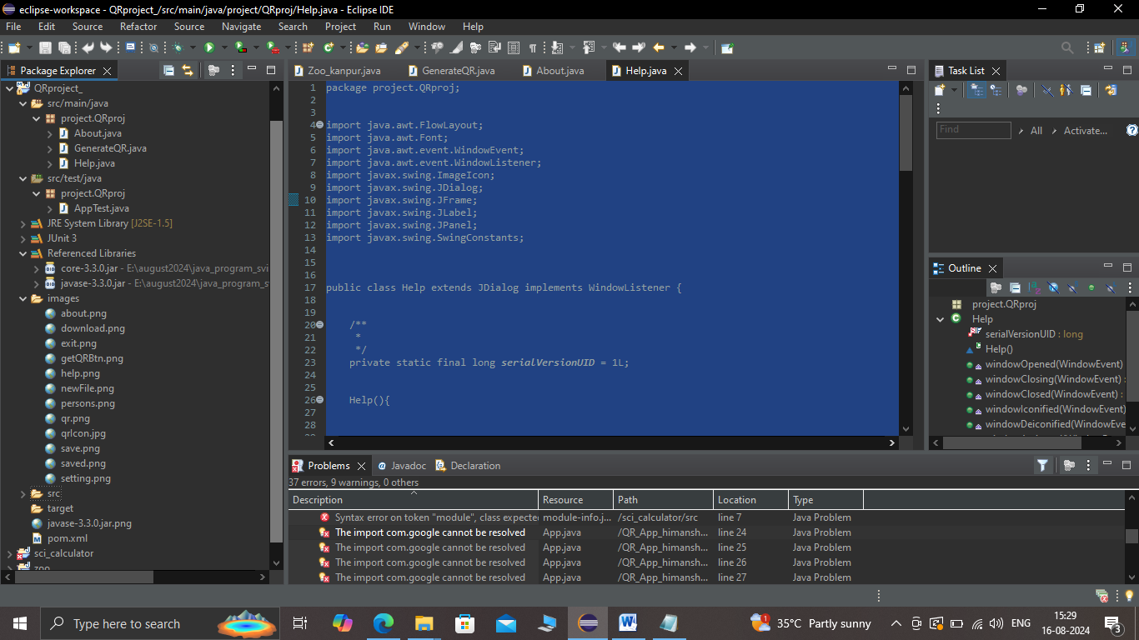

*EXTERNAL IMAGES USED IN PROJECT*

***EXTERNAL JAR FILES USED IN PROJECT***

***TO ADD GOOGLE ZXING LIBRARY***

***WHEN YOU TEST/RUN THIS PROJECT VIA IDE***

***YOU HAVE ADD EXTERNAL LIBRARY IN YOUR PROJECT VIA BUILD PROJECT***

***“YOU CAN FIND IT IN PROJECT MANUAL FOLDER”***

*USER DEFINED CLASEES USED IN PROJECT*