**MLOps Assignment 1**

**Task M2 Deliverable: Report - Process and Tooling**

**Introduction**

This report outlines following deliverable for Task M2 of the Assignment 1

* Screenshots for the 2 MLFlow experiments we ran on 2 data versions.
* Screenshots for the DVC Repository showing different version of data

**MLFlow Experiment Screenshots**

Experiment Name: v1 Dataset: This was using the v1 version of the data

Experiment Run Names: Support Vector Machine, Logistic Regression, Decision Tree: The three experiment runs on specified Algorithms to identify the best amongst them.

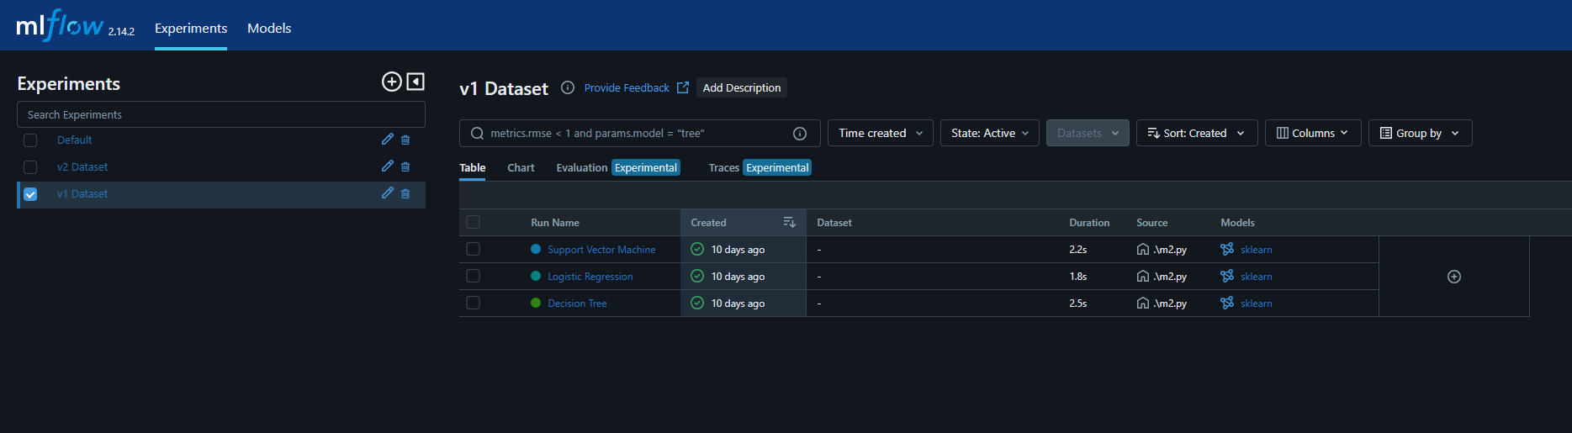

Screenshots for Experiment Name “v1 Dataset”, Run Name “Support Vector Machine”

Screenshot 1: Overview

Screenshot 2: Model Metrics

Screenshot 3: Model Artifacts

Screenshots for Experiment Name “v1 Dataset”, Run Name “Logistic Regression”

Screenshot 1: Overview

Screenshot 2: Model Metrics

Screenshot 3: Model Artifacts

Screenshots for Experiment Name “v1 Dataset”, Run Name “Decision Tree”

Screenshot 1: Overview

Screenshot 2: Model Metrics

Screenshot 3: Model Artifacts

Similar screenshots are available for the Experiment “v2 Dataset” and all of its 3 Runs. We are skipping it, as to not make this document more verbose.

**DVC Repository Versions Screenshot:**

Screenshot showing various versions of the dataset during various development phases. Since, DVC doesn't have a built-in command to list the versions of a file directly, we are combining DVC and Git commands to achieve this task

