**MLOps Assignment 1**

**Task M3 Deliverable: Report - Model Experimentation and Packaging**

**Introduction**

This report outlines the deliverable screenshot for Task M3 of the MLOps Assignment 1.

**Screenshot for Report on hyperparameter tuning results.**

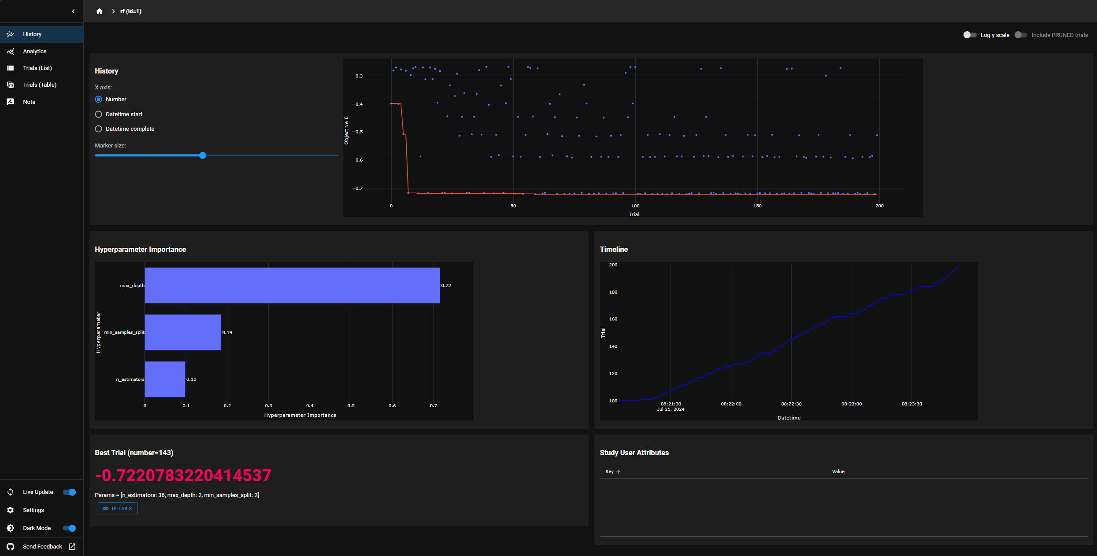

Screenshot 1: Optuna Dashboard: History

Screenshot 2.1: Optuna Dashboard: Analytics

Screenshot 2.2: Optuna Dashboard: Analytics

Screenshot 2.3: Optuna Dashboard: Analytics

Screenshot 3: Optuna Dashboard: Trial Runs

Screenshot 4: Optuna Dashboard: Individual Trial Run

**Screenshot for Dockerfile and Flask application code**

(Actual files in GitHub Repository link included as part of M1 deliverable)

Dockerfile

Flask Application

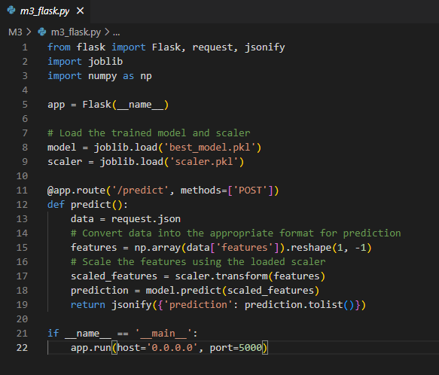

**Screenshots of the model running in a Docker container.**





