Container Orchestration –
Manage the lifecycle of containers, especially in large dynamic environments
*Provisioning and Deployment
*Availability
*Scaling
*Scheduling to infrastructure
*Rolling updates
*Health checks
What is Kubernetes?
Kubernetes is a portable, extensible open-source platform for managing
Containerized workloads and services that facilitates both declarative
Configuration and automation. It has a large, rapidly growing ecosystem. Kubernetes services
Support, and tools are widely available-
What kubernetes is not
Not a traditional, all-inclusive platform as service
Does not limit the types of applications
Does not deploy source code or build application
Does not prescribe logging, monitoring or alerting solutions
Does not provide built-in middleware, databases or other services
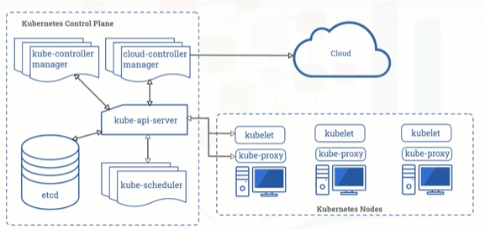
Diagram of kubernets

Kube-Api-server = Expose the kubernetes API
* All communication in the cluster utilizes the API

Etcd = * highly available key-value store
Contains all the cluster data
* source of truth for the state in a kubernetes cluster
Kubernetes scheduler - * Assigns newly created Pods to Nodes
- Determines where workloads should run
Kubernetes controller Manager
- Runs all the controller processes
- Controllers monitor the cluster state
- Controllers ensure the actual state matches the desired state

Cloud controller manager
- Runs controllers that interact with underlying cloud providers
- Links clusters into a cloud provider’s API
Nodes-
- The worker machines in kubernetes
- May be a virtual or physical machine
- Managed by the control plan
- Contain the services necessary to run application
Kubelet
- Communicates with the API server
- Ensure that Pods and their Associated containers are running
- Reports to the control plane on health and status
Container Runtime
- Downloads images and runs containers
- Kubernetes implements an interface so that this component is pluggable
- Docker is a well-known runtime
Kubernetes proxy
- Network proxy
- Maintains Network rules that allow communication to pods
Control Loops => A control loop is defined as a non-terminating loop that regulates the state of a system.
Controllers =>
- Monitor that state of a cluster
- Take action to ensure the actual state matches the desired state
- Communicate with the API server to initiate these actions
- Track kubernetes objects and ensure that the desire state is achieved.
Kubernetes Objects?
- Persistent Entities in Kubernetes
- Define the desire state for your workload
- Use the kubernetes API to work with them
Kubectl CLI
Client libraries
- Consist of two parts: spec and status
Characteristic of Objects
Namespaces
- Virtualization of a physical cluster
- Segregate cluster by team, project, etc
- Necessary with larger number of users.
- Provide a scope for object names
Names
- Each object has a name
- Names are unique for a resource type within a namespace.
Labels and selectors
Lebels are – key value pairs attached to objects
- Intended for identification of objects
- Not unique
- Organize and group objects
Selectors
- Identify and group a set of objects.
Basic Objects of Kubernetes
Pod –
- Simplest unit in kubernetes
- Represents processes running in your cluster
- Encapsulates a container(or sometimes multiple)
- Replicating a Pod serves to scale an application horizontally
Replicaset –
- Group of pods
- Maintains a set of identical Pods
- Definition consists of :
- Number of replicas
- Pod template
Deployment
- Provides updates for Pods and ReplicaSets
- Runs multiple replicas of your application
- Suitable for stateless application
- Update triggers a rollout

Kubectl CLI
- Key pool for working with kubernetes
- Provide functionality for working with clusters and workloads running On clusters
- Several different command types including declarative and imperative
Two type of command
Imperative commands _
- Quickly create, update and delete kubernetes objects
- Easiest to learn
- Don’t provide an audit trail
- Not very Flexible
Ex- kubetl run nginx –image nginx
- Work better on files

- Use configuration template
- Specify an operation such as create, replace, or delete
Ex- Kubectl create –f nginx.yml
Declarative Commands
- Configuration file define one or more objects
- No operation is specified
* Needed operations are inferred by kubectl
- Works of files and directories
- Configuration files define desired state, and kubernetes actualize that state
- Preferred method for production system

Using Kubernetes
Apply Command
- Kubectl apply –f file.yml
Viewing Resources
- Kubectl get deployments --namespace kube-system
- Kubectl describe deployment kube-dns-amd64 –namespace kube-system

ReplicaSet
- Replicate pods for redundancy
- Maintain desire state
- Supersede replicacontroller
We get a ReplicaSet for free when we create an object of type deployment

Command :-

K create –f replicaset.yml to create replica
K get pods To check how many pods
K get rs to check replicaSet

While it is possible to create a replicaSet without a deployment, it is recommended to create a deployment instead.

Scale Existing deployment
- Kubectl create –f deployment.yml
- Kubectl get pods
- Kubectl get deploy
- Kubectl scale deploy hello-kubernetes –replicas=3
- Kubectl delete pod pod-id

ReplicaSet - does it work

