https://social.technet.microsoft.com/

1) Docker don't support scalability across the multiple host.
2) If any container down or crash so we will monitor or manage. If you need any point of time 20 container should be running. Then who will manage this thing.
2) we need loadbalancer to access all the container.
But loadbalancer only work when all the containers expose on the same port number.
3) You can't expose same port of multiple containers in same host.
loadbalancer not directly connect to container it will reach to node.
4) Docker create container and the containers networking scope is local. If map a container port with host machine only then you can access. and you can't expose multiple container same port on same host machine.
5) how we can load balance.
containers bring scalability challenges.
We're starting to view the data center as a computer.
6) docker deploy container anywhere in any host.
we need a tools who can deploy our container evenly all cross the host machines.
In which node how much cpu how much ram, and let me deploy this container in this host. it should be decided by a tools
the tools see the entire data center as one computer. do we have any such facility in docker.
What is kubernetes?
1) Container Orchestrator
3) Infrastructure abstraction
4) Desired state
benefit of kubernetes
1) Speed of deployment
2) Ability to absorb change quickly
3) Ability to recover quickly
4) Hide complexity in the cluster
In kubernetes architecture has to primary component
1) Master (kubernetes control plane)
2) Node
Multiple masters and multiple nodes are making together a cluster.
Master has to linux 64 bits
nodes has to be linux 64 bits. But but windows 2019 onwards node can be windows also but windows version should be 2019+ 64 bit

MASTER HAS PRIMARY 4 COMPONENTS
Node has 1 pod or could be multiple pod
and pod has 1 container or could be multiple container.
MASTER HAS PRIMARY 4 COMPONENTS
1)
Apiserver =
Api = api is basically one endpoint
Apiserver means = It is contain all the api supported by kubernetes at one place. that's why it is called Api server.
what ever the feature in kubernetes if you want access it connect to apiserver.
Kube-apiserver = Fronted-end to the control plane.
expose the Api. if you want send any instruction to apiserver send it in json format. In other format kubernetes don't support.
2) Cluster store
Persistent storage cluster state and config
In Kubernetes cluster we do lots of things, we create we delete and many time pods destroy automatically.
We need something where we can store all the information about cluster.
Persistent store
Persistent knowledge or Persistent memory.
If you lost it you lost everything.
Powered by called etcd
distributed, consistent, watchable..
etcd store data in format of key-value pair
mango db or something you can say.
** You must have backup plan for it*** once you lost database you lost everything.

3) Kube-controller-Manager
kube = kubernetes
controller - controlling something
manager - multiple controller
controller of controllers
* Node controller
* Endpoints controller
* Namespace controller
* .......
controller is something who check in certain interval of time like.
what is your cpu
what is your ram
how many container do you have..
it is in loop and informing to apiserver.
watches for changes helps maintain desired state.
4) Kube-scheduler
kube-scheduler basically schedule the work.
Scheduler only assigning the work it is not doing by itself. but to whom it will assign to??? to nodes

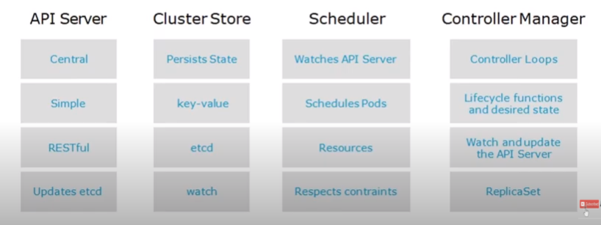

Node has 3 important components.
1) Kubelet
Kubelet would be in each node.
kube-scheduler is send the work and the kubelet is receiving the work.
* The main kubernetes agent
* Registers node with cluster
* Watches apiserver
* Instantiates pods
* Reports back to master
* Exposes endpoint on : 10255
kubelet itself register with the node

2) container engine
Usually docker
but could be rkt
kubelet initiate the pod but container is filled inside the pod by the docker.
becuase docker is container management tools
****Kubernetes Networking Requirements***************
All Pods can communicate with each other on all nodes.
All nodes can communicate will all pods.
No Network address translation (NAT)
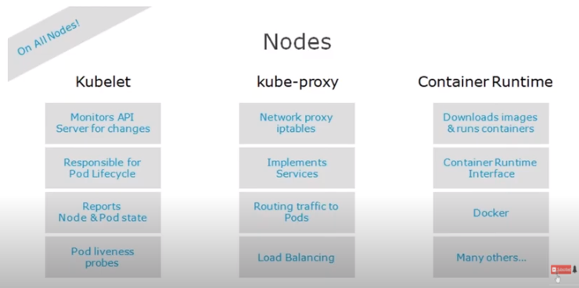

Pods -
vm --> container--> Pod
Hypervisor manage vm
docker manage container
pod manage the pod
vm ( have a boot file system, ) vm is running until your os is running.
Container has ( images) container is running is PID one is running
Pod has (container) Pod is running until the all container running inside the pod.
Inside the pod
trnprt layer
net
link , IPC mount
All containers in pod share the pod environment
If One pod two container inside. it is called tight coupling.
If one pod one container - Loose coupling . loose coupling is good.
First container inside the pod is called - Main container
and second container is called -- sidecar
Whatever assign to a pod. all container can access it.

How you will access the container form outside.
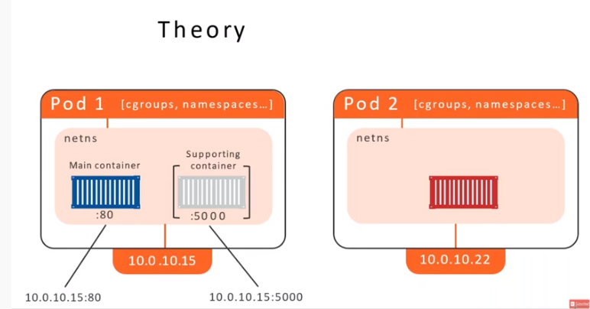
Intra-Pod Networking
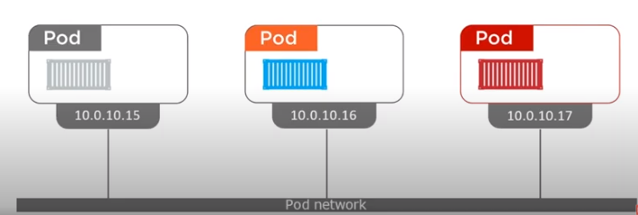
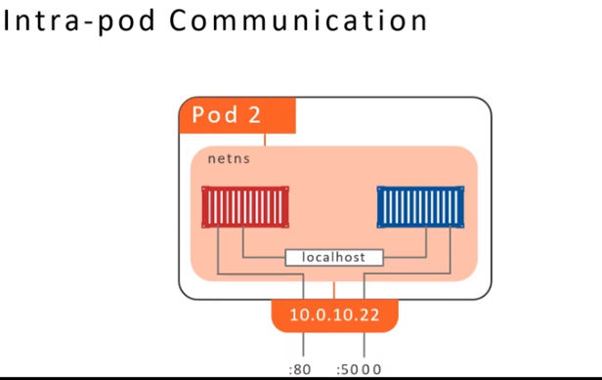

What is pod
One or more containers.
It's your application or service.
The most basic unit of work.
Unit of scheduling
Pod is ephemeral - No pod is ever "redeployed"
or you can never stop any pod.
atomicity - they're there or Not

Pods-continued.
what is the job of kubernetes
kubernetes job is keeping your pods running More specifically keeping the desired state.
state - is the pod up and running
Health - is the application in the pod running liveness probes.

Installation of kubernetes._

* There are more the 40 methods to setup kubernetes cluster.
the simplest method is
minikube
GKE , AKs, EKS
manual installation.
**** Manual way using kubeadm ****
Masker (controlplane)
-------------------------------
API server --> POD --> Container --> Docker Image --> Google registry
ETCD --> POD --> Container --> Docker Image --> Google registry
Controller Manager --> POD --> Container --> Docker Image --> Google registry
Scheduler --> POD --> Container --> Docker Image --> Google registry
******************
kubelet --- Because kubelet create a pod
Docker ---- Inside the pod there docker
kube proxy ---- assing Ip address
( these tools should be also there in master)
kubectl --- should be all in component because it is talking to apisever.
There are lots of things to be done like. who will download all the thing, who will authorize or authenticate. who will install all the thing.
then there is a tool
kubeadm init
****************************************************************
Worker (Node)
--------------------------
Kubelet
Docker
Kube porxy
Kubeadm

workstation - (your laptop)
-----------------------------------------------
Kubelet

How kubectl work iin workstaion
kubctl --> look --> $USER-HOME/.kube/config(yaml)
this file is generated by init process. and it has been store here while setuping the workstation.

How kubectl get AUTHORZIED AND AUTHENTICATION TO API server.
- Authentication == certificate
- Authorization == RBAC

What is the content for config file.?
---------------------------------------------
Cluster(s):
clustor1: http:/ip/of api server
clustor2: http:/ip/of api server
clustor3 http:/ip/of api server
user(s)
user1: key+cert
user2: key+cert
context(s)
context1: = clustor1+user1
context2: = clustor2+user2
this file you are using for working with multiple cluster
current-context == context2 ( if you want default cluster)

cmd ==> more ~/.kube/config
kubectl config view ==> to check yaml format

-----------------------------------------------------
Getting comfortable with kubectl

----------------------------------------------------
master
cmd kubectl

Namespace - vertical logical group of cluster
system name space ==> system related Pod
Default ==> If you want to create in Default namespace
Public ==> If you want to one pod for access everyone
Node ==> use for system admin for do maintaince work
______________________________________________________
How to work with API??
CURD -- GET - PUT - POST - DELETE
CREAT -->
CMD
CREATE
YAML
create yaml file
UPDATE-->
CMD
EDIT
YAML
create yaml file
READ
CMD
GET
YAML
create yaml file
DELETE
CMD
DELETE
YAML
create yaml file

to execute cmd in container
Kubectl exec hello-pod <cmd>

to execute cmd inside from the container
kubectl exec -it hello-pod /bin/bash

port-forward
Kubectl port-forward pod/hello-pod 5000:80 -n=<namespace>
port forwarding with ip
kubectl port-forward --address 0.0.0.0 pod/hello-pod 5000:80 -n=kubesystem

To check what you can do
kubectl auth can-i delete pod
kubectl auth can-i create pod
kubectl explain documentation of resource
kubectl explain pod
kubectl explain pod.spec

