**Wire frame Documentation**

**Insurance Premium Prediction**

**by Himanshu balodi**

**Home page :**

1. Run this project in local by executing the code "python app.py"

2. In browser open this link:

3. You will get an UI displayed below.

4. In browser you will get the web page of the Insurance prediction

5. Once you will be get the home page you will fill the all the user input data .

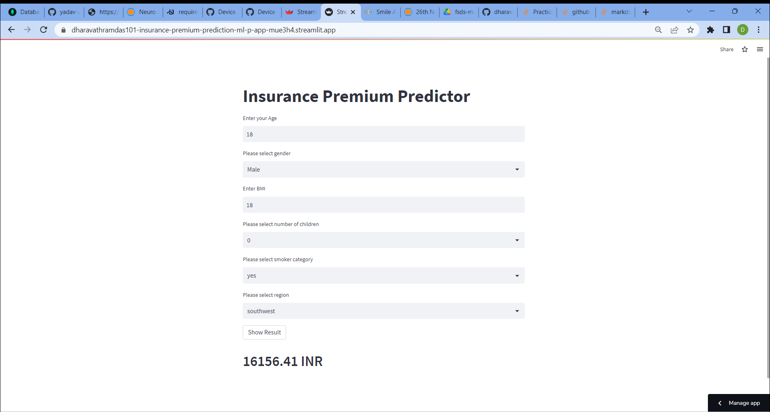

6. After fill the user input data for given format you click the below predict key.

you will this kind of users face.



7. You will see the person those who this kind of user input data belongs.

**Linkdin link :**  <https://www.linkedin.com/in/himanshu-balodi-54931124b/>

**GitHub link : https://github.com/himanshubalodi62/Insurance-Premium-Prediction.git**