Architecture
(Thyroid disease detection)
by Himanshu balodi
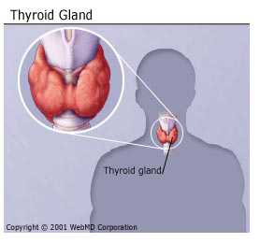

content
1.Tech stack used
2. Infrastructures Required
3. Data collection.
4. Project architecture
5. Training pipeline
6.Batch_prediction
7. Deployment process
8. Deployment access Airflow
9.web page

1.Tech Stack Used
1. Python
2. VS Code
3. Machine learning algorithms
4. Docker
5. MongoDB
6. Flask
7. API

.Infrastructure Required.
1. AWS S3
2. AWS EC2
3. AWS ECR
4. GitHub Actions
5. Airflow
6. AWS Elastic Beanstalk

. Data collection

. Project architecture

. Training pipeline

.Batch_prediction

. Deployment process

. Deployment access Airflow

. web page

