Name – Prajwal Joshi
Student id – 20711056

1. Write an applet program which can perform the arithmetic operations like Sum, Subtract, Multiplication & Division.

->import java.awt.*;

import java.applet.*;

import java.awt.event.*;

public class appletcalc extends Applet implements ActionListener

{

Button b1,b2,b3,b4,b5,b6,b7,b8,b9,b10,b11,b12,b13,b14,b15,b16;

String s1="",s2;

Frame f;Panel p2;

TextField t;int n1,n2;

public void init()

{

setLayout(new BorderLayout());

t=new TextField();

p2=new Panel();

p2.setLayout(new GridLayout(4,4));

b1=new Button("1"); b1.addActionListener(this);

b2=new Button("2"); b2.addActionListener(this);

b3=new Button("3"); b3.addActionListener(this);

b4=new Button("+"); b4.addActionListener(this);

b5=new Button("4"); b5.addActionListener(this);

b6=new Button("5"); b6.addActionListener(this);

b7=new Button("6"); b7.addActionListener(this);

b8=new Button("-"); b8.addActionListener(this);

b9=new Button("7"); b9.addActionListener(this);

b10=new Button("8"); b10.addActionListener(this);

b11=new Button("9"); b11.addActionListener(this);

b12=new Button("*"); b12.addActionListener(this);

b13=new Button("c"); b13.addActionListener(this);

b14=new Button("0"); b14.addActionListener(this);

b15=new Button("/"); b15.addActionListener(this);

b16=new Button("="); b16.addActionListener(this);

add(t,"North");

p2.add(b1);p2.add(b2);p2.add(b3);p2.add(b4);

p2.add(b5);p2.add(b6);p2.add(b7);p2.add(b8);

p2.add(b9);p2.add(b10);p2.add(b11);p2.add(b12);

p2.add(b13);p2.add(b14);p2.add(b15);p2.add(b16);

add(p2);

}

public void actionPerformed(ActionEvent e1)

{

String str=e1.getActionCommand();

if(str.equals("+")||str.equals("-")||str.equals("*")||str.equals("/"))

{String str1=t.getText();

s2=str;

n1=Integer.parseInt(str1);

s1="";

}

else if(str.equals("="))

{

String str2=t.getText();

n2=Integer.parseInt(str2);

int sum=0;

if(s2=="+")

sum=n1+n2;

else if(s2=="-")

sum=n1-n2;

else if(s2=="*")

sum=n1*n2;

else if(s2=="/")

sum=n1/n2;

String str1=String.valueOf(sum);

t.setText(""+str1);

s1="";

}

else if(str.equals("c"))

{

t.setText("");

}

else

{

s1+=str;

t.setText(""+s1);

}

}

}

/*<applet code="Cal" height=300 width=300>

</applet>*/

OUTPUT:

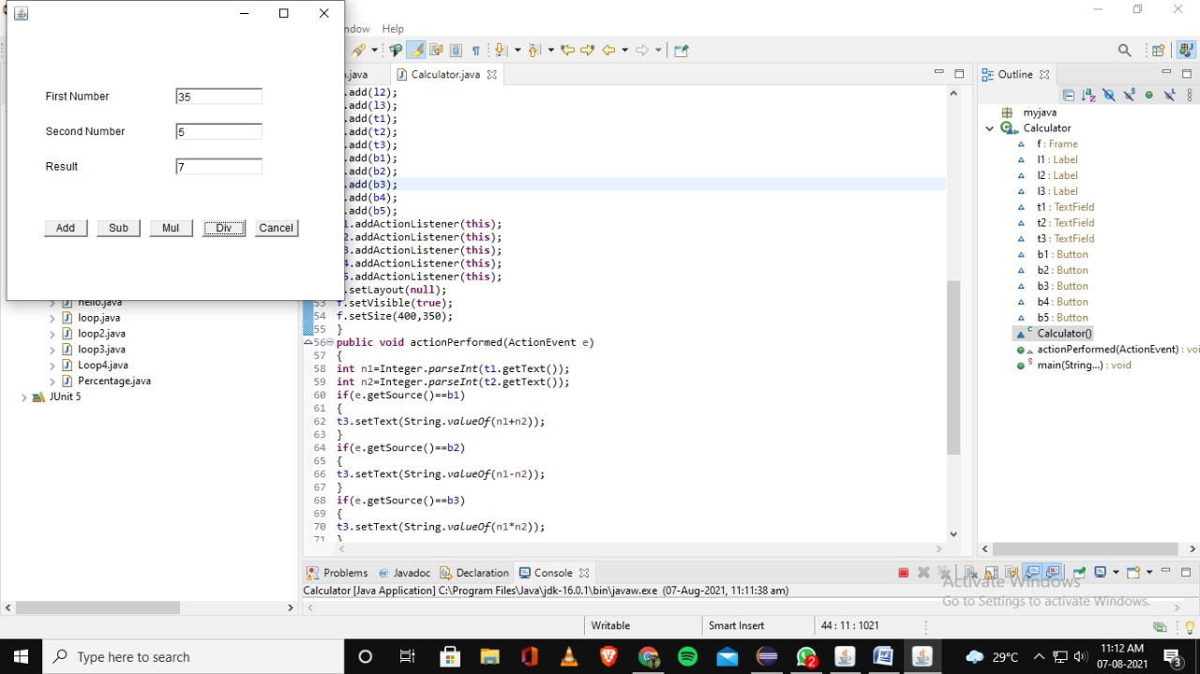
2.2. Write a program which writes the content on a file, save this file with your name, read this file and count the number of words in the file and print it in
the console.

->import java.io.BufferedReader;
import java.io.File; // Import the File class
import java.io.FileNotFoundException;
import java.io.FileReader;
import java.io.IOException; // Import the IOException class to handle errors

public class fileio {
public static void main(String[] args) throws IOException {

String line;
int count = 0;

try {
File myObj = new File("Prajwal.txt");
if (myObj.createNewFile()) {
System.out.println("File created: " + myObj.getName());
} else {
System.out.println("File already exists.");
}
} catch (IOException e) {
System.out.println("An error occurred.");
e.printStackTrace();
}

FileReader file = new FileReader("Prajwal.txt");
BufferedReader br = new BufferedReader(file);
//Gets each line till end of file is reached
while((line = br.readLine()) != null) {
//Splits each line into words
String words[] = line.split(" ");
//Counts each word
count = count + words.length;
}
System.out.println("Number of words present in given file: " + count);
br.close();
}
}

Output :

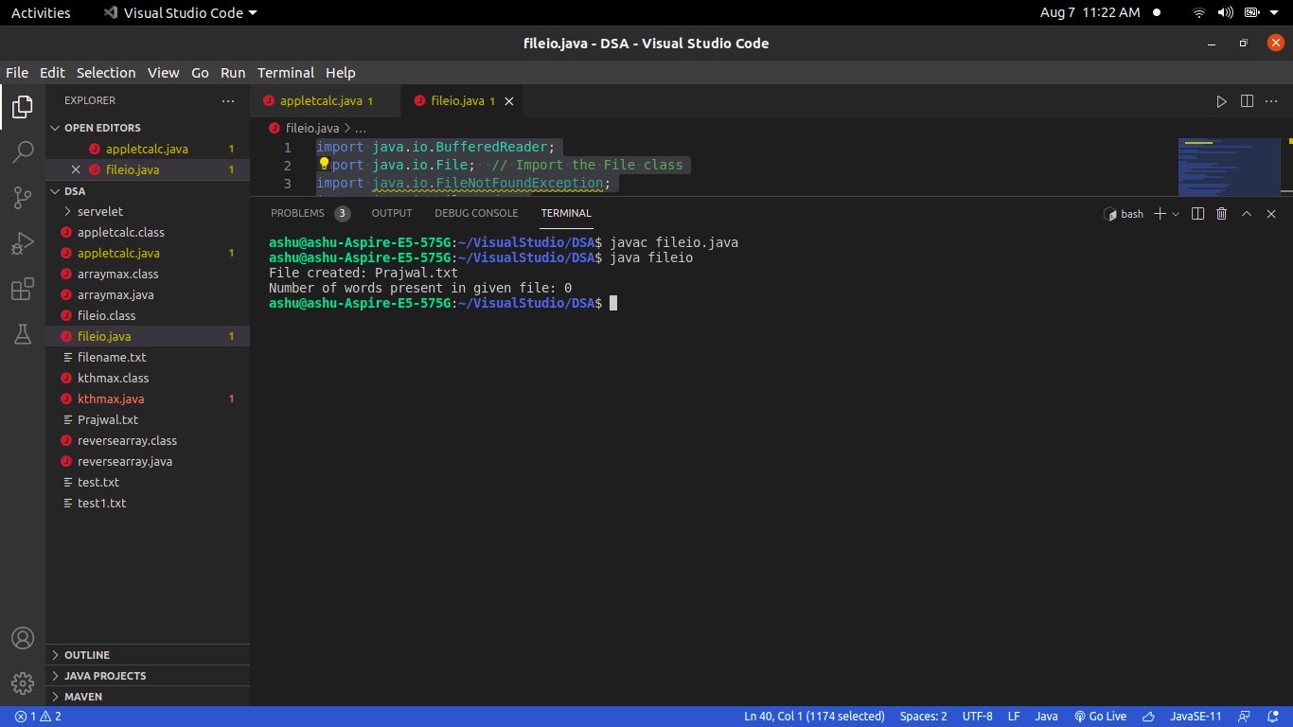
3.Write a program where client sends a string and server returns the reverse of the string Using TCP/IP Socket Programming

-> MyServer.java

import java.net.*;
import java.io.*;
class MyServer{
public static void main(String args[])throws Exception{
ServerSocket ss=new ServerSocket(3333);
Socket s=ss.accept();
DataInputStream din=new DataInputStream(s.getInputStream());
DataOutputStream dout=new DataOutputStream(s.getOutputStream());
BufferedReader br=new BufferedReader(new InputStreamReader(System.in));
String str="",str2="";
while(!str.equals("stop")){
str=din.readUTF();
System.out.println("client says: "+str);
str2=br.readLine();
dout.writeUTF(str2);
dout.flush();
}
din.close();
s.close();
ss.close();
}}

MyClient.java

import java.net.*;
import java.io.*;
class MyClient{
public static void main(String args[])throws Exception{
Socket s=new Socket("localhost",3333);
DataInputStream din=new DataInputStream(s.getInputStream());
DataOutputStream dout=new DataOutputStream(s.getOutputStream());
BufferedReader br=new BufferedReader(new InputStreamReader(System.in));
String str="",str2="";
while(!str.equals("stop")){
str=br.readLine();
dout.writeUTF(str);
dout.flush();
str2=din.readUTF();
System.out.println("Server says: "+reverse.str2);
}
dout.close();
s.close();
}}

