CA 3: Experiential Learning

Group Members:

|  |  |  |  |
| --- | --- | --- | --- |
| Sr. No. | PRN | Name of Student | Mail id |
| 1. | 22070122079 | HIMANI ARORA | himani.arora.btech2022@sitpune.edu.in |
| 2. | 22070122071 | MEET GOLANI | meet.golani.btech2022@sitpune.edu.in |
| 3. | 22070122080 | HIMANSHU CHOPADE | himanshu.chopade.btech2022@sitpune.edu.in |

**Problem Statement:** **Develop a "SPAMTIFY" Music Player Management System allowing users to create playlists, add songs, and play music. Users can search for songs by partial name and manage playlists seamlessly, including options to pause, skip, and quit during playback.**

**Explanation:**

The Music Player Management project is a simplified music player application developed using the C++ programming language. It aims to provide a basic music player with essential features for playback control and song searching.

• Basic Playback Control:

* This project includes functionality for playing and pausing songs. Users can easily start or pause playback, providing a fundamental user experience in music playback.

• Song Search:

* The application offers a search feature based on song titles or artists. This allows users to quickly locate specific songs in their collection, making it more user-friendly.

• C++ Classes and Inheritance:

* The core of the project's implementation revolves around the use of classes and inheritance. Classes are used to model songs, and inheritance is employed to structure and organize the code efficiently. For example, a base "Song" class can be inherited to create specialized classes for different types of songs or audio files

**Class Diagram:**

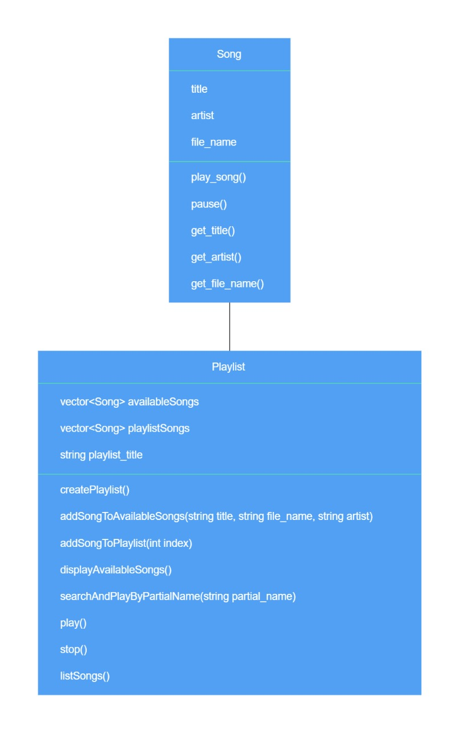

**Code snippets:**

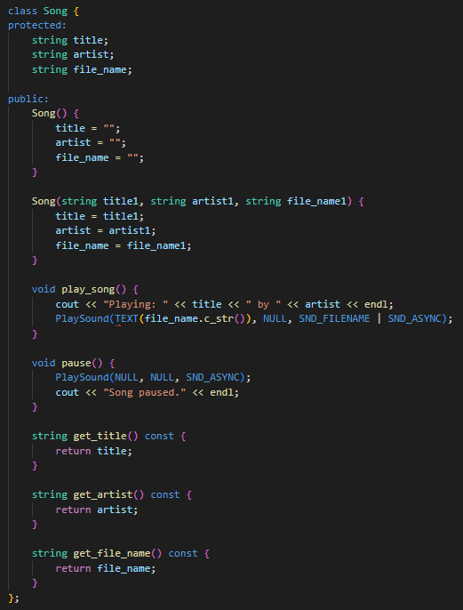 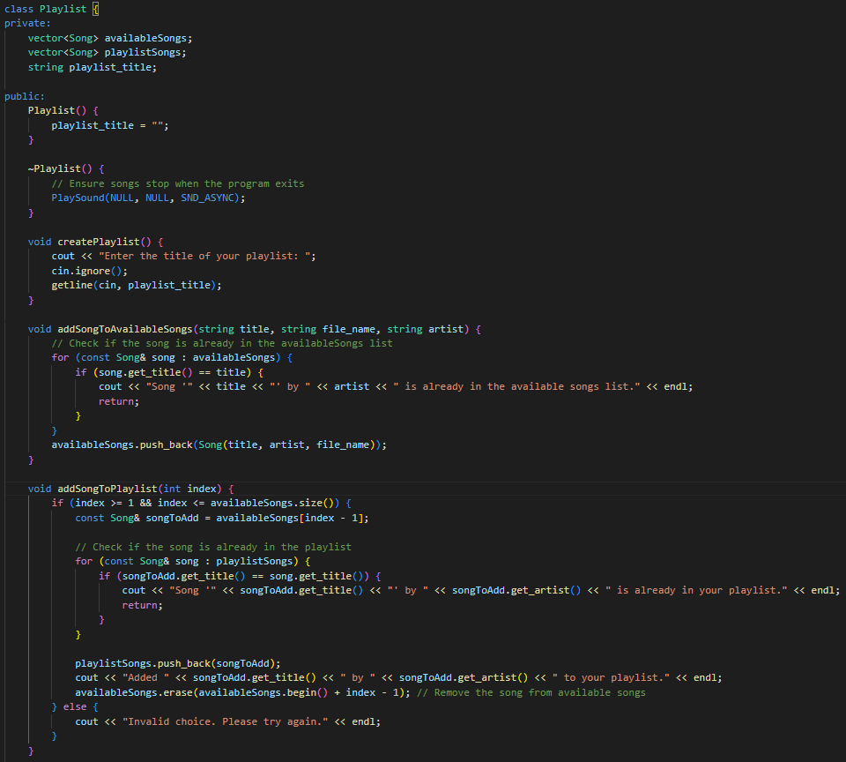

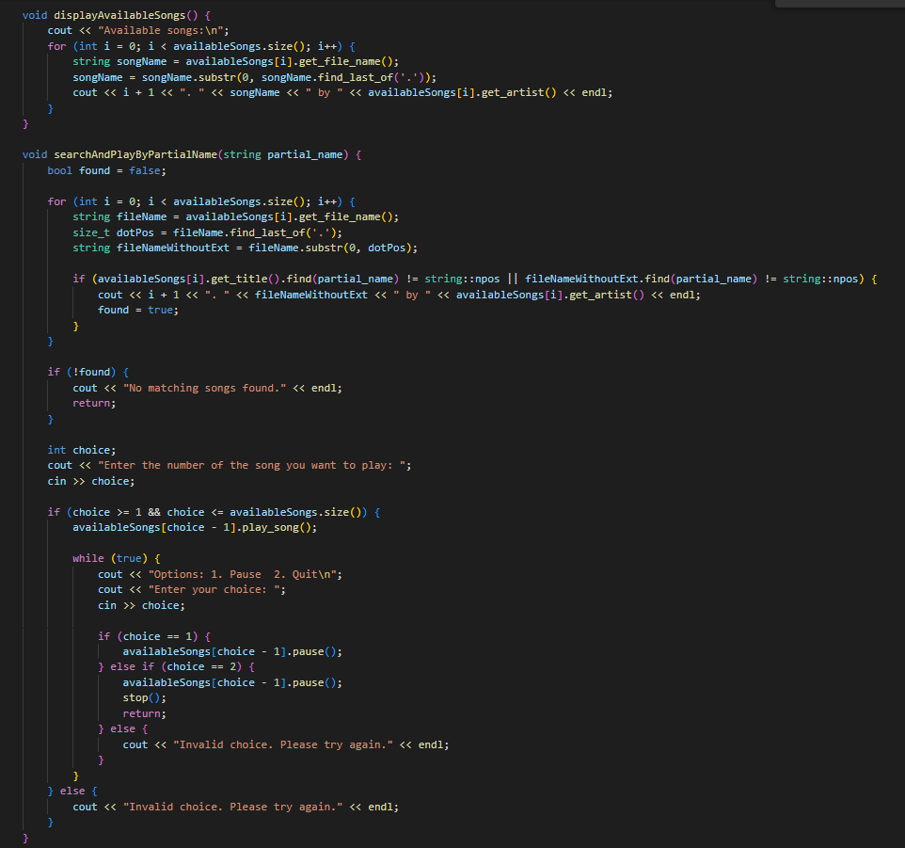 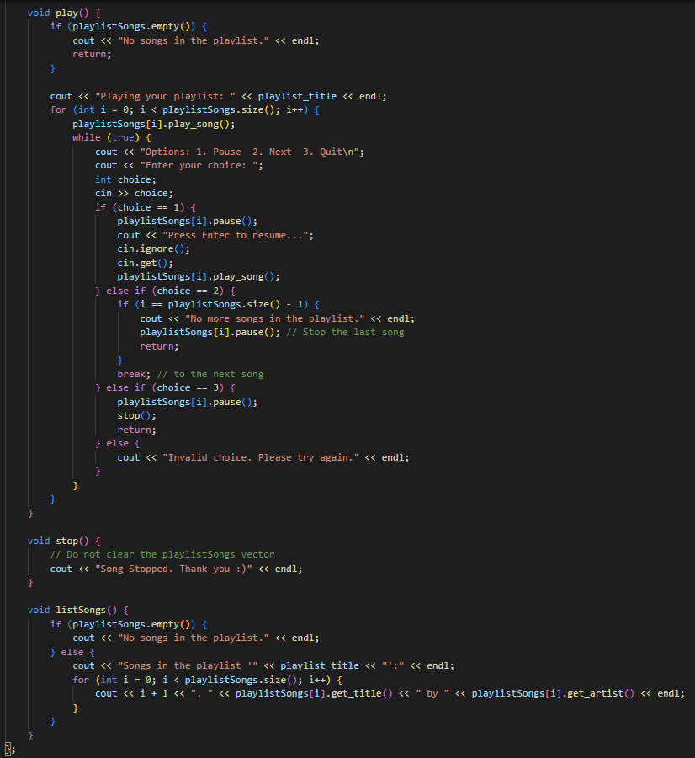

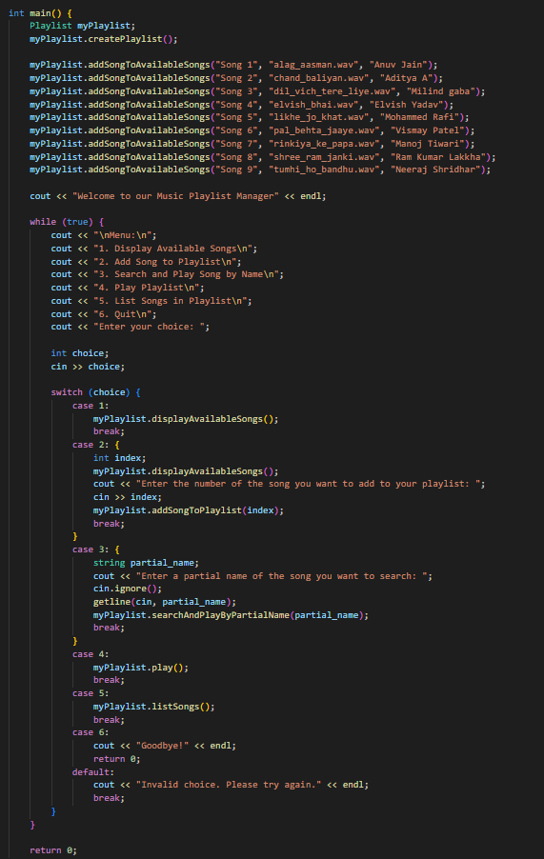

**Input/Output:**

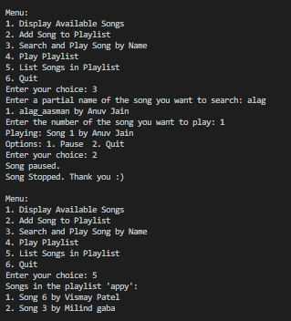 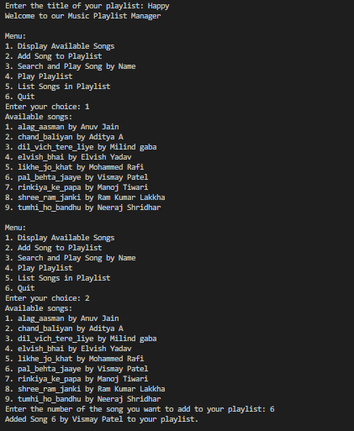

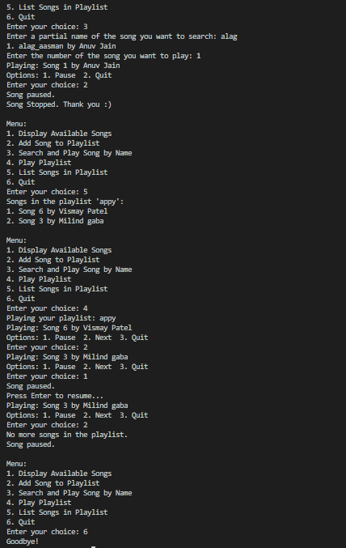

**GitHub repository link:** <https://github.com/himanshuchopade97/Spamtify.git>