A

Field Project Report on

E-Commerce Website (eBay Clone)

Submitted To,



KCES’s Institute of Management and Research, Jalgaon
An Autonomous Institute Affiliated to KBC North Maharashtra University, Jalgaon

NAAC Re-Accredited 'A' Grade (3.17) CGPA

Submitted By,
Name: Siddhant Ravindrarao Bagal

Name: Gagan Mahesh Patil

Under the Guidance of
Name: Prof. Shweta Ramani

For the partial fulfillment of degree
Bachelor of Computer Application (BCA)

Academic Year: 2026-27

DECLARATION

I hereby declare that the project work entitled “E-Commerce Website (eBay Clone)”, submitted under the guidance of Prof. Shweta Ramani, is my original work carried out in partial fulfillment of the requirements for the Bachelor of Computer Applications (BCA) degree during the academic year
2026-27.

This project report is entirely my own work and has not been copied or reproduced from any other source. I take full responsibility for the authenticity of the work and shall be accountable for any discrepancies, if found.

Date: Student Name

ACKNOWLEDGEMENT

I would like to express my sincere gratitude to everyone who supported me in completing this project report. First and foremost, I am deeply thankful to my project guide,
Prof. Charuta Khadke, for their valuable guidance, continuous support, and encouragement throughout the project.

I also extend my heartfelt thanks to the HOD, Sweta G. Phegade, Dean of the School of Computer Applications, Mr. S. N. Khan, for his helpful advice and constructive suggestions. I am equally grateful to our respected Director, Prof. B. V. Pawar, for his kind cooperation, motivation, and coordination.

Finally, I thank all those who directly or indirectly contributed to the successful completion of this project.

You’re faithfully,
Date: / /20

Institute certificate

Company Certificate: on letter head of respective company

INDEX

Sr. No. | Particulars | Page No.
1 | Abstract
2 | Introduction
3 | Proposed System
4 | Need of the System
5 | Software & Hardware Requirements
6 | Database Diagrams (DFD / ERD/ Use Case Diagrams)
7 | Database Design
8 | Project Screen Shots
9 | Future Scope
10 | Conclusion
11 | References

Abstract

The eBay Clone is a web-based e-commerce application developed to provide users with an online shopping experience similar to that of the popular eBay marketplace. The primary objective of this project is to develop a user-friendly platform where customers can explore products, view product details, manage their shopping carts, and proceed through the checkout process. The application demonstrates how web technologies can be used to create an organized and interactive online marketplace.
The system includes several essential modules, such as user registration, login, product listing, product details, shopping cart management, checkout, and a user dashboard. It provides a structured interface for browsing products across different categories and accessing relevant product information. The application also includes features for managing watchlist items and viewing purchased products, helping users organize their shopping activities efficiently.
The project is developed using HTML, CSS, and JavaScript, with Bootstrap used to support responsive layouts and improve the overall user interface. JavaScript is used to implement client-side interactions and manage various application features, while JSON data is used to store and retrieve product information within the application. The modular structure separates the pages, stylesheets, scripts, and product assets, making the application easier to understand and maintain.
This project provides practical knowledge of front-end web development, page navigation, user interface design, data handling, and the implementation of common e-commerce workflows. It also establishes a foundation for future enhancements, such as database integration, secure server-side authentication, payment gateway integration, order tracking, and seller management. Overall, the eBay Clone demonstrates the design and development of a basic online shopping platform while providing an opportunity to understand the fundamental concepts involved in building modern e-commerce applications.

Introduction
The rapid growth of internet technology has transformed the way people buy and sell products. E-commerce has become an essential part of modern business by allowing customers to purchase products online without visiting physical stores. Online marketplaces provide a convenient platform where buyers can explore different products, compare prices, and make purchasing decisions from anywhere. These platforms also help sellers reach a wider audience and manage their products more efficiently.
The eBay Clone is a web-based e-commerce project developed to demonstrate the fundamental working principles of an online shopping marketplace. The project is inspired by the functionality and user experience of eBay, one of the well-known online marketplace platforms. It aims to provide a simple, interactive, and user-friendly environment where users can browse products, view product information, add items to their shopping cart, and manage their shopping activities through a web interface.
The application incorporates essential e-commerce features, including user authentication interfaces, product listings, product detail pages, shopping cart management, watchlist functionality, and user dashboard components. These features are designed to make product discovery and shopping activities more organized and convenient. The interface is structured to provide easy navigation between different sections, allowing users to interact with the application efficiently.
The project focuses on applying front-end web development concepts to create a responsive and visually appealing e-commerce interface. Technologies such as HTML, CSS, JavaScript, and Bootstrap are used to structure web pages, design layouts, implement interactive elements, and support responsiveness across different screen sizes. Product information and related resources are organized to support the application's various pages and components.
Developing this project provides practical experience in website design, component organization, client-side programming, event handling, and the implementation of common e-commerce workflows. It also helps demonstrate how different web technologies work together to create an interactive online shopping experience.
Furthermore, the project provides a foundation for future development into a more comprehensive marketplace. Potential improvements include integrating a backend server and database, implementing secure authentication, adding payment gateway support, enabling seller accounts, and introducing order tracking and inventory management. These enhancements could extend the application's capabilities and bring it closer to a fully functional e-commerce platform.
In conclusion, the eBay Clone project demonstrates the basic concepts involved in developing an online marketplace. It combines web design and interactive functionality to create a platform that illustrates the essential features of modern e-commerce applications while providing valuable practical experience in web development.

Proposed System
The proposed system is an eBay Clone, a web-based e-commerce application designed to provide users with a convenient and interactive online shopping experience. The system aims to replicate the essential features of an online marketplace, allowing users to browse products, view product details, manage shopping cart items, and organize their shopping activities through a user-friendly interface.
The application provides a structured platform with different sections for product browsing, product information, shopping cart management, watchlist functionality, and user dashboard activities. It focuses on improving navigation, simplifying product discovery, and providing an organized shopping experience.
Key Features of the Proposed System
- User Interface: Provides a simple, interactive, and user-friendly interface for navigating different sections of the application.
- Product Listing: Displays available products with relevant information, helping users explore the products offered through the marketplace.
- Product Details: Allows users to view detailed information about individual products before making purchasing decisions.
- Shopping Cart Management: Enables users to organize selected products in a shopping cart before proceeding to checkout.
- Watchlist Management: Provides a facility for users to keep track of products they are interested in.
- User Dashboard: Organizes relevant user activities and provides access to different shopping-related sections.
- Responsive Design: Uses modern web design techniques and Bootstrap to support a consistent interface across different screen sizes.
- Interactive Functionality: Uses JavaScript to handle user interactions and implement client-side application behavior.
Technologies Used
The proposed system uses HTML to structure web pages, CSS to style the interface, JavaScript to implement interactive features, and Bootstrap to support responsive layouts. Product information and related resources are organized to support the application's functionality.
Advantages of the Proposed System
- Provides a convenient platform for exploring products online.
- Offers organized product listings and product information.
- Simplifies the management of selected products through shopping cart functionality.
- Allows users to maintain a watchlist of products of interest.
- Improves navigation through a structured and user-friendly interface.
- Demonstrates the practical application of front-end web development technologies.
- Provides a foundation for future integration of backend services, databases, payment systems, and seller management features.
In conclusion, the proposed system demonstrates the core functionality and design principles of an online marketplace. It provides a practical implementation of common e-commerce features while offering opportunities for future expansion into a complete online shopping platform.

Need of the System
With the rapid growth of internet usage and digital technology, online shopping has become an important part of modern life. Therefore, developing an e-commerce application is useful for understanding and implementing the essential processes involved in online shopping.
The eBay Clone project is developed to demonstrate the working of an online marketplace and address the need for a simple, organized, and interactive shopping platform. It provides an environment where users can browse products, view product details, manage selected items, and organize their shopping activities through a web-based interface.
The major needs of the system are described below:
- Convenient Online Shopping: Provides users with a platform to explore products without visiting physical stores.
- Organized Product Display: Presents product information in a structured manner, making it easier for users to browse available items.
- Efficient Product Selection: Allows users to select products and organize them in a shopping cart before checkout.
- Product Tracking: Provides watchlist functionality so users can keep track of products they are interested in.
- User-Friendly Interface: Offers simple navigation and an interactive interface to improve the overall user experience.
- Responsive Web Design: Supports access through different screen sizes using responsive web development techniques.
- Practical Application of Web Technologies: Demonstrates the use of HTML, CSS, JavaScript, and Bootstrap in developing an interactive e-commerce website.
- Understanding E-Commerce Workflows: Helps demonstrate common online shopping processes, including product browsing, cart management, and checkout interface design.
- Future Scalability: Establishes a foundation for adding advanced features such as database integration, secure authentication, online payments, order tracking, and seller management.
In conclusion, the need for this system arises from the importance of understanding modern e-commerce applications and their essential functionalities. The eBay Clone provides a practical learning platform for implementing online marketplace features and applying web development concepts to a real-world use case.

Software & Hardware Requirements

4.1 Software Requirements
The software requirements specify the applications, technologies, and tools needed to develop and run the eBay Clone project.
S. No. | Software/Technology | Requirement
1 | Operating System | Windows 10/11, Linux, or macOS
2 | Frontend | HTML5, CSS3, JavaScript
3 | CSS Framework | Bootstrap
4 | Code Editor | Visual Studio Code or any suitable code editor
5 | Web Browser | Google Chrome, Mozilla Firefox, or Microsoft Edge
6 | Data Format | JSON
7 | Development Tools | Browser Developer Tools

4.2 Hardware Requirements
The hardware requirements specify the minimum system configuration recommended for developing and running the application.
S. No. | Hardware Component | Minimum Requirement
1 | Processor | Intel Core i3 or equivalent
2 | RAM | 4 GB
3 | Hard Disk | 10 GB of available storage
4 | Display | 1366 × 768 resolution
5 | Input Devices | Keyboard and mouse
6 | Network | Internet connection for accessing online resources

Database Diagrams (DFD / ERD/ Use Case Diagrams)
- DFD Level 0: The e-commerce website acts as the central system connecting buyers, sellers, administrators, and external services. Buyers interact with products and orders, sellers manage listings, administrators oversee marketplace activities, and external services support payments and AI-based functional

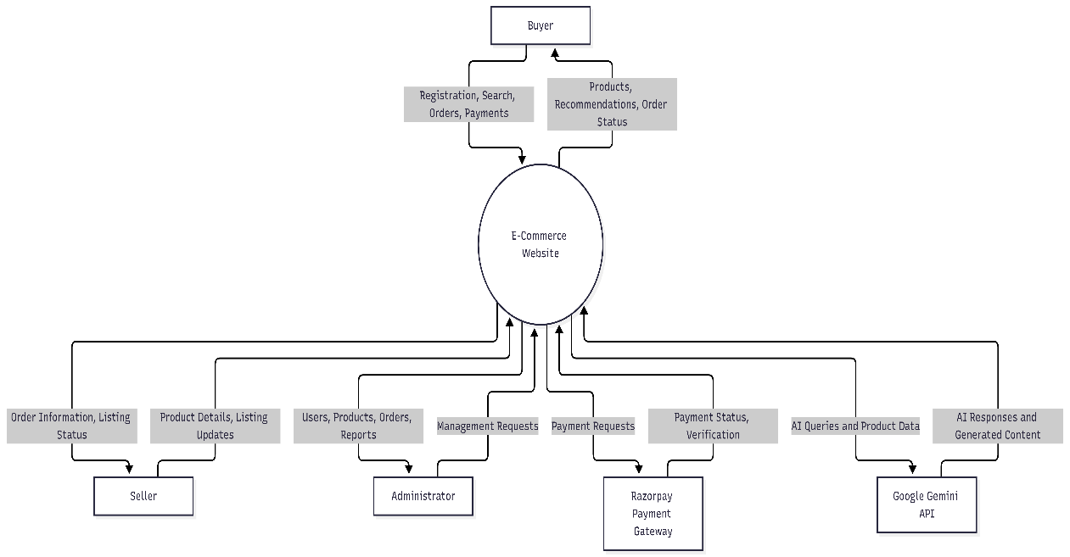

- DFD Level 1: The system processes user authentication, product management, shopping operations, payment transactions, AI requests, and administrative activities. Data stores maintain the information required by these processes.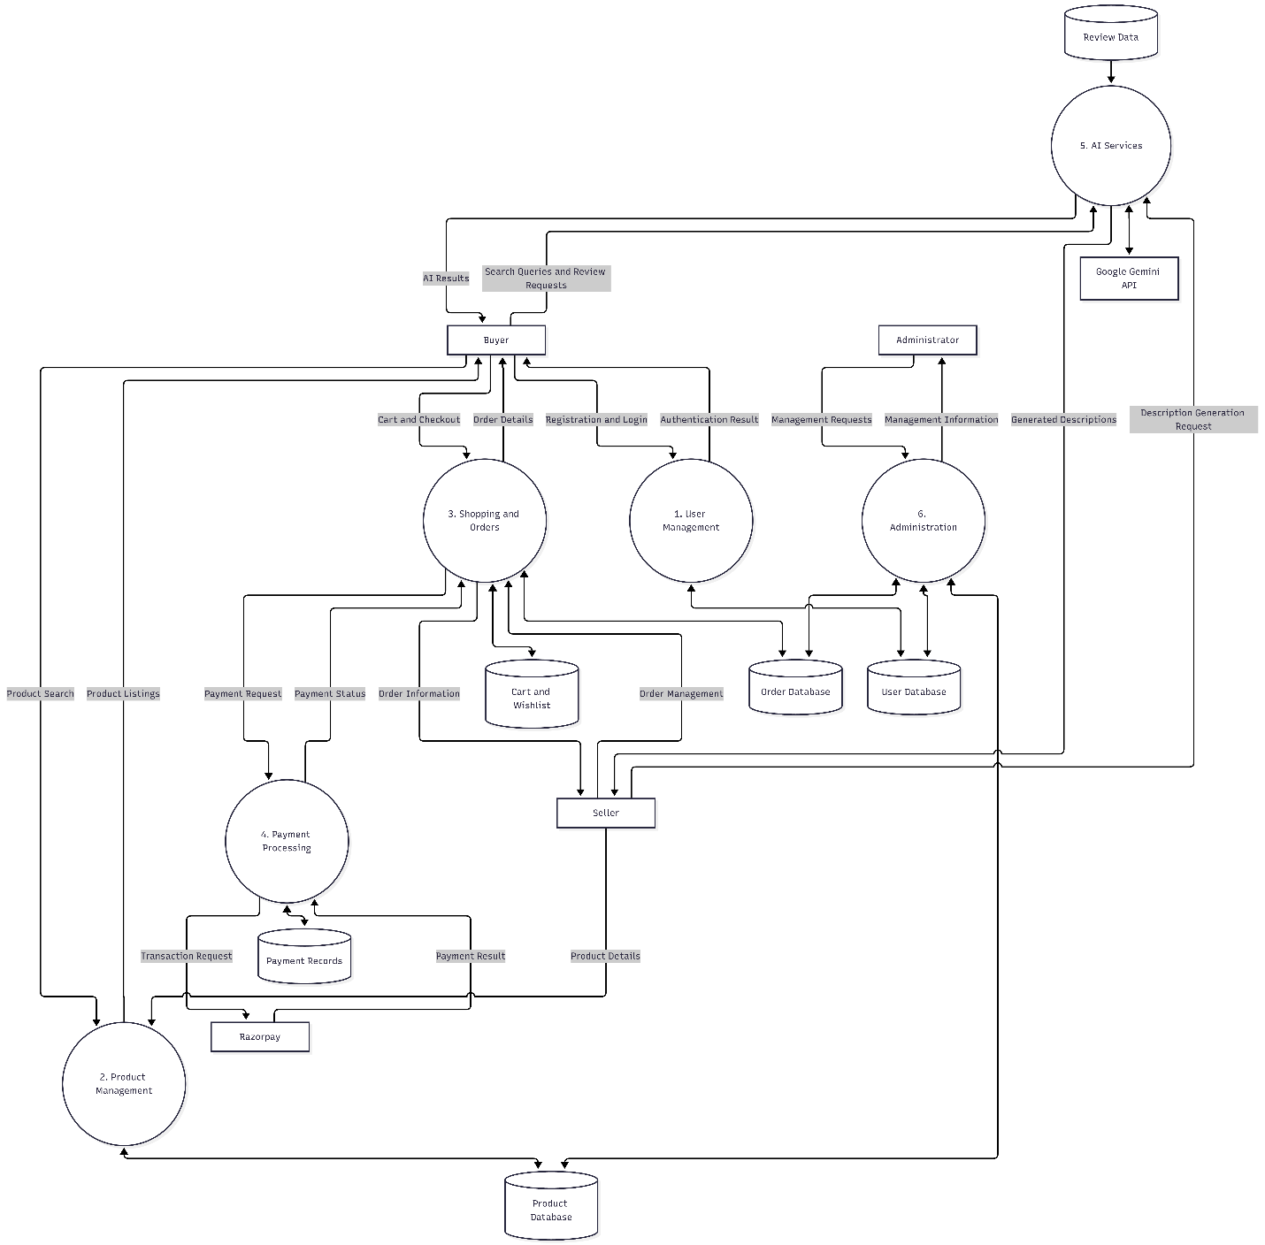

- ERD: The ERD represents the database structure of the e-commerce system, showing entities such as users, products, orders, payments, and reviews, along with their relationships.

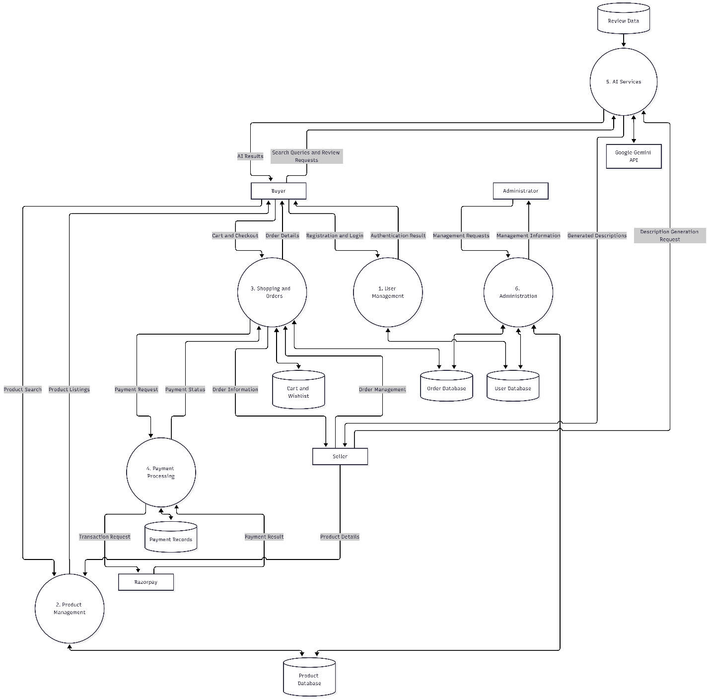

- Use case Diagram: The Use Case Diagram illustrates the interactions between buyers, sellers, administrators, and the e-commerce system, highlighting the main functionalities available to each user.
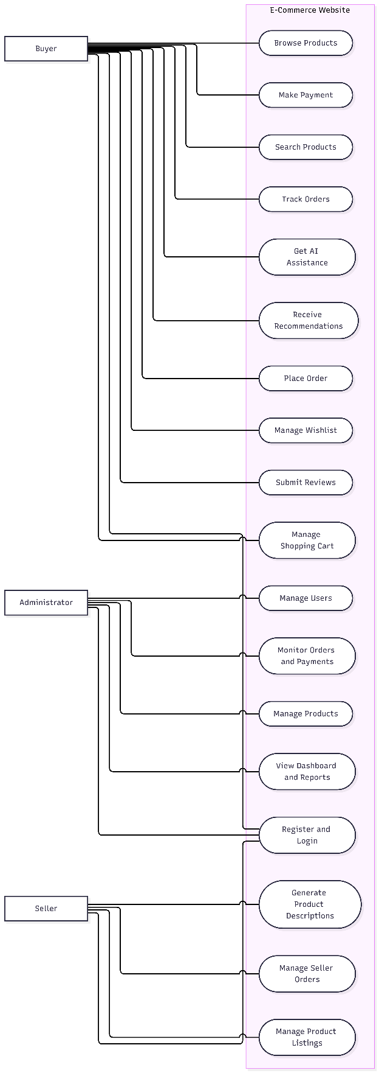
Database Design
The database design of the E-Commerce Website illustrates the organization of data and the relationships between different entities. It consists of tables such as User, Product, Category, Cart, Wishlist, Order, Payment, and Review, which manage essential information related to online shopping activities.
Each table contains a primary key (PK) to uniquely identify records, while foreign keys (FK) establish relationships between related tables. The User table stores customer and seller information, the Product and Category tables manage product details, and the Cart and Wishlist tables maintain users' selected and preferred products. The Order, Order Item, and Payment tables manage purchase details and transaction records, while the Review table stores customer feedback and ratings.
This relational database structure promotes organized data storage, maintains data consistency, and supports efficient retrieval of information. It provides the foundation for essential e-commerce operations, including product management, order processing, payment tracking, and customer interaction.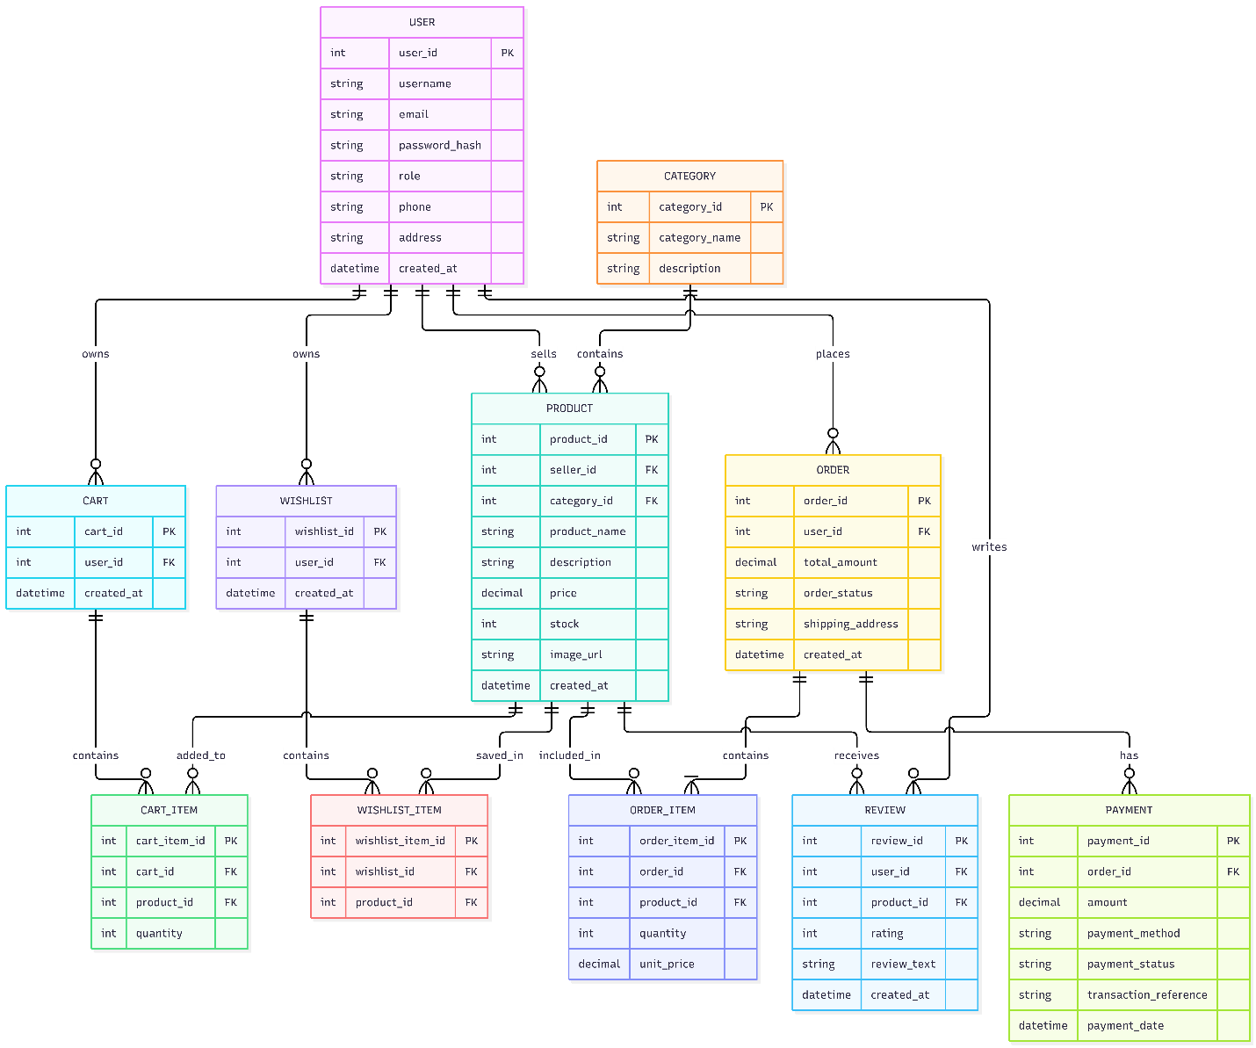
Project Screenshot

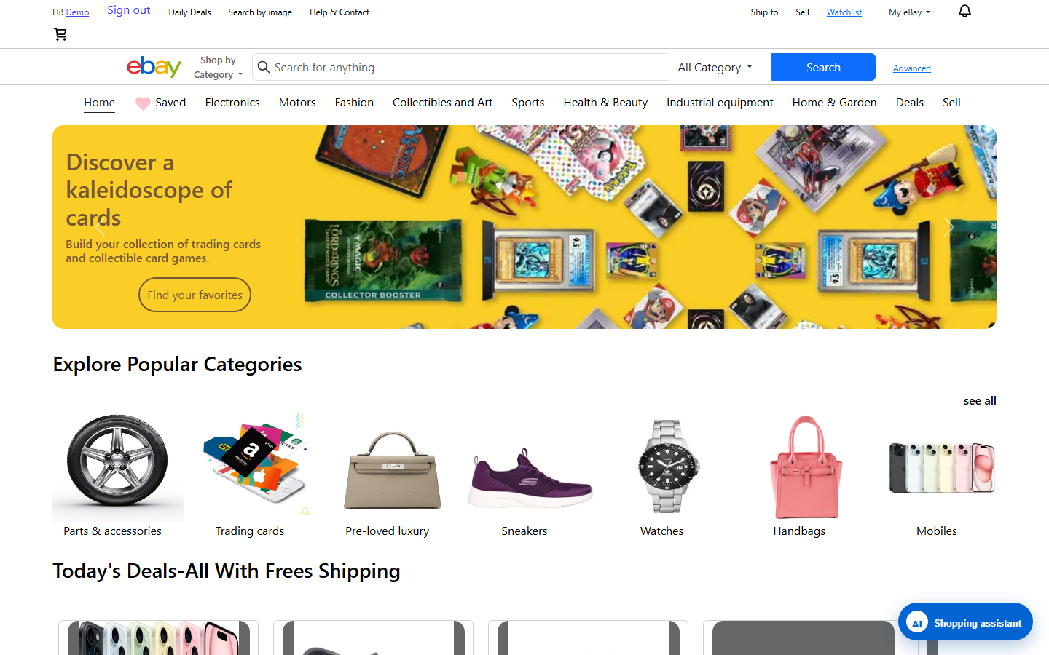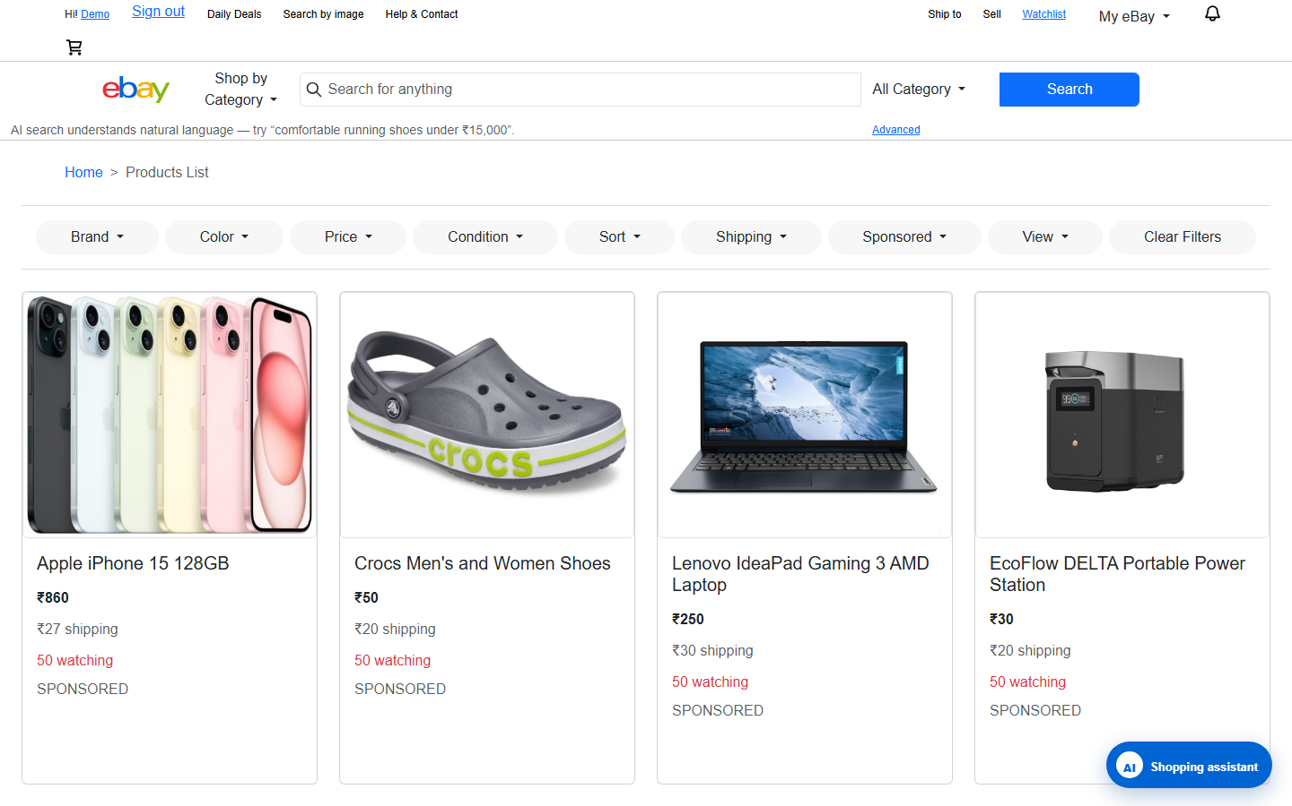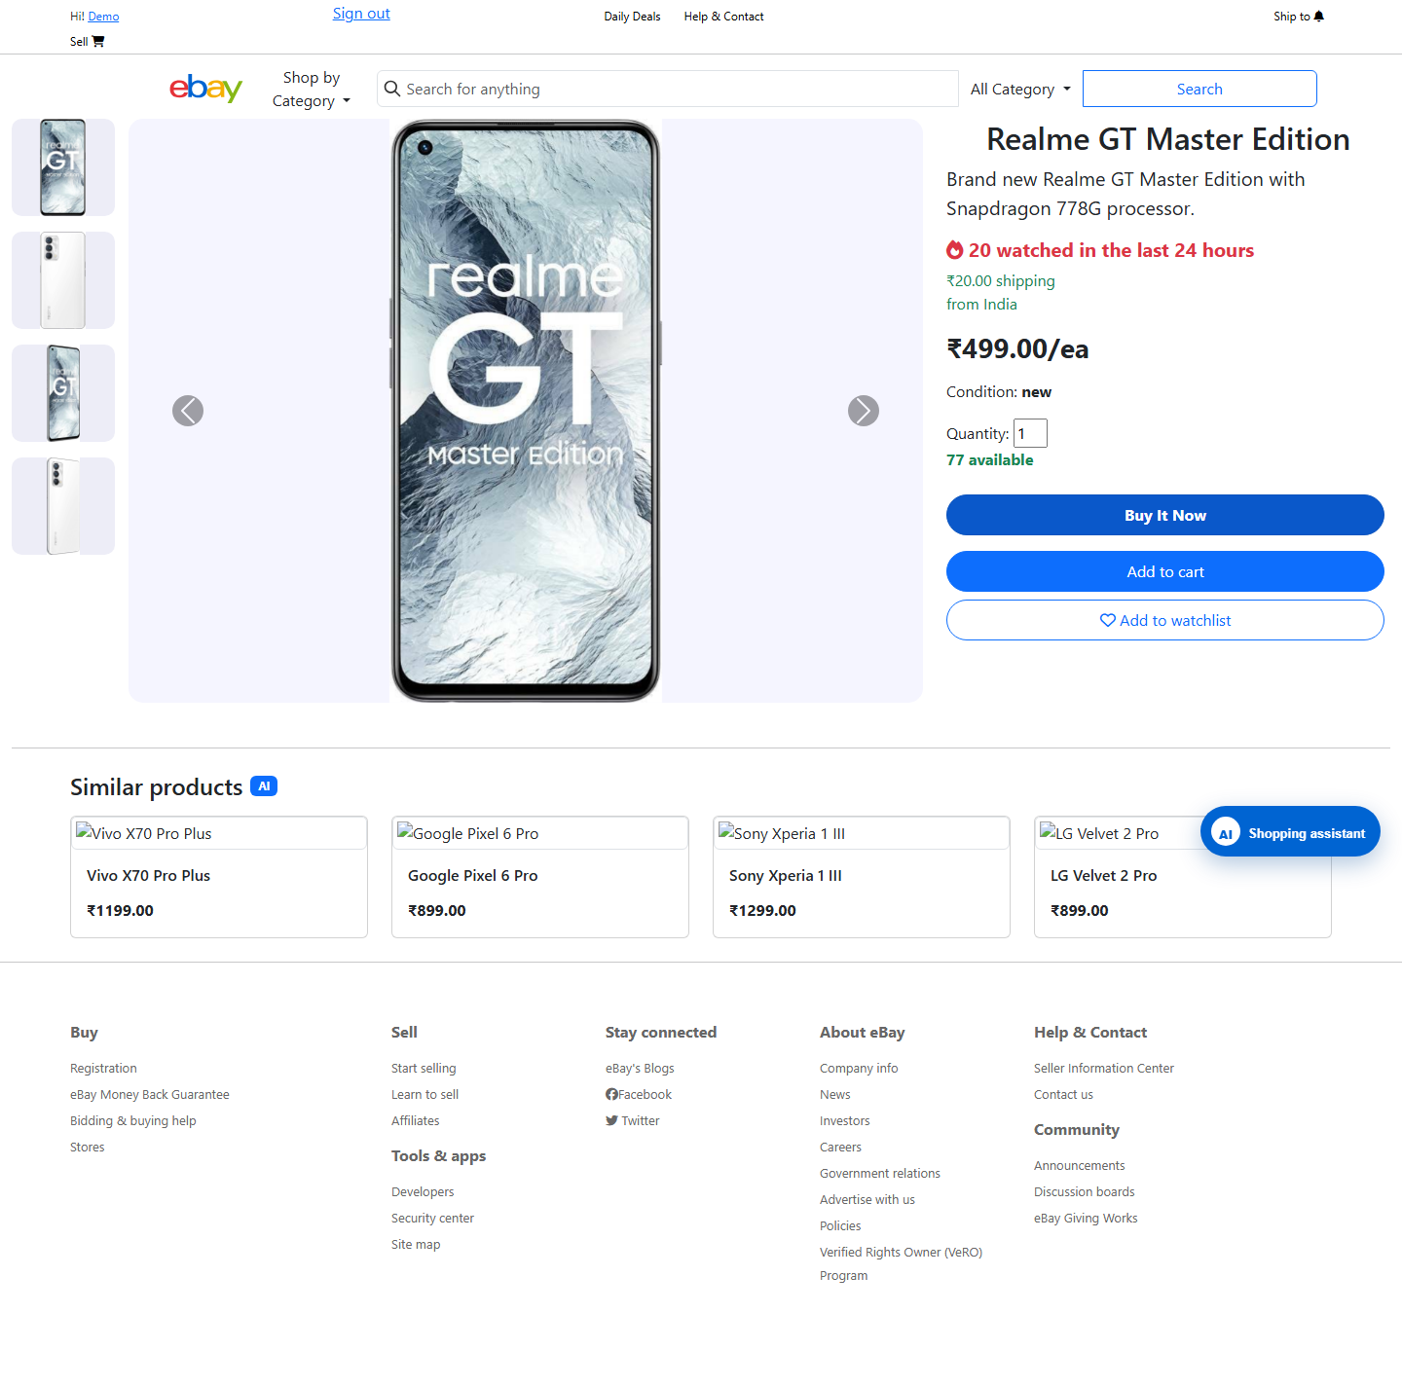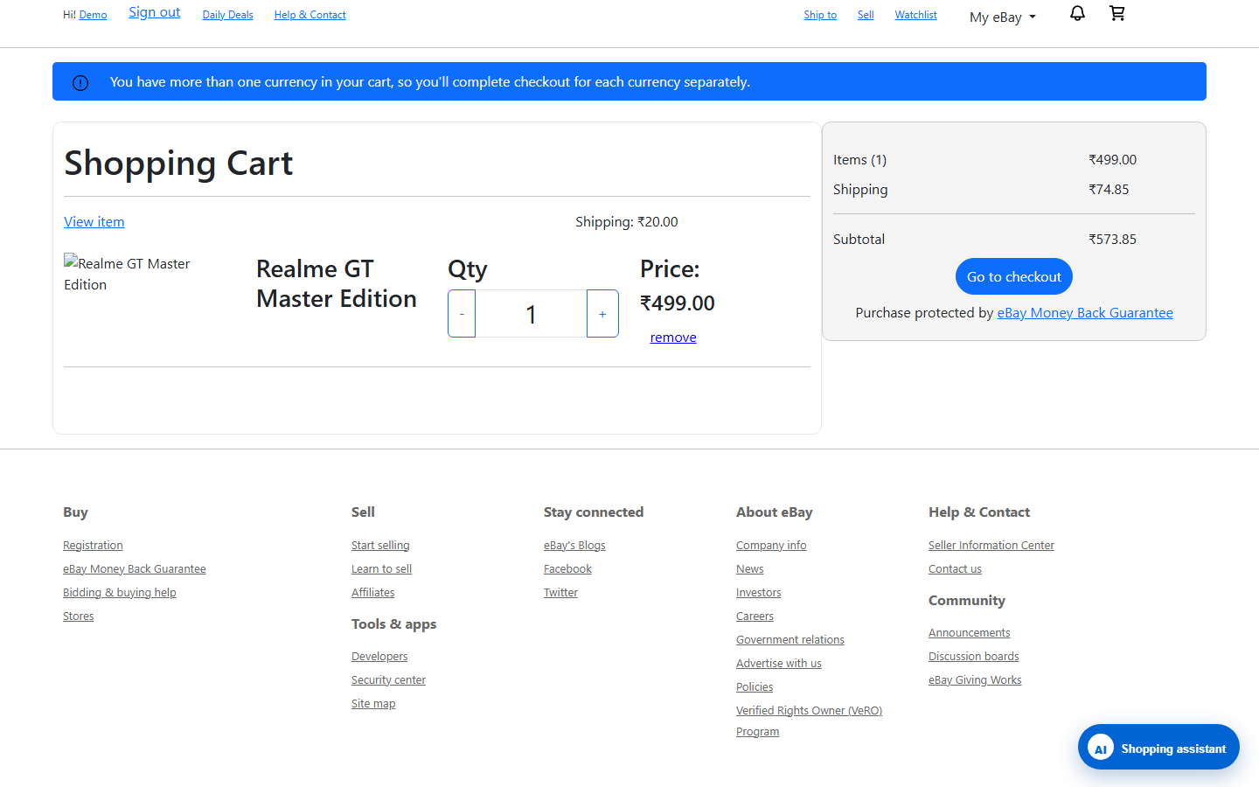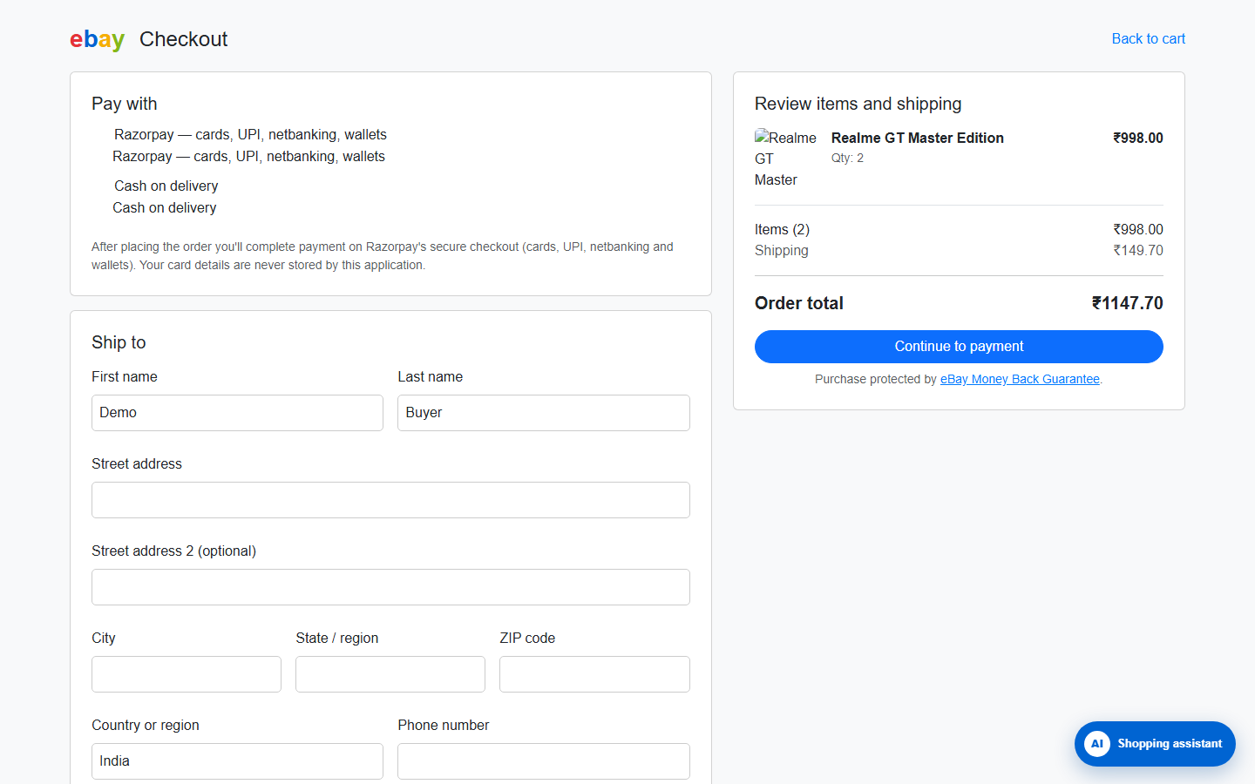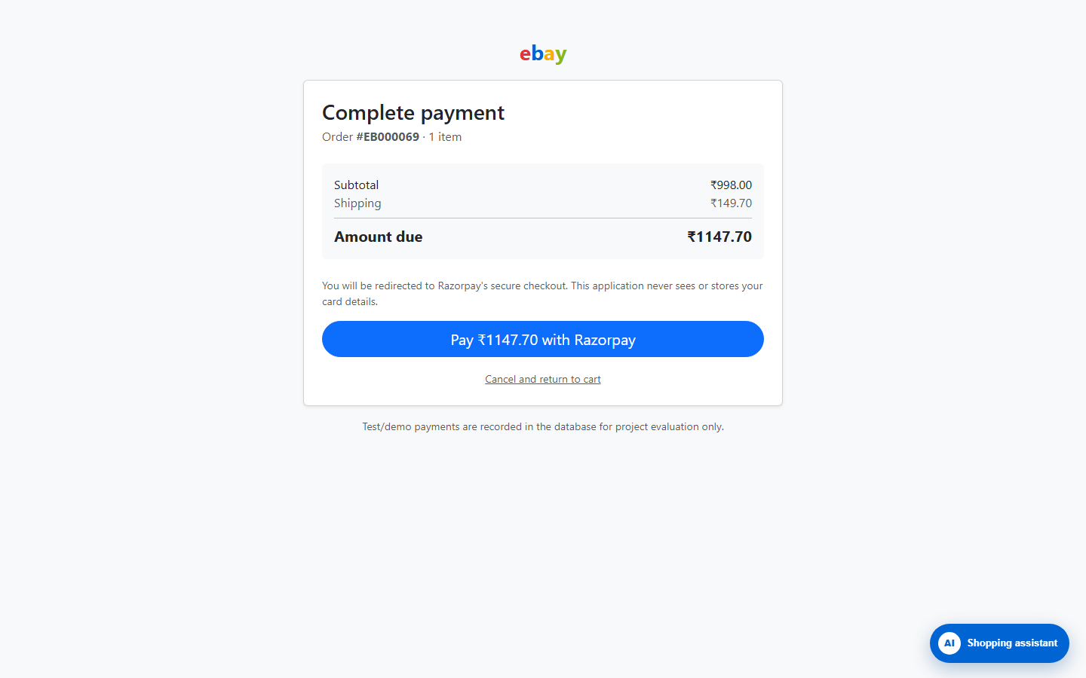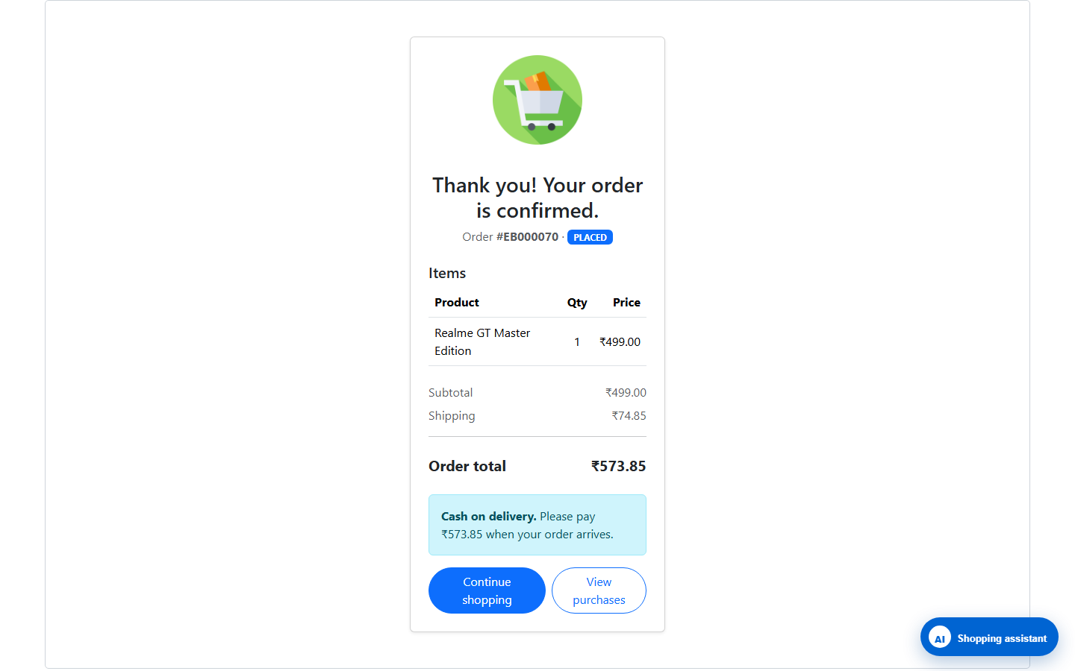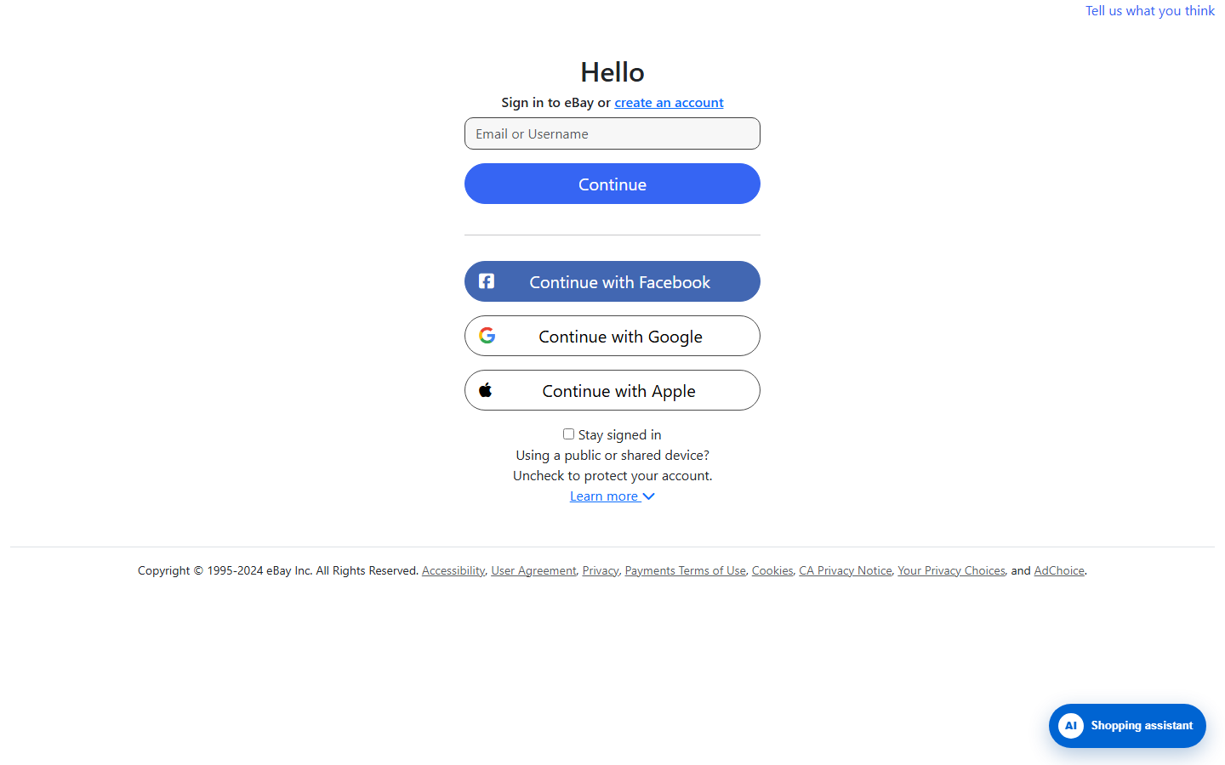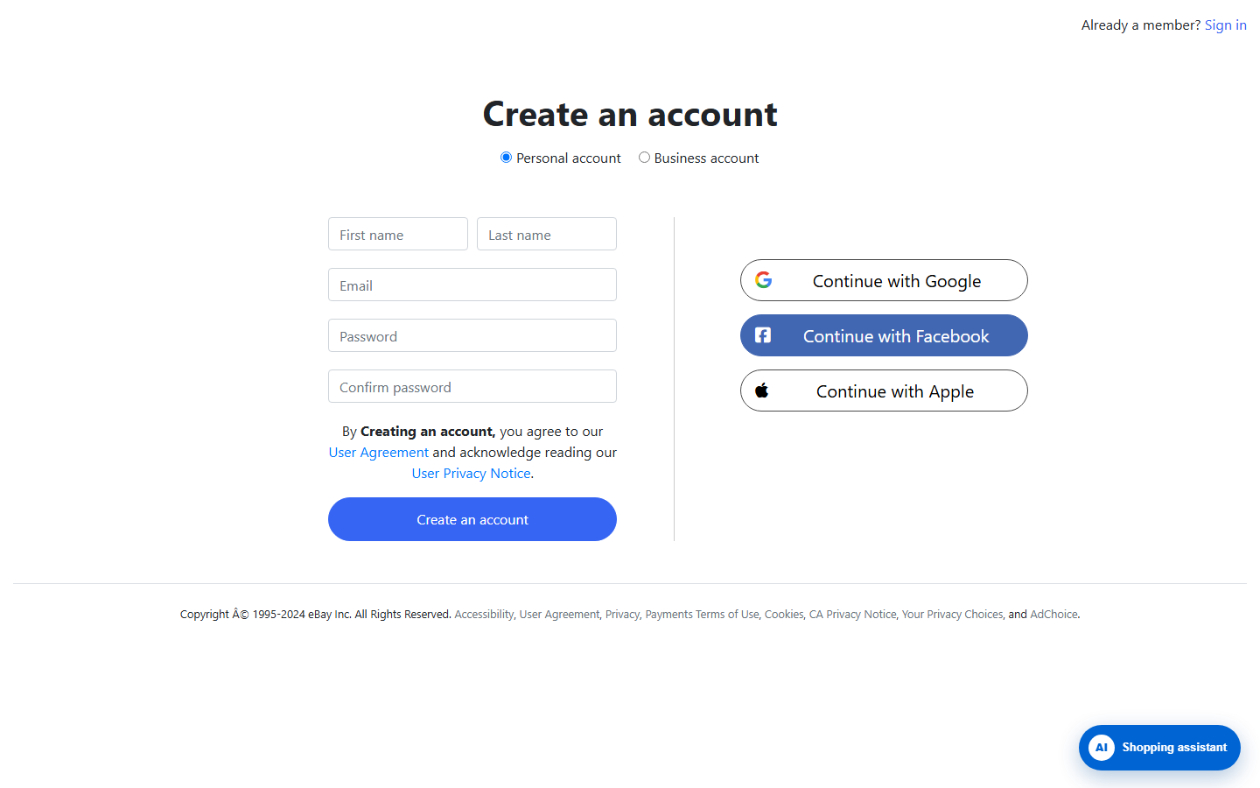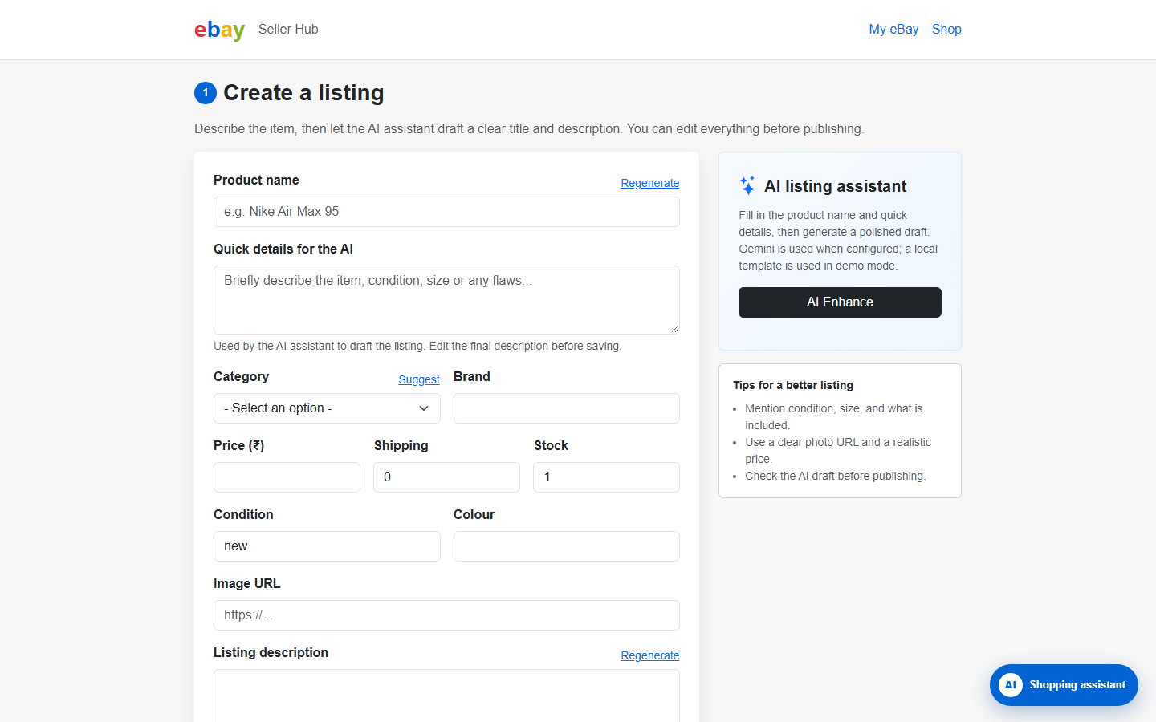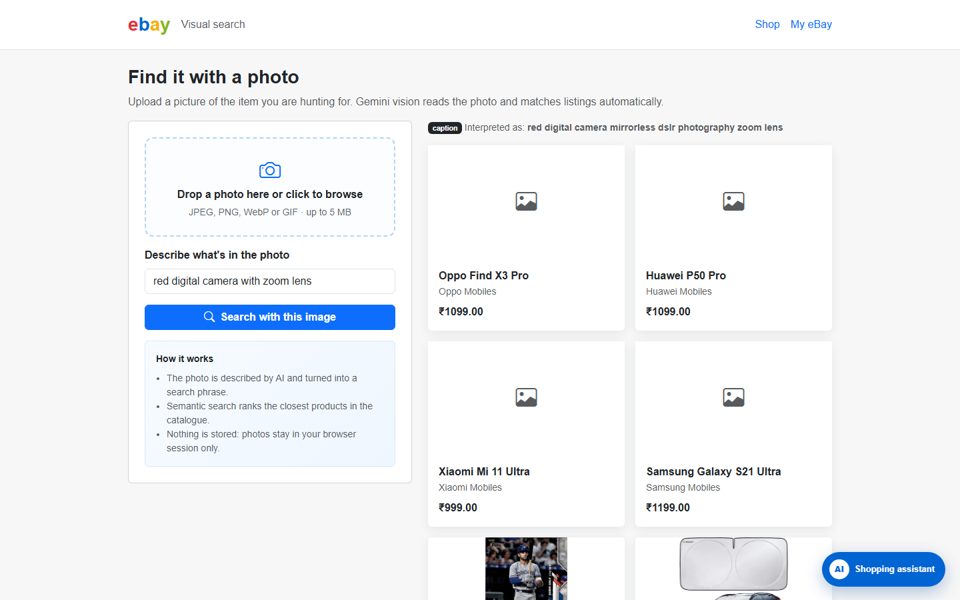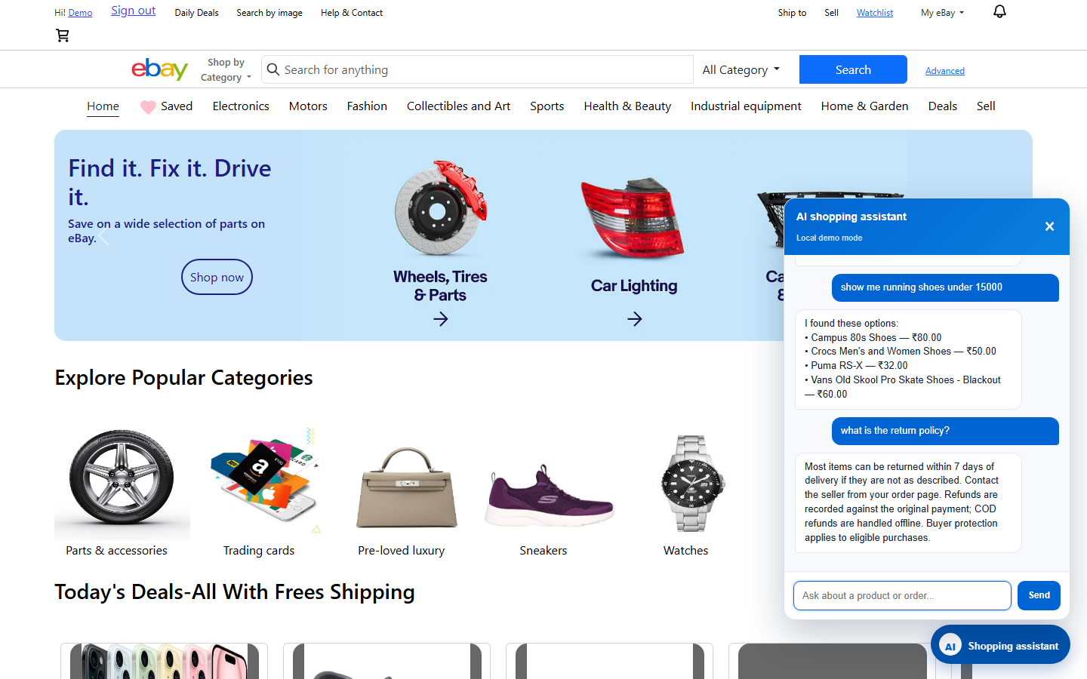

Future Scope
The eBay Clone project provides a foundation for developing a more advanced and fully functional e-commerce marketplace. Although the current system demonstrates essential shopping features and interactive web interfaces, several improvements can be implemented in the future to enhance its functionality, security, performance, and user experience.
The future scope of the project includes the following enhancements:
- Backend Integration: Integrate a backend framework such as Node.js, Django, or FastAPI to handle business logic, user requests, and application data.
- Database Integration: Implement a database such as MySQL, PostgreSQL, or MongoDB to store and manage user accounts, product information, orders, and shopping cart data.
- Secure User Authentication: Introduce secure registration, login, password recovery, and role-based access control to protect user accounts and information.
- Online Payment Integration: Integrate payment gateways to enable secure online transactions using supported payment methods.
- Seller Management: Develop seller accounts that allow users to add products, update prices, manage inventory, and track their sales.
- Order Management and Tracking: Implement order placement, order history, shipment tracking, and order status notifications.
- Advanced Search and Filtering: Add search suggestions, category filters, price ranges, product ratings, and sorting options to help users find products more efficiently.
- Product Reviews and Ratings: Allow customers to submit product reviews and ratings to help other buyers make informed purchasing decisions.
- Personalized Recommendations: Introduce recommendation features based on users' browsing history, shopping preferences, and previous purchases.
- Performance and Security Improvements: Optimize page loading, validate user inputs, protect sensitive information, and implement appropriate security measures.
- Mobile Application Development: Extend the platform into an Android and iOS application to provide convenient access through mobile devices.
- Notifications and Customer Support: Introduce email notifications, order updates, customer support tools, and automated assistance to improve communication with users.

Conclusion
The eBay Clone project successfully demonstrates the fundamental concepts of web development through the design and implementation of an interactive e-commerce website. The primary objective of the project is to provide a user-friendly platform that represents the essential features of an online marketplace, including product listings, product details, shopping cart management, watchlist functionality, and user dashboard interfaces.
The project utilizes HTML, CSS, JavaScript, and Bootstrap to create a structured, responsive, and interactive user interface. It demonstrates how these technologies can be combined to develop an organized website that supports product browsing and common shopping-related activities. The application also provides practical experience in designing web pages, managing client-side interactions, organizing project resources, and implementing essential e-commerce workflows.
Through the development of this project, valuable knowledge of front-end development, responsive web design, website navigation, and user interface implementation has been gained. The project also highlights the importance of creating simple and accessible interfaces that improve the overall user experience.
Although the current implementation focuses on essential e-commerce functionality, it provides a strong foundation for future improvements. Integration with a backend server, database, secure authentication system, online payment gateway, and order management system could further enhance its capabilities and transform it into a more comprehensive marketplace.
In conclusion, the eBay Clone is a practical demonstration of the application of modern web technologies in developing an online shopping platform. It fulfills its purpose as a web development project while providing valuable technical knowledge and a foundation for future enhancements in e-commerce application development.

References
The following references were used as learning resources and technical documentation for the development of the eBay Clone project.
- eBay Official Website — Reference for understanding the layout, product listings, and general functionality of an online marketplace.
Website: https://www.ebay.com
- HTML Documentation — MDN Web Docs — Reference for HTML elements, webpage structure, forms, and hyperlinks.
Website: MDN Web Docs
- CSS Documentation — MDN Web Docs — Reference for styling web pages, layouts, and responsive design techniques.
Website: MDN CSS Documentation
- JavaScript Documentation — MDN Web Docs — Reference for implementing interactive elements and client-side functionality.
Website: JavaScript Documentation
- Bootstrap Documentation — Reference for responsive layouts, grid systems, navigation components, and interface design.
Website: Bootstrap Documentation
- Visual Studio Code Documentation — Reference for understanding the code editor and its development features.
Website: Visual Studio Code
- Google Chrome DevTools Documentation — Reference for inspecting web pages, debugging JavaScript, and testing website behavior.
Website: Chrome DevTools
- Project Source Code and Assets — The HTML files, CSS stylesheets, JavaScript files, product data, and other resources used in the implementation of the eBay Clone project.
Note: These references provide background information and technical guidance. Include only the resources actually consulted during project development in your final report.

