what is recommender system

A recommender system is a tool or software that suggests items, such as movies, music, or products, to users based on their preferences and past interactions.

窗体顶端

窗体底端

types of Recommender System

·  ****Content-Based Filtering****: Recommends items similar to ones a user has liked before, focusing on item attributes like genre or keywords.

· · ****Collaborative Filtering****:

* · ****User-Based****: Recommends items based on similarities between users' preferences.
* ****Item-Based****: Suggests items similar to those a user has interacted with in the past.

· ****Hybrid Recommender Systems****: Combine different recommendation approaches like content-based and collaborative filtering to improve accuracy and diversity in suggestions.

· · ****Knowledge-Based Recommender Systems****: Use explicit domain knowledge or rules to generate recommendations tailored to user preferences and item attributes.

· · ****Context-Aware Recommender Systems****: Recommend items considering additional contextual information like time, location, or user mood to provide more personalized suggestions.

· · ****Matrix Factorization Methods****: Utilize mathematical techniques to break down user-item interaction matrices into simpler representations for better recommendation accuracy.

· · ****Deep Learning-Based Recommender Systems****: Utilize neural networks to learn complex patterns from user-item interactions, enabling more accurate recommendations at scale.

· · ****Demographic-Based Recommender Systems****: Recommend items based on demographic information such as age or gender, enhancing personalization in recommendations.

· · ****Association Rule Mining****: Discover patterns in user behavior to recommend items frequently bought or viewed together, commonly used in e-commerce for suggesting complementary products.

· · ****Community-Based Recommender Systems****: Utilize social network data to make recommendations based on items liked or endorsed by a user's social connections.

1. ·

Project flow

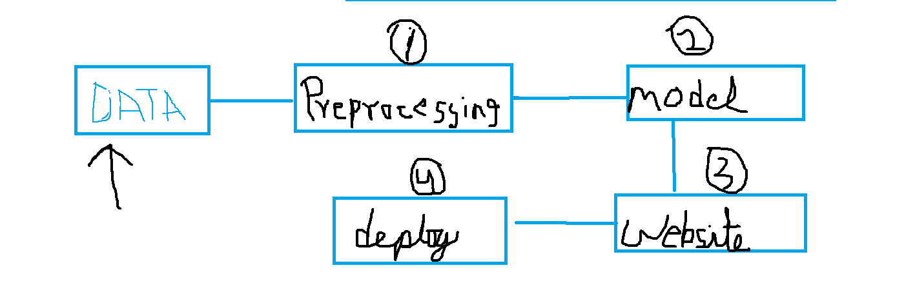

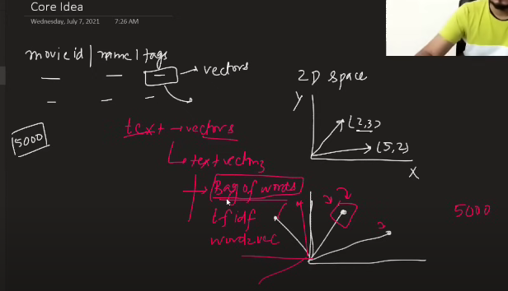

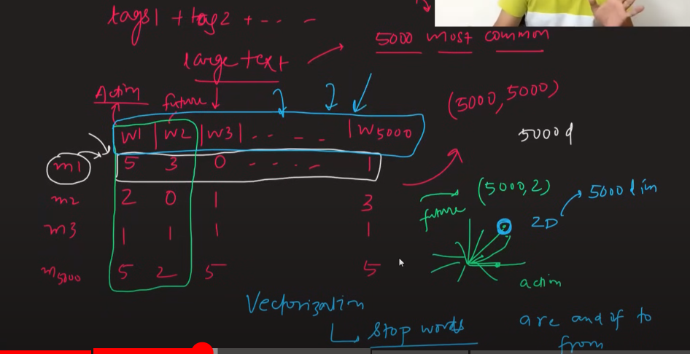5000-dimensional space.

Stop words are words that are removed from natural language data before or after processing because they are considered insignificant. Stop words are often articles, prepositions, pronouns, or auxiliary verbs that connect keywords and help form complete sentences. Some examples of stop words include "a," "an," "the," "and," "it," "for," "or," "but," "in," "are," "as," "at," "be," "by," "if," "into," "is," "no," "not," "of," "on," "such," "that," "their," "then," "there," "these," "they," "this," "to," "was," "will," and "with".

# **[sklearn.feature\_extraction.text](https://scikit-learn.org/stable/modules/classes.html" \l "module-sklearn.feature_extraction.text" \o "sklearn.feature_extraction.text)**.CountVectorizer

<https://scikit-learn.org/stable/modules/generated/sklearn.feature_extraction.text.CountVectorizer.html>

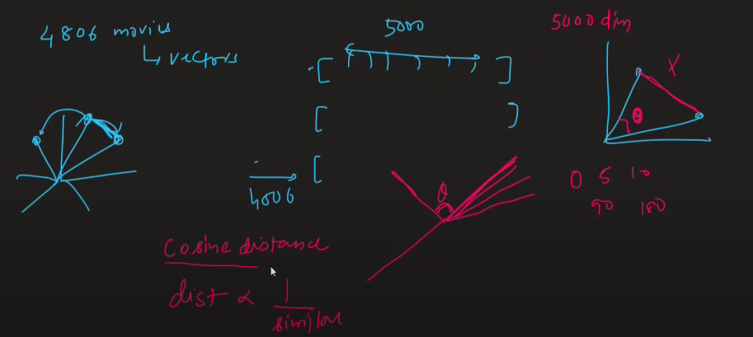

Cosine similarity measures the cosine of the angle between two vectors, while Euclidean distance calculates the straight-line distance between two points in space.

Why Euclidean distance fails in high dimensions?

This means when we have high number of dimensions distmax (d) ≈ distmin (d) , i.e. all points would be at same distance from each other. In High Dimensions, Euclidean Distance loses its significance!!! And this is why models like K-Nearest Neighbours which works on distances , fail in high dimensions.