**Project Name: My Parking Space**

**Project Member:**

**Himanshu Deshpande 210543181029**

**Amit Khendake 210543181042**

**Akshay Ringe 210543181006**

**Sahil Kshirsagar 210543181046**

**Abstract:**

With the increasing number of vehicles, finding a parking space in most areas is difficult for drivers. The common method of finding a free space is manual. This method takes time and effort. Hence, this project offers an online reservation system where the users can view various parking areas and select the available space. If the booking space is available then he/she can book it for specific time slot. The booked space will be marked red and will not be available for anyone else for that specified time. In this system cancelling the bookings is also an feature. User can remove their booked space anytime. Online payment can be done. After making payment, user will get a notification on his/her phone with unique parking number.

The aim is to automate its existing manual system by the help of computerized equipments and full-fledged computer software, fulfilling their requirements, so that their valuable data/information can be stored for a longer period with easy accessing and manipulation of the same. Basically the project describes how to manage for good performance and better services for the clients

**Functionalities provided by My Parking Space are as follows:**

* Provides the searching facilities based on various factors. Such as Car, Parking

Space, Parking Slots, Parking Fees

* My Parking Space also manage the Car Number details online for Parking Slots details, Parking Fees details.
* It tracks all the information of Parking, Car Number, Parking Slots etc
* Manage the information of Parking
* Shows the information and description of the Car, Parking Space to increase efficiency of managing the Car, Parking
* It deals with monitoring the information and transactions of Parking Slots.
* Manage the information of Car

**Implementation Technologies:**

1. **Spring Framework:**

Spring Framework is a Java platform that provides comprehensive infrastructure support for developing Java applications. Spring handles the infrastructure so you can focus on your application.

Spring enables you to build applications from “plain old Java objects” (POJOs) and to apply enterprise services non-invasively to POJOs. This capability applies to the Java SE programming model and to full and partial Java EE.

**1.1 Features of Spring Framework:**

**1. Lightweight**

Spring is modular lightweight framework which allows you to selectively use any of its modules on the top of Spring Core.

**2. Inversion of Control (IOC)**

This is another top feature of Spring framework where application dependencies are satisfied by the framework itself. Framework creates the object in runtime and satisfies application dependencies.

**3. Aspect Oriented Programming (AOP)**

Aspect Oriented Programming (AOP) is very popular in programming world and in Spring it is well implemented. Developer can use Aspect Oriented Programming (AOP feature of Spring to develop application in which business logic is separated from system services.

**4. Container**

Spring provides their own container for managing the bean lifecycle.

**5. MVC Framework**

Spring MVC Framework is used for developing MVC based web applications.

**6. Transaction Management**

Spring framework provides generic Transaction Management layer which can be used with or without J2EE(JEE) environment.

**7. JDBC Exception Handling**

Spring provides their own abstraction of JDBC exception which further simplifies the exception handling in program.

**1.2 Advantages of Spring Framework:**

**1. Solving difficulties of Enterprise application development**

Spring is solving the difficulties of development of complex applications, it provides Spring Core, Spring IoC and Spring AOP for integrating various components of business applications.

**2. Support Enterprise application development through POJOs**

Spring supports development of Enterprise application development using the POJO classes which removes the need of importing heavy Enterprise container during development. This makes application testing much easier.

**3. Easy integration other frameworks**

Spring designed to be used with all other frameworks of Java, you can use ORM, Struts, Hibernate and other frameworks of Java together. Spring framework do not impose any restriction on the frameworks to be used together.

**4. Application Testing**

Spring Container can be used to develop and run test cases outside enterprise container which makes testing much easier.

**5. Modularity**

Spring framework is modular framework and it comes with many modules such as Spring MVC, Spring ORM, Spring JDBC, Spring Transactions etc. which can used as per application requirement in modular fashion.

**6. Spring Transaction Management**

Spring Transaction Management interface is very flexible it can configure to use local transactions in small application which can be scaled to JTA for global transactions.

1. **The JDBC Template**

The central class of the Spring JDBC abstraction framework is the **JdbcTemplate** class that includes the most common logic in using the JDBC API to access data, such as handling the creation of connection, statement creation, statement execution, and release of resource. The**Jdbc-Template**class can be found in the **org.springframework.jdbc.core**package.

The **JdbcTemplate** class instances are thread-safe once configured. A single **JdbcTemplate** can be configured and injected into multiple DAOs.

We can use the **JdbcTemplate** to execute the different types of SQL statements. **Data Manipulation Language** (**DML**) is used for inserting, retrieving, updating, and deleting the data in the database such as **SELECT**, **INSERT**, or **UPDATE** statements

**2.1** **MySQL**

MySQL, the most popular Open Source SQL database management system, is developed, distributed, and supported by Oracle Corporation.

**Features of MySQL:**

* **MySQL is a database management system.**

A database is a structured collection of data. It may be anything from a simple shopping list to a picture gallery or the vast amounts of information in a corporate network. To add, access, and process data stored in a computer database, you need a database management system such as MySQL Server. Since computers are very good at handling large amounts of data, database management systems play a central role in computing, as standalone utilities, or as parts of other applications.

* **MySQL databases are relational.**

A relational database stores data in separate tables rather than putting all the data in one big storeroom. The database structures are organized into physical files optimized for speed. The logical model, with objects such as databases, tables, views, rows, and columns, offers a flexible programming environment.

* **MySQL software is Open Source.**

Open Source means that it is possible for anyone to use and modify the software. Anybody can download the MySQL software from the Internet and use it without paying anything.

* **The MySQL Database Server is very fast, reliable, scalable, and easy to use.**

MySQL Server was originally developed to handle large databases much faster than existing solutions and has been successfully used in highly demanding production environments for several years. Although under constant development, MySQL Server today offers a rich and useful set of functions. Its connectivity, speed, and security make MySQL Server highly suited for accessing databases on the Internet.

* **MySQL Server works in client/server or embedded systems.**

The MySQL Database Software is a client/server system that consists of a multithreaded SQL server that supports different back ends, several different client programs and libraries, administrative tools, and a wide range of application programming interfaces (APIs).

**2.3 ReactJs**

React (also known as React.js or ReactJS) is a free and open-source front-end JavaScript library for building user interfaces or UI components. It is maintained by Facebook and a community of individual developers and companies.

React can be used as a base in the development of single-page or mobile applications.

1. **Hardware and Software Requirements (Minimum):**

**Hardware:**

1. Intel i3 processor 3rd generation or later / AMD Ryzen 200 2nd generation or later

2. 2 GB ddr3 ram.

3. Windows 7 Home edition or later.

4. 200 GB Sata HDD Space

5. Data Connection 200 kbps

**Software:**

1. Eclipse 4.7 Oxygen
2. MySQL 5.7 with Workbench 8.0
3. Google Chrome version 79.0
4. Apache Tomcat Server 8.5
5. Maven Dependencies
6. **ER Diagram:**

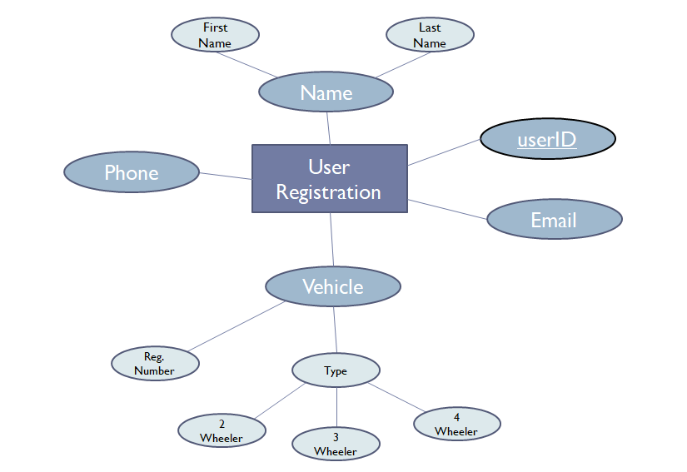

Figure 1: ER Diagram

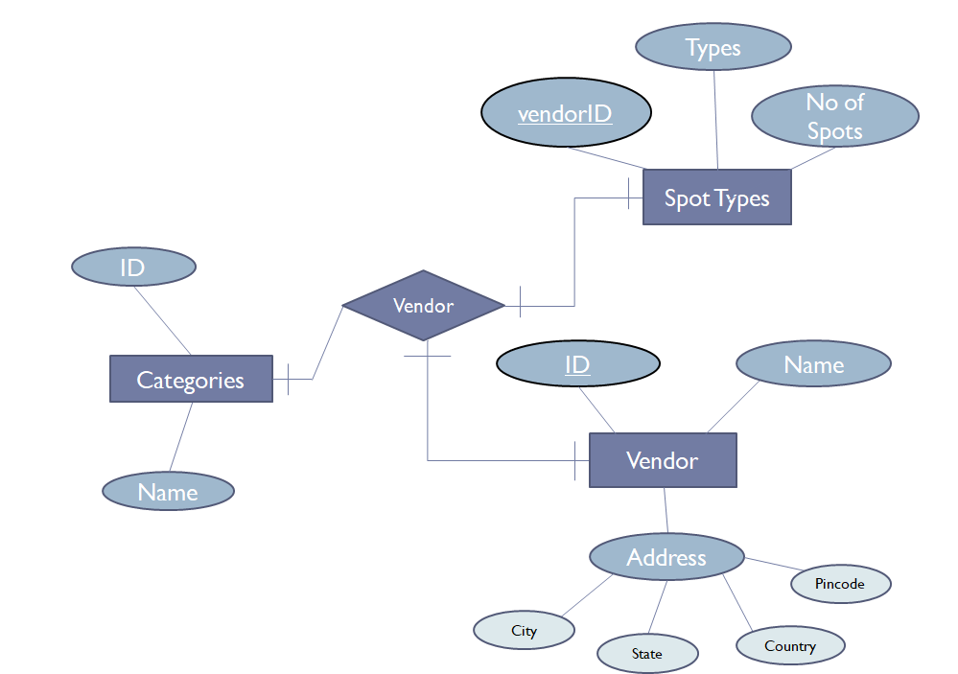

Figure 2: ER Diagram

1. **Table Structures:**

**Table: users**  
  
**Columns:**

|  |  |
| --- | --- |
| **id** | int PK |
| **email** | varchar(255) |
| **mobile** | bigint |
| first_name | varchar(255) |
| last_name | varchar(255) |
| middle_name | varchar(255) |
| password | varchar(255) |

**Table: vendors**  
  
**Columns:**

|  |  |
| --- | --- |
| **id** | int PK |
| address | varchar(255) |
| city | varchar(255) |
| country | varchar(255) |
| pincode | varchar(255) |
| state | varchar(255) |
| date_register | date |
| date_start | varchar(255) |
| name | varchar(255) |

**Table: spot_types**  
  
**Columns:**

|  |  |
| --- | --- |
| **id** | int PK |
| no_of_spot | int |
| type | varchar(255) |
| **booking_id** | int |
| **vendor_id** | int |

**Table: bookings**  
  
**Columns:**

|  |  |
| --- | --- |
| **id** | int PK |
| date | date |
| end_time | time |
| start_time | time |
| time_in | time |
| time_out | time |
| type | varchar(255) |
| **payment_id** | int |
| **vehicle_id** | int |

**Table: payments**  
  
**Columns:**

|  |  |
| --- | --- |
| **id** | int PK |
| overtime_dues | double |
| paid | double |
| penalty | double |
| price_booking | double |
| **booking_id** | int |

1. **Diagrams:**

Figure 3: Component Diagram

1. **End to End Flow of Application:**

**User:**

* 1. User will login to the portal or will have to register if he is not a registered user.
  2. After registration User will login and Dashboard page will be displayed to him which will display the locations and its booking status if any.
  3. From that page can User can click on the ‘**book’** button and reach the location details page.
  4. In the location details page the User has to pick a spot types among the variousdefined categories and brief about the parking slots and available parking slots at specific location
  5. A ‘**booking details’** will be displayed on the Website showing all the details of the parking slots along with the payment and address details.
  6. User will able to see his booking after the booking has been done by the respective vendors of the category chosen.

**Admin:**

1. Admin will login as Admin from the ‘**Admin ‘** page and will be able to see his share of bookings filed by the Users of a particular area.
2. Admin can Review the booking and after understanding it Admin will able see the booking.
3. It is the job of Admin to assign appropriate vendor or service person to resolve the matter at the hand as soon as possible to avoid disturbance among the public at the specific locations.
4. After conforming about the booking of the any slots, Admin will check the status of the current bookings and manage the vendors or locations related issues if any.

**7. Conclusion of the Project My Parking Space:**

Our project is only a humble venture to satisfy the needs to manage their project work. Several user friendly coding have also adopted. This package shall prove to be a powerful package in satisfying all the requirements of the school. The objective of software planning is to provide a frame work that enables the manger to make reasonable estimates made within a limited time frame at the beginning of the software project and should be updated regularly as the project progresses.

The difficulty of searching available parking lots has been completely eliminated by reserving lots via the proposed system. Users can get learn about parking areas for particular locations.

It saves user time in search of parking space available in such a long parking area.

8. **Future Scope of Project**

* The possible implementation with existing systems for the navigation of vehicles. It can reduce investments and increases the probability of real operation.
* We can give more advance software for Online Car Parking System including more facilities We will host the platform on online servers to make it accessible worldwide
* Integrate multiple load balancers to distribute the loads of the system
* Create the master and slave database structure to reduce the overload of the database queries
* Implement the backup mechanism for taking backup of codebase and database on regular basis on different servers

The above mentioned points are the enhancements which can be done to increase the applicability and usage of this project. Here we can

maintain the records of Car and Parking. Also, as it can be seen that now-a-days the players are versatile, i.e. so. there is a scope for introducing a method to maintain the My Parking Space. Enhancements can be done to maintain all the Car, Parking, Parking Space, Parking Slots, Parking Fees.

**References and Bibliography:**

* Google for problem solving
* <http://www.javaworld.com/javaworld/jw-01-1998/jw-01-Credentialreview.html>
* Database Programming with JDBC and Java by O'Reilly
* Head First Java 2nd Edition
* <http://www.jdbc-tutorial.com/>
* Java and Software Design Concepts by Apress
* <https://www.tutorialspoint.com/java/>
* http://www.javatpoint.com/java-tutorial
* <https://docs.oracle.com/javase/tutorial/>
* http://www.wampserver.com/en/
* http://www.JSP.net/
* http://www.tutorialspoint.com/mysql/
* httpd.apache.org/docs/2.0/misc/tutorials.html

**Thank You!**