

**Software Requirements Specification**

**for**

**Letter Dispatch Unit**

**Version 1.0 approved**

**Himanshu Dhankhar and Ashutosh Yadav**

**IIT Jodhpur**

**Software Engineering Project**

**CS223**

**1 March 2018**

*Copyrights are reserved*

*Software Requirements Specification for Letter Dispatch Unit* *Page ii*

Table of Contents

|  |  |  |  |
| --- | --- | --- | --- |
| Table of Contents........................................................................................................................... | | | ii |
| Revision History............................................................................................................................. | | | ii |
| 1. | Introduction.............................................................................................................................. | | 1 |
|  | 1.1 | Purpose........................................................................................................................................... | 1 |
|  | 1.2 | Document Conventions.................................................................................................................. | 1 |
|  | 1.3 | Intended Audience and Reading Suggestions................................................................................. | 1 |
|  | 1.4 | Product Scope................................................................................................................................. | 1 |
|  | 1.5 | References...................................................................................................................................... | 1 |
| 2. | Overall Description.................................................................................................................. | | 2 |
|  | 2.1 | Product Perspective........................................................................................................................ | 2 |
|  | 2.2 | Product Functions........................................................................................................................... | 2 |
|  | 2.3 | User Classes and Characteristics.................................................................................................... | 2 |
|  | 2.4 | Operating Environment.................................................................................................................. | 2 |
|  | 2.5 | Design and Implementation Constraints......................................................................................... | 2 |
|  | 2.6 | User Documentation....................................................................................................................... | 2 |
|  | 2.7 | Assumptions and Dependencies..................................................................................................... | 3 |
| 3. | External Interface Requirements........................................................................................... | | 3 |
|  | 3.1 | User Interfaces................................................................................................................................ | 3 |
|  | 3.2 | Hardware Interfaces........................................................................................................................ | 3 |
|  | 3.3 | Software Interfaces......................................................................................................................... | 3 |
|  | 3.4 | Communications Interfaces............................................................................................................ | 3 |
| 4. | System Features....................................................................................................................... | | 4 |
|  | 4.1 | System Feature 1............................................................................................................................ | 4 |
|  | 4.2 | System Feature 2 (and so on).......................................................................................................... | 4 |
| 5. | Other Nonfunctional Requirements....................................................................................... | | 4 |
|  | 5.1 | Performance Requirements............................................................................................................. | 4 |
|  | 5.2 | Safety Requirements....................................................................................................................... | 5 |
|  | 5.3 | Security Requirements.................................................................................................................... | 5 |
|  | 5.4 | Software Quality Attributes............................................................................................................ | 5 |
|  | 5.5 | Business Rules................................................................................................................................ | 5 |
| 6. | Other Requirements................................................................................................................ | | 5 |
| Appendix A: Glossary.................................................................................................................... | | | 5 |
| Appendix B: Analysis Models....................................................................................................... | | | 5 |
| Appendix C: To Be Determined List............................................................................................ | | | 6 |

Revision History

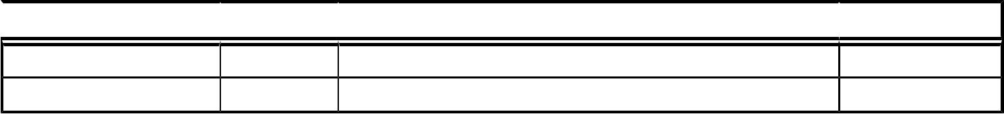

 Name  Date  Reason For Changes  Version

*Software Requirements Specification for Letter Dispatchment Unit* *Page 1*

1. Introduction

1.1 Purpose

The purpose of this document is to provide detailed description of the development and operation of letter dispatchment system. It will illustrate the purpose and complete declaration of the development of the software. It will also explain system constraints, user interface and the response of the system to any external factor.This document is primarily meant for the client but will also be used by the developers as a scale measure to guess there progress. Specifically it provides a means of communication among the project sponsors, System analysis software designers engineers and software quality engineers.Also it will support verification and validation ,and system testing activities and control system evolution.

1.2 Document Conventions

Admin means the person handling the system. Recipient is the person who will finally receive the letter. Delivery system which will be a manual process who deliver the letters to the department s, hostels and to the Post office also if someone wants to send letter outside the institute.

1.3 Intended Audience and Reading Suggestions

*This document is meant for users,developers, project managers,testers,and documentation writers. Our Stakeholders, company associated to hardware manufacturing, company providing embedded operating system, students , faculty and Admin or Institute may review the document to learn about the project and understand the requirements.*

1.4 Product Scope

This software will increase the efficiency in letter dispatchment system. This software can be used by all the institutes and co-operations in the letter dispatchment system.This system monitors dispatchment of letters collected at the entry point as well as letters collected from institute member and dispatches them correctly to there corresponding address or recipient with safety and security under given time limit. This letter dispatchment system also provide the facility to send the letter outside the Institute, for this extra cost will be taken by the institute from the sender for this feature. This system will also provides the complaint facility or enquiry and feedback.

1.5 References

This document builds on the following references: ● Software Engineering : A practitioner's approach , Roger S Pressman ● Ian Sommerville, Software Engineering, Ninth Edition, Addison-Wesley, 2011 ● IEEE. IEEE Std 830-1998 IEEE Recommended Practice for Software Requirements Specifications. IEEE Computer Society, 1998.

*Software Requirements Specification for Letter Dispatchment Unit* *Page 2*

1. Overall Description

2.1 Product Perspective

The Letter Dispatchment Unit is intended to replace the manual model of Letter record maintaninence using paper records. The paper records are replaced with a single interaction between the Faculty/Students and the Letter Dispatchment authority in institute . The system will interfere with email activities and also requires the data of institute members, provided by the institute by mail or in any document format. Automatic work is prefered at each hostel and department guard or warden level for verifying purpose and record maintenance . Computer will allocated to only one main hub of the system means to admin only.It is assumed that a Desktop available at each of the hostel warden office and Department Gaurd.

2.2 Product Functions

This product provides the following features:

1. Collect Letter from post man and deliver it to correct recipient.
2. Send Letters outside the institute.
3. Keep records of all collected letters.
4. register the complaint regarding Letter Issue.
5. Modify the database of the students/faculty.
6. Database of complaints registered.
7. Check the letter status of a specific letter.
8. Generate Report of Letters Received and payment collected and complaints.

2.3 User Classes and Characteristics

There are two types of users who will use the system are admin and recipient.Recipient can view the his letters collected till date and letters sent by him till date and also can send the letter,complain, and collect his letter .while admin will fill the report log , update the data and other information.

2.4 Operating Environment

This software will operate on all existing operating systems with support to c++ programs and all default hardware components provided as of date with any Computer is sufficient to run this software. A minimal amount of memory ( <10mb ) may be required to efficiently run this program and store the Data. LDS will also require network connectivity for updating database and sending emails. LDS also requires sufficient amount space for storage on hard disk.

2.5 Design and Implementation Constraints

2.5.1 e-commerce product will not be collected by the administration because they requires the physical presence of recipient at the time of delivery in institute in that case the agent will be sent directly to department or hostel for delivery.

2.5.2 No intra-institute letter will be collected.

*Software Requirements Specification for Letter Dispatchment Unit* *Page 1*

2.5.3 If any received letter doesn’t contain sufficient information will be sent back or returned back.

2.5.4 Letter/parcel to be sent will have maximum weight of 5 kg above it will not be accepted.\

2.6 User Documentation

A presentation and user manual describing the features of this software will be provided along the delivery of the software.

On request help for the given software will be available between 12 pm - 12 am on the following addresses:

[dhankhar.1@iitj.ac.in](mailto:dhankhar.1@iitj.ac.in)

[yadav.5@iitj.ac.in](mailto:yadav.5@iitj.ac.in)

Typical response time is ~3 hours.

2.7 Assumptions and Dependencies

*A vehicle is to be provided by the institute to deliver the letter. In case any institute member wants to send the letter outside for this appropriate payment and information will be taken and letter will be sent at indian post office branch near the institute. It is assumed that institute will provide correct data of all the institute members and in given a format.*

*It is also assumed that a Desktop is also provided at each hostel waredn ofiice and security office at each Department.*

1. System Features

3.1 Admin: Add Letter

|  |  |  |
| --- | --- | --- |
| Trigger: | entry in software.Admin will collect the letter from Postman and make a | |
| Precondition: | | Admin should be registered and login Letter must have to |
|  | be delivered by postman. | |
| Basic Path: | | Select “collect letter” option Admin will fill individual letter |
|  | details like recipient information Recipient information will be verified by | |
|  | the system automatically else else manual verification will be done if system | |
|  | cannot verify. A Letter collection mail will be sent automatically to recipient | |
|  | once verified. Automatically letter information and letter code will stored in | |
|  | letter DB. Admin will write the generated letter code on the letter. | |
| Alternative Path: | | No alternative path. Post condition: Letter will given to |

the delivery system.

Exception Path: Insufficient information about the recipient then letter will be returned back. other: Letter will contain information like name,contact number , roll number , hostel/department etc.

*Software Requirements Specification for Letter Dispatchment Unit* *Page 2*

3.2 Admin: Dispatch Letter

Trigger: Admin will classify the letter and it is given different bundles to delivery system.

Precondition: admin should be logged in.

Basic Path: Classified bundles of letters will be given to delivery system Admin will

choose”dispatch” option on home screen and fill the letters IDs that are going to

b be dispatched. Now delivery system will deliver the bundles to corresponding

hostel or department. Delivery system will manually take previous working day letter distribution

data.

Alternative Path: No Post condition: Letter bundle will be delivered to warden/department guard.

Exception Path: No exception paths exist other: No

3.3 Admin: Post Letter

Trigger:

Precondition:

Basic Path:

Alternative Path:

Post condition:

Exception Path:

other: No

Sender gives the letter/parcel to admin for posting to post office.

Sender must be a Institute member and payment should be given to admin.

admin will select “send letter” option. Admin will fill letter details like address,

Name,contact number, and letter size and letter/parcel weight must be under

5kg. Automatically payment to be done will be calculated using indian post

office payment chart with taxes and extra cost as applicable. A transaction Id

will be generated and payment details will be sent to sender by email along

with cost applicable. Then money will be taken from sender and payment

details will be stored in the Send letter database.

sender can directly go to post office to post the letter.

letter/parcel will be given to the delivery system that will post it to nearby

post office branch.

Insufficient information on letter , it will be returned back to sender.

**3.4 Administration: letter status**

Trigger: In case admin wants to see the letter status which can be required in many enquiry problems.OR there is a need to update the status of letter.

Precondition: No precondition Basic Path: admin will select “Letter status” and enter the letter id. If in case letter id is not known than select “ forgot letter id” after selecting “letter status” and enter the recipient roll number/ID and expected range of date of delivery of letter. Now system will show the status of letter received if it exists. Now if

admin wants to update the status of letter he will select “update status” option and then he will update the letter status.

Alternative Path: No

Post condition: Letter status will be mailed or informed to recipient if he needs it.

Exception Path: No

other: No

*Software Requirements Specification for Letter Dispatchment Unit* *Page 3*

3.5 Admin: update Database

Trigger:

Basic Path:

Alternative Path:

Post condition:

Exception Path:

other:

Institute will provide information of addition of new faculty/students or removal

of faculty/student Precondition: sufficient information will be provided by

institute.

select “update database” select “student” or “faculty” or “staff” or “warden” fill

the corresponding information and then click add/remove/update.

NO

Now new data will be used by LDS.

NO

NO

3.6 Admin : Generate Report

Trigger:

Precondition:

Basic Path:

Alternative Path:

Post condition:

Exception Path:

other:

whenever weekly or monthly report is required.

start date and end date must be valid and gap between them must be within

range of 9 months.

select “generate report” enter two valid dates in “from” and “to” option select

which type of report you want to generate from”letter reports” “payment

reports” . report will be generated on screen If you want to make a backup of

reports then select”backup” It will give the report within the dates to your

mail itself.

No

No

No

No

3.7 Admin: Complain

Trigger:

Precondition:

Basic Path:

Alternative Path:

Post condition:

Exception Path:

other:

complain will be registered when someone sends a complaint by a email.

complainant must be a in institute member.

select complaint option select “add complaint” fill information about

complainant and fill the problem statement . select “submit” complaint will be

registered and a complaint number will be generated and assigned to complaint

and complaint database will be updated now a complaint registration mail will

be sent to complainant along with complaint number. in complain menu if admin

selects update complain status admin must have to enter the complaint number

and then update complaint status.

No

complaint will be considered and enquiry will be done by the admin.

No

No

*Software Requirements Specification for Letter Dispatchment Unit* *Page 4*

4. Other Nonfunctional Requirements

3.3 Performance Requirements

Software will be secure means anyone cannot access the reports ,payment data etc. software will be fast means it must not hang up and will not use very large amount of memory and storage. It must run on both linux and windows operating system. software must be easy to handle and not be very much complex.

3.4 Safety Requirements

for safety of data being stored in current process than any power cut can cause the loss of data so for that a UPS must have to be provided. data will time to time backed up by the admin.

3.5 Security Requirements

computer on which the system is running will be protected by password lock which is known to admin only. so that no one can uninstall the software.

3.6 Software Quality Attributes

software quality attributes will be defined by the gui and other operations provided by the developer.

3.7 Business Rules

Illegal transfer or copy of software must not generated by user.User has to pay one time and can use the software life time.Any discrepancy with software authorizes the development agency to file court case against user.User will be given a key by company to login.

1. Other Requirements

delivery vehicle and registers ,envelops and post office payment chart for different mails.

Appendix A: Glossary

**Staff: technical people who is working in institute.**

**Guard: security person deployed at each department or hostel**

**Warden: hostel supervisor deployed at each hostel**

**Administration: core management team of institute**

**Main hub: room allocated for letter dispatch authority**

**Entry point: main gate of institute**

**Delivery system: transportation resources provided by institute**

*Software Requirements Specification for Letter Dispatchment Unit* *Page 5*

Appendix B: Analysis Models

USE CASE DIAGRAM FOR LDS:

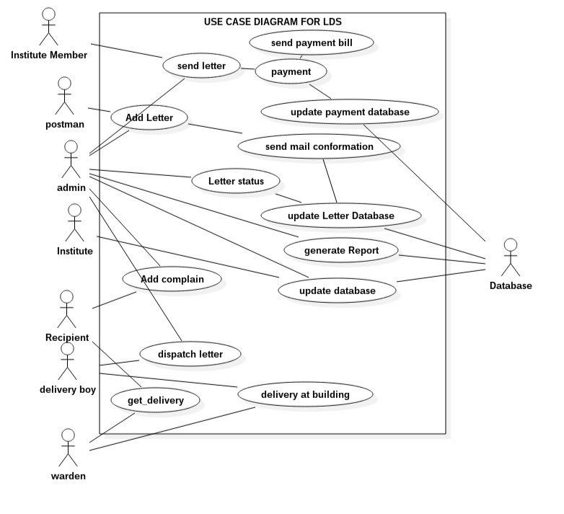

*Software Requirements Specification for Letter Dispatchment Unit* *Page 6*

CLASS DIAGRAMS FOR LETTER DISPATCH UNIT

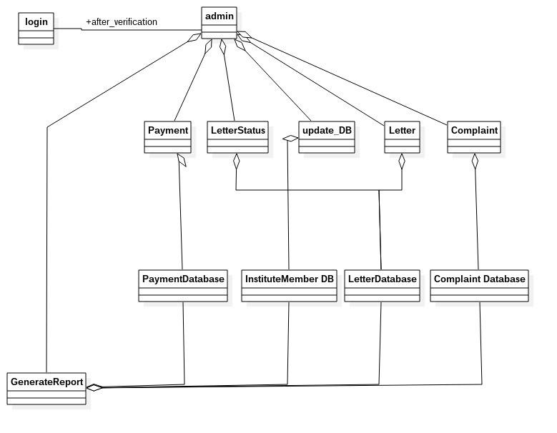

*Software Requirements Specification for Letter Dispatchment Unit* *Page 7*

CLASSES IN DETAILS:

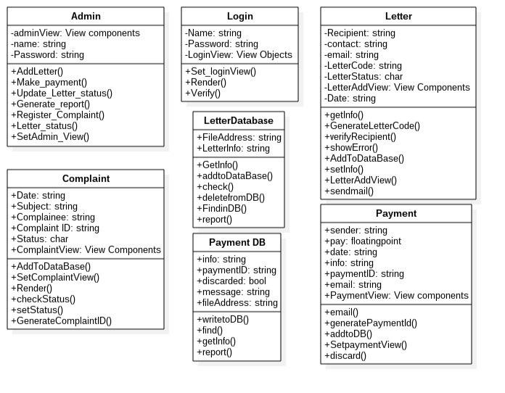

*Software Requirements Specification for Letter Dispatchment Unit* *Page 8*

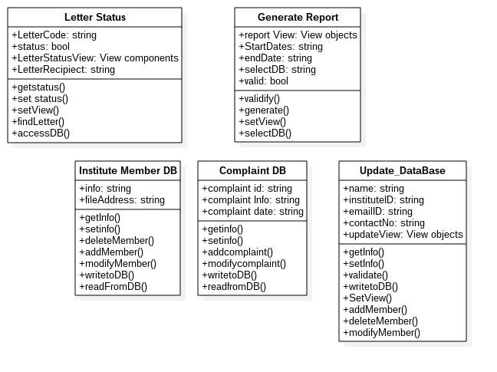

*Software Requirements Specification for Letter Dispatchment Unit* *Page 9*

Activity Diagram for: ADD LETTER

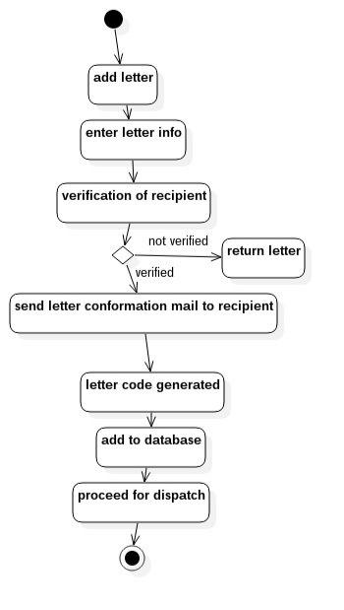

*Software Requirements Specification for Letter Dispatchment Unit* *Page 10*

Activity Diagram : Send Letter

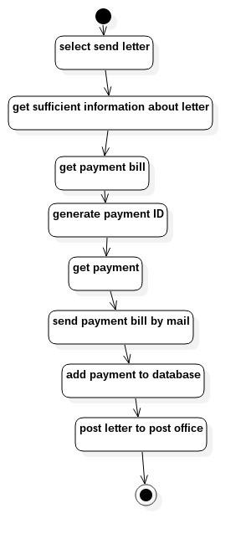

*Software Requirements Specification for Letter Dispatchment Unit* *Page 11*

Activity Diagram : complain

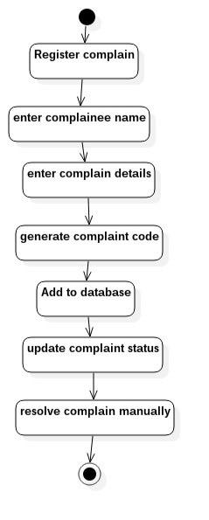

*Software Requirements Specification for Letter Dispatchment Unit* *Page 12*

Activity Diagram : Generate Report

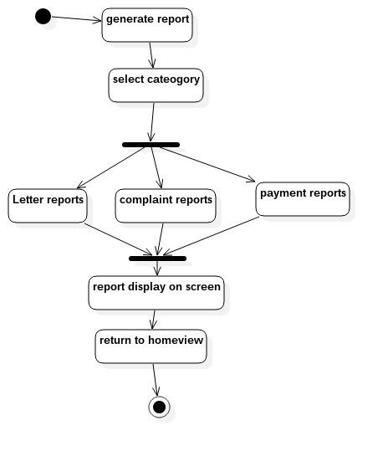

*Software Requirements Specification for Letter Dispatchment Unit* *Page 13*

Activity Diagram : Update Database

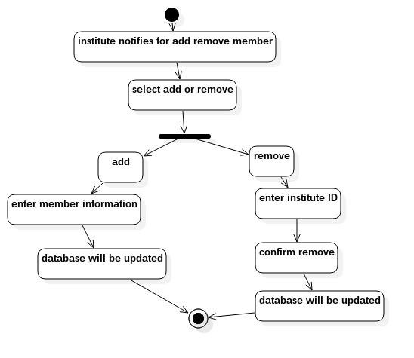

*Software Requirements Specification for Letter Dispatchment Unit* *Page 14*

Sequence Diagram : Add Letter

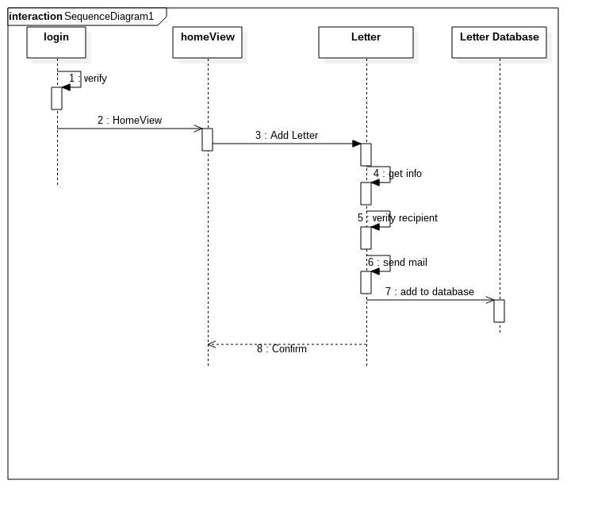

*Software Requirements Specification for Letter Dispatchment Unit* *Page 15*

Sequence Diagram: Send Letter

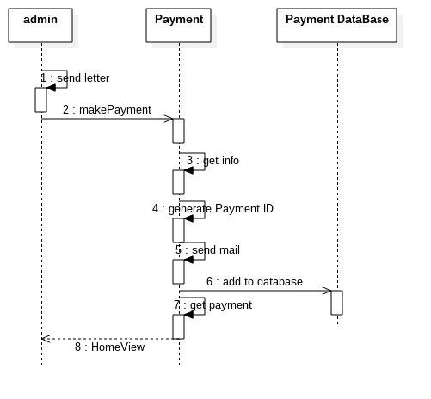

*Software Requirements Specification for Letter Dispatchment Unit* *Page 16*

Sequence Diagram : complaint

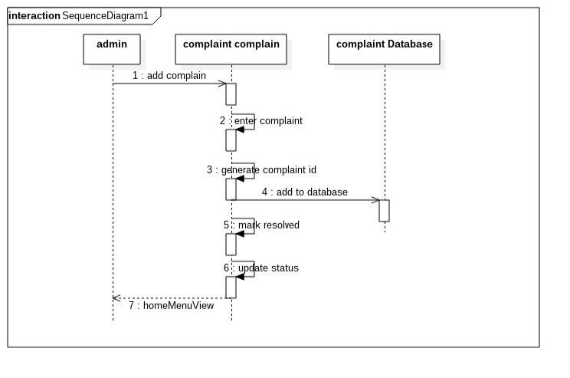

*Software Requirements Specification for Letter Dispatchment Unit* *Page 17*

Sequence Diagram : Generate Report

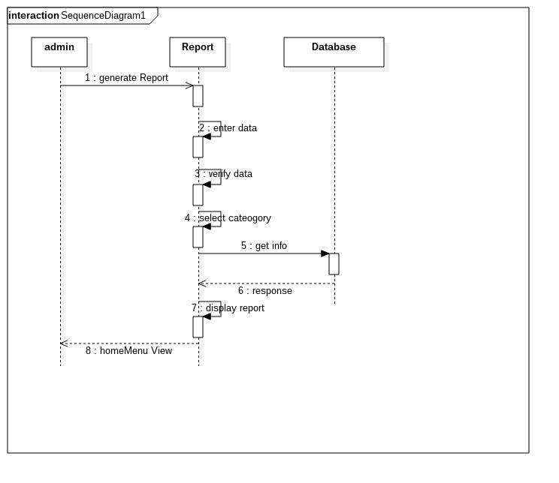

*Software Requirements Specification for Letter Dispatchment Unit* *Page 18*

Sequence Diagram : Letter status

