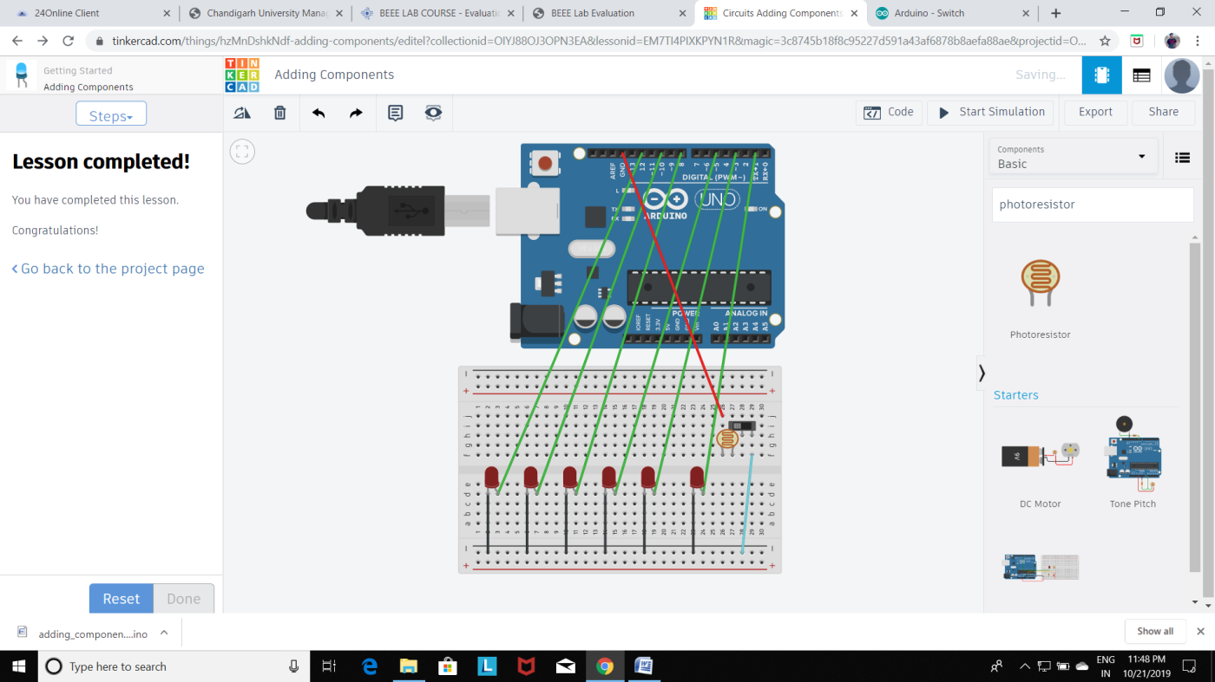

**Aim: Design automatic led Diwali lights (consisting of 6 led’s) such that it only works during night and can generate two patterns which can be toggled with switch. a. Pattern 1 –led chaser b. Pattern 2 – even-odd led’s**

.

**Observation:**

**2. automatic led Diwali lights (consisting of 6 led’s) that only works during night and can generate two patterns which can be toggled with switch. a. Pattern 1 –led chaser b. Pattern 2 – even-odd led’s**

**Precaution:**

1. Connection must be made carefully with the breadboard and Arduino.
2. Wire should be connected to the pin which is defined in the program.
3. Code should be in case sensitive form.
4. While making connections connection of the breadboard should be kept in mind.

**Learning Outcome:**

1. We get better understanding of Arduino and its components.
2. We get some skills to use various sensor along with Arduino.