# Creating and hosting a simple Angular application on Azure WebApp

Check if Angular CLI is installed or not

ng --version

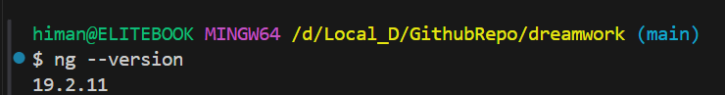

Create angular application

ng new angularhgoel

run application

ng serve

Open below url to confirm app Running

http://localhost:4200