|  |  |  |
| --- | --- | --- |
| Yeshwantrao Chavan College of Engineering | | |
| Department of Artificial Intelligence & Data Science | | |
| Semester 1 | Section: I | Session: Odd 2023-24 |
| Course: Lab: Big Data Hadoop | | |
|  | | |
| Practical No: 02 | | |
| Aim: File management operation in Hadoop | | |
| **1) Start Hadoop Daemons by running the following commands** | | |

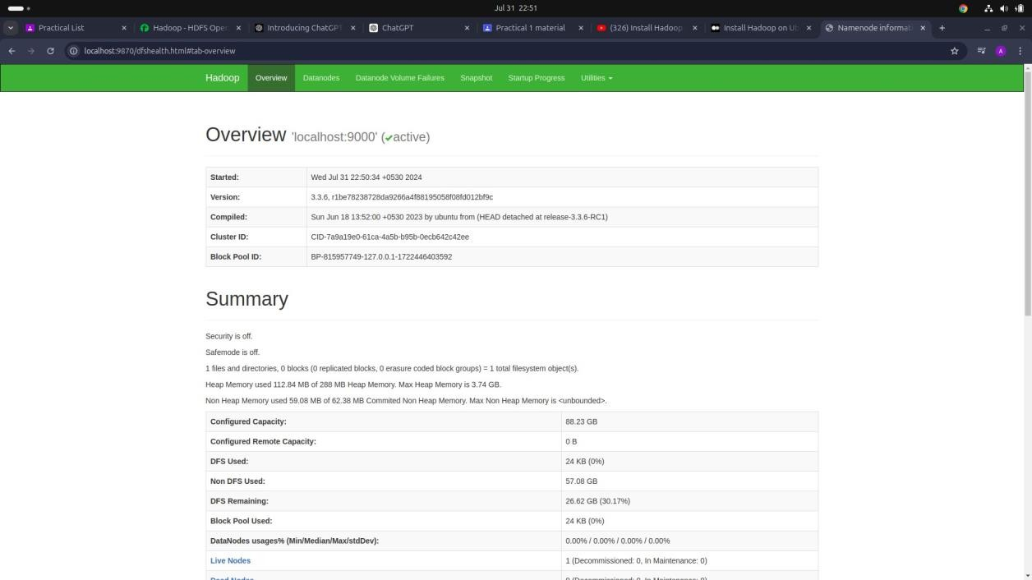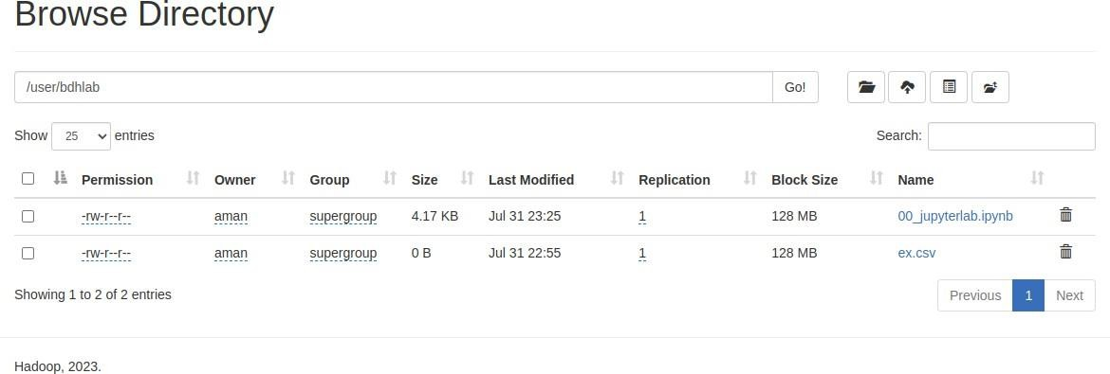

1. mkdir
2. copyFromLocal
3. copyToLocal

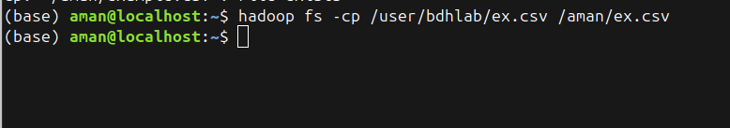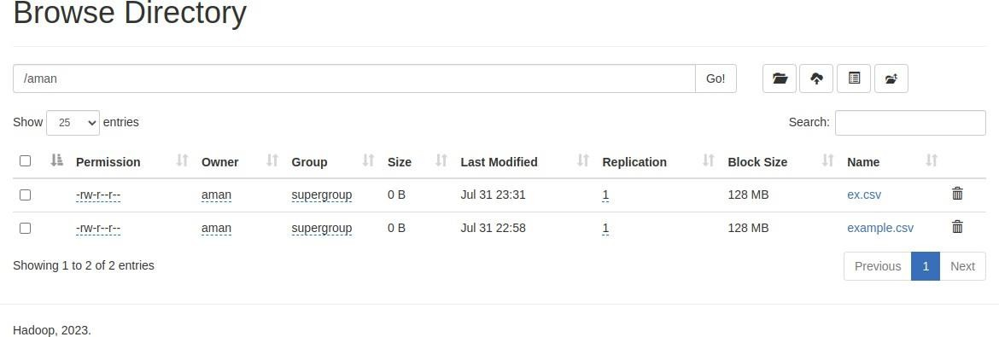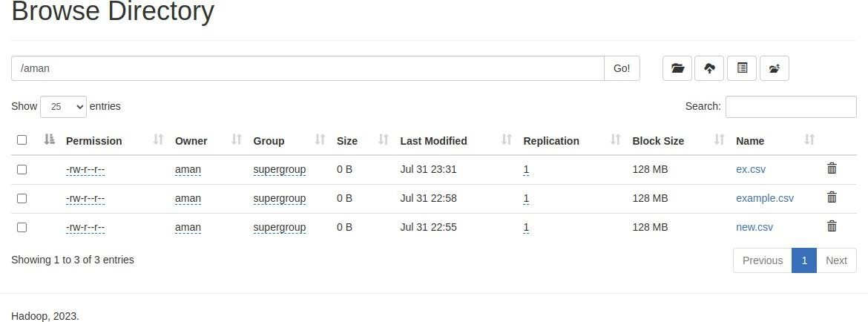

1. cp
2. mv

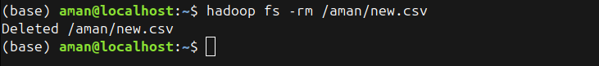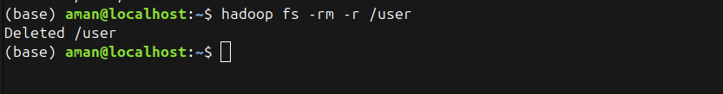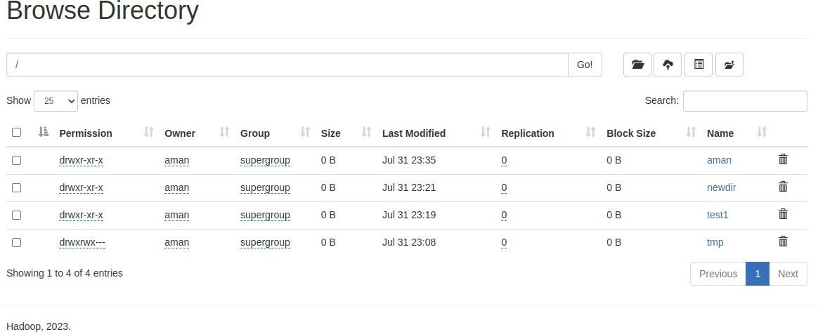

1. rm
2. getmerge

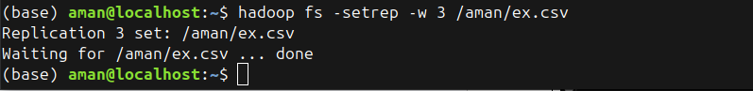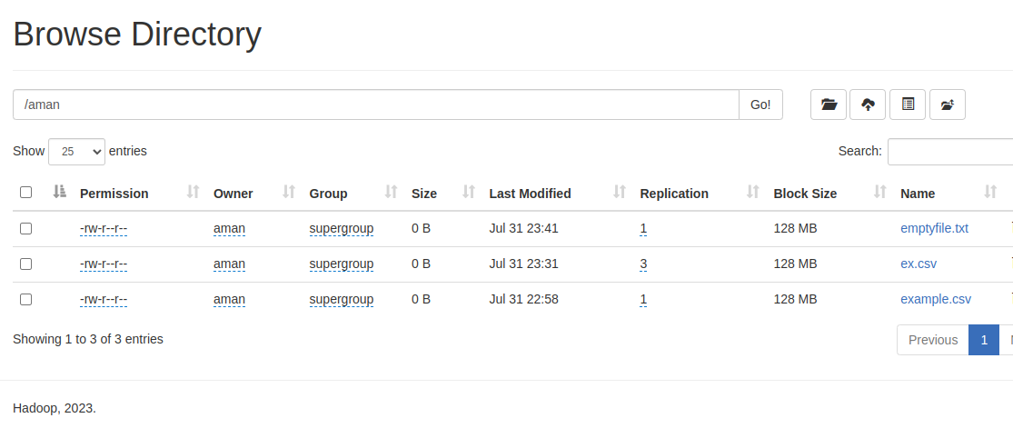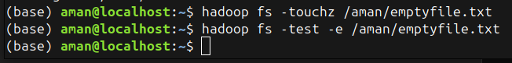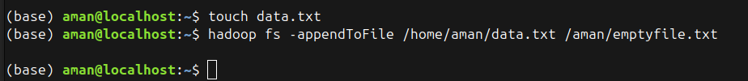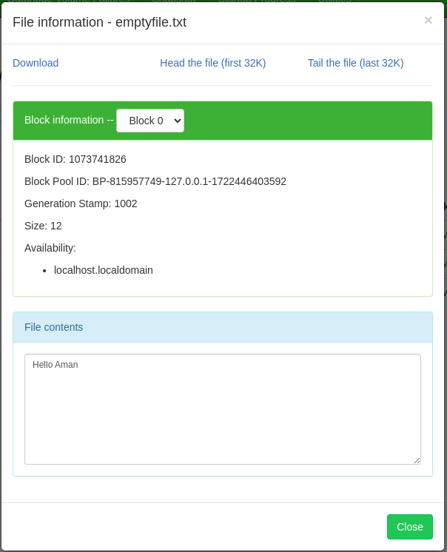

1. setrep
2. touchz

|  |  |  |
| --- | --- | --- |
| 1. tail      1. df      1. du | | |
| Submitted by: | | |
| Name: Himanshu Dhomane | Roll No.: 43 | Reg. No.: 21070297 |