|  |  |  |
| --- | --- | --- |
| Yeshwantrao Chavan College of Engineering | | |
| Department of Artificial Intelligence & Data Science | | |
| Semester 7 | Section: I | Session: Odd 2024-25 |
| Course: Lab: Big Data Hadoop | | |
|  | | |
| Practical No: 03 | | |
| Aim: MapReduce Program to Calculate Frequency of Words from  Datasets | | |
| 1. Checking Hadoop and javac Versions      1. Starting HDFS | | |

1. Wordcount.java Program

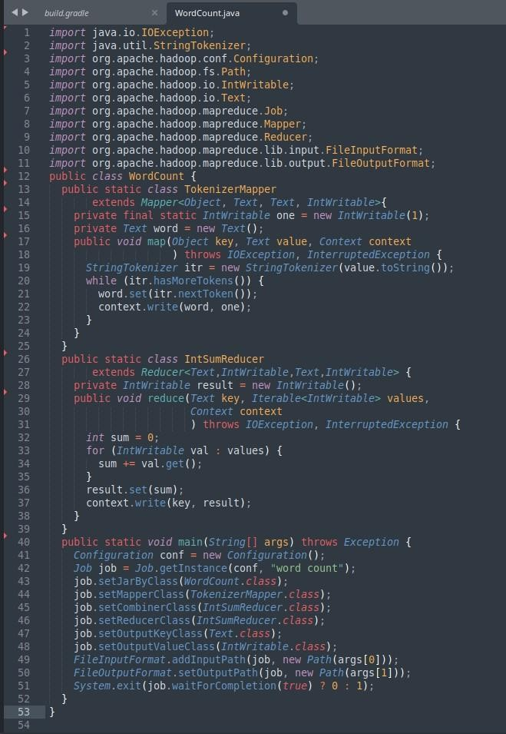

1. Creating & Writing input.txt

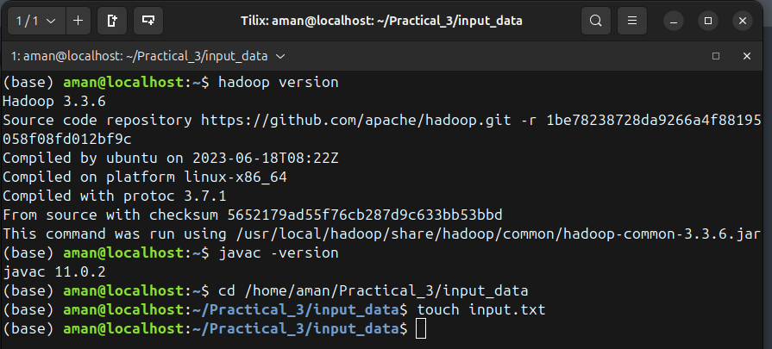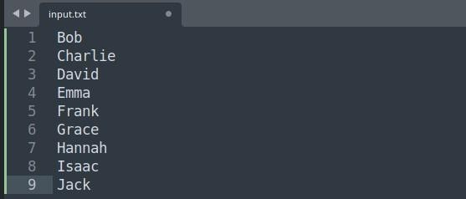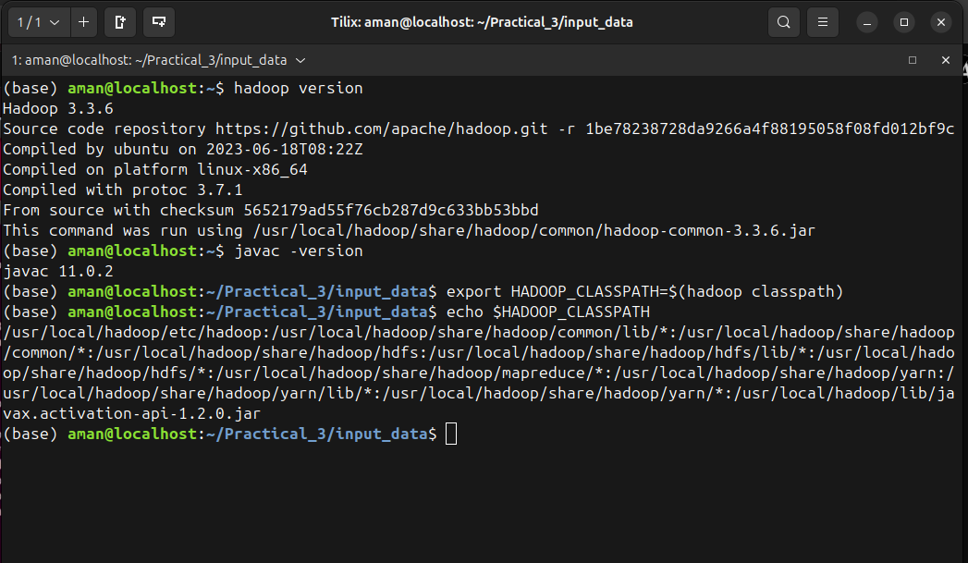

\

1. Setting up classpath
2. Making Directory in HDFS

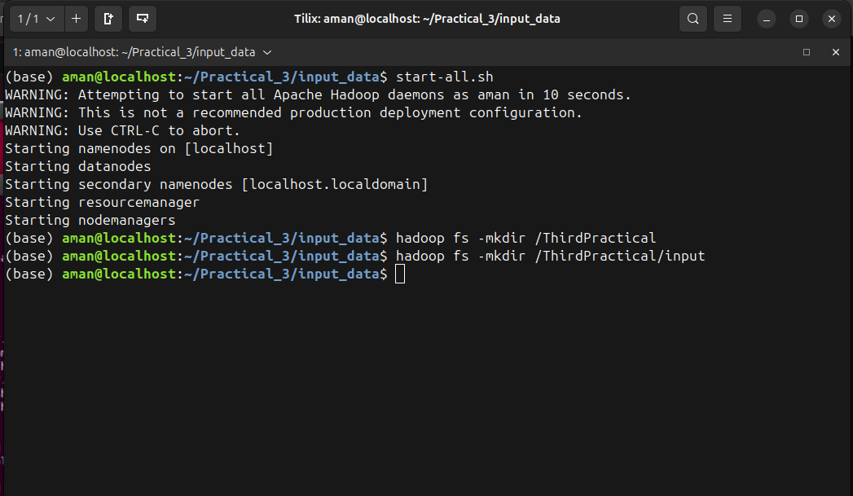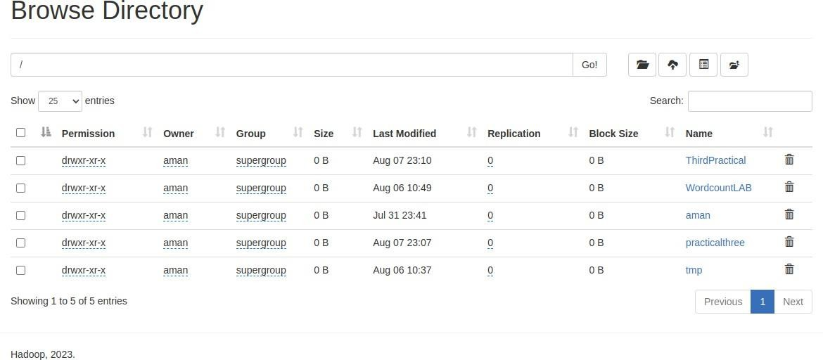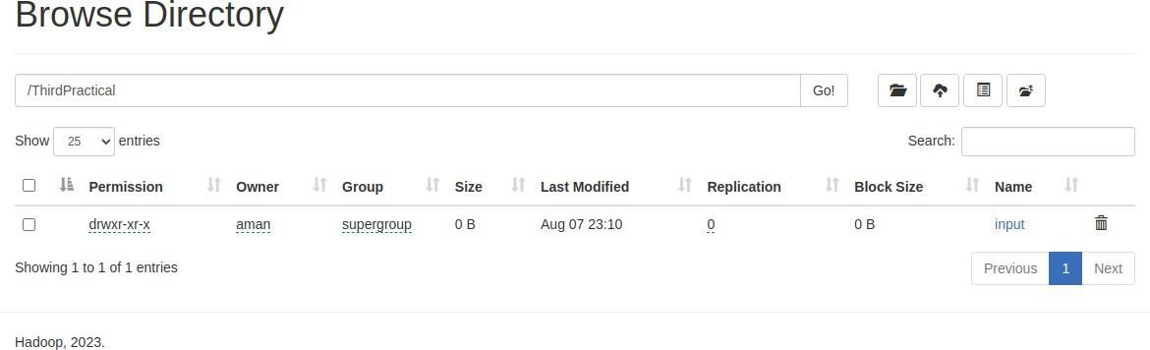

1. Pasting input.txt in directory

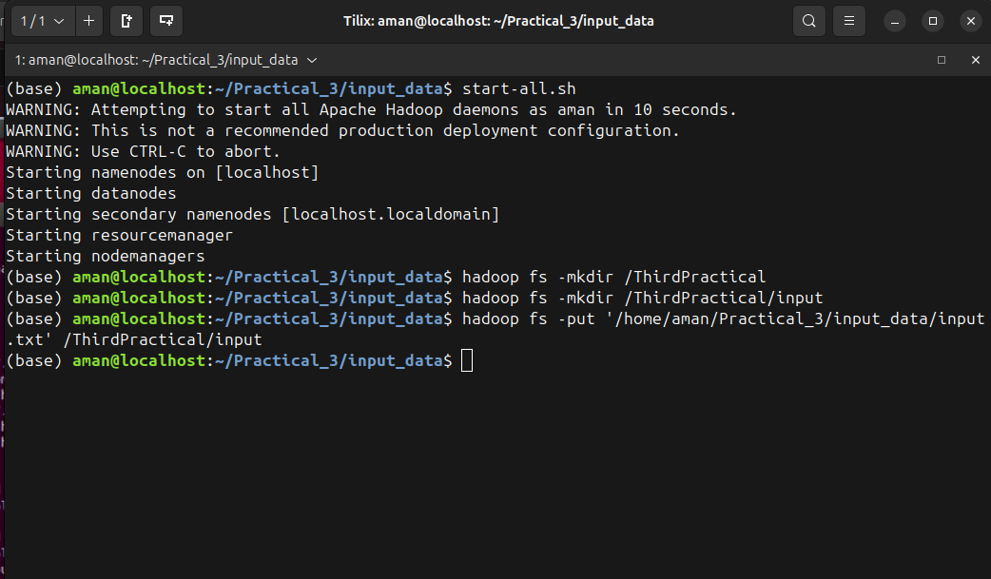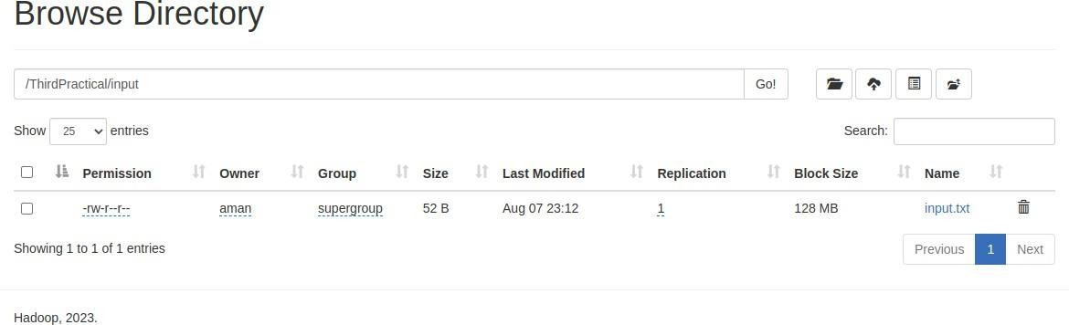

1. Executing program

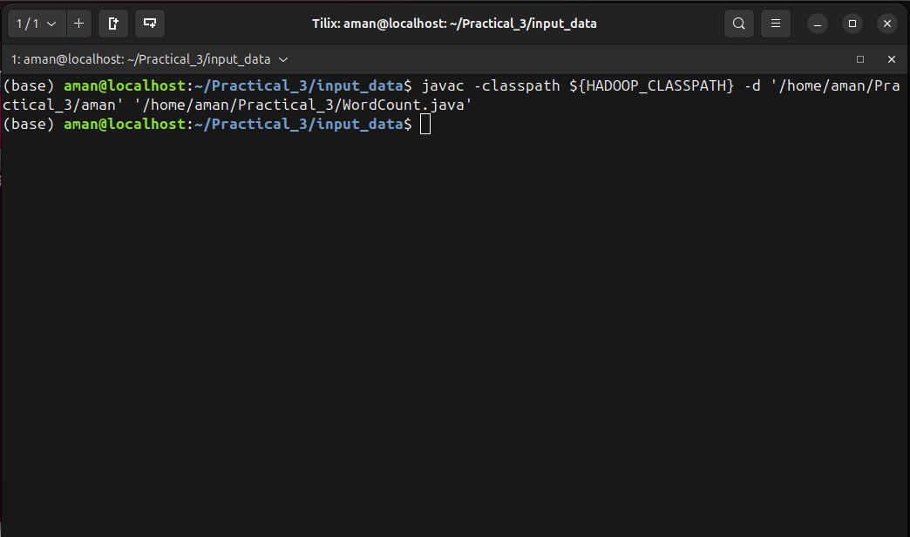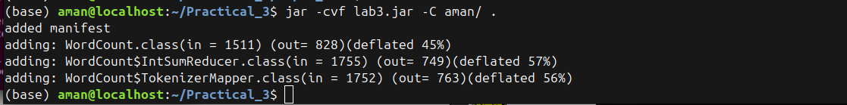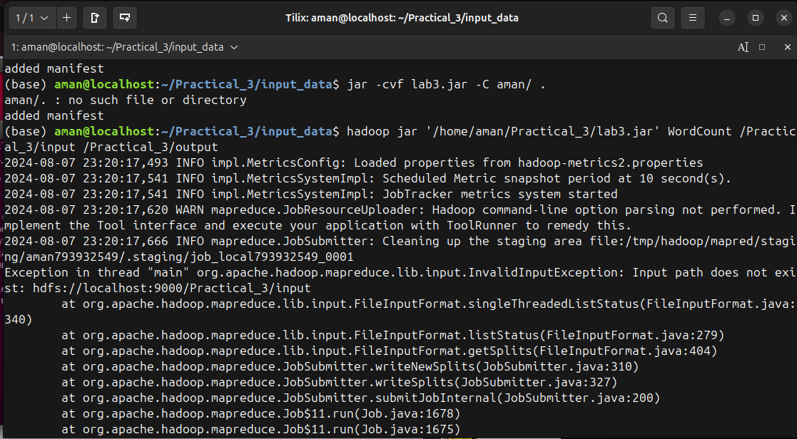

1. deflating pkg in aman/
2. Running Wordcount.java

|  |  |  |
| --- | --- | --- |
| 11) Checking Wordcount / Output | | |
| Submitted by: | | |
| Name: Himanshu Dhomane | Roll No.: 43 | Reg. No.: 21070297 |